[Quintin Lopez-Scarim]
[February 2nd, 2024]
[23533621]
Report – [Bootloader Development]

Introduction
The goal of this bootloader development is to create a bootloader to run on the i386 (486 CPU) platform, and another one that runs on the akita platform – with both programs simply sending a UART message. This basic program lays the groundwork for a typical bootloader development flow, ad gives experience in the basics along with a method of debugging in the form of UART messages.

Investigation:
Experiment: x86
1). Utilizing the following command:
qemu-system-x86_64 -cpu qemu64 -nographic -drive file=x86-mini.bin,format=raw -device loader,file=lemon_log.bin,addr=0x500 -s -S

I tested the bootloader for the i386 platform on the x86_64 emulator, and did indeed have the machine complete the task identically to the i386 platform.
2). The reasoning for the program working on both platforms is the standardization of the memory mapping and the backwards compatibility caused by the standardized boot process, without either of these variable results could have occurred when trying to map the program over to the x86_64 system.

Experiment: Arm
3.) Utilizing the following command:
qemu-system-arm -M raspi2b -nographic -device loader,file=arm-mini.bin,addr=0x00 -device loader,file=lemon_log.bin,addr=0xA0000000 -s -S

I tested the bootloader for the akita platform on the raspi2 platform and it did not complete the task correctly. It remained running seemingly nothing, with no output.
4.) This result likely occurred due to the uniqueness of arm, the memory layout is not standardized like the x86 or x64 systems. This means that the program may have not been loaded into the right place to run, and that UART likely was also mapped elsewhere.
5.)The lack of cross-compatibility for arm is what differs itself from x86 and x64 systems. Due to standardization most if not all of the bootloader process (simple ones at least) can be transferred between x86 and x64, whereas even the most basic of programs are typically not transferrable for arm due to unique memory mapping.
Design
The design section should include a detailed description of the module’s design and how it was implemented. Hardware and software layout diagrams (i.e. hardware connection block diagram, software flow chart, etc.) should be included to illustrate the design’s intricacies. The experimental results should also be displayed in this section and Figures should be labeled with descriptive figure captions occurring below the figure. Screen shots of schematics or waveform results are allowed; however, use text boxes to label the axes. (See the grouped picture and text boxes below).

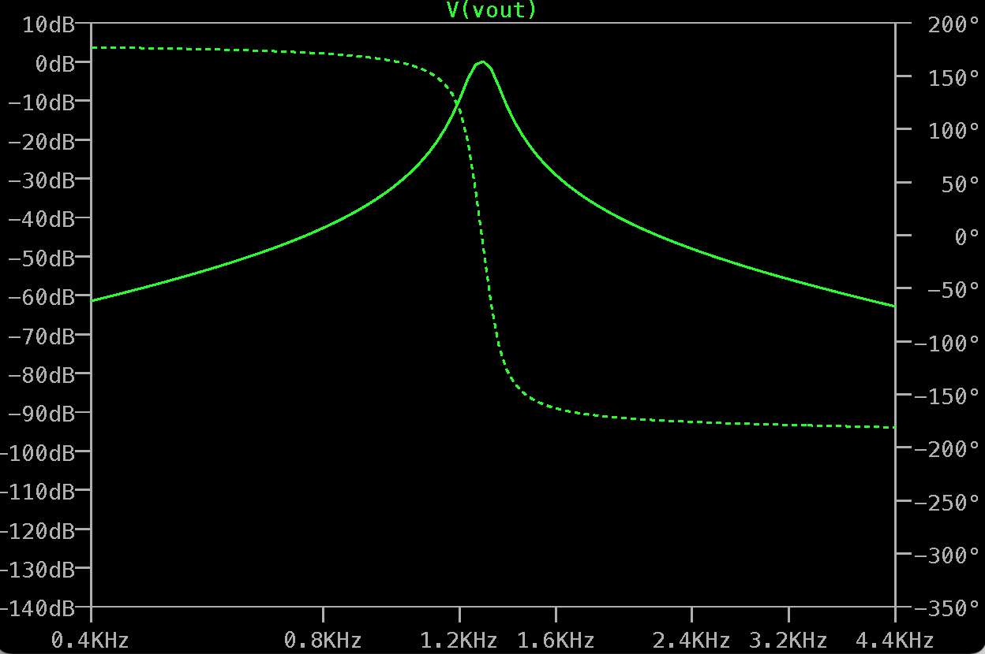
Active Filter Circuit Gain (dB)
Active Filter Circuit Phase (dB)
Frequency (Hz)Figure 1. Frequency response of the active filter modeled in LTSpice.
Conclusion
This lab serves as an introduction to emulation and bootloaders, and provides a real-life example of the effects of standardization vs unique architectures. It provides a foundation to expand on for unique bootloader programs, and also the resources to emulate a vast amount of different patterns.

