综合测试终端使用说明书

目录

1 环境配置 3

1.1 示波器驱动安装： 3

综合测试终端软件使用说明书

# 环境配置

## 镜像源更换为国内

1. 打开终端，输入 su root
2. 备份默认源：cp /etc/apt/sources.list /etc/apt/sources.list.bak
3. 打开 /etc/apt/sources.list，屏蔽默认源，加入以下内容：

#阿里云源

deb http://mirrors.aliyun.com/ubuntu/ focal main restricted universe multiverse

deb-src http://mirrors.aliyun.com/ubuntu/ focal main restricted universe multiverse

deb http://mirrors.aliyun.com/ubuntu/ focal-security main restricted universe multiverse

deb-src http://mirrors.aliyun.com/ubuntu/ focal-security main restricted universe multiverse

deb http://mirrors.aliyun.com/ubuntu/ focal-updates main restricted universe multiverse

deb-src http://mirrors.aliyun.com/ubuntu/ focal-updates main restricted universe multiverse

deb http://mirrors.aliyun.com/ubuntu/ focal-proposed main restricted universe multiverse

deb-src http://mirrors.aliyun.com/ubuntu/ focal-proposed main restricted universe multiverse

deb http://mirrors.aliyun.com/ubuntu/ focal-backports main restricted universe multiverse

deb-src http://mirrors.aliyun.com/ubuntu/ focal-backports main restricted universe multiverse

#清华源

# 默认注释了源码镜像以提高 apt update 速度，如有需要可自行取消注释

deb https://mirrors.tuna.tsinghua.edu.cn/ubuntu/ focal main restricted universe multiverse

# deb-src https://mirrors.tuna.tsinghua.edu.cn/ubuntu/ focal main restricted universe multiverse

deb https://mirrors.tuna.tsinghua.edu.cn/ubuntu/ focal-updates main restricted universe multiverse

# deb-src https://mirrors.tuna.tsinghua.edu.cn/ubuntu/ focal-updates main restricted universe multiverse

deb https://mirrors.tuna.tsinghua.edu.cn/ubuntu/ focal-backports main restricted universe multiverse

# deb-src https://mirrors.tuna.tsinghua.edu.cn/ubuntu/ focal-backports main restricted universe multiverse

deb https://mirrors.tuna.tsinghua.edu.cn/ubuntu/ focal-security main restricted universe multiverse

# deb-src https://mirrors.tuna.tsinghua.edu.cn/ubuntu/ focal-security main restricted universe multiverse

# 预发布软件源，不建议启用

# deb https://mirrors.tuna.tsinghua.edu.cn/ubuntu/ focal-proposed main restricted universe multiverse

# deb-src https://mirrors.tuna.tsinghua.edu.cn/ubuntu/ focal-proposed main restricted universe multiverse

## QT安装

1. 打开终端，切换至/home/$user/soft目录，输入指令：

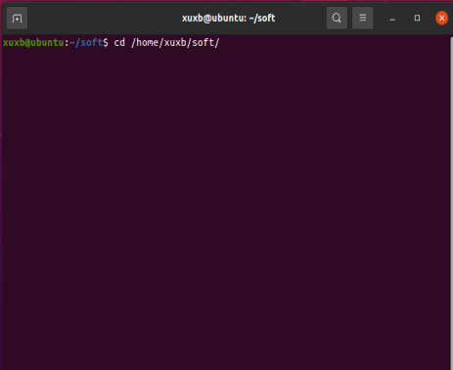

1. 输入ls，查看QT软件安装包是否存在

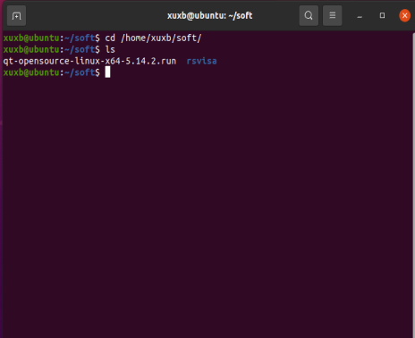

1. 安装QT，输入指令：chmod 777 qt-opensource-linux-x64-5.14.2.run，回车。再输入指令sudo ./ qt-opensource-linux-x64-5.14.2.run，执行安装。

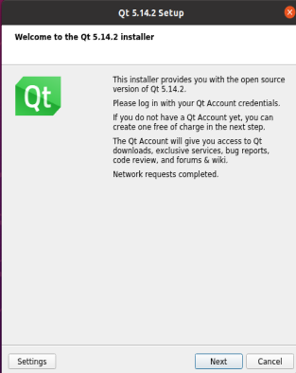

1. 勾选全部安装

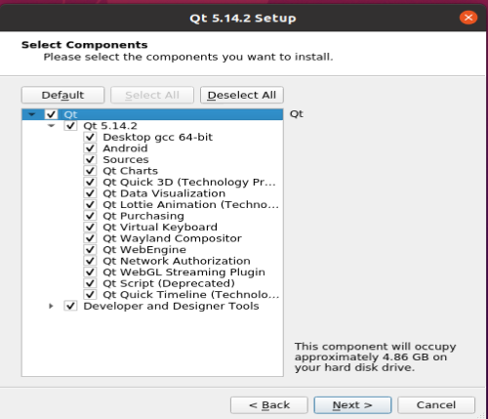

1. 按照提示进行安装，安装完成。

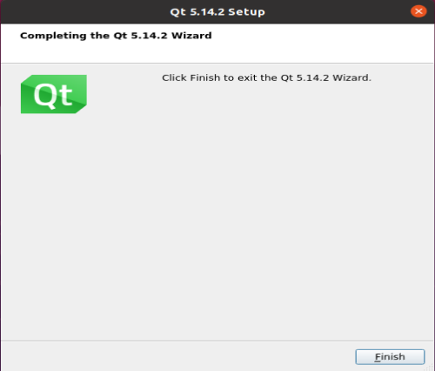

## Python 安装

1. 更新pip

输入指令：pip3 install –upgrade pip，如果没有安装pip，则首先输入指令sudo apt install python3-pip。

1. 添加镜像源

输入指令：sudo add-apt-repository ppa:deadsnakes/ppa

1. 安装python 3.8

sudo apt install python3.8

1. 验证安装成功

python3.8 --version



1. 安装python3-dev

sudo aptitude python3-dev

## 数据库安装

1. 打开终端，输入 sudo apt install postgresql

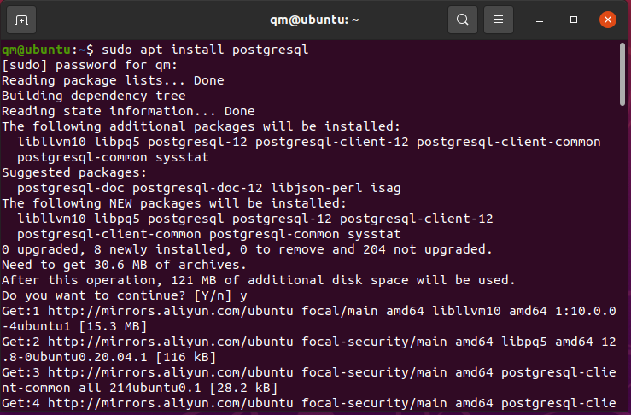

1. 安装完成

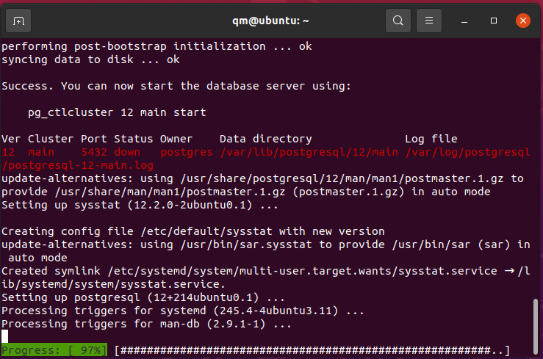

1. 启动数据库服务

sudo systemctl is-active postgresql



sudo systemctl is-enabled postgresql



sudo systemctl status postgresql

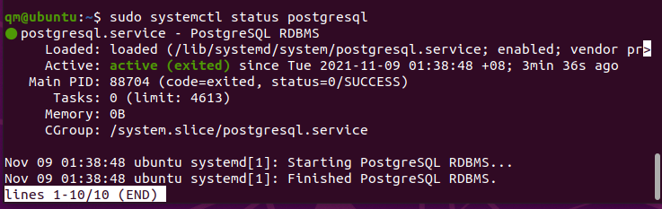

sudo pg_isready



sudo su – postgres

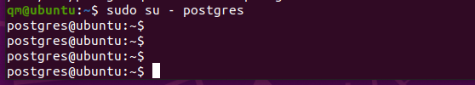

Psql

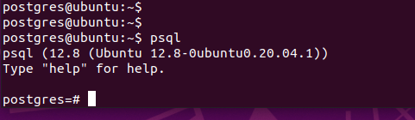

exit



1. 客户端安装与配置

sudo apt install ca-certificates

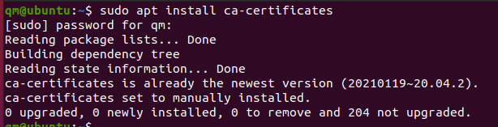

sudo apt install curl

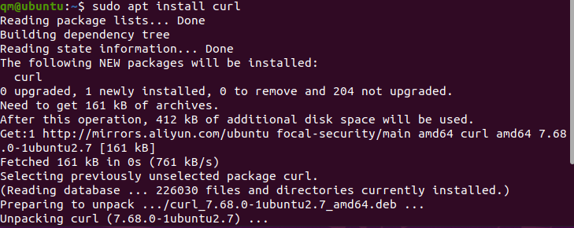

curl https://www.pgadmin.org/static/packages_pgadmin_org.pub | sudo apt-key add

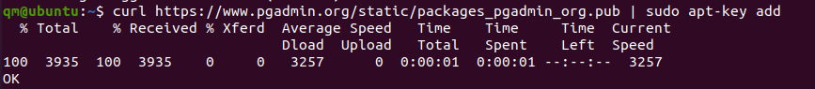

sudo sh -c 'echo "deb https://ftp.postgresql.org/pub/pgadmin/pgadmin4/apt/$(lsb_release -cs) pgadmin4 main" > /etc/apt/sources.list.d/pgadmin4.list && apt update'

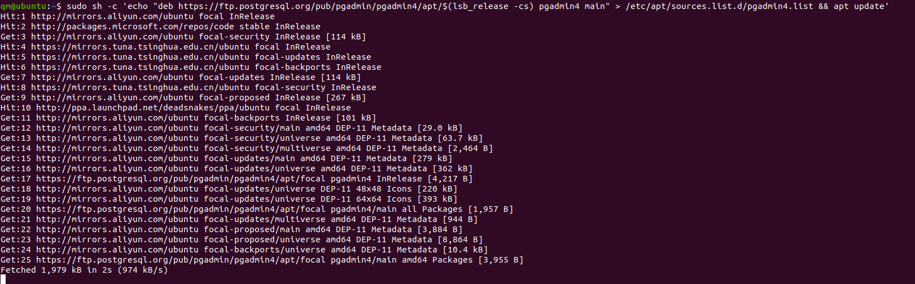

sudo apt install pgadmin4

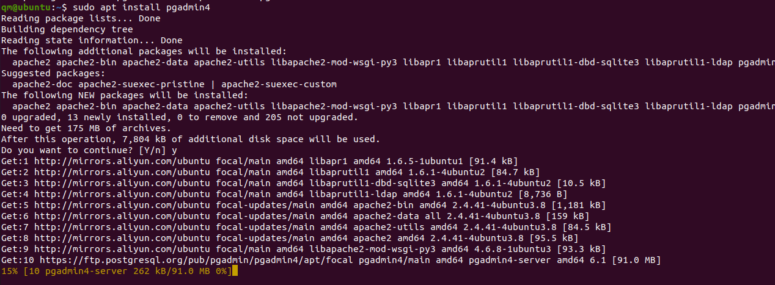

## 示波器驱动安装

1. 打开终端，切换至/home/$user/soft/rsvisa目录，输入指令：

cd /home/$user/soft/rsvisa。

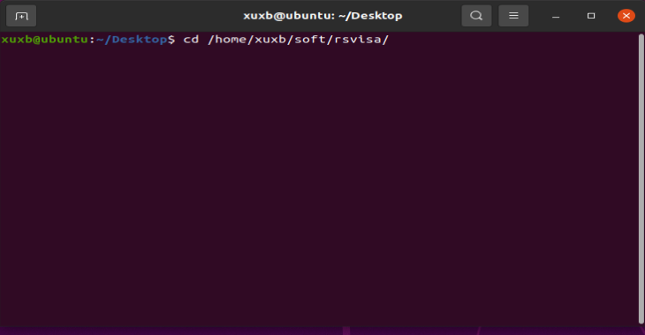

1. 输入指令：ls，查看驱动安装包是否存在

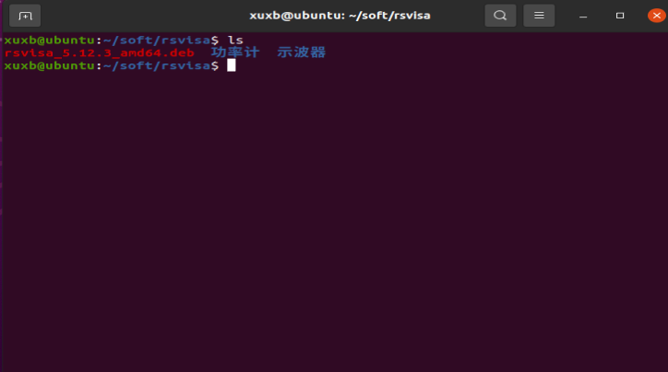

1. 安装驱动，输入指令sudo dpkg –i rsvisa_5.12.3_amd64.deb

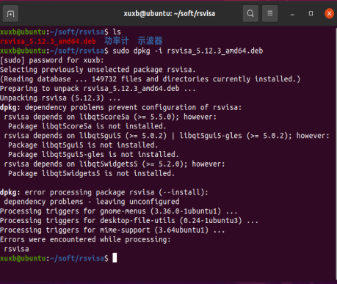

1. 安装完成。

## Wireshark安装与配置

1. 打开Ubuntu应用商店

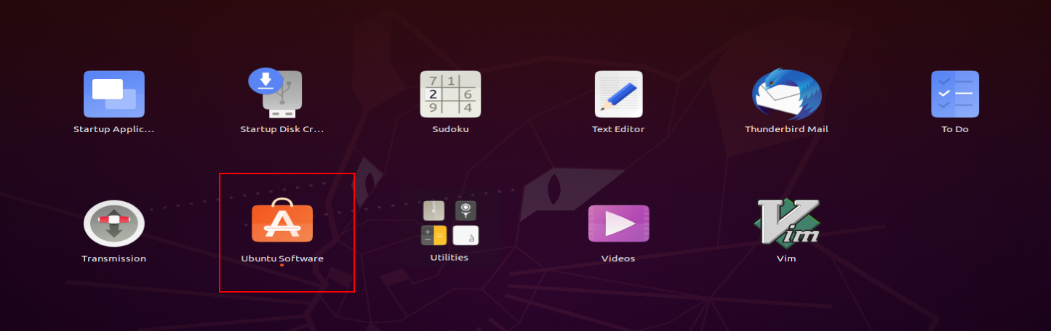

1. 搜索框中输入： wireshark

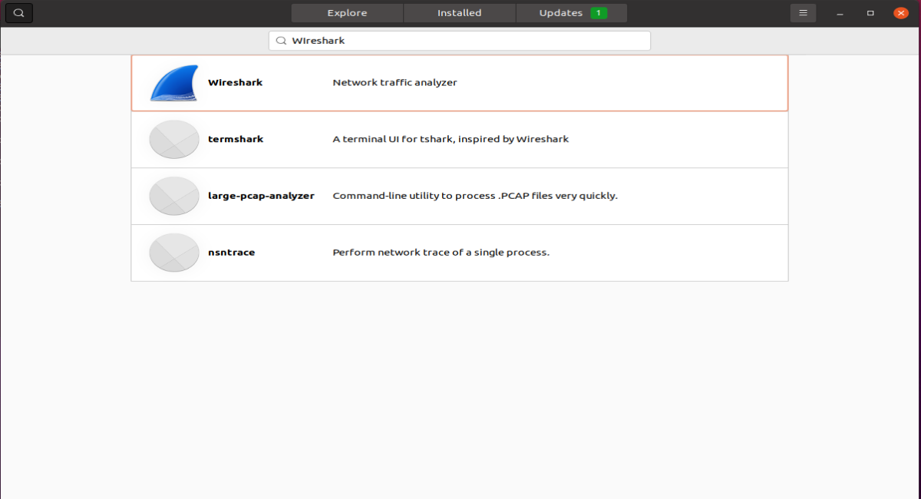

1. 单击第一个选项，然后单击install

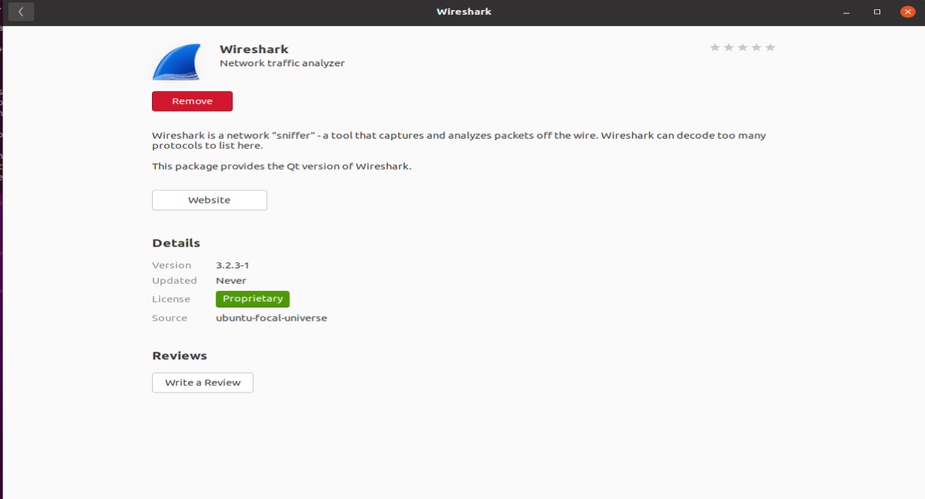

1. 完成安装

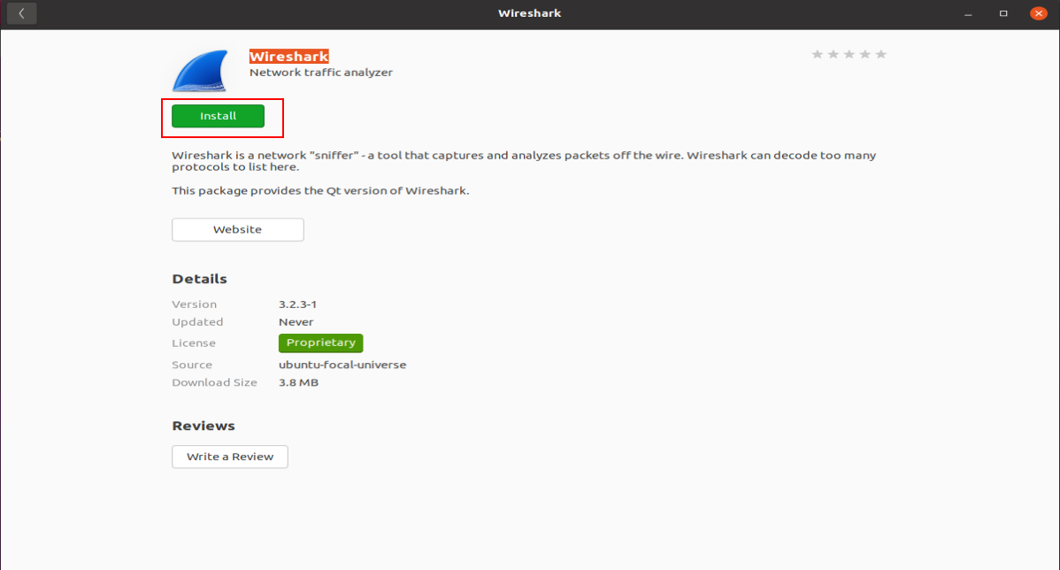

1. 配置环境，启动终端，输入以下指令

sudo groupadd wireshark // 添加组

sudo chgrp wireshark /usr/bin/dumpcap //修改组

sudo chmod 4755 /usr/bin/dumpcap //设置读写操作权限

sudo gpasswd -a xuxb wireshark // 这里 -a 后面的用户要改为你自己的用户名

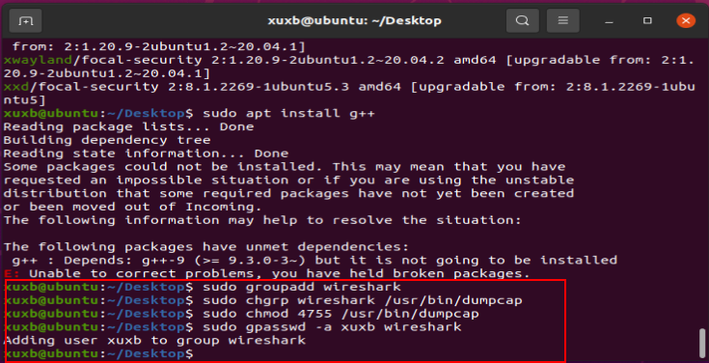

## *配置软链接

ln -s /root/.local/share/SK-005 $脚本存放目录/skv_scripts