Invite Workflow: How It Works and What We Changed
Oct 6, 2026 · @QMAZ Holdings

Overview
An administrator invites a person by email from Settings → Users, and that person can only enter the system after choosing their own password and signing in with it. Between 2026-10-03 and 2026-10-06 we built and hardened this flow in six rounds, each started by something you noticed while testing.
Four parties take part:
Party | What it does in the invite
Administrator | Fills in email, full name and role, then presses Send invite
Edge function oe-invite-user | Checks the admin may invite, asks Supabase Auth to send the email, saves the role on the profile
Supabase Auth | Sends the branded email, verifies the one-time link, sends the browser back to the app
The app on Vercel | Shows Set your password at /invite/set-password, saves the password, sends the person to sign in
The end result: the invited person sees who they are and what role they have, types a password twice, confirms, and lands on the sign-in page with their email filled in. The admin sees Pending until that happens and Accepted afterwards. Nobody reaches the system without a password, and an admin signed in on the same browser stays signed in.

Flow chart
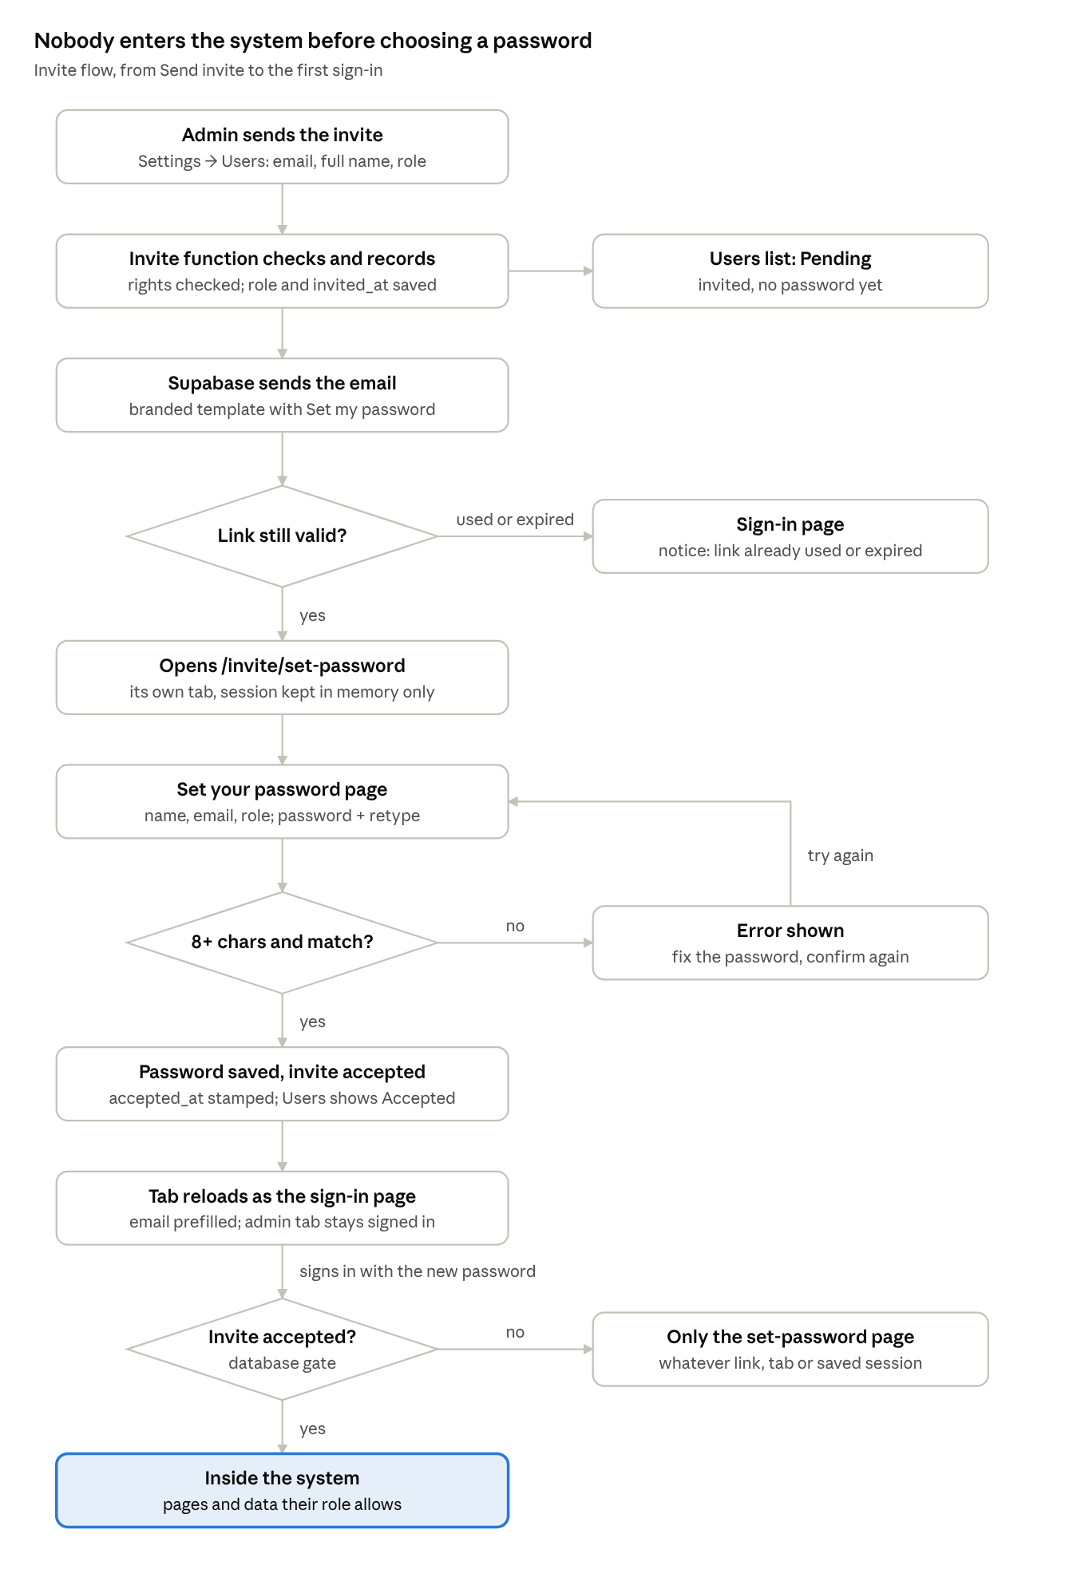
invite flow · 8 steps, 3 decisions
The three decisions are where the fixes live: a used link stops at sign-in, a bad password loops back, and the database gate keeps anyone without a password out, however they arrive.

Timeline of changes
Each round started from something you saw while testing; the root cause was rarely where the symptom showed. The table is in the order it happened, so it reads as a story.
# | What you noticed | Root cause | Fix
1 | Wanted a page showing the invited person and role, with password + retype, then a redirect to sign in | The page existed but showed no name or role, and after saving it went straight into the system | Set-password page shows name, email, role; New password + Retype password; Confirm password signs out and opens sign-in with the email prefilled
2 | The invite email was plain text; Users tab had no invite status | Supabase's default template; no columns recording invite or acceptance | Branded HTML email template; invited_at / accepted_at columns; Pending / Accepted column in Users
3 | Invite link ended at "127.0.0.1 refused to connect" | supabase config push sent the whole auth section, overwriting the live Site URL with the local default | Repaired in the dashboard; config.toml now carries the real Vercel address
4 | Clicking Set my password a second time opened the system with full access | First click left a saved session; second click had no invite marker, so the app treated the person as signed in | Server-side gate: invited but not accepted = only the set-password page; used-link message
5 | Wanted a proper address instead of /#... | Single-page app had one path; the invite returned to / | New route /invite/set-password: Vercel rewrite, invite redirect, address bar kept in step
6 | Admin signed in on the same browser was logged out when the invitee confirmed | One saved session per browser; the invite replaced it, and sign-out was broadcast to all tabs | Invite tab keeps its session in memory only, then reloads as the sign-in page

Round 1: the set-password page
When the email link opens, Supabase puts type=invite and the session tokens after # in the address. The app reads that once at start-up and shows the page.
const INITIAL_HASH = window.location.hash;
const NEEDS_PASSWORD = /type=(invite|recovery)/.test(INITIAL_HASH);
The page loads the profile the admin created, so it can show name, email and role before the person types anything. Confirming calls updateUser({ password }), removes the tokens from the address bar, signs the invite session out and shows sign-in with "Your password is saved".

Round 2: branded email and invite status
The email is a Go template that Supabase fills in. It can only print what the invite sends, so the edge function now passes the role's label in the user's metadata.
{{ if .Data.full_name }}Hi {{ .Data.full_name }},{{ end }}
{{ .Email }} · {{ .Data.role_label }}
<a href="{{ .ConfirmationURL }}">Set my password</a>
Status needs two facts the database did not keep. The migration 20261003000000_oe_invite_status.sql adds them and a function the invited person calls on themselves:
Column | Set by | Meaning
invited_at | Sign-up trigger and the invite function | The invite was sent
accepted_at | oe_accept_invite(), right after the password is saved | The person chose a password
The Users table shows Pending when only invited_at is set, Accepted when accepted_at is set, and a dash for accounts the developer created directly.

Round 3: "127.0.0.1 refused to connect"
The address after redirect_to= decides where Supabase sends the browser. It had become the local-development default because supabase config push replaces every auth setting in supabase/config.toml, not only the email template. The fix was to restore Site URL and Redirect URLs in the dashboard and to write the real address into config.toml, so a future push cannot undo it.
site_url = "https://project-monitoring-expense.vercel.app"
additional_redirect_urls = ["https://project-monitoring-expense.vercel.app/**", "http://localhost:5173/**"]

Round 4: the second-click bypass
This was a security hole. The first click turned the one-time token into a session saved in the browser. The second click hit a used token, so Supabase returned #error=...&error_code=otp_expired instead of type=invite. The app found the saved session, saw no invite marker, and let the person in without a password.
The fix does not trust the address bar. It asks the database whether the invite was accepted, every time the app enters:
if (prof && prof.invited_at && !prof.accepted_at) {
setAuth({ status: "set_password" });
return;
}
A used link with no session now shows "That link was already used or has expired. Ask your administrator to send a new invite."

Round 5: the /invite/set-password route
A route is a path in the address that maps to one screen. This app has no router library, so two pieces make the route work:
- vercel.json rewrites /invite/set-password to index.html, so Vercel serves the app instead of a 404.
- The app asks Supabase to return invites to that path, and keeps the address bar in step: the path while setting a password, / everywhere else.
The Redirect URLs list in Supabase needs /** at the end, or Supabase rejects the path and falls back to the Site URL.

Round 6: the admin was logged out
Supabase saves the signed-in session in the browser's local storage, one per site, and tells every open tab when it changes. Opening the invite in the admin's browser replaced the admin's session; signing the invitee out then signed the admin out everywhere.
The invite tab is now isolated. Its Supabase client keeps the session in memory only, and when it is done it reloads itself as the normal sign-in page. The success message travels across that reload in sessionStorage, which belongs to that one tab.
const INVITE_TAB = INITIAL_PATH === INVITE_PATH || NEEDS_PASSWORD;
createClient(url, key, { auth: { persistSession: !INVITE_TAB, ... } });

How each round was checked
Every change was verified headlessly: the app was built against a small mock Supabase server and opened in a simulated browser (jsdom). The last run covered five cases, all passing: fresh invite with an admin signed in, the reloaded sign-in page, a used link, the bare address, and a pending person with a saved session. A real email end to end is still yours to try after deploying.

Components and files
The workflow lives in seven places; the app file holds the most logic, the database holds the facts the logic trusts.
File | Runs where | Its job in the invite
supabase/functions/oe-invite-user/index.ts | Supabase Edge Functions | Checks the caller has settings.users; blocks admin-role invites by non-admins and duplicate emails; calls inviteUserByEmail with full_name, role_label and redirectTo; saves role, invited_at on the profile
supabase/migrations/20261003000000_oe_invite_status.sql | Supabase database | Adds invited_at and accepted_at; sign-up trigger copies the invite time; oe_accept_invite(); backfills older invites
supabase/templates/invite.html | Supabase Auth email | The branded email: greeting, email and role card, Set my password button, fallback link, expiry note
supabase/config.toml | Supabase CLI | Wires the email template; holds Site URL and Redirect URLs, which config push sends to the live project
vercel.json | Vercel | Rewrites /invite/set-password to the app
src/App.jsx | The browser | Everything the person sees (pieces below)
docs/SETUP.md, README.md | Documentation | Setup, deploy steps, the config-push warning
The pieces inside src/App.jsx:
Piece | What it does
NEEDS_PASSWORD, LINK_ERROR | Read once from the address at start-up: an invite link, or a used/expired link
INVITE_PATH, INVITE_TAB | The route /invite/set-password, and whether this tab exists only to set a password
loadSupabase() | Creates the Supabase client; the invite tab gets persistSession: false
api.inviteUser | Calls the edge function with redirect_to set to the invite route
api.updatePassword | Saves the password, then calls oe_accept_invite
InviteForm | The admin's Invite user dialog
Users table Invite column | Pending, Accepted or a dash, with dates on hover
SetPassword | The page: who you are, role chip, password + retype, Show/Hide, Confirm password
enter() | The gate: invited and not accepted = set-password page only
passwordSet / handoffToSignIn | Ends the invite session and reloads to sign-in, carrying the notice in sessionStorage
Login (notice prop) | Shows the one-time message and prefills the email

Deploy checklist
Three things are still open as of this writing: the migration is not pushed, the round 6 fix is not committed, and no real email has been tested end to end. The gate in round 4 and the Pending / Accepted column both read the migration's columns, so push it first.
- ☐ Push the database migration (adds invited_at, accepted_at, oe_accept_invite)
- ☐ Deploy the invite function (sends role_label, stamps invited_at)
- ☐ Commit and push src/App.jsx and docs/SETUP.md (the isolated invite tab) so Vercel redeploys
- ☐ Supabase → Authentication → URL Configuration: Site URL = https://project-monitoring-expense.vercel.app
- ☐ Same page, Redirect URLs: add https://project-monitoring-expense.vercel.app/**
- ☐ Supabase → Authentication → Emails → Templates → Invite user: paste supabase/templates/invite.html, subject "You're invited to Project Expense Monitoring" (or use config push, now safe because config.toml has the real address)
- ☐ Test: invite a spare email address, open the email in the admin's browser, set a password, confirm the admin stays signed in and the row turns Accepted
- ☐ Test: click the email button a second time and confirm it shows "already used or has expired"
supabase login
supabase link --project-ref <your project ref>
supabase db push
npm run functions:deploy
git add src/App.jsx docs/SETUP.md
git commit -m "Isolate the invite tab so the admin stays signed in"
git push
Later: custom SMTP in Supabase changes the sender from "Supabase Auth" to your own name and lifts the built-in limit of a few emails per hour.

Key concepts and lessons
Six ideas explain every bug we hit; knowing them lets you predict the next one.
Concept | What it means | Where it bit us
Session | Proof that a browser is signed in, kept as tokens. Supabase saves it in local storage, one per site, shared by every tab | Round 4: a leftover session let the person in. Round 6: the invite replaced the admin's session
One-time token | The code in the email link works once; after that Supabase returns an error instead of a session | Round 4: the second click looked different from the first, so the app's address-bar check missed it
Redirect URL | Where Supabase sends the browser after verifying a link. It must be on the allow list, or Supabase uses the Site URL instead | Round 3: pointed at 127.0.0.1. Round 5: needed /** for the new path
Route and rewrite | A route maps an address to a screen. A single-page app has one real file, so the host must rewrite other paths to it | Round 5: without the Vercel rewrite, /invite/set-password would be a 404
Configuration as code | config.toml describes the live project; pushing it replaces everything it lists, not only what you changed | Round 3: pushing the email template also pushed a local Site URL
Trust the server, not the address bar | Anything in the URL can be missing or replayed. Decisions about access belong to data the server keeps | Round 4: the fix reads accepted_at from the database instead of looking for type=invite
Lessons worth keeping:
- Test the second time, not only the first. Every flow with a one-time link needs a test for the link used twice, used late, and opened with someone else already signed in.
- Defence in depth. The invite is now guarded twice: the isolated invite tab, and the database gate. Either alone would stop round 4.
- Know the blast radius of a command. Before running a deploy or push command, ask what else it sends.
- One shared resource, two users, one browser is a classic bug source. Here it was local storage; elsewhere it can be cookies or a cache.
- Small, verified steps. Each round changed one thing and was checked by an automated test before moving on.

Self-check questions
Try answering each one before reading the answer under it.
- Which part sends the invite email: the app, the edge function, or Supabase Auth? Supabase Auth sends it. The edge function only asks it to, through inviteUserByEmail, after checking permissions.
- Why can the email show the role, when Supabase Auth knows nothing about roles? The edge function puts the role's label into the user's metadata as role_label, and the template prints {{ .Data.role_label }}.
- What do Pending and Accepted each depend on? Pending = invited_at set and accepted_at empty. Accepted = accepted_at set, written by oe_accept_invite() after the password is saved.
- The link says redirect_to=http://127.0.0.1:3000. Where do you look first? Supabase → Authentication → URL Configuration. Then ask what last changed it; here it was supabase config push.
- Why did checking for type=invite in the address not stop the second-click bypass? A used token returns an error in the address, not type=invite, while the saved session from the first click is still there.
- Why is the gate in enter() safer than any address-bar check? It reads accepted_at from the database, which the visitor cannot fake or replay, and runs on every entry path.
- What two things make /invite/set-password work? The Vercel rewrite to index.html, and /** in Supabase's Redirect URLs so the path is allowed.
- Why was the admin logged out, and why doesn't it happen now? Both shared one saved session in local storage, and sign-out was broadcast to every tab. The invite tab now keeps its session in memory only.
- After confirming, why does the invite tab reload instead of just showing the sign-in form? Its session is memory-only, so a sign-in there would vanish on refresh. Reloading turns it into a normal tab first.
- How does the "Your password is saved" message survive that reload? It is stored in sessionStorage, which belongs to that tab, and read once by the sign-in page.
- What breaks if the migration is not pushed but the app is deployed? The profile has no invited_at or accepted_at, so the gate never triggers and the Users column shows only dashes. If the new invite function is deployed too, saving the profile fails with "Invited, but the role could not be saved".

