DL Lab 3: Plot Loss Curve

Lab Objective:

In this assignment, you should use matplotlib or anything else to plot loss curves.

Dataset Introduction:

1. train_losses_log.log
2. test_losses_log.log
3. metrics_log.log

In these 3 log files, there are different evaluation scores. For example, train_losses_log.log contains total_loss, cos, mse, bce, ssim, dice and kl. Thus, you need to plot 7 curves in “one figure”. Same for other log files.

Example:

Drawing an image “same” as example (the image below), except the color of curves and the position of legends. The upper one uses train_losses_log.log.; the middle one uses test_losses_log.log; the bottom one uses metrics_log.log.

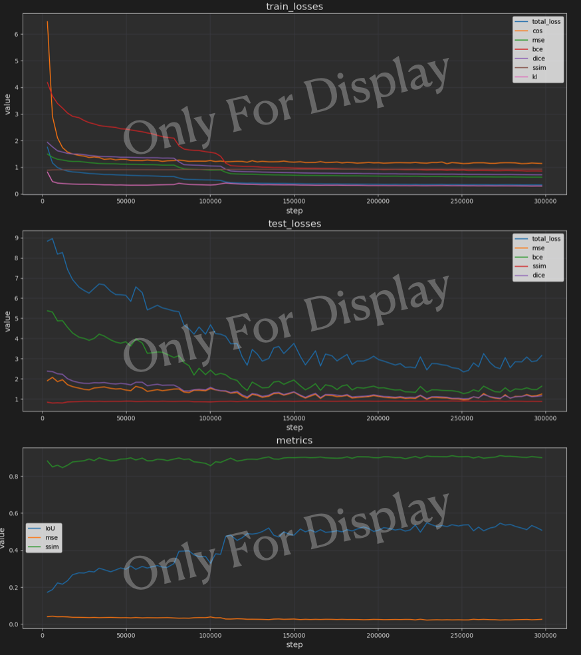

Rules:

[1] You should implement homework by yourself. This assignment should be done individually. Please do not plagiarize the assignment. Once the T.A. finds plagiarism, these students will receive a score of zero on the assignment.

[2] If the assignment format and files are not in accordance with the regulations, the assignment score × 0.9.

[3] If the assignment is missing or incomplete for any item, the assignment score will be deducted proportionally to the incompleteness.

[4] If you submit your assignment late, your score will be multiplied by 0.9 for each day of delay.

Submission:

[1] Please submit your code and image, the filename should be A3_studentID_studentName.ipynb and A3_studentID_studentName.png (or JEPG etc).

[2] It is okay to plot three images for different log files. But please “merge they into a single image” before you submit.

[3] Remember leave your drawing result in ipynb file!!!

[4] A Report in PDF format and filename should be A3_studentID_studentName.pdf.

The report needs to explain how you finish the homework. The Report is limited to a maximum of 2 pages.

Descriptions of code:

Your code must be submitted following the format TAs give you. Any additional sections can also be included.

Assignment Evaluation:

Code & model performances (40%)

Report (60%)

Deadline: 10/8 9:00 PM

---------------------------------TA Contact information-----------------------------------

Sheng Yang mail: sk774325.ai12@nycu.edu.tw

Kuan-Lin Chen mail: andy90123.ai12@nycu.edu.tw