LifeBridge – Fall Detection Module

Contents
Overview 3
Presentation Layer 3
User Interface Module 3
Authentication and Identity Integration Service 4
Edge Device 5
Business Logic Layer 5
Event API Gateway 5
Event Router 6
Fall Detection Module 6
Alert Manager 7
Logging / Monitoring 7
Data Layer 8
Events DB / Data Mart 8
Identity DB 8
Configuration Store 9
End to End Relationships and Flows 9
Authentication and Authentication Flow 9
Fall Detection and Event Processing Flow 10
Alert Notification Flow 11
Monitoring, History and Analytics Flow 11
Overall Cross-Layer Relationships (High Level) 11
Appendix A: Module Responsibility Summary 12

Overview
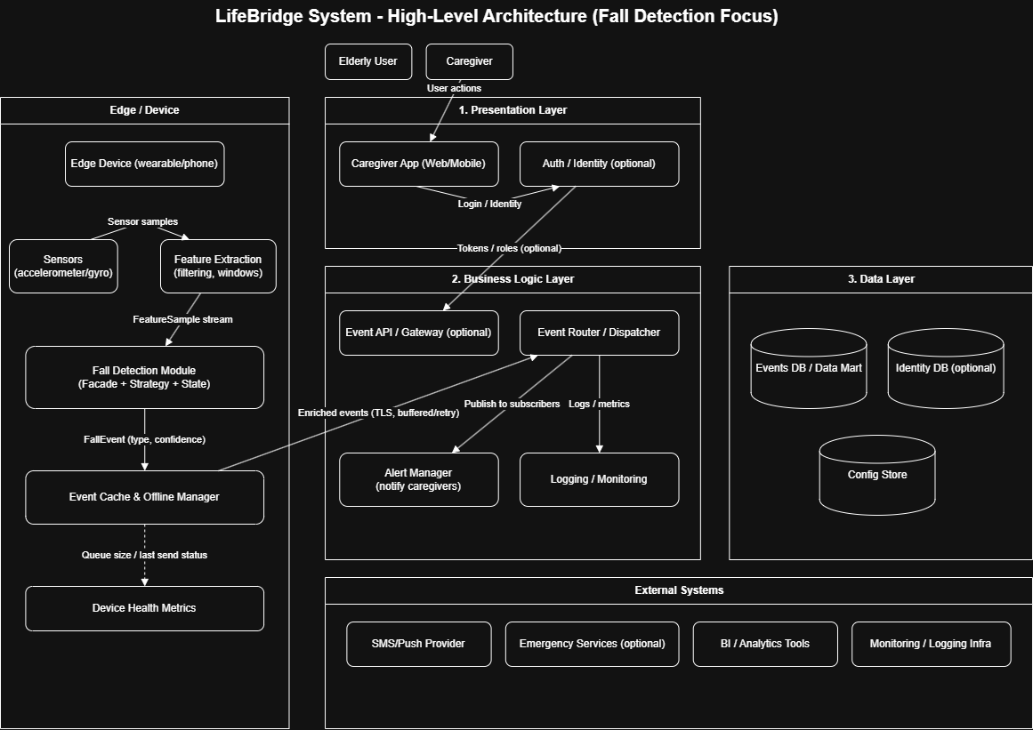
Architectural Description and Design; Roles, Activities, and Data.
This diagram presents the main logical components of LifeBridge (fall detection focused), including their primary responsibilities and key interactions.

Presentation Layer

User Interface Module
Main functions:
User authentication
- Display login screens for caregivers.
- Interface with authentication and identity (optional) for seamless access.
Monitoring dashboard
- Display real-time fall-related status (last event, current state, confidence (according to recent measurements).
- Present recent alerts and device health indicators.
Alert management
- Show active and recent fall alerts, including details (time, type, confidence).
- Allow acknowledgement and escalation actions (call, message, push, emergency dial etc).
History and reports
- View fall event history and trends over time.
- Filter by date range and event type (potential, confirmed or cleared).
Profile and device view
- View user, device profile, and connection status.
- Display customization feedback message (read only) if checked by caregiver.
Notifications
- Deliver push or SMS notifications, received from the system.
- Show system warnings (offline, low battery).

Main interactions
With authentication and identity
- Used for caregiver authentication and identity verification.
- UI -> Authentication and Identity for login; receives access tokens and basic role information.
With event API / Gateway
Used for all fall-related system interactions:
  - Retrieve current fall status and recent alerts.
  - Request fall event history and filtered views.
  - Acknowledge fall alerts.
  - UI -> event API / Gateway -> internal services placed in the Business Logic Layer.
With notification services (indirect)
- UI receives notifications from (and generated by) Alert Manager.
- Notifications reflect fall events, acknowledgements, and system warnings.

Authentication and Identity Integration Service
Main responsibilities
- Provide authentication and identity verification for caregivers.
- Issue and validate access tokens used by the Presentation Layer.
- Deliver basic identity attributes required for authentication errors or recovery.
Main functions
- Authenticate caregivers during login.
- Validate tokens delivered by the UI on subsequent requests.
- Generate identity data (caregiver ID, contacts, etc.) to subsequent services.
Main interactions
- With UI Module
  - UI -> Authentication and Identity Integration Service login and token validation.
  - Authentication and Identity Integration Service -> UI returns access token and identity data.
- With Business Logic Layer
  - Backend services depend on validated tokens passed from UI.
  - No direct business process with the service.

Edge Device

Main functions
Sensor data capture
- Capture motion data on the device from sensors (accelerometer, gyroscope, smartwatch (optional)).
Local processing environment
- Run extraction logic feature for filtering and processing raw sensor data.
- Provide a local runtime environment for the Fall Detection Module when deployed on the Edge Device.
Event caching and offline handling
- Host the edge event cache and offline manager for buffering detection events during connectivity errors.
- Forward fall detection events when connectivity is restored.
Health and monitoring
- Monitor device health indicators (battery, sensors uptime or battery if needed, connectivity status).
- Present device status and health specs to main monitoring services.

Key relationships

Input sources

Receives motion data from on device sensors.

Sends filtered and structured samples to the Fall Detection Module.

Interaction with Business Logic Layer

Sends fall detection events (via the edge event cache and offline manager) to the central Event Router (potential human recipient).

Issue configuration update reports from backend services (detection thresholds, timing parameters).

Interaction with Data Layer (indirect)

Gets configuration data from back services.

Avoid prolonged data storage locally; only caches events and configuration temporarily until successful delivery confirmation.

Interaction with Presentation Layer

User friendly operation; no direct UI is hosted on the Edge Device.

Device status (online / offline, last event timestamp) may be visible to caregivers through backend monitoring.

Business Logic Layer

Event API Gateway
Main functions
Event access (caregiver)
- Provide a single-entry point for fall related operations from the UI.
- Provide endpoints to fetch current status, recent alerts, and event history.
Alert actions
- Accept caregiver actions on alerts (acknowledge, further actions).
- Forward validated requests to the Event Router.
Request validation / authentication
- Validate tokens/identity requests from the Presentation Layer.
- Apply basic authentication binds (caregiver scope to assigned users).
Interactions
With User Interface Module
- Receives caregiver requests (status, history, alert actions).
- Sends responses (FallEvent list, current state, acknowledgement status).
With Authentication and Identity Integration Service
- Validates access tokens and identity claims when required.
With Event Router
- Forwards fall related operations to internal services:
  - Acquire current state / recent events.
  - Submit alert acknowledgements / further actions.
- Receives processing results and returns them to the UI.

Event Router
Main functions
Event intake
- Receive complex fall events from the edge unit (directly or via gateway).
- Establish events into internal structure.
Routing and fan out
- Route events to the relevant downstream components (Alert Manager, logging and monitoring, data storage).
- Ensure consistent ordering and delivery criteria per user or device stream.
Policy application (high level)
- Apply routing rules (severity thresholds, escalation eligibility, etc.).
- Support retries and backoff signals for offline and resend scenarios.
Interactions
With edge event cache and offline manager
- Receives detailed events (type, confidence, timestamp, device status).
- Returns delivery acknowledgements (success, fail or retry).
With Alert Manager
- Issue fall events for notification and escalation (further action) flow.
With logging / monitoring
- Sends operational specs, errors, and processing confirmations.
With Events DB / Data Mart
- Writes raw events and joined records (directly or via storage service).

Fall Detection Module
Main functions
Classification
• Consume feature samples and classify result (fall, no fall and concerning anomaly).
• Output event confidence and supporting data.
False alarm reduction
• Apply local decision logic (multi-window confirmation, cooldown, etc.).
• Release cleared outcomes when a concerning anomaly (=fall) is not validated.
State handling
• Maintain per-user/device detection state (idle, suspected, confirmed).
• Produce consistent flow for downstream alerting.
Interactions
With feature extraction (edge)
- Receives feature sample windows as input to detection.
With edge event cache and offline manager
- Sends fall detection outputs to be buffered and forwarded.
With Configuration Store (indirect)
- Reads thresholds and timing parameters used by detection logic.

Alert Manager
Main functions
Notification reasoning
- Decide when a fall event requires notifying caregivers.
- Select notification method (push/SMS) and escalation-action path.
Acknowledgement handling
- Track caregiver acknowledgement state for each alert.
- Trigger escalation-action when acknowledgement is missing or negative.
Interactions
With Event Router
- Receives fall events and alert-relevant state transitions.
With SMS/push provider
- Sends notifications containing event summary and actions.
With emergency services
- Escalates further action confirmation / unacknowledged (unresponsive human agent) critical events.

Logging / Monitoring
Main functions
- Collect system logs, measurements, and error events across backend services.
- Support health dashboards and operational accessibility options.
Interactions
With Event Router
- Receives processing metrics and error traces.
With monitoring / logging method
- Issues logs and specs to external observation tools.

Data Layer

Events DB / Data Mart
Main functions
- Store raw and previous fall related events, optimized for queue and review.
- Maintain joined event timelines per user or device
(suspected -> confirmed -> cleared).
- Support queries for caregiver views (recent alerts, history, trends) and operational analytics.
Interactions
With Event Router
- Primary persistence target for fall events.
- Receives raw events and consolidated records (normalized schema).
- Serves query results for event history and current state configuration.
With Alert Manager
- Stores alert lifecycle state (created, notified, acknowledged, escalated).
- Enables fetching of active/recent alerts to caregiver dashboard.
With analytics tools
- Presents read only views, optimized for analytics (trends, false alarm rate, response times). Generated time based graphs for analysis and review.
- Supports periodic extracts if required (CSV/JSON).
With UI Module (through event API / Gateway)
- Indirectly serves fall event history, filters by date range and event type.
- Supports drill-down from dashboard -> specific event details.

Identity DB
Main functions
- Store caregiver accounts and minimal profile attributes (IDs, contact methods).
- Store mappings between caregivers and monitored elderly users/devices.
- Store consent and audit records relevant to monitoring/notifications.
Interactions
With Authentication and Identity Integration Service
- Source of truth for caregiver identity attributes and access scope.
With Event API / Gateway
- Used to authorize caregiver access to specific monitored users/devices.
- Provides canonical caregiver IDs for logging and audit.
With Alert Manager
- Supplies contact channels and routing rules per caregiver (push token, phone).
- Supports escalation preferences when configured.

Configuration Store
Main functions
- Store fall detection configuration parameters (thresholds, timing windows, cooldowns).
- Store device-specific configuration and feature extraction settings.
- Support versioning and safe updates of configuration values.
Interactions
With Fall Detection Module (indirect via services)
- Supplies thresholds and timing parameters used by detection logic.
- Enables consistent behaviour across devices and software versions.
With Edge Device
- Provides configuration updates (sampling rate, preprocessing parameters).
- Does not store long-term edge data; edge only caches locally until delivery.
With Event Router
- May provide routing/alert policy parameters (severity thresholds, escalation rules).
With UI Module (through services)
- Supports read-only configuration snapshots when exposed to caregivers/admins (if required).

End to End Relationships and Flows

Authentication and Authentication Flow
- Caregiver opens LifeBridge (Web/Mobile) and logs in.
- The UI communicates with the Authentication and Identity Integration Service (optional).
- Authentication service generates tokens (OAuth2/OIDC, etc.).
- On each API request:
- UI -> Event API / Gateway.
- Gateway validates the token (if enabled).
- Authentication requests are forwarded to backend services (Alert Manager, Event Router, reporting APIs).
- Backend services read/write Identity DB and Events DB as required.
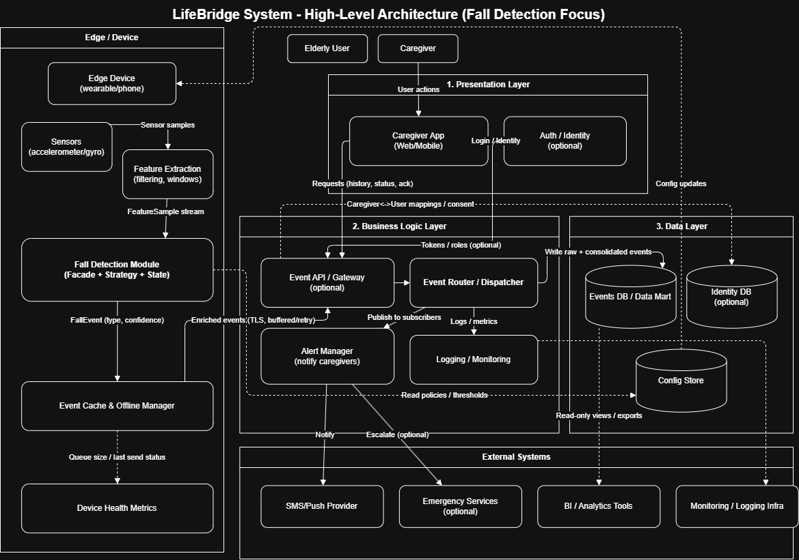

Fall Detection and Event Processing Flow
- On the Edge Device:
- Motion sensors (accelerometer/gyroscope) continuously capture raw motion data.
- Feature extraction component filters and windows the sensor data.
- Fall Detection Module:
- Analyses feature samples using detection strategies.
- Produces a FallEvent (type, confidence).
- Edge Event Cache and Offline Manager:
- Enriches events with metadata (device ID, timestamp, health status).
- If online: sends events securely (TLS) to the backend Event API / Gateway.
- If offline: buffers events locally and retries until delivery succeeds.
- Business Logic Layer:
- Event Router consumes incoming events.
- Deduplicates and validates fall events.
- Forwards confirmed events to:
  - Alert Manager (for caregiver notification).
  - Logging / Monitoring services.
- Events DB:
- Stores raw and consolidated fall events.
- Maintains event lifecycle state (detected, acknowledged, resolved).

Alert Notification Flow
- Alert Manager receives a validated fall event.
- Alert severity is evaluated based on confidence and configuration.
- Notifications are triggered:
- SMS / Push notifications sent via external provider.
- Caregiver:
- Receives alert in real time.
- Acknowledges, escalates, or resolves the alert via the UI.
- Alert status updates are persisted in the Events DB and reflected back in the UI.

Monitoring, History and Analytics Flow
- Events DB holds historical fall events and alert outcomes.
- Backend services:
- Aggregate event statistics (frequency, false alarms, response times).
- UI requests dashboards and history views:
- UI -> API Gateway -> Backend services.
- Backend reads from Events DB and returns:
- Event timelines.
- Trends and summaries.
- External BI / Analytics tools (optional):
- Access read-only views or scheduled exports for analysis.

Overall Cross-Layer Relationships (High Level)
Presentation Layer -> Business Logic Layer
Caregiver UI calls backend APIs for:
- Event history.
- Alert acknowledgment.
- Device status.
Business Logic Layer -> Data Layer
- Event Router and Alert Manager <-> Events DB.
- Identity services <-> Identity DB.
- Configuration services <-> Configuration Store.
Edge Processing Path
Edge Device -> Feature extraction -> Fall Detection Module
-> Edge Event Cache and Offline Manager
-> Event API / Gateway
-> Event Router
-> Events DB.
Alerting Path
- Events DB / Event Router -> Alert Manager -> SMS / Push Provider -> Caregiver.
Monitoring Path
- Edge Device and Backend services -> Logging / Monitoring Infrastructure.

Appendix A: Module Responsibility Summary
A.1 Presentation Layer
- Initiates authentication and session flows for caregivers.
- Displays system status, alerts, and historical events.
- Allows acknowledgment and basic configuration interactions.
A.2 Authentication and Identity Integration Service
- Validates authentication tokens and resolves user roles.
- Integrates with external identity providers.
- Enforces authorization for protected operations.
A.3 Edge Device
- Captures sensor data and performs local preprocessing.
- Executes fall detection logic locally.
- Buffers events and forwards them when connectivity is available.
A.4 Business Logic Layer
- Routes incoming events and commands between modules.
- Applies domain rules for fall classification and escalation.
- Coordinates alerting, persistence, and system state updates.
A.5 Data Layer
- Persists fall events, identity data, and configuration.
- Supports queries for monitoring, reporting, and analysis.
- Maintains minimal, privacy-aware stored data.
