Question 1d

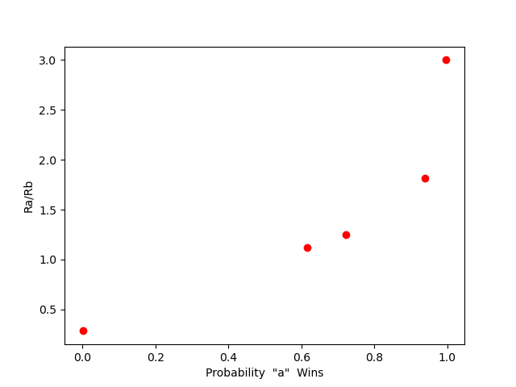

Question 1e)

You would first initialize n to 1 as there has to be a starting game then call the winProbability function. Suppose the result of the winProbability function is not equal to 0.9. In that case, you want to increment n and call the win probability function again with the new value of n, if it is equivalent to 0.9 then you want to print out the value of n, and that will be the smallest value of n or number of games played so that the win probability of ‘a’ is 0.9. The simulation in the start will always result in the winProbability being equal to 1, but as n increases, calling the winProbability function will become more accurate.