# Report on squash scoring methods

## Problem

*Briefly describe the problem you are investigating. What do you expect to see?*

***Report marking criteria – is the problem stated clearly and concisely?***

I am investigating one of the squash players to see whether English or PARS scoring method is better for keeping track of the scores and to see with which scoring method a player has a higher win probability. I would expect one of the players to have a higher win probability with the PARS scoring system as the number of rallies played is less than the English scoring method which means that in theory, the player should perform better as the match is shorter. The player does not get tired quickly. Whereas with the English scoring, the game can get prolonged if the server cannot win a point, which means the longer the match is on the player's performance would go down***.***

## Method

*Summarize the method you are using to investigate the problem.*

***Report marking criteria – is the method stated with sufficient detail to allow someone else to replicate the results?***

I will write an algorithm to simulate a game of squash with both scoring systems which will then return the final scores of the two players in a game. Then another function that will calculate the win probability of one of the players using the game algorithm. Using the win probability function, I will be simulating n number of games. I will be using n as a hundred thousand as with a more significant number of n the more accurate the results. After that, to get a better spread, I will be using different values for the player's abilities, and these values will be stored in a CSV file as they can be changed or added to. Therefore, both the scoring systems should use the values that are in the CSV file so that there is a better comparison with both the scoring systems as they will be using the same values. Finally, I will plot my results on a graph with the CSV file values stored as a list of tuples with corresponding x and y values.

## Assumptions

*Are there any assumptions that either you or the coursework specification have made that may affect your confidence in the results?*

***Report marking criteria – are the key assumptions listed?***

The time taken for each rally will be the same. The players ability does not decrease/the player does not get tired as the number of games increases. Players are perfectly healthy with no injuries.

## Results

*Show the results of your simulations – including one figure that allows easy comparison. Explain what the results show.*

***Report marking criteria – are the results clear and well-presented? Are appropriate figures used? Are figures labelled and titled?***

From the results below it can be seen that the win probability for one of the players is similar with both the scoring systems but in this case player “a” was used for the simulations. On the y-axis there is the probability that “a” wins and on the x-axis ability of ”a” divided by ability of “b”. Then there is a legend the shows which line is for which scoring system. Both the scoring system are fair as it can been seen from the results below that they have a similar output so there is no advantage to the better player.

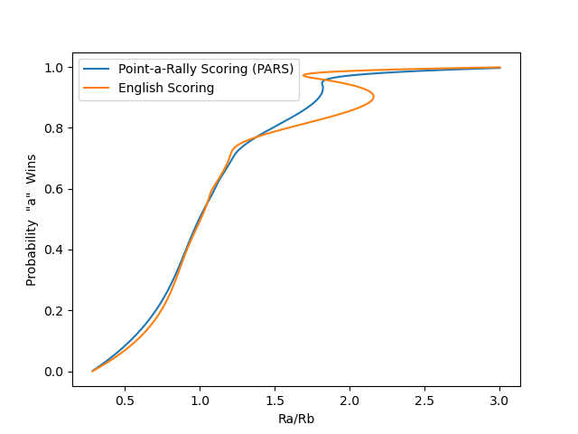

## Conclusions

*Briefly summarize your progress towards solving the problem, highlight any limitations and potential future extensions.*

The results were unexpected as the win probability turned out to be similar for both the scoring systems. I would have liked to have more simulations and more values input into the CSV, so I can get more accurate results. The limiting factor was the hardware that I was using it would take a long time to simulate a high number of games. For future project I would like to automate this process by getting live data of any player input into the program. I would also like to consider factors such as the time of the game, players playing with an injury, so that the data is more realistic and also try use the data from the past to try and predict the outcome of upcoming matches. The abilities of the players had no effect on the scoring systems but the player with the higher ability playing against a player with a lower ability has a greater probability of winning. To conclude the PARS scoring system would be better if the match was being broadcasted as the games would not take very long around an hour per game depending on the skill level that is being played where as with the English scoring system