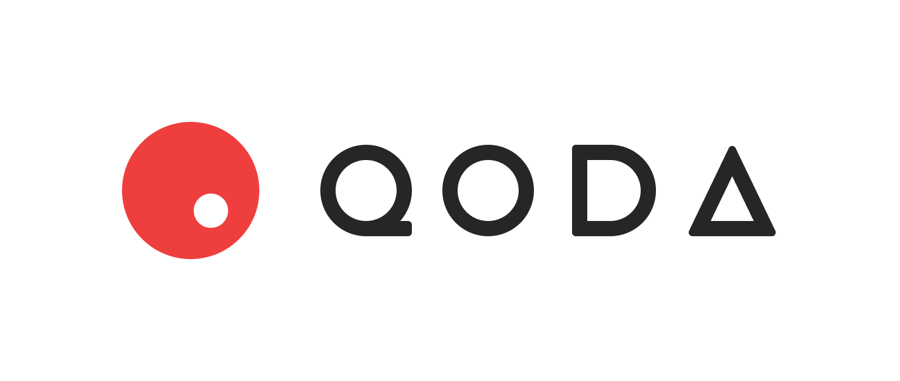

23 Dec, 2021

1.0 Introduction to DeFi Fixed Income
The most popular collateralized lending/borrowing protocols today include Compound, Aave, and MakerDAO. These protocols offer a floating interest rate via a pool which users can supply or borrow from. While these protocols solve a variety of use cases, there is increasingly more demand both from lenders and borrowers for more predictable, fixed interest rates.
In the long term, the path to growth and maturity of the DeFi fixed income space should begin with the mindset that interest rates as a product can be tradeable in an orderbook exchange type of environment. Furthermore, with accurate traded interest rate data across a variety of maturities, one can start to bootstrap the construction of a crypto Yield Curve. As in traditional financial markets, the yield curve is the fundamental building block upon which more complex and customized fixed income products can be built. Much in the same way Uniswap functions as an on-chain oracle for real-time spot currency prices, Qoda can become the de facto on-chain oracle for crypto yield curve data.
With these goals in mind, we hope to achieve Qoda’s mission: To bring tradeable fixed income markets to the DeFi world.
2.0 The Qoda Protocol
Qoda enables collateralized borrowing and lending of crypto assets at fixed interest rates for fixed periods, where terms are set by the users themselves. It is implemented similar to a futures exchange, where the quoted figure is the implied APY of the loan.
2.1 Off-Chain Quotes
The Quote is Qoda’s analogue to limit orders in an orderbook. Users publish Quotes into the platform, indicating whether they are a borrower or lender, what rate they wish to deal at, for what size, and until which maturity date. Importantly, a Quote can theoretically be generated completely off-chain via the browser or the Quoter’s local machine. The reasoning for this mechanism is to provide gas savings for users – only the bare minimum of trade executions ever need to hit the blockchain. The basic structure of a Quote looks like this:

Quote {
address principalTokenAddress, // Contract address of the token
address quoter, // Public address of the Quoter
uint8 side, // 0 if Quoter is borrowing, 1 if Quoter is lending
uint256 quoteExpiryTime, // Timestamp after which Quote is no longer valid
uint256 maturity, // Timestamp at which loan expires
uint256 principal, // Initial size of the loan at inception
uint256 principalPlusInterest, // Final amount to be paid at expiry
uint256 nonce, // To guarantee uniqueness of Quote, prevent signature replay attacks
bytes signature // Used for verifying Quote
}
The key field is the signature. The Quoter hashes all the other fields of the Quote and signs that hash with their private key, generating the signature. The signature trustlessly proves that the Quoter is in fact willing to enter the loan at the specified terms. A Responder to a Quote needs to enter all the fields of the Quote together with the accompanying signature in order to transact. If the fields do not match the signature, the transaction will revert.
2.2 Maturities
Maturities are UNIX timestamps that represent the settlement date of loans. Maturity dates must be explicitly enabled on the platform before it becomes a valid date. To start, these will be quarterly dates similar to futures exchange offerings, i.e. 31st March, 30th June, 30th September, 31st December 12:00am GMT, with the flexibility to add more tradeable dates if desired.
2.3 Assets
Each ERC20 token supported by Qoda is mapped one-to-one to an Asset. Its main purpose is to define the scope for deposit of collateral. The Asset struct has the following fields:

Asset {
bool isEnabled, // Must be true for the Asset to be enabled
address oracleFeed // Address of the associated Chainlink oracle price feed
uint riskFactor // Value between 0 – 1, used to discount the value of the collateral
// provided by a borrower
uint[] maturities // A list of all the enabled maturity dates for this Asset
}
An Asset must be enabled before users may deposit collateral denominated in the ERC20 token. For more information on this, see Collateral Management (section 2.5).
2.4 Markets
Each FixedRateLoanMarket is a separate smart contract deployment characterized by two parameters: principalTokenAddress, the address of the ERC20 token which the loan will be denominated in, and maturity, the UNIX timestamp representing the settlement date of the loan.
Each FixedRateLoanMarket is itself an instance of ERC20 and has its own associated qToken. For example:
A user lends 1,000 USDC at 10% fixed rate, expiring on 31 March, 2022. When the transaction is executed, the system will mint 1,100 qUSDCH22 tokens to the user (H22 here references the expiry date, i.e. March 2022. See http://cmegroup.com/month-codes.html for more). Upon the expiry of the contract on 31st March 1:00am, the qUSDCH22 tokens will be redeemable for the underlying USDC tokens at a 1:1 rate.
The advantage of qTokens is that it allows for greater capital allocation efficiency. If the Qoda protocol is trusted, then the qTokens themselves will hold value and can be traded in secondary markets, staked in yield farms, used as collateral itself in other protocols, etc.
Note that the qToken is not 100% freely transferrable. Every FixedRateLoanMarket also maintains a mapping of accountBorrows in storage for how much each user has borrowed in total. Users can only transfer qTokens that are in excess of their current borrows. For example, an account that only lends and never borrows can freely transfer their tokens, but an account that owns 1,100 qUSDCH22 tokens but has also borrowed 1,000 USDC expiring March 2022 may only transfer out 100 qUSDCH22. This is to protect the protocol from users gaming the collateral management system by borrowing off of the qToken and then immediately transferring out the qToken to another address, leaving the borrowing account uncollateralized.
2.5 Collateral Management
The net borrows of any account must always be overcollateralized at all times to ensure nondefault. Any account in danger of undercollateralization is subject to liquidations as described in section 2.7. The overall collateral health of an account, called accountLiquidity, depends on two components:
1) totalCollateralValue Before an account is allowed to take on a loan, they must fund it with collateral, which can be denominated in any token that is an enabled Asset (section 2.3). Its value is expressed in USD terms using Chainlink price feeds, calculated as:
where riskFactor is a parametrized value from 0.0 to 1.0 based on the Asset. The value will be higher for safer Assets, and lower for riskier Assets. Note this means that the totalCollateralValue of an account will always be lower than the actual market value of the underlying tokens. Hence, the riskFactor parameter ensures that account borrows will always be overcollateralized.
2) totalBorrowValue The sum of all the borrows of an account across all Markets. This is calculated as:
Note that the borrowAmt refers to the full principalPlusInterest amount, not just the principal amount upon inception of the loan. The amount of qTokens for a particular Market also act as a credit to the user for that Market. The feature of netting off borrowAmt with qTokens makes borrows and lends fungible for each Market, which give users the flexibility to trade in and out of positions.
The account is considered properly collateralized as long as the ratio of totalCollateralValue / totalBorrowValue remains above 1. If an account falls below this, it will be subject to liquidation.
2.6 Settlement of Loans
Borrowers may repay their borrows for any Market at any time before its maturity date. They may either repay with the underlying token, or with the corresponding qToken. The repayments are held in escrow until the maturity date. In order to encourage timely repayment of borrows, any account that has not paid after the maturity date block has been finalized is subject to the same liquidation procedures described in section 2.7, even if the account is still overcollateralized.
At 12:00am on the maturity date, all trading for that Market will cease. There will be a grace period of 1 hour to allow enough time for borrowers to make their repayments, or for liquidators to pay on behalf of any non-payers, so that the smart contract funds are sufficient for lenders for withdrawal. At 1:00am, the lenders may burn their qTokens to redeem the underlying from the smart contract at a 1:1 exchange rate.
2.7 Liquidations
When an account’s accountLiquidity falls below 1 or if it is late in its repayments, it is subject to liquidations. In this scenario, a third-party, called the liquidator, can repay the principalPlusInterest on behalf of the borrower. The equivalent USD value of the borrower’s collateral plus a parameterized percentage of the value, called the liquidationPenalty, will be released to the liquidator as an economic incentive for maintaining the collateral health of the system as a whole. The onus will be on the liquidator to swap the received collateral back to the currency of the loan if they wish to crystallize their profits. To bootstrap the protocol, Qoda will also be running its own liquidation bot, but it is expected to quickly be outpaced by third party liquidation bots with more sophisticated strategies when the economic motivation becomes apparent.
3.0 Future Roadmap
The long-term goal for Qoda is to establish itself as a powerhouse for fixed income – a decentralized investment bank that connects those who need capital to those who have capital. To that end, there are several exciting future products in the pipeline on Qoda’s long-term roapmap. These include pegged floating rate loans (e.g., Compound/Aave mid rates, perpetual futures funding rates, etc.), over-the-counter derivative products such as fixed-for-floating interest rate swaps, decentralized corporate bond origination and secondary trading for crypto businesses, and credit default swaps. More details to follow on this.

