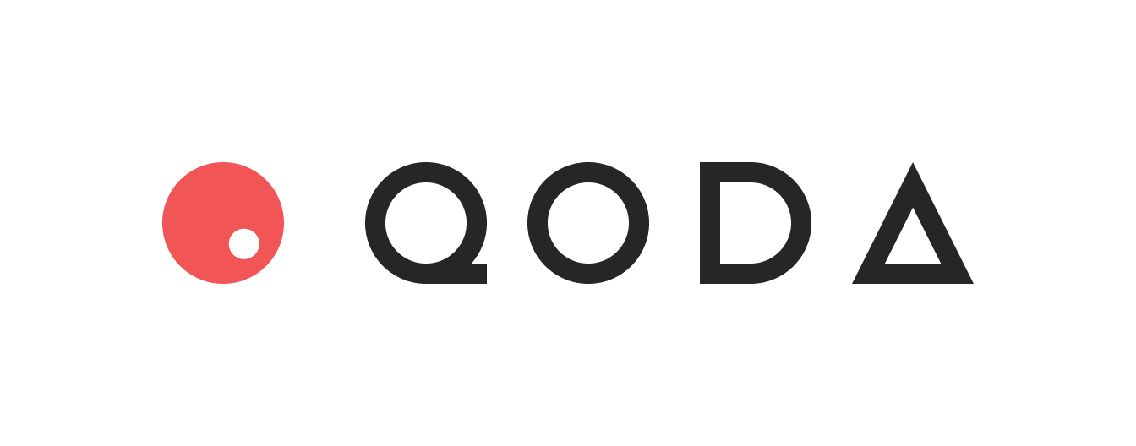

The Current Landscape of DeFi Lending/Borrowing
The most popular collateralized lending/borrowing protocols today include Compound, Aave, and MakerDAO. These protocols offer a floating interest rate via a pool which users can supply or borrow from. While these protocols solve a variety of use cases, there is increasingly more demand both from suppliers and borrowers for more predictable, fixed interest rates.
We can make another nuanced observation. We can think of interest rate as a product that can be traded. After all, if your view is that DeFi interest rates will go up, you can borrow funds from one party at 2% and then turn around and lend those funds to another party at 3%, effectively locking in a profit of 1%. Typically, in the current generation of lending/borrowing protocols, the supply and borrow rates are set algorithmically as a function of the amount of liquidity in the pool. By allowing lenders and borrowers to instead set their own rates, can we promote the trading of fixed interest rates?
Enter Qoda: The Craigslist for borrowing/lending
Qoda aims to be a decentralized over-the-counter hub for users to post listings (called “Quotes”) for collateralized lending/borrowing at fixed interest rates for fixed periods.
Before moving on to explain the protocol in detail, some quick terminology first:
Quoters publish “Quotes” either on- or off-chain to indicate their intention to lend or borrow a sum of money at a fixed interest rate for a specific period of time.
Responders can search for published Quotes that they want to accept. Once accepted, the Quoter and Responder become opposite counterparties in a Fixed Rate Loan agreement.
Brokers are hubs for matching Quoters and Responders, and serve as intermediaries to Qoda’s smart contracts. They are free to list Quotes either on-chain or off-chain. Any user can serve as a Broker by implementing the necessary infrastructure, and be rewarded for every Fixed Rate Loan agreement they originate.
Liquidators scan the blockchain for existing fixed rate loan contracts. If any borrowers are in danger of being undercollateralized, their account can be liquidated for a reward to the liquidator.
At its core, Qoda’s smart contracts manage the loan execution and settlement, margining, liquidation, and interest accrual calculations. This is further supported by the Qoda Broker dApp, a UI which facilitates users trading with one another completely on-chain. All Quotes on the Broker dApp will be posted on-chain as events (as opposed to storage, saving gas) so that the platform remains provably decentralized, with no user’s data reliant on a centralized backend storage.
Importantly, Qoda maintains the following key features:
1) No centralized custody of user funds
2) Off-Chain Quoting
3) On-Chain loan contract settlement
Let’s go through each of these features.
No Centralized Custody of User Funds
When a Responder has responded to a Quote, a Fixed Rate Loan agreement is instantiated. The smart contract will automatically handle transfers of the loan and collateral, as well as calculating the accrual of fixed interest over time. The Qoda smart contract takes the collateral as escrow, which can only be released back to the borrower when they’ve repaid the loan. Or released to Liquidators in the case of undercollateralized accounts.
Off-Chain Quoting
Suppose a lender wants to put out a listing to lend their assets. The basic structure of their quote looks like this:
Quote {
address addressLoanToken,
address addressLender,
uint256 quoteExpiryBlock,
uint256 endBlock,
uint256 notional,
uint256 fixedRatePerBlock,
uint256 nonce,
bytes signature
}
addressLoanToken – The contract address of the token which the loan will be denominated in.
addressLender – The public address of the lender
quoteExpiryBlock – The block number after which a published Quote is no longer valid
endBlock – The block number at which the Fixed Rate Loan contract expires
notional – The size of the loan
fixedRatePerBlock – The fixed interest of the loan, converted to a rate per block
nonce – Value to guarantee uniqueness of the quote
Finally, the most interesting field is the signature. The Quoter hashes all the other fields of the Quote and signs that hash, generating the signature. The signature trustlessly proves that the Quoter is in fact willing to enter the loan at the specified terms. Note that at this point, the Quote itself can be fully instantiated off-chain. Theoretically, a lender and borrower can come to an agreement on the terms of the loan completely off-chain whether via email, a Discord chat, some white-label exchange, or anywhere else. All they need to do is generate the signature, and reference that when submitting the trade. This feature provides gas savings for users who may not want to post their Quotes on the blockchain, or for those who want to deal privately without informing the public about the loan details until the trade is confirmed.
On-chain Contract Settlement
When a Responder who is browsing through the list of Quotes, sees a loan deal which they want to enter, how do they enter the trade? The Responder inputs the details of the Quote along with the Quoter’s signature, sending it as a transaction to the smart contract. The protocol will match the Quote details against the signature to verify that all the details of the loan are correct. If the hash of the inputs and the given signature do not match, the trade submission will fail and be reverted.
Roadmap
Qoda transforms the lending/borrowing scene into an open, decentralized fixed interest rate market, where users can set what rates they wish to lend and borrow at. The fixed interest rate allows users of the platform to generate more stable income compared to existing floating rate interest solutions. The Craigslist-style listings allow easy entry/exit out of being a lender or borrower. This promotes trading around the interest rate, and could in fact lead to traders market making the product, offering two-sided Quotes where they are willing to borrow at a lower rate and lend at a higher rate. This is a key step in fostering the growth of the DeFi fixed income market as a whole.
Qoda’s mechanism for off-chain Quote generation lends itself particularly well to over-the-counter derivative products, such as options or fixed-to-floating interest rate swaps. This can be an area for potential growth in the future.
Another interesting avenue for potential future growth is in origination of “corporate bonds”. Suppose a large crypto project wants to raise funds but does not want to give up further token equity. Instead of raising funds via selling equity, they can issue debt in the form of a decentralized corporate bond with enticing fixed-rate yields (perhaps sweetening the pot with minting NFTs to bondholders).

