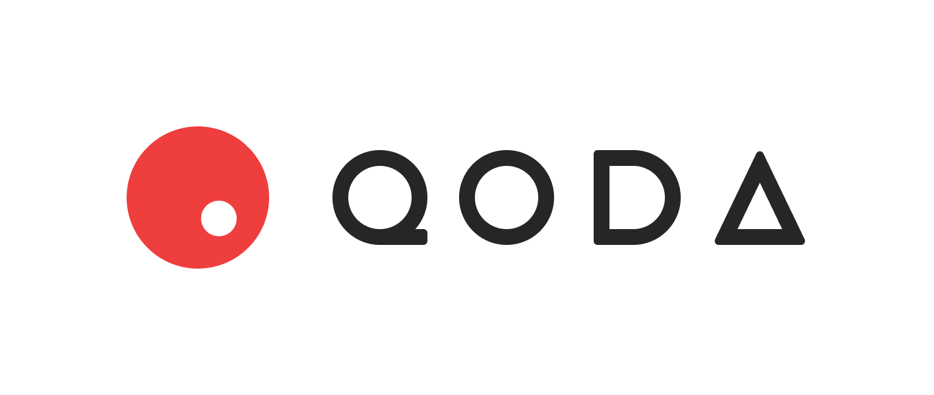
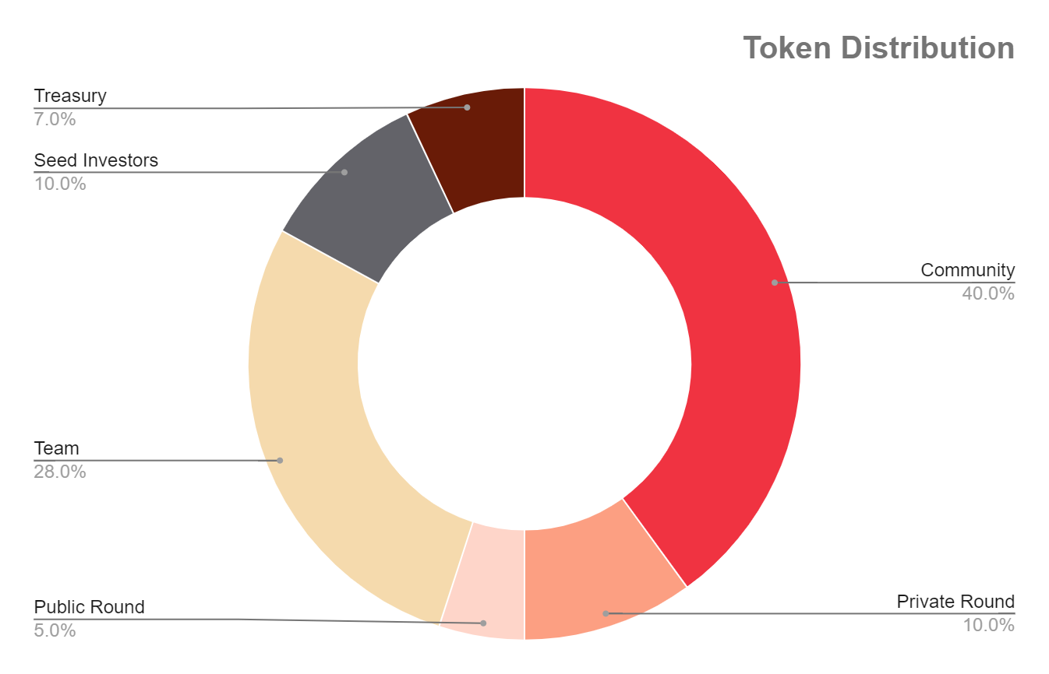

NOTE: This draft not yet finalized, numbers are subject to change

TOKEN INFORMATION

Ticker QODA
Total Token Supply 1,000,000,000
Inflation 0%

Team 28% of tokens with 3 years vesting, 6 months cliff
Seed Investors 10% of tokens with 3 years vesting
Private Round 10% of tokens with 2.5 years vesting
Public Round 5% of tokens, no vesting
Treasury 7% of tokens
Community 40% of tokens

QODA tokens will be distributed to the community via airdrops, liquidity provider incentives, trader incentives, volume incentives, and participation in governance.

QODA treasury tokens will be set aside for development work and projects, strategic partnershipsl, and rewards to token holders.

