WILSON GICHUHI NJUGIA

SCT212-0043/2018

REMOTE CODE ENGINE



OBJECTIVES

**Primary objective**

* Design a platform that helps users run code remotely. Anyone who does not have a laptop close. Works on web(Mobile/ Desktop).

**Specific objectives**

* To build a scalable and reliable remote code execution engine that supports various programming languages.
* To provide developers with a seamless and secure coding experience.
* To allow developers to execute code on the platform's servers without worrying about infrastructure management.
* To create a platform that is easy to use and accessible to developers of all levels.

**Potential use cases**

* Hiring Platforms.
* Coding competitions.
* Aid from programming classes.
* Technical writing, with interactive tutorials

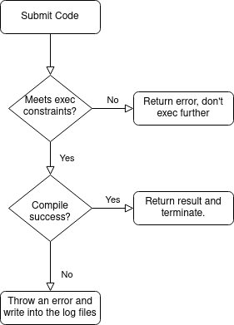

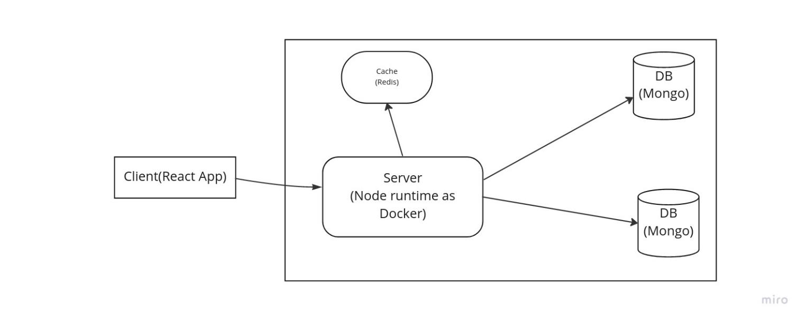

**Known issues**

**- security**

**- scale(prodution constraints)**