@RestController
public class IndexController {
Map<String,Object> params=new HashMap<String,Object>();
@RequestMapping(value = {"/{city_id}/{user_id}"},method =RequestMethod.GET)
public Object test1(@PathVariable("city_id")String city_id,@PathVariable("user_id")String user_id){
params.clear();
params.put("city_id",city_id);
params.put("user_id",user_id);
return params;
}
@GetMapping(value = {"/test2"})
public Object test2(@RequestParam(defaultValue ="0",name = "page") int page,int size){
params.clear();
params.put("page",page);
params.put("size",size);
return params;
}
@RequestMapping(value = {"/test3/save_user"})
public Object test3(@RequestBody User user){
params.clear();
params.put("user",user);
return params;
}
@RequestMapping(value = {"/test4"})
public Object test4(@RequestHeader("access_token") String accessToken,String id){
params.clear();
params.put("accessToken",accessToken);
params.put("id",id);
return params;
}
@RequestMapping(value = {"/test5"})
public Object test5(HttpServletRequest request){
params.clear();
params.put("id",request.getParameter("id"));
return params;
}
}
参数：Ids=q,q,b
@PostMapping("/create")
Reply create(@RequestAttribute("userBean") UserBean userBean,@RequestParam(value = "ids",required=false) List<String> ids) {
//transTemplateService.create(userBean, templateDTO);
System.out.println("================"+ids.size());
return ReplyHelper.success();
}
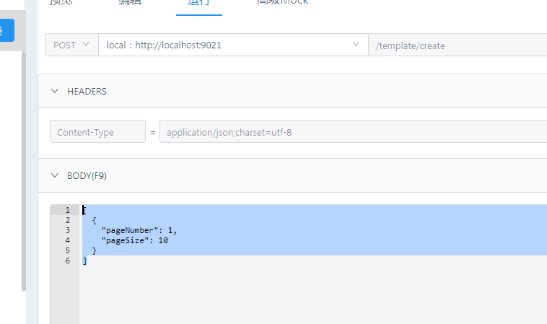
[
{
"pageNumber": 1,
"pageSize": 10
}
]
或
["a","b","c"]
@PostMapping("/create")
Reply create(@RequestAttribute("userBean") UserBean userBean,@RequestBody List<PageDto> ids) {
//transTemplateService.create(userBean, templateDTO);
System.out.println("================"+ids.size());
return ReplyHelper.success();
}

