
Faculty of Engineering and Technology
Electrical and Computer Engineering Department
Computer Networks Laboratory ENCS4130
EXP. No. 5. Dynamic Routing 3 (Path Vector) BGP
Report#1
_____________________________________________________________________________________________
Prepared by:
Qosai Badaha _ 1210469
Instructor : Dr.Ibrahim Nimr

Teacher assistant : Eng.Tariq Odeh

Section : 2

BIRZEIT

November – 2025

Contents
Abstract : 5
Acronyms and Abbreviations: 6
2 Theory 7
2.1 Dynamic Routing 7
2.2 Autonomous Systems 8
2.3 Border Gateway Protocol (BGP) 9
2.3.1 Types of BGP 10
2.3.2 Why BGP Matters 11
2.3.3 BGP Communication and Finite-State Machine (FSM) 12
2.4 Route Redistribution 12
3 Procedure and Discussion 13
3.1 Building the Topology 14
3.1.1 Configuration for PCs 15
3.1.2 Configuration for Routers 20
3.2 Configuring OSPF Routing 24
3.3 Router 1 Configuration: 25
3.1 Configuration of EIGRP 26
Router 2 Configuration: 26
3.4 Configuration of BGP for Inter-AS Routing 27
Router 1 Configuration: 27
Router 2 Configuration: 27
3.1 Route Redistributing BGP into OSPF 27
Router 1 Configuration: 27
3.2 Route Redistributing OSPF into BGP 28
Router 1 Configuration: 28

Table of Figures

Figure 1Dynamic Routing. 7
Figure 2Autonomous Systems. 8
Figure 3: BGP finite-state machine and message flow. 9
Figure 4: Dynamic routing topology. 13
Figure 5 My topology. 13
Figure 6: Static IP configuration for the PC0. 15
Figure 7: Router 0 interface connected to 192.69.1.0/27 network assigned 192.69.1.1. 15
Figure 8: Static IP configuration for the PC1 16
Figure 9Router 0 interface connected to 192.69.1.33/27 network assigned 192.69.1.34. 16
Figure 10Static IP configuration for the PC2. 17
Figure 11: Router 1 interface connected to 192.69.1.64/26 network assigned 192.69.1.65. 17
Figure 12Static IP configuration for the PC3. 18
Figure 13Static IP configuration for the PC4. 18
Figure 14Router 2 interface connected to 192.69.1.128/26 network assigned 192.69.1.129. 18
Figure 15Static IP configuration for the PC5. 19
Figure 16Router 3 interface connected to 192.69.1.192/26 network assigned 192.69.1.193. 19
Figure 17Router 0 interface connected to 192.69..0.0/30 network assigned 192.69.0.1. 20
Figure 18Router 1 interface connected to 192.69.0.0/30 network assigned 192.69.0.2. 20
Figure 19Router 1 interface connected to 192.69.0.4/30 network assigned 192.69.0.5. 21
Figure 20Router 2 interface connected to 192.69.0.4/30 network assigned 192.69.0.6. 21
Figure 21Router 2 interface connected to 192.69.0.8/30 network assigned 192.69.0.9 22
Figure 22Router 3 interface connected to 192.69.0.8/30 network assigned 192.69.0.10 22
Figure 23Shows the OSPF setup on the router 0. 23
Figure 24Shows the OSPF setup on the router 1 , with networks added and the router ID set 24

Abstract :

This experiment focused on the study and configuration of the Border Gateway Protocol, which is the main protocol used for routing between autonomous systems on the Internet. The goal was to understand how BGP works in practice by setting up peer connections between routers in different autonomous systems and combining it with interior routing protocols such as OSPF and EIGRP. The lab was carried out in Cisco Packet Tracer, where a network topology with multiple routers, PCs, and sniffers was built. The main tasks included enabling BGP, forming neighbor relationships, setting timers, and redistributing routes between BGP and the interior protocols to achieve complete connectivity. Verification was done using show commands to check routing tables and neighbor states, while packet sniffers were used to observe BGP messages like OPEN, UPDATE, and KEEPALIVE. Through these steps, the experiment provided practical experience with dynamic routing and showed how BGP supports scalable and policy-based communication across different networks.

Acronyms and Abbreviations:

OSPF Open Shortest Path First
BGP Border Gateway Protocol
EIGRP Enhanced Interior Gateway Routing Protocol
iBGP Internal Border Gateway Protocol
eBGP External Border Gateway Protocol
AS Autonomous System
AD Administrative Distance
FSM Finite-State Machine
IANA Internet Assigned Numbers Authority
IGP Interior Gateway Protocol
EGP Exterior Gateway Protocol
ACL Access Control List
TCP Transmission Control Protocol
ICMP Internet Control Message Protocol

Theory

Dynamic Routing

Dynamic routing is a technique that enables routers to automatically share routing information and update their routing tables without manual intervention. This approach makes the network more adaptable, allowing it to react when links fail or when new routes become available. Unlike static routing—where paths are fixed and must be reconfigured by hand—dynamic routing protocols can independently find and choose the optimal path. Examples of these protocols include OSPF, EIGRP, RIP, and BGP. Each one relies on its own metrics, such as hop count or available bandwidth, to determine the preferred route. Another key idea is administrative distance, which indicates how trustworthy a route is compared with others. Overall, dynamic routing leads to faster convergence and more efficient data flow both within a single autonomous system and across multiple autonomous systems.

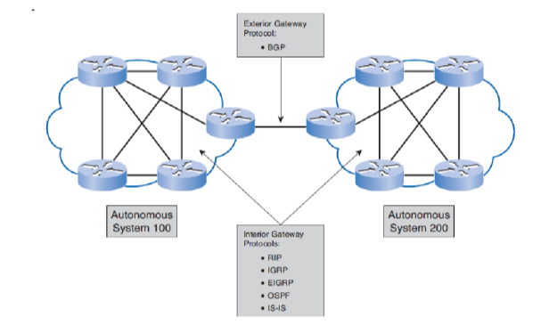
Figure 1Dynamic Routing.

Autonomous Systems

An autonomous system is a group of networks operated by a single organization under one unified routing strategy. Typical examples include ISPs or large enterprises that manage their own internal and external network links. Every autonomous system is assigned a unique identifier known as an Autonomous System Number, which is globally allocated to prevent any overlap. These systems form the core structure of the Internet, as the global network is essentially a collection of many interconnected autonomous systems. Within an AS, routers typically use interior routing protocols like OSPF or EIGRP, while BGP is responsible for routing traffic between different ASes. This design enables data to travel across multiple autonomous systems step by step until it arrives at its intended destination.

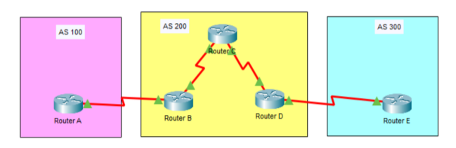
Figure 2Autonomous Systems.

Border Gateway Protocol (BGP)

The Border Gateway Protocol is the primary routing protocol used to exchange routes between autonomous systems across the Internet. It operates as a path-vector protocol, meaning it chooses routes based on the list of autonomous systems a path traverses. For BGP to function, every autonomous system needs at least one router running BGP, and that router must establish a connection with a BGP-enabled router in another AS. BGP’s role is to advertise which networks are reachable and the paths to reach them. Using these announcements, BGP constructs a logical view of the AS-level topology and selects the most suitable route for forwarding traffic. A key capability of BGP is its built-in loop avoidance: a router discards any route that includes its own AS number in the path. This mechanism helps ensure stability and dependable routing across the global Internet.
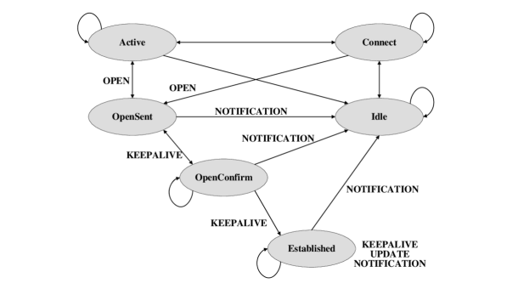
Figure 3: BGP finite-state machine and message flow.

Types of BGP

Border Gateway Protocol can be divided into two main types based on where the routers are located. Internal BGP, or iBGP, is used between routers that belong to the same autonomous system. It helps share routes learned from BGP across all routers inside that AS. External BGP, or eBGP, is used when routers are in different autonomous systems, and it is the method that allows communication across the Internet. The difference is important because iBGP works only within one AS, while eBGP connects separate ASes together. In practice, both types are needed to make sure that routing information flows correctly inside and outside the autonomous system.

External BGP (eBGP)

External BGP is the type of BGP used when routers belong to different autonomous systems. Its purpose is to allow one AS to learn about networks that exist outside its own boundaries. When a router receives an update from an eBGP neighbor, the information includes the next-hop address and the full AS path, which makes it possible to forward traffic correctly and avoid routing loops. This type of BGP is essential for organizations that connect to the Internet or that rely on multiple service providers, since it provides a reliable way to share external routing information and maintain connectivity across different domains.

Internal BGP (iBGP)

Internal BGP is the type of BGP used between routers that belong to the same autonomous system. Its role is to make sure that routes learned from external BGP peers are shared consistently across all routers inside the AS. Without iBGP, only the router that receives the external routes would know about them, which would cause problems in forwarding traffic. By using iBGP, every router in the AS can learn about external networks and forward packets correctly. In large networks, this is very important because it keeps internal routing stable while still allowing the AS to connect to other systems through eBGP. Together, iBGP and eBGP make it possible to maintain both internal consistency and external connectivity.

Why BGP Matters

Border Gateway Protocol plays a central role in how the Internet works because it allows routers in different autonomous systems to exchange routing information in a stable and controlled way. One of its strengths is scalability, since it can manage a very large number of routes without overwhelming the network. BGP also supports multihoming, which means an organization can connect to more than one provider at the same time, improving reliability and performance. Another important feature is policy-based routing, where administrators can control how traffic enters or leaves their autonomous system. In addition, BGP prevents routing loops by checking the AS path before accepting a route. Because BGP runs over TCP, it ensures reliable communication between peers and keeps sessions active through mechanisms like keepalive
messages. These capabilities make BGP essential for building fault-tolerant, efficient, and secure communication across the global Internet.

BGP Communication and Finite-State Machine (FSM)

Border Gateway Protocol relies on a set of messages to establish and maintain communication between routers. The OPEN message is used at the start of a session to agree on parameters such as version, AS number, hold time, and router ID. Once the session is active, routers exchange KEEPALIVE messages at regular intervals to confirm that the connection is still valid. Routing information is shared through UPDATE messages, which advertise new routes or withdraw old ones. If a serious error occurs, a NOTIFICATION message is sent and the session is closed immediately.
To manage these exchanges in an organized way, BGP follows a finite-state machine. A session begins in the Idle state, then moves through Connect and Active depending on whether the TCP handshake succeeds. After sending and receiving the OPEN message, the session passes through OpenSent and OpenConfirm. Once the peers exchange KEEPALIVE messages successfully, the session reaches the Established state, where UPDATE messages are continuously shared. This structured process ensures that BGP sessions are stable and that routing information is exchanged reliably across autonomous systems.

Route Redistribution

In practical networks, it’s common for multiple routing protocols to exchange routing information. BGP typically handles routing between autonomous systems, while protocols such as OSPF and EIGRP operate within the AS for internal path selection. To ensure that all routers have a complete view of reachable networks, engineers configure route redistribution. This mechanism allows routes learned from one routing protocol to be injected into another. For instance, when BGP routes are redistributed into OSPF or EIGRP, internal routers gain visibility of external destinations. Likewise, redistributing OSPF or EIGRP routes into BGP enables the autonomous system to advertise its internal networks to outside peers. Through this two-way redistribution, the network maintains full end-to-end connectivity and seamless communication between internal and external routing domains.

Procedure and Discussion

In this experiment, the network topology was built as shown in Figure 4. The setup included four routers, one switch, several PCs, and two sniffers for packet analysis. Interior routing was handled using OSPF in AS 100 and EIGRP in AS 200, while BGP was configured to connect the two autonomous systems together. Each router and PC was assigned an IP address according to the subnet plan, making sure that no duplicate addresses were used. The sniffers were placed strategically between Router1 and Router2, and between Router1 and PC2, to capture and analyze traffic. This allowed us to observe both internal routing updates and external BGP messages. By combining OSPF, EIGRP, and BGP, the topology provided a complete environment to study how internal and external routing protocols interact and how route redistribution ensures full connectivity across the network.
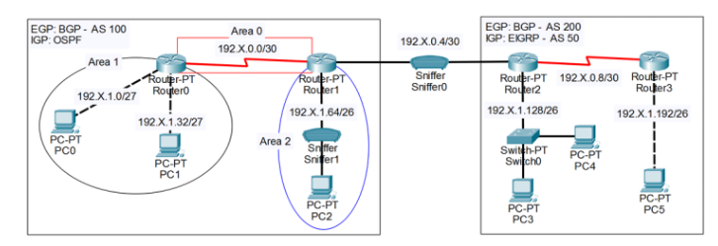
Figure 4: Dynamic routing topology.

Building the Topology

The lab topology was designed with four routers and six PCs, divided into two autonomous systems. In AS 100, Router0 and Router1 were configured to run OSPF as the interior routing protocol. In AS 200, Router2 and Router3 were configured with EIGRP for internal routing. Each PC was assigned an IP address based on the subnet plan, where the value of x was taken from the student ID. Since the ID is 1210469, the value of x equals 69, and this value was used in calculating the IP addressing scheme across the topology. This ensured that all devices had unique addresses and that the network was consistent with the lab requirements.
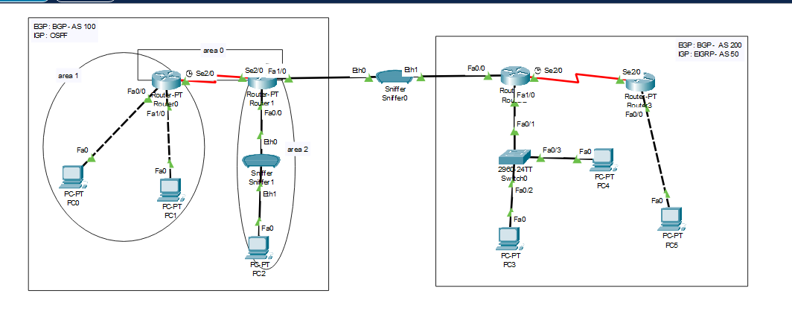
Figure 5 My topology.

After the topology was completed, IP addresses were configured on all router interfaces and PCs according to the subnet plan. Each autonomous system was assigned its own range of addresses, ensuring that no overlaps occurred between AS 100 and AS 200. Router interfaces were given addresses at the edge of each subnet, while PCs were assigned host addresses within their respective ranges. The value of x = 69 (taken from the student ID) was used in calculating the subnets, which guaranteed consistency with the lab requirements. This careful assignment of IPs allowed proper communication between devices and ensured that routing protocols could operate correctly once configured.

Configuration for PCs

Network 192.69.1.0 /27 :
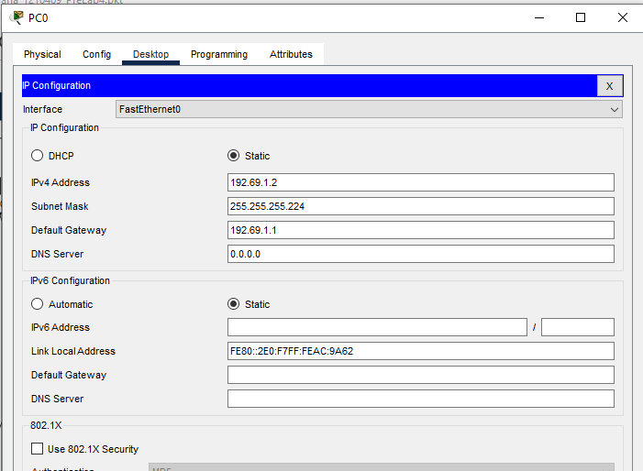
Figure 6: Static IP configuration for the PC0.

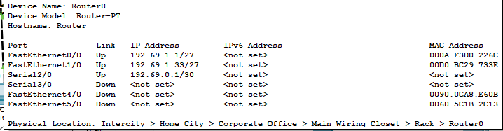
Figure 7: Router 0 interface connected to 192.69.1.0/27 network assigned 192.69.1.1.

Network 192.69.1.32 /27 :

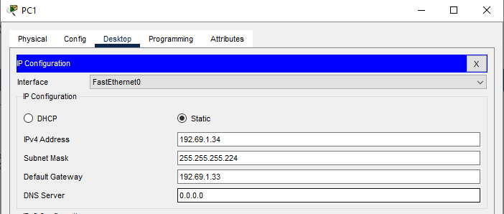
Figure 8: Static IP configuration for the PC1

Figure 9Router 0 interface connected to 192.69.1.33/27 network assigned 192.69.1.34.

Network 192.69.1.64 /26 :

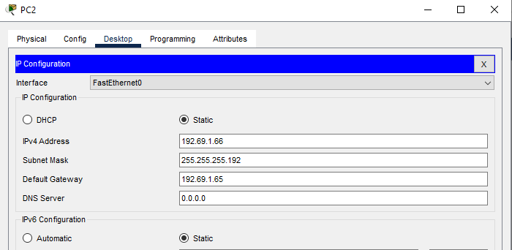
Figure 10Static IP configuration for the PC2.

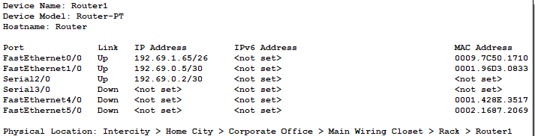
Figure 11: Router 1 interface connected to 192.69.1.64/26 network assigned 192.69.1.65.

Network 192.69.1.128 /26 :

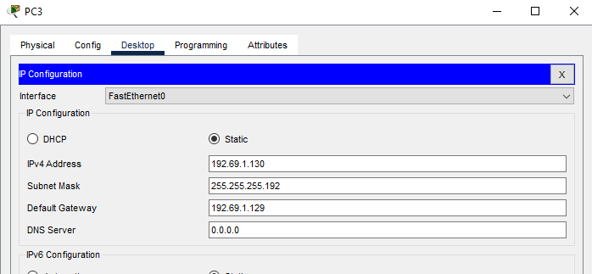
Figure 12Static IP configuration for the PC3.

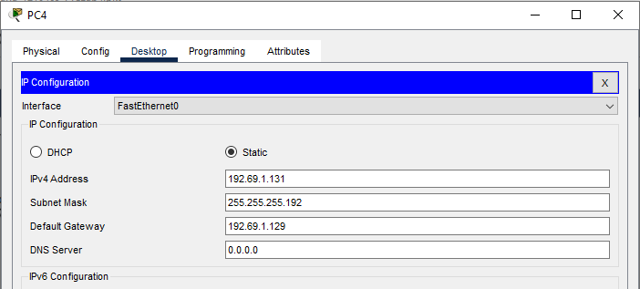
Figure 13Static IP configuration for the PC4.

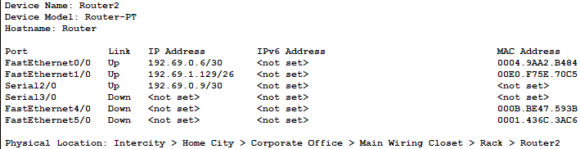
Figure 14Router 2 interface connected to 192.69.1.128/26 network assigned 192.69.1.129.

Network 192.69.1.192 /26 :

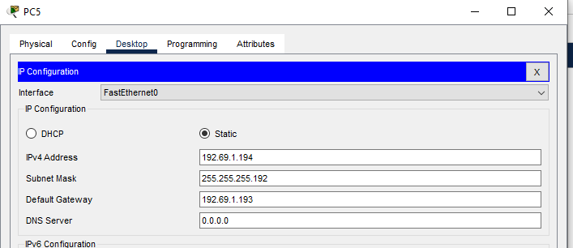
Figure 15Static IP configuration for the PC5.

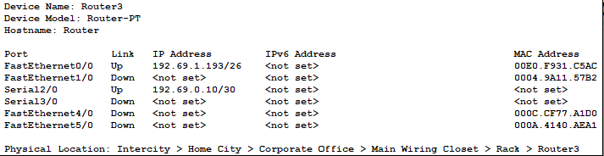
Figure 16Router 3 interface connected to 192.69.1.192/26 network assigned 192.69.1.193.

Configuration for Routers

Network 192.69.0.0 /30 :
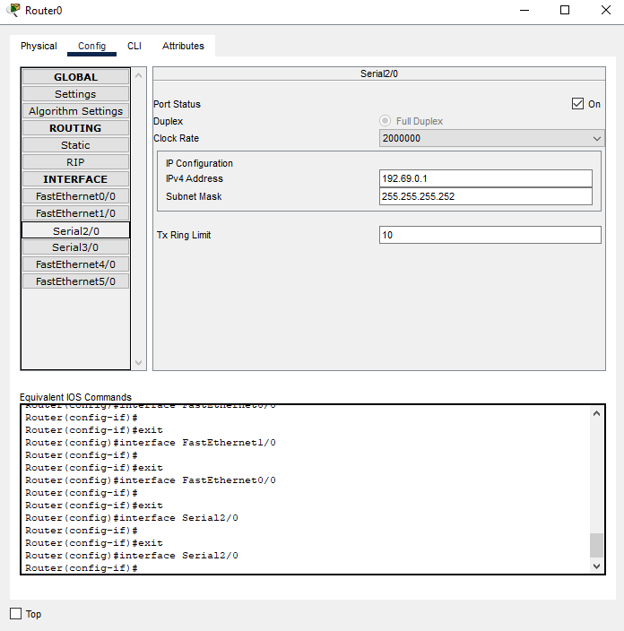
Figure 17Router 0 interface connected to 192.69..0.0/30 network assigned 192.69.0.1.
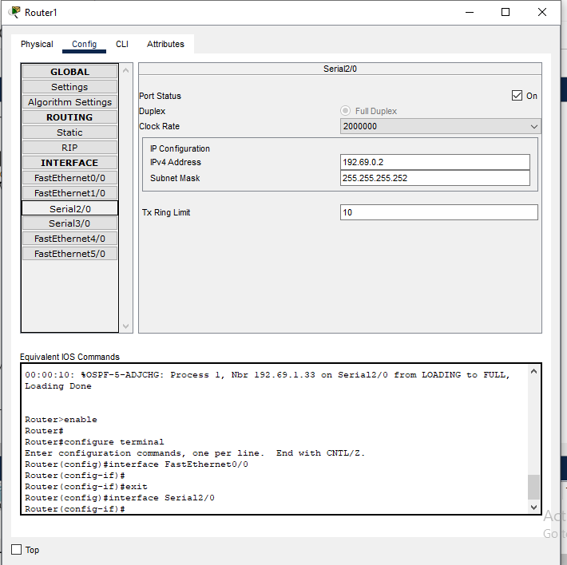
Figure 18Router 1 interface connected to 192.69.0.0/30 network assigned 192.69.0.2.

Network 192.69.0.4 /30 :
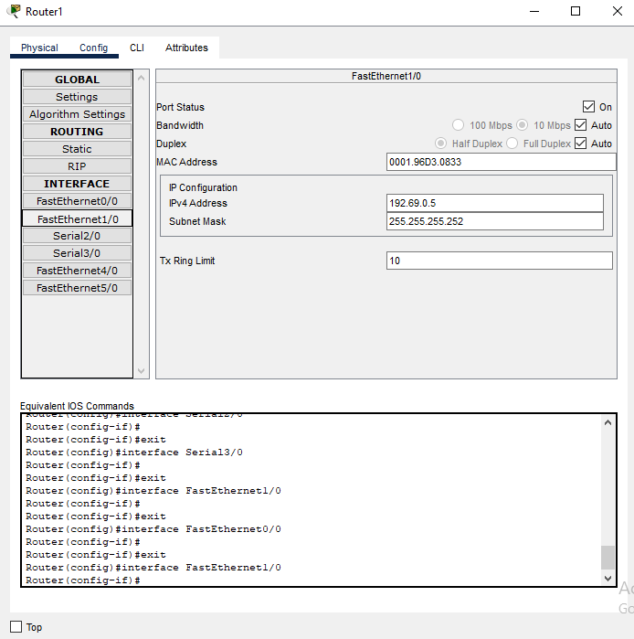
Figure 19Router 1 interface connected to 192.69.0.4/30 network assigned 192.69.0.5.
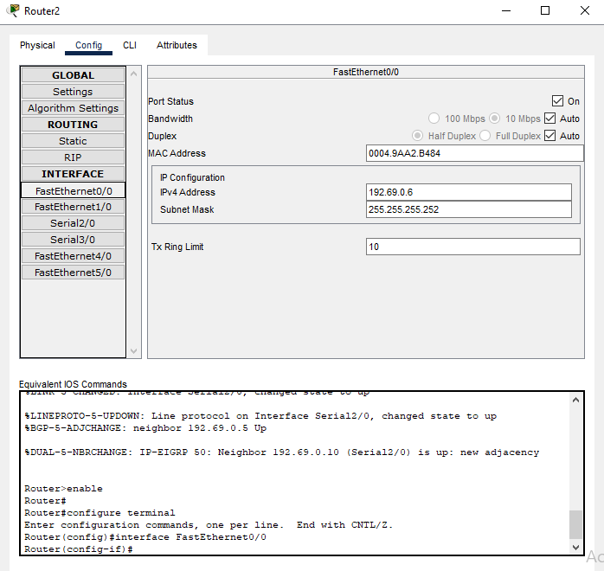
Figure 20Router 2 interface connected to 192.69.0.4/30 network assigned 192.69.0.6.

Network 192.69.0.8 /30 :
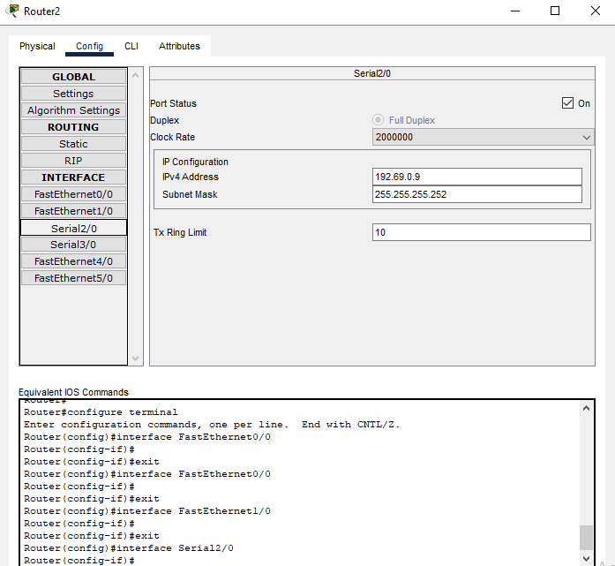
Figure 21Router 2 interface connected to 192.69.0.8/30 network assigned 192.69.0.9

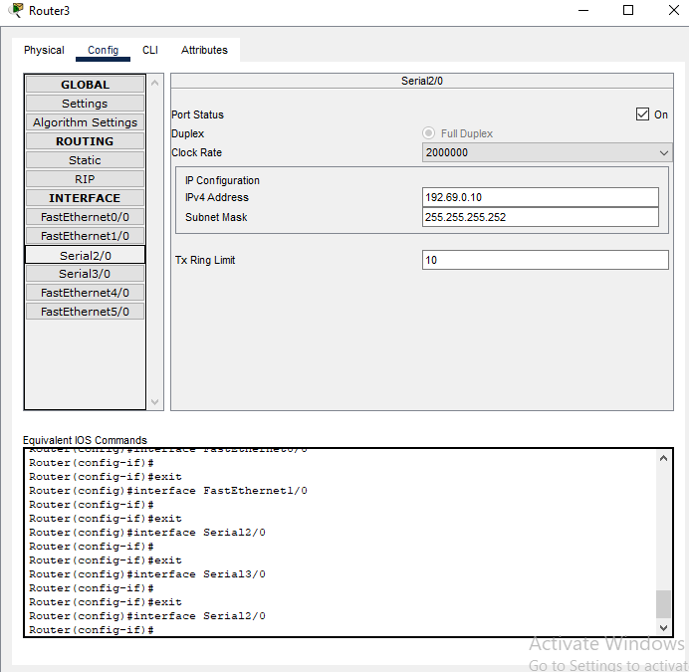
Figure 22Router 3 interface connected to 192.69.0.8/30 network assigned 192.69.0.10

Configuring OSPF Routing

OSPF was configured in AS 100 to enable dynamic routing between Router0 and Router1. Each router was assigned the appropriate network statements for its connected subnets, while the BGP link between AS 100 and AS 200 was excluded from OSPF. This ensured that internal routing inside AS 100 was correctly established without interfering with inter-AS communication.
Router0 Configuration:
- Router ( config )# router ospf 1
- Router ( config - router )# network 192. 69 .0.0 0.0.0.3 area 0
- Router ( config - router )# network 192. 69.1.0 0.0.0.31 area 1
- Router ( config - router )# network 192. 69.1.32 0.0.0.31 area 1

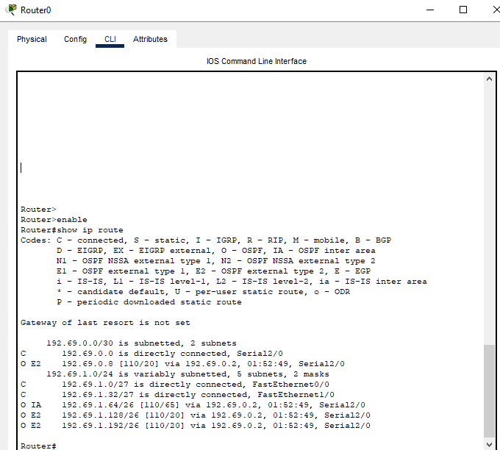
Figure 23Shows the OSPF setup on the router 0.

Router 1 Configuration:
Router(config)# router ospf 1
Router(config-router)# network 192.14.1.64 0.0.0.63 area 2
Router(config-router)# network 192.14.0.0 0.0.0.3 area 0

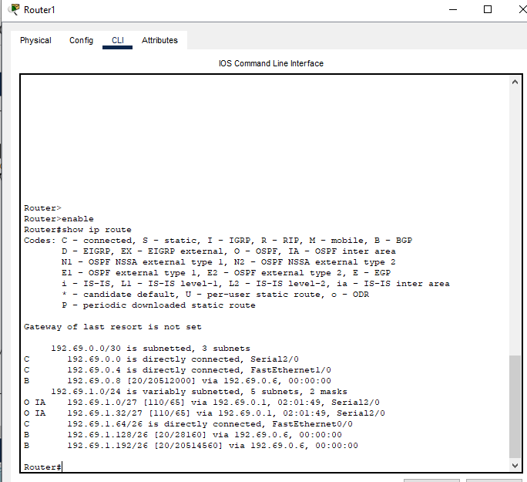
Figure 24Shows the OSPF setup on the router 1 , with networks added and the router ID set

Configuration of EIGRP

We configured the EIGRP routing protocol for AS 200 to handle the internal routing. On Router 3, we started EIGRP with AS number 50 using the router eigrp 50 command, then we added the connected networks with the network statements. We also used no auto-summary to stop the automatic summarization and make sure all subnets are advertised correctly. After that, we configured Router 2 with the same AS, but we made sure not to include the BGP link in the EIGRP configuration.

Router 3 Configuration:

- Router(config)# router eigrp 50
- Router(config-router)# network 192.69.1.192 0.0.0.63

- Router(config-router)# network 192.69.0.8 0.0.0.3
- Router(config-router)# no auto-summary

Router 2 Configuration:

- Router(config)# router eigrp 50
- Router(config-router)# network 192.69.0.8 0.0.0.3

- Router(config-router)# network 192.69.1.192 0.0.0.63
- Router(config-router)# no auto-summary

Configuration of BGP for Inter-AS Routing
We configured the BGP routing protocol only on Router 1 and Router 2 since it is responsible for connecting different Autonomous Systems. On Router 1, we first enabled the BGP process by assigning it to AS number 100 using the command router bgp 100. After that, we established a neighbor relationship with the router in AS 200 by using the command neighbor 192.69.0.6 remote-as 200, which allows Router 1 to communicate with its external peer. The same configuration was then applied on Router 2, but with the appropriate IP address and AS number to match its side of the connection. This setup ensures that both routers can exchange routing information across the two ASes.

Router 1 Configuration:

Router(config)# router bgp 100
Router(config-router)# neighbor 192.69.0.6 remote-as 200

Router 2 Configuration:
Router(config)# router bgp 200
Router(config-router)# neighbor 192.69.0.5 remote-as 100

Route Redistributing BGP into OSPF
To achieve full network reachability between Autonomous Systems 100 and 200, bidirectional route redistribution was configured on Router 1 (ASBR).First, under the OSPF process, the command redistribute bgp 100 subnets was used. This allowed OSPF routers within AS 100 to learn external routes advertised by BGP from AS 200. The subnets keyword ensured all detailed subnetted routes were included, not just major classful networks.

Router 1 Configuration:

Router(config)# router ospf 1
Router(config-router)# redistribute bgp 100 subnets

Route Redistributing OSPF into BGP
Then, under the BGP process, the command redistribute ospf 1 was applied. This enabled BGP to advertise routes learned via OSPF within AS 100 to its eBGP peer in AS 200.
This mutual redistribution ensured that routers in both autonomous systems could dynamically exchange and reach all networks across the entire topology.

Router 1 Configuration:

Router(config)# router bgp 100
Router(config-router)# redistribute ospf 1

