
Faculty of Engineering and Information Technology
Computer Science Department
COMP242 Project #2

Project Title: Medical Patient Monitoring and Treatment Tracker

Submission Deadline: Thursday, 13/11/2025 at 11:00 PM
Submission Format: Java source files (.java) + input files (.txt)
Tools Allowed: Java only. No arrays. No arrayList. No scene builder. Use linked lists only.

Project Objective
Design and implement a Medical Patient Monitoring System using linked lists only. The system will manage patient records, medical conditions, treatments, medications, and symptoms. It will read data from input files, allow dynamic updates, and generate reports, all while maintaining the relationships between linked lists. Figure 1 illustrates the Abstract System Overview: How Everything Connects.

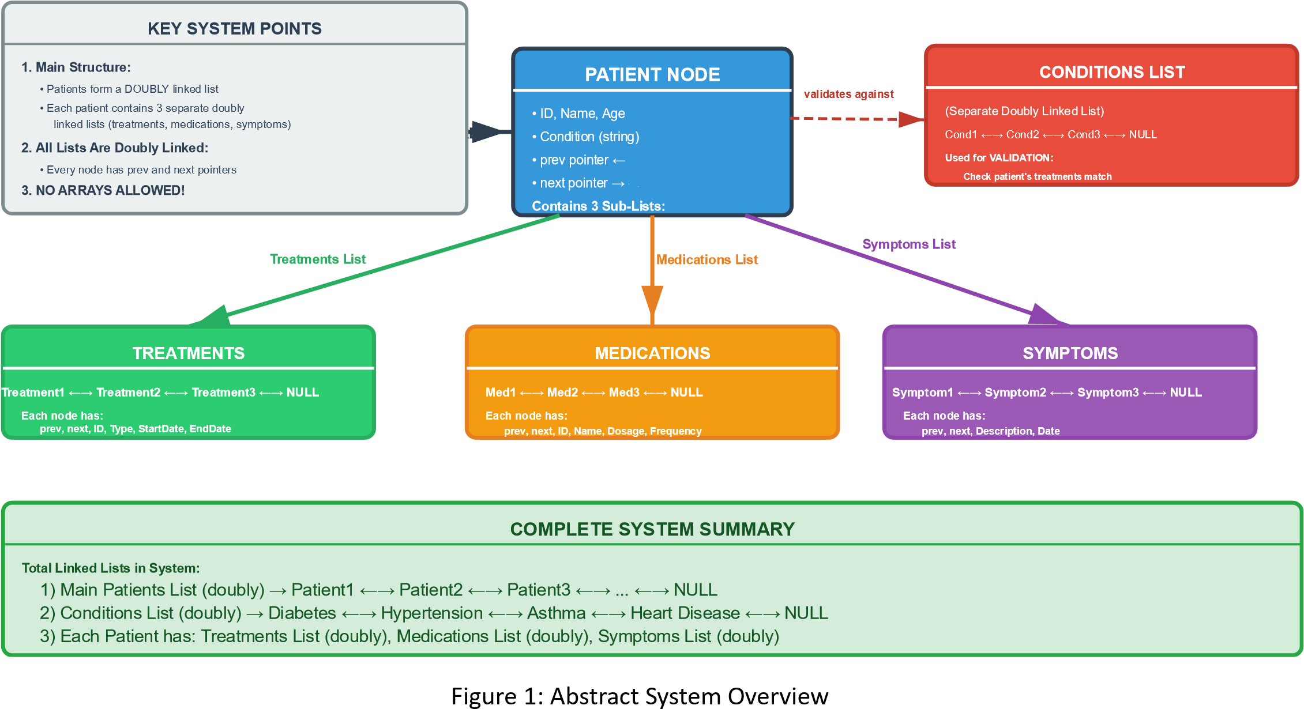

Required Input Files
- conditions.txt: Defines each medical condition and its recommended treatments and medications.
Format:
ConditionName|Treatment1,Treatment2,...|Medication1,Medication2,...
Example:
Diabetes|Insulin Therapy,Diet Counseling|Insulin,Metformin
Hypertension|Blood Pressure Monitoring,Stress Relief|Amlodipine,Lisinopril
Asthma|Inhaler Use,Allergy Testing|Salbutamol,Montelukast
Heart Disease|Cardiac Rehab,Medication Adjustment|Atorvastatin,Beta Blockers
……
- patients.txt: Contains basic patient information.
Format:
PatientID,Name,Age,Condition
Example:
101,Lina,34,Diabetes
102,Omar,45,Hypertension
103,Sara,29,Asthma
104,Bilal,52,Heart Disease
……

- treatments.txt: Lists treatments assigned to patients.
Format:
TreatmentID,PatientID,TreatmentType,StartDate,EndDate
Example:
T001,101,Insulin Therapy,01.10.2025,31.10.2025
T002,101,Diet Counseling,05.10.2025,20.10.2025
T003,102,Blood Pressure Monitoring,03.10.2025,18.10.2025
……

- medications.txt: Lists medications prescribed to patients. Format:
MedicationID,PatientID,MedicationName,Dosage,Frequency
Example:
M001,101,Insulin,10 units,Daily
M002,101,Metformin,500 mg,Twice Daily
M003,102,Amlodipine,5 mg,Daily
……

Clarification on Treatments and Medications Based on Conditions

• | The conditions.txt file defines each medical condition along with its recommended treatments and recommended medications.
• | For example, the condition "Diabetes" recommends treatments like "Insulin Therapy" and "Diet Counseling" and medications like "Insulin" and "Metformin".
• | When assigning treatments and medications to patients (in treatments.txt and medications.txt), the treatment types and medication names should correspond to those recommended for the patient's condition.
• | This means that for a patient with Diabetes, only treatments and medications listed under Diabetes in conditions.txt should be assigned.
• | The system should validate that treatments and medications assigned to a patient match the recommended ones for their condition. If an assignment does not match, it should be flagged or rejected.

Data Structures (Linked Lists Only)
Each entity is represented using a linked list. Arrays and ArrayLists are not allowed.
Patient Node
- Patient ID
- Name
- Age
- Condition
- Linked list of: o Treatments o Medications
o Symptoms

Condition Node • Condition Name
- Linked list of:
o Recommended Treatments o Recommended Medications
Treatment Node
- Treatment ID
- Type
- Start Date
- End Date
Medication Node
- Medication ID
- Name
- Dosage
- Frequency

Symptom Node
- Symptom Description
- Date Recorded

Sample Linked List Visualization
Here are diagrams showing how linked lists are structured in this project:

Example: Patient Lina (ID: 101)
• | Condition: Diabetes
• | Treatments:  [T001: Insulin Therapy] → [T002: Diet Counseling] → NULL
• | Medications:  [M001: Insulin] → [M002: Metformin] → NULL
• | Symptoms:  [Fatigue] → [Blurred Vision] → NULL

Functional Requirements
- Patient Management
  - Add, update, delete, and search patients.
  - Assign treatments and medications based on condition.
  - Deleting a patient removes all linked lists related to this patient.
- Condition Management
  - Add, update, delete conditions.
  - Modify recommended treatments and medications.
  - View all patients with a specific condition.
- Treatment & Medication Management
  - Add, update, delete treatments and medications.
  - Sort by name, type, or date.
- Symptom Tracking • Add/remove symptoms.
  - View symptom history.
Reporting Features

A. Condition Summary Report (Sorted in ascending order by condition)
Condition | Patients | Treatments | Medications
Diabetes | 10 | Insulin Therapy, Diet | Insulin, Metformin
Hypertension | 8 | BP Monitoring, Stress Relief | Amlodipine, Lisinopril

B. Patient Treatment Report (Sorted in ascending order by name)
Patient Name | Condition | Treatments | Medications
Lina | Diabetes | Insulin Therapy, Diet | Insulin, Metformin
Omar | Hypertension | BP Monitoring, Stress Relief | Amlodipine, Lisinopril

C. Medication Adherence Report (Sorted in ascending order by name)
Patient Name | Medication | Frequency | Last Refill
Lina | Insulin | Daily | 20.10.2025
Omar | Amlodipine | Daily | 18.10.2025

GUI Requirements
- Table views for patients, treatments, medications.
- Menus for each entity type.
- Date picker for treatment and medication dates.
- Combo box for sorting (ascending/descending).
- Linked list visualizations (include Next Patient and Previous Patient buttons. Pressing Next updates, the table view with the next patient’s details, while pressing Previous updates it with the previous patient’s details)

Submission Requirements
- Submit .java files and .txt input files.
- Minimum:
  - 30 patients o 5 treatments per patient o 3 medications per patient
  - 5 conditions in conditions.txt
- Code must be well-commented and follow Java conventions (Remember COMP2311).
- GUI must reflect condition-based logic.
- Reports must show condition-patient-treatment-medication relationships.
- Please submit your Java files (java) and corresponding test text files (txt) via the ITC by Thursday, 13/11/2025 at 11:00 PM. Late submissions will not be accepted under any circumstances.

All the Best

