Information Security Lab (HDU IS Labs)

Work1 Secure REST API Development & CVE Reproduction

Name: Zhang Jiexiang
Student ID: 23320317
Date: 2026-10-20

Table of Contents
1. Screenshots
1.1 Shellshock reproduction vs. remediation comparison screenshots
1.2 API testing and CI pipeline verification
2. Difference Analysis
2.1 Behavior comparison of victim.cgi and safe.cgi
2.2 Root cause analysis of CVE-2014-6271
2.3 Remediation principles
3. Personal Contributions
4. Lessons Learned and Pitfalls

1. Screenshots

1.1 Shellshock Reproduction vs. Remediation Comparison
The figure below shows the attack/defense comparison for the reproduction of CVE-2014-6271 (Shellshock): the left side shows the command execution output of the vulnerable victim.cgi under a malicious User-Agent, and the right side shows the normal response of the patched safe.cgi to the same payload.
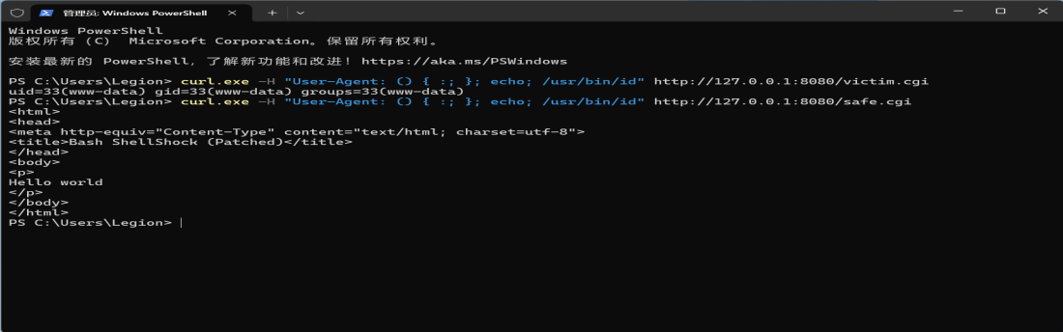
Figure 1 Shellshock reproduction vs. remediation (victim.cgi vs. safe.cgi)

1.2 API Testing and CI Pipeline Verification
In addition to the vulnerability reproduction, the API functionality and the CI pipeline of this lab were also verified:
- API functionality: after login, accessing GET /api/data with a JWT returns HTTP 200 and the protected data; accessing it without a token returns 401, confirming that authentication is enforced.
- JWT authentication verification: curl.exe was used to verify three scenarios — logging in to obtain a token, accessing a protected endpoint with a token, and being rejected without a token. The results matched expectations.
- CI pipeline: both bandit (SAST) and Dependency-Check (SCA) in GitHub Actions passed, no critical vulnerabilities were found, and the pipeline ran successfully.

2. Difference Analysis

2.1 Behavior Comparison of victim.cgi and safe.cgi
Under the same attack payload (malicious User-Agent: () { :; }; echo; /usr/bin/id), the two scripts behave completely differently:
 | Unpatched bash 4.3.0 (/usr/local/bash-4.3.0/bin/bash) | Patched bash (/bin/bash) | Core difference: Bash version
Response status | HTTP 200, body is uid=33(www-data) gid=33(www-data) groups=33(www-data) | HTTP 200, normal HTML page (Hello world) | Command was injected and executed on the vulnerable version
Command output | Yes (result of /usr/bin/id) | No | The patch successfully blocked command execution
Conclusion: when an unpatched Bash parses an environment variable starting with () {, it treats the trailing content as part of the function body, parses and executes it; a patched Bash validates such environment variables and no longer executes the commands after the function body.

2.2 Root Cause Analysis of CVE-2014-6271
CVE-2014-6271 (Shellshock) affects unpatched Bash versions 1.14~4.3. Its root cause can be decomposed into two layers:
(1) Bash's function import flaw: when Bash imports an environment variable starting with () {, it treats it as a function definition and, after parsing the function body, continues to execute the commands after ;, resulting in command injection.
(2) CGI's environment variable propagation chain: the Apache CGI mechanism injects HTTP request headers (such as User-Agent) into the environment variable HTTP_USER_AGENT and passes it to the interpreter of the CGI script. An attacker only needs to place a malicious payload in a request header to make Bash execute arbitrary commands, achieving remote code execution (RCE).

2.3 Remediation Principles
The remediation in this lab and the general protection recommendations correspond as follows:
- Upgrade Bash: upgrade to a fixed version (>=4.3-29 or 4.4+). The official patch fixes the flaw in parsing environment variable function definitions; this is the most direct root-cause fix.
- Avoid importing untrusted environment variables: do not let externally controllable data (such as HTTP headers) directly enter environment variables passed to the Bash interpreter.
- Harden the CGI environment: limit the number of injectable HTTP headers, or use a secure interpreter to execute CGI scripts.
- Deploy WAF/IDS: block requests containing the () { signature at the network layer to stop exploitation attempts.
In this lab, safe.cgi points its shebang to the patched /bin/bash, so the same attack payload can no longer execute commands, directly verifying the effectiveness of the Bash upgrade remediation.

3. Personal Contributions
All parts of this lab were completed independently. The main contributions are as follows:
- Secure API development: built the secure FastAPI-based REST API from scratch, implementing JWT authentication (PyJWT HS256), bcrypt password hashing, parameterized queries to prevent SQL injection, and three endpoints for login, data retrieval, and profile.
- Repository and CI/CD: created the GitHub repository, wrote the GitHub Actions pipeline, integrated bandit (SAST) and Dependency-Check (SCA) automated security scans, and all pipeline runs passed.
- CVE reproduction and remediation: reproduced CVE-2014-6271 Shellshock command injection using the vulhub target (vulhub/bash:4.3.0-with-httpd) and a malicious User-Agent to achieve RCE; wrote the safe.cgi remediation script, completed the attack/defense comparison verification, and organized the results into a remediation report (see fix/CVE-2014-6271-Shellshock-Remediation-Report.md).

4. Lessons Learned and Pitfalls
The following typical problems were encountered and solved during the lab, and the takeaways are as follows:
- PyJWT requires sub to be a string: when issuing a JWT, declaring sub as an integer triggers a validation error. It must be explicitly converted to a string (e.g., str(user_id)), otherwise a runtime error occurs.
- bandit false positives: bandit reports low-severity warnings for some code (such as logging or temporary file writes), which directly fail the pipeline; add --exit-zero to the pipeline command or whitelist the false positives to keep the pipeline green.
- CRLF breaks the shebang: the original target script used CRLF line endings, which appended
to the end of the shebang path, making the interpreter path invalid and causing exec to fail with HTTP 500; converting to LF line endings fixed the issue. This also highlighted the real-world impact of cross-platform file encoding on a security lab environment.
Through this lab, I completed the full secure development loop from secure coding and automated scanning to real vulnerability reproduction and remediation, gaining a deeper understanding of OWASP common risks and the CVE analysis process.

