First , install docker first using docker-install-ubuntu.docx

1. Install necessary package first in necessary-package folder

sudo dpkg -i *.deb

These packages are needed for install docker-compose, acl, and unzip

2. copy docker_images.tar, canvas-lms.zip files to the home directory and extract canvas-lms.zip file

unzip canvas-lms.zip

3. load docker images from docker_images.tar file using the following command.

docker load -i docker_images.tar

once you run the `docker images` command, you will see following images

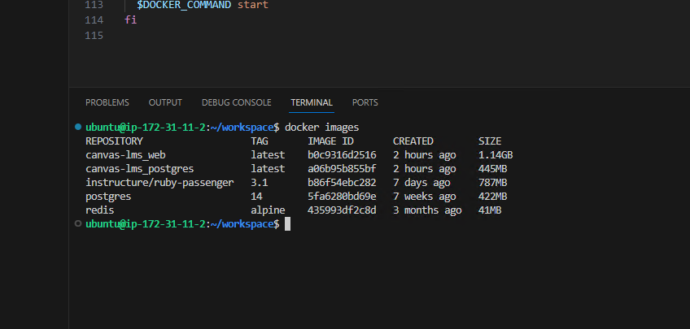

4. decompress node_modules.tar.gz file using the following command

tar -xzf node_modules.tar.gz

cp -r node_modules ./canvas-lms/volumes/

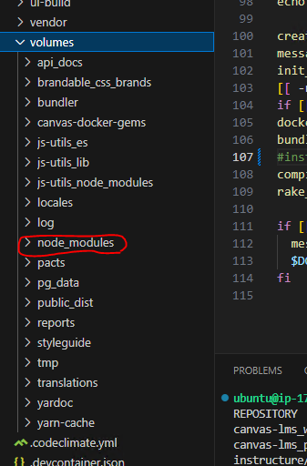

5. goto canvas-lms folder and set access control list using the following commands

sudo setfacl -Rm u:9999:rwX,g:9999:rwX .

sudo setfacl -dRm u:9999:rwX,g:9999:rwX .

sudo setfacl -Rm u:1000:rwX,g:1000:rwX .

sudo setfacl -dRm u:1000:rwX,g:1000:rwX .

6. edit ./script/docker_dev_update.sh file as follows:

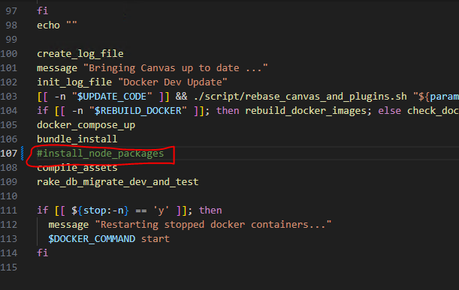

Add new command in ./script/common/canvas/build_helpers.sh file as follows:

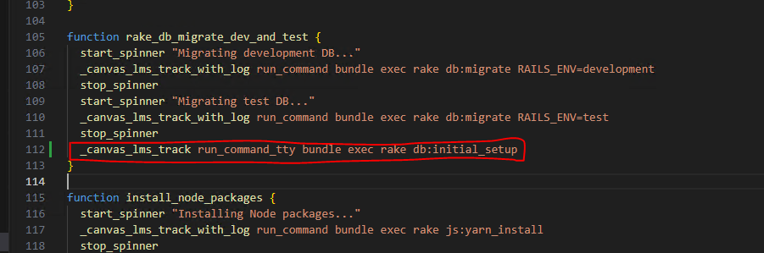

And run the following command:

./script/docker_dev_update.sh

Once successful, you need to add email and password of administrator

You can use [admin@itu.edu](mailto:admin@itu.edu), and P@ssw0rd as an example.

* if you get some errors, you can check ./log/docker_dev_update.log file.

If error is related to permission or (can’t stat … /volumes/pg_data), check step 4 again.

If all is going well, success!

You can check docker ip address by following command:

docker inspect cd2a43352d04 | grep "IPAddress"

you need to replace container id (cd2a43352d04):

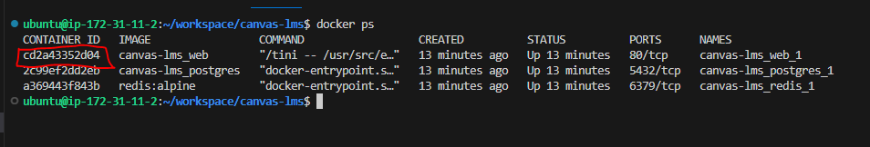

If you find ip address of docker container, open chrome and go to http://{ip-address}

You can find following picture

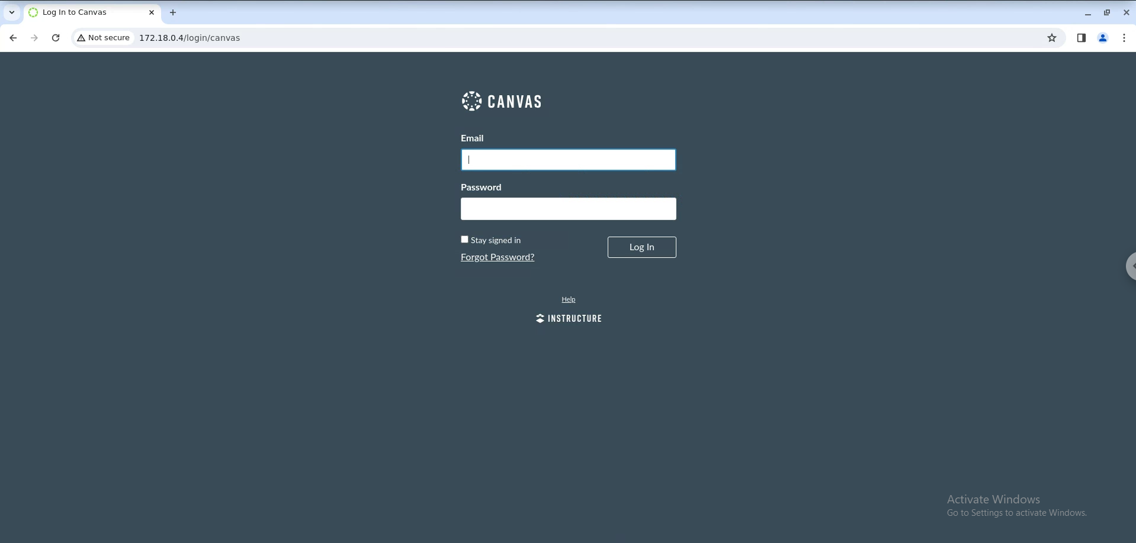

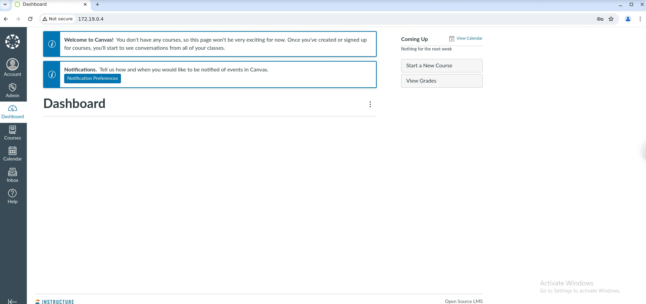

To stop service, go to the canvas-lms folder and run the following command

docker-compose down

To start service, go to the canvas-lms folder and run the following command

docker-compose up -d

*References:

<https://github.com/instructure/canvas-lms/blob/master/doc/docker/developing_with_docker.md>