static const struct of_device_id xilinx_vdmatest_of_ids[] = {

    { .compatible = "xlnx,axidma-chrdev"},

};√

static const struct of_device_id xilinx_vdmatest_of_ids[] = {

    { .compatible = "xlnx,axidma-chrdev",},

    {}

};×

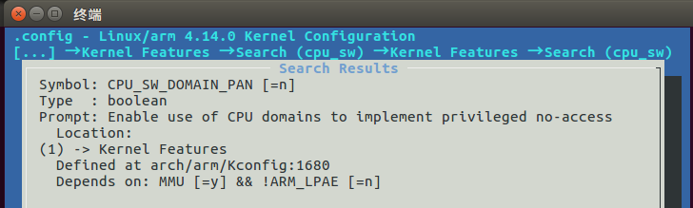

./axidma_benchmark_1ch -v -f 640x512x8 -g 640x512x8 -c 0

vdma amba_pl:axidma_chrdev0: Failed to get pixel clock

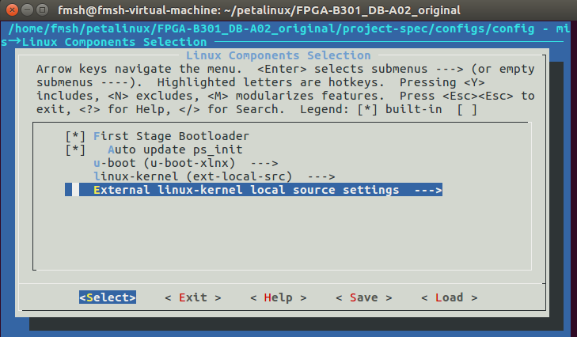

petalinux-package --boot --fsbl ./images/linux/zynq_fsbl.elf --u-boot –fpga --kernel –force

EXPORT_SYMBOL_GPL(xilinx_vtc_intr_clear);

fmsh@fmsh-virtual-machine:~/petalinux/FPGA-B301_DB-A02_original$ petalinux-build -c device-tree

[INFO] building device-tree

[INFO] sourcing bitbake

INFO: bitbake virtual/dtb

Loading cache: 100% |############################################| Time: 0:00:00

Loaded 3444 entries from dependency cache.

Parsing recipes: 100% |##########################################| Time: 0:00:08

Parsing of 2570 .bb files complete (2536 cached, 34 parsed). 3446 targets, 149 skipped, 0 masked, 0 errors.

NOTE: Resolving any missing task queue dependencies

Initialising tasks: 100% |#######################################| Time: 0:00:01

Checking sstate mirror object availability: 100% |###############| Time: 0:00:08

NOTE: Executing SetScene Tasks

NOTE: Executing RunQueue Tasks

NOTE: linux-xlnx: compiling from external source tree /home/fmsh/linux-4.14.0-v2018.3

ERROR: linux-xlnx-4.14-xilinx-v2018.3+git999-r0 do_compile: oe_runmake failed

ERROR: linux-xlnx-4.14-xilinx-v2018.3+git999-r0 do_compile: Function failed: do_compile (log file is located at /home/fmsh/petalinux/FPGA-B301_DB-A02_original/build/tmp/work/plnx_zynq7-xilinx-linux-gnueabi/linux-xlnx/4.14-xilinx-v2018.3+git999-r0/temp/log.do_compile.27592)

ERROR: Logfile of failure stored in: /home/fmsh/petalinux/FPGA-B301_DB-A02_original/build/tmp/work/plnx_zynq7-xilinx-linux-gnueabi/linux-xlnx/4.14-xilinx-v2018.3+git999-r0/temp/log.do_compile.27592

Log data follows:

| DEBUG: Executing python function externalsrc_compile_prefunc

| NOTE: linux-xlnx: compiling from external source tree /home/fmsh/linux-4.14.0-v2018.3

| DEBUG: Python function externalsrc_compile_prefunc finished

| DEBUG: Executing shell function do_compile

| NOTE: make -j 2 HOSTCC=gcc -isystem/home/fmsh/petalinux/FPGA-B301_DB-A02_original/build/tmp/work/plnx_zynq7-xilinx-linux-gnueabi/linux-xlnx/4.14-xilinx-v2018.3+git999-r0/recipe-sysroot-native/usr/include -O2 -pipe -L/home/fmsh/petalinux/FPGA-B301_DB-A02_original/build/tmp/work/plnx_zynq7-xilinx-linux-gnueabi/linux-xlnx/4.14-xilinx-v2018.3+git999-r0/recipe-sysroot-native/usr/lib -L/home/fmsh/petalinux/FPGA-B301_DB-A02_original/build/tmp/work/plnx_zynq7-xilinx-linux-gnueabi/linux-xlnx/4.14-xilinx-v2018.3+git999-r0/recipe-sysroot-native/lib -Wl,-rpath-link,/home/fmsh/petalinux/FPGA-B301_DB-A02_original/build/tmp/work/plnx_zynq7-xilinx-linux-gnueabi/linux-xlnx/4.14-xilinx-v2018.3+git999-r0/recipe-sysroot-native/usr/lib -Wl,-rpath-link,/home/fmsh/petalinux/FPGA-B301_DB-A02_original/build/tmp/work/plnx_zynq7-xilinx-linux-gnueabi/linux-xlnx/4.14-xilinx-v2018.3+git999-r0/recipe-sysroot-native/lib -Wl,-rpath,/home/fmsh/petalinux/FPGA-B301_DB-A02_original/build/tmp/work/plnx_zynq7-xilinx-linux-gnueabi/linux-xlnx/4.14-xilinx-v2018.3+git999-r0/recipe-sysroot-native/usr/lib -Wl,-rpath,/home/fmsh/petalinux/FPGA-B301_DB-A02_original/build/tmp/work/plnx_zynq7-xilinx-linux-gnueabi/linux-xlnx/4.14-xilinx-v2018.3+git999-r0/recipe-sysroot-native/lib -Wl,-O1 -Wl,--allow-shlib-undefined -Wl,--dynamic-linker=/home/fmsh/petalinux/FPGA-B301_DB-A02_original/build/tmp/sysroots-uninative/x86_64-linux/lib/ld-linux-x86-64.so.2 HOSTCPP=gcc -E zImage CC=arm-xilinx-linux-gnueabi-gcc -mno-thumb-interwork -marm -fuse-ld=bfd -ffile-prefix-map=/home/fmsh/linux-4.14.0-v2018.3=/kernel-source/ LD=arm-xilinx-linux-gnueabi-ld.bfd UIMAGE_LOADADDR=0x8000

| CHK include/config/kernel.release

| GEN ./Makefile

| CHK include/generated/uapi/linux/version.h

| CHK include/generated/utsrelease.h

| Using /home/fmsh/linux-4.14.0-v2018.3 as source for kernel

| /home/fmsh/linux-4.14.0-v2018.3 is not clean, please run 'make mrproper'

| in the '/home/fmsh/linux-4.14.0-v2018.3' directory.

| /home/fmsh/linux-4.14.0-v2018.3/Makefile:1049: recipe for target 'prepare3' failed

| make[2]: *** [prepare3] Error 1

| Makefile:146: recipe for target 'sub-make' failed

| make[1]: *** [sub-make] Error 2

| Makefile:24: recipe for target '__sub-make' failed

| make: *** [__sub-make] Error 2

| ERROR: oe_runmake failed

| WARNING: /home/fmsh/petalinux/FPGA-B301_DB-A02_original/build/tmp/work/plnx_zynq7-xilinx-linux-gnueabi/linux-xlnx/4.14-xilinx-v2018.3+git999-r0/temp/run.do_compile.27592:1 exit 1 from 'exit 1'

| ERROR: Function failed: do_compile (log file is located at /home/fmsh/petalinux/FPGA-B301_DB-A02_original/build/tmp/work/plnx_zynq7-xilinx-linux-gnueabi/linux-xlnx/4.14-xilinx-v2018.3+git999-r0/temp/log.do_compile.27592)

ERROR: Task (/opt/petalinux/components/yocto/source/arm/layers/meta-xilinx/meta-xilinx-bsp/recipes-kernel/linux/linux-xlnx_2018.3.bb:do_compile) failed with exit code '1'

NOTE: Tasks Summary: Attempted 670 tasks of which 665 didn't need to be rerun and 1 failed.

Summary: 1 task failed:

/opt/petalinux/components/yocto/source/arm/layers/meta-xilinx/meta-xilinx-bsp/recipes-kernel/linux/linux-xlnx_2018.3.bb:do_compile

Summary: There were 2 ERROR messages shown, returning a non-zero exit code.

ERROR: Failed to build device-tree

grep -rnw '/path/to/somewhere/' -e 'pattern'

* -r or -R is recursive,
* -n is line number, and
* -w stands for match the whole word.
* -l (lower-case L) can be added to just give the file name of matching files.
* -e is the pattern used during the search

Along with these, --exclude, --include, --exclude-dir flags could be used for efficient searching:

* This will only search through those files which have .c or .h extensions:
* grep --include=\*.{c,h} -rnw '/path/to/somewhere/' -e "pattern"
* This will exclude searching all the files ending with .o extension:
* grep --exclude=\*.o -rnw '/path/to/somewhere/' -e "pattern"
* For directories it's possible to exclude one or more directories using the --exclude-dir parameter. For example, this will exclude the dirs dir1/, dir2/ and all of them matching *.dst/:
* grep --exclude-dir={dir1,dir2,*.dst} -rnw '/path/to/search/' -e "pattern"

This works very well for me, to achieve almost the same purpose like yours.

For more options, see [man grep](https://ss64.com/bash/grep.html).

Dynamic_clock 驱动频率

xilinx_vdmafb

SD卡配置

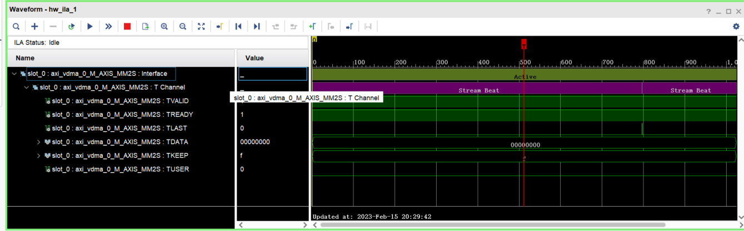

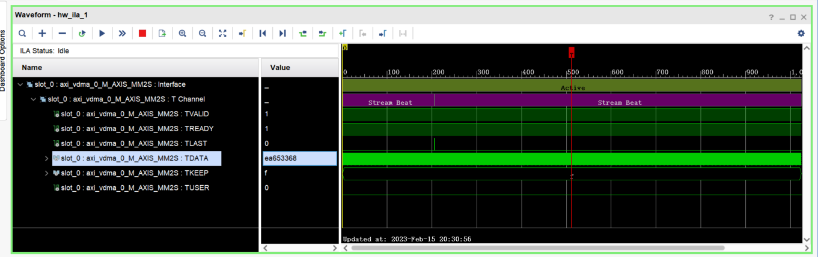

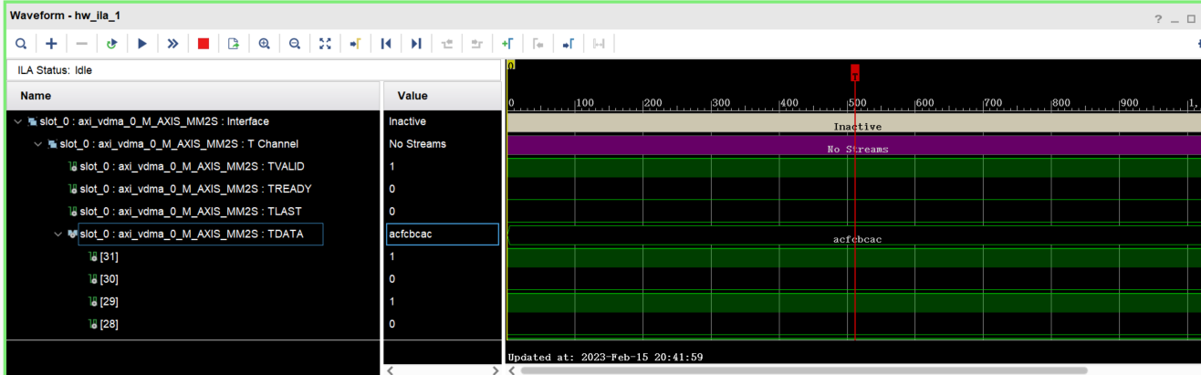

* 1. 单独编译vdma驱动
  2. 测试vdma接收通路
  3. 合并驱动为一个framebuffer设备

C++ 调用c生成的.so需要extern “C”{}，不然无法识别符号