# Design

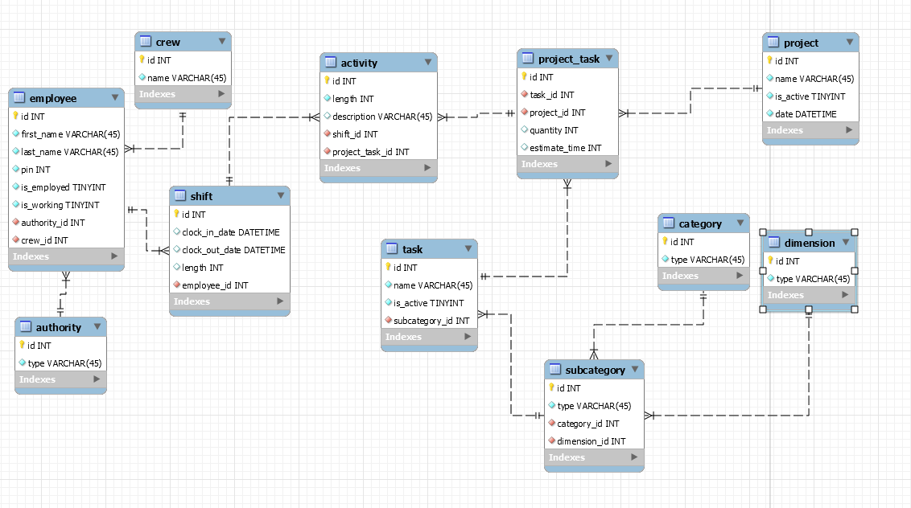Relevant Sql and Model are in [Database/v3 of the github](https://github.com/jose56wonton/time-track/tree/master/Database/v3)

Figure : Design V3

Note for use with loopback 5 other tables are generated. They can also be created with the ‘drop_and_create_credential_tables.sql’ script found at the link above. For more details check the api documentation

# Hosting

The Database is hosted on Google Cloud Platform under [Joshua@aaconcretinc.com](mailto:Joshua@aaconcretinc.com). If you contact me ([joshuawootonn@gmail.com](mailto:joshuawootonn@gmail.com)) I can add you to the account so that you can edit the settings. Jay is also on the account.

* Public IP: 35.188.67.48
* Connection Name: graceful-smithy-206022:us-central1:time-track