Project Report

SEA-Geko: An AI-Powered Learning and Career Readiness Platform for ASEAN Youth

Prepared by:
CodeQuest

BorNEO HackWknd 2026
13.03.2026

Table of Contents

1. Introduction 3
1.1. Background of Case Study 3
1.2. Chosen SDG 3
1.3. Problem Statement 3
1.4. Objectives 4
2. Review of Existing Solutions 5
2.1. Analysis of Current Solutions 5
2.2. Gaps and Limitations 5
3. Methodology 7
3.1. Tech Stack 7
3.2. Architecture 7
3.3. Implementation Process 8
4. Results 9
4.1. Outcome of the Work 9
4.2. Development Feedback and Observations 9
5. Prototype Showcase 10
6. AI Acknowledgement 11
6.1. Disclosure 11
6.2. Usage 11
7. Conclusion 12
7.1. Future Improvements 12
8. References 13

Introduction

Background of Case Study
SEA-Geko was developed from a problem that many students and young people face today. A lot of them genuinely want to learn, improve their skills, and prepare for better opportunities, but they often do not know where to begin. They search online, watch tutorials, save courses, and make study plans, yet many still feel lost because the path is not clear. In many cases, learning platforms give access to content, but they do not give enough direction, continuity, or confidence for users who are trying to build themselves step by step.
This issue becomes more serious in Southeast Asia, where learners come from very different language backgrounds, internet conditions, and educational environments. Some users may have unstable connectivity. Others may feel discouraged because most tools and learning resources are built mainly around English-speaking users. Because of this, many learners do not only need more content. They need a learning experience that feels guided, practical, and closer to their real goals. SEA-Geko was created as a response to that situation. Because of this, the challenge is no longer just access to information, but access to direction, continuity, and confidence in learning

Chosen SDG
The primary Sustainable Development Goal addressed by SEA-Geko is SDG 4: Quality Education, because the platform is designed to make learning more inclusive, guided, and accessible for students and youth with different language backgrounds and connectivity conditions. SEA-Geko also supports SDG 8 by helping users build confidence and readiness for future work through interview preparation and career-oriented learning pathways. This SDG alignment is suitable because the platform is designed not only to help users learn, but also to help them apply their learning in practical and career-related situations. The relevance of this goal is clear, as the UN defines SDG 4 around inclusive quality education and improved access to relevant skills for employment.

Problem Statement
The problem is not simply a shortage of learning content. The deeper issue is that many learners still lack a clear direction for what to study, how to continue, and how to connect learning to real opportunities. Many students and young job seekers do not have a clear roadmap showing what to study, how to continue learning, and how to connect that learning to employment. At the same time, digital inequality remains a real issue in the region. UNESCO highlights that access challenges in Southeast Asia still include urban-rural gaps, affordability problems, and weak infrastructure. UNICEF also reports that among underserved and marginalized youth in the region, 47.8 percent struggle with basic workplace software proficiency and 72.2 percent have little to no advanced digital skills. These gaps affect both learning and employability.

Objectives
The first objective of SEA-Geko is to provide learners with clearer direction through structured, AI-assisted learning paths. The second is to support learning continuity in low-connectivity situations. The third is to improve accessibility through multilingual support for ASEAN learners. The fourth is to connect education with employability by integrating interview preparation, CV-based guidance, and progress tracking into the same platform.

Review of Existing Solutions

Analysis of Current Solutions
There are already several popular platforms in the learning and skills market. Duolingo is widely known for short, gamified lessons and broad language-learning accessibility. Its strength is motivation and bite-sized practice, but its focus is mainly language learning rather than broader academic lessons and role-specific interview preparation.
Coursera offers a very large catalog of professional and academic courses from universities and companies, and its mobile ecosystem supports on-the-go learning. However, it is centered on course consumption rather than lightweight AI-generated personalization for each learner, and it is less focused on multilingual ASEAN-specific interview readiness in a single guided workflow.
Khan Academy is strong in free educational practice and supports offline video access in some cases, but its offline and permanently disconnected learning pathways are more limited and often depend on separate solutions such as downloads or Kolibri-based workflows. It is highly valuable for foundational learning, yet it does not directly combine personalized AI lesson generation, multilingual interview practice, and user-created course workflows in one platform.
Quizlet now offers AI-supported study features such as flashcards, summaries, study guides, and practice tests. These features are helpful for review and memory reinforcement, but the platform does not provide a full end-to-end learning journey that covers identifying learner needs, generating structured lessons, tracking course progress, and preparing users for job interviews.
In the interview-preparation space, platforms such as Interviewing.io and LinkedIn’s Interview Prep AI provide mock interview support and personalized questions, especially for professional preparation. These systems are useful, but they usually focus on interview training as a separate product rather than integrating it with multilingual learning content and educational continuity for underserved ASEAN learners. Taken together, these platforms are strong in their own areas, but most do not combine personalized learning generation, low-connectivity continuity, multilingual access, and interview readiness in one guided workflow.

Gaps and Limitations
The biggest gap we observed is fragmentation. Many current solutions do not connect learning, continuity, and employability in one experience. They may provide useful features, but they still expect users to figure out their own direction and manage their own workflow across multiple platforms. For confident or highly independent learners, that may be manageable. For many students and youth, it becomes a barrier.
Another limitation is that not enough platforms are designed with regional realities in mind. Learners in Southeast Asia may face unstable internet access, device limitations, or language preferences that are not well supported by mainstream systems. Some tools are content-rich but not context-aware. SEA-Geko tries to respond to these limitations by bringing together AI-generated learning support, multilingual access, offline continuity, and interview preparation in one prototype. The intention is not simply to add more features, but to make the overall journey feel more connected and useful. For this reason, SEA-Geko was designed not as a replacement for every existing platform, but as a more connected experience that addresses the gaps between learning, continuity, and career preparation.

Methodology

Tech Stack
SEA-Geko was built as a web-based prototype using a modern full-stack approach. The front end was developed with React, TypeScript, and Vite, which helped us create a responsive and flexible user interface for course generation, learning interaction, and interview preparation. This combination was useful because it allowed faster iteration during development while keeping the application structure manageable.
On the back end, the project uses Node.js with server-side API handling for content generation, learner data flow, and AI-powered features. The system was designed to support different AI providers depending on configuration, which made the prototype more adaptable during testing and development. The overall tech stack was chosen because it allowed us to move quickly in a hackathon setting while still supporting a feature-rich experience.

Architecture
The architecture of SEA-Geko is built around a clear separation between the user interface, the application logic, and the generation layer. On the client side, users interact with onboarding, course generation, learning pages, downloads, community features, and interview preparation. These flows are managed in the front-end application. On the server side, API routes handle generation requests, profile context, interview logic, and impact-related features.
The system also includes support for low-connectivity continuity. Downloaded learning content can be stored and reopened later, which helps maintain learning progress even when internet access is not stable. In addition, the platform supports multilingual content and user settings, allowing the same system to adapt to different learning contexts. This architecture made it possible to combine educational generation, user progression, and practical employability features within one connected prototype.
When a user enters a topic or goal, the system sends that input to the generation layer, which creates a structured outline, lesson components, and supporting activities. The application then presents this content through guided modules, tracks progress across the learning flow, and supports later reuse through saved or downloadable content. In interview mode, the system uses role-based prompting to generate practice questions and response feedback aligned with the user’s target role.

Implementation Process
The implementation process began with defining the learner journey first rather than building isolated features. We identified the main stages a user would move through: entering the platform, setting a learning goal, generating structured content, progressing through lessons, tracking development, and finally using interview preparation to connect learning to future opportunities. This user-first view helped us avoid building features that looked impressive but did not support a clear flow.
From there, we built the project step by step. We implemented course generation, lesson flow, and interactive content first, then added multilingual support, offline continuity, and interview preparation. Community-related features and impact tracking were added to give the platform more depth beyond one-time generation. This process allowed us to gradually shape the prototype into something that felt like a complete learner journey instead of a single AI demo.

Results

Outcome of the Work
The final prototype successfully demonstrates a complete user journey rather than a single isolated feature. Users can enter a learning goal, generate structured course content, study through guided lesson components, access interview preparation, and view progress within the same platform. This shows that SEA-Geko is able to connect learning support and career readiness in one working prototype.
In our internal testing and demo flow, the major functional paths were completed successfully, including topic-based generation, lesson navigation, interview-related features, and progress-related views. This gave us confidence that the concept works not only at the idea level, but also as a usable prototype.

Development Feedback and Observations
During development, one of our clearest observations was that content generation alone is not enough if the learning experience still feels unstructured. AI can generate material quickly, but if the experience is not organized well, users can still feel lost. This reinforced the importance of user flow, module structure, and a clearer sense of progression throughout the system.
We also observed that continuity and practicality matter a lot. Features such as downloadable learning content and interview mode gave the platform more depth because they connected learning to real situations. Another important lesson was that language and accessibility are not secondary features in this context; they are central to whether the platform feels inclusive or not. These observations helped shape the project into a more realistic and user-centered solution. These observations reinforced our decision to focus not only on AI output quality, but also on user flow, continuity, and relevance to real learner needs.

Prototype Showcase
This section presents key screens from the SEA-Geko prototype to show the main user journey, from entry and course generation to learning interaction, interview preparation, and progress tracking. The screenshots are arranged to demonstrate how the platform connects education and career readiness in one guided workflow.
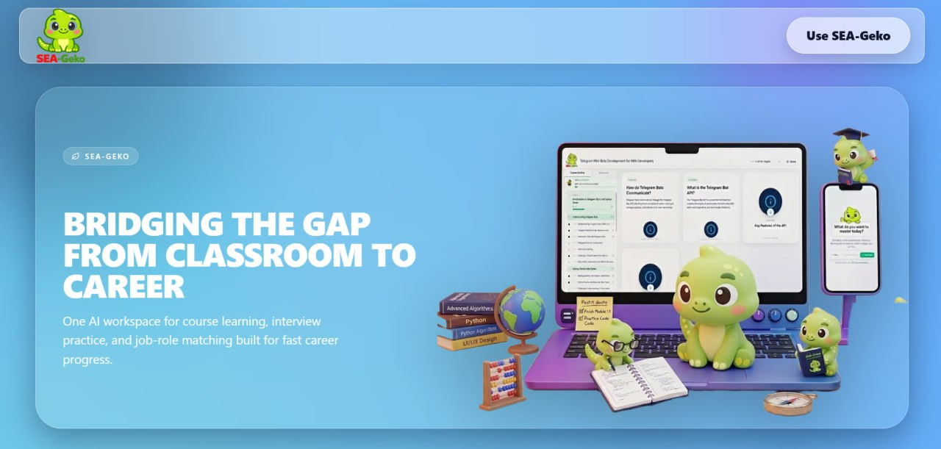
Figure 1. SEA-Geko landing page
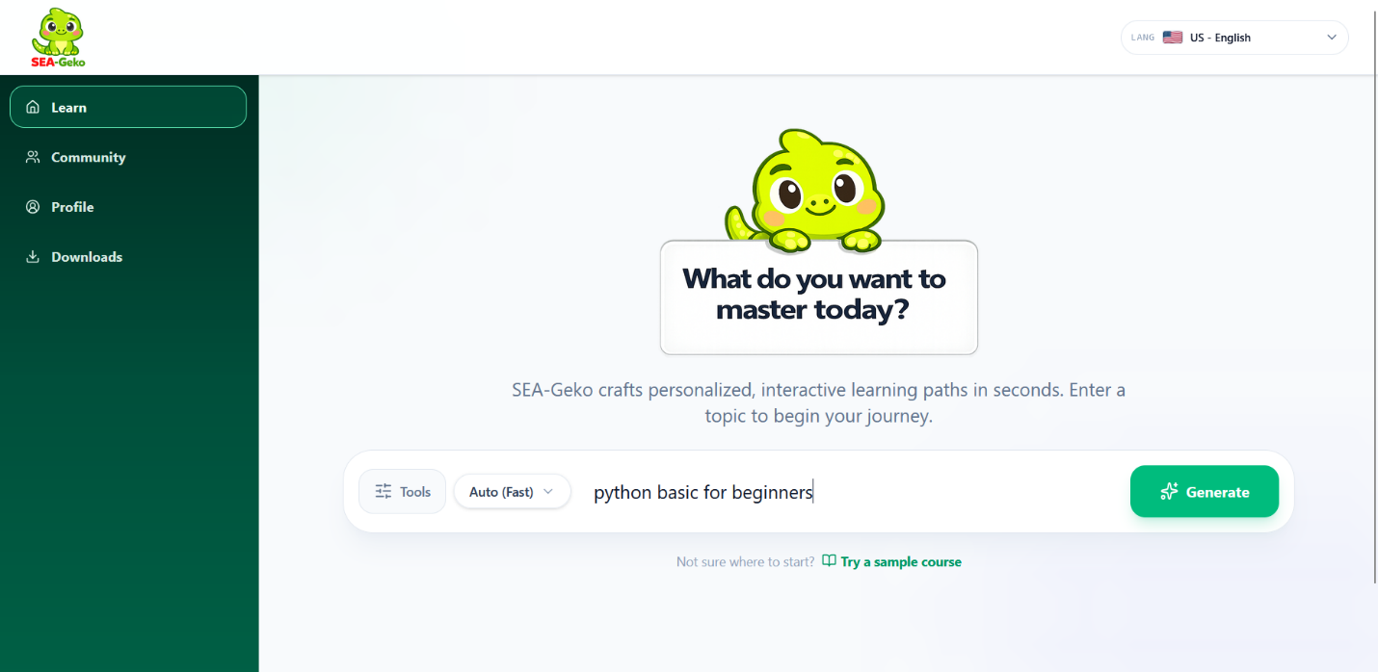
Figure 2. Topic input and AI learning path generation screen

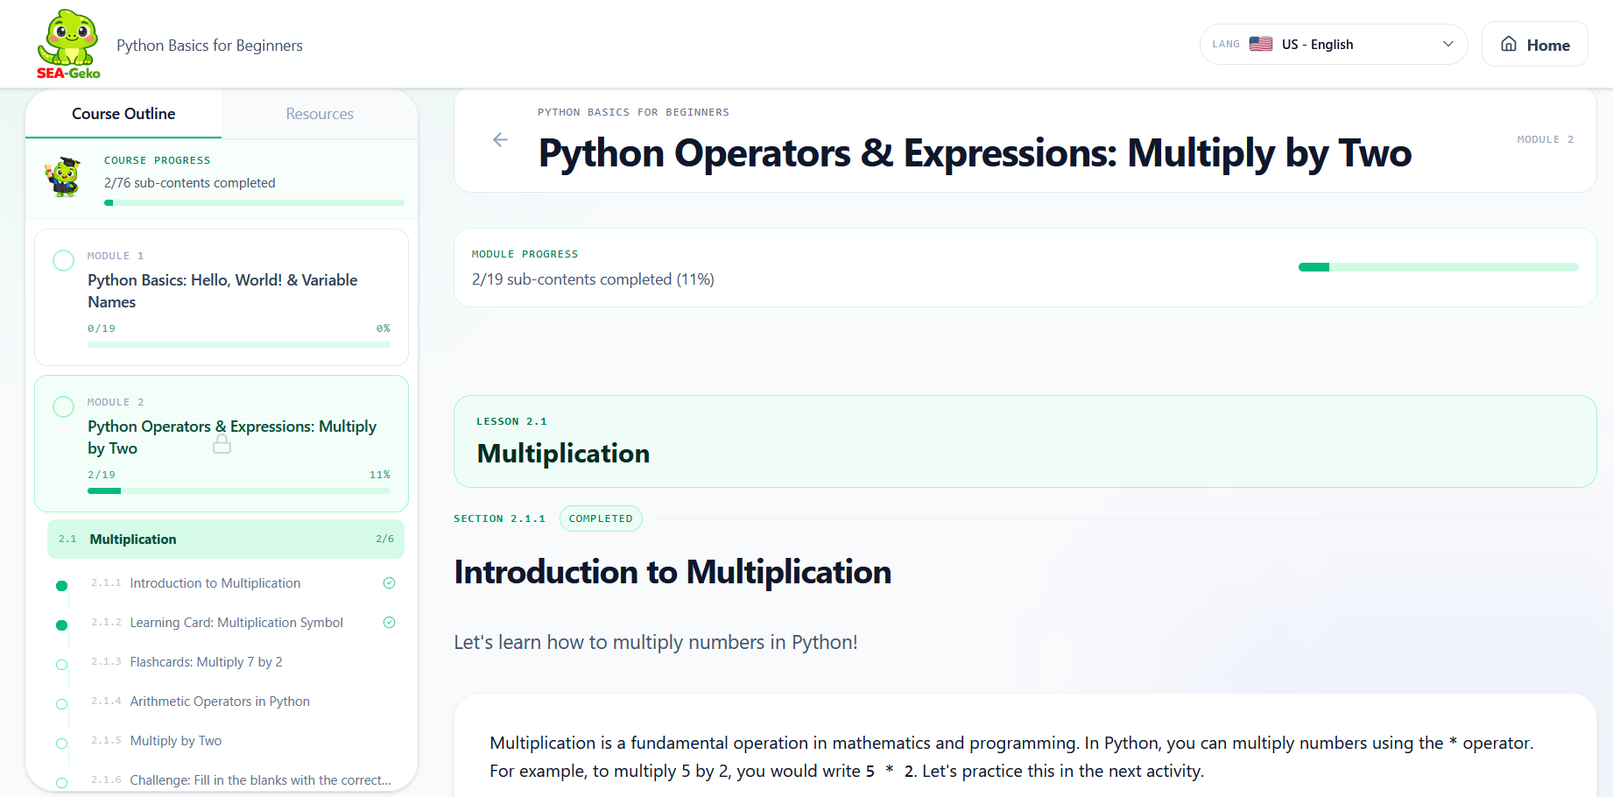
Figure 3. Generated course interface with modules and progress tracking

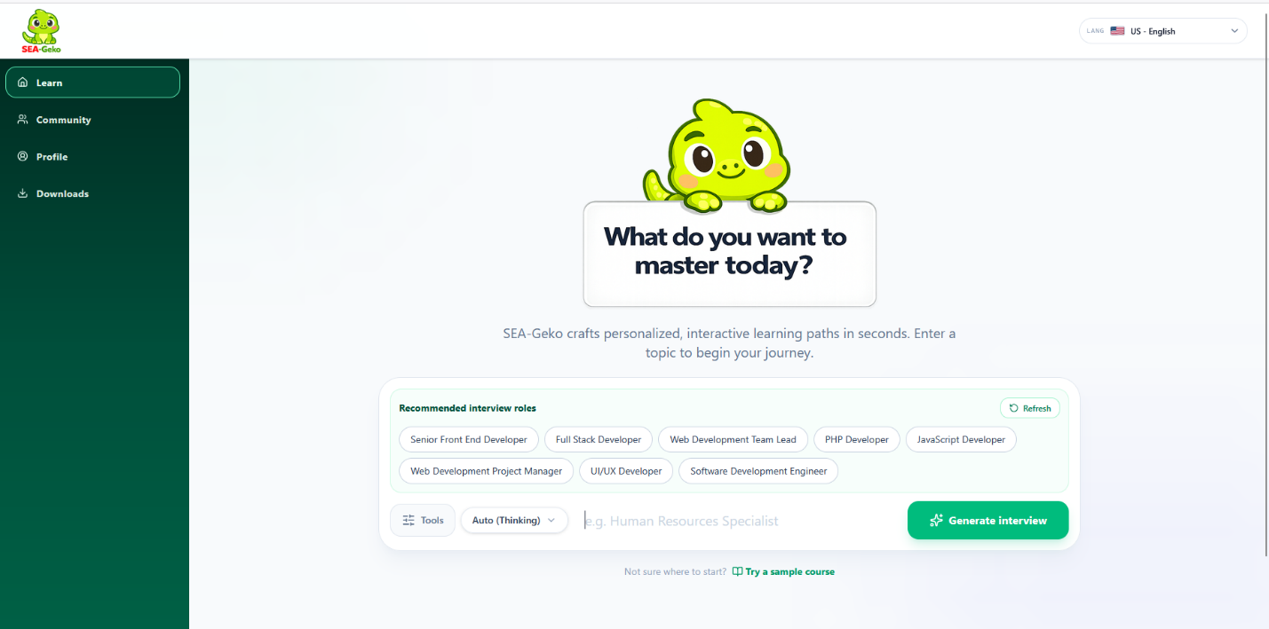
Figure 4. Recommended interview roles based on user profile or CV context

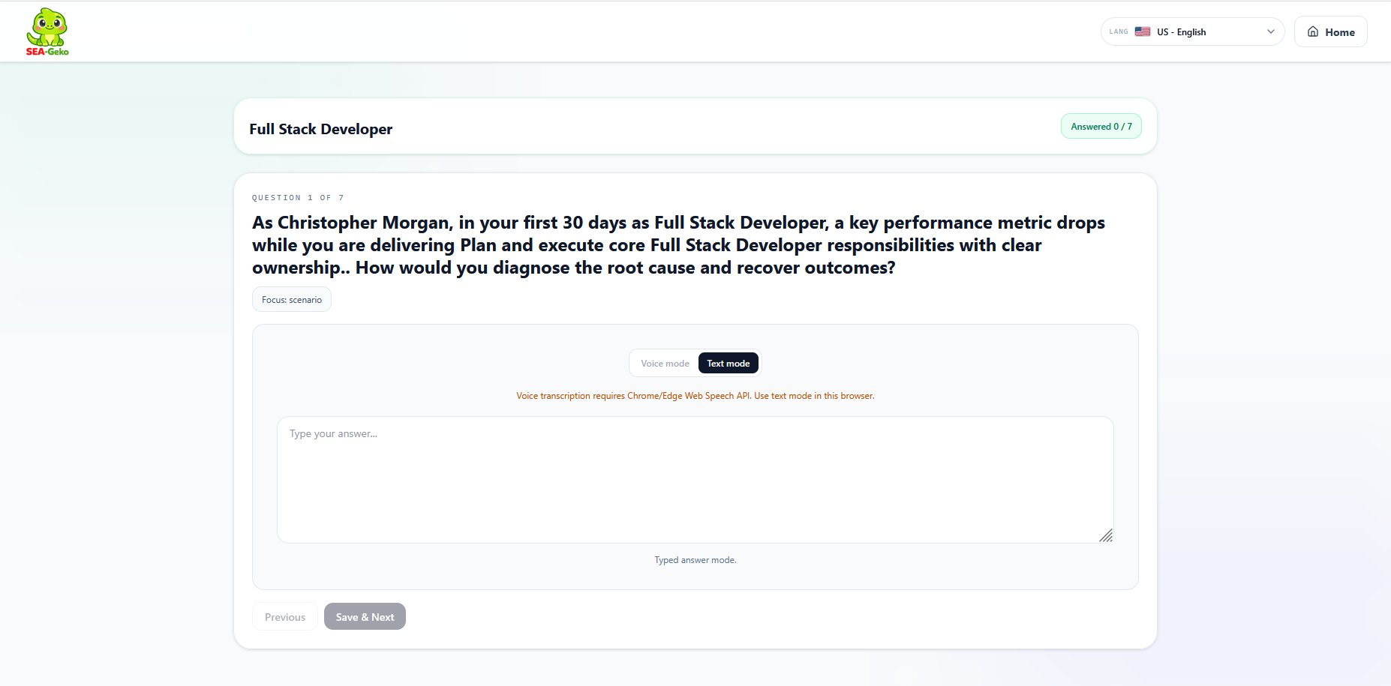
Figure 5. Role-based interview question and answer interface

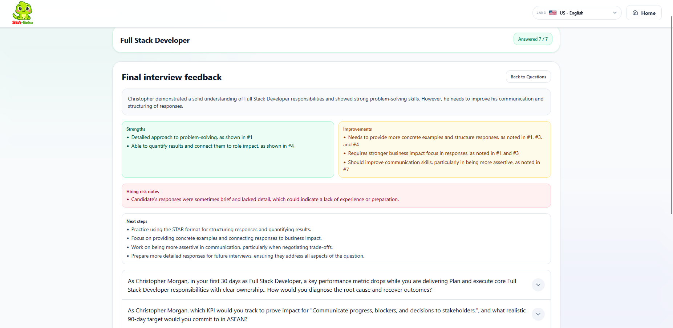
Figure 6. Final interview feedback with strengths and improvement areas

AI Acknowledgement

Disclosure
AI tools were used during both the development process and the product experience of SEA-Geko. These included ChatGPT for ideation, writing refinement, and debugging support; GitHub Copilot for selected coding assistance; and model APIs such as OpenRouter and Mistral for testing and integrating AI-generated learning and interview features within the prototype. All AI use has been disclosed in this report in accordance with the hackathon requirements.

Usage
ChatGPT was used to support brainstorming, wording improvement, debugging, and report refinement during development. GitHub Copilot was used to assist with selected implementation tasks and speed up parts of the coding workflow. OpenRouter, Mistral, and other tested model services were used within the prototype to generate learning outlines, lesson content, interview questions, and feedback based on user input. Although AI tools supported the process, the project direction, system design, feature decisions, integration work, and final review were completed by the team.

Conclusion
SEA-Geko was created to address a simple but important challenge: many students and young people want to improve themselves, but they often do not know where to start or how to continue. The project responds to that challenge by combining guided learning generation, multilingual access, offline continuity, and interview preparation in one platform. Instead of treating study and employability as separate issues, SEA-Geko connects them through one learner-centered experience.
As a hackathon project, the prototype demonstrates both technical effort and social relevance. It shows that AI can be used in a more meaningful way when it supports direction, continuity, and real user needs rather than just producing content. The project is still at prototype stage, but it already presents a clear concept with strong future potential. At its current stage, SEA-Geko already demonstrates a meaningful prototype, and with further testing and refinement, it has the potential to become a scalable solution for more inclusive learning and career readiness across the region.

Future Improvements
In the future, SEA-Geko can be improved by testing it with real student groups and collecting more structured feedback on learning outcomes, confidence, and completion rates. This would help validate whether the platform’s guided flow truly improves learner continuity over time. More advanced personalization could also be added so that the system can adjust more precisely to different learner backgrounds, target roles, and preferred study styles.
Another important future direction is stronger partnerships with educators, schools, or youth-focused organizations. That would allow the platform to move beyond prototype use and into real community settings. With further improvement, SEA-Geko could become not only a useful learning tool, but also a practical bridge between education, confidence, and opportunity for young people across the region.

References
https://sdgs.un.org/goals/goal4
https://media.unesco.org/sites/default/files/webform/ed3002/swindell-and-radford-2025-addressing-cross-cutting-themes-in-the-use-of-education-technology-and-digital-learning-in-southeast.pdf
https://www.unicef.org/eap/media/16091/file/SEE Regional Case for Support - EAPRO (2024) (002).pdf.pdf
https://unesdoc.unesco.org/ark:/48223/pf0000387824
https://openrouter.ai/
https://mistral.ai/

