Why does the IMT distribution have a long tail and what factors control the shape of the distribution?
- Strength of signal into the Rb-E2F switch
- Feedback from later stages of the cell cycle into the Rb-E2F switch

What insight does a stochastic model give?
Total protein dynamics
The model was run at intermediate input strength (AKT = 0.6, ERK = 0.25, FAK = 0.6) and molecular evolution windows were separated based upon mitotic time (G1 < 18 hours and G1 > 24 hours). All traces were then aligned at the initial mitotic event and included 40 hours before and after the event for a total window of 80 hours. There are several interesting observations from the molecular averages. We looked for the first evident difference that linked a change in signaling to a longer mitotic time. Skp2 has consistent elevated concentration prior to short mitotic time. Concomitantly, CDH1 levels are slightly lower for short mitotic time. p21, and its cyclin-bound pool, show identifiable difference between long and short division. p21 and pp21 are elevated in long dividing cells, as are the p21-bound cyclin D, cyclin A, and cyclin B. Cyclin E stands out from this group as the cyclin E-p21 complex has a higher concentration in quickly dividing cells. Additionally, the cyclin B-p21 complex peaks after mitosis (Cdc20 peak). The Rb-E2F switch components show differential behavior as well. The mitotic inhibitor Rb is increased in long dividing cells and its phosphorylated state shows decreased levels; fractionally, this means an even smaller proportion of inactivated Rb, preventing binding to E2F. E2F has decreased levels in long dividing cells at the mitotic event.

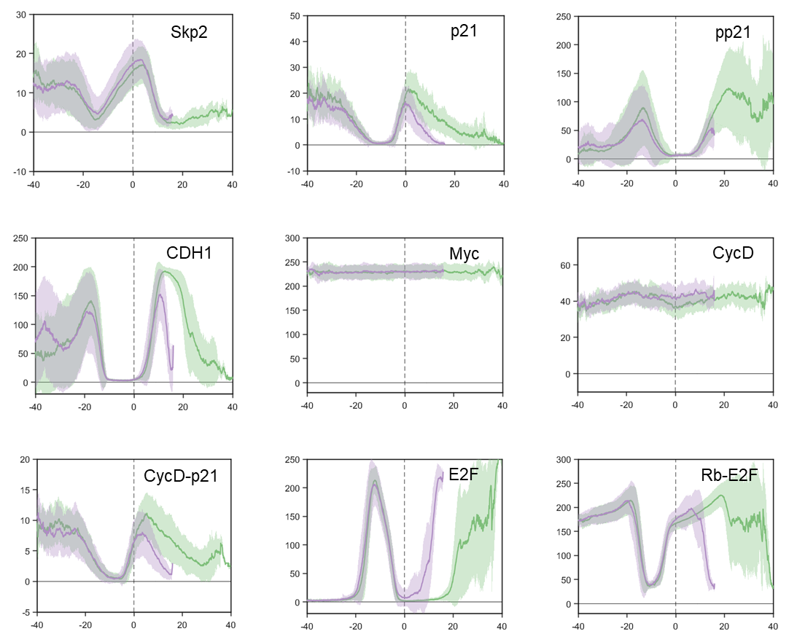
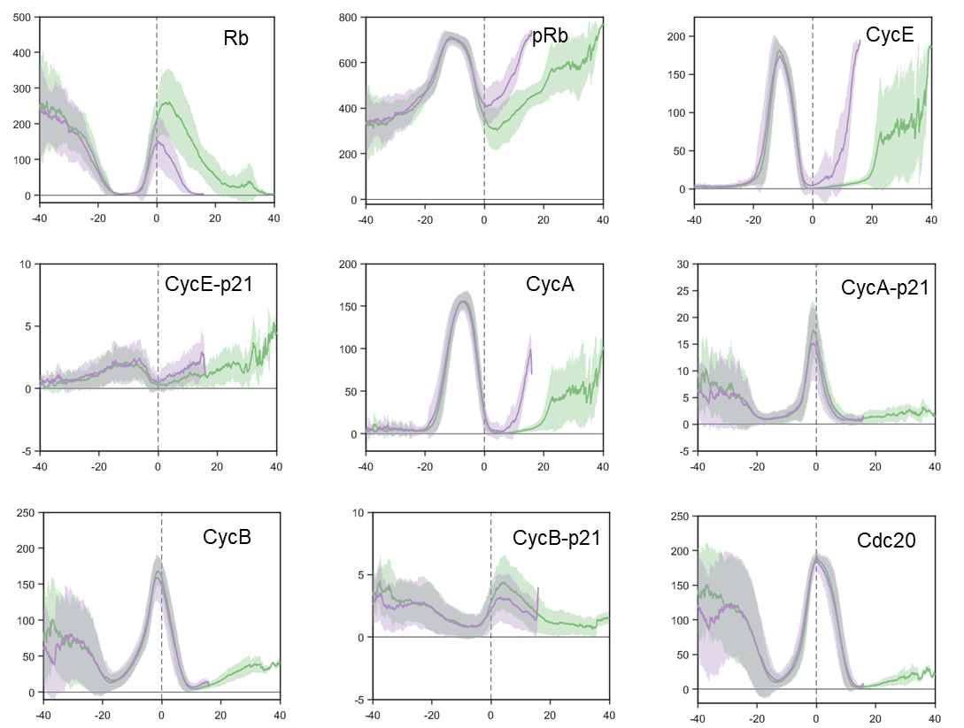

Relative protein concentrations in phase-space (limit cycles with dwell time)
Using cyclin E, cyclin A, and Cdc20 peaks as markers for G1/S transition, S-G2-M time, and the S/M transition respectively, we plotted the limit cycle for the stochastic model and calculated the system dwell time at each phase space coordinate. Comparing the slowly dividing and quickly dividing cells on separate plots allows us to examine where the system is spending the majority of its time and highlights differences in signaling between the two differently behaving states. We notice that the slowly dividing cells spend a large fraction of time in low cyclin E, cyclin A, and Cdc20 state. This would correspond to extended G1 (quiescence). The path to reach the state is different than the path taken by quickly dividing cells through phase space. For quickly dividing cells, Cdc20 remains high as cyclin E increases. The path from cyclin A to Cdc20 peak remains nearly the same for both conditions. This method of model visualization could be implemented for other complex systems to reveal otherwise less obvious information.
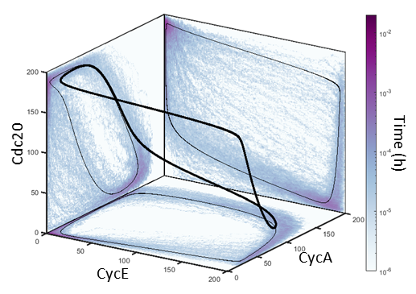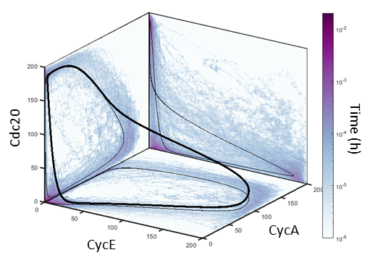
A.
B.

in silico experiments
In our model, p21 and its cyclin-bound species have distinct evolution profiles for quickly and slowly dividing cells. This prompted the hypothesis that mitotic time might depend on p21. We tested this hypothesis by performing an in silico knockdown experiment. p21 expression was set to 0, and the stochastic model was run. We then compared the distribution of intermitotic time, time spent in G1, and time spent in S-G2-M. p21 knockdown results in decreased intermitotic time, with a greater proportion of cells populating the primary peak. We found the decreased intermitotic time is caused by a decrease in G1 time, associated with a change in Rb-E2F switch behavior. Surprisingly, there is no change in S-G2-M time. The association of p21 with cyclin A and cyclin B, both components of later stages of the cell cycle, had initially led us to predict S-G2-M variation. 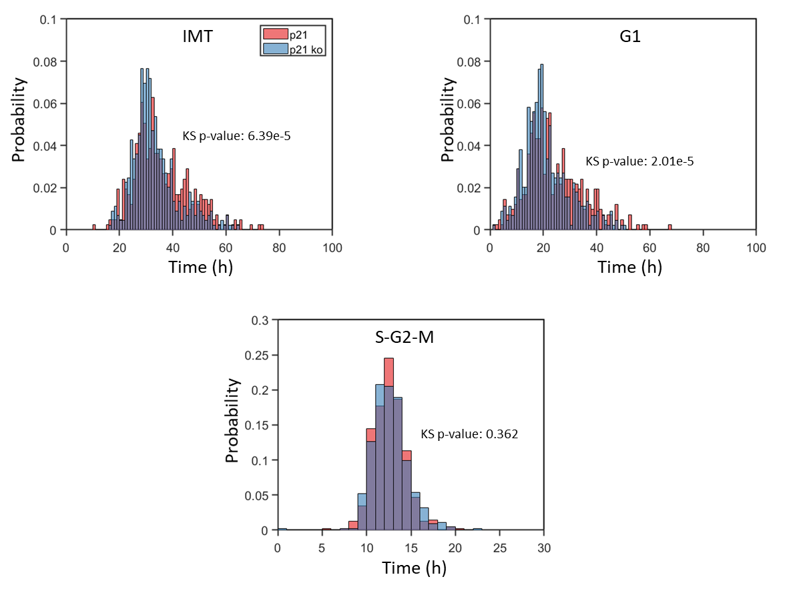
A.
B.
C.

Understanding how the cell choice to divide (fate decision) is made has important implications for our understanding of cancer progression. Simplified models can give insight into important signaling pathways and suggest critical topology needed to produce complex behavior.

