**Qu Lab Website User Manual**

**Accounts:**

Github( <https://github.com/> ), file management

Netlify( <https://app.netlify.com/> ), website building

username: QuLabEmail@gmail.com

password(gmail): 3125B3125B

password(github):3125b3125B

**To edit files:**

<https://github.com/QuLab1234/QuLab> (after logging in)

Folders:

Content: Most text contents

To edit publications:

Location: QuLab/content/publication/journal-article

1. Copy template

Click “Copy raw contents”, and copy all the text.

1. Create a new publication

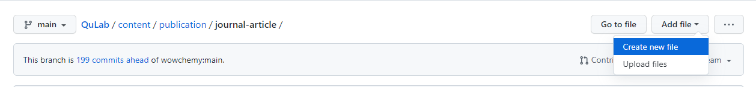

Under location: QuLab/content/publication/journal-article. Click “Create new file”, enter folder name as year_journal, e.g., “2022_Nature/”

Enter the file name, “index.md”. Paste the text inside the text block below.

1. Edit text and click “Commit new file” under the text block.

1. Check the established folder. The change will be automatically updated to <https://app.netlify.com/>. Wait for the website building to complete.



**To check website building:**

https://app.netlify.com/teams/qulab1234/overview (after logging in)

The change of Github files will be updated here and trigger a new building. The state can be checked at the “Builds” block.

