
FPT UNIVERSITY
- - - - - - - - ❖ - - - - - - - -

FPT UNIVERSITY
PROJECT TITLE:
ANALYSIS OF THE DETERMINANTS AND PREDICTION OF E-COMMERCE ORDER SHIPPING FEES: A STUDY ON OLIST DATA
Course: ADY201M
Class: AI2107 – Group 2
Semester: FALL26
Supervisor: minhnt79
Members: Kiều Đại Dương (HE201928)
Trần Chí Kiên (HE200774)
Quách Xuân Thành (HE204852)
Time of work: November 2026
MEMBER CONTRIBUTION TABLE
Member | Responsible part | Contribution (%)
Kiều Đại Dương | Part 1: Understanding the business problem (context, core questions, data problem formulation)  Part 4: Analysis with SQL (8 queries on the cleaned table) | 33.3%
Quách Xuân Thành | Part 5: Exploratory data analysis (EDA): fee distribution, fee over time, correlation, unusual clusters in the scatter plots | 33.3%
Trần Chí Kiên | Part 2: Exploring the Olist data (quality and structure of the nine source tables)  Part 3: Data cleaning (handling missing and out-of-range values, merging tables, final table of 108,937 rows)  Part 6: Regression to predict the shipping fee (Linear Regression, Random Forest) | 33.3%
ABSTRACT
The shipping fee affects purchasing decisions, but the public Olist dataset does not provide the carriers' rate tables. This report analyzes the factors related to the shipping fee (freight_value) of each product line in an order and builds a regression model to predict the fee.
Data and processing. From nine source tables (112,650 product lines in orders), the team explored data quality and then cleaned the data, with each rule labeled "Mandatory" or "Decision", with a reason and a row-count log. The final table has 108,937 rows and 10 columns (delivered orders, from 01/2017 to 08/2018, fee greater than 0); 3,713 rows (3.30%) were removed.
Analysis. SQL and EDA show that the fee rises with weight (from 15.17 to 39.62 BRL between the lightest and heaviest groups), volume (from 14.91 to 27.36 BRL) and distance (from 12.66 to 35.91 BRL); the Pearson correlation with the fee is highest for weight (0.61) and volume (0.58).
Model. The data was split randomly 80/20 (87,149 training rows, 21,788 test rows). With four features (weight, volume, distance, price), Random Forest achieves on the test set an MAE of 3.60 BRL, RMSE of 7.76 BRL and R² of 0.751, better than the Linear Regression baseline (MAE 5.22 BRL, RMSE 9.97 BRL, R² 0.590). The highest importance belongs to volume (0.348), distance (0.310) and weight (0.214).
Limitations. The results describe observed associations, not causal relationships; the data is from 2017–2018 and lacks carrier information and rate tables; the predicted fee is for reference only.
Keywords: shipping fee, Olist, data cleaning, SQL, EDA, regression, Random Forest.
TABLE OF CONTENTS
PART 1. UNDERSTANDING THE BUSINESS PROBLEM: PREDICTING OLIST SHIPPING FEES 8
1.1. Business context and rationale for the project 8
1.2. Core business questions 8
1.3. Formulating the problem as a data science task 9
PART 2. EXPLORING THE OLIST DATA 10
2.1. Assessing the source and structure of the data 10
2.2. Checking data types 11
2.3. Checking missing and duplicate data 11
2.4. Checking out-of-range values 12
2.5. Checking keys 12
2.6. Checking relationships between tables 12
2.7. Surveying time coverage 12
2.8. Surveying extreme values 13
2.9. Checking the payments table and the scope of data use 13
2.10. Summary of the issues found 14
PART 3. DATA CLEANING 15
3.1. Goal, principles and decision framework 15
3.2. Data flow diagram 15
3.3. Preparing the tables before merging 16
3.4. Merging the tables 18
3.5. Handling missing values 18
3.6. Defining the data scope 19
3.7. Handling out-of-range values and checking the target variable 19
3.8. Data transformation and finalizing the schema 19
3.9. Cleaning log (audit trail) and results 21
3.10. Limitations of the final data 22
PART 4. DATA ANALYSIS WITH SQL 24
4.1. Purpose and method 24
4.2. Fees by category, seller and time (Queries 1–3) 24
4.3. Data overview and shipping fee (Query 4) 26
4.4. Fee by weight, volume, distance and price (Queries 5–8) 26
4.5. Overall conclusions 27
PART 5. EXPLORATORY DATA ANALYSIS (EDA) 29
5.1. Goal and method 29
5.2. Verifying the table after cleaning 29
5.3. Distribution of the shipping fee 29
5.4. Fee over time 30
5.5. Factors related to the fee 31
5.6. Explaining unusual clusters in the scatter plots 32
5.7. Checking the remaining open issues 33
5.8. EDA conclusions and model proposal 34
PART 6. REGRESSION TO PREDICT THE SHIPPING FEE 35
6.1. Goal and experimental design 35
6.2. Baseline model: Linear Regression 35
6.3. Random Forest 35
6.4. Feature importance 36
6.5. What Part 6 has not done 36
PART 7. CONCLUSION 38
7.1. Logical flow and main results of the project 38
7.2. Answers to the three business questions 38
7.3. Practical significance 39
7.4. Limitations 39
7.5. Future work 39
REFERENCES 40
APPENDIX A. DATA DICTIONARY OF THE NINE SOURCE TABLES 41
APPENDIX B. CROSS-REFERENCE OF PART 2 FINDINGS TO THE HANDLING RESULTS IN PART 3 42
APPENDIX C. SQL QUERIES 43
APPENDIX D. ADDITIONAL DETAILED EDA RESULTS 46
APPENDIX E. FORMULAS 47
APPENDIX F. SYNCHRONIZATION NOTES ACROSS THE NOTEBOOKS 48
APPENDIX G. SOURCE CODE STRUCTURE AND HOW TO RE-RUN 49
LIST OF TABLES
Table 2.1. The six data quality dimensions and how they are checked in the project 10
Table 2.2. The nine source tables: size and role 10
Table 2.3. Columns with missing values 11
Table 2.4. Results of the value-range checks 12
Table 2.5. Values beyond the upper IQR fence (on the source tables) 13
Table 2.6. Assessment of the usability of each table 13
Table 2.7. Catalogue of Part 2 findings (input to Part 3) 14
Table 3.1. Error (km) when representing a zip code prefix by the median versus the mean 16
Table 3.2. Missing components after the merge 18
Table 3.3. Decisions for each type of missing value 18
Table 3.4. Seller–customer distance by fee group 19
Table 3.5. Data dictionary of the final table (108,937 rows × 10 columns) 20
Table 3.6. Log of row-removal steps 21
Table 3.7. Metrics before and after cleaning 22
Table 3.8. Limitations of the final data table 22
Table 4.1. The five categories with the highest average fee (categories with at least 1,000 rows, excluding unknown) 24
Table 4.2. The five sellers with the most rows 25
Table 4.3. Average fee by order month 25
Table 4.4. Data overview and shipping fee 26
Table 4.5. Average fee by weight, volume, distance and price group 26
Table 4.6. Conclusion table for each query 27
Table 5.1. Descriptive statistics of freight_value 29
Table 5.2. EDA evidence for each feature 31
Table 5.3. Unusual clusters and check results 32
Table 5.4. Summary of decisions in Part 5 33
Table 6.1. Train/test split (random, 80/20, random_state = 42) 35
Table 6.2. Comparison of the two models on the test set 35
Table 6.3. Feature importance 36
Table 7.1. What each part solves and what it leaves for the next 38
Table A.1. Columns of the nine source tables 41
Table B.1. Where each Part 2 finding is handled 42
Table D.1. The ten most common categories (EDA) 46
Table F.1. Points to synchronize 48
Table G.1. Notebooks and run order 49
LIST OF FIGURES
Figure 2.1. Relationship diagram of the eight tables according to the Olist data page (the cat_map table is not drawn) 11
Figure 3.1. From 9 source tables to the final table of 108,937 rows and 10 columns 15
Figure 3.2. Points inside the box (grey), points outside the box (blue) and the Brazil bounding box (red); the horizontal axis is longitude, the vertical axis is latitude 16
Figure 3.3. Distribution of the distance (km) from each point to the median coordinate of its zip code prefix, with a log-scale horizontal axis 17
Figure 3.4. Boxplots of price, weight_g, distance_km, volume_cm3 and freight_value on the final table 21
Figure 3.5. Rows remaining after each cleaning step (drawn from the log table) 21
Figure 4.1. Average fee by group for the four factors (drawn from the results of Queries 5–8) 27
Figure 5.1. Distribution of freight_value (histogram with 200 bins, horizontal axis is the shipping fee up to 409.68 BRL, vertical axis is the number of rows; no data removed) 29
Figure 5.2. Number of product rows by order month 30
Figure 5.3. Average (Mean, blue) and median (Median, orange) shipping fee by month 30
Figure 5.4. Scatter plots between freight_value and (left to right, top to bottom) weight, volume, distance, price 31
Figure 5.5. Pearson correlation matrix among the five numeric variables: price, weight_g, volume_cm3, distance_km and freight_value 31
Figure 5.6. Boxplot of freight_value for the 20 most common categories (outliers not shown) 32
Figure 6.1. Importance of the four features in Random Forest (sums to 1) 36
LIST OF ABBREVIATIONS AND TERMS
Term | Meaning
BRL (R$) | Brazilian real, the currency of Brazil
EDA | Exploratory Data Analysis
Grain | The observation unit of the table; here, one product in one order, identified by (order_id, order_item_id)
IQR | Interquartile Range – the range between the 25th and 75th percentiles
MAE, RMSE, R² | Mean absolute error; root mean squared error; coefficient of determination (formulas in Appendix E)
Bias | Mean predicted minus actual error; negative means the prediction is lower than actual
Baseline model | A simple model used for comparison; in Part 6 it is Linear Regression
Data leakage | Using information that is not available at prediction time when building the model
Zip code prefix (ZIP prefix) | The first five digits of the postal code, used to attach coordinates
Haversine | Formula for the straight-line distance between two coordinates
One-hot | Encoding a categorical variable into 0/1 columns

PART 1. UNDERSTANDING THE BUSINESS PROBLEM: PREDICTING OLIST SHIPPING FEES

1.1. Business context and rationale for the project
Business context
In e-commerce, the shipping fee is part of the total cost of a purchase and can influence whether a customer completes the order. According to a Baymard Institute survey (2024) in the US, 48% of respondents abandoned an order before payment because of extra costs such as shipping, taxes and fees being too high [1]. In Brazil, the NuvemCommerce 2026 report found that 57% of consumers abandon an order when they see a high shipping fee [2].
Olist is an e-commerce platform in Brazil. The public Olist dataset provides information on products, orders, sellers, customers and shipping fees, but it does not contain detailed rate tables from the carriers [3].
Core problem to solve
Because the carriers' fee calculation is not disclosed, it is unclear how strongly factors such as weight, product size, price and geographic distance are related to the shipping fee. The team therefore uses the Olist data to analyze these relationships and to build a regression model that predicts the shipping fee for each product line in an order.
Value/importance for the business
- Understanding the factors related to shipping fees:
The results can help sellers and logistics operations teams better understand which factors are related to the shipping fee, how strongly each one is related, and which groups of orders have hard-to-predict fees.
- Supporting shipping-fee estimation and cross-checking:
The model provides a reference fee derived from historical data, helping sellers estimate shipping costs and compare them with the actual fee to spot cases where the fee is unusually high or low relative to orders with similar characteristics. The predicted fee is for reference only and does not replace the official rate table or fee calculation of the platform and the carriers.
- Supporting logistics analysis and planning:
The dashboard lets users visualize, monitor and compare shipping fees by product group and distance, providing additional information for logistics analysis and planning.

1.2. Core business questions
- Question 1 (descriptive): How are shipping fees on Olist distributed, and how do they change with product and delivery characteristics?
- Question 2 (explanatory): When the characteristics are considered together, which one contributes most to the fee?
- Question 3 (predictive): With what error, in BRL, can the fee of the product be predicted, and how do the models compare with each other?

1.3. Formulating the problem as a data science task
Problem type
A regression problem combined with exploratory data analysis (EDA). The goal is to study the relationship between product characteristics, geographic distance and the shipping fee, and to build a model that predicts the fee from historical data.
Target variable (y)
freight_value: The shipping fee recorded for each product line in an Olist order, measured in Brazilian reais (BRL or R$). This is the continuous variable the model must predict.
Planned feature variables (X)
- Product characteristics: Weight (product_weight_g), product volume (volume_cm3).
- Product price: The selling price of the product in the order (price).
- Geographic distance: The estimated distance between seller and customer (distance_km), computed from the geographic coordinates of the two parties.
The input variables were chosen from information that can be determined before payment; information that arises after the order is placed, such as customer reviews or payment results, is not used. The list above contains candidate features; the model in Part 6 currently uses four: weight, volume, distance and price.
Evaluation criteria
The team uses the following metrics to evaluate how well the shipping fee can be predicted:
- MAE (Mean Absolute Error): The average absolute difference between the actual and predicted fee, in BRL. This is the primary evaluation metric; lower is better.
- RMSE (Root Mean Squared Error): Measures the deviation between actual and predicted values, with particular emphasis on large errors. Lower is better.
- R² (R-squared): Measures how much of the variation in the shipping fee the model explains. Higher is better.
Model evaluation method
The team splits the rows at random: 80% for training and 20% for testing, with random_state = 42 fixed so that results are reproducible. This split is not grouped by order or by time, so the evaluation scores may be optimistic; this limitation is discussed in Part 7 (Section 7.4 of the report).
Scope and limitations of the study
The study focuses on orders that were delivered successfully and have a shipping fee greater than 0. The model therefore cannot predict free-shipping cases and does not necessarily represent cancelled or failed orders.
In addition, the Olist data covers the historical period 2016–2018, so the predictions cannot be applied directly to today's shipping fees. The data also does not provide the full rate tables and fee mechanisms of the carriers, so the study only assesses the observed relationship between the factors and the shipping fee and does not claim a causal relationship.

PART 2. EXPLORING THE OLIST DATA

2.1. Assessing the source and structure of the data
Part 1 set the task of predicting freight_value at the product-line level. Before cleaning or modeling, the team needs to know what the source data contains, how good its quality is and which tables are usable. Part 2 therefore only observes and records: no rows are deleted, no missing values are filled and no tables are merged. Each finding here is an input to a handling decision in Part 3.
The team uses the six data quality dimensions of DAMA UK [10] as the framework for organizing the checks. This framework is only a reference, not a mandatory standard.
Table 2.1. The six data quality dimensions and how they are checked in the project
Quality dimension | How it is assessed | Section
Uniqueness | Check whether keys are duplicated | 2.3, 2.5
Completeness | Count missing values | 2.3
Validity | Check data types and value ranges | 2.2, 2.4
Consistency | Check foreign keys and relationships between tables | 2.6, 2.9
Timeliness | Survey the time coverage of the data | 2.7
Accuracy | Cannot be verified because there is no independent reference data | —

The source is the Brazilian E-Commerce Public Dataset by Olist on Kaggle [3], containing e-commerce transactions in Brazil for 2016–2018, released under the CC BY-NC-SA 4.0 license [6]: anyone using or distributing derivative works must give attribution, use it non-commercially and share under the same license. The dataset page lists the update frequency as "Never"; this describes the published release and does not replace checking the exact version of the CSV files in use. According to the source description, personal and partner identifiers have been replaced by anonymous codes.
The source consists of nine CSV files. Table 2.2 gives the size of each table and the role it was considered for; Figure 2.1 shows the relationships between the tables.
Table 2.2. The nine source tables: size and role
Table | Rows | Columns | Role considered
items | 112,650 | 7 | Observation table, containing price and freight_value
orders | 99,441 | 8 | Order status and timestamps
products | 32,951 | 9 | Category, weight, dimensions
customers | 99,441 | 5 | Customer zip code prefix and state
sellers | 3,095 | 4 | Seller zip code prefix and state
geo | 1,000,163 | 5 | Coordinates by zip code prefix
cat_map | 71 | 2 | Translation of categories into English
payments | 103,886 | 5 | Checked for leakage risk
reviews | 99,224 | 7 | Post-delivery reviews, not selected

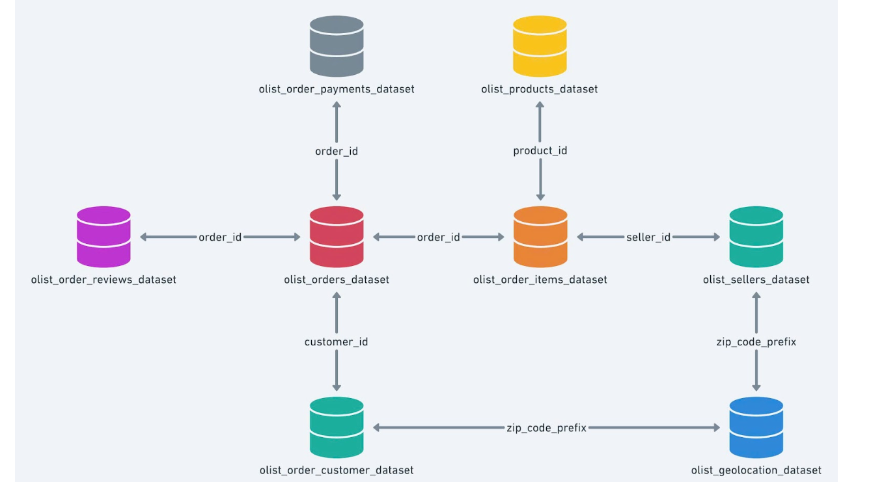
Figure 2.1. Relationship diagram of the eight tables according to the Olist data page (the cat_map table is not drawn)
The diagram shows that orders and items are joined by order_id; items joins products by product_id and sellers by seller_id; orders joins customers by customer_id. The customers and sellers tables both join geo only through zip_code_prefix. Because the zip code prefix is not unique in geo (Section 2.5), this join easily duplicates rows if merged directly, which is why Part 3 must collapse geo to one row per prefix before merging. The table names in the figure (for example olist_order_customer_dataset) differ slightly from the actual file names (olist_customers_dataset).

2.2. Checking data types
Eight date-time columns are stored as text (object): five columns of orders, shipping_limit_date of items, and two columns of reviews. The remaining columns have types consistent with their meaning. Part 2 does not convert types; Part 3 converts only the order_purchase_timestamp column because it is the only one used.

2.3. Checking missing and duplicate data
Two of the seven main tables have missing values (Table 2.3). In orders, the missing timestamps reflect orders that were not yet approved or delivered; in products, 610 products are missing the category and three descriptive fields at the same time, and 2 products are missing both weight and dimensions.
Table 2.3. Columns with missing values
Table | Column | Missing rows | Share
orders | order_approved_at | 160 | 0.16%
orders | order_delivered_carrier_date | 1,783 | 1.79%
orders | order_delivered_customer_date | 2,965 | 2.98%
products | product_category_name | 610 | 1.85%
products | product_name_lenght | 610 | 1.85%
products | product_description_lenght | 610 | 1.85%
products | product_photos_qty | 610 | 1.85%
products | product_weight_g; length; height; width | 2 per column | 0.01%

As for fully duplicated rows, only the geo table has them: 261,831 rows. The other six tables have no duplicate rows.

2.4. Checking out-of-range values
The team set the range rules before checking: price greater than 0 and freight_value non-negative; weight and the three dimensions greater than 0; state codes among the 27 administrative units of Brazil; coordinates inside the approximate bounding box of Brazil (latitude from −34 to 5.3, longitude from −74 to −28 [8][9]). The bounding-box check is only a screen and does not verify the true location of each point.
Table 2.4. Results of the value-range checks
Rule | Violations / records | Comment
price ≤ 0 | 0 | Passed
freight_value < 0 | 0 | Passed
freight_value = 0 | 383 rows | Does not violate the range but needs review; cause unknown
product_weight_g ≤ 0 | 4 products | A weight of 0 g is invalid
Length, height, width ≤ 0 | 0 | Passed
Invalid state codes (customers, sellers, geo) | 0 | Passed
geo coordinates outside the Brazil bounding box | 31 points | Needs review; see Section 3.3

2.5. Checking keys
On keys: the keys of six tables (including the composite key order_id, order_item_id of items) are all unique. Only geolocation_zip_code_prefix of geo is not unique: there are 1,000,163 rows but only 19,015 distinct zip code prefixes, meaning each prefix has dozens of coordinate points on average.

2.6. Checking relationships between tables
The four relationships by identifier are all intact: every product_id, order_id and seller_id of items and every customer_id of orders exists in the parent table. Three remaining mismatches need handling: 13 products have a category with no translation in cat_map; 278 rows of customers and 7 sellers have a zip code prefix that is not in geo. As a result, some merged rows will lack coordinates.

2.7. Surveying time coverage
Orders span from 04/09/2016 to 17/10/2018. The data is continuous from 2017-01 to 2018-08 (800 to 7,544 orders per month). The start and end of the series have very few orders: 2016-09 has 4 orders, 2016-10 has 324, there are no orders in 2016-11, 2016-12 has 1; 2018-09 has 16 and 2018-10 has 4. This uneven coverage is the basis for Part 3 restricting the analysis period.

2.8. Surveying extreme values
The team uses the Tukey upper fence (Q3 + 1.5 × IQR) to count extreme values. Only the upper fence is considered because all six variables take only non-negative values; freight_value alone has a lower fence of 0.975 with 521 values below it, including the 383 rows equal to 0 noted in 2.4. A value beyond the fence is only a sign of extremeness and does not prove it is wrong.
Table 2.5. Values beyond the upper IQR fence (on the source tables)
Variable | Upper fence | Values beyond the fence | Share
price | 277.400 | 8,427 | 7.48%
freight_value | 33.255 | 11,613 | 10.31%
product_weight_g | 4,300.000 | 4,551 | 13.81%
product_length_cm | 68.000 | 1,380 | 4.19%
product_height_cm | 40.500 | 1,892 | 5.74%
product_width_cm | 52.500 | 912 | 2.77%

2.9. Checking the payments table and the scope of data use
Hypothesis to test: does payment_value contain the shipping fee? For each order present in both items and payments (98,665 orders), the team compared the sum of payment_value with the sum of price plus freight_value. Result: 99.42% of orders match exactly. payment_value therefore directly contains the target variable and must not be used as a feature (data leakage). The reviews table is also not used because reviews are created after the customer receives the goods, so they do not exist at prediction time.
Table 2.6. Assessment of the usability of each table
Table | Assessment | Basis
items | Used as the observation table | Contains freight_value and the composite key
orders | Partly used | Keep order status and order timestamp; the delivery timestamps are information from after the order was placed
products | Partly used | Keep weight, dimensions, category; drop the three descriptive fields
customers, sellers | Partly used | Keep zip code prefix and state; drop the customer identifier and city name
geo | Conditionally used | Has coordinates but the prefix is not unique, some points fall outside the bounding box, and some prefixes are not covered
cat_map | Conditionally used | Translations missing for some categories
payments | Not selected | payment_value contains freight_value: leakage
reviews | Not selected | Created after the customer receives the goods

2.10. Summary of the issues found
Table 2.7. Catalogue of Part 2 findings (input to Part 3)
STT | Section | Type of finding | Table / column | Figure
1 | 2.2 | Data type | 8 date columns | Stored as text
2–4 | 2.3 | Missing | orders: 3 timestamps | 160; 1,783; 2,965 rows
5 | 2.3 | Missing | products: category and 3 descriptive fields | 610 cells per field
6 | 2.3 | Missing | products: weight and 3 dimensions | 2 cells per field
7 | 2.3 | Fully duplicated | geo | 261,831 rows
8 | 2.4 | Needs investigation | items.freight_value = 0 | 383 rows
9 | 2.4 | Out of range | products.product_weight_g = 0 | 4 products
10 | 2.4 | Needs review | geo: coordinates outside the Brazil bounding box | 31 points
11 | 2.5 | Non-unique key | geo.geolocation_zip_code_prefix | 1,000,163 rows / 19,015 prefixes
12 | 2.6 | Foreign key mismatch | products – cat_map | 13 products
13–14 | 2.6 | Zip code prefix not covered | customers – geo; sellers – geo | 278 rows; 7 sellers
15 | 2.7 | Time coverage | order_purchase_timestamp | Very few orders in 2016 and late 2018
16 | 2.8 | Values beyond the IQR fence | 6 variables | 2.77% to 13.81%
17 | 2.9 | Leakage risk | payments.payment_value | 99.42% of 98,665 orders match

Limits of Part 2. There is no independent reference source to confirm real-world accuracy; some geographic checks rely on a bounding box; counting foreign-key matches does not replace checking individual values; the figures should be confirmed by re-running the notebook on the exact CSV version.

PART 3. DATA CLEANING

3.1. Goal, principles and decision framework
The goal of Part 3 is to turn the nine source tables into a single table in which each row is one product in one order (grain = order_id, order_item_id), clean and informative enough for analysis and modeling. This part handles exactly the findings recorded in Part 2.
Two principles govern every step:
- Prevent data leakage. Leakage occurs when information that is not available at prediction time is used to build the model, distorting the evaluation results [4]. The team therefore prefers rules that can be fixed in advance (missing values, out-of-range values); thresholds that depend on the data distribution must be computed on the training set.
- Record the whole handling process (audit trail). NIST uses this concept for mechanisms that record activity for inspection and tracing [5]. The team records the row count before and after each step and summarizes them in Section 3.9.
Each rule carries one of two labels: Mandatory (a value that is invalid under the defined range) or Decision (the team chose one of several possible treatments). Each rule also states whether it looks at freight_value, because a decision based on the target variable can bias the model evaluation.

3.2. Data flow diagram
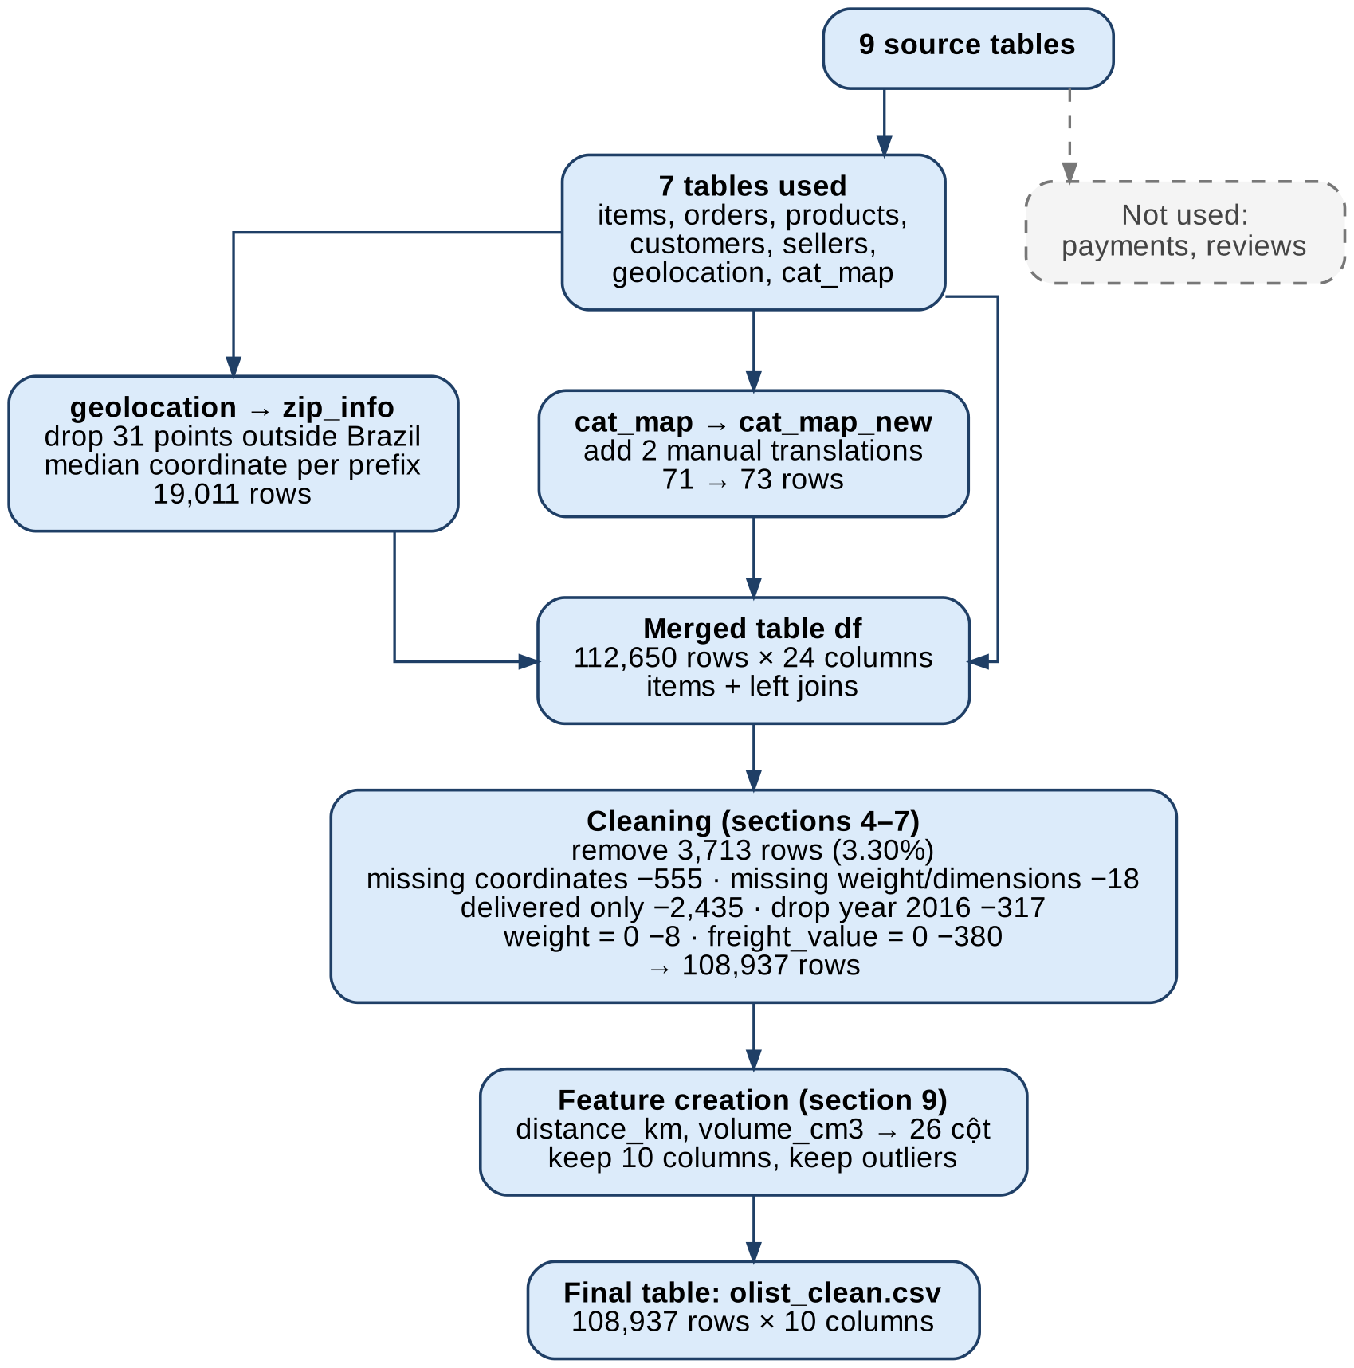
Figure 3.1. From 9 source tables to the final table of 108,937 rows and 10 columns

3.3. Preparing the tables before merging
Two tables need handling before merging to avoid duplicated rows and missing categories: geo (non-unique zip code prefix) and cat_map (missing translations).

3.3.1. Representative coordinates for each zip code prefix
Step 1 – remove points outside the bounding box. Plot the geo points together with the Brazil bounding box (Figure 3.2). 31 points fall outside the box. These points all carry valid Brazilian state codes (Section 2.4 of Part 2) but their coordinates lie outside the bounding box, even though the box contains all of Brazil's territory (extreme points from 33.75°S to 5.27°N and from 73.98°W to 28.85°W, islands included). The state says one place and the coordinates say another, so the team removes the 31 points (Mandatory, does not look at freight_value). After this step geo has 1,000,132 rows and 19,011 prefixes. Limitation: wrong points that lie inside the bounding box are not removed in this step.
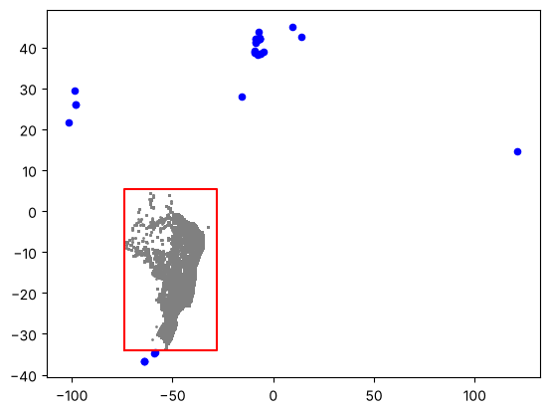
Figure 3.2. Points inside the box (grey), points outside the box (blue) and the Brazil bounding box (red); the horizontal axis is longitude, the vertical axis is latitude
Step 2 – choose the representative: median or mean. Each zip code prefix has many points, and a single coordinate is needed. The team measured the error of the two options as the distance (Haversine) from each point to the prefix's representative coordinate (Table 3.1). The median is lower than the mean and at all three quartiles, because the mean is affected by points lying far away within the same prefix. The team chose the median.
Table 3.1. Error (km) when representing a zip code prefix by the median versus the mean
Statistic | Median | Mean
mean | 1.27 | 1.48
25% | 0.26 | 0.31
50% | 0.50 | 0.57
75% | 0.89 | 1.02

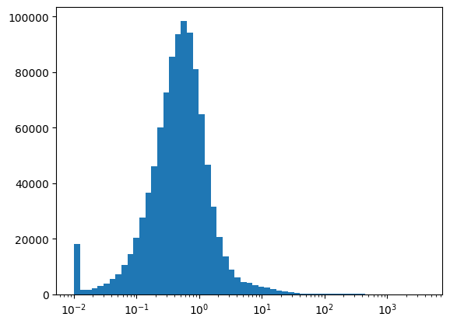
Figure 3.3. Distribution of the distance (km) from each point to the median coordinate of its zip code prefix, with a log-scale horizontal axis
Figure 3.3 shows that most points lie close to the representative coordinate: the peak of the distribution is around 0.5 km, matching the median of 0.50 km. Two points need to be read correctly. First, the tall bar at 0.01 km is not a real peak: the plotting code uses clip(lower=0.01) so that it can draw on a log scale, so every point with an error below 0.01 km is piled into the first bar. Second, the right tail extends to thousands of km (largest 3,360.80 km), so the mean is much larger than the median. These points lie inside the bounding box and so are not removed; because the median is used, their effect on the representative coordinate is smaller than it would be with the mean.
Step 3 – should duplicate rows in geo be dropped? Duplicate rows make one location count several times when taking the median. The team re-measured the error after dropping duplicates (738,305 rows remain): the mean rose from 1.27 to 1.36 km and the median from 0.50 to 0.52 km. Dropping duplicates did not improve the error, so the team kept the duplicate rows.
Step 4 – should far points be removed by IQR? With the threshold Q3 + 1.5 × IQR of the error (1.84 km), 75,788 points (7.6%) exceed the threshold, belonging to 8,502 of the 19,011 prefixes; if removed, 206 prefixes would lose all their points. The IQR only measures the distance to the prefix's median and does not prove that a point is wrong. For example, for a prefix with only 2 points, the median is the midpoint so both points are equidistant from it: the IQR flags both or neither and cannot identify the wrong one (112 of the 206 prefixes that would lose all their points are of this kind). The team did not remove more by IQR (Decision, does not look at freight_value).
Step 5 – collapse to one row per prefix. The result is the zip_info table with 19,011 rows, one per zip code prefix, with a unique key. Limitation: the median coordinate may still be off for prefixes with many wrong points inside the box; the coordinates have not been checked against state geographic boundaries.

3.3.2. Categories missing translations
13 products belong to 2 categories that are not in cat_map: portateis_cozinha_e_preparadores_de_alimentos (10 products) and pc_gamer (3 products). The team set manual translations for the two categories, appended to a copy cat_map_new (73 rows), without modifying the original cat_map (Decision, does not look at freight_value). Reason: dropping the rows would discard information that exists, whereas with only 2 categories a manual entry is cheap.

3.4. Merging the tables
Take items as the base table and left-join orders, products, cat_map_new, customers, sellers and zip_info in turn; zip_info is joined twice, once for the customer coordinates (c_lat, c_lng) and once for the seller coordinates (s_lat, s_lng). A left join from items guarantees no observation rows are lost, and since each join key of the auxiliary tables is already unique, no rows are duplicated. Check: the merge keeps all 112,650 rows, and the number of columns rises from 7 to 24.

3.5. Handling missing values
After the merge, 10 columns have missing values (Table 3.2). The team handled them group by group, comparing at least two options for each group.
Table 3.2. Missing components after the merge
Column group | Missing rows
product_category_name, product_category_name_english | 1,603
product_weight_g, product_length_cm, product_height_cm, product_width_cm | 18
c_lat, c_lng (customer coordinates) | 303
s_lat, s_lng (seller coordinates) | 253

Table 3.3. Decisions for each type of missing value
Issue | Options considered | Decision and reason
Coordinates missing on at least one side: 555 rows (0.49%) | Fill with the state median coordinate, or drop the rows | Drop (Decision). Filling with the state median is off by 116.16 km on average (median 49.81 km), whereas the representative coordinate of a prefix is off by only 1.27 km; the number of rows dropped is small
Weight and dimensions missing: 18 rows (all 4 columns missing together) | Fill with the category median, or drop the rows | Drop (Decision). Weight and dimensions are core features; all 4 columns are missing together so one cannot be inferred from another; 17 of the 18 rows also lack a category, so there is no similar group to take a median from
Category missing: 1,579 rows (1.41%) | Drop the rows, or label them unknown | Label unknown (Decision). The group with a missing category is clearly lighter (median weight 400 g versus 700 g, median price the same at 75), meaning it is not missing at random; dropping it would change the weight distribution

After the three treatments above, the table has no missing cells. Note that the 1,579 unknown rows fall to 1,510 in the final table because 69 rows were dropped in later steps.

3.6. Defining the data scope

3.6.1. Keep delivered orders only
109,642 of 112,077 rows (97.8%) belong to delivered orders. The fee of an undelivered or cancelled order has not been confirmed as a fee actually incurred, so the team keeps only delivered and drops 2,435 rows (Decision, looks at freight_value). Side check: the median freight_value of the delivered group is 16.25, and of the other groups from 15.11 to 17.63 (excluding approved and unavailable because they have only 3 and 7 rows), so the removal does not noticeably shift the fee level; comparing medians is not enough to conclude that the two distributions are the same.

3.6.2. Restrict the time period
2016 has only 3 scattered months (3, 313 and 1 rows, with 2016-11 missing) whereas every month from 2017-01 to 2018-08 has data. The team keeps orders from 01/01/2017 and drops 317 rows from 2016 (Decision, does not look at freight_value); the delivered data already ends at 2018-08.

3.7. Handling out-of-range values and checking the target variable
Weight equal to 0. Part 2 found 4 products with a weight of 0 g; after the merge they account for 8 rows. A weight of 0 g is not a valid value for goods that have to be shipped, so the team drops the 8 rows (Mandatory, does not look at freight_value).
freight_value equal to 0. The hypothesis "the fee is 0 because the seller and the customer are close to each other" was tested by comparing the distances of the two groups (Table 3.4). The hypothesis is rejected: the zero-fee group is not closer.
Table 3.4. Seller–customer distance by fee group
Group | Mean distance | Median distance
freight_value = 0 | 675.2 km | 505.6 km
freight_value > 0 | 595.5 km | 431.3 km

The data has no column that explains why the fee is 0 (free shipping, a discount code or a recording error). Keeping these rows would force the model to learn a fee that the available features cannot explain, so the team drops the 380 rows (Decision, looks at freight_value). A consequence to record: the model cannot predict free-shipping cases.

3.8. Data transformation and finalizing the schema

3.8.1. Meaning of freight_value in multi-item orders
Question: in a multi-item order, is the freight_value of each row the product's own fee or part of the order's fee that has been split? The notebook cites the column description on Kaggle ("if an order has more than one item the freight value is splitted between items"), meaning the order's fee has been divided among the items. The team keeps freight_value at product level (Decision, looks at freight_value) because each row is already the share of the fee allocated to that product, and because aggregating by order would lose the weight, dimensions and category of each product. The limitations section (Section 3.10) notes that how the fee is split is not fully determined.

3.8.2. Two new features
- distance_km: the straight-line distance between seller and customer, computed with the Haversine formula [7] from the representative coordinates of the two zip code prefixes (formula in Appendix E). Values range from 0 to 3,398.49 km, with a median of 431.31 km.
- volume_cm3: the product of length, height and width. Values range from 168 to 296,208 cm³, with a median of 6,468. The three edges are used only to compute the volume and are not kept in the final table.

3.8.3. Grain and final schema
There are no duplicate rows by (order_id, order_item_id), so this pair uniquely identifies each row. The team renamed product_weight_g to weight_g and product_category_name_english to category, and kept 10 columns: the two grain keys, seller_id, the order timestamp, the four planned model features (price, weight_g, volume_cm3, distance_km), category and the target variable freight_value. The team did not create other features, to keep the problem simple; category and seller_id are not used as features but are kept for analysis in later parts. The customer and seller states, the coordinates, the three dimension edges and the code columns serve only for checking, filtering and feature creation, so they are not kept in the final table.
Table 3.5. Data dictionary of the final table (108,937 rows × 10 columns)
Column | Type | Meaning | Role
order_id, order_item_id | string, integer | Order ID; sequence number of the item within the order | Key (grain)
seller_id | string | Seller ID | Identifier, used for analysis
order_purchase_timestamp | datetime | Order placement time | Time
price | float | Selling price of the product (BRL) | Feature
weight_g | float | Weight (grams) | Feature
volume_cm3 | float | Length × height × width (cm³) | Feature
distance_km | float | Straight-line distance between seller and customer (km) | Feature
category | string | English category; unknown if missing | Analysis
freight_value | float | Shipping fee of the product in the order (BRL) | Target variable

3.8.4. Outliers
Number of values beyond the upper IQR fence in the final table: price 8,069 (7.41%), weight_g 15,301 (14.05%), distance_km 8,304 (7.62%), volume_cm3 9,676 (8.88%), freight_value 11,216 (10.30%) (Figure 3.4). The lower fences of the four input variables are all negative, so there are no values beyond a lower fence.
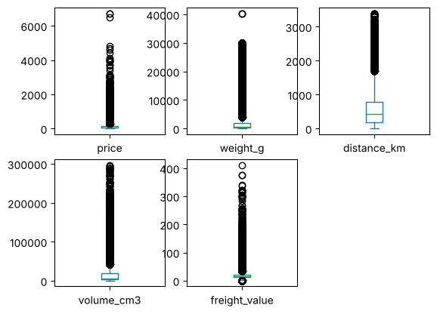
Figure 3.4. Boxplots of price, weight_g, distance_km, volume_cm3 and freight_value on the final table
The team kept them as they are, with no trimming and no capping, because: (1) the groups beyond the fence for price, weight_g, distance_km and volume_cm3 all have a higher median freight_value than the rest (24.83 vs 16.05; 27.71 vs 15.56; 29.34 vs 15.81; 30.38 vs 15.9), meaning they are real orders rather than errors; (2) the group of freight_value beyond the fence has a higher median distance_km (916.16 vs 404.1 km) and higher weight_g (5,950 vs 600 g), consistent with heavy goods travelling far; (3) freight_value is the target variable, so removing or capping would change the quantity to be predicted, and removing would lose 11,216 rows. If capping is needed, the IQR threshold must be computed on the training set at the modeling stage. Limitation: it is not determined whether the 133 rows with freight_value below the 0.98 lower fence are real fees or recording errors.

3.9. Cleaning log (audit trail) and results
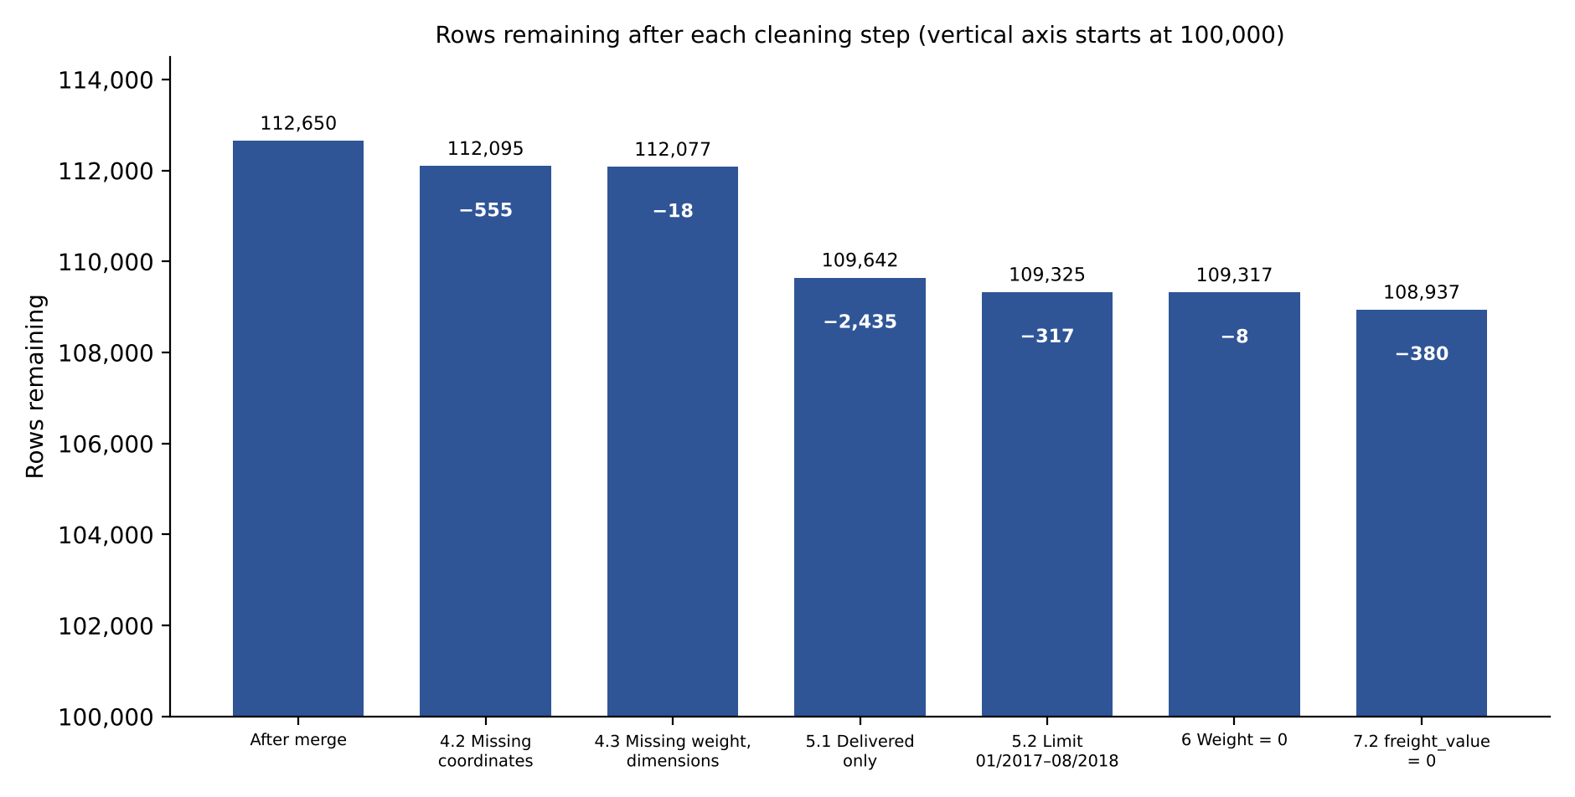
Figure 3.5. Rows remaining after each cleaning step (drawn from the log table)
Table 3.6. Log of row-removal steps
Section | Rule | Type | Xem freight | Rows removed | Remaining
3 | After merging the tables |  |  | 0 | 112,650
4.2 | Missing coordinates | Decision | No | 555 | 112,095
4.3 | Missing weight and dimensions | Decision | No | 18 | 112,077
5.1 | Keep delivered orders only | Decision | Yes | 2,435 | 109,642
5.2 | Restrict to 01/2017–08/2018 | Decision | No | 317 | 109,325
6 | Weight equal to 0 | Mandatory | No | 8 | 109,317
7.2 | freight_value = 0 | Decision | Yes | 380 | 108,937

The six steps removed 3,713 rows in total (3.30%): 8 Mandatory rows and 3,705 Decision rows; the total matches the final row count (112,650 − 3,713 = 108,937). The steps run in sequence, so the number of rows removed in each step is counted on the table remaining after the earlier steps. One step modifies values: assigning unknown to the missing category (1,579 rows at the time of handling).
Table 3.7. Metrics before and after cleaning
Metric | Before | Sau
Rows | 112,650 (items) | 108,937
Columns | 24 (after merge) | 10
Missing cells | 4,390 | 0
Duplicate grain rows | 0 | 0
Purchase date type | object | datetime64
Weight = 0 | 4 products | 0 rows
freight_value = 0 | 383 rows | 0 rows

The output file olist_clean.csv matches the in-memory table: 108,937 rows, 10 columns, total freight_value 2,180,045.81, no missing cells, no duplicate grain rows, 1,510 unknown rows. The file is data derived from the Olist dataset, released under the CC BY-NC-SA 4.0 license [6].

3.10. Limitations of the final data
Table 3.8. Limitations of the final data table
Limitation | Figure | Why it cannot be remedied
Wrong coordinates inside the Brazil bounding box are still kept | 31 points outside the box were removed; 75,788 points (7.6%) beyond the IQR threshold are kept | The data has no reference coordinates to determine which points are wrong
Missing shipping information | distance_km is only a straight-line distance; 26 rows have a distance of 0 | No carrier, delivery method or actual route distance
How freight_value is split in multi-item orders relies only on the Kaggle description; the team did not verify it | No reference figures to compare against | The data does not record how the fee is divided among products
Four decisions based on freight_value were applied before the train/test split | Keep delivered (5.1), drop 380 zero-fee rows (7.2), keep the fee at product level (9.1), keep values beyond the fence (9.6) | The test set does not contain the rows removed in 5.1 and 7.2
Free-shipping orders cannot be predicted | 380 rows with freight_value = 0 were removed | The data has no column explaining why the fee is 0 (free shipping, a discount code or a recording error)
Very low freight_value is unexplained | 133 rows below the 0.98 lower fence | The data does not record how the fee is calculated, so it cannot be determined whether it is a real fee or an error
The unknown category merges many kinds of products | 1,510 rows | The source data has no category
Only covers 01/2017 – 08/2018 | 2016 has only 317 scattered rows | The data has no other period

PART 4. DATA ANALYSIS WITH SQL

4.1. Purpose and method
With the clean table in hand, the team uses SQL to query and summarize the data directly for data exploration. At this step the team does not yet know which factors are related to the fee and has not chosen a model; SQL lets the team look at the data before forming specific hypotheses for EDA and modeling. The exploratory questions are: (1) what is the size of the data and how are fees distributed (Query 4); (2) how does the fee differ across categories, sellers and time, and which order characteristics accompany it (Queries 1–3); (3) when one characteristic of the order changes, does the average fee change with it, considering the four measurable characteristics weight, volume, distance and price (Queries 5–8).
Hypotheses to test (not results yet). From general knowledge of shipping, heavy, bulky or long-distance goods usually cost more; the selling price may be indirectly related because expensive goods tend to be large and heavy. The team chose the four characteristics because they are numeric characteristics that are available and make practical sense, not because it already knows they determine the fee. SQL only describes: it does not conclude causation and does not rank importance, because the factors are related to each other (for example weight and volume); the strongest relationship, predictive ability and the shape of the relationship (linear or not) are examined in EDA (Part 5) and the model (Part 6).
Method: load olist_clean.csv into an in-memory SQLite database as the table olist_clean. Checks after loading match Part 3: 108,937 rows, 10 columns, 0 missing cells, 0 duplicate-key rows, period 2017-01 to 2018-08, 1,510 unknown rows. There are 8 queries; the full text is in Appendix C. In Queries 5–8 each table gives the number of rows and the average fee by group. The factors are grouped using round cut-offs, not chosen to optimize the results. The column so_dong is the number of rows (products), not the number of orders.

4.2. Fees by category, seller and time (Queries 1–3)
Table 4.1. The five categories with the highest average fee (categories with at least 1,000 rows, excluding unknown)
Category | Rows | Avg. fee (BRL) | Avg. weight (g) | Avg. distance (km)
office_furniture | 1,655 | 40.17 | 11,329.06 | 558.63
luggage_accessories | 1,073 | 27.83 | 5,787.57 | 555.01
garden_tools | 4,196 | 22.94 | 2,826.94 | 649.89
baby | 2,961 | 22.24 | 3,271.29 | 599.65
auto | 4,121 | 21.86 | 2,595.50 | 617.00

Query 1. The five most expensive categories have fees of 21.86 to 40.17 BRL; office_furniture ranks first because its goods are the heaviest (11,329 g), while the distances of the categories are close to each other (555 to 650 km). The fee differences between categories mostly go together with weight.
Table 4.2. The five sellers with the most rows
Seller ID (seller_id) | Rows | Avg. fee (BRL) | Avg. weight (g) | Avg. distance (km)
6560211a19b47992c3666cc44a7e94c0 | 1,991 | 13.70 | 255.40 | 596.67
4a3ca9315b744ce9f8e9374361493884 | 1,947 | 17.61 | 2,140.12 | 562.80
1f50f920176fa81dab994f9023523100 | 1,865 | 18.75 | 1,801.61 | 692.51
cc419e0650a3c5ba77189a1882b7556a | 1,704 | 14.45 | 336.53 | 609.89
da8622b14eb17ae2831f4ac5b9dab84a | 1,546 | 16.07 | 1,333.27 | 401.48

Query 2. The five busiest sellers have fees of 13.70 to 18.75 BRL, below the overall 20.01 BRL; sellers of light goods (255 g and 337 g) have the lowest fees. The differences are mainly due to the type of goods and the delivery distance.
Table 4.3. Average fee by order month
Month | Rows | Avg. fee (BRL) | Avg. weight (g) | Avg. distance (km)
2017-01 | 912 | 17.17 | 2,054.11 | 619.41
2017-02 | 1,858 | 19.92 | 2,469.12 | 650.44
2017-03 | 2,883 | 19.00 | 2,231.39 | 644.31
2017-04 | 2,548 | 19.53 | 2,260.64 | 673.09
2017-05 | 3,983 | 19.34 | 2,233.41 | 629.33
2017-06 | 3,459 | 19.53 | 2,291.80 | 578.24
2017-07 | 4,393 | 19.15 | 2,383.11 | 608.31
2017-08 | 4,756 | 19.03 | 2,180.40 | 629.60
2017-09 | 4,711 | 19.77 | 2,165.06 | 648.03
2017-10 | 5,178 | 19.74 | 2,087.72 | 632.28
2017-11 | 8,435 | 19.52 | 2,114.21 | 605.70
2017-12 | 6,152 | 18.92 | 2,045.49 | 586.76
2018-01 | 7,998 | 19.07 | 2,166.15 | 591.66
2018-02 | 7,478 | 18.58 | 1,909.74 | 615.02
2018-03 | 7,981 | 20.86 | 2,150.34 | 593.18
2018-04 | 7,634 | 20.74 | 2,246.12 | 560.66
2018-05 | 7,558 | 19.91 | 2,085.46 | 549.03
2018-06 | 6,981 | 22.23 | 1,926.14 | 569.72
2018-07 | 6,934 | 22.95 | 1,864.27 | 607.05
2018-08 | 7,105 | 20.57 | 1,671.15 | 509.77

Query 3. From 02/2017 to 02/2018, the average fee fluctuated within a narrow range of 18.6 to 19.9 BRL. From 03/2018 the fee is higher, 19.9 to 22.95 BRL, peaking in 07/2018. January 2017 has only 912 rows, so it is not used for comparison.
Additional point. In the same period, the Brazilian government introduced a minimum road freight rate table (ANTT, 05–06/2018; the law was signed on 09/08/2018), and a CNI survey recorded road transport costs rising by about 12% afterwards. This is context that may be relevant; the Olist data has no carrier information, so the team cannot yet conclude the cause. Source: Diário do Transporte, 25/08/2018, https://diariodotransporte.com.br/2018/08/25/levantamento-da-cni-aponta-transporte-rodoviario-12-mais-caro-apos-tabela-do-frete/

4.3. Data overview and shipping fee (Query 4)
Table 4.4. Data overview and shipping fee
Rows | Orders | Min. fee | Avg. fee | Max. fee
108,937 | 95,377 | 0.01 | 20.01 | 409.68

The table has 108,937 rows belonging to 95,377 orders. The average fee is 20.01 BRL but the highest fee reaches 409.68 BRL (about 20 times the average), meaning the fee is strongly right-skewed. When evaluating a model, MAE should therefore be reported together with the error by group, not just on the overall average.

4.4. Fee by weight, volume, distance and price (Queries 5–8)
Table 4.5. Average fee by weight, volume, distance and price group
Factor | Group | Rows | Avg. fee (BRL)
Weight | Very light (<500 g) | 43,532 | 15.17
 | Light (500–2,000 g) | 40,632 | 17.89
 | Medium (2–5 kg) | 11,220 | 22.81
 | Heavy (>5 kg) | 13,553 | 39.62
Volume | Small (<2,000 cm³) | 16,927 | 14.91
 | Medium (2,000–5,000) | 30,224 | 16.27
 | Large (5,000–15,000) | 29,070 | 18.61
 | Very large (>15,000) | 32,716 | 27.36
Distance | Near (<200 km) | 28,096 | 12.66
 | Medium (200–800 km) | 54,032 | 19.80
 | Far (800–1,500 km) | 17,099 | 23.74
 | Very far (>1,500 km) | 9,710 | 35.91
Price | Cheap (<50) | 37,965 | 14.73
 | 50–100 | 31,941 | 18.01
 | 100–200 | 26,093 | 23.13
 | Expensive (>200) | 12,938 | 34.16

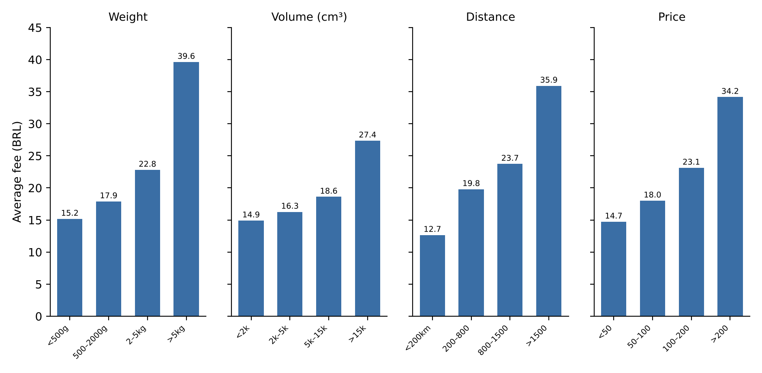
Figure 4.1. Average fee by group for the four factors (drawn from the results of Queries 5–8)
The fee rises with all four factors: from 15.17 to 39.62 BRL (about 2.6 times) by weight, from 14.91 to 27.36 BRL (1.8 times) by volume, from 12.66 to 35.91 BRL (2.8 times) by distance and from 14.73 to 34.16 BRL (2.3 times) by price. These need to be read with caution: a high price often goes with large and heavy goods, and weight is related to volume, so these tables are not the separate effect of each factor and do not show which factor is more important.

4.5. Overall conclusions
Table 4.6. Conclusion table for each query
Query | Finding | Conclusion
1. Category | office_furniture is the most expensive (40.17 BRL) and the heaviest (11,329 g); the distances of the categories are close to each other | Fee differences between categories mostly go together with weight
2. Seller | The five busiest sellers have fees of 13.70–18.75 BRL, below the overall level; sellers of light goods have low fees | Differences between sellers are mainly due to the type of goods and the delivery distance
3. By month | Fee of 18.6–19.9 BRL until 02/2018, then 19.9–22.95 BRL, highest in 07/2018 | The average fee changes by month, higher from 03/2018
4. Overview | Average 20.01, maximum 409.68 BRL (about 20 times): right-skewed | The fee is strongly right-skewed: the average is far below the maximum value
5. Weight | 15.17 → 39.62 BRL (×2.6) | The heavier the goods, the higher the average fee
6. Volume | 14.91 → 27.36 BRL (×1.8) | The larger the goods, the higher the average fee, clearest in the very large group
7. Distance | 12.66 → 35.91 BRL (×2.8) | The farther the delivery, the higher the average fee
8. Price | 14.73 → 34.16 BRL (×2.3); price goes with large, heavy goods | A high price goes with a high fee, but it is not the separate effect of price

Overall conclusions. (1) All four factors go with a higher fee. By the increase between the lowest and highest groups, distance (×2.8) and weight (×2.6) are largest, followed by price (×2.3) and volume (×1.8). SQL does not tell which factor is most important; that belongs to EDA (correlation) and the feature importance in Part 6. (2) A high price often goes with large and heavy goods, so the by-group tables are not the separate effect of each factor. (3) The fee is strongly right-skewed, so MAE should be reported with the error by group. (4) Fee differences between categories and sellers are mainly due to weight and distance; the average fee also changes by month, higher from 03/2018.
Cross-check with Part 6. The model in Part 6 uses four features (weight_g, volume_cm3, distance_km, price), exactly the four factors of Queries 5–8. The proposal to report error by group has not been carried out.
Limitations of SQL. The average is pulled up by a few very large fees, so the median should also be examined in EDA. Only group averages are compared, so the separate effect of each factor cannot be isolated; it is not determined whether the fee of a multi-item order is the item's own fee or an order fee that has been split; the distance is a straight line from zip code prefix coordinates; cleaning decisions that look at freight_value were applied to the whole dataset before the train/test split.

PART 5. EXPLORATORY DATA ANALYSIS (EDA)

5.1. Goal and method
SQL gave evidence by group. The Python EDA adds charts and correlation coefficients in order to (1) re-verify the table after cleaning, (2) describe the distribution of freight_value, (3) examine each group of factors, (4) explain the unusual clusters, and (5) check the remaining open issues. The EDA results use the whole dataset only to describe history; combined with the SQL evidence, EDA is the basis for choosing the four input features and two models in Section 5.8; model evaluation still belongs to Part 6.

5.2. Verifying the table after cleaning
The table has no missing cells, no duplicate keys (order_id, order_item_id), and no negative or non-positive values that violate the rules in the 5 numeric columns checked (freight_value and distance_km non-negative; price, weight_g, volume_cm3 greater than 0). The order_purchase_timestamp column was converted to datetime without creating missing values. These checks are not enough to claim that every value is valid.

5.3. Distribution of the shipping fee
Table 5.1. Descriptive statistics of freight_value
Statistic | Value (BRL)
Rows | 108,937
Mean | 20.012
Standard deviation | 15.701
Minimum | 0.010
25th percentile | 13.080
Median | 16.280
75th percentile | 21.150
Maximum | 409.680

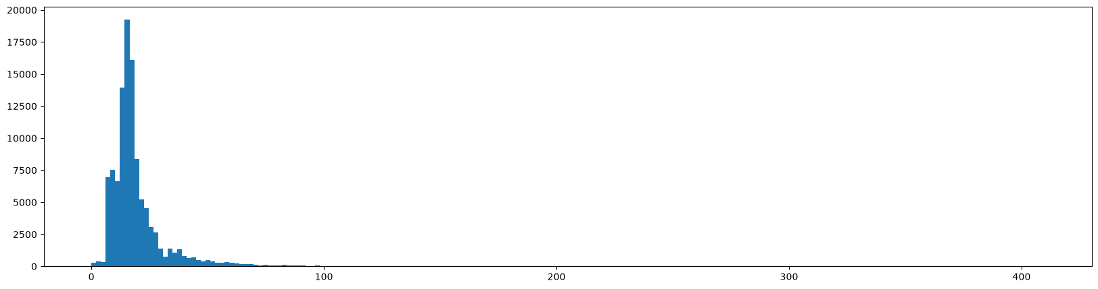
Figure 5.1. Distribution of freight_value (histogram with 200 bins, horizontal axis is the shipping fee up to 409.68 BRL, vertical axis is the number of rows; no data removed)
The mean (20.01) is larger than the median (16.28): the distribution is right-skewed, 50% of rows lie between 13.08 and 21.15 BRL, and the tail extends to 409.68 BRL. With a lower fence of 0.975 and an upper fence of 33.255 BRL, 133 rows are below the lower fence and 11,216 rows above the upper fence, a total of 11,349 rows (10.42%). The cleaning part reported only 11,216 rows because it counted only the upper fence, so the two numbers do not contradict each other. All 133 very-low-fee rows belong to orders with two or more items (100.0%); when an order has several items, the shipping fee is split among the rows, so the fee of each row can be very low. These are statistical extremes, not evidence of errors, so they are kept.

5.4. Fee over time
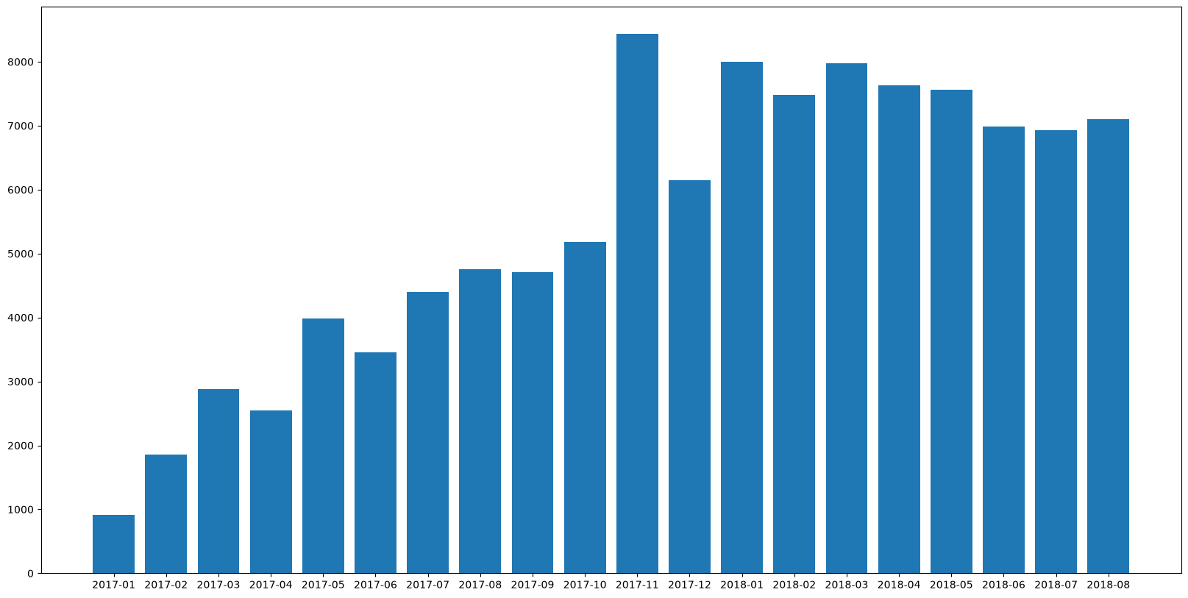
Figure 5.2. Number of product rows by order month
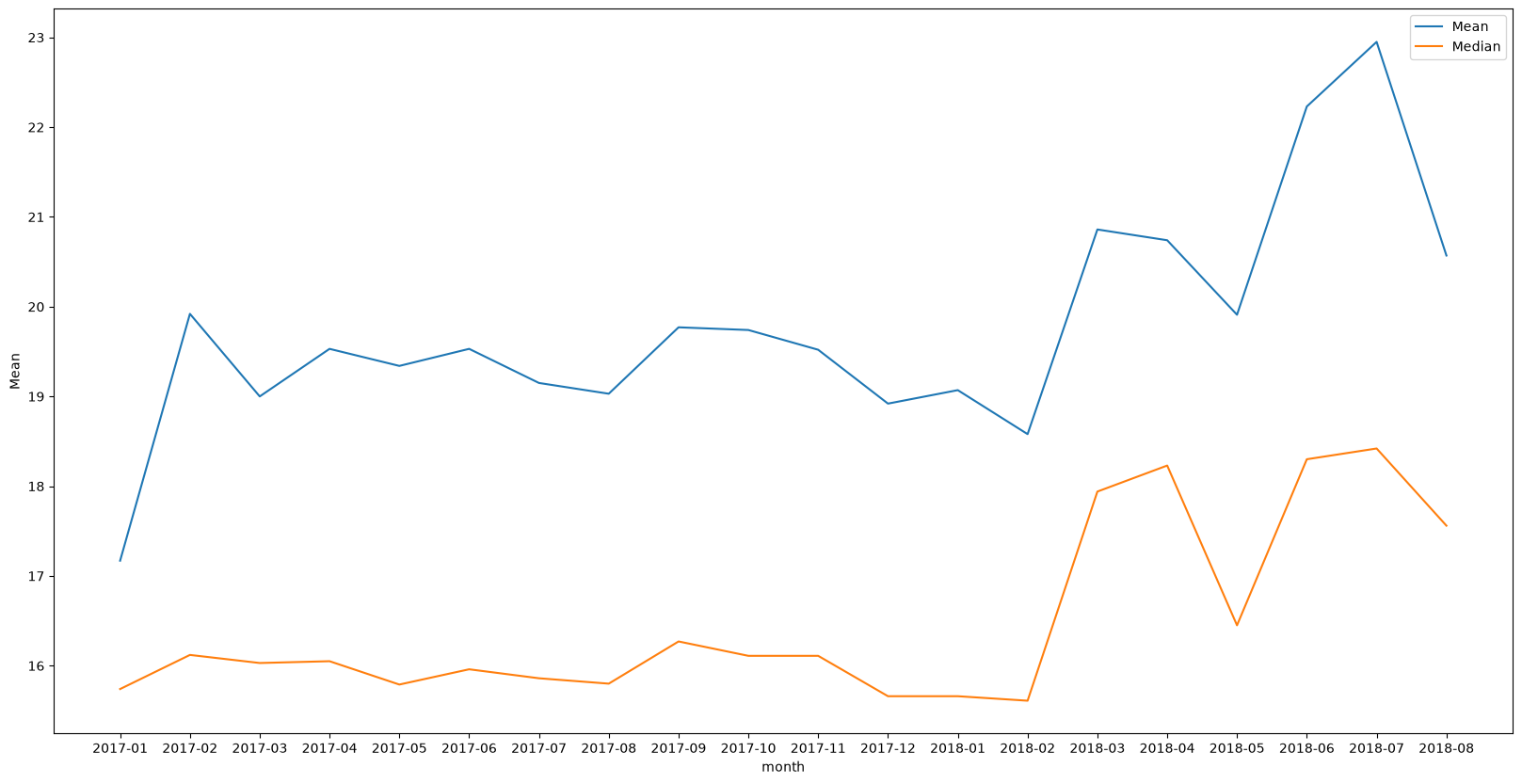
Figure 5.3. Average (Mean, blue) and median (Median, orange) shipping fee by month
The median fee is fairly stable around 15–16 BRL for most of 2017 and early 2018, and clearly higher in 06–07/2018 (July 2018: mean 22.95, median 18.42). The average fee is lowest in 01/2017 (17.17 BRL, only 912 rows so treat with caution) and highest in 07/2018 (22.95 BRL, 6,934 rows); the median rose from 15.74 to 18.42 BRL and the share of fees of 40 BRL or more rose from 3.29% to 10.85%, while average weight and distance did not rise correspondingly. The mean is always higher than the median, showing that a right tail exists in every month, and with 20 months there is not enough evidence to conclude anything about seasonality. The chart does not show whether the change comes from the rate table, seasonality, or the mix of products and distances, because those factors were not held fixed. Because the distribution may change over time, the data split at the modeling step should be considered; Part 6 currently splits randomly by row (see Section 7.4).

5.5. Factors related to the fee
For each numeric factor, the team draws a scatter plot against freight_value and computes the Pearson correlation coefficient (which measures linear relationship). For the categorical factor (category) and the seller ID (seller_id), the team uses statistics by group and does not encode them as ordinal numbers. The clean table no longer has the customer and seller states, so EDA does not consider state as a factor.
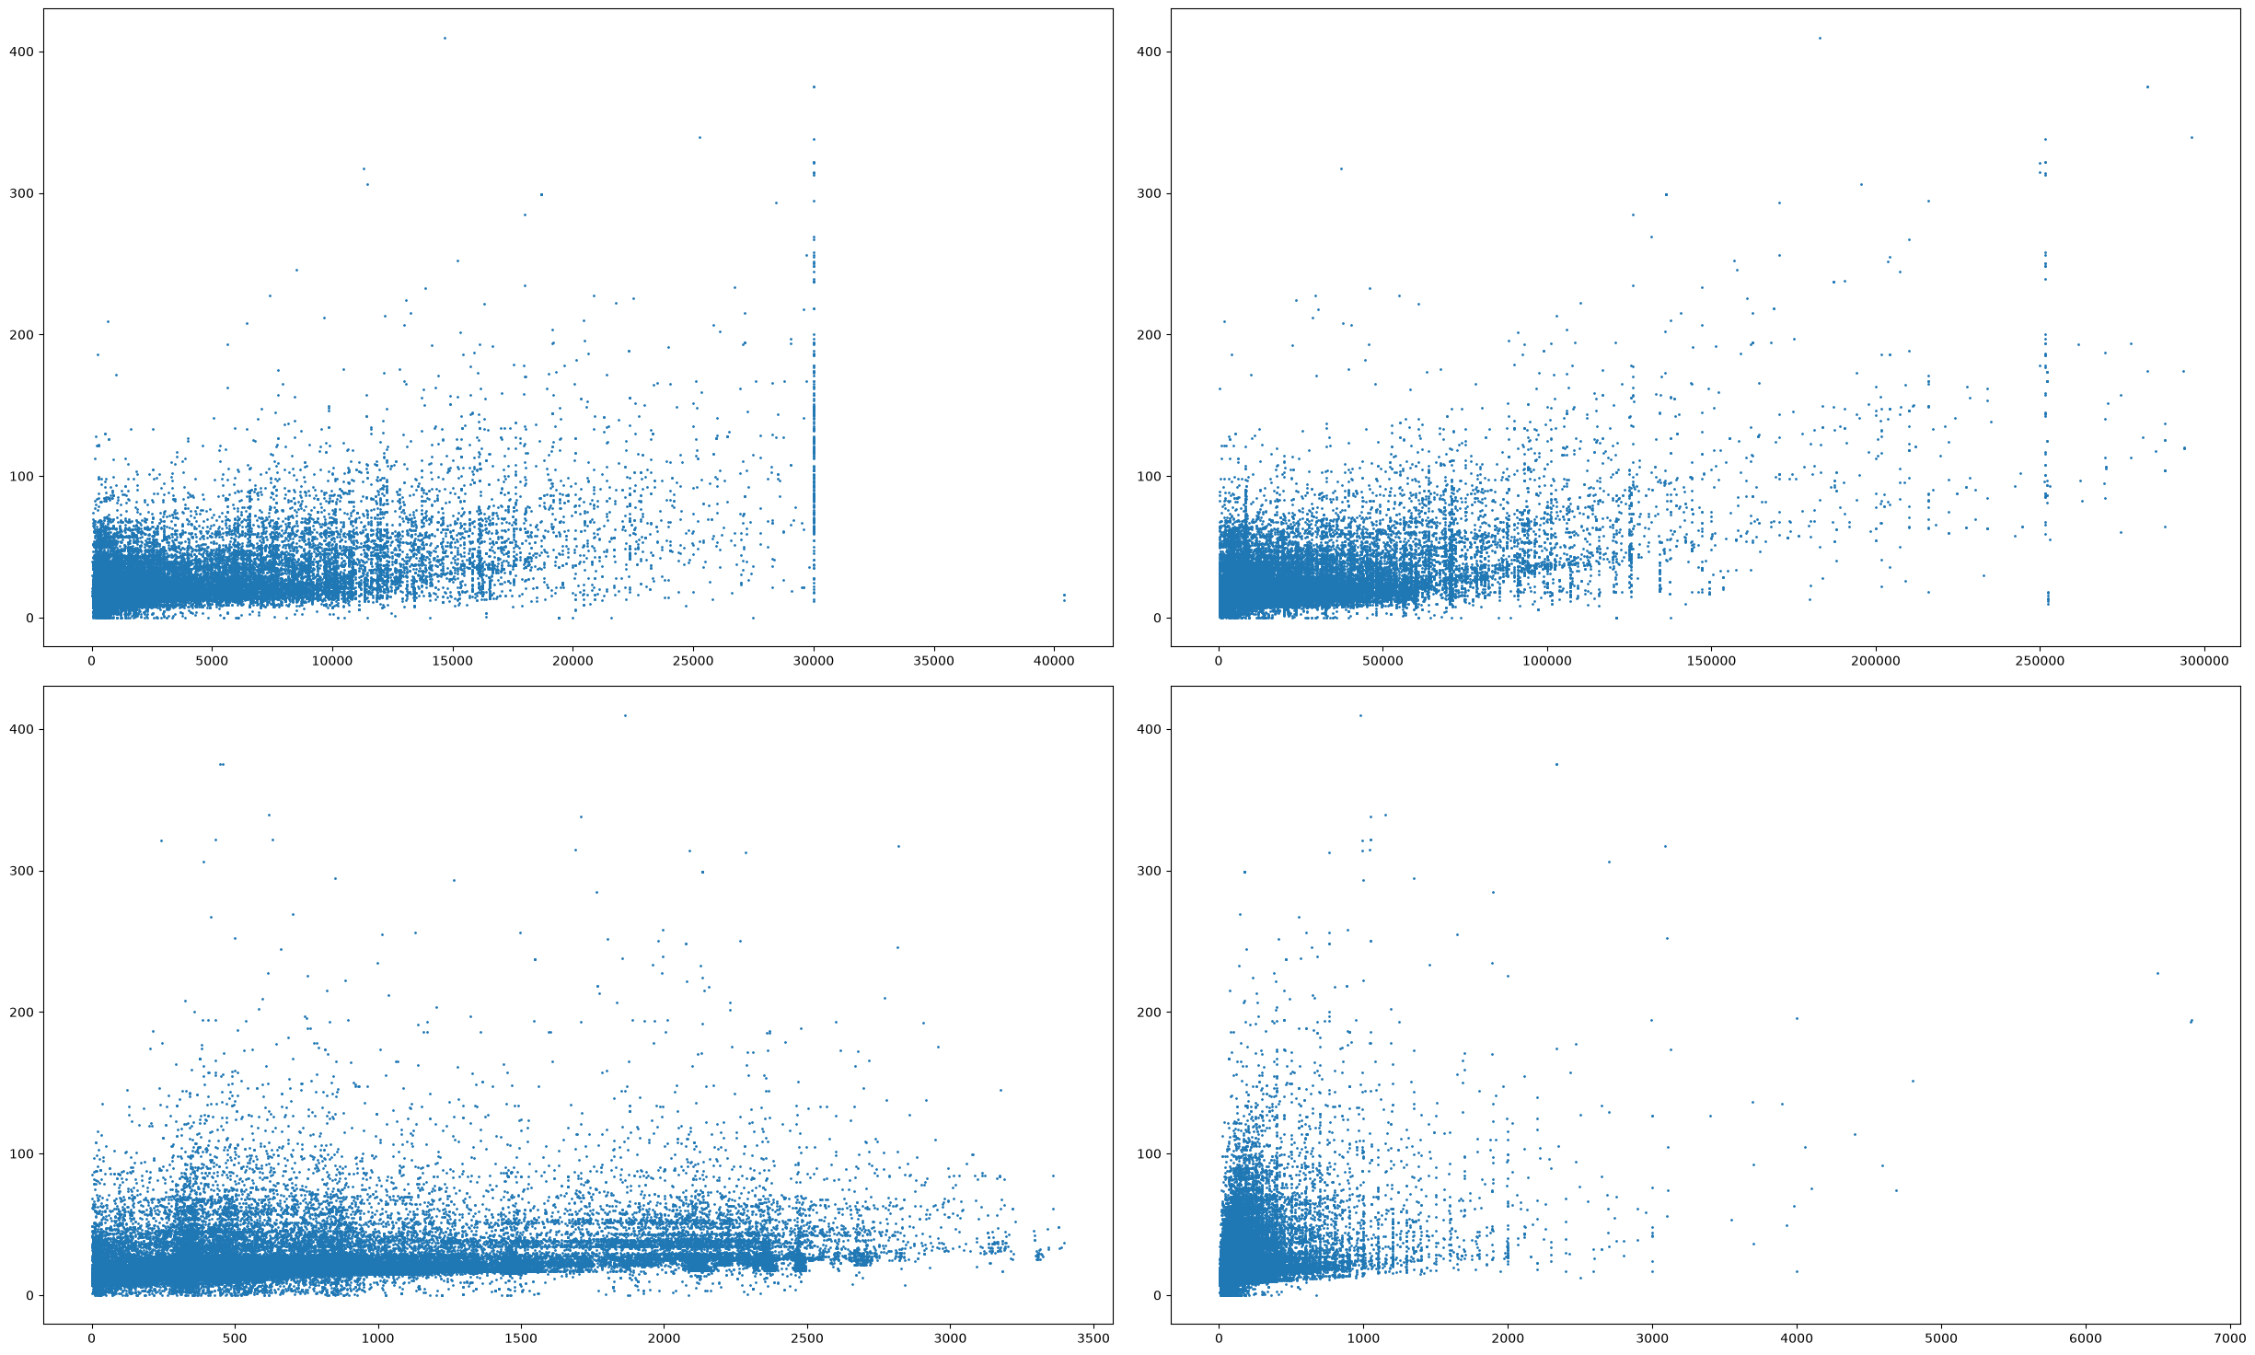
Figure 5.4. Scatter plots between freight_value and (left to right, top to bottom) weight, volume, distance, price
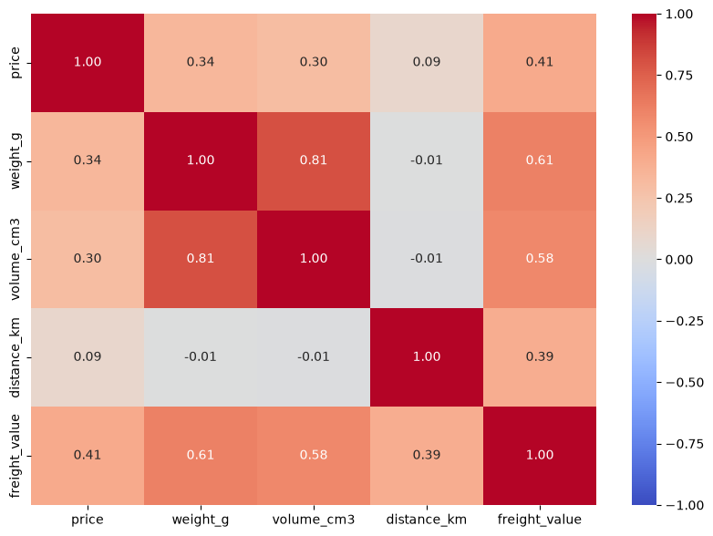
Figure 5.5. Pearson correlation matrix among the five numeric variables: price, weight_g, volume_cm3, distance_km and freight_value
Table 5.2. EDA evidence for each feature
Feature | Evidence
weight_g | Pearson 0.61 (highest); wide scatter for heavy goods, with a cluster at 30,000 g
volume_cm3 | Pearson 0.58; correlation of 0.81 with weight, so the two variables contain overlapping information
price | Pearson 0.41; large scatter, and it does not prove that expensive products cause high fees
distance_km | Pearson 0.39; it is the Haversine distance between zip code prefix coordinates; the same distance has many fee levels
category | Among the 20 most common categories: median of office_furniture 34.12 BRL, the other groups 15.10–17.67 BRL; mostly overlapping
seller_id | The five busiest sellers (Query 2, Part 4): average fee 13.70–18.75 BRL, differing along with the type of goods and the distance

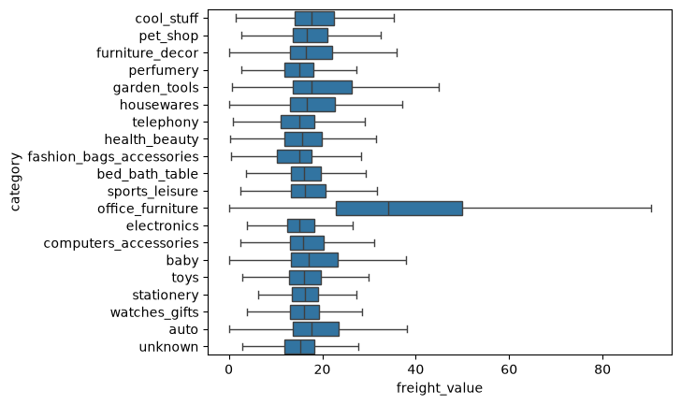
Figure 5.6. Boxplot of freight_value for the 20 most common categories (outliers not shown)
Main observations. First, the physical characteristics give the most prominent signal, but weight and volume are correlated at 0.81, so part of the information is overlapping. Second, distance has a weaker correlation (0.39); price has a moderate correlation (0.41). Third, among the 20 most common categories, the median fee of office_furniture (34.12 BRL) is clearly higher, the other categories range only from 15.10 to 17.67 BRL and their boxes overlap a lot; differences between categories may go together with differences in weight and volume. The five busiest sellers have average fees of 13.70–18.75 BRL (Query 2), so EDA does not use the seller ID as a variable.
Pearson only measures linear association in the historical data, so EDA does not use it to rank the factors with certainty; Figures 5.4 and 5.6 also show wide scatter and a lot of overlap for every factor.

5.6. Explaining unusual clusters in the scatter plots
The scatter plots in Section 5.5 have some odd clusters of points. The team filtered each cluster by weight, volume, distance or fee, then looked at the categories and product characteristics to assess plausibility before modeling. A statistical outlier does not mean the data is wrong.
Table 5.3. Unusual clusters and check results
Cluster | Filter condition | Result | Assessment
Weight of 30 kg | weight_g = 30,000 (259 rows) | Many categories: health_beauty 59, housewares 42, sports_leisure 27, furniture_decor 20, furniture_living_room 19 | May be a weight-declaration round figure; needs verification
Over 40 kg | weight_g > 40,000 (3 rows) | Same category bed_bath_table, volume 23,660 cm³, fee only 12.06–16.32 BRL | Worth checking
Large volume | volume_cm3 ≥ 250,000 | health_beauty 47, furniture_living_room 14, furniture_decor 13, housewares 10, bed_bath_table 8 | May be bulky goods
Giao xa | distance_km > 2,500 | For example, a row of only 700 g with a fee of 54.02 BRL (watches_gifts), 625 g with a fee of 34.15 BRL (garden_tools) | Distance may contribute to the high fee
Very high fee | freight_value > 200 | The top examples weigh 18,000–30,000 g, with volume 126,000–282,750 cm³ | Consistent with heavy, bulky goods

Conclusion: many unusual points have characteristics consistent with real shipping, but there is not enough evidence to confirm that all of them are valid; the team therefore does not automatically delete outliers and keeps them for the modeling step. Limits of the data: the table has seller_id but no carrier, service type, actual route, rate or fee-discount policy, so the exact cause of each high or low fee cannot be determined; distance_km is a straight line by zip code prefix, and the 26 rows with a distance of 0 km do not mean free delivery.

5.7. Checking the remaining open issues
- The unknown category. 1,510 rows (1.39%), with no missing cell in the other columns. Compared with the group that has a category, this group has a slightly lower median fee (15.24 vs 16.32) and is lighter (400 g vs 700 g). There is no evidence that this is wrong data or that it lacks predictive information, so it is kept as a separate category level; the limitation is that the model does not know the true product type. The two categories missing translations were kept under their original codes, so they are not conflated with unknown.
- freight_value = 0. The raw data has 383 rows; 1 row was removed for lacking valid coordinates and 2 rows belong to shipped orders (not delivered), leaving exactly 380 rows before the zero-fee filter. Distance does not explain the value 0 (median 505.6 km, not lower than the positive-fee group at 431.3 km). The evidence does not prove these rows are wrong, and does not show whether they are free shipping, promotions or another way of recording. At checkout it is not known in advance which cases have a fee of 0, so the tool does not apply to those cases.
- Outliers. High-fee regions usually go with heavy, bulky goods or long routes, but there is no independent rate table to verify each point, so the target is neither deleted nor transformed. Consequence: the problem is harder in the high tail; Part 6 has not analyzed the error in this region.
Table 5.4. Summary of decisions in Part 5
Issue | Evidence | Decision | Limitation / impact
unknown category | 1,510 rows, 1.39%; no missing cells in the other columns | Keep as a separate group | True category unknown
Zero fee | 383 raw rows; 380 remain | Removed from the target | Only positive fees are predicted
IQR outliers | 133 below + 11,216 above = 11,349 rows | Keep as is | Extremely high fees may be hard to predict; no error analysis by group yet
Representative geography | Median coordinates of the zip code prefix, Haversine | Accepted with limitations | Not the actual route distance
Missing information for fee calculation | No carrier, service, rate table or promotions | Recorded, not speculated | Only a historical reference level

5.8. EDA conclusions and model proposal
No single feature fully explains freight_value: the scatter plots are all wide, the boxplots overlap, and the target variable is right-skewed with a high-fee region that is hard to predict. From this the team proposes two models: Linear Regression as a simple model to test the linear relationship combining several features, and Random Forest to try non-linear relationships and interactions that a straight line struggles to represent (at the cost of making each prediction harder to explain). The two models are compared on the same test set in Part 6.
The four input variables chosen are weight_g, volume_cm3, distance_km and price, because all four are positively correlated with the fee and SQL shows the average fee rising with each group of every variable. Three groups of variables are not included: category (the boxplots mostly overlap, and the team prioritizes direct physical features), order month (the fee fluctuates but a stable seasonal pattern has not been demonstrated) and the identifiers seller_id, order_id, order_item_id. This exclusion is meant to simplify and does not claim that these variables have no predictive value.

PART 6. REGRESSION TO PREDICT THE SHIPPING FEE

6.1. Goal and experimental design
Part 6 answers Question 3 and adds feature importance for Question 2: it predicts freight_value for each product line with Random Forest, using Linear Regression as the baseline for comparison, evaluated with MAE, RMSE and R² on the test set. The notebook reads the file olist_clean.csv (108,937 rows, 10 columns) from the output folder on Google Drive.

6.1.1. Features and target variable
The target variable is freight_value (BRL). The four input features are weight_g (weight), volume_cm3 (volume), distance_km (seller–buyer distance) and price (selling price). The team's reasoning: weight, volume and distance are the physical factors that determine the shipping fee; price is added to test whether price contributes information. None of the four columns has missing values. The remaining columns of the clean table (category, seller_id, the order ID, the order timestamp) are not put into the model in this version.

6.1.2. Splitting into training and test sets
Table 6.1. Train/test split (random, 80/20, random_state = 42)
Set | Rows
Training (train) | 87,149
Test (test) | 21,788

The data is split randomly by row with train_test_split, with random_state = 42 so results are reproducible; the split is done before training so the test set takes no part in learning. This split is not grouped by order or by time: rows from the same order, seller or product can fall into both sets, so the test score may be higher than when predicting orders from a later period (see Section 7.4).

6.2. Baseline model: Linear Regression
Linear Regression predicts with a linear combination of the four features. The notebook uses it as a point of comparison: if Random Forest cannot beat the linear model, there is no need for a more complex model. Results on the test set: MAE 5.22 BRL, RMSE 9.97 BRL, R² 0.590.

6.3. Random Forest
Random Forest consists of many decision trees, each learning on a random sample of the training set; the prediction is the average of the trees, so it can learn non-linear relationships and interactions. Configuration: n_estimators = 100, random_state = 42, other parameters left at their defaults; there is no hyperparameter tuning step. Random Forest does not require data normalization.
Table 6.2. Comparison of the two models on the test set
Model | MAE (BRL) | RMSE (BRL) | R²
Linear Regression (baseline) | 5.22 | 9.97 | 0.590
Random Forest | 3.60 | 7.76 | 0.751

Random Forest is better on all three metrics: MAE is 1.62 BRL lower (about 31%), RMSE is 2.21 BRL lower and R² is 0.161 higher. The mean absolute error of 3.60 BRL compares with an average fee of 20.01 BRL over the whole data and a median of 16.28 BRL. The model explains about 75.1% of the variation in the fee on the test set. The trade-off is that Random Forest is harder to explain per prediction than linear coefficients.

6.4. Feature importance
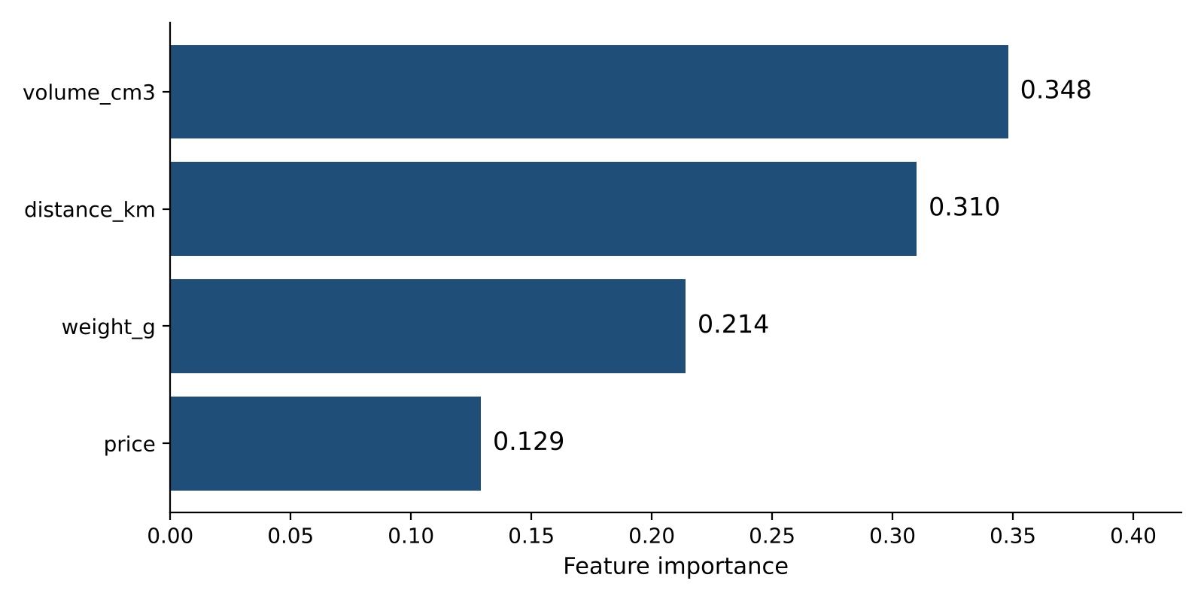
Figure 6.1. Importance of the four features in Random Forest (sums to 1)
Table 6.3. Feature importance
Feature | Importance
volume_cm3 | 0.348
distance_km | 0.310
weight_g | 0.214
price | 0.129

Volume, distance and weight are used most by the trees (total 0.872), and price the least. This is consistent with EDA in that physical characteristics and distance contain notable signal. Pearson measures linear association, whereas importance measures how much a feature is used to reduce error in the trees; the two measures do not mean the same thing, so the order can differ (Pearson ranks weight above volume, importance ranks volume above weight, and the two variables are correlated at 0.81 so the information is split between them). Importance does not prove causation and does not exactly explain an individual prediction.

6.5. What Part 6 has not done
- There is no error analysis by group (high fee, heavy goods, long routes, category), so it cannot show which group of orders is hardest to predict.
- There is no separate validation set, no hyperparameter tuning and no cross-validation.
- There is no baseline based on the median freight_value of the training set; the current baseline is Linear Regression.
The unexplained portion of the fee is therefore measured only in total (1 − R² ≈ 24.9% on the test set), not broken down by group.

PART 7. CONCLUSION

7.1. Logical flow and main results of the project
Table 7.1. What each part solves and what it leaves for the next
Part | Question | Main result | Handed to the next part
1 | What is the problem and how is it measured? | Regression of freight_value at product-line level; 3 questions; MAE, RMSE, R² | Need to know whether the data is suitable
2 | What does the source data look like? | 9 tables; 17 findings (missing, duplicate, out-of-range, keys, leakage in payments) | Need a handling rule for each finding
3 | How is it handled? | 112,650 → 108,937 rows, 10 columns; every decision has a reason and a label | Clean table for analysis
4 | How is each factor related (by group)? | The fee rises with weight and distance; volume, distance and price | Need to check with charts and correlation
5 | How strong is the linear relationship? | Pearson: weight 0.61, volume 0.58, price 0.41, distance 0.39 | Propose two models
6 | Can it be predicted, and is it better than the baseline? | Random Forest: MAE 3.60, RMSE 7.76, R² 0.751 (test); Linear Regression: 5.22, 9.97, 0.590 | Answer the three questions

7.2. Answers to the three business questions
Question 1 – How is the fee distributed and how does it change with the characteristics? The fee is right-skewed: mean 20.01, median 16.28, maximum 409.68 BRL; half of the rows lie within 13.08–21.15 BRL. SQL shows that the average fee rises with all four characteristics: by weight from 15.17 to 39.62 BRL (lightest versus heaviest group), by volume from 14.91 to 27.36, by distance from 12.66 to 35.91 and by price from 14.73 to 34.16. The fee also differs between categories (highest office_furniture at 40.17 BRL, with goods averaging 11,329 g) and fluctuates by month (17.17 BRL in 01/2017, highest 22.95 BRL in 07/2018). This is a description by group; it does not isolate the separate effect of each factor and is not a causal relationship.
Question 2 – Considered together, which characteristic contributes most? Among the four characteristics examined (weight, volume, distance, price), weight, volume and distance are more strongly related than price. By Pearson, weight_g 0.61 and volume_cm3 0.58 come first, followed by price 0.41 and distance_km 0.39; by Random Forest importance (four features), volume_cm3 0.348, distance_km 0.310, weight_g 0.214, price 0.129. The two measures give different orders and weight and volume are correlated with each other at 0.81, so the reliable conclusion is "the physical characteristics (weight, volume) together with distance are the main factors"; no single factor should yet be ranked with certainty. category was examined only through statistics by group and is not put into the model in this version.
Question 3 – With what error in BRL can the fee be predicted, and how do the models compare? Random Forest achieves an MAE of 3.60 BRL (the average fee over the whole data is 20.01 BRL), RMSE 7.76 BRL, R² 0.751 on the test set (20% of rows split at random). The four features explain about 75.1% of the variation in the fee; the unexplained part is about 24.9% (1 − 0.751). This figure comes from a single random split and its stability has not been measured; the notebook has not analyzed which group of orders this unexplained part lies in.
Model comparison: on the same test set, Random Forest is better than Linear Regression on all three metrics: MAE 3.60 versus 5.22 BRL (about 31% lower), RMSE 7.76 versus 9.97 BRL, R² 0.751 versus 0.590. This is consistent with EDA, where the scatter plots show wide scatter and relationships that do not lie on a straight line. The conclusion applies only to the four features and the default configuration used; other non-linear models have not been tried and hyperparameters have not been tuned.

7.3. Practical significance
- Sellers can use the predicted fee as a reference point to estimate costs and compare against the actual fee.
- Logistics teams can treat volume, distance and weight as the characteristics to watch when estimating fees; which groups of orders have large errors needs further analysis.
- The predicted fee does not replace the official rate table of the platform and the carriers.

7.4. Limitations
- Only delivered orders, fee greater than 0, period 01/2017 – 08/2018; it does not apply directly to today's fees or to other markets; it does not predict free-shipping cases.
- The distance is a straight line between the representative coordinates of zip code prefixes; the data has no carrier, service, rate table or promotions.
- How freight_value is split in multi-item orders relies only on the Kaggle description and has not been verified.
- Four cleaning decisions that look at freight_value were applied before the train/test split; the test set is 20% of rows split at random, not grouped by order or time, so rows from the same order or seller can lie in both sets and the test score may be more optimistic than when predicting orders from a later period.
- Only two models, only four features (no category), no hyperparameter tuning, no error analysis by group; the results only describe observed associations and do not claim causation.

7.5. Future work
The directions below were already mentioned or are direct consequences of the limitations above:
- Add a baseline based on the median freight_value of the training set; add error analysis by group (high fee, heavy goods, long routes, category) to learn which group of orders the unexplained part of the fee lies in.
- Compare the model trained with and without the zero-fee rows, and with and without non-delivered orders; report separate errors for multi-item orders and the unknown category; try a log transform for right-skewed variables (proposed in Part 3, Section 10.4).
- Split train/test by time or by order, and assess stability with multiple splits or multiple periods instead of a single random split.
- Build a dashboard visualizing fees by product group and distance as described in Part 1.

REFERENCES
[1] Baymard Institute (2024), a survey of 1,012 US adults aged 18 and over, cited in the EMARKETER article "Extra costs are the No. 1 reason consumers abandon online carts". https://www.emarketer.com/content/extra-costs-are-the-top-reason-consumers-abandon-online-carts
[2] Nuvemshop and Opinion Box (2026), E-Consumidor 2026, a report on the online shopping behavior of Brazilian consumers. https://site.nuvemshop.com.br/hubfs/%5BBR%5D%20Descarreg%C3%A1veis/E-Consumidor%202026.pdf
[3] Olist, Brazilian E-Commerce Public Dataset by Olist, Kaggle. https://www.kaggle.com/datasets/olistbr/brazilian-ecommerce/data (accessed 28/10/2026).
[4] S. Kaufman, S. Rosset, C. Perlich, O. Stitelman, Leakage in data mining: formulation, detection, and avoidance, ACM Transactions on Knowledge Discovery from Data 6(4), 2012. DOI: 10.1145/2382577.2382579.
[5] NIST, Security and Privacy Controls for Information Systems and Organizations, SP 800-53 Rev. 5, 2020. DOI: 10.6028/NIST.SP.800-53r5.
[6] Creative Commons, Attribution-NonCommercial-ShareAlike 4.0 International. https://creativecommons.org/licenses/by-nc-sa/4.0/
[7] Haversine formula, Wikipedia. https://en.wikipedia.org/wiki/Haversine_formula
[8] IBGE, Pontos extremos do Brasil. https://educa.ibge.gov.br/criancas/voce-sabia/23101-pontos-extremos.html
[9] Wikipedia, List of extreme points of Brazil. https://en.wikipedia.org/wiki/List_of_extreme_points_of_Brazil
[10] UK Government Data Quality Hub, Meet the data quality dimensions (the six dimensions according to DAMA UK). https://www.gov.uk/government/news/meet-the-data-quality-dimensions

APPENDIX A. DATA DICTIONARY OF THE NINE SOURCE TABLES
Table A.1. Columns of the nine source tables
Table | Columns (type)
orders | order_id, customer_id, order_status (string); order_purchase_timestamp, order_approved_at, order_delivered_carrier_date, order_delivered_customer_date, order_estimated_delivery_date (string, datetime format)
items | order_id (string); order_item_id (integer); product_id, seller_id (string); shipping_limit_date (string, datetime); price, freight_value (float)
products | product_id, product_category_name (string); product_name_lenght, product_description_lenght, product_photos_qty, product_weight_g, product_length_cm, product_height_cm, product_width_cm (float)
customers | customer_id, customer_unique_id, customer_city, customer_state (string); customer_zip_code_prefix (integer)
sellers | seller_id, seller_city, seller_state (string); seller_zip_code_prefix (integer)
geo | geolocation_zip_code_prefix (integer); geolocation_lat, geolocation_lng (float); geolocation_city, geolocation_state (string)
cat_map | product_category_name, product_category_name_english (string)
payments | order_id, payment_type (string); payment_sequential, payment_installments (integer); payment_value (float)
reviews | review_id, order_id, review_comment_title, review_comment_message (string); review_score (integer); review_creation_date, review_answer_timestamp (string, datetime)

APPENDIX B. CROSS-REFERENCE OF PART 2 FINDINGS TO THE HANDLING RESULTS IN PART 3
Table B.1. Where each Part 2 finding is handled
STT | Issue (Part 2) | Handling (Part 3) | Section
1 | 8 date columns stored as text | Only order_purchase_timestamp is loaded and converted to a date type; the other date columns are not used | 3.6.2
2–4 | 3 timestamps of orders missing | Not loaded into the merged table | 3.4
5 | Category and 3 descriptive fields missing 610 cells | Assign unknown to the missing category (1,579 rows); the three descriptive fields are not loaded | 3.5
6 | Weight and 3 dimensions missing 2 cells | Drop the 18 rows with missing values | 3.5
7 | geo fully duplicated 261,831 rows | Keep the duplicate rows; one row per prefix by collapsing with the median | 3.3.1
8 | freight_value = 0 (383 rows) | Drop the 380 rows remaining at the time of handling | 3.7
9 | product_weight_g = 0 (4 products) | Drop the 8 rows with weight 0 | 3.7
10 | Coordinates outside the Brazil bounding box | Drop 31 points before computing the representative coordinates | 3.3.1
11 | geo: 1,000,163 rows for 19,015 prefixes | Collapse by median: 19,011 prefixes, one row each | 3.3.1
12 | 13 products missing a category translation | Add manual translations for 2 categories | 3.3.2
13–14 | 278 customer rows and 7 sellers without coordinates | Drop 555 rows missing coordinates on at least one side | 3.5
15 | Uneven time coverage | Drop 317 rows from 2016 | 3.6.2
16 | Values beyond the IQR fence | Re-measured on the final table, kept as is | 3.8.4
17 | Leakage in payments | Not loaded in Part 3 | 2.9

APPENDIX C. SQL QUERIES
The queries run on the olist_clean table in SQLite (the notebook's sql() function). The results are given in Part 4. The groups are split at round cut-offs; the queries match the notebook "4. Data Analysis with SQL" (8 queries). The SQL aliases and group labels (for example so_dong, nhom_can_nang) are Vietnamese, exactly as in the notebook, and are kept unchanged.

Query 1 – Fee by category (top 5)
SELECT category,
COUNT(*) AS so_dong,
ROUND(AVG(freight_value), 2) AS phi_TB,
ROUND(AVG(weight_g), 2) AS can_nang_TB,
ROUND(AVG(distance_km), 2) AS khoang_cach_TB
FROM olist_clean
WHERE category <> 'unknown'
GROUP BY category
HAVING COUNT(*) >= 1000
ORDER BY phi_TB DESC
LIMIT 5;

Query 2 – Fee by seller (top 5 busiest)
SELECT seller_id AS nguoi_ban,
COUNT(*) AS so_dong,
ROUND(AVG(freight_value), 2) AS phi_TB,
ROUND(AVG(weight_g), 2) AS can_nang_TB,
ROUND(AVG(distance_km), 2) AS khoang_cach_TB
FROM olist_clean
GROUP BY seller_id
ORDER BY so_dong DESC
LIMIT 5;

Query 3 – Fee by month
SELECT STRFTIME('%Y-%m', order_purchase_timestamp) AS thang,
COUNT(*) AS so_dong,
ROUND(AVG(freight_value), 2) AS phi_TB,
ROUND(AVG(weight_g), 2) AS can_nang_TB,
ROUND(AVG(distance_km), 2) AS khoang_cach_TB
FROM olist_clean
GROUP BY thang
ORDER BY thang;

Query 4 – Data overview and shipping fee
SELECT COUNT(*) AS so_dong,
COUNT(DISTINCT order_id) AS so_don_duy_nhat,
MIN(freight_value) AS phi_nho_nhat,
ROUND(AVG(freight_value), 2) AS phi_ship_TB,
MAX(freight_value) AS phi_lon_nhat
FROM olist_clean;

Query 5 – By weight group
WITH b AS (
SELECT freight_value,
CASE WHEN weight_g < 500 THEN '1. Rất nhẹ (<500g)'
WHEN weight_g < 2000 THEN '2. Nhẹ (500-2000g)'
WHEN weight_g < 5000 THEN '3. Trung bình (2-5kg)'
ELSE '4. Nặng (>5kg)' END AS nhom_can_nang
FROM olist_clean
)
SELECT nhom_can_nang,
COUNT(*) AS so_dong,
ROUND(AVG(freight_value), 2) AS phi_ship_TB
FROM b
GROUP BY nhom_can_nang
ORDER BY nhom_can_nang;

Query 6 – By volume group
WITH b AS (
SELECT freight_value,
CASE WHEN volume_cm3 < 2000 THEN '1. Nhỏ (<2.000 cm3)'
WHEN volume_cm3 < 5000 THEN '2. Vừa (2.000-5.000)'
WHEN volume_cm3 < 15000 THEN '3. Lớn (5.000-15.000)'
ELSE '4. Rất lớn (>15.000)' END AS nhom_the_tich
FROM olist_clean
)
SELECT nhom_the_tich,
COUNT(*) AS so_dong,
ROUND(AVG(freight_value), 2) AS phi_ship_TB
FROM b
GROUP BY nhom_the_tich
ORDER BY nhom_the_tich;

Query 7 – By distance group
WITH b AS (
SELECT freight_value,
CASE WHEN distance_km < 200 THEN '1. Gần (<200km)'
WHEN distance_km < 800 THEN '2. Trung bình (200-800km)'
WHEN distance_km < 1500 THEN '3. Xa (800-1500km)'
ELSE '4. Rất xa (>1500km)' END AS nhom_khoang_cach
FROM olist_clean
)
SELECT nhom_khoang_cach,
COUNT(*) AS so_dong,
ROUND(AVG(freight_value), 2) AS phi_ship_TB
FROM b
GROUP BY nhom_khoang_cach
ORDER BY nhom_khoang_cach;

Query 8 – By selling price group
WITH b AS (
SELECT freight_value,
CASE WHEN price < 50 THEN '1. Rẻ (<50)'
WHEN price < 100 THEN '2. 50-100'
WHEN price < 200 THEN '3. 100-200'
ELSE '4. Đắt (>200)' END AS nhom_gia
FROM olist_clean
)
SELECT nhom_gia,
COUNT(*) AS so_dong,
ROUND(AVG(freight_value), 2) AS phi_ship_TB
FROM b
GROUP BY nhom_gia
ORDER BY nhom_gia;

APPENDIX D. ADDITIONAL DETAILED EDA RESULTS
Table D.1. The ten most common categories (EDA)
Category | Rows | Mean | Median | Q1 | Q3
bed_bath_table | 10,901 | 18.43 | 16.19 | 13.29 | 19.72
health_beauty | 9,394 | 18.92 | 15.79 | 11.98 | 19.80
sports_leisure | 8,398 | 19.36 | 16.25 | 13.39 | 20.72
furniture_decor | 7,979 | 20.89 | 16.43 | 13.08 | 22.20
computers_accessories | 7,611 | 18.83 | 15.98 | 13.11 | 20.29
housewares | 6,765 | 21.02 | 16.76 | 13.01 | 22.66
watches_gifts | 5,621 | 17.37 | 16.01 | 13.05 | 19.22
telephony | 4,394 | 15.64 | 15.10 | 11.02 | 18.23
garden_tools | 4,196 | 22.94 | 17.67 | 13.78 | 26.25
auto | 4,121 | 21.86 | 17.60 | 13.74 | 23.49

APPENDIX E. FORMULAS
Haversine [7] (the straight-line distance between two points on a sphere of radius 6,371 km): convert latitude φ and longitude λ from degrees to radians; a = sin²((φ₂ − φ₁)/2) + cos φ₁ · cos φ₂ · sin²((λ₂ − λ₁)/2); c = 2 · arcsin(√a); d = 6371 · c (km). a lies between 0 and 1; a = 0 when the two points coincide. The result is a straight line on the sphere, not the actual shipping route.
IQR fence (Tukey): upper fence = Q3 + 1.5 × (Q3 − Q1); lower fence = Q1 − 1.5 × (Q3 − Q1).
MAE = the mean of |y − ŷ|. RMSE = the square root of the mean of (y − ŷ)². R² = 1 − Σ(y − ŷ)² / Σ(y − ȳ)². Here y is the actual fee, ŷ is the predicted fee, and ȳ is the mean of y.
Pearson correlation between two variables is a coefficient measuring the degree of linear relationship, from −1 to 1.

APPENDIX F. SYNCHRONIZATION NOTES ACROSS THE NOTEBOOKS
While cross-reading the six notebooks on GitHub, the team noticed the following points that need to be aligned before submission. These are differences between the parts and do not change the figures stated in the report.
Table F.1. Points to synchronize
STT | Content | Proposal
1 | Schema and data file. Notebooks 3, 4, 5 and 6 all use the 10-column table (108,937 rows). However, data/cleaned/olist_clean.csv in the repository is still the old 27-column version, different from the file that Part 3 exports. | Upload the 10-column version to the repository
2 | Baseline model. Part 3 (Section 10.4) says it will compare with a baseline based on the median of the training set; Part 6 uses Linear Regression as the baseline and has no median-based model yet. The Part 6 notebook also mentions "RQ4", whereas Part 1 has only three questions. | Align the baseline model and the number of questions
3 | Data split. Part 6 and Section 5.5 of Part 5 split randomly 80/20 by row (87,149 / 21,788), not grouped by order or time; but Sections 2.2 and 3.7 of Part 5 say "split train/validation/test by time" and "choose by MAE on the time-based validation", and Section 10.4 of Part 3 also mentions a time-based split. | Align the description, or change the split if a time-based one is wanted
4 | Query numbering in Part 5. Sections 3.1 to 3.6 cite Queries according to the old SQL version (weight is Query 2, distance is Query 3, by month is Query 7; it also mentions Query 4 same_state and Query 6 order_n_items of the 27-column version), whereas Section 5.2 and notebook 4 now use Query 5 (weight), 6 (volume), 7 (distance), 8 (price) and the fee by month is Query 3. | Re-check the Query numbers against notebook 4
5 | Spearman and cross-validation. Part 5 uses only Pearson (no Spearman) and Part 6 has no cross-validation. | If needed, add Spearman and cross-validation
6 | Meaning of freight_value in multi-item orders. Section 9.1 of Part 3 relies on the Kaggle column description to keep the fee at product level; the quotation was not independently verified when the report was prepared (the Kaggle page was not accessible). | Re-check the quotation
7 | Data in the repository. The four source CSV files (customers, orders, products, reviews) in data/raw contain only a blank line, so Parts 2 and 3 cannot be re-run from the repository; data/cleaned/olist_clean.csv is still the 27-column version (different from the 10-column table exported by Part 3). | Re-upload all nine files and the 10-column clean version to the repository
8 | README. The README says "basic version (v0)", lists five notebooks with old names (01_Problem_Definition … 05_EDA) and a claend folder, and does not yet reflect the current six notebooks. | Update the README
9 | Paths when running. The notebooks read data from Google Drive or /content/ depending on the part. | Standardize the paths (for example data/raw, data/cleaned)
10 | Figure axis labels. The figure of points inside the bounding box and the figure of the error distribution in Part 3 have no axis labels; in the distribution figure the first bar is an effect of clip(lower=0.01). | Add xlabel, ylabel and a note

APPENDIX G. SOURCE CODE STRUCTURE AND HOW TO RE-RUN
Source code: https://github.com/QuachThanh2206/ADY201m-Group8-AI2107. The notebooks folder has six notebooks; the data/raw folder lists nine source CSV files but four of them (customers, orders, products, reviews) in the repository contain only a blank line and are not real data; the data/cleaned folder contains olist_clean.csv in the old 27-column version (108,937 × 27), not the 10-column version that Part 3 now exports. Notebooks 3 and 6 read and write data on Google Drive (the output folder).
Table G.1. Notebooks and run order
Order | Notebook | Input | Output
1 | 1. Business Understanding and Analysis | — | Problem, questions, criteria
2 | 2. Data Exploration and Quality Assessment | 9 source CSV files | Catalogue of data quality findings
3 | 3. Clean data | 7 source CSV files (payments and reviews not loaded) | olist_clean.csv (108,937 × 10)
4 | 4. Data Analysis with SQL | olist_clean.csv | Eight queries and summaries
5 | 5. Exploratory Data Analysis | Clean file (10 columns) | Charts, correlations, checks
6 | 6. Regression Analysis | Clean file (10 columns) | Models, results on the test set, feature importance

Part 1 of this report matches the notebook "1. Business Understanding and Analysis" as updated on 09/11/2026 on GitHub (compared with the earlier version, four places were changed): the three questions in Section 1.2 were reworded to match the features and results of Part 6; Section 1.3 drops the phrase "belonging to supervised learning"; the two metrics MAPE and MdAPE were removed; the paragraph on the baseline model and cross-validation in "Model evaluation method" was removed. The bar and line charts (Figures 3.5, 4.2, 4.3, 6.1) were redrawn by this report from figures in the notebooks; the remaining figures are taken from the notebooks or from the Olist data page.

