Movement with WASD + mouse

‘space’ for barrier
‘r’ to switch characters (like from main character to some ally who heals everyone in the party?)

Photon Bullet (lmb) just shoots out 1 slim photon bullet. It would be a yellow pixel line that spawns at the player’s root and through a simple animation becomes from 1 pixel dot to a line and shoots out towards the mouse pointer’s position. The animation time should be adjustable for me so that I can decide which one gives me the best feel of shooting without feeling slow.

Also about the aiming. The player can rotate their head in a certain arc of the direction they face with the mosue. They can move around with WASD and change primary directions and then that would change the arc too. More effort and thinking is needed for the aiming and I am open for suggestions.

Photon Beam (holding lmb) Releases a beam of photons but locks the player in a direction (both primary and specific).

The engine draws a hitbox from player to the point clicked, and then that rectangular hitbox is divided into segments equal to that of the animation for photon beam and the animation is duplicated over those segments and appropriately ends with a separate ending animation. The photon beam slowly fades out when the hold has been released.

Quick Heal (rmb) dynamic healing so that the player doesn’t last forever in a battle? Or maybe limited sets of fixed healing potions that can be accessed with rmb click? So that the player actually uses a priest…

A simple green vfx with a ‘+’ uis showing around the player and healing him would do the trick here. I prefer the limited sets. The count of potions could be a pixel font number as subscript/superscript with a potion icon beside the health bar.

Alright.
The total types of characters are not decided except the main character [???]. And I want to focus on his combat more.

Regarding light, it could be a stamina bar type thingy.
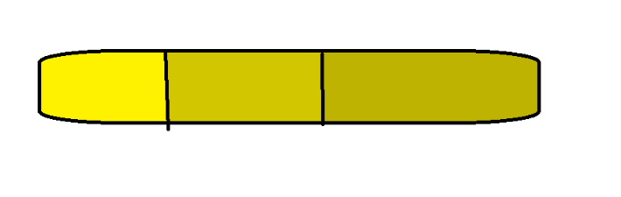
Something like this.

The left-most (brightest) section would be player’s hope which is fixed and cannot be changed at all. Strongest but very low. (hehe, personality lol)

The middle section is humanity’s hope which can either increment or decrement it’s maximum capacity based on player’s achievements and some side quests.

The above both sections cannot regenerate their light.

The darkest/rightmost section would be physical light which provides the weakest burst of power but can be regenerated and has a fixed maximum.

Core Parts of Combat:
- Anticipation
- Hit
- Recovery

Some tips I heard (more to be figured out by myself): For fast-paced action, Anticipation and Hit animations can be made within 1/10th seconds.

Anticipation includes stuff like aiming and firerate. Hit includes the animation that player and enemy undergo after getting hit or attacking (respective). Recovery is the longest section cuz u have nothing much to show there except an animation and the player’s dopamine will fall off slightly since the anticipation part is over.
I also heard of using tricks like freeze frames, white flash on enemy, glitch processing, bam & pew-pew & other comical effects (compulsory for my game) and stuff like screenshake that players would hate if it’s a recurring thing.

I also need to mention sound design and VFX since they too matter a lot. I have to ensure that I find good sound effects and time them properly. VFX is also important for the player to feel happy that something happened and to display some fancy visuals ig.

But the comical effects I talked about earlier fall under VFX.

