
<12>

Co-working Space
Software Design Specification (SDS)
Version: <1.0>
CM Identifier:<G12_SE03_v1.0>

Revision History

Sl. No. | Prepared/  Modified by | E-mail | Version | Date | Approved by | Descriptions/  Remarks
1. | Mahmoud Ismail | mahmoud.ismail.zidan@gmail.com | <1.2.> | 25/4/16 | -- | Sec.1, 2, 3.1, 5, 6
2. | Mohamed Hassan | mohammed_hassan9466@outlook.com | <1.0.> | 23/4/16 | -- | Sec. 3.2, 4
3. | Abdallah Mohamed | innocence55@hotmail.com | <1.1.> | 24/4/16 | -- | Sec. 3.3
4. | Mohamed Hamada | mohamedhamada2134@gmail.com | <1.1.> | 24/4/16 | -- | Sec. 3.3

Distribution list
Name | E-mail | Notes
Dr.BasemIbrahim | basem@eng.cu.edu.eg | Reply needed.
Eng.LydiaWaheed | eng.lydiawahid@hotmail.com | Reply needed.
Co-Working Space manager | creativo@space.com | Reply needed.

Table of Contents

1. Introduction 5
1.1 Purpose of this Document 5
1.2 Scope 5
1.3 Table of Acronyms and Definitions 5
1.4 References 5
1.5 Overview of Document 5
2. System Architecture 6
3. Design Models 6
3.1 Design Patterns Description 6
3.1.1 Design Pattern I 6
3.1.2 Design Pattern II 6
3.2 Class Diagrams 7
3.3 Interaction Diagrams 8
3.4 State Chart Diagrams (if needed) 11
3.5 Activity Diagrams (if needed) 11
3.6 Component Diagrams (if needed) 11
4. Data Models 12
5. System Deployment 13
6. Traceability to Requirements 13

List of Figures

Figure 1 – System Architecture(MVC web model based on Laravel framework)[2] 6
Figure 2 – Class diagram (for iteration 1) 7
Figure 3 – SD1 (Sign up) 8
Figure 4 – SD2 (Sign in) 9
Figure 5 – SD3 (Room reservation) 10
Figure 6 – SD4 (Events registration) 11
Figure 7 – SD5 (Membership subscription) 12
Figure 8 – ER (for iteration 1) 13
Figure 9 – Deployment diagram 14

List of Tables

Table- 1: Traceability Matrix 14

Introduction

Purpose of this Document

The purpose of this document is to provide an overview of the proposed solution to the problems specified in the Software Requirements Specification Document. It provides the system architecture , in addition to the design and the data models.

Scope

Our project is mainly concerned with building a website with an online reservation system. It will be designed to facilitate the processes of rooms’ bookings, memberships’ subscriptions and events’ registration.Users can remotely use these facilities through their registered accounts on the website.
The system also aims to maximize the Creativo manager and employees productivity by providing tools to assist in remotely monitoring and automating the booking, subscriptions and registration processes, that would otherwise have to be performed manually in a mundane and inefficient ways.By maximizing the manager’s (and employees) work efficiency; the system will meet its’ customers needs, while remaining easy to use and understand.

At this iteration the user can create an account on the website, log in and make a room booking , subscribe to a membership, or register in an event.

Table of Acronyms and Definitions

Term | Definition
DB | Database
mvc | Model View Controller
ER | Entity-Relationship

References

- “Software Engineering”, 7th Edition, Ian Sommerville, Addison-Wesley, 2004
[2] laravelbook.com/laravel-architecture/

Overview of Document
The rest of this document shows our system architecture, then it illustrates the system design models which mainly consists of the design patterns, class diagrams, and interaction diagrams. It also describes our data model via an entity-relationship diagram. Finally, it shows how the system will be deployed, and explains the traceability of requirements.

System Architecture
Our system uses the MVC model.

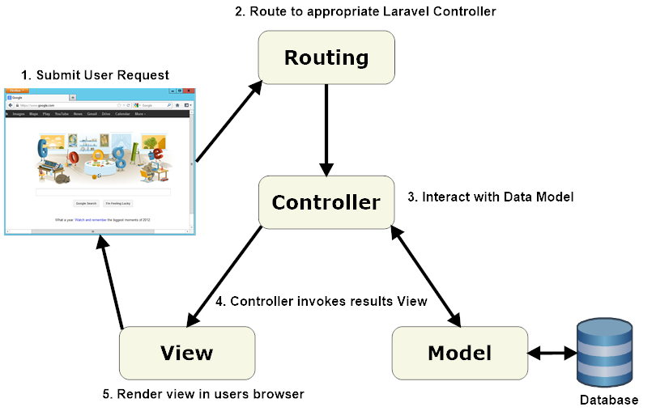

Figure 1 – System Architecture(MVC web model based on Laravel framework)[2]

The Http request (user request) first gets routed to the corresponding derived controller class method via the “route.php” file. The derived controller class then interacts with the data model as needed and invokes the required view.

Design Models

Design Patterns Description

Design Pattern I
The MVC pattern. The architecture of our web-based application system is organized using the
MVC pattern. This allows the data to change independently of its representation and vice versa.

Design Pattern II
Will be used in iteration 2

Class Diagrams

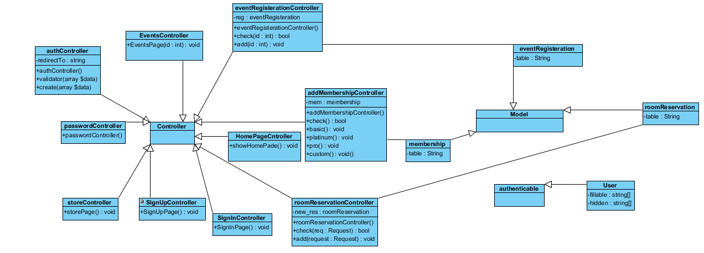

Figure 2 – Class diagram (for iteration 1)

Note:

Built-in classes : Controller , Model, authenticable.

Interaction Diagrams

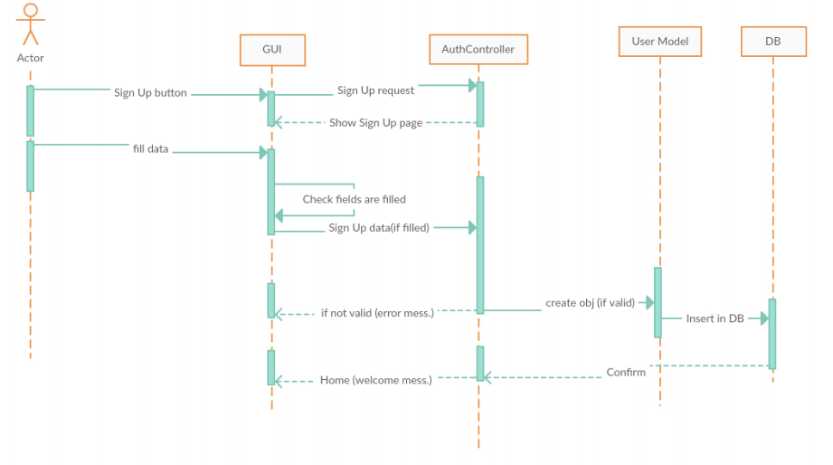

Figure 3 – SD1 (Sign up)
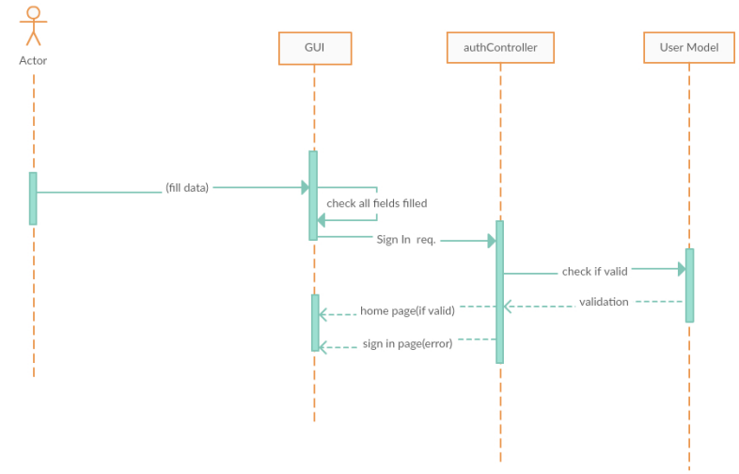
IN
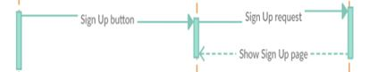
IN

IN

Figure 4 – SD2 (Sign in)

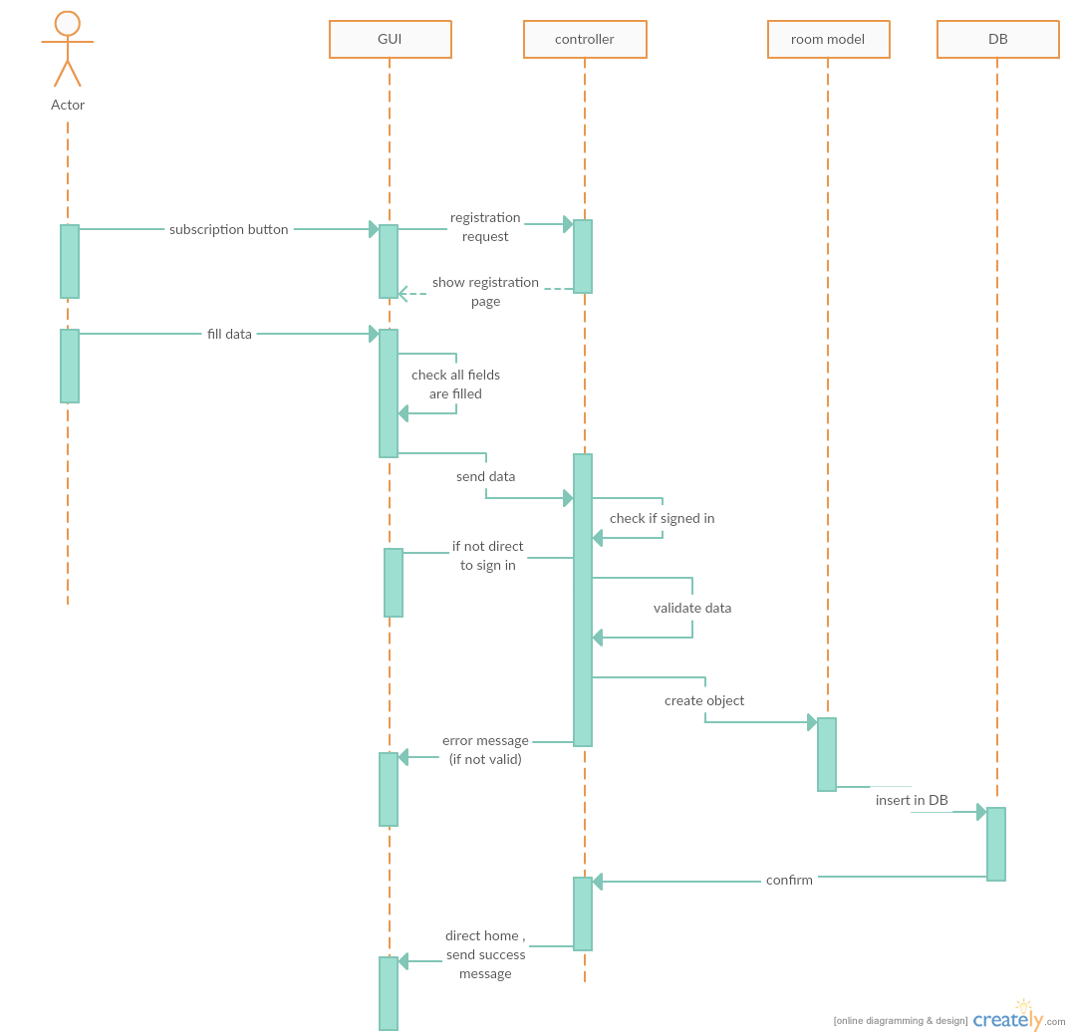

Figure 5 – SD3 (Room reservation)

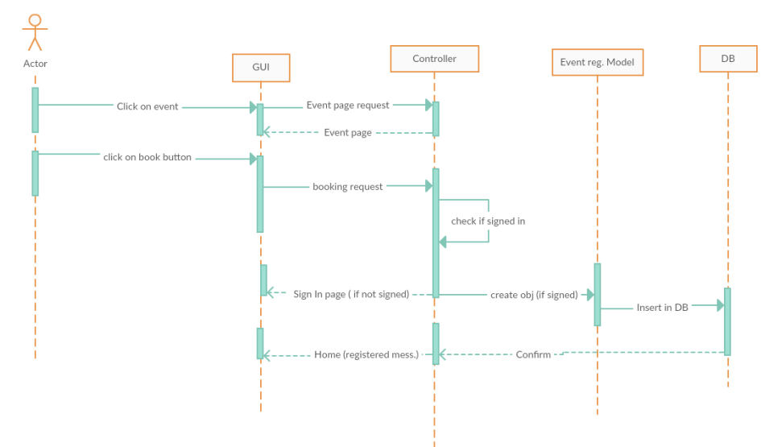

Figure 6 – SD4 (Events registration)

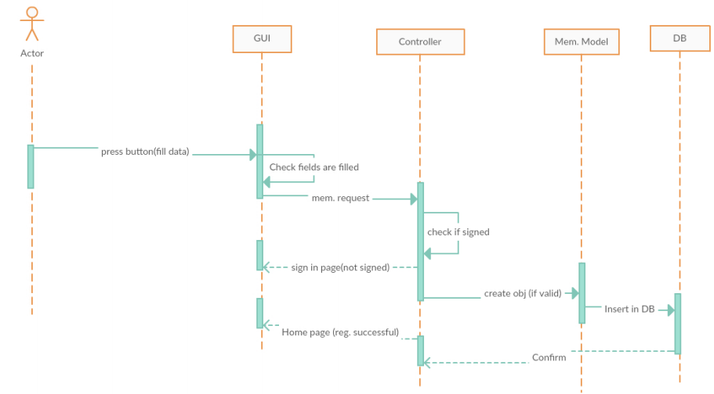

Figure 7 – SD5 (Membership subscription)

State Chart Diagrams (if needed)
N/A

Activity Diagrams (if needed)
N/A

Component Diagrams (if needed)
N/A

Data Models
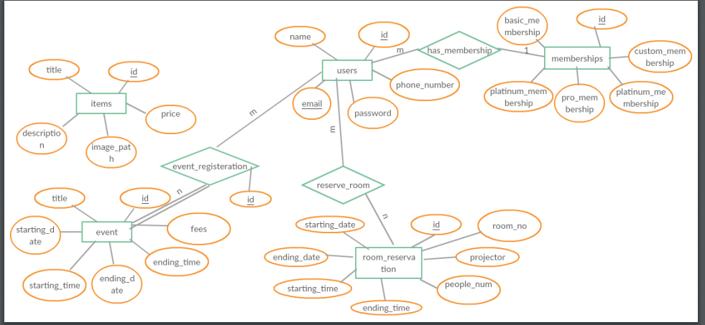

Figure 8 – ER (for iteration 1)

System Deployment

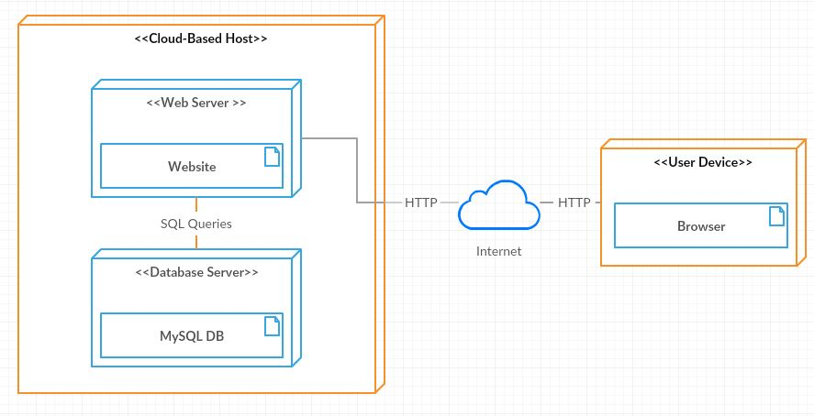

Figure 9 – Deployment diagram

Traceability to Requirements

--- | SD1 | SD2 | SD3 | SD4 | SD5
US2 | ✓
US3 |  | ✓
US4 |  |  | ✓
US5 |  |  |  | ✓
US6 |  |  |  |  | ✓

Table- 1: Traceability Matrix

