**4) System Interface Designs**

This section of the study covers the UI and functionality of Woodlands University College's new course administration system, as well as the design process in steps. Throughout the system design, the emphasis was on simplification and usefulness in order to decrease the time required to complete any activities while simultaneously improving the innovation and consciousness of students and staff. The applications' main features are available with fewer UI engagements and thus are quicker to analyze.

As the institution has desired, it is a graphical representation of the user interface. It is computerized and basic in appearance, making it simple to use. To create a comfortable for the client, we utilized a consistent theme that the user can forecast in buttons, the images as well as the title are clear, and to make it much more attentiveness, we found a way to make it more legible and focused in hierarchical, fetched controls around the user, also kept the user delivering details concerning system answers. To solve all of our challenges and complete the rest of our project, we employed draught interface layouts, design changes, and algorithmic evaluation. To produce the web application, the following languages will be used: HTML, CSS, JAVASCRIPT, PHP.

**4.1) Draft Interface Designs**

Designs of graphical elements that reflect the planned user interfaces are included in this part, such as wireframes, system navigation diagrams, mockup layouts, and system activities event illustrations.

**4.1.1) Wireframes**

A wireframe is a visual representation of the design of a website. It is easy for web designers to create websites. It represents the how website looks in its fundamental format. This provides the client with a schematic view of their system. The layout idea was created with an online application called Balsamiq (Balsamiq Cloud, 2021), after communicating with the customer about the functioning and requirements.

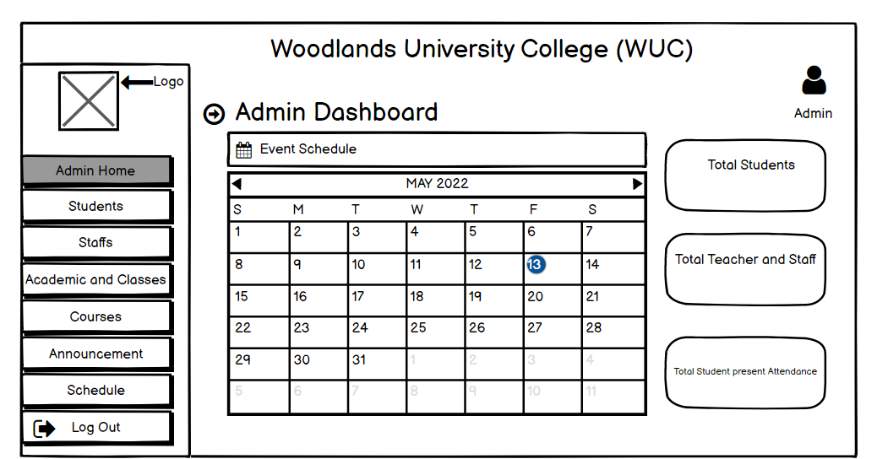

**Fig: Admin Home Page**

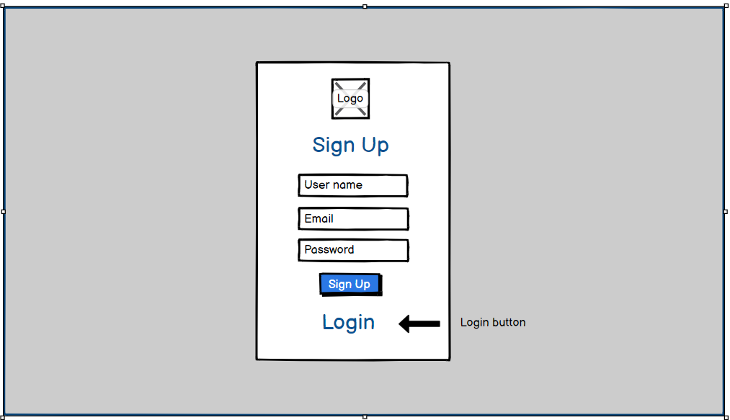

**Fig: Login/Sign Up Page**

**4.1.2 System Navigation Designs**

This category contains a graphical demonstration of a sequence of webpages in course management system navigation. Staff and students both have access to the web application. Every panel is displayed by a container that includes the screen headline and a panel id. System navigation tends to play a key part in user interfaces by developing, assessing, and applying ways for users to traverse the system. It is the art of linking systems that create them function effectively, as well as displaying the system window's route. The navigation system perfectly demonstrates the design of the informational structure and the user's specific position, which is particularly meaningful in a sophisticated system. A well-designed navigation system assists users in developing a conceptual framework of the informational structure in order to effectively made analysis of the information.

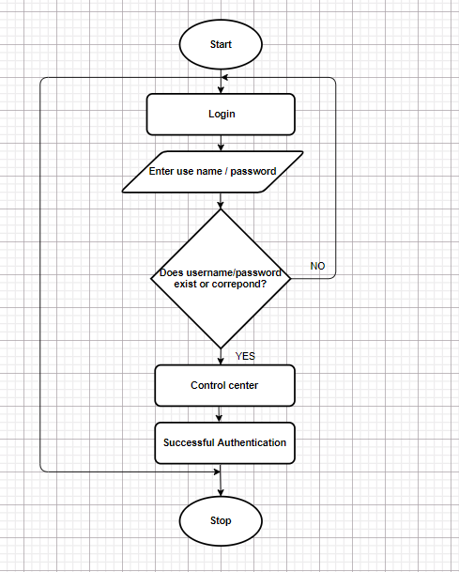

**Login Screen Navigation**

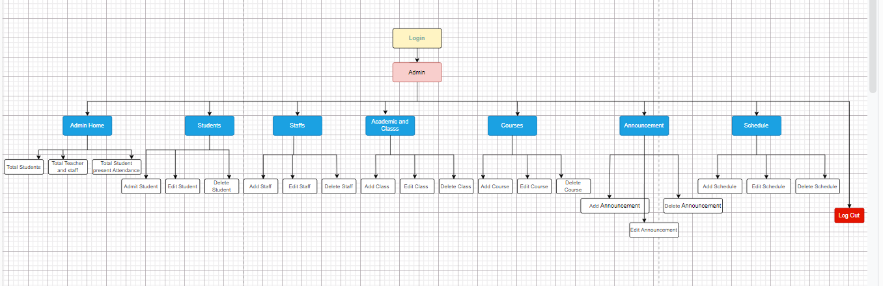

**Fig: Admin Home Screen Navigation**

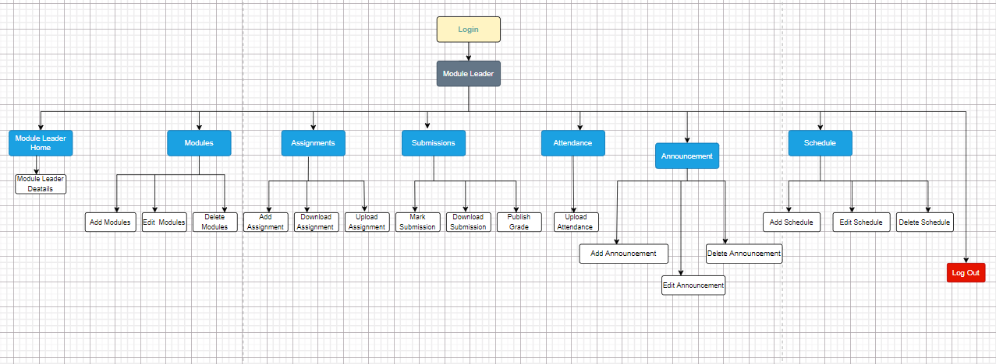

**Fig: Module leader Home Screen Navigation**

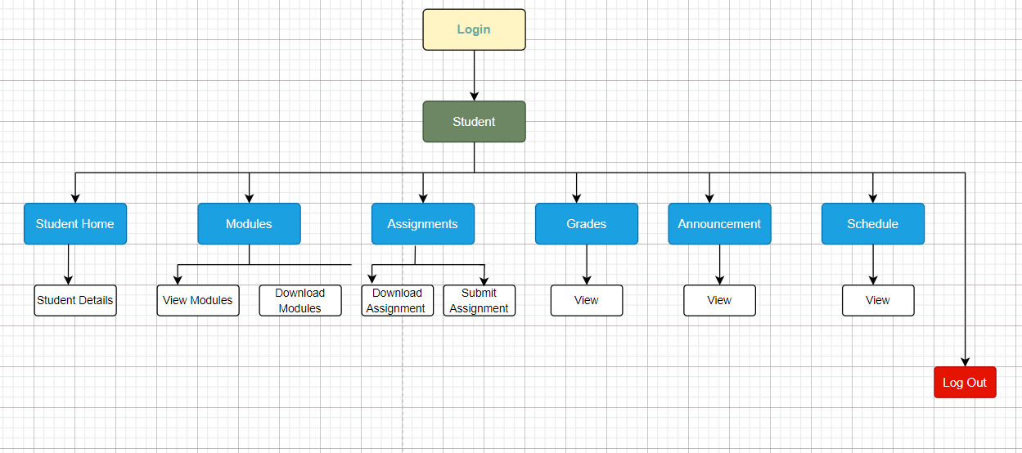

**Fig: Student Home Screen Navigation**