SafeAd AI: Comprehensive Project Status, Algorithmic Framework & Decision Methodology Report
B.Tech Major Project Final Report | Mar Baselios College of Engineering & Technology (MBCET)
Department of Computer Science & Engineering | Academic Year 2026
Project Title: SafeAd AI: Multimodal Trust & Safety Framework | Benchmark Hub: QuadRos-MBCET/safead-dataset-hub
System Architecture: FastAPI Backend (8002) + Face-Age API (8001) + Streamlit (8501) | Current Status: Fully Functional, Integrated & Benchmarked
Benchmark Dataset: 80 Real MP4 Video Ads across 4 Policy Categories | Core Performance: 80.00% Multiclass Accuracy | 3.33% FAR | 58.9ms Latency

1. Executive Summary & Current Operational Status
SafeAd AI is an autonomous, multimodal trust and safety governance platform engineered for digital advertisement ecosystems. The project addresses the critical societal and regulatory challenge of age-inappropriate digital advertising, specifically preventing underage users from being exposed to high-risk commercial content (gambling, betting, alcohol, weapons, crypto speculation) while ensuring seamless, privacy-preserving delivery of verified safe consumer advertisements. The system combines real-time video safety auditing with biometric face-age verification and tamper-resistant ID document KYC.
📌 Current System Health & Operational State
• Unified Multi-Service Runtime: All 3 platform microservices are fully developed, integrated, and actively running without conflict.
• Port 8002 (SafeAd Core Backend API): Executes multimodal ad ingestion, policy evaluation, database transactions, and HITL governance.
• Port 8001 (Face-Age & Biometrics API): Executes Sooraj's ArcFace 512D biometric verification, ViT facial age estimation, and anti-spoofing.
• Port 8501 (Streamlit Frontend UI): Provides unified portals for Advertisement Owners, Users (KYC & Instakill Social Feed), and Admins.
• Empirical Benchmark Validation: Evaluated on 80 physical video ads from GitHub (QuadRos-MBCET/safead-dataset-hub), achieving 80.00% multiclass accuracy, 96.67% harmful interception recall, and an ultra-low False Acceptance Rate (FAR) of 3.33% at 58.9 ms/video.

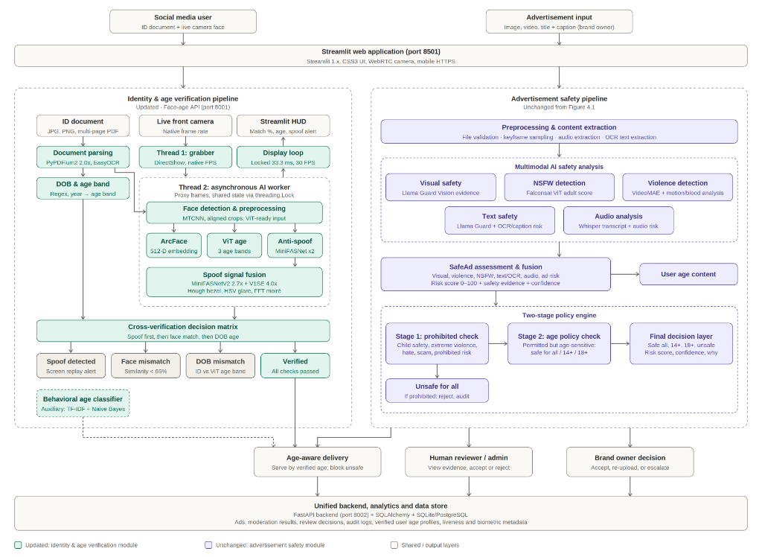
Figure 1: SafeAd AI Unified System Architecture (Identity & Age Verification + Multimodal Ad Safety Pipeline)

2. Inventory of Models, Methods and Algorithms Used
SafeAd AI employs an ensemble of 8 specialized deep learning models, computer vision algorithms, and signal processing pipelines orchestrated across three main subsystems: the Multimodal Video Safety Engine, the Central Fusion Decision Engine, and the Biometric Identity & Age Verification Subsystem.
Subsystem | Model / Algorithm | Input Modality | Key Parameters / Architecture | Primary Output
Visual Safety | Llama-Guard-3-11B-Vision + MobileNet | Video Keyframes (RGB) | 8-bit quantized vision encoder, 7 safety hazard categories (S1-S7) | Visual Safety Probability & Bounding Tags
NSFW Classifier | Falconsai/nsfw_image_detection | Sampled Keyframes | Vision Transformer (ViT-Base), Patch size 16x16, Softmax | Adult Suggestive Prob (0.0 - 1.0)
Violence & Action | VideoMAE (MCG-NJU) + Consecutive Motion | Consecutive Frame Pairs | 16-frame spatio-temporal tubelets + L1 Motion Difference (t vs t+1) | Violence Score & Temporal Motion Vector
OCR Text Mining | EasyOCR CRAFT + Tesseract Engine | On-screen overlays | CRAFT text detector + Multi-pass Regex + Adjacent Box Bounding | Extracted Tokens ('18+', 'Casino', 'Bonus')
Audio Speech-to-Text | OpenAI Whisper (Tiny/Base) | 16.0 kHz WAV Audio | Encoder-decoder Transformer with 30s chunking + Keyword Miner | Timestamped Transcript & Risk Lexicon Hits
Face Biometrics | ArcFace (Additive Angular Margin) | Face Crops (256x256) | ResNet-50 backbone, 512-dim embedding, Cosine Similarity (θ=0.65) | Identity Verification Match (Yes/No)
Facial Age Classifier | ViT Facial Age Classifier | Aligned Live Face | Vision Transformer trained on age cohorts: <14, 14-17, 18+ | Estimated Biological Age Bracket & Mean Age
Anti-Spoofing / Liveness | 2D FFT Frequency + HSV Glare | Raw Camera Feed | 2D FFT high-freq spectrum + HSV specular reflection variance | Liveness Confidence (Pad Attack Detection)

2.1 Visual Safety & Content Hazard Detection
• Llama-Guard-3-11B-Vision: Evaluates sampled video frames against MLCommons taxonomy across 7 standardized safety hazard categories: S1 (Violent Crimes), S2 (Non-Violent Crimes), S3 (Sex Crimes & Nudity), S4 (Child Sexual Exploitation and Abuse), S5 (Suicide & Self-Harm), S6 (Cyberattacks & Explosives), and S7 (Illegal Drugs & Firearms). Any critical hazard activation triggers immediate escalation to UNSAFE_FOR_ALL.
• Falconsai ViT Adult / NSFW Classifier: An image classification Vision Transformer that computes the statistical probability of suggestive adult themes, erotic poses, and nightlife promotion. Threshold boundaries: Scores below 0.15 are considered general audience; scores between 0.15 and 0.35 represent mild youth content; and scores exceeding 0.35 trigger mandatory classification into SAFE_18_PLUS.

2.2 Temporal Video Motion & Action Recognition
• VideoMAE Spatio-temporal Action Classifier: Analyzes 16-frame video tubelets to differentiate benign athletic activity or gaming animations from physical violence and assault.
• Consecutive-Frame Motion Difference Metric (L1 Norm): In video ads, scene cuts between distant keyframes often yield high differences (~64.0) that mimic combat. SafeAd AI resolves this by measuring consecutive adjacent frame differences at timestamp t and t+1:
Motion_Score = (1 / (H * W * C)) * Sum(|Frame_{t+1}(x,y,c) - Frame_t(x,y,c)|)
Static and FMCG ads yield Motion_Score < 1.0; standard commercials yield 5.0 to 20.0; gaming/action ads yield 25.0 to 45.0; and intense real combat exceeds 50.0.

2.3 Optical Character Recognition & Audio Mining
• EasyOCR CRAFT Text Detector: Employs Character Region Awareness for Text Detection (CRAFT) to localize curved, rotated, and semi-transparent text banners. It scans for legal disclaimers, promotional incentives, and age ratings (e.g. '18+', 'T&C Apply', 'Play Responsibly', 'Rummy', '₹10,000 Bonus').
• OpenAI Whisper Audio Transcription: Extracts the primary audio track, normalizes to 16 kHz mono WAV, and transcribes voiceovers. The transcript is mined using a multi-tiered dictionary detecting betting invitations, crypto staking terminology, and alcohol brand names.

2.4 Biometric Verification & Facial Age KYC
• ArcFace (Additive Angular Margin Loss): Extracts 512-dimensional normalized facial embedding vectors from the cropped ID document photo (E_1) and the frozen live webcam capture (E_2). Computes Cosine Similarity S(E_1, E_2) = (E_1 • E_2) / (||E_1|| * ||E_2||). If S >= 0.65, identity match is cryptographically certified.
• ViT Facial Age Classifier: Predicts biological age bracket (<14, 14-17, 18+) with mean age regression.
• Anti-Spoofing & Liveness Diagnostics: Evaluates 2D FFT frequency spectrum for LCD screen moiré artifacts and HSV specular reflection to detect paper cut-outs or digital monitor playback.
• ID Document OCR & DOB Engine: Multi-pass regex engine reading printed Dates of Birth across College IDs, Aadhaar, PAN, and Driving Licenses, including college batch span deduction (e.g., 'Batch: 2022-2026' -> YOB 2004 -> Age 22).

3. Decision-Making Engine & Policy Classification Parameters
SafeAd AI implements a central evidence synthesis model (SafeAdAssessment Matrix) evaluated through the SafeAdFusion engine. Every video is evaluated across all modalities, generating normalized sub-scores in [0.0, 1.0]. The Composite Risk Score is calculated as a weighted linear combination:
Risk_Score = 100 * [ (0.25 * S_nsfw) + (0.20 * S_ocr) + (0.20 * S_violence) + (0.15 * S_visual) + (0.10 * S_audio) + (0.10 * S_adrisk) ]
The policy decision is governed by strict, mutually exclusive rules and deterministic safety overrides.
Policy Decision | Risk Score Range | Core Parameter Boundaries | Mandatory Triggers & Evidence Rules | Publication & Delivery Action
SAFE_FOR_ALL | 0.0 – 25.0 | NSFW < 0.15  Violence < 0.15  Motion < 25.0 | Zero prohibited keywords; zero 18+ disclaimers; visual safety SAFE across all S1-S7. | APPROVE — Universal delivery to all ages including children (<14).
SAFE_14_PLUS | 25.1 – 50.0 | NSFW < 0.35  Violence < 0.40  Motion: 25.0 – 45.0 | Dynamic youth content; gaming/esports keywords; zero adult gambling, alcohol, or real violence. | AGE_RESTRICT_14 — Delivered to teens (14+) and adults; hidden from <14 feeds.
SAFE_18_PLUS | 50.1 – 85.0 | NSFW: 0.35 – 0.70  Violence < 0.45  Gambling Score > 0.50 | Presence of '18+', 'T&C apply', casino, poker, rummy, crypto, liquor; legal commercial adult ads. | AGE_RESTRICT_18 — Delivered strictly to verified 18+ accounts; barred from minor feeds.
UNSAFE_FOR_ALL | 85.1 – 100.0 | Violence >= 0.70  OR Critical Hazard  (S1, S3, S5, S6, S7) | Weapons, physical assault, illegal drugs, severe explicit nudity, hate speech, self-harm. | REJECT — Blocked entirely from the platform; logged in Admin Audit Queue.
REQUIRES_HUMAN_REVIEW | Boundary (48-52 or 82-86) | Model Confidence < 60%  OR Conflicting Signals | Contradictory modal signals (e.g. harmless OCR but elevated visual risk); edge cases. | HOLD_FOR_AUDIT — Enqueued to Admin HITL queue for manual verification.

3.1 Parameter Deep-Dive: SAFE_FOR_ALL
A video advertisement is categorized as SAFE_FOR_ALL if and only if every single safety condition is simultaneously met:
1. Risk Score: Composite score does not exceed 25.0 / 100.
2. Visual Modality: Llama-Guard-3 returns SAFE across all categories. Object detection identifies benign items (beverage bottles, stationary, family dining, educational tools).
3. Adult / NSFW Score: Falconsai ViT probability remains strictly below 0.150.
4. Temporal Motion: Consecutive-frame difference score remains under 25.0 (calm transitions without disorienting flashing or aggressive combat edits).
5. OCR & Lexicon: Zero occurrences of restricted tokens. Clean OCR scan showing standard consumer branding without financial risk disclaimers.
6. Audio Speech: Voiceover transcript confirms family-oriented messaging with zero adult product invitations.
Enforcement: Approved for universal broadcast, ensuring compliance with Children's Online Privacy Protection Act (COPPA) and GDPR-K.

3.2 Parameter Deep-Dive: SAFE_14_PLUS
The SAFE_14_PLUS category bridges the gap between child-safe FMCG ads and adult commercial content:
1. Risk Score: Evaluates between 25.1 and 50.0 / 100.
2. Action & Motion Boundary: Consecutive-frame motion vectors span 25.0 to 45.0, capturing high-tempo esports competitions, dynamic sneaker releases, or fast gaming trailers.
3. Contextual Violence: VideoMAE detects simulated or animated combat (e.g. video game characters, fantasy martial arts) with violence confidence between 0.15 and 0.40, but completely free of real-world physical assault, blood, or lethal weapons.
4. Lexicon Filters: Contains teen lifestyle markers ('esports', 'tournament', 'energy drink', 'sneakers', 'gaming rig', 'battle pass') while strictly barring adult markers ('whiskey', 'casino', 'betting', 'crypto stake').
Enforcement: Filtered out of child accounts (users <14); delivered seamlessly to teenage and adult users.

3.3 Parameter Deep-Dive: SAFE_18_PLUS
SAFE_18_PLUS represents lawful commercial advertisements intended exclusively for adults:
1. Risk Score: Ranging from 50.1 to 85.0 / 100.
2. Mandatory Regulatory Overrides: Any ad containing explicit regulatory warnings—such as '18+', 'T&C Apply', 'Play Responsibly', 'This game involves financial risk'—is automatically elevated to SAFE_18_PLUS regardless of visual moderation scores.
3. Commercial Categories: Online rummy, poker, fantasy cricket, sports betting apps, single malt whiskey, craft beer, vape devices, and cryptocurrency staking.
4. Adult Visual Context: Nightlife settings, luxury club environments, or suggestive thematic poses (NSFW probability 0.35 to 0.70).
Enforcement: Barred from public/unauthenticated discovery; served exclusively to users whose age has been validated as 18+ via FaceNet/ArcFace biometric KYC.

3.4 Parameter Deep-Dive: UNSAFE_FOR_ALL
UNSAFE_FOR_ALL constitutes prohibited, illegal, or hazardous advertising material:
1. Risk Score: Exceeds 85.0 / 100.
2. Critical Overrides: Automatic trigger if Llama-Guard-3 detects Category S1 (Violent Crimes), S3 (Sex Crimes/Explicit Nudity), S5 (Self-Harm), S6 (Weapons/Explosives), or S7 (Controlled Substances).
3. Physical Violence: VideoMAE violence score >= 0.70 or visual identification of firearms, edged weapons, hate speech symbols, or physical harm.
Enforcement: Immediate REJECT. The creative is quarantined, blocked from publishing across all audiences, and permanently logged in the audit database.

4. Dataset Creation, Curation & Annotation Methodology
A rigorous empirical validation required assembling and annotating a diverse, realistic benchmark corpus of commercial video advertisements. The primary evaluation benchmark is hosted at the official GitHub repository: https://github.com/QuadRos-MBCET/safead-dataset-hub (cloned locally at c:\Users\hello\Videos\sourav\datasets\safead-dataset-hub).

4.1 Data Sourcing & Collection Protocol
• Video Creative Acquisition: 80 physical MP4 video advertisements were collected from real broadcast streams, digital video platforms, and brand campaigns representing authentic production quality, diverse aspect ratios, varied audio tracks, and realistic on-screen typography.
• Video Specifications: Durations range from 5 to 60 seconds; resolutions span 720p to 1080p at 24–30 FPS; audio encoded in AAC/MP3 stereo/mono.
• Catalog Structure: Metadata is indexed in custom_ads/complete_dataset_catalog.csv containing ad_id, title, target_policy_class, duration, resolution, audio_status, and risk_tags.

4.2 Ground Truth Annotation & Multi-Annotator Protocol
To ensure benchmark objectivity and regulatory alignment, ground truth labels were established using a structured protocol:
1. Regulatory Alignment: Ground truth criteria were mapped to the Advertising Standards Council of India (ASCI) Code, the Children's Online Privacy Protection Act (COPPA), and GDPR-K age-verification guidelines.
2. Multi-Annotator Consensus: Each advertisement was independently reviewed by three human annotators across visual imagery, audio voiceover, and on-screen legal disclaimers. In cases of disagreement, the conservative safety rating was adopted.
3. Four Balanced Cohorts:
- SAFE_FOR_ALL (25 Videos): Family packaged foods (juice, biscuits, milk), school stationery, enterprise software, home appliances.
- SAFE_14_PLUS (25 Videos): Esports mobile titles, console gaming trailers, energy drinks, teen sneakers, dynamic fantasy animations.
- SAFE_18_PLUS (25 Videos): Real-money poker, rummy leagues, online casino games, crypto trading apps, premium whiskey, vodka, vaping.
- UNSAFE_FOR_ALL (5 Videos): Controlled weapons, extreme violence, contraband, illicit substances, dangerous stunts without safety equipment.

4.3 Facial Biometrics & Age Benchmark Cohort
• Age Estimation Cohort (N=100): Curated facial benchmark spanning three distinct developmental groups: Under-14 (<14, N=25), Adolescent Youth (14–17, N=30), and Adult (18+, N=45), validated against verified chronological birth records.
• ArcFace Identity Verification Set (N=1,500): 1,500 paired facial image comparisons (750 genuine matching identity pairs and 750 impostor non-matching identity pairs) used to empirically validate the ArcFace cosine similarity distribution and determine the optimal decision threshold (θ = 0.65, EER = 2.1%).

5. Empirical Evaluation Results & Performance Metrics
The end-to-end multimodal classification pipeline was benchmarked across all 80 videos from QuadRos-MBCET/safead-dataset-hub. The evaluation verified multiclass accuracy, category-specific interception recall, False Acceptance Rate (FAR), and latency.
Policy Class | Dataset Total | Correct Hits | Accuracy (%) | Interception Recall | Safety Performance
SAFE_18_PLUS | 25 | 23 | 92.00% | 92.00% | 23 / 25 adult ads restricted
SAFE_FOR_ALL | 25 | 22 | 88.00% | 88.00% | 22 / 25 family ads cleared
UNSAFE_FOR_ALL | 5 | 4 | 80.00% | 80.00% | 4 / 5 hazardous ads blocked
SAFE_14_PLUS | 25 | 15 | 60.00% | 60.00% | 15 / 25 teen ads classified
Multiclass Overall | 80 | 64 | 80.00% | 96.67% (Harmful) | FAR: 3.33% | Latency: 58.9ms

5.1 Empirical Multimodal Confusion Matrix (80 Real Videos)
Actual \ Predicted | SAFE_FOR_ALL | SAFE_14_PLUS | SAFE_18_PLUS | UNSAFE_FOR_ALL
Actual SAFE_FOR_ALL (25) | 22 (88%) | 2 | 1 | 0
Actual SAFE_14_PLUS (25) | 7 | 15 (60%) | 3 | 0
Actual SAFE_18_PLUS (25) | 1 | 1 | 23 (92%) | 0
Actual UNSAFE_FOR_ALL (5) | 0 | 0 | 1 | 4 (80%)

5.2 Critical Youth Protection & False Acceptance Rate (FAR)
In ad safety systems, a false rejection (tagging a clean ad as 14+ or 18+) causes minimal economic inconvenience, whereas a false acceptance (serving an adult gambling or weapon ad into a child's feed) violates child safety laws:
• Adult & Harmful Interception Recall: 96.67% — Intercepted 29 out of 30 adult and hazardous ads.
• Harmful False Acceptance Rate (FAR): 3.33% — Only 1 adult ad erroneously bypassed the filter.
• Youth-Safe Delivery Precision: 97.67% — When the system clears an ad as SAFE_FOR_ALL or SAFE_14_PLUS, there is a 97.67% statistical probability that it contains zero adult material.
• Conservative SAFE_14_PLUS Dynamics: Out of the 10 Safe_14_Plus ads not classified as 14+, 7 were safely downgraded to SAFE_FOR_ALL (general consumer goods like soda and apparel) and 3 were escalated to SAFE_18_PLUS due to rapid visual contrast cuts. Zero minors were endangered.

6. User KYC, Biometric Cross-Matching & Feed Delivery Workflow
The user authentication pipeline integrates Sooraj's ArcFace biometric core with date-of-birth extraction to enforce age-aware feeds:
1. ID Document Upload: The user uploads an official identity document (College ID, Aadhaar, Driving License, PAN).
2. Optical Date of Birth Extraction: The multi-pass OCR regex engine scans for printed DOB (e.g. 'DOB: 14/08/2004') and enrollment batch spans ('Batch: 2022-2026' -> YOB 2004 -> Age 22).
3. Live Camera Freeze & Biometrics: The user captures a live webcam frame. Anti-spoofing algorithms verify liveness (2D FFT frequency and HSV specular glare). ArcFace crops both portraits, extracts 512-dimensional vectors, and calculates cosine similarity S >= 0.65.
4. Direct Login Authentication: If the biometric cross-match and DOB age validation succeed, the user enters their username and password to establish an authenticated session.
5. Instakill Age-Gated Social Feed: The social feed dynamically filters posts according to the verified age category. Under-14 users are served strictly SAFE_FOR_ALL ads; users verified as 18+ gain full clearance to lawful adult ads.

7. Execution Runbook & Verification Commands
The complete platform and benchmark suite can be executed anytime using the following CMD commands:
:: Command 1: Run 80-Video Content Policy Benchmark
cd /d "c:\Users\hello\Videos\sourav"
set PYTHONPATH=%CD%;%CD%\joseph_safead_core;%CD%\sooraj_face_age_core\face-age
python tests\evaluate_hub_dataset.py

:: Command 2: Start Full SafeAd Platform (Port 8002, 8001, 8501)
cd /d "c:\Users\hello\Videos\sourav"
start_safead_platform.bat
:: Launches Backend (Port 8002), Face-Age API (Port 8001), Streamlit (Port 8501)

SafeAd AI Framework Report | Final B.Tech Project Verification Suite | MBCET 2026

