Report
task2
number of spiral:
I tried to solve this question but unfortunately.
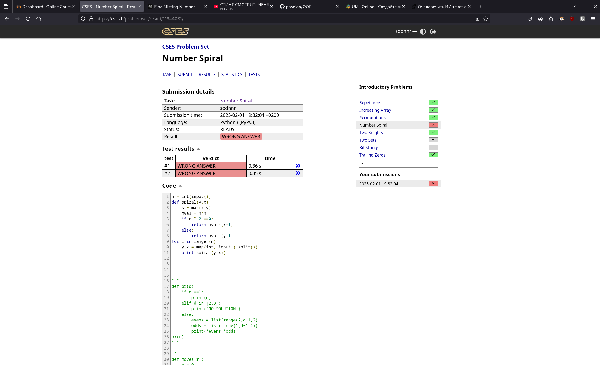
Trailing zero:
this one was not that
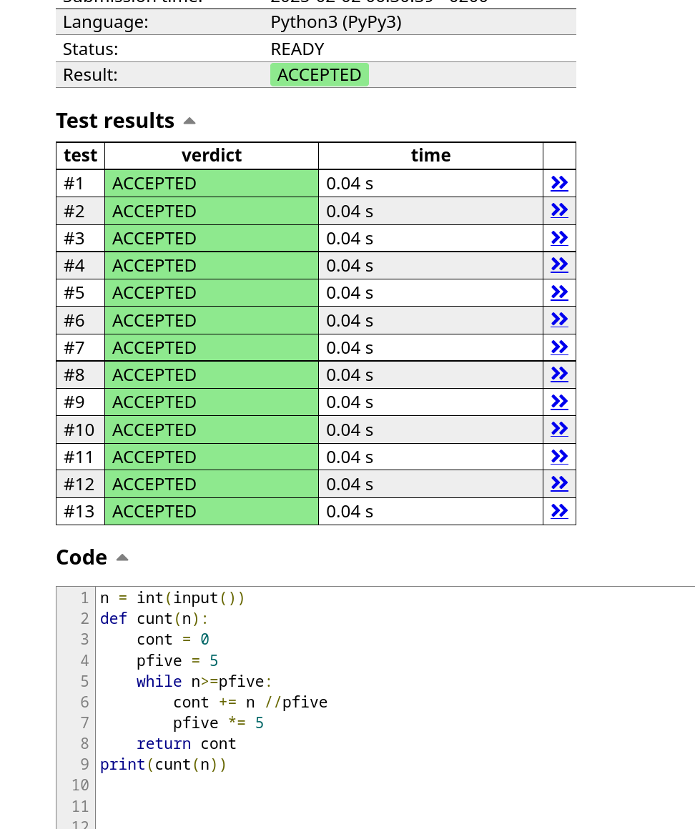
Coin piles:
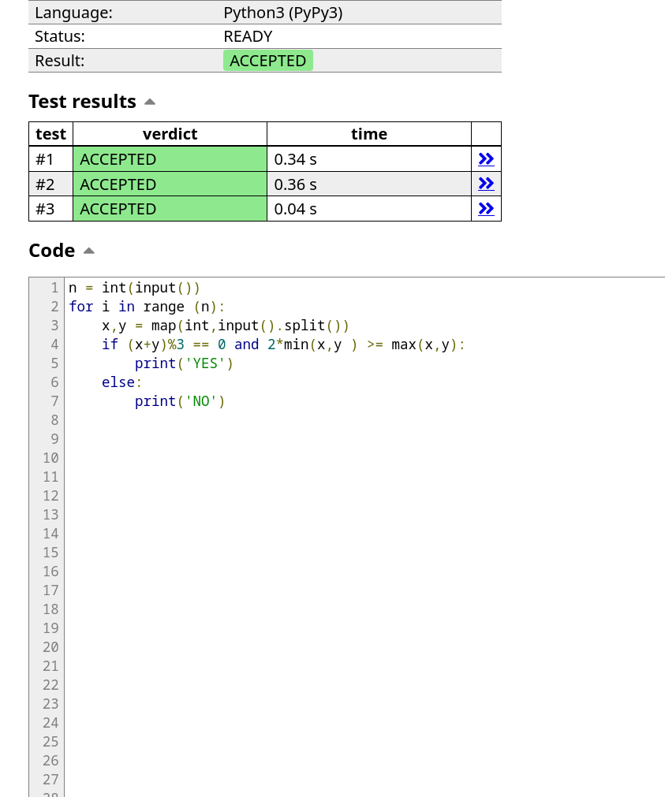
Palindrome reorder
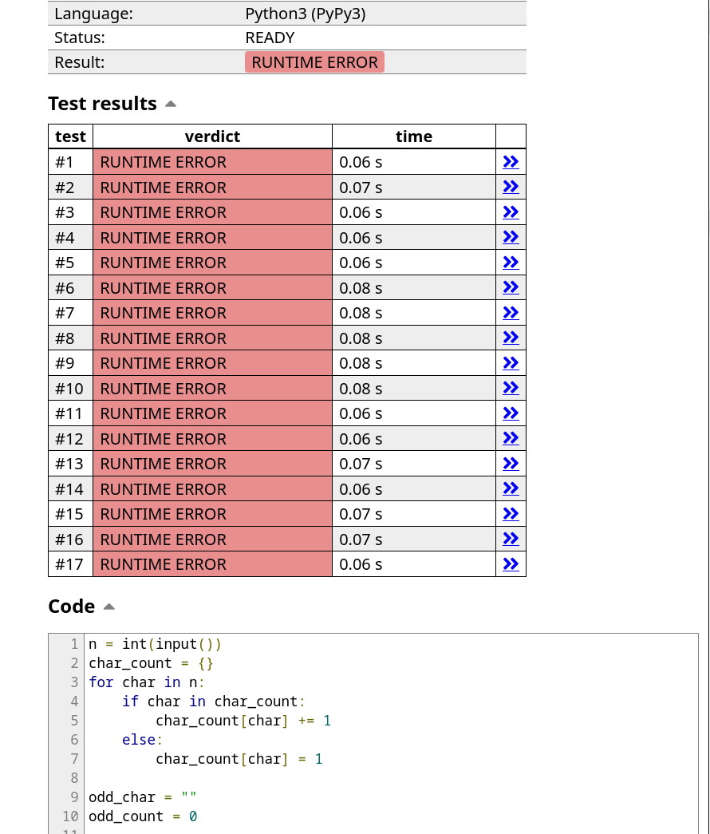
Gray code
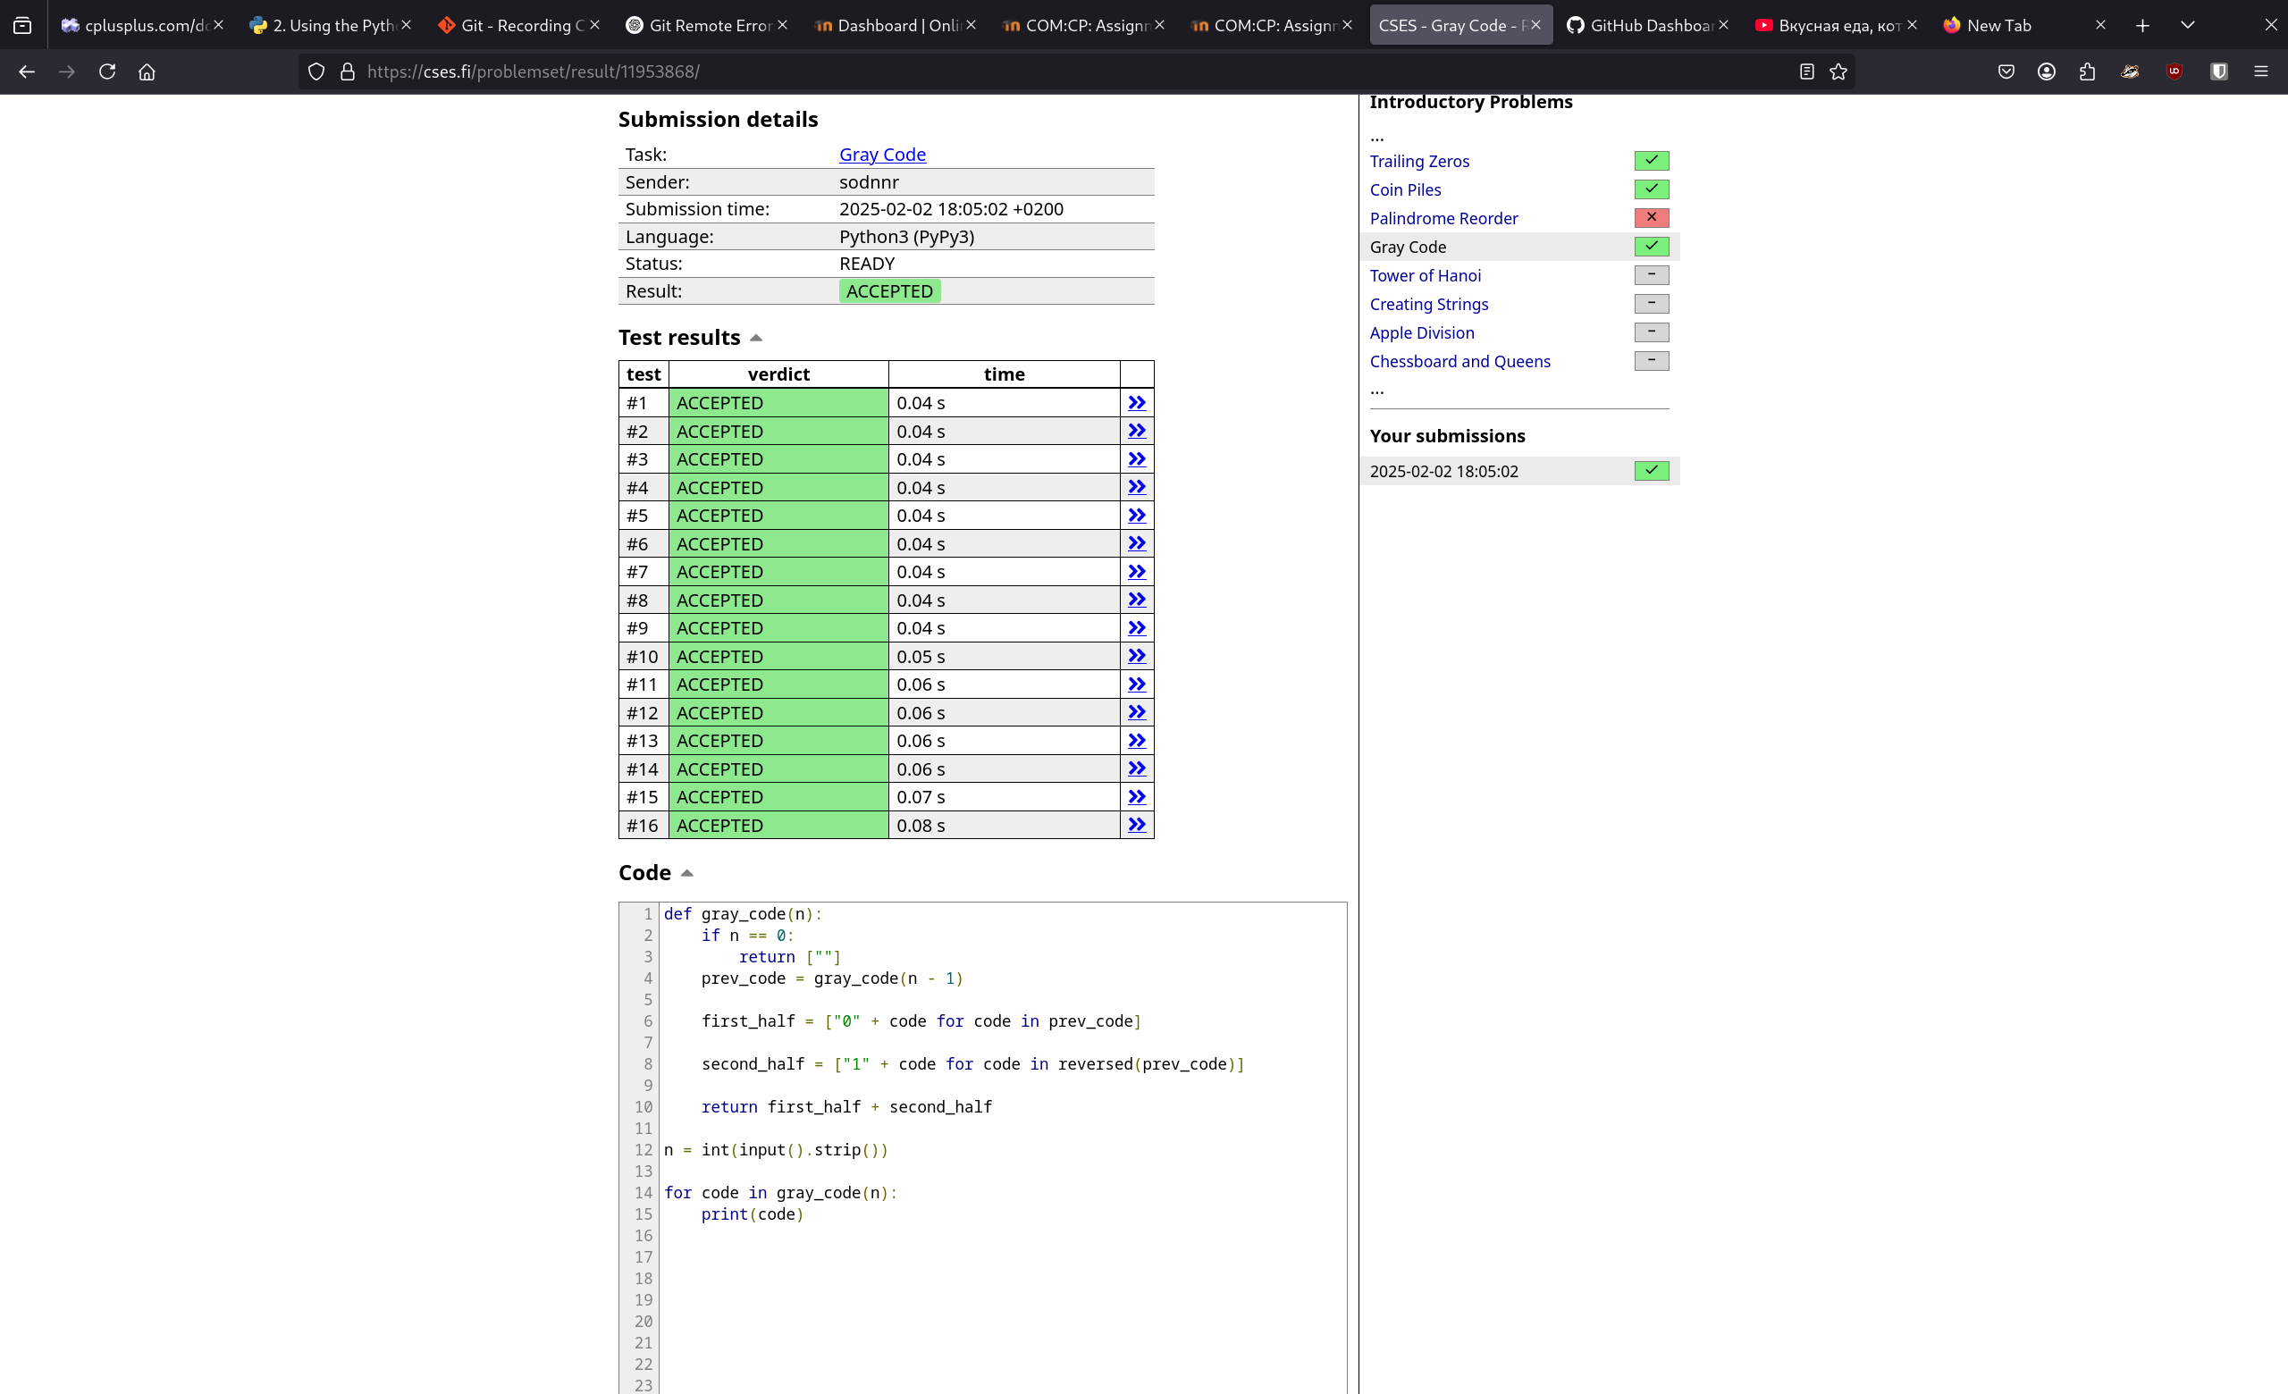
only the palindrome reorder was the problem. I didn’t get it. The others was normal I spend time quite a lot for these tasks, they was not that easy as the first two.

