Task 3
You are given a list of n integers, and your task is to calculate the number of distinct values in the list.
The first input line has an integer n: the number of values.
The second line has n integers x1​,x2​,…,xn​
Print one integers: the number of distinct values.
Here the problem with time I have no idea how to fix it.

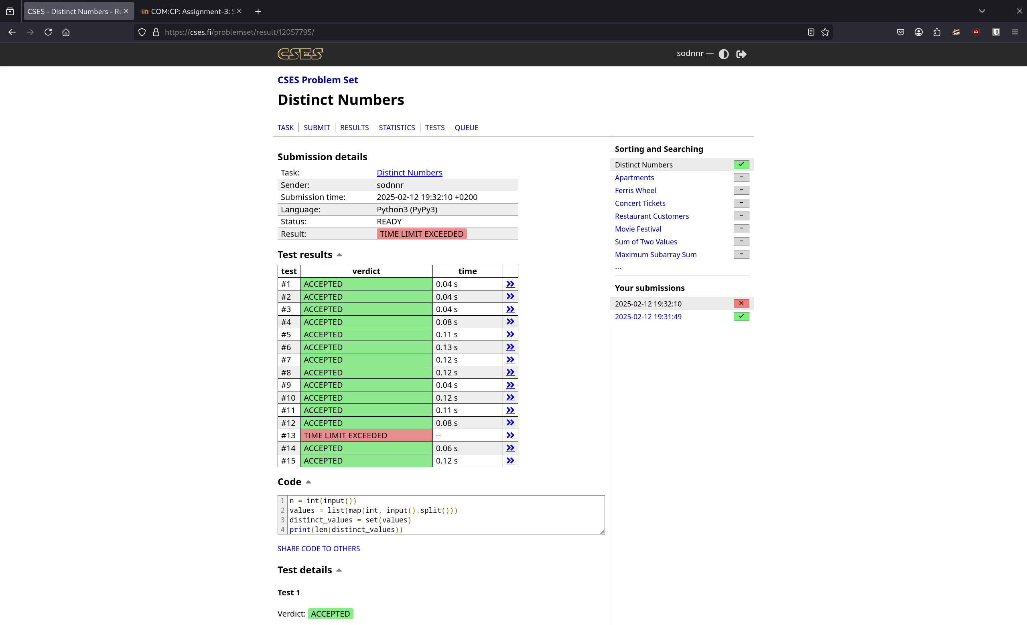

There are n applicants and m free apartments. Your task is to distribute the apartments so that as many applicants as possible will get an apartment.
Each applicant has a desired apartment size, and they will accept any apartment whose size is close enough to the desired size.
input
The first input line has three integers n, m, and k: the number of applicants, the number of apartments, and the maximum allowed difference.
The next line contains n integers a1​,a2​,…,an​: the desired apartment size of each applicant. If the desired size of an applicant is x, they will accept any apartment whose size is between x−k and x+k.
The last line contains m integers b1​,b2​,…,bm​: the size of each apartment.
output
Print one integer: the number of applicants who will get an apartment.
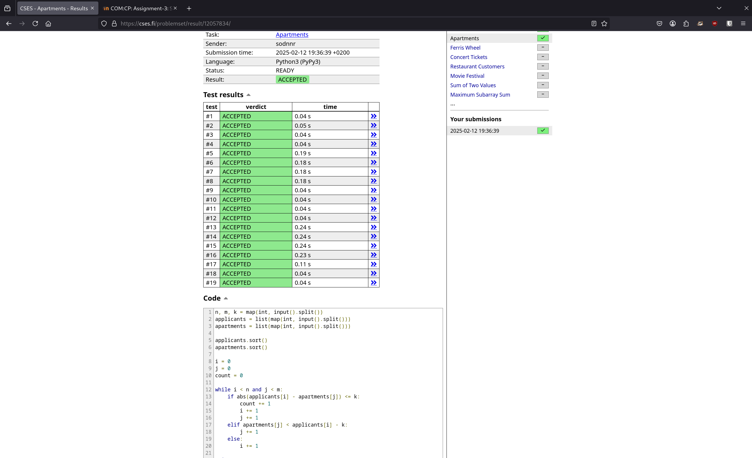
There are n children who want to go to a Ferris wheel, and your task is to find a gondola for each child.
Each gondola may have one or two children in it, and in addition, the total weight in a gondola may not exceed x. You know the weight of every child.
What is the minimum number of gondolas needed for the children?

Input
The first input line contains two integers n and x: the number of children and the maximum allowed weight.
The next line contains n integers p1​,p2​,…,pn​: the weight of each child.

Output
Print one integer: the minimum number of gondolas.
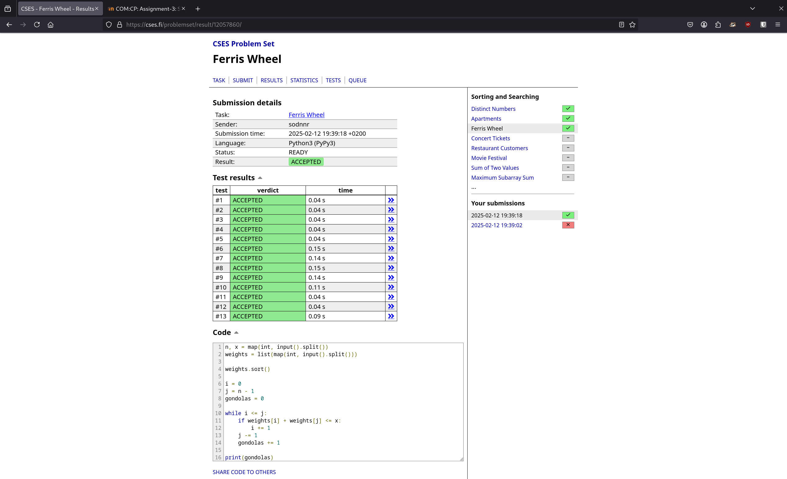
There are n concert tickets available, each with a certain price. Then, m customers arrive, one after another.
Each customer announces the maximum price they are willing to pay for a ticket, and after this, they will get a ticket with the nearest possible price such that it does not exceed the maximum price.

Input
The first input line contains integers n and m: the number of tickets and the number of customers.
The next line contains n integers h1​,h2​,…,hn​: the price of each ticket.
The last line contains m integers t1​,t2​,…,tm​: the maximum price for each customer in the order they arrive.

Output
Print, for each customer, the price that they will pay for their ticket. After this, the ticket cannot be purchased again.
If a customer cannot get any ticket, print −1.
Here the again problem with time limit maybe its because python
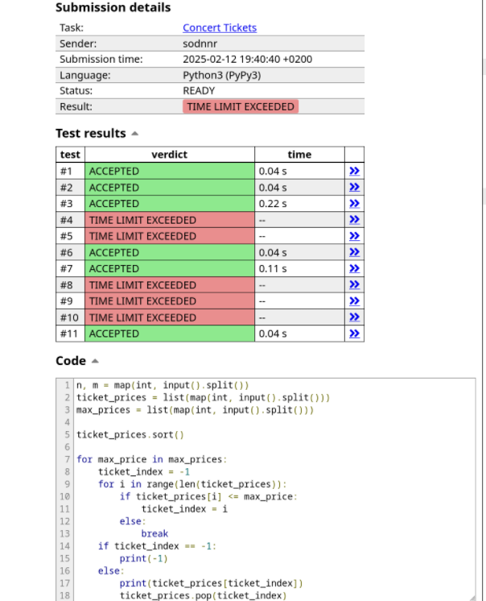

You are given the arrival and leaving times of n customers in a restaurant.
What was the maximum number of customers in the restaurant at any time?

Input
The first input line has an integer n: the number of customers.
After this, there are n lines that describe the customers. Each line has two integers a and b: the arrival and leaving times of a customer.
You may assume that all arrival and leaving times are distinct.

Output
Print one integer: the maximum number of customers.
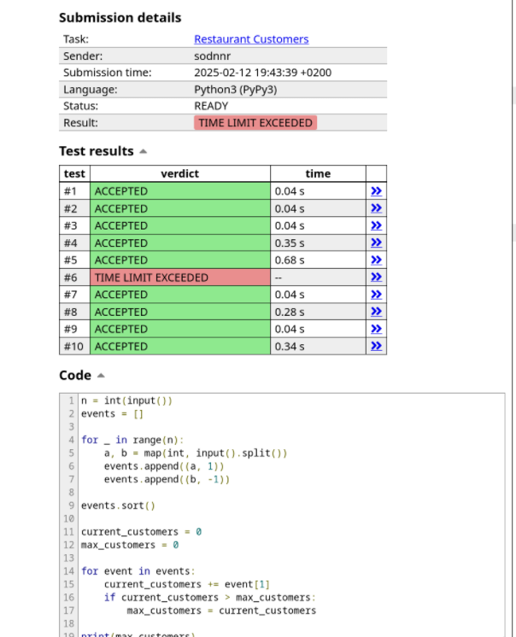
In a movie festival n movies will be shown. You know the starting and ending time of each movie. What is the maximum number of movies you can watch entirely?

Input
The first input line has an integer n: the number of movies.
After this, there are n lines that describe the movies. Each line has two integers a and b: the starting and ending times of a movie.

Output
Print one integer: the maximum number of movies.
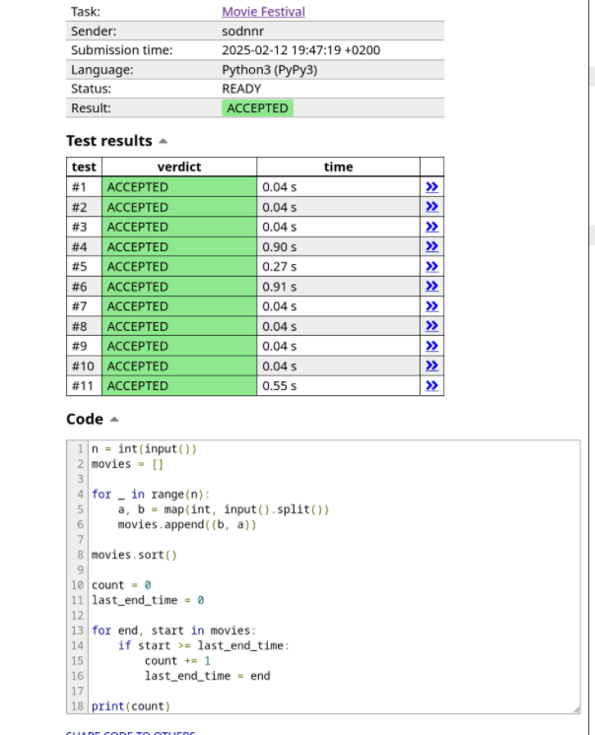
You are given an array of n integers, and your task is to find two values (at distinct positions) whose sum is x.

Input
The first input line has two integers n and x: the array size and the target sum.
The second line has n integers a1​,a2​,…,an​: the array values.

Output
Print two integers: the positions of the values. If there are several solutions, you may print any of them. If there are no solutions, print IMPOSSIBLE
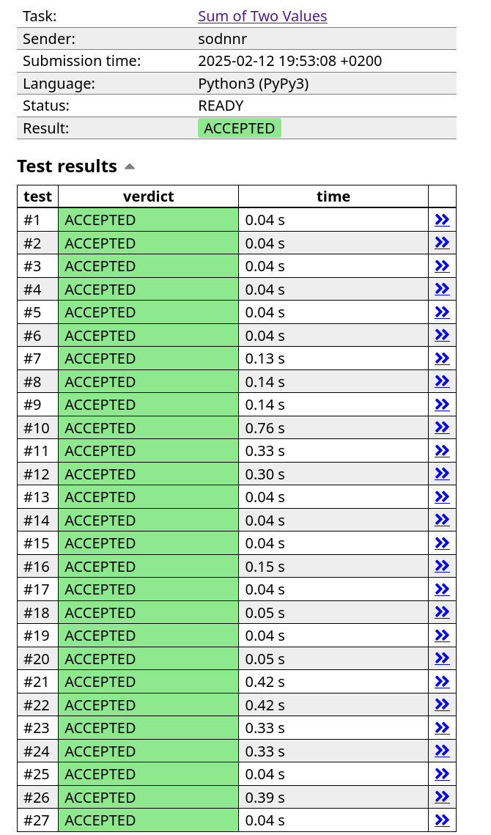

Given an array of n integers, your task is to find the maximum sum of values in a contiguous, nonempty subarray.

Input
The first input line has an integer n: the size of the array.
The second line has n integers x1​,x2​,…,xn​: the array values.

Output
Print one integer: the maximum subarray sum.

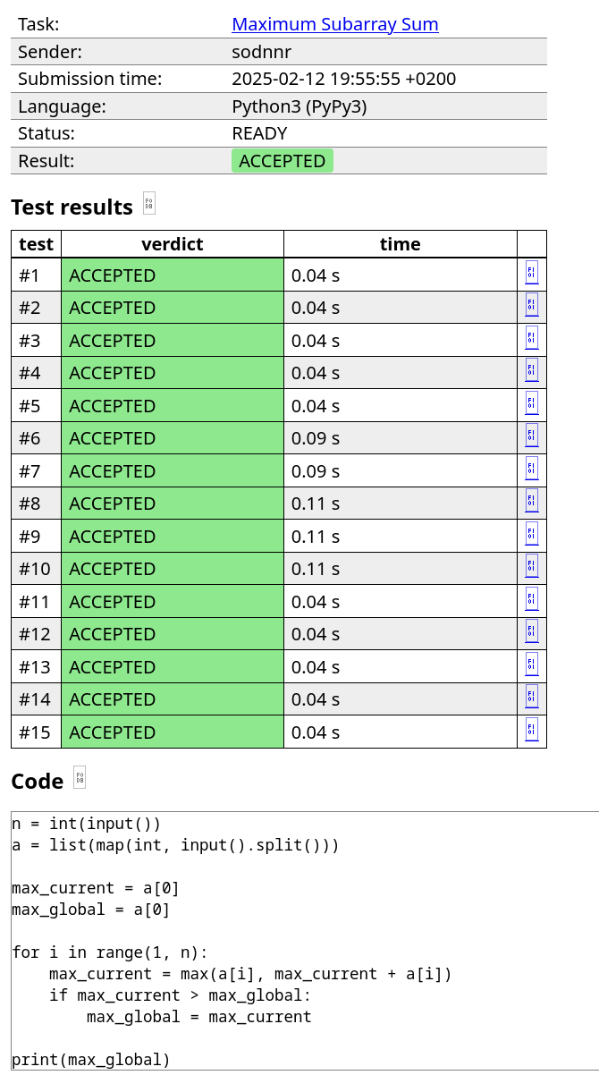
There are n sticks with some lengths. Your task is to modify the sticks so that each stick has the same length.
You can either lengthen and shorten each stick. Both operations cost x where x is the difference between the new and original length.
What is the minimum total cost?

Input
The first input line contains an integer n: the number of sticks.
Then there are n integers: p1​,p2​,…,pn​: the lengths of the sticks.

Output
Print one integer: the minimum total cost.
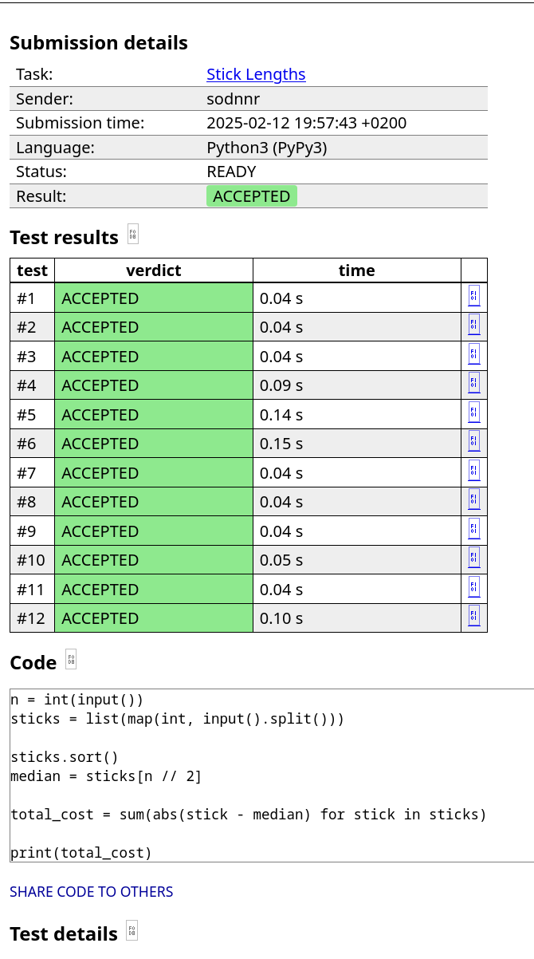
You have n coins with positive integer values. What is the smallest sum you cannot create using a subset of the coins?

Input
The first input line has an integer n: the number of coins.
The second line has n integers x1​,x2​,…,xn​: the value of each coin.

Output
Print one integer: the smallest coin sum.
