Question 2: For this question you’ll need to use SQL. Follow this link to access the data set required for the challenge. Please use queries to answer the following questions. Paste your queries along with your final numerical answers below.

1. How many orders were shipped by Speedy Express in total?
2. What is the last name of the employee with the most orders?
3. What product was ordered the most by customers in Germany?

A) How many orders were shipped by Speedy Express in total?

Solution

SELECT ods.shipperid, shp.shippername, COUNT(orderid) Total_shipped  
FROM orders ods  
JOIN shippers shp  
ON ods.shipperid = shp.shipperid  
GROUP BY ods.shipperid  
ORDER BY Total_shipped;  
LIMIT 1;

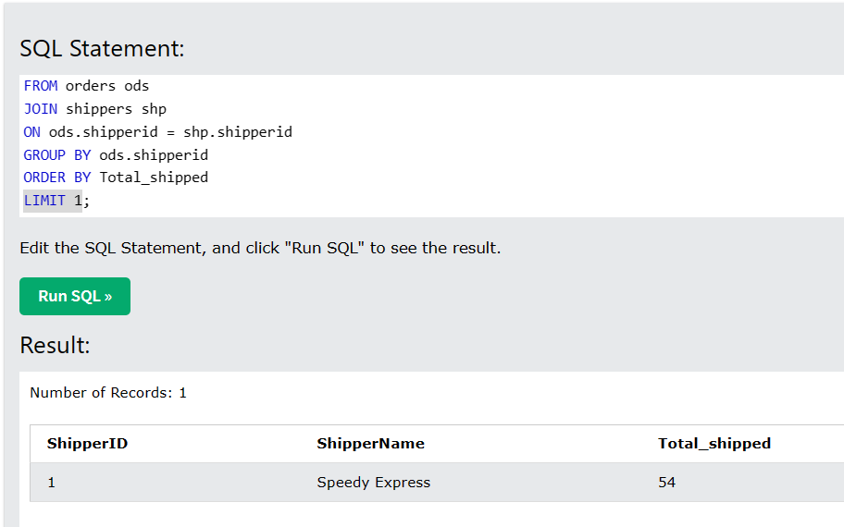

B) What is the last name of the employee with the most orders?

Solution

SELECT emp.lastname, COUNT(orderid) Total_order_per_emp  
FROM employees emp  
JOIN orders ods  
ON emp.employeeid = ods.employeeid  
GROUP BY ods.employeeid  
ORDER BY Total_order_per_emp DESC  
LIMIT 1;

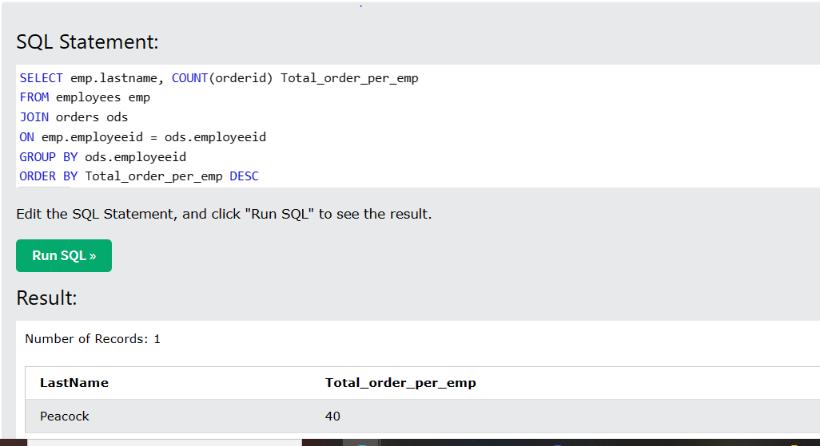

C) What product was ordered the most by customers in Germany?

Solution

SELECT p.productname, COUNT(orderdetailid) Most_order_product, cus.country  
FROM customers cus  
JOIN orders ods  
ON cus.customerid = ods.customerid  
JOIN orderdetails odds  
ON ods.orderid = odds.orderid  
JOIN products p  
ON p.productid = odds.productid  
WHERE cus.country = 'Germany'  
GROUP BY p.productname  
ORDER BY Most_order_product DESC  
LIMIT 1;

