**ANSIBLE**

**ANSIBLE is a configuration management tool**

**What is Configuration management?**

[Configuration management](https://www.netapp.com/devops-solutions/configuration-management) (CM) is an automated method for maintaining computer systems and software in a known, desired state.

**Automation History**

1. Bash Scripting / Batch Scripting
2. Python / Ruby
3. PowerShell
4. Puppet
5. Salt Stack
6. Chef
7. Ansible

**What is Ansible**

Ansible is an open-source automation tool, or platform, used for IT tasks such as [configuration management](https://www.simplilearn.com/configuration-management-2-article), application deployment, intraservice orchestration, and provisioning.

**Benefits of Ansible**

* **Simple:** Ansible is very simple tool.
* **Free:** Ansible is an open-source tool.
* **Very simple to set up and use:** No special [coding](https://www.simplilearn.com/tutorials/programming-tutorial/coding-for-beginners) skills are necessary to use Ansible’s playbooks
* **Powerful:** Ansible lets you model even highly complex IT workflows.
* **Flexible:**You can orchestrate the entire application environment no matter where it’s deployed. You can also customize it based on your needs.
* **Agentless:** You don’t need to install any other software or firewall ports on the client systems you want to automate. You also don’t have to set up a separate management structure.
* **YAML:** No Programming structured, its easy to read and write.

**Use cases of Ansible**

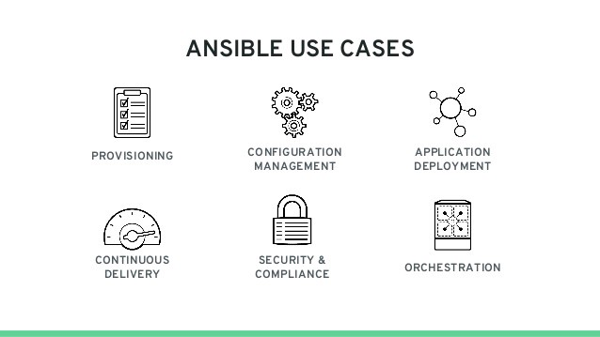

* Automation (Any system automation, Server, Database, configuration, start restart services)
* Change Management (Production server changes)
* Provisioning (Setup server from scratch or cloud provisioning)
* Orchestration (Large scale automation framework, can integrate with other tool like Jenkins, docker)

**Ansible Architecture**

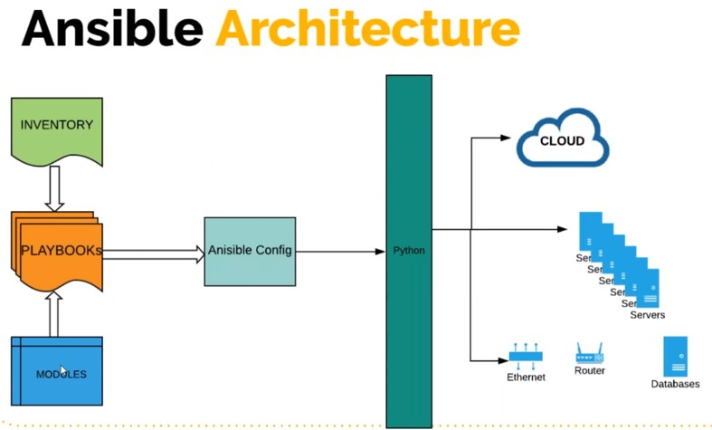

### **What is Ansible Playbook**

Playbooks are the files where the Ansible code is written. Playbooks are written in YAML format. YAML means "Yet Another Markup Language,". It is basically a blueprint of automation tasks—which are complex IT actions executed with limited or no human involvement.

### **What is Ansible Inventory**

Inventory file defines the hosts and groups of hosts upon which commands, modules, and tasks in a playbook operate. The file can be in one of many formats depending on your Ansible environment and plugins. The default inventory located at **/etc/ansible/hosts**

### **What is Ansible Config file**

The file that governs the behavior of all interactions performed by the control node. In Ansible’s case that default configuration file is (ansible.cfg) located in /etc/ansible/ansible.cfg.

### Ansible uses the python module, python script to connect to the target machine. It dumps the python script and execute there and return the output.

**Ansible Connections:**

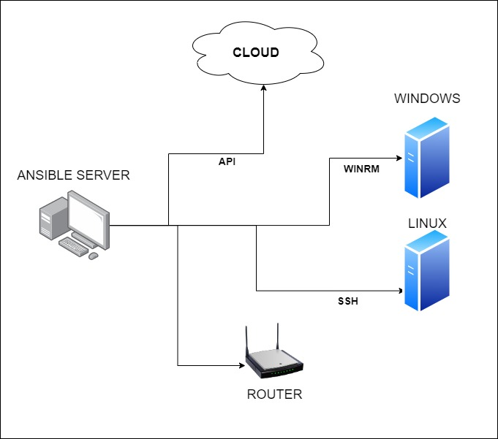

**Control machine**: A control machine is the central node in an Ansible infrastructure. It is used to manage all the other machines in the network.

**Remote machine**: A remote machine is any machine that is not the control machine. Remote machines are managed by the control machine using SSH.

**Target machine**: A target machine is a remote machine being provisioned or configured by Ansible.

**JSON and YAML**

**JSON YAML**

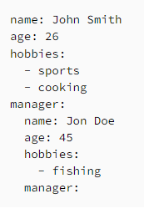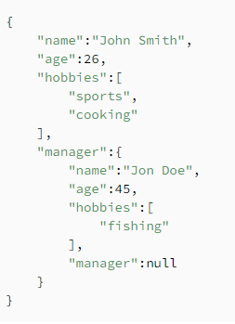

[**https://docs.ansible.com/ansible/latest/reference_appendices/YAMLSyntax.html**](https://docs.ansible.com/ansible/latest/reference_appendices/YAMLSyntax.html)

**ANSIBLE SETUP on AWS Cloud**

[**https://docs.ansible.com/ansible/latest/installation_guide/installation_distros.html**](https://docs.ansible.com/ansible/latest/installation_guide/installation_distros.html)

* Launch EC2 instance for Control Machine
  + Give a name as Control Machine
  + Select Ubuntu 18.04 image
  + Create a security group as “control-sg”
  + Create a Key pair as “control-key”
  + Copy and paste the Setup.sh script into User-data field
  + Launch the instance
* Let’s Launch EC2 instance for Target machine
  + Give a name as “Centos-target”
  + Select Centos 7 image from Marketplace
  + Keep t2.micro instance type
  + Give count as 2 machines
  + Create security group – webapp-sg
    - Allow port 22 from myip
    - Allow port 22 from “control-sg”
  + Create new key pair for these webapp instances.
* Let’s launch one more EC2 instance for database
  + Give a name as “db01”
  + Select Centos 7 image from Marketplace
  + Keep t2.micro instance type
  + Give count as 1 only
  + Create a key pair
  + Create a security group as “db-sg”
    - Allow port 22 from myip
    - Allow port 22 from “control-sg”

Let’s login to Control Machine

* Check Ansible version: - $ ansible –version
* Create a project folder: - $ mkdir sscademy
* Create exercises inside this dir:- $ mkdir exercise1

**Inventory and Ping Module**

Default/Global inventory location

**$ ls /etc/ansible/hosts**

**We can create our own inventory file inside the project directory. Its always best practice to create project specific inventory file.**

**$ cd exercise1**

**$ vim inventory**

web01 ansible_host=private_ip_of_web01 ansible_user=centos ansible_ssh_private_key_file=sscadmy-key.pem

web02 ansible_host=private_ip_of_web02 ansible_user=centos ansible_ssh_private_key_file=sscadmy-key.pem

db01 ansible_host=private_ip_of_db01 ansible_user=centos ansible_ssh_private_key_file=sscadmy-key.pem

:wq

**Create a ssh_key.pem file**

$ vim sscademy-key.pem

Copy and paste the .pem key content inside this

$ chmod 400 sscademy-key.pem

**Let’s test it**

$ ansible -i inventory -m ping web01

Now it will ask for the host path confirmation (yes/no).

Instead of supplying yes or no, we can handle it in better way by editing the **ansible.cfg** file

$ sudo vim /etc/ansible/ansible.cfg

Find an entry called “**host_key_checking**”

Make it uncommented, **host_key_checking: False**

**Save and quit**

**=====================================================**

Now run ansible ad-hoc command again.

$ ansible -i inventory -m ping web01

$ ansible -i inventory -m ping web02

$ ansible -i inventory -m ping db01

Instead of pinging individual servers, we can make server group in the Inventory file.

$ vim inventory

web01 ansible_host=private_ip_of_web01 ansible_user=centos ansible_ssh_private_key_file=sscadmy-key.pem

web02 ansible_host=private_ip_of_web02 ansible_user=centos ansible_ssh_private_key_file=sscadmy-key.pem

db01 ansible_host=private_ip_of_db01 ansible_user=centos ansible_ssh_private_key_file=sscadmy-key.pem

[webservergrp]

web01

web02

[dbservergrp]

db01

[dc_nverginia:children]

webservergrp

dbservergrp

Now run ansible ad-hoc command again.

$ ansible -i inventory -m ping webservergrp

$ ansible -i inventory -m ping dbservergrp

$ ansible -i inventory -m ping dc_nverginia

$ ansible -i inventory -m ping all

$ ansible -i inventory -m ping ‘*’

$ vim inventory

web01 ansible_host=private_ip_of_web01

web02 ansible_host=private_ip_of_web02

db01 ansible_host=private_ip_of_db01 ansible_user=centos ansible_ssh_private_key_file=sscadmy-key.pem

[webservergrp]

web01

web02

[dbservergrp]

db01

[dc_nverginia:children]

webservergrp

dbservergrp

[webservergrp:vars]

ansible_user=centos

ansible_ssh_private_key_file=sscadmy-key.pem

[dc_nverginia:children]

ansible_user=centos

ansible_ssh_private_key_file=sscadmy-key.pem

Test now

$ ansible -i inventory -m ping all

**Ad Hoc Commands**

$ cp -r exercise1/ exercise2

$ cd exercise2

**Commands:**

**Example 1:**

$ ansible -i inventory -m yum -a “name=httpd state=present” web01

$ ansible -i inventory -m yum -a “name=httpd state=present” web01 –become

*Run same command and check what will happen*

**Example 2:**

$ ansible -i inventory -m service -a “name=httpd state=started enabled=yes” web01 –become

**Example 3:**

$ vim index.html

$ ansible -i inventory -m copy -a “src=index.html dest=/var/www/html/index.html” web01 –become

**ANSIBLE PLAYBOOKS written in YAML**

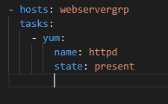

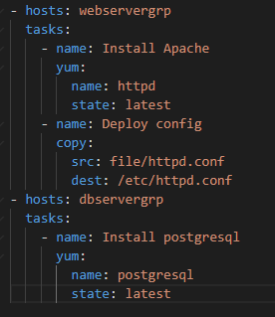

**Now lets start writing the Ansible playbooks**

* + Refer 2nd_playbook.yaml
  + After writing the playbooks if you want to check the syntax then you can use the command
    - $ ansible-playbook -i inventory 2_playbook.yaml –syntax-check
    - $ ansible-playbook -i inventory 2_playbook.yaml

**ANSIBLE MODULES**

List all the ansible modules

$ ansible-doc -l

$ ansible-doc yum

<https://docs.ansible.com/ansible/2.9/modules/modules_by_category.html>

$ ansible-playbook -i inventory 2_playbook.yaml -C

We can test the playbook before it actually applied. We call this as dry run.

Run 4_db.yaml playbook to understand how to install mysql, add database

Now you will get an error for python.

Lets login to database server using ssh

$ yum search python | grep -i mysql

Copy the package name and we are going to add in the playbook

Now you can refer 5_db.yaml playbook.

Execute the playbook again.

$ ansible-playbook -i inventory 5_db.yaml

Now lets add a database user

Refer 6_db.yaml playbook

$ ansible-playbook -i inventory 6_db.yaml

**Ansible Configuration Settings**

**Order of Ansible Config**

1. **ANSIBLE_CONFIG (environment variable if set)**
2. **ansible.cfg (in the current directory)**
3. **~/. ansible.cfg (in the home directory)**
4. **/etc/ansible/ansible.cfg**

Let’s explore the global ansible.cfg from **/etc/ansible/ansible.cfg**

After exploring the global configuration, lets create local ansible configuration in the project directory

**$ /ACM/exercise4/vi ansible.cfg**

[defaults]

host_key_checking = False

inventory = ./inventory

forks = 5

log_path = /var/log/ansible.log

[privilege_escalation]

become = True

become_method = sudo

become_ask_pass = False

Let’s test the ansible using this configuration

$ ansible-playbook 4_db.yaml

$ sudo touch /var/log/ansible.log

$ sudo chown ubuntu.ubuntu /var/log/ansible.log

$ ansible-playbook 4_db.yaml

$ cat /var/log/ansible.log

$ ansible-playbook 4_db.yaml –vv

--vv – verbosity

**Ansible Variables**

1. Playbook Variables
2. Inventory Based Variables

* In Inventory File
* group_vars/all
* group_vars/groupname
* host_vars/hostname

1. Roles

1. **Playbook variables**

Let’s refer the variables defines inside the playbook.

**7_db_with_vars.yaml**

**8_db_with_vars_debug.yaml**

1. **Inventory Based Variables**
   1. Variables for Groups –

**group_vars/all**

**group_vars/groupname**

* 1. Variables for hosts –

**host_vars/hostname**

1. **Variables for Groups**

$ cp -r exercise6/* exercise7

$ cd exercise7

$ mkdir group_vars

$ vim group_vars/all

# Variables accessible by ALL the Hosts from the Inventory file

dbuser: devopsadmin

dbpass: test123

dbname: devops

$ ansible-playbook 9_db_with_vars_from_groupvars.yaml

1. **Variables for Host**

$ cp -r exercise7/* exercise8

$ cd exercise8

$ rm -rf db.yaml index.html group_vars/all

Refer 10_vars_precedence.yaml

Now let’s create **group_vars/all** file

$ mkdir group_vars

$ vim group_vars/all

USERNM: globaluser

COMMNT: variable from group_vars/all

**Now we can see that the precedence of the variables goes to variables mentioned in the playbook. If we comment the variables from the playbook, then it will take from group_vars/all.**

Let’s work on **group_vars/groupname**

As we have given the target machines group names in the inventory file, we can create the groupname file with same name.

**E.g. $ vi group_vars/webservergrp**

USERNM: webservergrpuser

COMMNT: variable from group_vars/webserver file

Let’s work on **host_vars/hostname**

As we have given the target machines names in the inventory file, we can create the hostname file with same name.

E.g. $ mkdir host_vars

$ vi host_vars/hostname

$ vi host_vars/web02

USERNM: web02user

COMMNT: variable from host_vars/web02 file

So you have seen the highest priority goes first to playbook 🡪 host_vars/hostname🡪 group_vars/groupname 🡪 group_vars/all

One more thing which super seeds all the priorities, which is variables passed through command line

$ ansible-playbook -e USERNM=cliuser -e COMMNT=cli vars_precendence.yaml