CodeSPrint UI – GIft Card

HTML5, CSS3, Javascript, Bootstrap

Please read the document carefully!

Follow the guidelines including project naming conventions!

Contents

Technology to use: 2

Template code URL: 2

Use-case: 2

Landing page: 2

Guidelines: 2

Place gift card order page: 3

Guidelines: 3

View gift card order page: 4

Guidelines: 4

Contact Us page: 4

Key Notes: 5

Team work: 5

Repository Naming Convention (Strict): 5

Example: 5

Deployment/Demonstration: 5

Recommendation: 5

Proposed team-task distribution: 6

Bonus feature (OPTIONAL): 6

# Technology to use:

HTML5, CSS3, Javascript, Bootstrap

# Template code URL:

<https://github.com/FSDIIHT/codesprint-giftcard-ui>

# Use-case:

Create a responsive website with following pages:

1. Landing page
2. Place Gift card order page
3. View Gift Card orders page
4. Contact Us page

# Landing page:

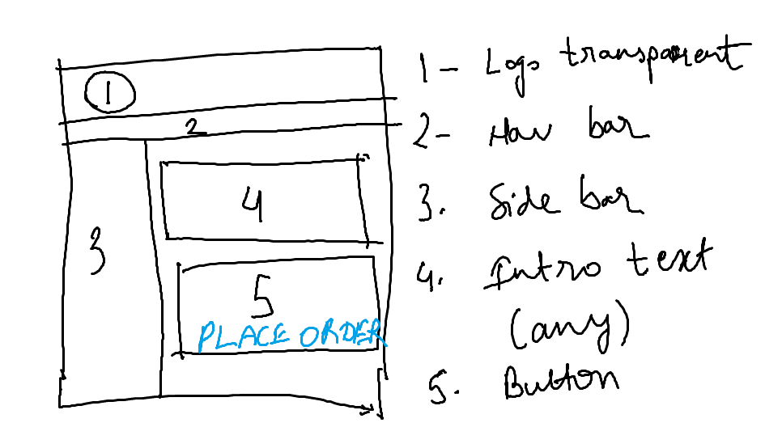

## Guidelines:

1. “Place Order” i.e. 5 is a big full page button.
2. Page is responsive.
3. Use bootstrap navbar for 2
4. Logo image must be rounded using bootstrap
5. Nav-bar and Side-bar will contain menu items:
   1. Home
   2. Place Gift card order
   3. View Gift Card orders
   4. Contact Us
6. Navbar, sidebar and logo (header) must be repeated on all pages.

# Place gift card order page:

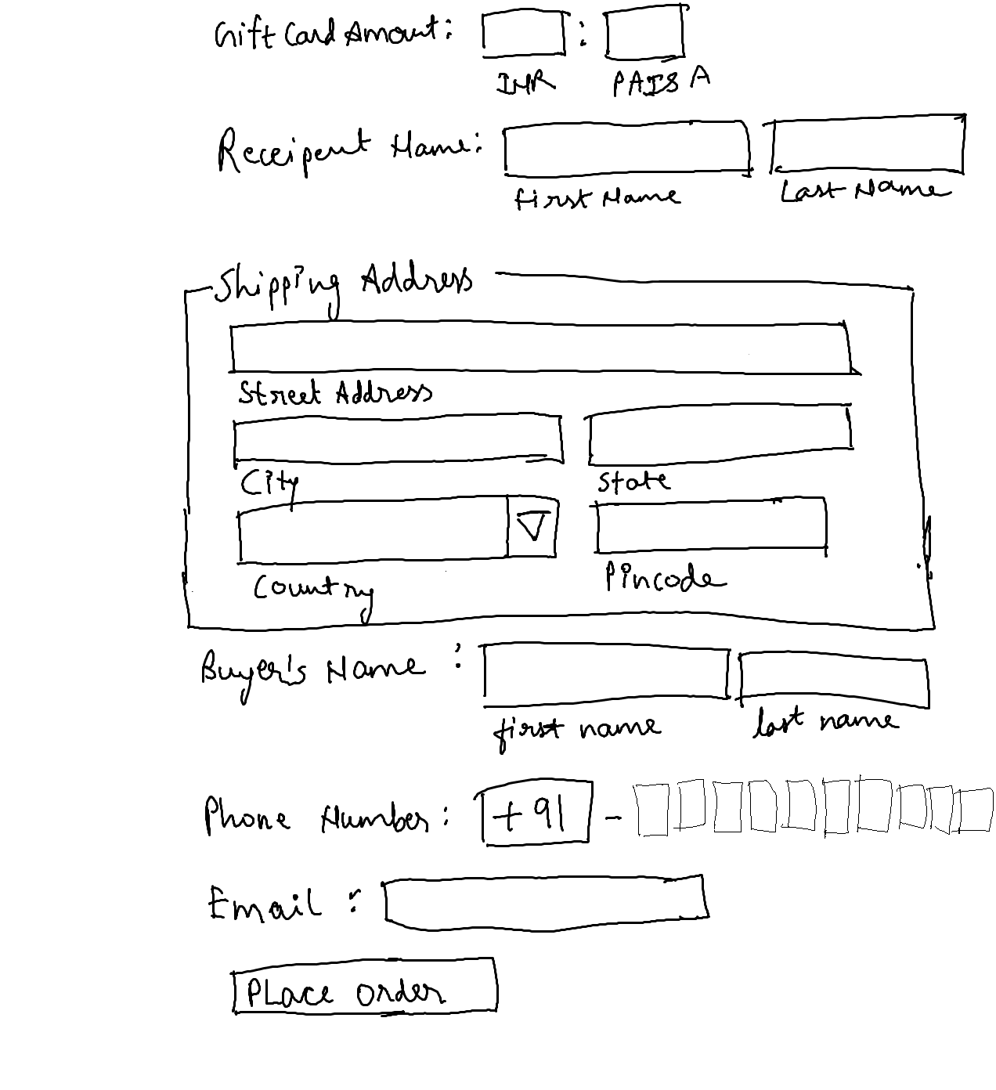

## Guidelines:

1. On the page load, input focus must come to gift card amount input field.
2. You should be able to press “TAB” key and “SHIFT + TAB” to navigate from top field to bottom field and vide-versa.
3. On click of “Place order” button, gift card order details must be saved in local storage OR web storage
4. Gift card amount must allow numbers only
5. Minimum value for paise must be 0.
6. Maximum value for paise must be 100.
7. Firstname and Lastname must not allow numbers.
8. Use fieldset for shipping address.
9. In shipping address, input field labels must be below input fields as shown in image.
10. Pincode must allow only number. The length of number must be 6. Length less than 6 or more than 6 is not allowed.
11. Buyers name must not allow numbers.
12. You have to implement 10 text input fields for mobile number. Each text field will allow input of 1 number between 0 to 9. First text filed must not allow 0. The input focus should move automatically from one text field to another after input of number.
13. Use email validation for email field.

# View gift card order page:

It must display all gift card orders in responsive table:

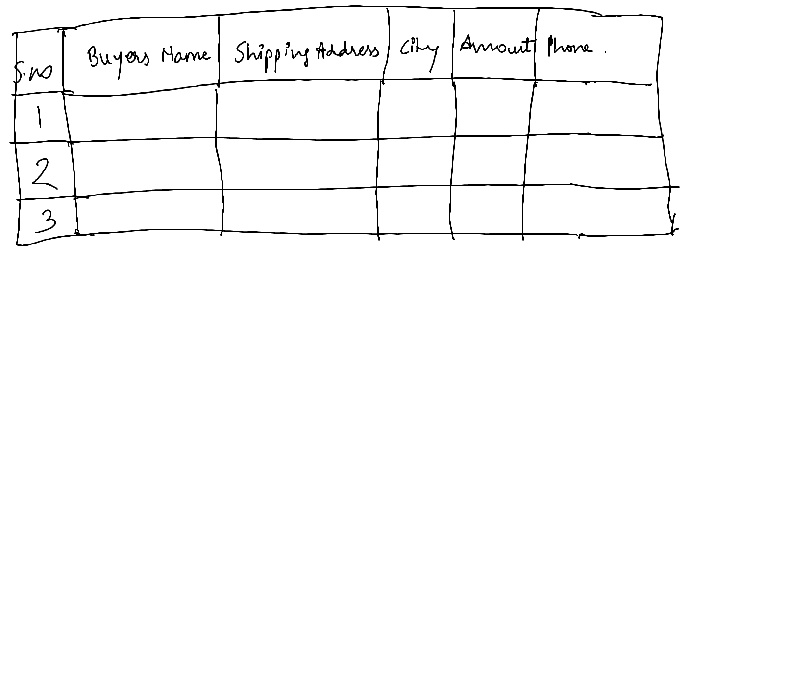

## Guidelines:

1. Table must be responsive.
2. Table must load data from local storage OR web storage.

# Contact Us page:

1. Implement generic contact us form with basic fields and basic validation.
2. It is to your discretion:
   1. To choose the layout of contact form.
   2. To choose alignment of form on the page.
   3. To implement/non-implement the validation for each field in form.
   4. To choose number of fields in contact us form.

# Key Notes:

## Team work:

1. You have to develop this UI as one of the team member.
2. Mentor will be assigning you part/module/feature of UI, to be designed by you.
3. Your team will have to integrate all modules in any one machine before final presentation/demo.

## Repository Naming Convention (Strict):

1. Create two repositories in your github account.
   1. 123456-codesprint-ui-mywork
   2. 123456-codesprint-ui-teamwork
2. Strictly, follow the github repository naming convention, else we will not be able to track and review your submission. It may be as good as not participating in codesprint.
   1. associateid-codesprint-ui-mywork:
      1. it will contain the module/feature developed by you.
      2. only associateid will change as per each associate. Rest of the repository name will remain same.
      3. associateid-codesprint-ui-mywork must contain mywork.txt file.
      4. you must document your work/role, describe the module developed, any challenges faced in the file mywork.txt
   2. associateid-codesprint-ui-teamwork repository will contain complete integrated UI solution where, each module is developed by different associates.

## Example:

1. If my associate Id is 123456 and my team includes members with associate id 123457, 123458, 123459, 123460 and 123461. In above team, 123460 is team lead. Each of the team member will work on respective module/feature assigned to them. Mentor will moderate the same.
   * 1. In given scenario, my github account will contain 2 repository:
        1. 123456-codesprint-ui-mywork
        2. 123460-codesprint-ui-teamwork
        3. 123456 will commit the code in his/her repo on github so that same can be used for integration.
        4. Integrated solution will be present in 123460-codesprint-ui-teamwork
2. 123456-codesprint-ui-mywork will contain mywork.txt,
3. Mywork.txt will describe my work/role in team. The sample is given in github template.

## Deployment/Demonstration:

1. Once solution is integrated, you may use:
   1. <https://ngrok.com/> (It may require installation)
   2. OR
   3. <https://www.npmjs.com/package/live-server>
   4. To deploy/demo the solution in network

## Recommendation:

1. I will recommend you to use live-server to develop/test your feature/module as well.

# Proposed team-task distribution:

1. Mentor may distribute the task for the team as per his/her discretion as per local circumstances and team skills.
2. Proposed modules:
   1. Developer 1:
      1. Homepage + Contact Us Page
   2. Developer 2:
      1. Form development 1 - All fields and validations excluding shipping address
   3. Developer 3:
      1. Form development 2 – shipping address part of form
   4. Developer 4:
      1. Saving to localstorage
      2. Reading from localstorage
   5. Developer 5:
      1. View gift card orders page
   6. …
   7. …
   8. …
   9. …
   10. Developer n
       1. Some task…

# Bonus feature (OPTIONAL):

Develop below feature to get 10 extra bonus points:

1. Place order button on “place gift card order” page must be disabled till all form validations are passed.