Hex Board Information V1

1) Each Hex Cell
Each hex cell has the same base image as show in diagram 1. The measurements are shown in the key below.
NB: This graphic is not a “perfect hexagon”, but just an approximation for optimised implementation. (So formulas using √3 not applicable here !!!)
When combining the cells together to form a grid, the graphics are over-layed by one pixel in both the x and y direction.
The base image, which is provided by static/assets/hex2.png, has the dimension of 91 x 81.

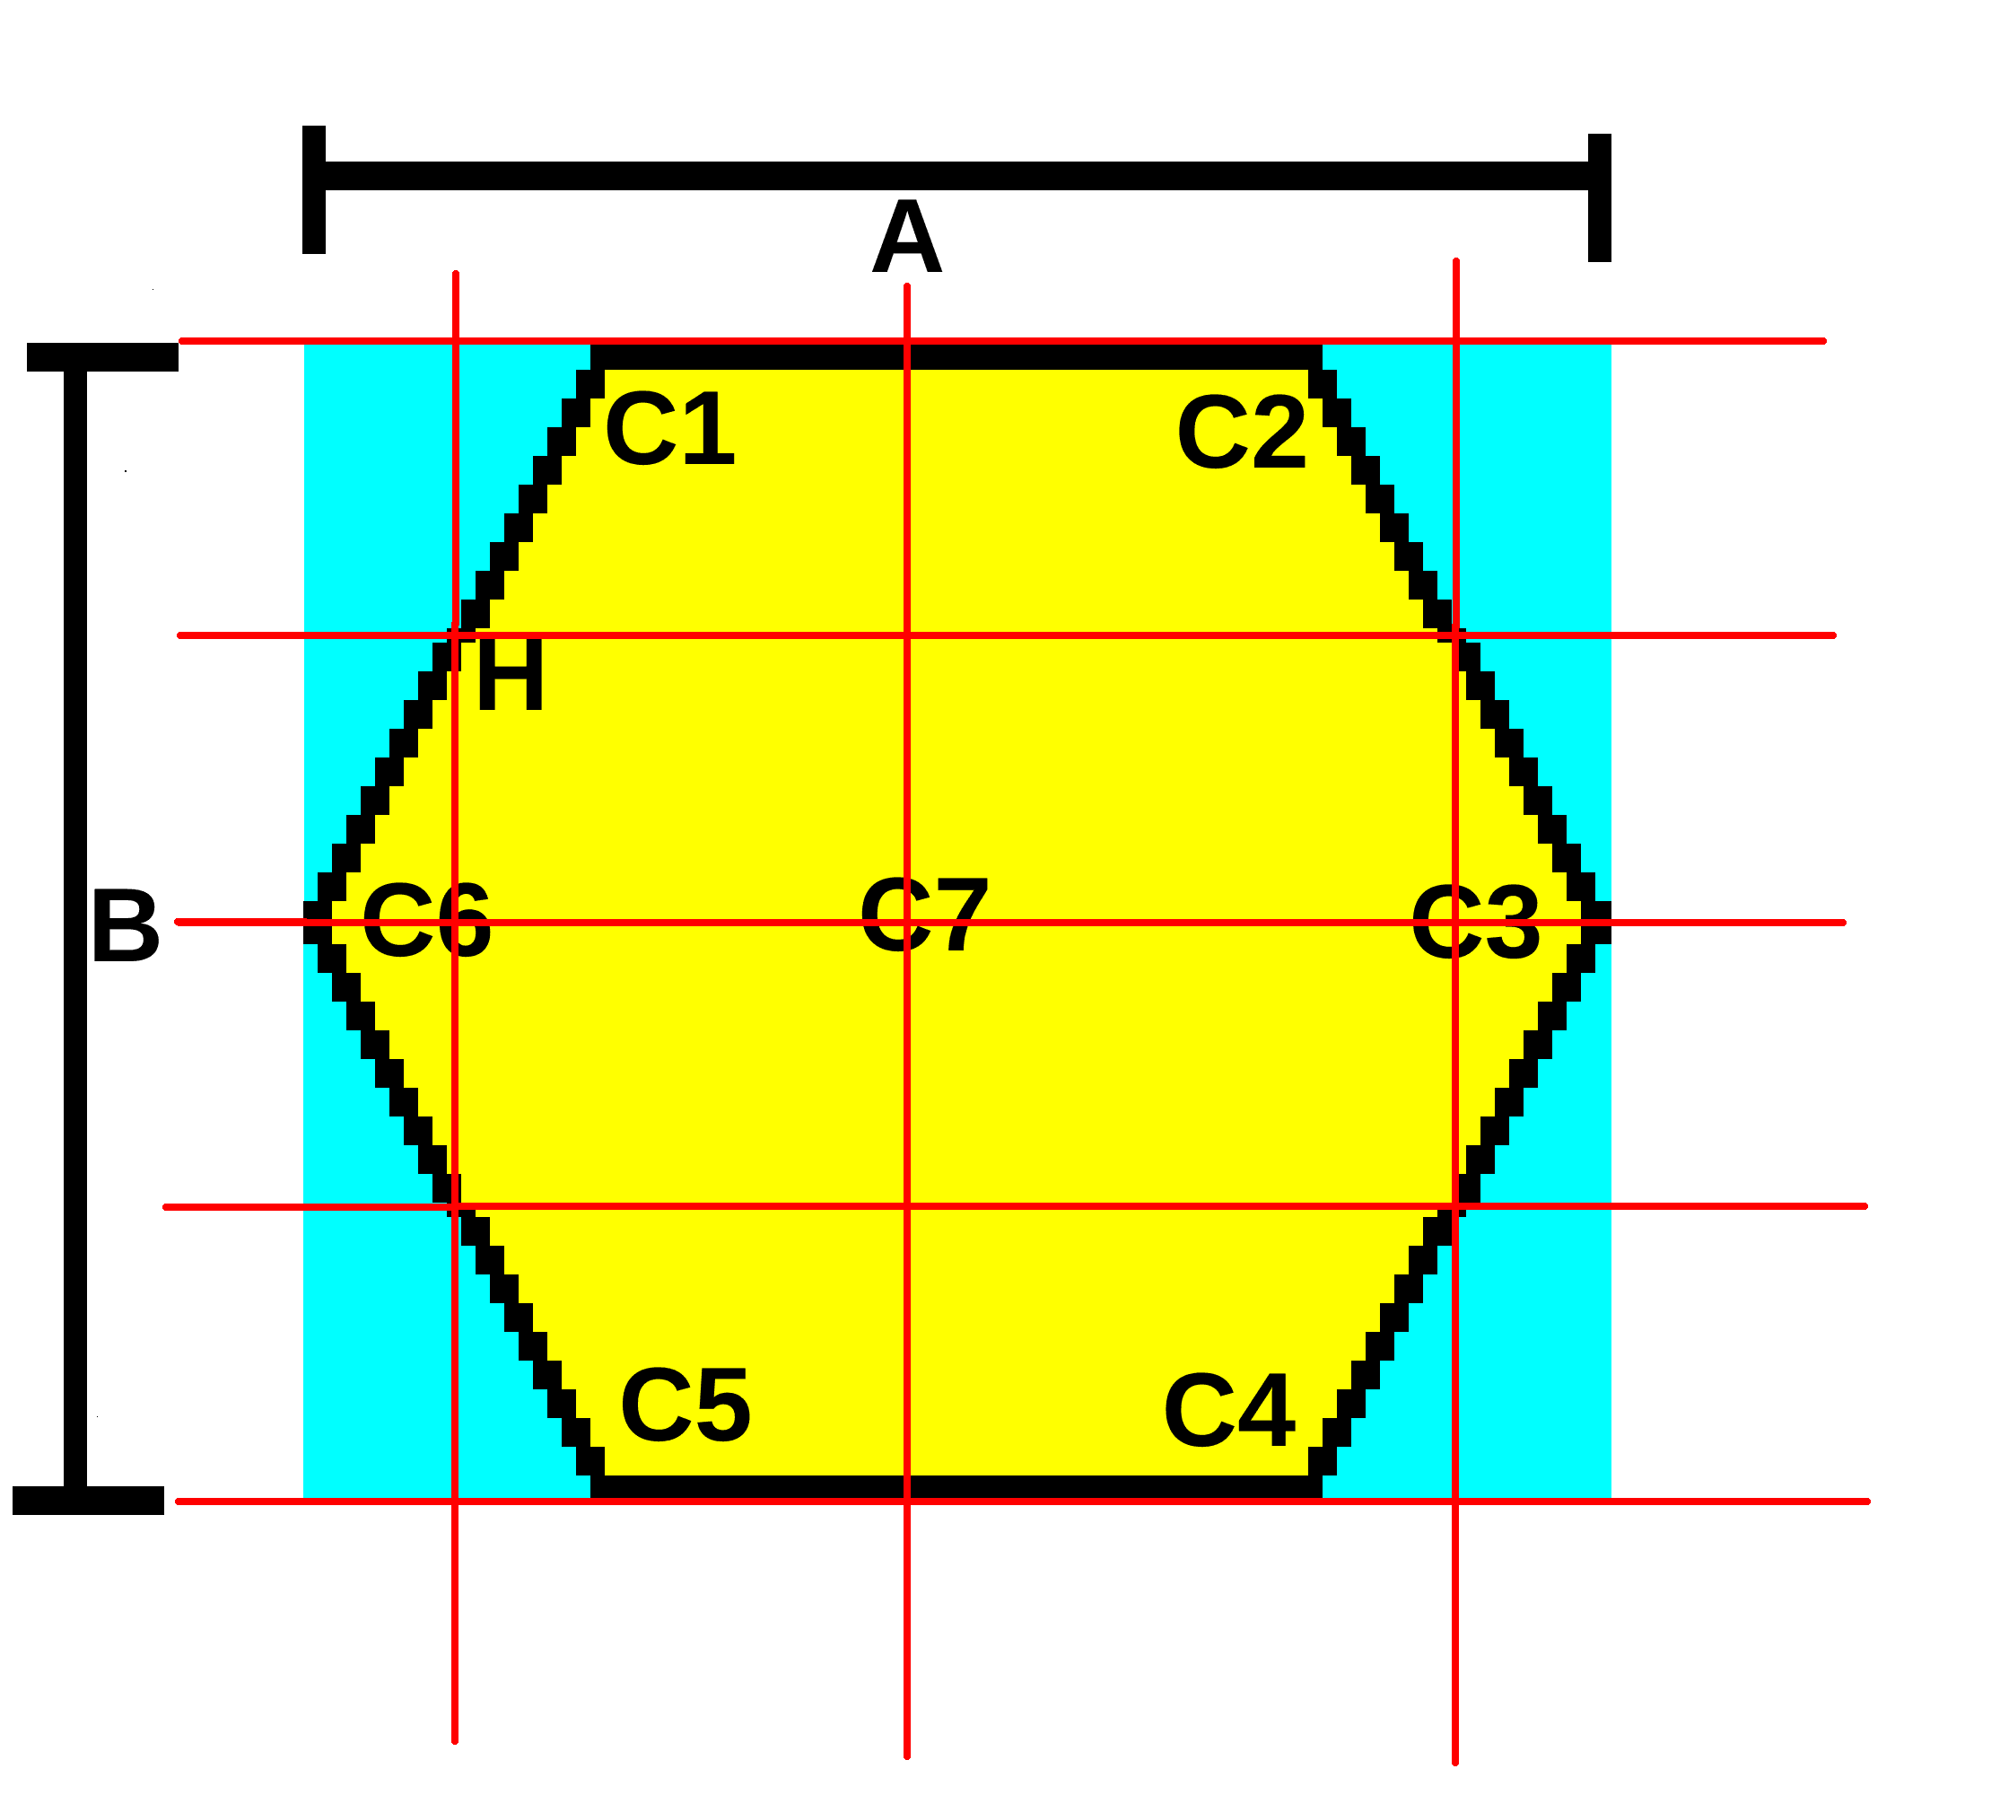Diagram 1

Key
A = 91 width of graphic (but last pixel row will be overlapped unless last row of hexes)
B = 81 height of graphic (but last pix column will be overlapped unless last column of hexes)
C1= (20,0)
C2 = (70,0)
C3 = (90,40)
C4 = (70,80)
C5 = (20,80)
C6 = (0,40)
C7 = (45,40)
H = (10,20)
The Cyan areas are transparent in hex2.png
The Yellow area is coloured by the program according to requirements.
The Red lines indicate the rectanguler Cartesian grid used by the (original) program to convert mouse coordinates to hex cell coordinates

Assuming the above dimensions, then the centres of hexagons are calculated using formulas containing “xWidth” and xHeight” where …

xWidth = 70 … this is the number of pixels to add to a hex centre x coord to reach the vertical centre line of the next hex (because the next hex is at at different y position in the grid)

yHeight = 40 … this is the number of pixels to add to a hex centre y coord to reach the next hexagon below (because the next hex is at at different x position in the grid)

2) Hex Board Examples:
In diagram 2, the size of the board is “2”. This value indicates the number of major hexagon rings that make up one side of the hexagon. A major hexagon ring is a ring of 6 small hexagons (as defined in the previous section) plus one extra black hexagon at the centre. (So a total of 7)
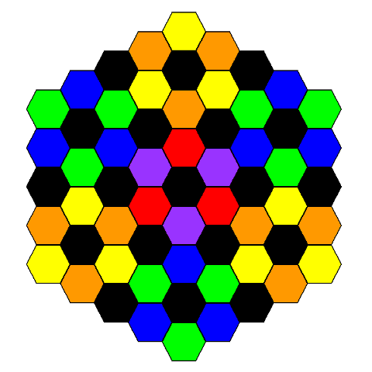Diagram 2

In Diagram 3, the hex board size is 3

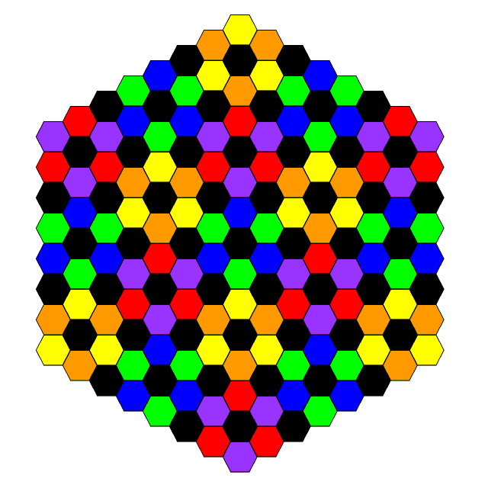Diagram 3

3) The Coordinate Systems

The coordinate systems are based on information taken from the website …

https://www.redblobgames.com/grids/hexagons/

… this implementation uses “odd-q” vertical layout with double height horizontal layout and double row values (diagram 4). Also the cubic grid coordinates (diagram 5) are supported.

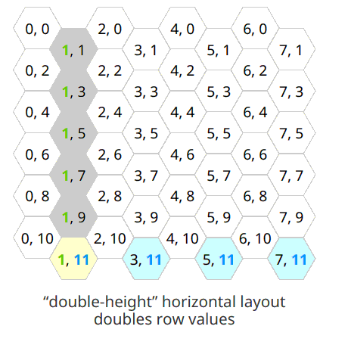Diagram 4

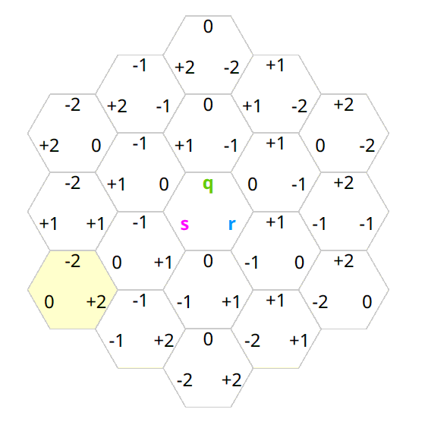Diagram 5

