Q2PRO-X 1.6 Beta 5 by ly
Q2PRO-X 1.6 Beta 5 AVFX Advanced Features Guide

Project author: ly
Celestial bodies, volumetric media, surface materials and map-authored scenes
English edition • Q2PRO-X 1.6 Beta 5 by ly • 2026-10-10

Contents
The entries are links: click one to jump to that section.
Materials and reflections in beta 3
Metallic materials and reflections: beta 2
What this guide covers
How to read this
A map of the subsystems
1. Sky and space
1.1. What is available
1.2. Modern and real sky
1.3. Stars, the Milky Way and constellations
1.4. Sun, Moon and Earth
1.5. Meteors, comets and spaceships
1.6. The black hole
2. Volumetric media
2.1. Volumetric fog
2.2. Volumetric clouds
2.3. Backends and volumetric media
3. Water, puddles and reflections
3.1. Water
3.2. Puddles
3.3. Three classes of reflection
3.4. Mirror Surfaces
4. Surface materials
4.1. What they are
4.2. Floor and wall coverings
4.3. Grass
4.4. Wildlife
5. Map-authored content
5.1. Surface drawing
5.2. Volumetric steam and smoke
5.3. Why the generator never touches them
6. Local effects and sound
6.1. Flashlight and monster contacts
6.2. AVFX audio
7. Diagnostics and frame cost
7.1. What you can inspect without any debug mode
7.2. A practical tuning order for your own machine
7.3. Competitive play
8. Presets and custom sets
9. Quick reference

Materials and reflections in beta 3
Existing metals gain improved reflective response, anisotropy and antialiasing. The metal catalog itself was introduced in beta 2.
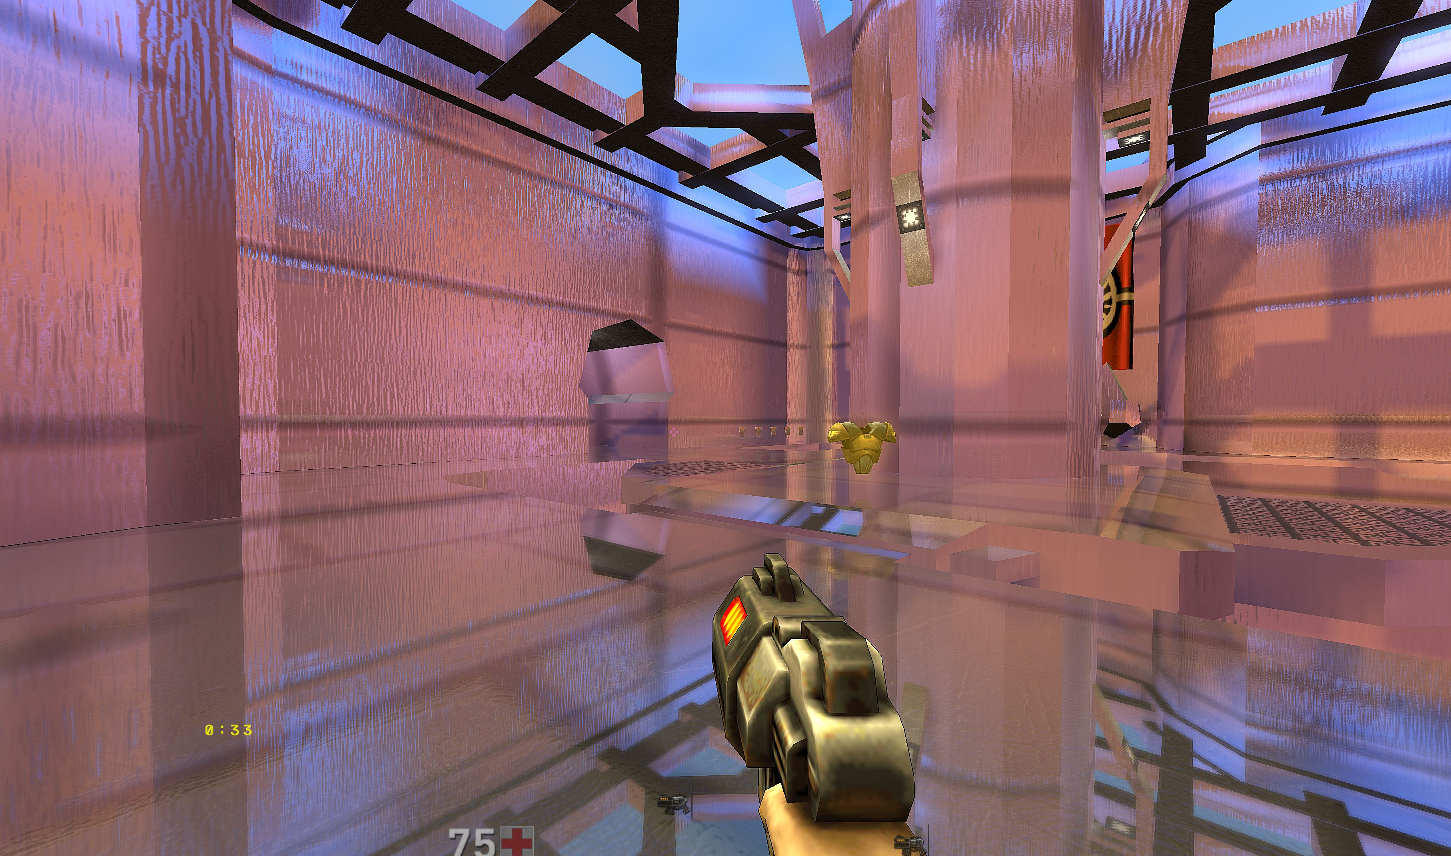
Updated metallic surface appearance.
Brick geometry forms individual rectangular bricks with joints. Expensive detail follows visibility and projected size; it is separate from the user LOD switches.
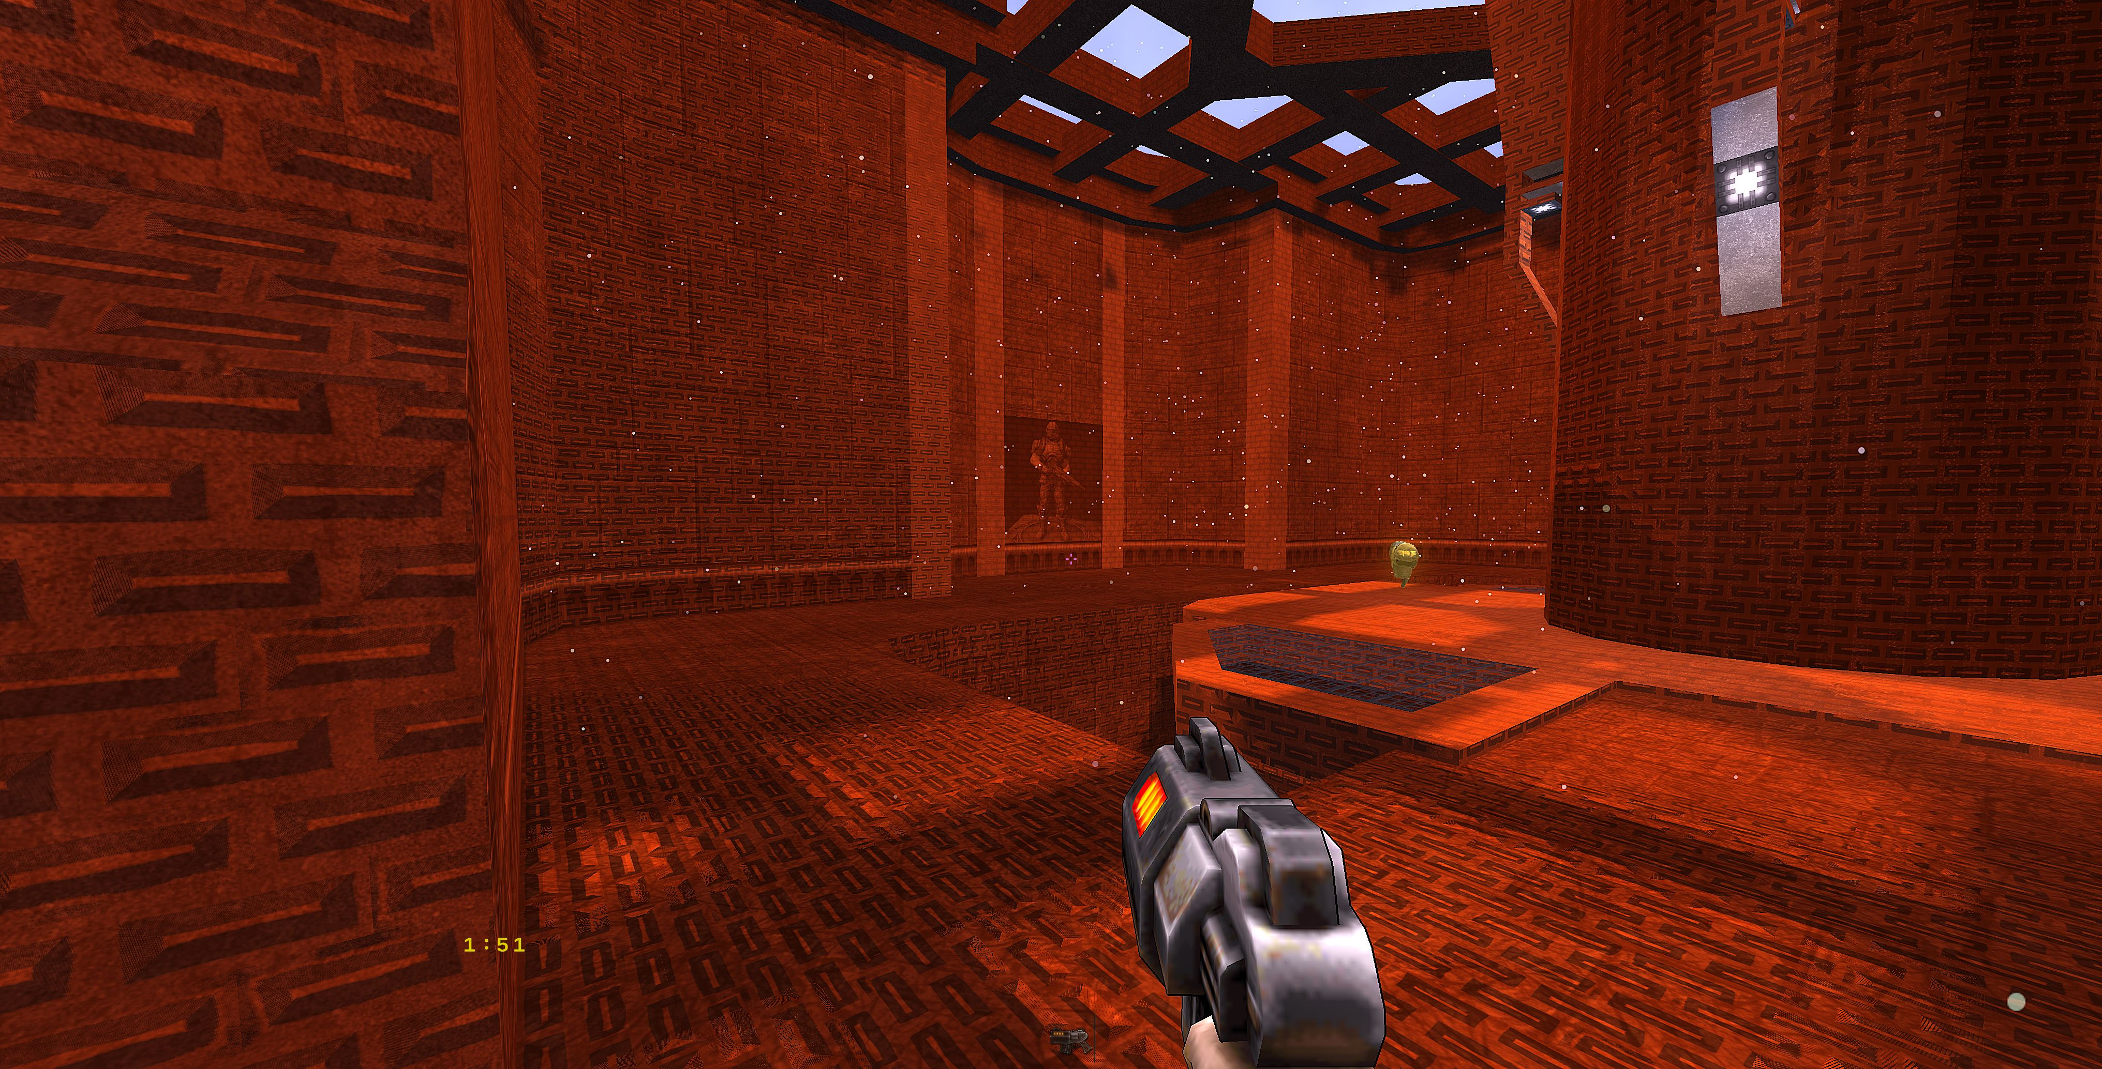
Brick material without geometry.
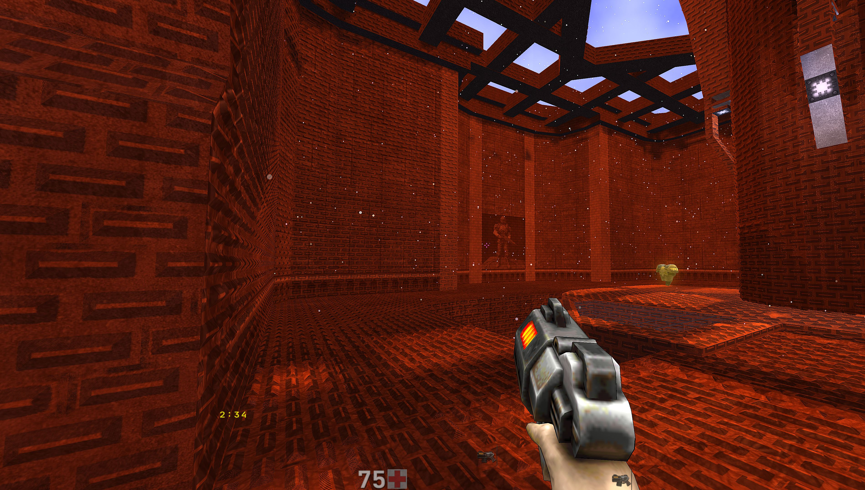
The same view with individual brick geometry.
Fixed dark squares and shaking after generation, the water/lava tessellation master, and model-highlight composition in mirrors and puddles. Puddles can separately reflect vegetation and falling leaves, excluding stones, soil and leaves on the ground. Reduced repeated work is not a fixed-FPS guarantee; complex puddle SSR can still be expensive.

Metallic materials and reflections: beta 2
Floor and wall material pickers now include a metal category: 32 variants each, IDs 129–160. Existing IDs 1–128 are unchanged. An opaque covering uses its own material pattern instead of inheriting the underlying map texture. Existing scale, density, relief and other covering controls retain their purpose. A metallic material does not automatically enable the separate Mirror Surfaces system.
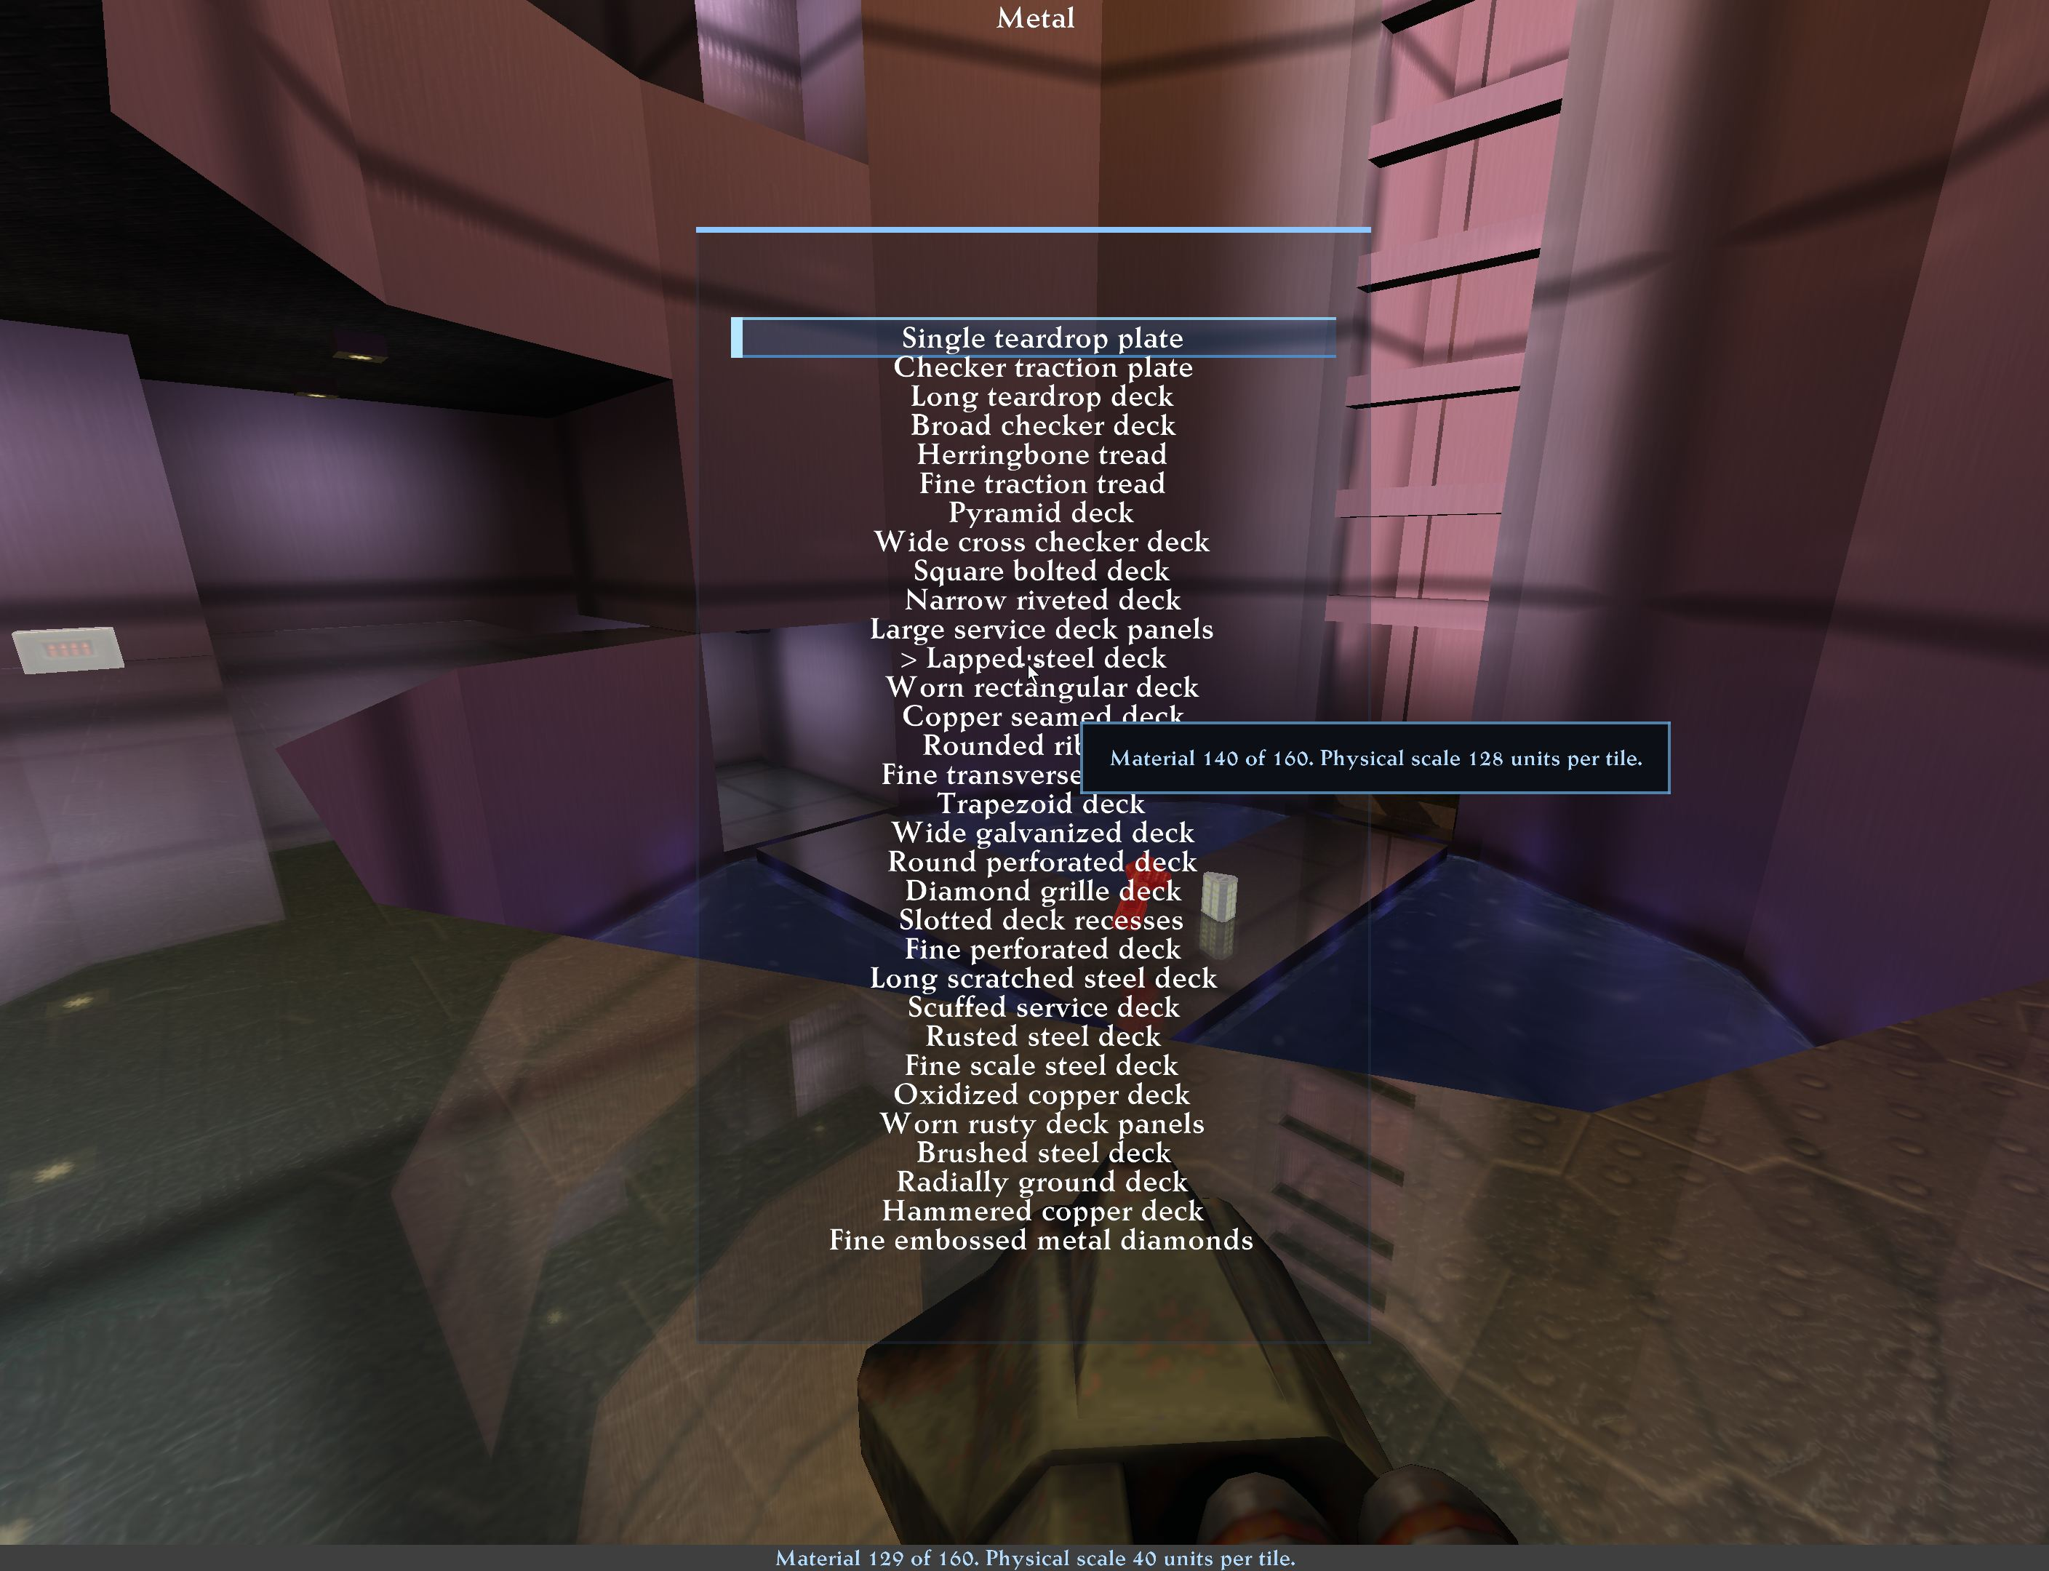
Metallic floor material category.
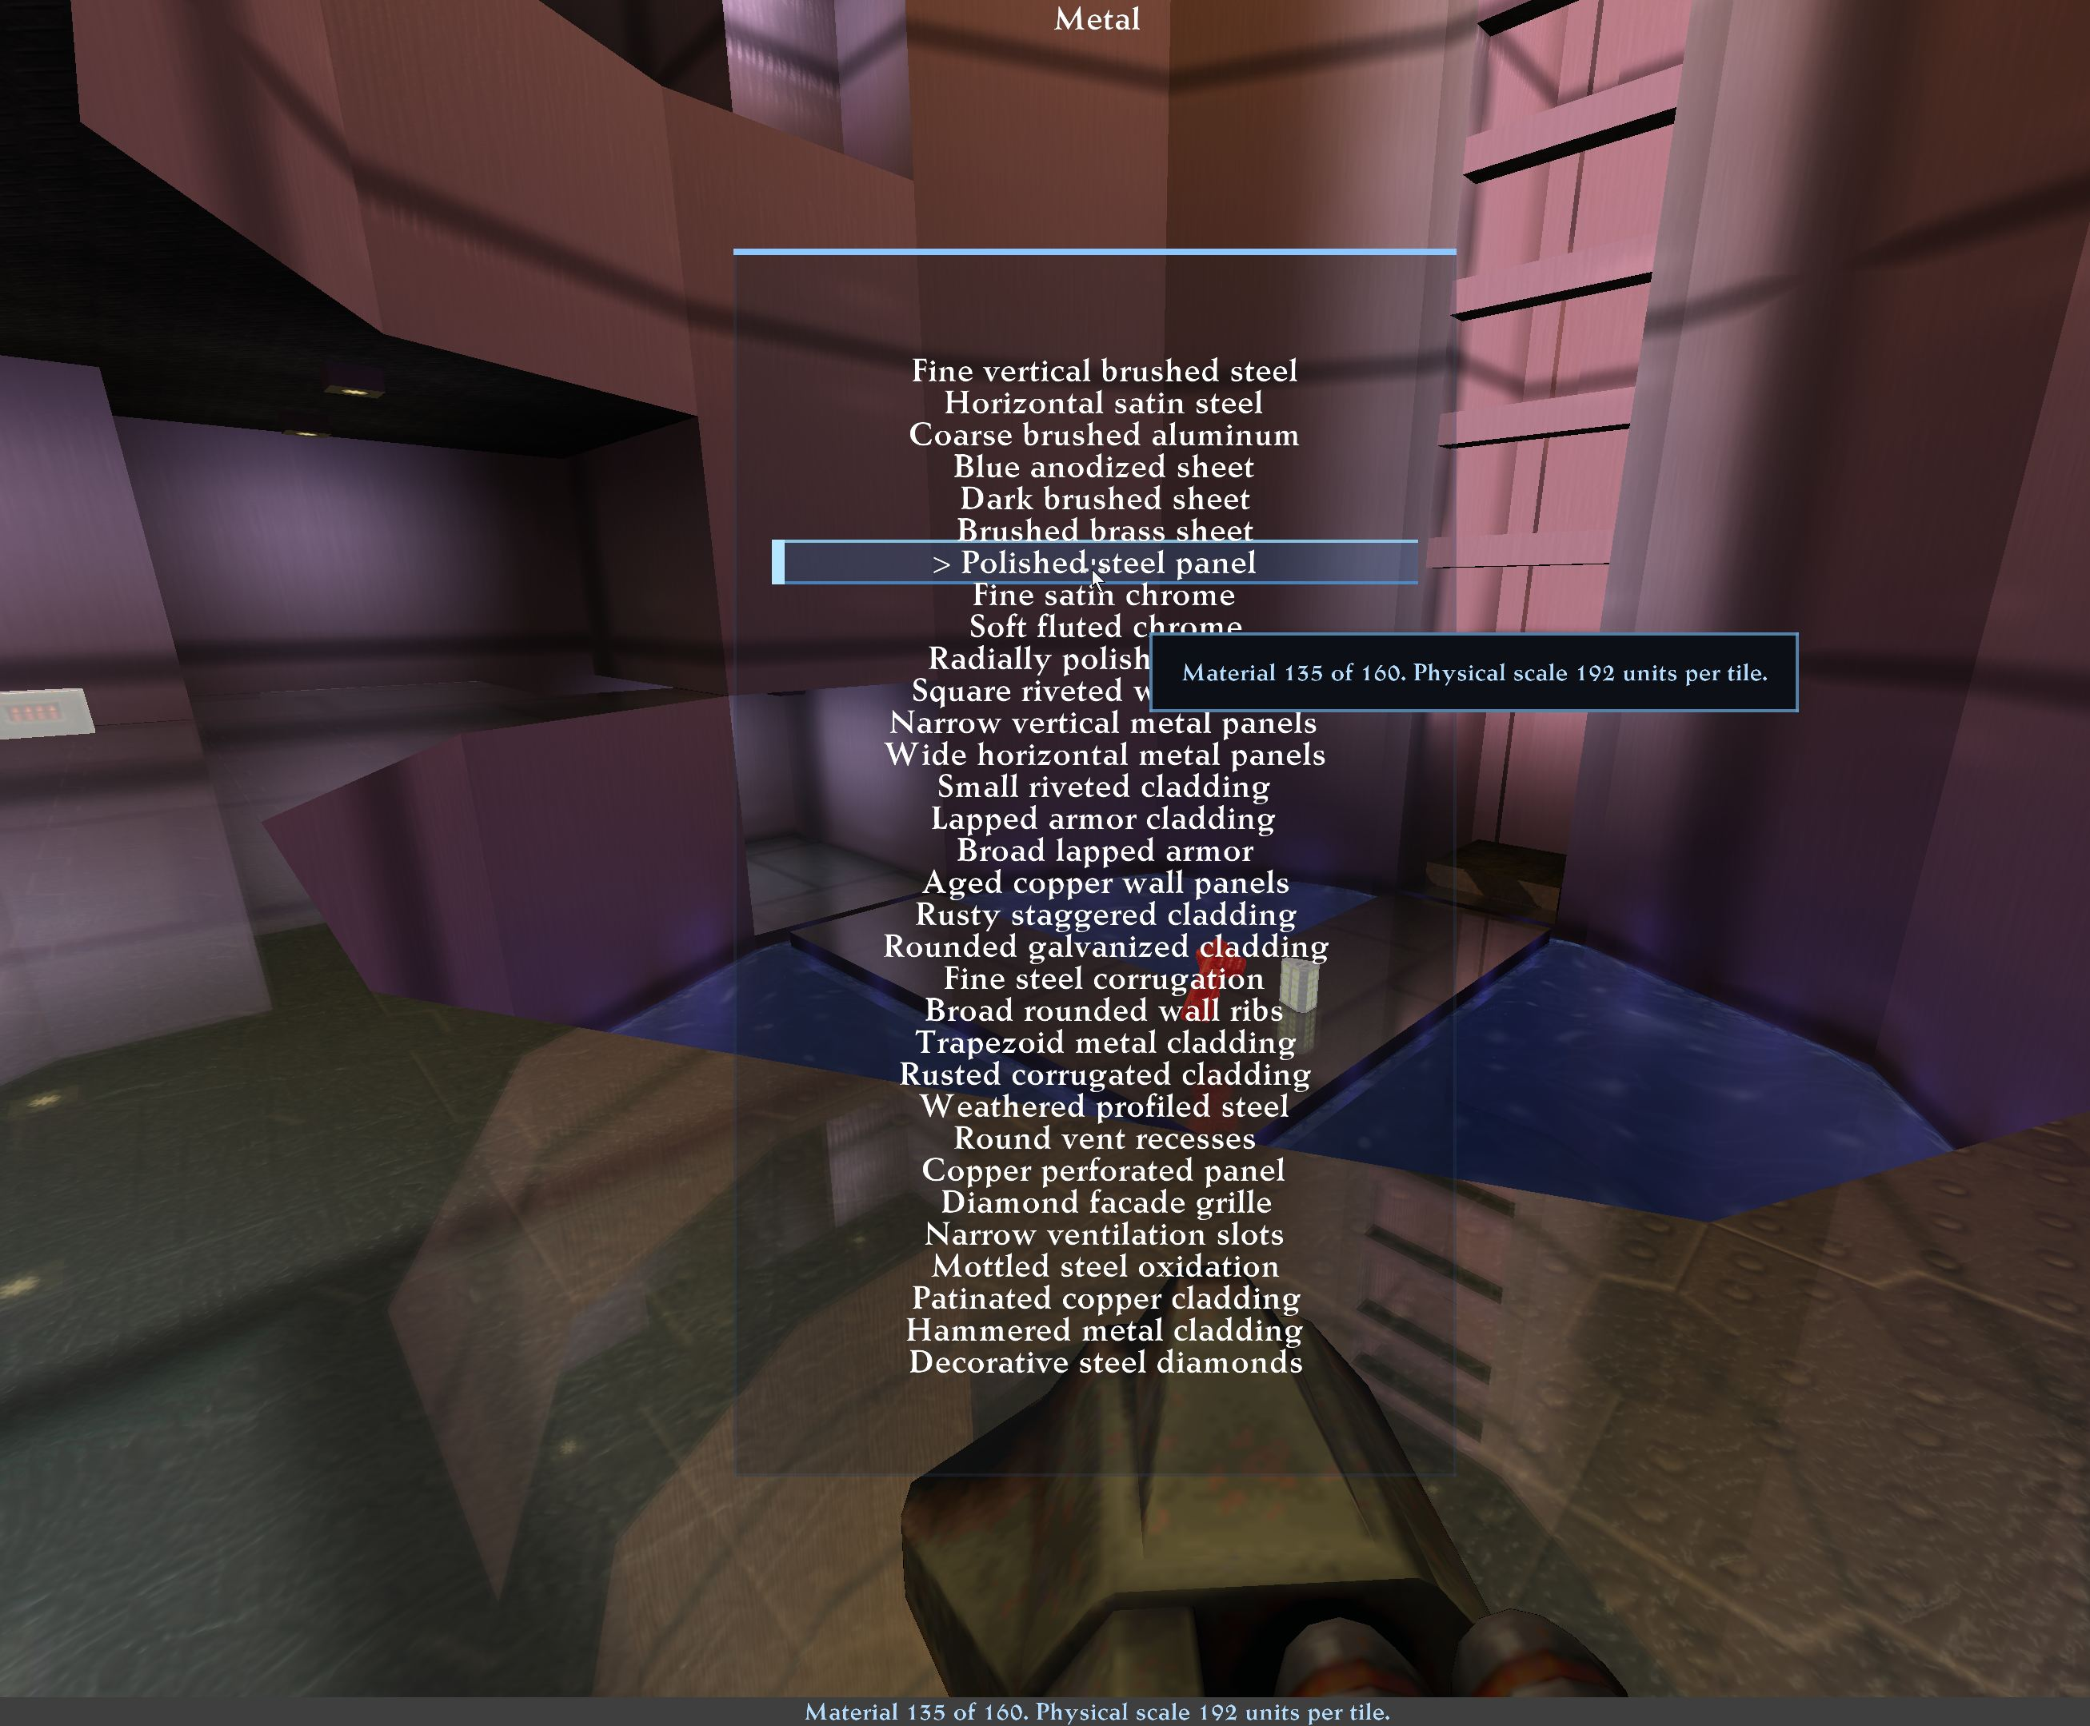
Metallic wall material category.
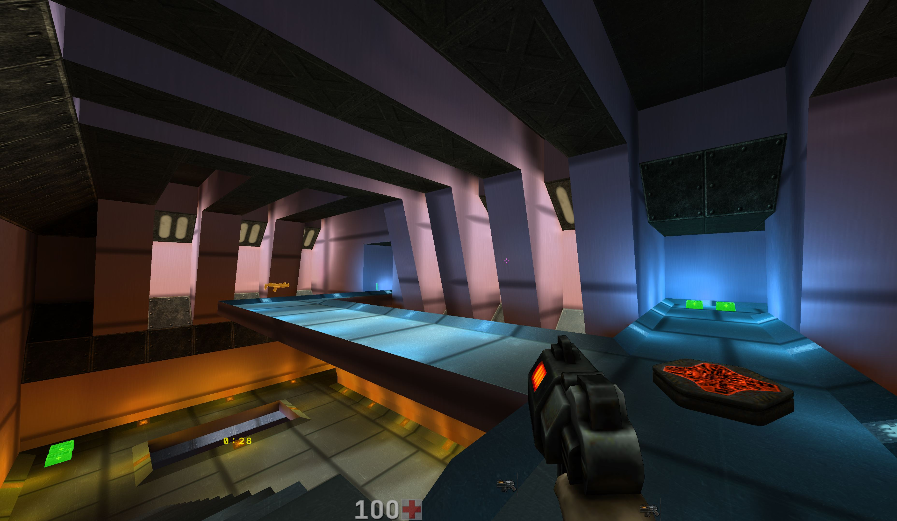
Metallic covering example supplied by the project author.
Moving opaque BSP objects, such as platforms, are included in shared reflection snapshots and planar scene capture. Fixed a longstanding camera-state defect that could make model reflections disappear even at Extra quality. The shared mirror, water and puddle path is corrected without reducing quality budgets. Screen-space reflections remain limited by available geometry and server data.
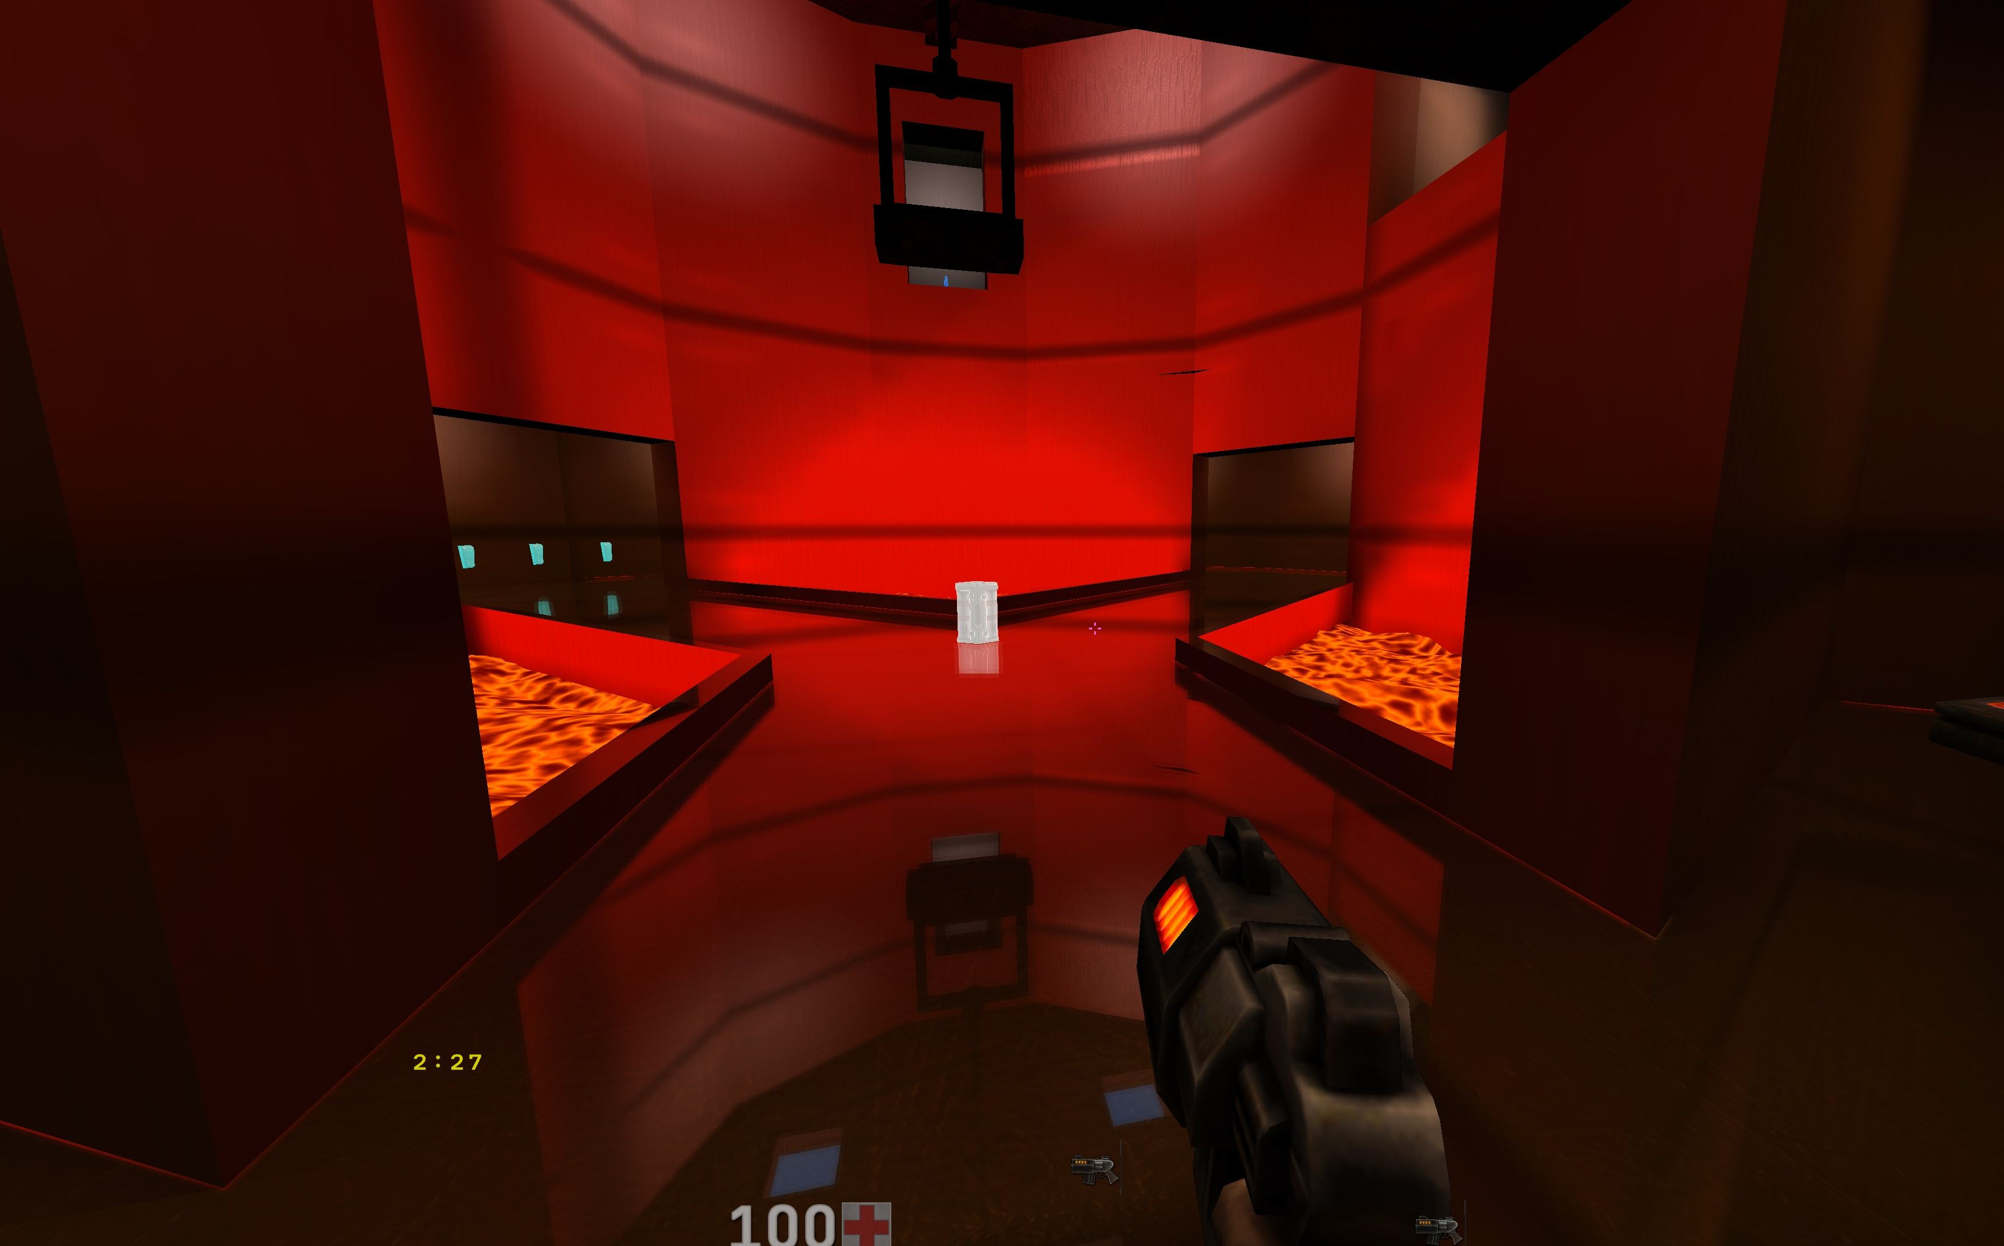
Moving architecture in a reflection.

What this guide covers
The Q2PRO-X AVFX layer consists of two very different parts. The first is the weather and the overall atmosphere: rain, snow, ash, dust, mist, their density, the wind and the speed. That part is described in the AVFX settings guide.
The second part is the large independent subsystems: sky and space, volumetric media, water and reflections, surface materials, wildlife and map-authored scenes. Each has its own menu, its own frame cost and its own dependencies. They are collected here.
A general rule. Everything in this guide works only while the AVFX master switch is on. With it off, none of the subsystems described here simulate, draw or prepare resources.

How to read this
Every section is arranged the same way: what it is, where it lives in the menu, what it depends on, and what the frame pays for it. The menu-row tables come from the release menu file itself, so the captions in them match what you see in the game.

A map of the subsystems
Group | What it contains | Menu path
Surfaces and water | Materials, coverings, grass, wildlife, water, puddles, reflections, mirrors | Main menu → Advanced Visual Effects → AVFX Detailed Settings → Surfaces & Water
Sky and celestials | Sky, stars, Milky Way, planets, Sun, Moon, Earth, meteors, comets, spaceships, black hole | Main menu → Advanced Visual Effects → AVFX Detailed Settings → Sky & Celestials
Local FX and sound | Flashlight, monster contacts with the environment, AVFX sound volumes | Main menu → Advanced Visual Effects → AVFX Detailed Settings → Local FX & Sound

1. Sky and space

1.1. What is available
Sky & Celestials
Type | Section | Row | Variable or target | What it does
Section | Sky Layers | Sky Layers
Navigation | Sky Layers | Sky & Clouds settings... | q2prox_avfx_storm_sky | Open Sky & Clouds: weather sky tint, sky darkening, storm tint, procedural clouds and fog.
Navigation | Sky Layers | Volumetric clouds... | q2prox_avfx_volclouds | Open Volumetric clouds: GPU-raymarched world cloud layer lit by sun/moon. Can occlude celestial disks. Default OFF.
Section | Celestial Objects | Celestial Objects
Navigation | Celestial Objects | Sun settings... | q2prox_avfx_sun | Open Sun settings: visible disk, time mode, position, color, brightness, cloud shadowing.
Navigation | Celestial Objects | Moon settings... | q2prox_avfx_moon | Open Moon settings: visible disk, mode, position, phase, size, brightness, cloud shadowing.
Navigation | Celestial Objects | Earth settings... | q2prox_avfx_earth | Open Earth settings: separate blue-marble planet behind clouds, mode, position, phase, size, HD texture, body rotation.
Navigation | Celestial Objects | Stars settings... | q2prox_avfx_stars | Open stars settings: real-data catalog + extra background + Milky Way + Venus + Mars + cloud occlusion + day/moon fade + horizon-strength twinkle + constellation lines + star/planet forced bloom. Default OFF.
Navigation | Celestial Objects | Black Hole... | q2prox_avfx_blackhole | Open Black Hole settings: optional lensing background body with an event-horizon shadow, photon ring, accretion disk, flow strands and polar jets. Farther than Sun/Earth/Moon, nearer than the stars. Default OFF.
Navigation | Celestial Objects | Meteors... | q2prox_avfx_meteors | Open meteors settings: sky meteors / shooting stars (M1) and falling impact meteors (M2). Bolide visuals, trails, fragmentation, impact flash, shatter, puddle evaporation, camera shake.
Navigation | Celestial Objects | Spaceships... | q2prox_avfx_spaceships | Open optional AVFX sky-spaceship flybys: distant stock Quake II ships enter from beyond the horizon, cross the sky on long varied routes and fade into the distance. Client-only decorative, no gameplay. Default OFF.
Navigation | Celestial Objects | Back to detailed AVFX settings... | q2prox_avfx_details | Return to detailed AVFX settings.

1.2. Modern and real sky
The AVFX sky comes in several kinds: the map's own sky, a weather sky, a plain blue one, stars, space, a nebula, a sunny sky and a mystic one. The chosen sky decides the background every other celestial object is drawn against.
One important detail: celestial bodies and stars are drawn in the sky, not on top of the world. Level geometry occludes them exactly as it occludes any distant object.

1.3. Stars, the Milky Way and constellations
Stars Settings
Type | Section | Row | Variable or target | What it does
Section | Main | Main
Toggle | Main | Stars | cl_avfx_stars | Master toggle for the AVFX celestial stars layer. Default OFF. Applies immediately.
List | Main | Background mode | cl_avfx_stars_background_mode | Background star source. Generated / Real catalog / Real catalog + generated. Applies immediately. [Generated background / Real catalog / Real catalog + generated background]
Slider | Main | Global brightness | cl_avfx_stars_brightness | Global brightness multiplier for all stars. 3.0 default. Applies immediately.
Section | Sections | Sections
Navigation | Sections | Visibility and fade... | q2prox_avfx_stars_visibility | Open star visibility and sky-fade controls.
Navigation | Sections | Catalog and background... | q2prox_avfx_stars_catalog | Open real catalog and generated background star controls.
Navigation | Sections | Bloom and orientation... | q2prox_avfx_stars_bloom_orientation | Open star bloom and celestial-sphere orientation controls.
Navigation | Sections | Colors and twinkle... | q2prox_avfx_stars_color | Open colourful accent stars and smooth twinkle controls.
Navigation | Sections | Planets and constellations... | q2prox_avfx_stars_objects | Open planets, constellations and Milky Way menus.
Navigation | Sections | Meteors and comets... | q2prox_avfx_meteors | Open meteors settings.
Section | Service | Service
Navigation | Service | Reset to defaults | cl_avfx_defaults_stars | Reset only the star controls shown in this menu.

The star field has its own child pages: visibility, catalog, bloom and orientation, colour, objects, the Milky Way, planets and constellations. Planets and the Milky Way are independent layers: they can be enabled and disabled separately from the main star field.

1.4. Sun, Moon and Earth
The Sun, the Moon and the Earth are large celestial bodies with their own position, appearance, lighting and rotation. The Sun has a disk, a corona, a glow and beams through clouds; the Moon has phases, appearance, lighting and rotation; the Earth has an atmosphere, a cloud layer and rotation.
There is a strict occlusion rule worth knowing so that it is not mistaken for a defect:
- the direct solar disk, the corona and the glow are occluded by the Moon and the Earth;
- volumetric-fog inscatter is occluded by them too, but only within their visible limb;
- stars and sky objects are occluded by the bodies;
- screen-space god rays and the broad sky glow are not hard-cut by the bodies.
The accepted final look is a soft cloth of rays around the silhouette of the Moon and the Earth, not a bright rim on the sun-facing side.

1.5. Meteors, comets and spaceships
Meteors and comets fly across the sky; spaceships have their own flight modes, aerobatics and appearance. A separate system handles a meteor falling and striking the ground, with its own damage in single player.

1.6. The black hole
Black Hole
Type | Section | Row | Variable or target | What it does
Section | Main | Main
Toggle | Main | Black Hole | cl_avfx_blackhole | Master switch for the AVFX black hole. Default OFF; enabling it does not change any other AVFX setting. Applies immediately.
List | Main | Quality | cl_avfx_blackhole_quality | Render quality. High is the recommended default; Ultra is expensive. Applies immediately. [Low / Balanced / High / Ultra]
Slider | Main | Azimuth | cl_avfx_blackhole_azimuth | Azimuth in degrees (manual mode). Applies immediately.
Slider | Main | Elevation | cl_avfx_blackhole_elevation | Elevation in degrees (manual mode). Applies immediately.
Slider | Main | Size | cl_avfx_blackhole_size | Angular size multiplier (menu up to 100.0; console/cfg engine range up to 3000.0). Applies immediately.
Slider | Main | Brightness | cl_avfx_blackhole_brightness | Brightness of all black-hole emission. Lensing and the shadow remain. Applies immediately.
Section | Sections | Sections
Navigation | Sections | Position & animation... | q2prox_avfx_blackhole_position | Position mode, drift, disk orientation, precession, animation speed and stable seed.
Navigation | Sections | Lensing & horizon... | q2prox_avfx_blackhole_lensing | Gravitational lens, event-horizon shadow and photon ring.
Navigation | Sections | Accretion disk... | q2prox_avfx_blackhole_disk | Accretion disk geometry, material, turbulence, rotation and Doppler beaming.
Navigation | Sections | Streams & jets... | q2prox_avfx_blackhole_streams | Flow strands and optional polar jets.
Navigation | Sections | Colors & glow... | q2prox_avfx_blackhole_colors | All colors, HDR peak, bloom, optional god rays and cloud occlusion.
Navigation | Sections | Quality & performance... | q2prox_avfx_blackhole_quality | Quality, field render scale, antialiasing and temporal stability.
Navigation | Sections | Consumption... | q2prox_avfx_blackhole_consumption | Matter consumption. Pale-gray Moon dust and three kinds of Earth matter (atmosphere, water, soil/rock) tear into the hole. Needs a body and the Black Hole visible and close. Default OFF.
Section | Service | Service
Navigation | Service | Reset all Black Hole settings | cl_avfx_defaults_blackhole | Reset EVERY Black Hole setting, including the master switch, to its default.
Navigation | Service | Back to Sky & Celestials... | q2prox_avfx_details_sky | Return to Sky & Celestials.

The black hole is the heaviest celestial subsystem. It consists of position, lensing, the accretion disk, streams, colours, quality and a consumption mode. Consumption can draw in celestial bodies and meteors and comets already in flight, and dust lifted from the surface has a settings set of its own.
The preset generator makes the black hole available only from the Ultra Quality tier upward, precisely because of its frame cost.

2. Volumetric media

2.1. Volumetric fog
Volumetric fog / mist
Type | Section | Row | Variable or target | What it does
Toggle |  | Volumetric fog | cl_avfx_volfog | Master toggle for AVFX volumetric fog / mist. Applies immediately.
List |  | Quality | cl_avfx_volfog_quality | Quality preset. Low reduces steps; Standard is baseline; Ultra increases steps. Applies immediately. [Low / Standard / Ultra]
Slider |  | Render scale | cl_avfx_volfog_render_scale | Performance scale for effective raymarch steps. Applies immediately.
Slider |  | Raymarch steps | cl_avfx_volfog_steps | Requested raymarch sample count; effective count also uses quality and render scale. Applies immediately.
Navigation |  | Shape and distance... | q2prox_avfx_volfog_shape | Open fog distance, height and layer-shape controls.
Navigation |  | Density and noise... | q2prox_avfx_volfog_look | Open density, noise, color and wind controls.
Navigation |  | Fog lighting... | q2prox_avfx_volfog_lighting | Open sun, moon, lightning, flashlight and debug controls.
Navigation |  | Reset to defaults | cl_avfx_defaults_volfog | Reset only the volumetric-fog controls shown in this menu.

Volumetric fog is not a flat veil but a real volume in which light scatters. It has shape, appearance and lighting on separate child pages.
The two main cost controls here are the performance scale and the step count. The scale cuts the effective number of ray samples, and the step count is the requested number. The effective count depends on both, plus the quality tier.

2.2. Volumetric clouds
Volumetric clouds
Type | Section | Row | Variable or target | What it does
Section | Main | Main
Toggle | Main | Volumetric clouds | cl_avfx_volclouds | Master toggle for AVFX volumetric clouds. Applies immediately.
Section | Quality & performance | Quality & performance
List | Quality & performance | Quality | cl_avfx_volclouds_quality | Quality preset. Low is faster, Quality is baseline, Ultra increases sample count. Applies immediately. [Low / Quality / Ultra]
List | Quality & performance | Cloud detail source | cl_avfx_volclouds_noise_source | Cloud detail source. Fast procedural uses in-shader hash. Rich 3D noise uses Perlin-Worley textures. Applies immediately. [Fast procedural / Rich 3D noise]
Slider | Quality & performance | Render scale | cl_avfx_volclouds_render_scale | Internal cloud buffer scale. 1.00 renders the same cloud pass at full resolution; lower values render cheaper and upscale. Applies immediately.
Slider | Quality & performance | Raymarch steps | cl_avfx_volclouds_steps | Base raymarch sample count per pixel. Effective count also uses quality preset. Applies immediately.
Slider | Quality & performance | Shadow steps | cl_avfx_volclouds_shadow_steps | Light-march samples toward sun per main step. 0 disables self-shadow. Applies immediately.
Section | Submenus | Submenus
Navigation | Submenus | Shape and coverage... | q2prox_avfx_volclouds_shape | Open cloud placement, height, coverage, density and size controls.
Navigation | Submenus | Detail and motion... | q2prox_avfx_volclouds_detail | Open cloud detail, erosion, turbulence, wind and evolution controls.
Navigation | Submenus | Layers and sky coverage... | q2prox_avfx_volclouds_layers | Choose full-sphere or upper-sky coverage and open per-layer cloud controls.
Navigation | Submenus | Cloud lighting... | q2prox_avfx_volclouds_lighting | Open lighting, scene-shadow, lightning and debug settings for volumetric clouds.
Section | Service | Service
Navigation | Service | Reset to defaults | cl_avfx_defaults_volclouds | Reset only the volumetric-cloud controls shown in this menu.

Volumetric clouds are additionally split into three independent layers. Each layer is enabled separately and has its own height, density and motion.
An important difference from fog. The clouds' own internal buffer scale is currently reserved and does not affect rendering: the raymarch always runs at scene resolution. The real cost controls for clouds are the step count and the quality tier.

2.3. Backends and volumetric media
Volumetric media are the part of AVFX most sensitive to the graphics backend. The client's own menu carries the general recommendation: use the win32egl backend for the best performance.
A practical tuning order:
1. Enable the volume you want.
2. Leave the factory render scale and step count.
3. Look at the frame rate in a scene typical for you.
4. For fog, reduce the performance scale first, then the step count.
5. For clouds, reduce the step count and the quality tier: the cloud buffer scale currently changes nothing.
6. Only then reduce the density and the number of layers.
Details on choosing a backend are in the video guide.

3. Water, puddles and reflections

3.1. Water
Water
Type | Section | Row | Variable or target | What it does
Section | Base Water | Base Water
Toggle | Base Water | Enhanced water | cl_avfx_water | Master switch for the enhanced water surface (needs cl_avfx_world 1; lava/slime untouched). Applies live - no vid_restart. Applies immediately.
List | Base Water | Water quality | cl_avfx_water_quality | Shader detail level of the enhanced water (low / normal / high). Applies immediately. [low / normal / high]
Slider | Base Water | Water strength | cl_avfx_water_strength | Strength of the enhanced-water look (0..1, default 0.65). Applies live - no vid_restart. Applies immediately.
List | Base Water | Water color | cl_avfx_water_color | Water colour profile (natural or artificial water tints). Applies live - no vid_restart. Applies immediately. [original / natural / clear / tropical / pool / ocean / lake / glacier / deep / murky / toxic]
List | Base Water | Water texture | cl_avfx_water_surface_style | BSP water surface texture. 0=Standard, 1..12 reference styles. Detail layer only; does not change water effects. Applies immediately. [Standard / Clear shallow / Pool caustics / Calm ripples / Wind ripples / Ocean chop / Dark deep / Green lagoon / Grey calm / Murky pond / Rough foam / Whitewater / Soft caustics]
Slider | Base Water | Water motion speed | cl_avfx_water_surface_speed | Water style motion speed (0.1=10x slower, 1=default, 10=10x faster). Applies immediately.
Toggle | Base Water | Surface ripples | cl_avfx_water_ripples | Animated surface-ripple layer on the water (separate from raindrop impact rings). Applies immediately.
Toggle | Base Water | Drifting foam | cl_avfx_water_foam | Drifting foam patches on the water surface - small patches fade in, drift, and fade out. Applies immediately.
Section | Celestial Response | Celestial Response
Toggle | Celestial Response | Water celestial response | cl_avfx_water_celestial_lighting | Water/puddles/foam/runoff/rings react to sun+moon state. On by default; fixes bright daytime water showing at night. Applies immediately.
Slider | Celestial Response | Water celestial strength | cl_avfx_water_celestial_strength | How strongly sun+moon drive water colour/brightness (0..2, default 1.0). Applies immediately.
Slider | Celestial Response | Water min brightness | cl_avfx_water_celestial_min_brightness | Floor brightness for water when there's no celestial light (0..1, default 0.05). Otherwise it can go very dark at night. Applies immediately.
Slider | Celestial Response | Water night tint | cl_avfx_water_celestial_night_tint | Cool deep-blue tint of water in darkness (0..1, default 0.55). Applies immediately.
Slider | Celestial Response | Water specular response | cl_avfx_water_celestial_specular_scale | Brightness scalar for CPU water-glint paths (foam/runoff/rings/drops); shader paths self-scale. Applies immediately.
Section | Realistic Water | Realistic Water
Toggle | Realistic Water | Realistic water | cl_avfx_water_realistic | Optional realistic mode over enhanced water: procedural waves/normals + fresnel sky reflection + sun glint. Off by default; needs Enhanced water + cl_avfx_world 1. Applies immediately.
Navigation | Realistic Water | Surface and waves... | q2prox_avfx_water_realistic_surface | Open realistic-water surface and waves settings.
Navigation | Realistic Water | Reflection... | q2prox_avfx_water_realistic_reflect | Open realistic-water reflection settings.
Navigation | Realistic Water | Colour and depth... | q2prox_avfx_water_color_depth | Open realistic-water colour and depth settings.
Navigation | Realistic Water | Foam and shore... | q2prox_avfx_water_foam_shore | Open realistic-water foam and shore settings.
Section | Extra | Extra
Navigation | Extra | Reflections... | q2prox_avfx_water_reflections | Open water reflection settings: scene SSR, coloured 3D model reflections and liquid reflection distortion for BSP water.
Section | Service | Service
Navigation | Service | Reset to defaults | cl_avfx_defaults_water | Reset only the water controls shown in this menu.

AVFX water has several levels. The base layer improves the map's water surface. Realistic water adds separate child pages for the surface, the reflection, the colour and depth, and the foam and shore.

3.2. Puddles
Puddles
Type | Section | Row | Variable or target | What it does
Section | Base puddle | Base puddle
Toggle | Base puddle | Rain puddles | cl_avfx_rain_puddles | Puddles (wet patches) forming on horizontal surfaces where rain falls. Applies immediately.
Slider | Base puddle | Puddle density | cl_avfx_rain_puddle_density | Fraction of horizontal rain hits that form a puddle (0..1, default 1.0). Applies immediately.
Slider | Base puddle | Puddle alpha | cl_avfx_rain_puddle_alpha | Puddle opacity (0..1, default 0.4). Applies immediately.
List | Base puddle | Puddle texture | cl_avfx_rain_puddle_surface_style | AVFX puddle surface texture. 0=Standard, 1..12 reference styles. Detail layer only; does not change puddle effects. Applies immediately. [Standard / Wet asphalt / Muddy / Swamp film / Dirty ripples / Droplet film / Macro droplets / Clean wet / Grey ripple / Mud streaks / Shallow clear / Broken foam / Rough muddy]
Slider | Base puddle | Puddle motion speed | cl_avfx_rain_puddle_surface_speed | Puddle style motion speed (0.1=10x slower, 1=default, 10=10x faster). Applies immediately.
Slider | Base puddle | Puddle size | cl_avfx_rain_puddle_max_size | Puddle size (0.2..100; 1.0 = default; 0.2 = 5x smaller, 100 = 100x larger). Applies immediately.
Slider | Base puddle | Puddle count | cl_avfx_rain_puddle_count | Max number of puddles (0.2..500; 1.0 = default ~384. 0.2 = 5X fewer; 500 = fills the 4096 buffer). Applies immediately.
Slider | Base puddle | Puddle fill rate | cl_avfx_rain_puddle_fill_rate | How fast surfaces fill with puddles (0.01..20. 0.2 = Default, 5x slower than base; 20 = near-instant). Applies immediately.
Section | Specular | Specular
Toggle | Specular | Puddle specular | cl_avfx_rain_puddle_specular | Fake puddle specular: animated procedural highlights + sky-colour mix so wet asphalt reads wet, not just dark. No real reflection. Applies immediately.
Slider | Specular | Puddle specular strength | cl_avfx_rain_puddle_specular_strength | Strength of the fake puddle specular highlights (0..1; 0.6 = default). Applies immediately.
Section | Contact effects | Contact effects
Navigation | Contact effects | Splashes, rings, runoff, contact... | q2prox_avfx_puddle_detail | Open puddle step-splash, rings, runoff (drip) and water-contact settings.
Section | Extra | Extra
Navigation | Extra | Reflections... | q2prox_avfx_puddle_reflections | Open the puddle Reflections submenu: scene reflection (SSR), model-reflection categories and liquid reflection distortion.
Section | Service | Service
Navigation | Service | Reset all puddle settings | cl_avfx_defaults_puddles | Reset ALL puddle settings. Base, specular, splashes, rings, runoff and water contact (reflections have their own reset in the Reflections submenu).

Puddles are tied to rain: they appear on suitable surfaces, accumulate and dry. They have their own detail settings and their own reflections.

3.3. Three classes of reflection
This is where confusion arises most often. Q2PRO-X has exactly three, and they are independent:
Class | What is reflected | Where it is configured
Model reflections | Real entities: players, weapons, items, armor, ships | The water and puddle reflection child pages
Scene reflection | Screen-space reflection of the scene itself, plus the shared liquid-warp parameters | The water reflection child page
Mirror Surfaces | The separate system of true mirrors | Main menu → Advanced Visual Effects → AVFX Detailed Settings → Surfaces & Water → Mirror Surfaces

The preset generator respects that boundary: model reflections appear from Ultra Quality, mirrors only at Extra Quality, and scene reflection in water is enabled from Quality upward.

3.4. Mirror Surfaces
Mirror Surfaces
Type | Section | Row | Variable or target | What it does
Section | Surfaces | Surfaces
Toggle | Surfaces | Mirror surfaces | cl_avfx_surface_mirror | Master toggle for experimental mirror surfaces. The saved choice is effective only in deathmatch 0, on a local deathmatch 1 server, or in dm2/mvd2 Demo Player playback. Remote deathmatch 1 is hard-blocked independently of user cvars. Off by default. Applies immediately.
Toggle | Surfaces | Floors and slopes | cl_avfx_surface_mirror_floors | Mirror floors and up-facing slopes (stairs, ramps). On by default. Applies immediately.
Toggle | Surfaces | Walls | cl_avfx_surface_mirror_walls | Mirror vertical and steep walls. Off by default (higher cost). Applies immediately.
Slider | Surfaces | Floor/slope angle limit | cl_avfx_surface_mirror_floor_slope_max | Angle limit (degrees) separating floors/slopes from walls. Applies immediately.
Section | Scene Reflection | Scene Reflection
Toggle | Scene Reflection | Scene reflection | cl_avfx_surface_mirror_scene_reflection | Screen-space reflection of static world detail. On by default. Applies immediately.
Slider | Scene Reflection | Scene reflection strength | cl_avfx_surface_mirror_scene_reflection_strength | Strength of the reflected scene. Applies immediately.
Toggle | Scene Reflection | Reflect Surface Objects | cl_avfx_surface_mirror_surface_objects | Reflect already enabled Surface Objects: grass, ivy, ferns and falling leaves; no stones, soil or ground litter. Does not enable them. Applies immediately.
Section | More | More
Navigation | More | Model reflections... | q2prox_avfx_mirror_models | Open model reflections and their individual content categories.
Navigation | More | Quality & service... | q2prox_avfx_mirror_quality | Open quality and service: quality, roughness, distance, plane budget, diagnostics.
Navigation | More | Reset to defaults | cl_avfx_defaults_surface_mirror | Reset mirror surface settings to defaults.
Navigation | More | Back to Surfaces & Water... | q2prox_avfx_details_surfaces | Back to Surfaces & Water.

Mirrors are the most expensive class of reflection, because the scene is built separately for them. They have their own model and quality child pages.

4. Surface materials

4.1. What they are
Surface Materials
Type | Section | Row | Variable or target | What it does
Section | Master | Master
Toggle | Master | Surface Materials | cl_avfx_surface_materials | Master toggle for AVFX Surface Materials — living material layers over eligible static walls/floors. Families: mold, wall runoff. Needs cl_avfx on. Default off. Applies immediately.
List | Master | Quality | cl_avfx_surface_materials_quality | Surface detail and wildlife budgets. Higher adds material samples, feeding actors, flies and reaction records; Ultra uses the full 256-actor feeding pool. Applies immediately. [Performance / Balanced / High / Ultra]
Slider | Master | Detail distance | cl_avfx_surface_materials_distance | Smooth detail LOD distance (world units). Colonies keep identity; only fine detail fades far away. Applies immediately.
Section | Families | Families
Navigation | Families | Mold settings... | q2prox_avfx_surface_materials_mold | Open Mold settings: walls/floors, alpha, coverage, colony scale and wall bottom-up distribution.
Navigation | Families | Wall runoff... | q2prox_avfx_surface_materials_wall_water | Open Wall runoff settings: animated water droplets, beads and rivulets on eligible static WALLS only (floors never affected). Auto mixes broad world regions.
Navigation | Families | Greenery... | q2prox_avfx_surface_materials_greenery | Open Greenery settings: moss, lichen, ivy, leafy creep and small weeds grown over eligible static walls and floors. A shader coating on the original texture, not the separate 3D grass.
Navigation | Families | Cracks... | q2prox_avfx_surface_materials_cracks | Open Cracks settings: hairline, branching, network, chipped and deep fractures worn into eligible static walls and floors. Damage in the existing material; collision and gameplay never change.
Navigation | Families | Brick surfaces... | q2prox_avfx_surface_materials_brick | Open Brick surface settings: irregular masonry with real bump and parallax relief coating eligible static walls and floors. The original texture stays underneath according to coverage; map geometry and collision never change.
Navigation | Families | Wildlife... | q2prox_avfx_surface_materials_crawlers | Open Wildlife settings: insects, tadpoles, snails and Snakes living on eligible static surfaces. Local AVFX only; server gameplay never changes.
Navigation | Families | Drawing... | q2prox_avfx_surface_materials_drawing | Open Drawing: paint your own marks directly on world walls, ceilings, floors and slopes with the mouse. Saved locally per mod and per map revision; never sent to a server. Default off.
Navigation | Families | Floor Surfaces... | q2prox_avfx_surface_materials_floor_surfaces | Open Floor Surfaces: a covering built from 160 reference-derived floor materials with real bump, depth and optional shader motion. It can be enabled on floors, walls and ceilings independently; the name only picks the catalog. Default OFF.
Navigation | Families | Wall Surfaces... | q2prox_avfx_surface_materials_wall_surfaces | Open Wall Surfaces: the second, independent covering layer, built from 160 reference-derived wall materials. Both layers may cover the same face; one shared control decides which lies underneath. Default OFF.
Section | Service | Service
Navigation | Service | Reset to defaults | cl_avfx_defaults_surface_materials | Reset all Surface Materials controls to defaults.
Navigation | Service | Back to Surfaces & Water... | q2prox_avfx_details_surfaces | Back to Surfaces & Water.

Surface materials are the family of effects that bring a level's walls and floors to life: mold, brickwork, cracks, greenery and water running down walls. Each material is enabled separately and has its own coverage, shape and colour settings.
Brick geometry deserves a separate mention: it gives the masonry real relief rather than only a pattern. It is the most expensive part of the materials, which is why the preset generator enables it only at Extra Quality.

4.2. Floor and wall coverings
Floor and wall coverings are independent families with menus of their own. They decide what exactly a surface is covered with, and how densely.
Coverage here means the fraction of the level's surface an effect occupies. Low coverage gives isolated patches, high coverage gives a continuous layer. The preset generator has a separate Full coverage mode that raises material and covering coverage to the maximum and lays it out uniformly.

4.3. Grass
Grass: Placement & Appearance
Type | Section | Row | Variable or target | What it does
Section | Placement & Performance | Placement & Performance
List | Placement & Performance | Quality | cl_avfx_surface_grass_quality | Grass quality profile. Higher raises instance count, blade detail, draw distance and CPU/GPU cost. Ultra is the visual reference. Applies immediately. [Performance / Balanced / High / Ultra]
Slider | Placement & Performance | Density | cl_avfx_surface_grass_density | Blade density multiplier over the quality profile. Applies immediately.
Slider | Placement & Performance | Cell size | cl_avfx_surface_grass_cell_size | Grass cell size in world units; changing it rebuilds grass cells. Applies immediately.
Slider | Placement & Performance | Draw distance | cl_avfx_surface_grass_distance | Grass draw distance before the quality multiplier. Used only with Distance LOD on. Applies immediately.
Toggle | Placement & Performance | Distance LOD | cl_avfx_surface_grass_lod | On: distance cutoff and thinning. Off: no distance restrictions. PVS and the instance cap remain active. Applies immediately.
Slider | Placement & Performance | Max grass blades | cl_avfx_surface_grass_max_instances | Hard blade cap. With LOD off, grass has a fixed allocation across the map; entering another room never redistributes it. Ultra allows eight million. Applies immediately.
Slider | Placement & Performance | Maximum slope | cl_avfx_surface_grass_slope_max | Maximum surface slope that grows grass (0 = flat floors only). Applies immediately.
Toggle | Placement & Performance | Outdoor only | cl_avfx_surface_grass_outdoor_only | Grow grass only on cells open to the sky; off allows indoor eligible floors too. Applies immediately.
Section | Appearance | Appearance
Slider | Appearance | Height | cl_avfx_surface_grass_height | Base grass blade height in world units. Applies immediately.
Slider | Appearance | Height variation | cl_avfx_surface_grass_height_variation | Per-blade random height spread around the base height. Applies immediately.
Slider | Appearance | Width | cl_avfx_surface_grass_width | Grass blade width in world units. Applies immediately.
List | Appearance | Antialiasing | cl_avfx_surface_grass_antialiasing | Grass geometry antialiasing. 2x..8x accumulate that many fixed sub-pixel samples of the original vertical blades per frame. Distant blades are never replaced by flat coverage. Applies immediately. [Off / 2x / 3x / 4x / 5x / 6x / 7x / 8x]
Slider | Appearance | Color red | cl_avfx_surface_grass_color_r | Base grass colour, red channel (linear). Applies immediately.
Slider | Appearance | Color green | cl_avfx_surface_grass_color_g | Base grass colour, green channel (linear). Applies immediately.
Slider | Appearance | Color blue | cl_avfx_surface_grass_color_b | Base grass colour, blue channel (linear). Applies immediately.
Slider | Appearance | Color variation | cl_avfx_surface_grass_color_variation | Per-blade colour spread around the base colour. Applies immediately.
Navigation | Appearance | Back to Grass... | q2prox_avfx_grass | Back to Grass.

Grass has three child pages: placement, lighting and motion. Placement decides where grass appears and how densely; lighting reconciles it with the level's light; motion governs the sway.

4.4. Wildlife
Wildlife
Type | Section | Row | Variable or target | What it does
Section | Master | Master
Toggle | Master | Wildlife | cl_avfx_surface_materials_crawlers | Wildlife family master. Creatures live on eligible static surfaces. Needs the Surface Materials master and one surface lane. Default off. Applies immediately.
Toggle | Master | Walls | cl_avfx_surface_materials_crawlers_walls | Let wildlife move on eligible walls. Independent of the floor lane. Applies immediately.
Toggle | Master | Floors | cl_avfx_surface_materials_crawlers_floors | Let wildlife move on eligible floors and slopes. Independent of the wall lane. Applies immediately.
List | Master | Creatures | cl_avfx_surface_materials_crawlers_variant | Choose regional Auto, Random mixing, or one creature type. Fixed species keep stable numbers as new types are appended. Applies immediately. [Auto / Random (all) / Ants / Beetles / Spiders / Roaches / Tiny mixed insects / Sparse mixed routes / Tadpoles / Snails / Snakes]
Section | Appearance | Appearance
Slider | Appearance | Alpha | cl_avfx_surface_materials_crawlers_alpha | How strongly the creatures show over the surface. 0 is a real no-op. Applies immediately.
Slider | Appearance | Density | cl_avfx_surface_materials_crawlers_density | How many routes are occupied. Lowering it removes routes without moving the rest. 0 is a real no-op. Applies immediately.
Slider | Appearance | Size | cl_avfx_surface_materials_crawlers_scale | Physical size of the creatures. It changes their size, not their number or where the routes run. Applies immediately.
Slider | Appearance | Population | cl_avfx_surface_materials_crawlers_population | Peak number of creatures. It multiplies how many can appear per area; at 100 there are a hundred times more than at 1. Applies immediately.
Slider | Appearance | Visibility | cl_avfx_surface_materials_crawlers_contrast | How hard the creatures read against the surface. Higher darkens the body and lifts its outline, so they stay visible on bright and dark surfaces alike. Applies immediately.
Slider | Appearance | Size variation | cl_avfx_surface_materials_crawlers_size_variation | How much individual creatures differ in size. Applies immediately.
Navigation | Appearance | Movement... | q2prox_avfx_surface_materials_crawlers_motion | Open Movement settings: travel speed, route curvature, gait and grouping.
Navigation | Appearance | Colour and wall placement... | q2prox_avfx_surface_materials_crawlers_place | Open Colour and wall placement: RGB tint, spread up a wall, reach and boundary softness.
Navigation | Appearance | Surfaces and blood... | q2prox_avfx_surface_materials_crawlers_environment | Open Snake reactions on puddles and grass, plus blood spreading after a kill.
Navigation | Appearance | Audio and contacts... | q2prox_avfx_surface_materials_crawlers_contacts | Open optional Snake audio and wildlife contacts with hazards and local weapons.
Section | Service | Service
Navigation | Service | Reset Wildlife | cl_avfx_defaults_surface_materials_crawlers | Reset Wildlife controls to defaults.
Navigation | Service | Back to Surface Materials... | q2prox_avfx_surface_materials | Back to Surface Materials.

Wildlife means the small creatures crawling over the level's surfaces. It has child pages for environment, motion, placement and contacts, and for snakes there are separate combat settings in single player.
Wildlife takes no part in the generator's Full coverage mode. A continuous carpet of wildlife does not make a level look finished, so that is a deliberate exception. Water running down walls is excluded for the same reason.

5. Map-authored content
Two subsystems differ fundamentally from everything else in AVFX: their content is created by a person for one specific map, not by a random algorithm.

5.1. Surface drawing
Drawing
Type | Section | Row | Variable or target | What it does
Section | Master | Master
Toggle | Master | Drawing | cl_avfx_surface_materials_drawing | Show your own drawings on world surfaces. Drawings are local, saved separately for each mod and each map revision, and are never deleted by a reset or a preset. Default off. Applies immediately.
Toggle | Master | Walls and ceilings | cl_avfx_surface_materials_drawing_walls | Show and allow drawing on eligible walls and ceilings. Turning it off hides those drawings; it never deletes them. Applies immediately.
Toggle | Master | Floors and slopes | cl_avfx_surface_materials_drawing_floors | Show and allow drawing on eligible floors and up-slopes. Turning it off hides those drawings; it never deletes them. Applies immediately.
Section | Editor | Editor
Navigation | Editor | Open editor | avfx_surface_drawing_editor | Open the drawing editor. It opens in Paint mode: the mouse moves a cursor and the camera stays frozen. Tab switches to Navigate to move the view; Escape closes.
Navigation | Editor | Document info | avfx_surface_drawing_info | Print the current mod, map, BSP revision, file path, layer/stroke counts and save state to the console.
Navigation | Editor | Save | avfx_surface_drawing_save | Save the current drawing now. Editing also autosaves shortly after each completed stroke.
Section | Editor panel | Editor panel
Slider | Editor panel | Panel opacity | cl_avfx_surface_materials_drawing_editor_alpha | Opacity of the editor toolbox. Affects the panel only, never the drawings. Applies immediately.
Slider | Editor panel | Panel scale | cl_avfx_surface_materials_drawing_editor_scale | Size multiplier for the editor toolbox. Applies immediately.
Slider | Editor panel | Panel width | cl_avfx_surface_materials_drawing_editor_width | Base width of the editor toolbox in pixels, before the scale multiplier. Applies immediately.
Slider | Editor panel | Panel height | cl_avfx_surface_materials_drawing_editor_height | Base height of the editor toolbox in pixels, before the scale multiplier. Applies immediately.
Navigation | Editor panel | Reset panel position | avfx_surface_drawing_panel_reset | Put the toolbox back to its default place. You can also drag it by its title bar.
Section | Service | Service
Navigation | Service | Reset settings | cl_avfx_defaults_surface_materials_drawing | Reset the display and editor settings to defaults. Saved drawings are not touched.
Navigation | Service | Back to Surface Materials... | q2prox_avfx_surface_materials | Back to Surface Materials.

Drawings are vector objects anchored to specific surfaces of a specific map: layers, strokes, points, effects and contour regions. They are worked on in an editor inside the game.
The key concepts:
Concept | What it is
Drawing document | The working copy for one specific map: layers, strokes, anchored points, effects and contours
Drawing material | A portable named vector template in normalized coordinates, with no map identity
Material instance | A copy of a template projected onto a chosen surface and embedded in the current document as one undo transaction
Authored surface dataset | The complete set of documents owned by one active authoring or preset scope

A drawing material is portable between maps; a drawing document is not. Once placed, an instance has no live link to the library: it becomes part of the document.

5.2. Volumetric steam and smoke
Surface Volumes
Type | Section | Row | Variable or target | What it does
Section | Master | Master
Toggle | Master | Surface Volumes | cl_avfx_surface_volumes | Show volumetric steam and smoke in the areas you marked on this map. It appears in the current map immediately: no map reload and no video restart. Needs cl_avfx on. Default off. Applies immediately.
List | Master | Quality | cl_avfx_surface_volumes_quality | Volume detail for every shape independently. One shader serves every tier, so changing this compiles nothing. Applies immediately. [Low / Balanced / High / Ultra]
Slider | Master | Shape density | cl_avfx_surface_volumes_gpu_budget_ms | Calibrated density control for each visible shape. The legacy numerical scale is retained for preset compatibility; it is not measured GPU milliseconds or a whole-pass GPU ceiling. Adding a shape leaves existing shapes unchanged; total GPU load grows with visible shape count. Applies immediately.
Slider | Master | Per-shape primitive limit | cl_avfx_surface_volumes_max_lobes | Upper bound on volume primitives built for EACH shape. It is never divided between shapes. Applies immediately.
List | Master | LOD (distance) | cl_avfx_surface_volumes_lod | Distance visibility of whole marked areas. Off shows every area; Near/Medium/Far show only areas within a growing distance of the camera. An area always draws WHOLE and fades out completely at its cutoff — never in pieces. Applies immediately. [Off / Near / Medium / Far]
Section | Editor | Editor
Navigation | Editor | Open editor | avfx_surface_volumes_editor | Open the editor. It opens in Paint mode: the mouse moves a cursor and the camera stays frozen. Tab switches to Navigate to move the view; Escape closes. EVERY per-area parameter — colour, shape, motion, turbulence, light response — is edited inside the editor panel with sliders, on its group tabs.
Section | Preset | Preset
Navigation | Preset | Save | avfx_surface_volumes_save | Save this map's steam and smoke now. The layout is kept per mod and per map and comes back the next time you enter this map; it also saves automatically when you leave the map or the game. Saving an AVFX user preset additionally captures it into that preset.
Navigation | Preset | Revert | avfx_surface_volumes_revert | Go back to the last saved steam of this map.
Section | Service | Service
Navigation | Service | Diagnostics | avfx_surface_volumes_info | Print the identity, bundle, document, resident resources, per-frame counters and the exact reason the pass is or is not drawing.
Navigation | Service | Back to Surfaces & Water... | q2prox_avfx_details_surfaces | Back to Surfaces & Water.

Volumetric steam and smoke (Surface Volumes) are map-authored content too: volumes placed on one specific map and tuned for it.

5.3. Why the generator never touches them
The AVFX preset generator preserves both drawings and a map's volumetric media on every generation. The reason is simple: this is hand-made authored work bound to one specific map. A random scene has no right to erase it.
An AVFX preset does own the complete authored-surface datasets: loading a preset, resetting to defaults or clearing atomically replaces or empties the whole dataset across every map, leaving no trace of the previous preset. The libraries of portable materials and shapes survive that.

6. Local effects and sound

6.1. Flashlight and monster contacts
Local FX & Sound
Type | Section | Row | Variable or target | What it does
Section | Local FX & Sound | Local FX & Sound
Navigation | Local FX & Sound | Player Contact Effects... | q2prox_avfx_contact_settings | Open every AVFX Player Contact Effect setting: blood on models, sprays, world stains, corpse pools, BFG vaporization, weapon impact marks and their budgets.
Navigation | Local FX & Sound | Flashlight settings... | q2prox_avfx_flashlight | Open Flashlight settings: toggle, range, cone angle, color, flicker, battery.
Navigation | Local FX & Sound | Monster environmental contacts... | q2prox_avfx_monster_contacts | Open Monster environmental contacts: footprints, puddle ripples and landing splashes (local single-player / DM-training only).
Navigation | Local FX & Sound | AVFX sound volumes... | q2prox_avfxvol | Open AVFX sound volume layers: ambience, rain, snow, water, steam, thunder, meteor, surface steps.
Section | Related | Related
Navigation | Related | Lightning interaction... | q2prox_avfx_lightning_discharges | Open Lightning discharges & damage — lightning interaction with monsters, objects and surfaces.
Navigation | Related | Back to detailed AVFX settings... | q2prox_avfx_details | Return to detailed AVFX settings.

The flashlight is a local light source with its own settings and a separate shadows child page. Monster contacts with the environment are the environment's reaction to creatures moving through it.

6.2. AVFX audio
AVFX sounds have their own volumes, separated from the game's overall volume: weather, events and contacts are configured independently.
AVFX Sound Volumes
Type | Section | Row | Variable or target | What it does
Section | Master | Master
Toggle | Master | Sounds | cl_avfx_audio | Master gate for all AVFX sound layers (thunder, rain/wind/snow/water beds, drop ticks, ring plips, footsteps). Silent if a layer's WAV is missing. Applies immediately.
Slider | Master | Sound volume | cl_avfx_audio_volume | Overall loudness of AVFX sound effects (multiplies s_volume and every sub-layer). Applies immediately.
Section | Weather & environment | Weather & environment
Toggle | Weather & environment | Wind sound | cl_avfx_audio_wind | Gate for the wind audio layer: ambient wind/dust/ash/fog loops, storm variant and gust one-shots. Silent if WAV missing. Applies immediately.
Toggle | Weather & environment | Rain sound | cl_avfx_audio_rain | Gate for the main rain-noise loops (light/normal/heavy + underwater). Drop ticks and ring plips have their own gates. Silent if WAV missing. Applies immediately.
Toggle | Weather & environment | Rain drop sound | cl_avfx_audio_rain_drops | Allow close raindrop tick sounds (rain preset only). Silent if WAV missing. Applies immediately.
Toggle | Weather & environment | Snow sound | cl_avfx_audio_snow | Gate for the snow-preset ambience: a deliberately soft winter-wind loop (snow_wind_loop.wav), not loud snow noise. Silent if WAV missing. Applies immediately.
Toggle | Weather & environment | Water sound | cl_avfx_audio_water | Allow ring-plip and soft water-surface sounds for AVFX water contacts (if WAVs present). Applies immediately.
Toggle | Weather & environment | Thunder | cl_avfx_audio_thunder | Allow thunder sound tied to lightning events. Applies immediately.
Navigation | Weather & environment | Events & sky... | q2prox_avfxvol_events | Open steam, sky-event, spaceship and Black-Hole sound controls.
Navigation | Weather & environment | Contacts & wildlife... | q2prox_avfxvol_contacts | Open surface-contact and positional wildlife sound controls.
Section | Service | Service
Navigation | Service | AVFX sounds off | set cl_avfx_audio 0 | Mute AVFX through its master only. Child preferences and all visual/non-AVFX settings stay untouched.
Navigation | Service | Restore AVFX sound defaults | cl_avfx_defaults_audio | Restore every AVFX sound control to its registered default. Optional Black-Hole audio remains OFF by default.

That separation lets you keep the weather visible but quiet — a frequent choice for competitive play.

7. Diagnostics and frame cost

7.1. What you can inspect without any debug mode
The cl_avfx_info command prints the state of the AVFX layer to the console: which effects are active right now, the counters and the budgets. It changes nothing and requires no debug mode to be enabled.
The same action is available from the Advanced effects info… row in the main AVFX menu.

7.2. A practical tuning order for your own machine
1. Start from a ready preset, or from the generator at the Balanced tier.
2. Look at the frame rate in a typical scene, not in an empty corridor.
3. If you need speed, first reduce the step count of the volumetric media, and for fog its performance scale as well.
4. Then disable the most expensive families: mirrors, model reflections, brick geometry.
5. Then reduce material coverage and grass density.
6. Touch weather density and particle counts last: they give less of a gain than you would expect.
A separate saving is the distance LOD: it skips small effects beyond a chosen distance with a soft fade. Puddles, cascade flows and the rain particles themselves are never affected by it.

7.3. Competitive play
Online matches have their own modes: allowing AVFX in multiplayer, allowing it in demos, and a competitive limit that caps opacity, density and particle counts so weather cannot hide targets.
AVFX Modes
Type | Section | Row | Variable or target | What it does
Toggle |  | Multiplayer | cl_avfx_multiplayer | Allow AVFX during real multiplayer matches; off disables it there. Applies immediately.
Toggle |  | Demo playback | cl_avfx_demo | Allow AVFX during demo (.dm2/.mvd2) playback. Applies immediately.
Toggle |  | Competitive limit | cl_avfx_competitive_limit | In multiplayer, caps alpha/density/particle counts so weather can't hide targets. Applies immediately.

There is also a global AVFX disable: it switches the layer off across every mod without rewriting local settings or presets.

8. Presets and custom sets
Any combination of the subsystems described here is saved as an ordinary AVFX preset. Presets can be global or mod-dependent, and custom slots are protected from being overwritten by the shipped presets.
Details are in the AVFX presets guide. The quick way to obtain a new combination is the preset generator, which has a guide of its own.

9. Quick reference
Task | Where to go
Enable or disable the whole layer | Main AVFX menu → Enable
Sky, stars, planets, bodies | Sky & Celestials
Fog and clouds | Sky & Celestials → the volumetric media
Water, puddles, reflections | Surfaces & Water
Mold, brick, cracks, greenery | Surface Materials
Grass and wildlife | Surface Materials → the matching child pages
A map's drawings and volumetric steam | Surface Materials → Drawing, Surface Volumes
AVFX sound volumes | Local FX & Sound
Behaviour in matches and demos | Modes
State and counters | cl_avfx_info
Put everything back | Restore defaults

