Q2PRO-X 1.6 Beta 5 by ly
AVFX Player Contact Effects

Project author: ly
AVFX Player Contact Effects
English edition • Q2PRO-X 1.6 Beta 5 by ly • 2026-10-10

Contents
The entries are links: click one to jump to that section.
Contact presets and underwater impacts
Purpose and limits
Biological and mechanical targets
Where effects appear
Opening settings
Contact presets
Factory: Basic
Factory: Extra
Global user presets
Reset and information
Detailed settings
General and blood
Marks and vaporisation
Surface debris
Blood reflections
Budgets
Weapons: light, automatic and explosive
Practical setup
A restrained starting scene
Frame-rate drops near blood
Effects are too strong
Complete menu reference
Preset hub and factory profiles
General settings, blood, marks and vaporisation
Debris, reflections and budgets
All weapon controls
Saved settings and unaffected systems

Contact presets and underwater impacts
Contact presets are available under the common Presets menu, both from the main menu and during play. Their settings remain separate from ordinary AVFX.
Weapon craters and decals attach to the solid bottom beneath water, rather than being moved to the liquid surface according to blood rules. They are drawn before transparent water. A projectile's subsequent impact on the bottom does not generate a second water-surface effect; the initial water entry and solid impact remain.
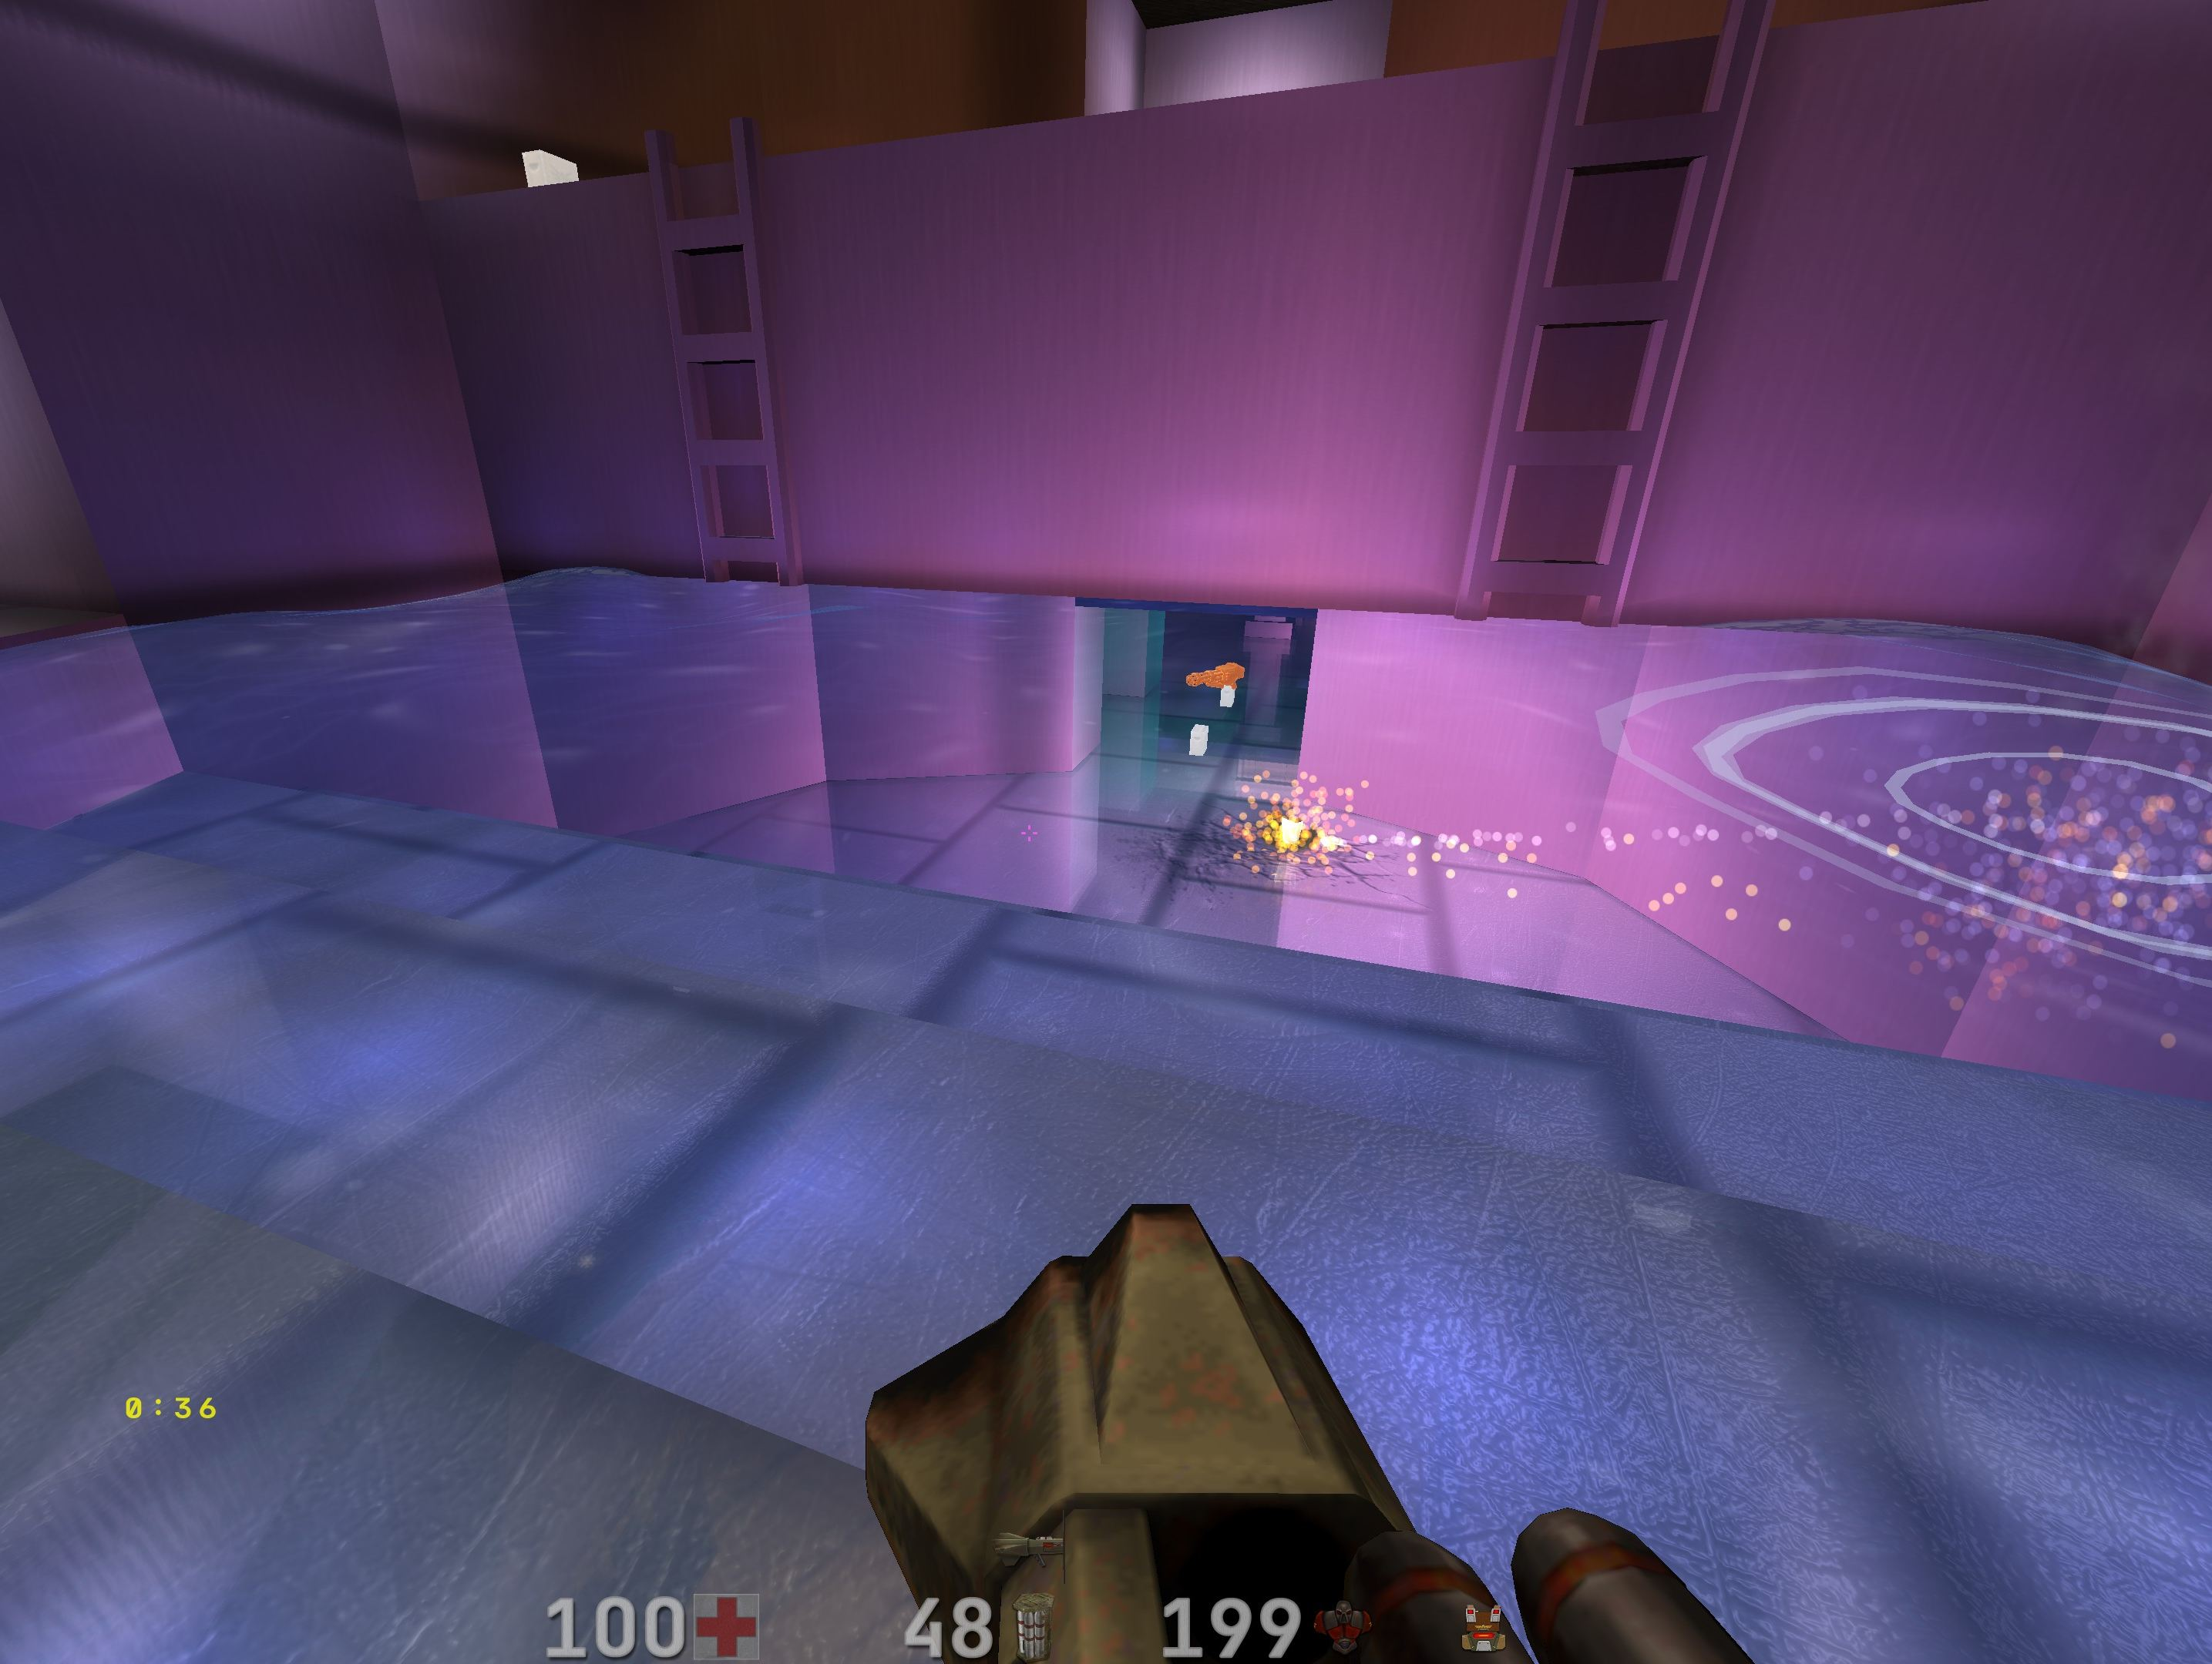
An impact mark on a solid surface beneath transparent water.
If the server sends no underwater-impact event, the client invents no mark. This is particularly relevant to opaque water. Leaving a map releases blood and contact data with its AVFX state. Ordinary AVFX presets, including Metallic Sheen, do not replace the separate Contact settings.

Purpose and limits
AVFX Player Contact Effects are a separate local visual layer that strengthens the response of the world and opponents to weapon hits. It displays blood on living biological targets, model wounds, flying drops and spray, surface stains, bleeding and pools beside confirmed corpses. World impacts create weapon-specific marks, craters, cracks and physical surface fragments. Vaporisation adds charred remains, smoke and heat.
The system works in single-player and multiplayer. It uses information already available to the client and reconciles prediction, confirmation, Ping Adaptation, Network God and LagHax. It changes visuals only: network protocol, server authority, damage, hit registration, demo format, entity visibility and gameplay remain unchanged. No server mod is required.
The layer shows your hits on other players, monsters and the world. It does

not draw your own player's blood from incoming damage or turn unconfirmed

prediction into a second permanent pool or mark.

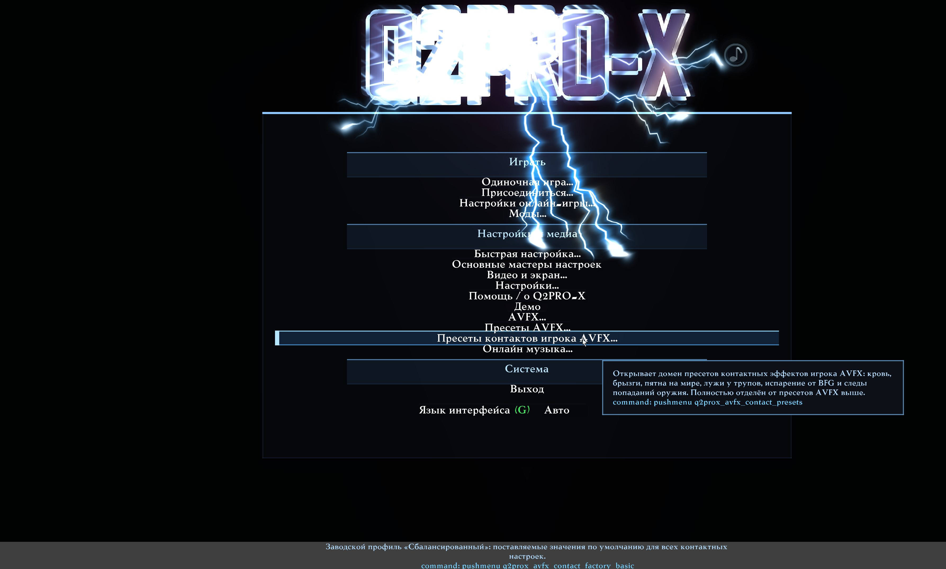
The contact-preset entry in an earlier Russian menu. In the current version, use the common Presets menu.

Biological and mechanical targets
Biological players and monsters may produce blood, wounds and corpse pools. Mechanical targets cannot produce blood; configured sparks and fragments may replace it. Mixed targets use an explicitly defined combination. Unknown models are handled conservatively: no persistent corpse blood reservoir is created without a confirmed biological policy. A mechanical flying drone must not bleed merely because the server sent a generic impact effect.

Where effects appear
- On a living target's model: a local wound and accumulated marks from repeated hits.
- Between target and world: physically directed drops and spray, accounting for impact strength and direction.
- On BSP textures or surface materials: blood stains, weapon marks, craters, cracks and fragments.
- On water and puddles: contact marks consistent with the liquid and its surface.
- Beside a confirmed corpse: blood leaves wounds and forms a bounded growing pool according to the weapon and available budget.
Reflections are allowed only where the geometry also permits a reflecting water puddle. Horizontal and supported sloping surfaces use the shared liquid-reflection system; vertical blood streaks never reflect the scene.

Opening settings
There are two independent entry points:
1. Main Menu → Presets → AVFX Player Contact Presets for ready-made profiles.
2. **Main Menu → Advanced Visual Effects → Detailed AVFX Settings → Local Effects
and Sound → Player Contact Effects** for all parameters.
The first provides a starting profile, user saving and full reset. The second offers detailed blood, mark, vaporisation, debris, reflection, budget and weapon controls. Reference screenshots below use the Russian interface; generated control tables provide the English labels and help.
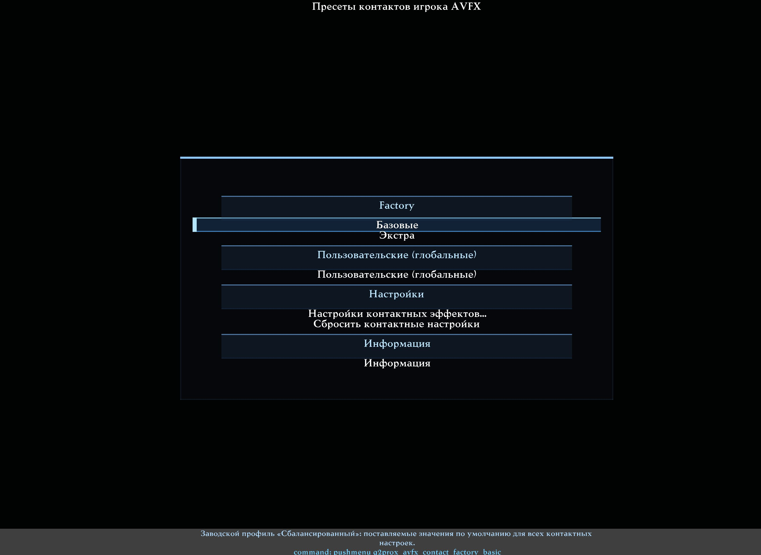
The Contact Presets hub: factory profiles, global slots, settings, reset and information.

Contact presets
Contact presets have their own scope, independent of ordinary AVFX in both directions:
- Loading an ordinary AVFX preset does not change Contact Effects.
- Loading a Contact preset does not change weather, materials, meteors or other ordinary AVFX systems.
- The ordinary AVFX generator neither reads nor generates Contact parameters.
- Contact presets do not use mod-specific or music slots.

Factory: Basic
Balanced restores supplied Contact behaviour and High quality. It is the recommended starting point.

Factory: Extra
Cinematic Extra preserves weapon logic while increasing blood quantity, effect lifetime and quality. Bloody World is the project owner's preset: abundant long-lived blood, large pools, scene reflections and Extra quality.
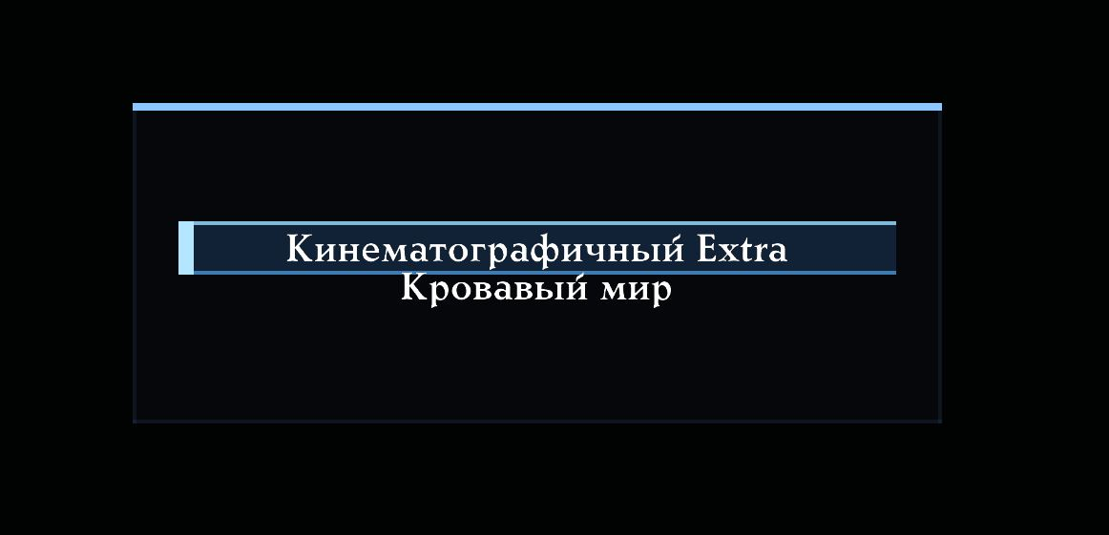
Factory Extra profiles: Cinematic Extra and Bloody World.

Global user presets
Twelve slots are shared across mods. Each supports a custom name, loading, saving the current Contact settings and renaming. Saving captures the entire Contact domain, including weapons, reflections and budgets, but excludes ordinary AVFX and global Standard RGB.
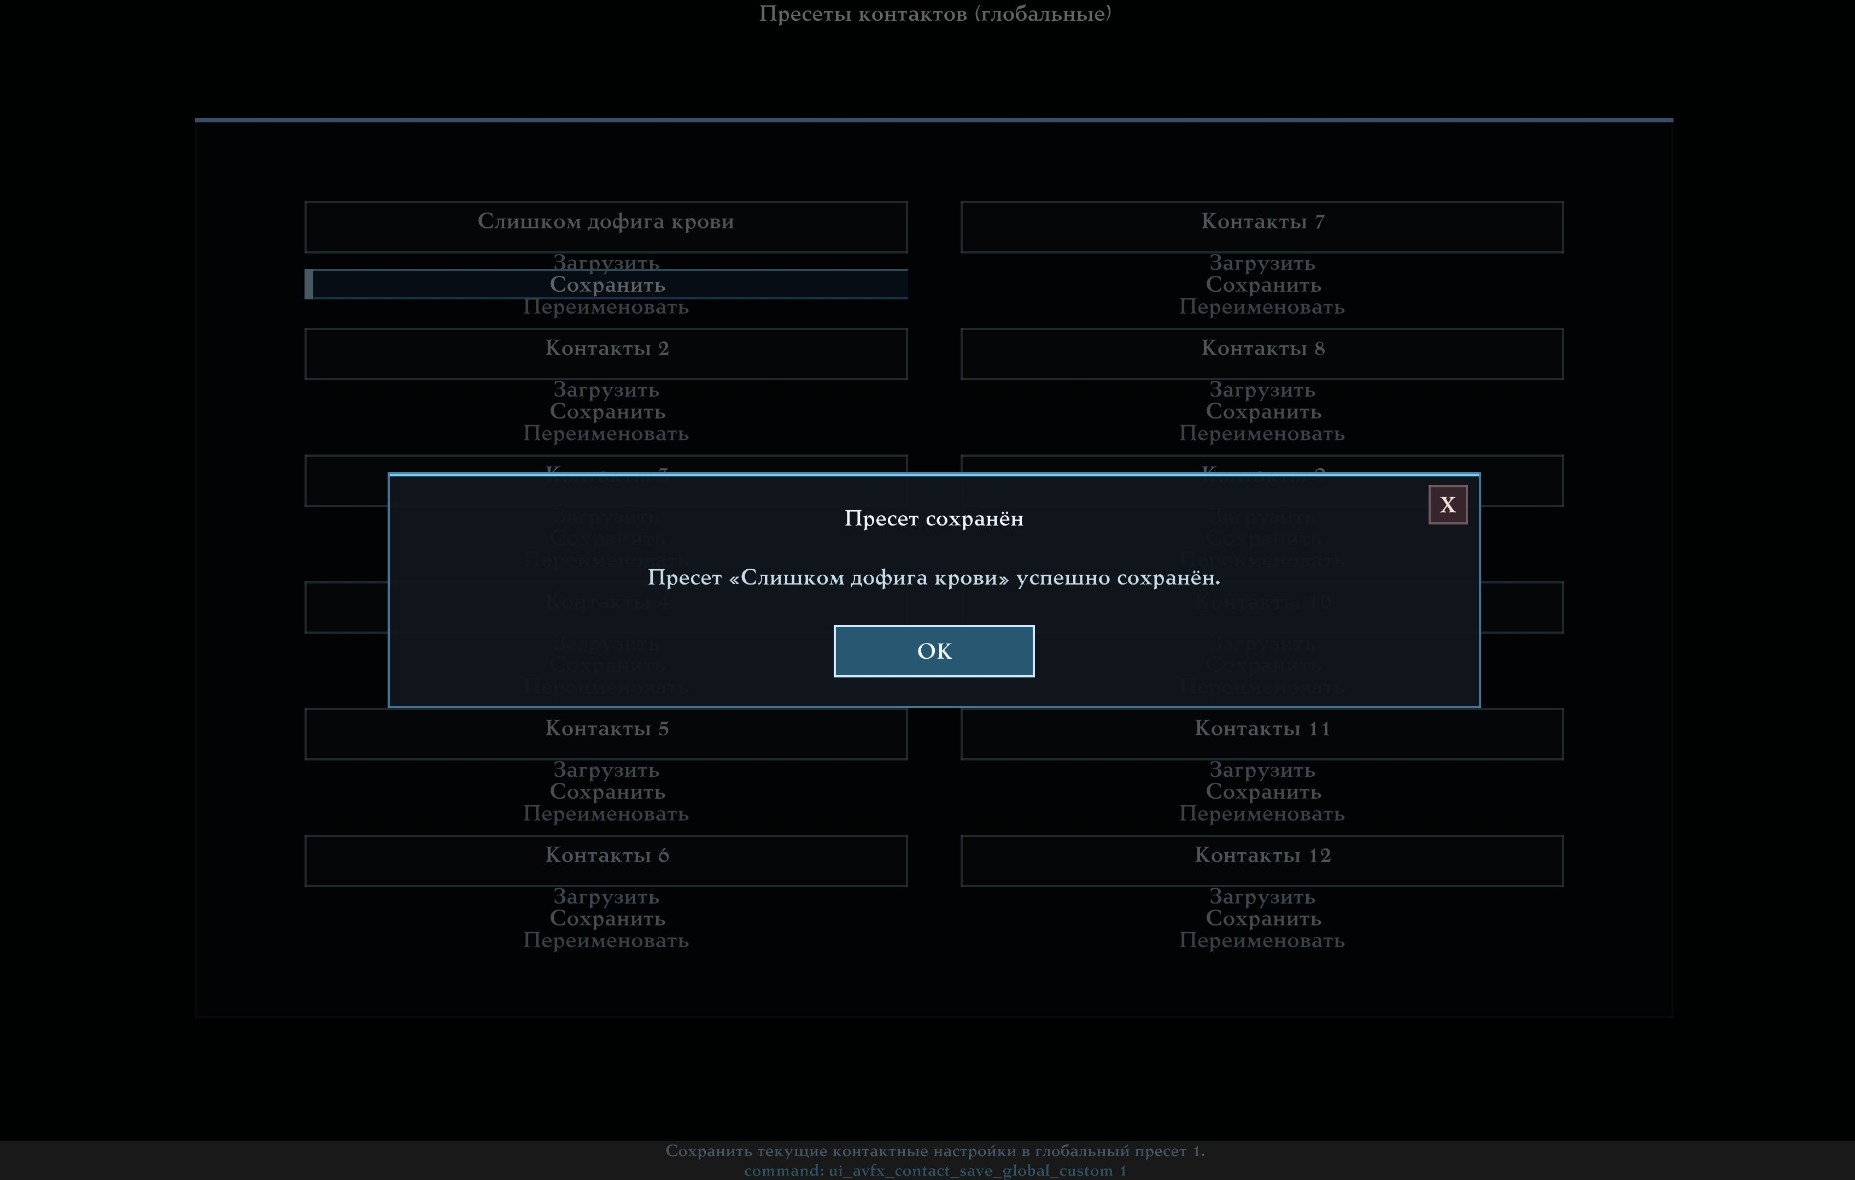
Global Contact slots with Load, Save and Rename actions.

Reset and information
Reset Contact Settings restores factory values and clears current contact state without affecting ordinary AVFX. Information explains three main rules: the effects are visual only, vaporisation does not disable blood, and Contact presets are separate from ordinary AVFX presets.

Detailed settings
The Player Contact Effects hub contains eight pages. Changes apply immediately.
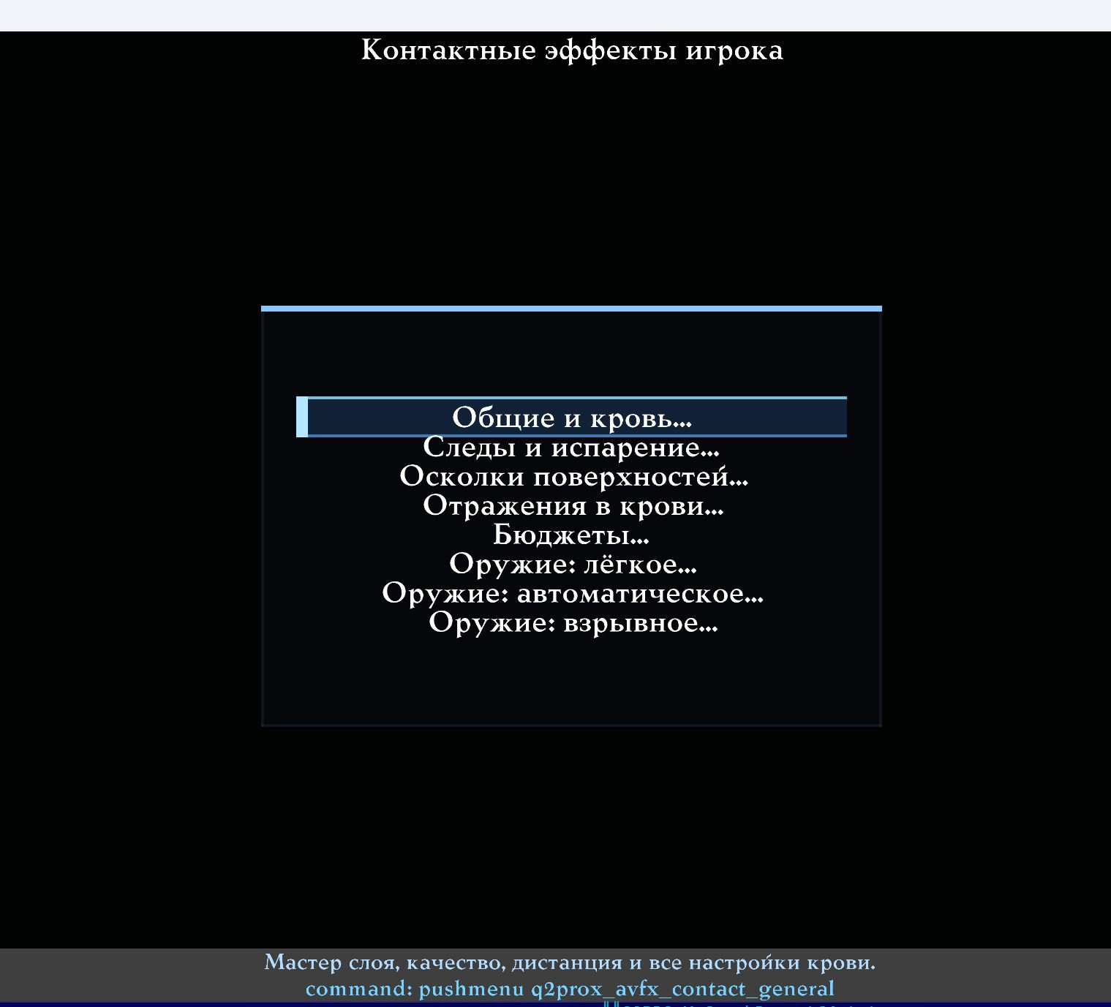
The detailed Contact Effects hub and its eight pages.

General and blood
The master switch, quality level and overall biological-effect intensity are here. Separate controls cover drop count and size, model wounds, world stains, lifetime, corpse bleeding, pool growth and size, blood RGB and liquid response. Reduce quantity and lifetime before disabling the entire system to retain impact feedback at a lower cost.
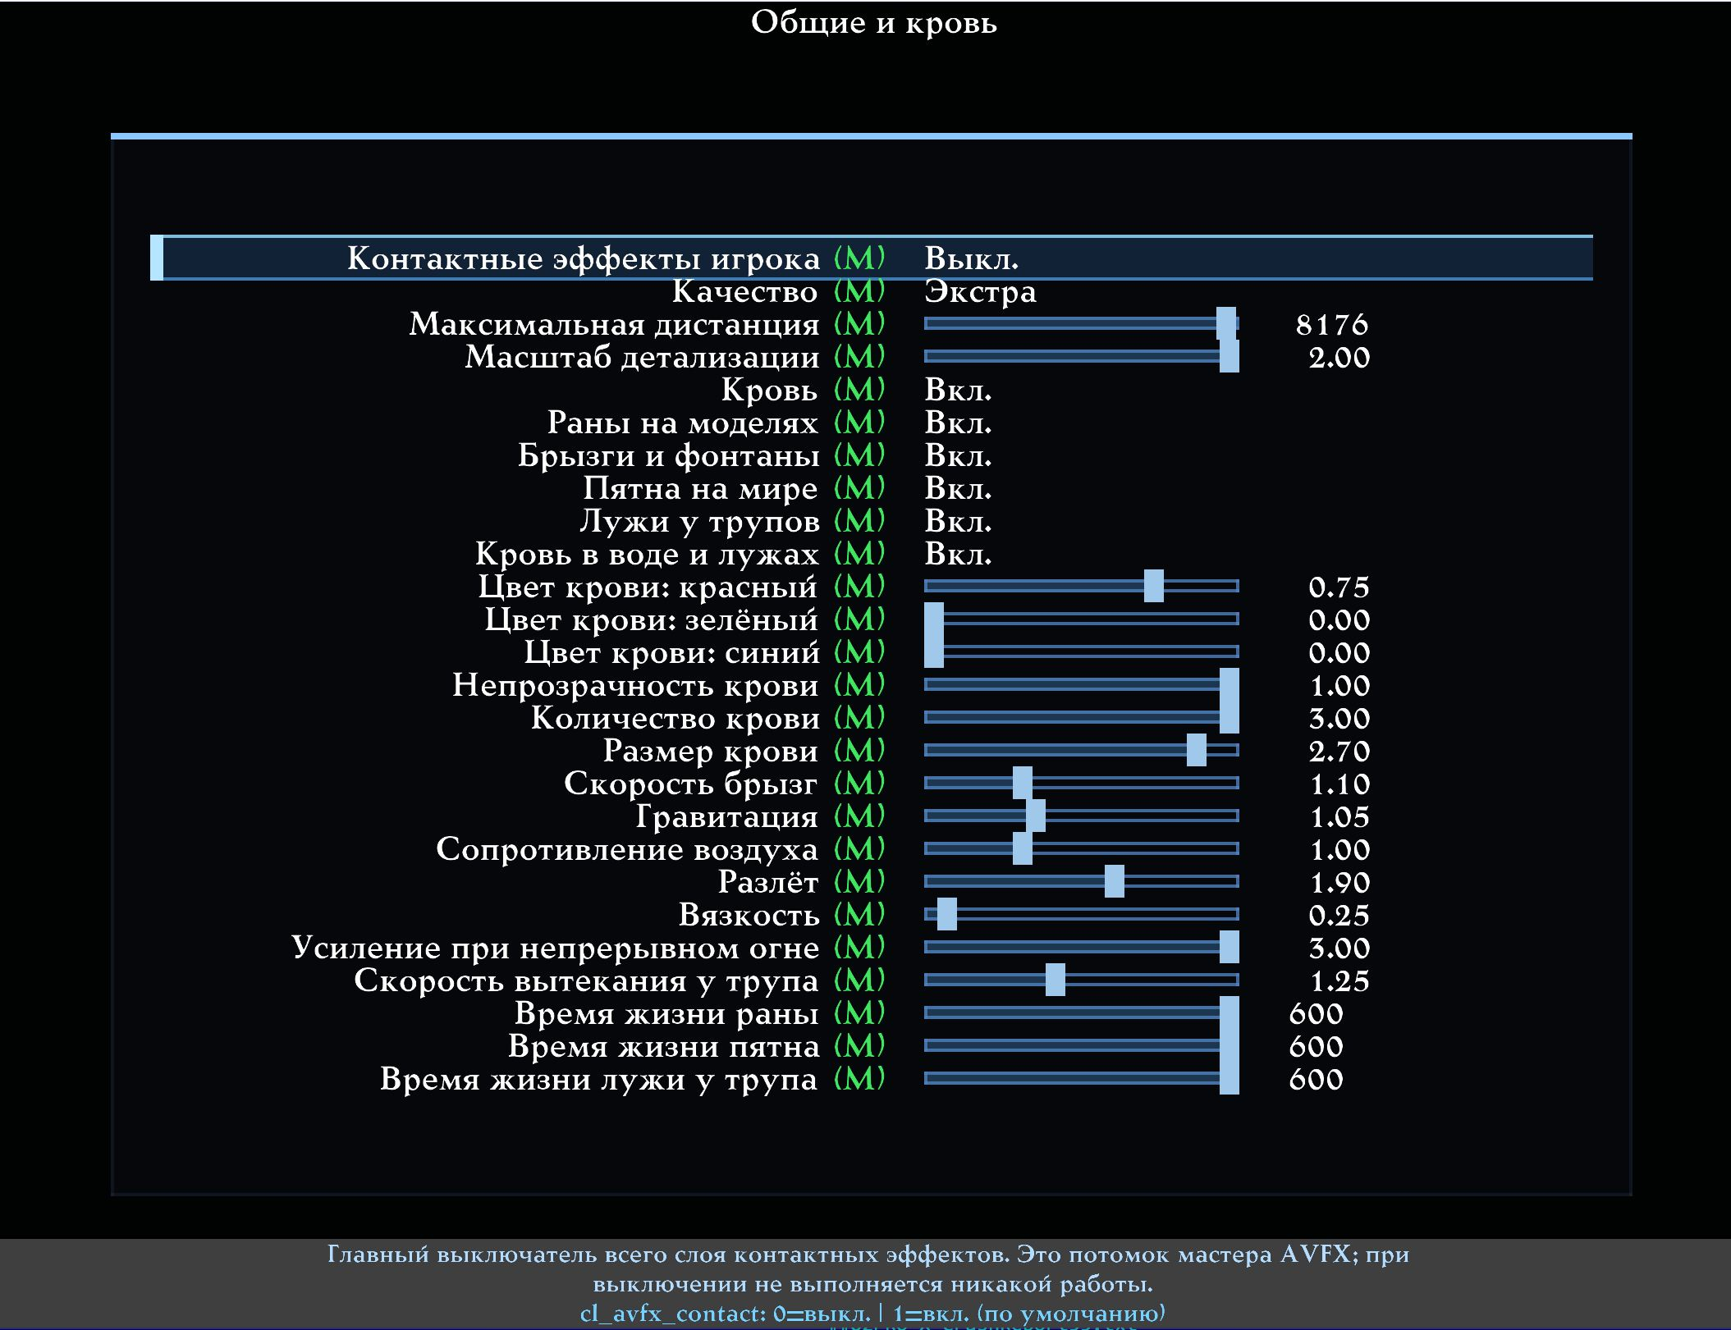
General and Blood: quality, intensity, lifetime and blood RGB.

Marks and vaporisation
Surface-impact marks are independent of blood. Controls cover size, intensity, lifetime and geometric offset, plus vaporisation scale, smoke, heat and lifetime. Vaporisation is an additional channel: when both it and blood are enabled for a weapon, both operate. BFG uses vaporisation by default; other weapons can enable it separately on their weapon page.
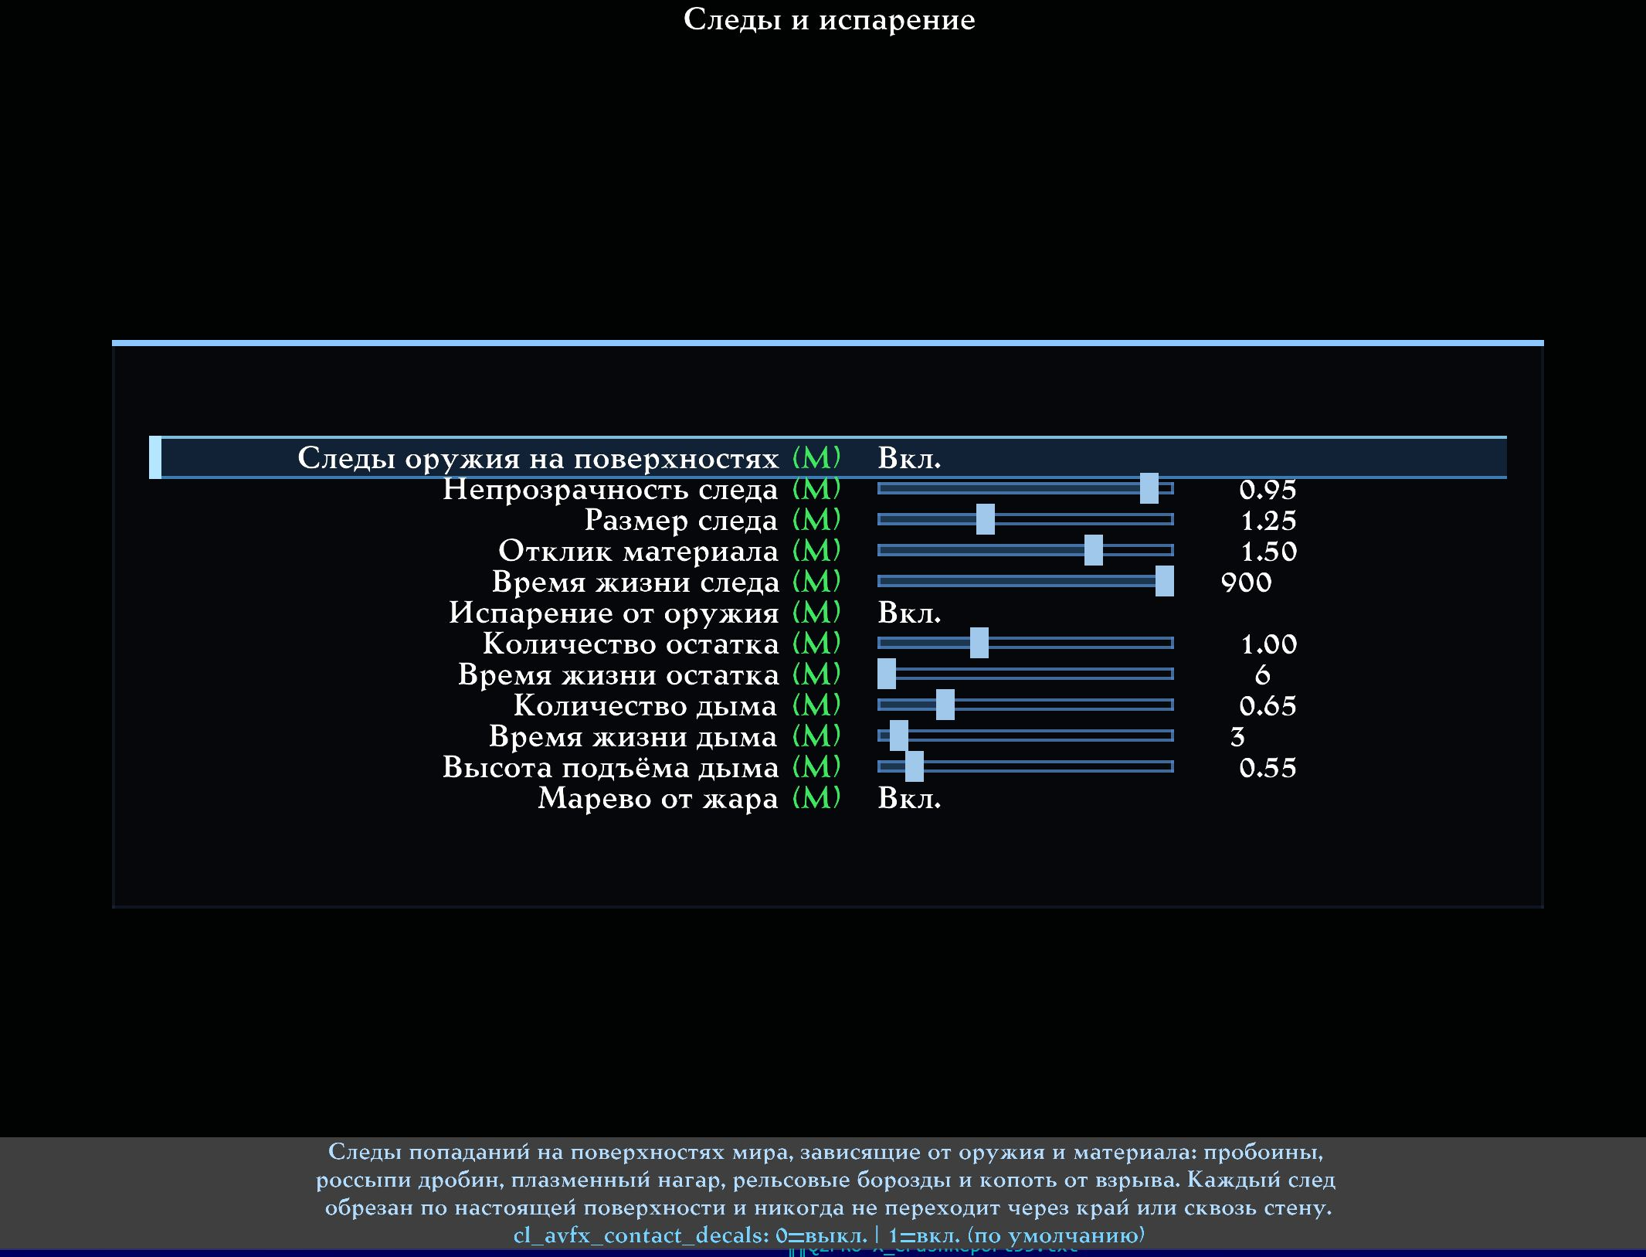
Marks and Vaporisation: impact marks and smoking remains.

Surface debris
Fragments provide a physical-looking material response to impacts. General controls set quantity, size, speed, spread, gravity, bounce and lifetime. Weapon-specific multipliers further scale the result: light weapons can produce few small fragments, while explosives and BFG can produce more and larger ones.
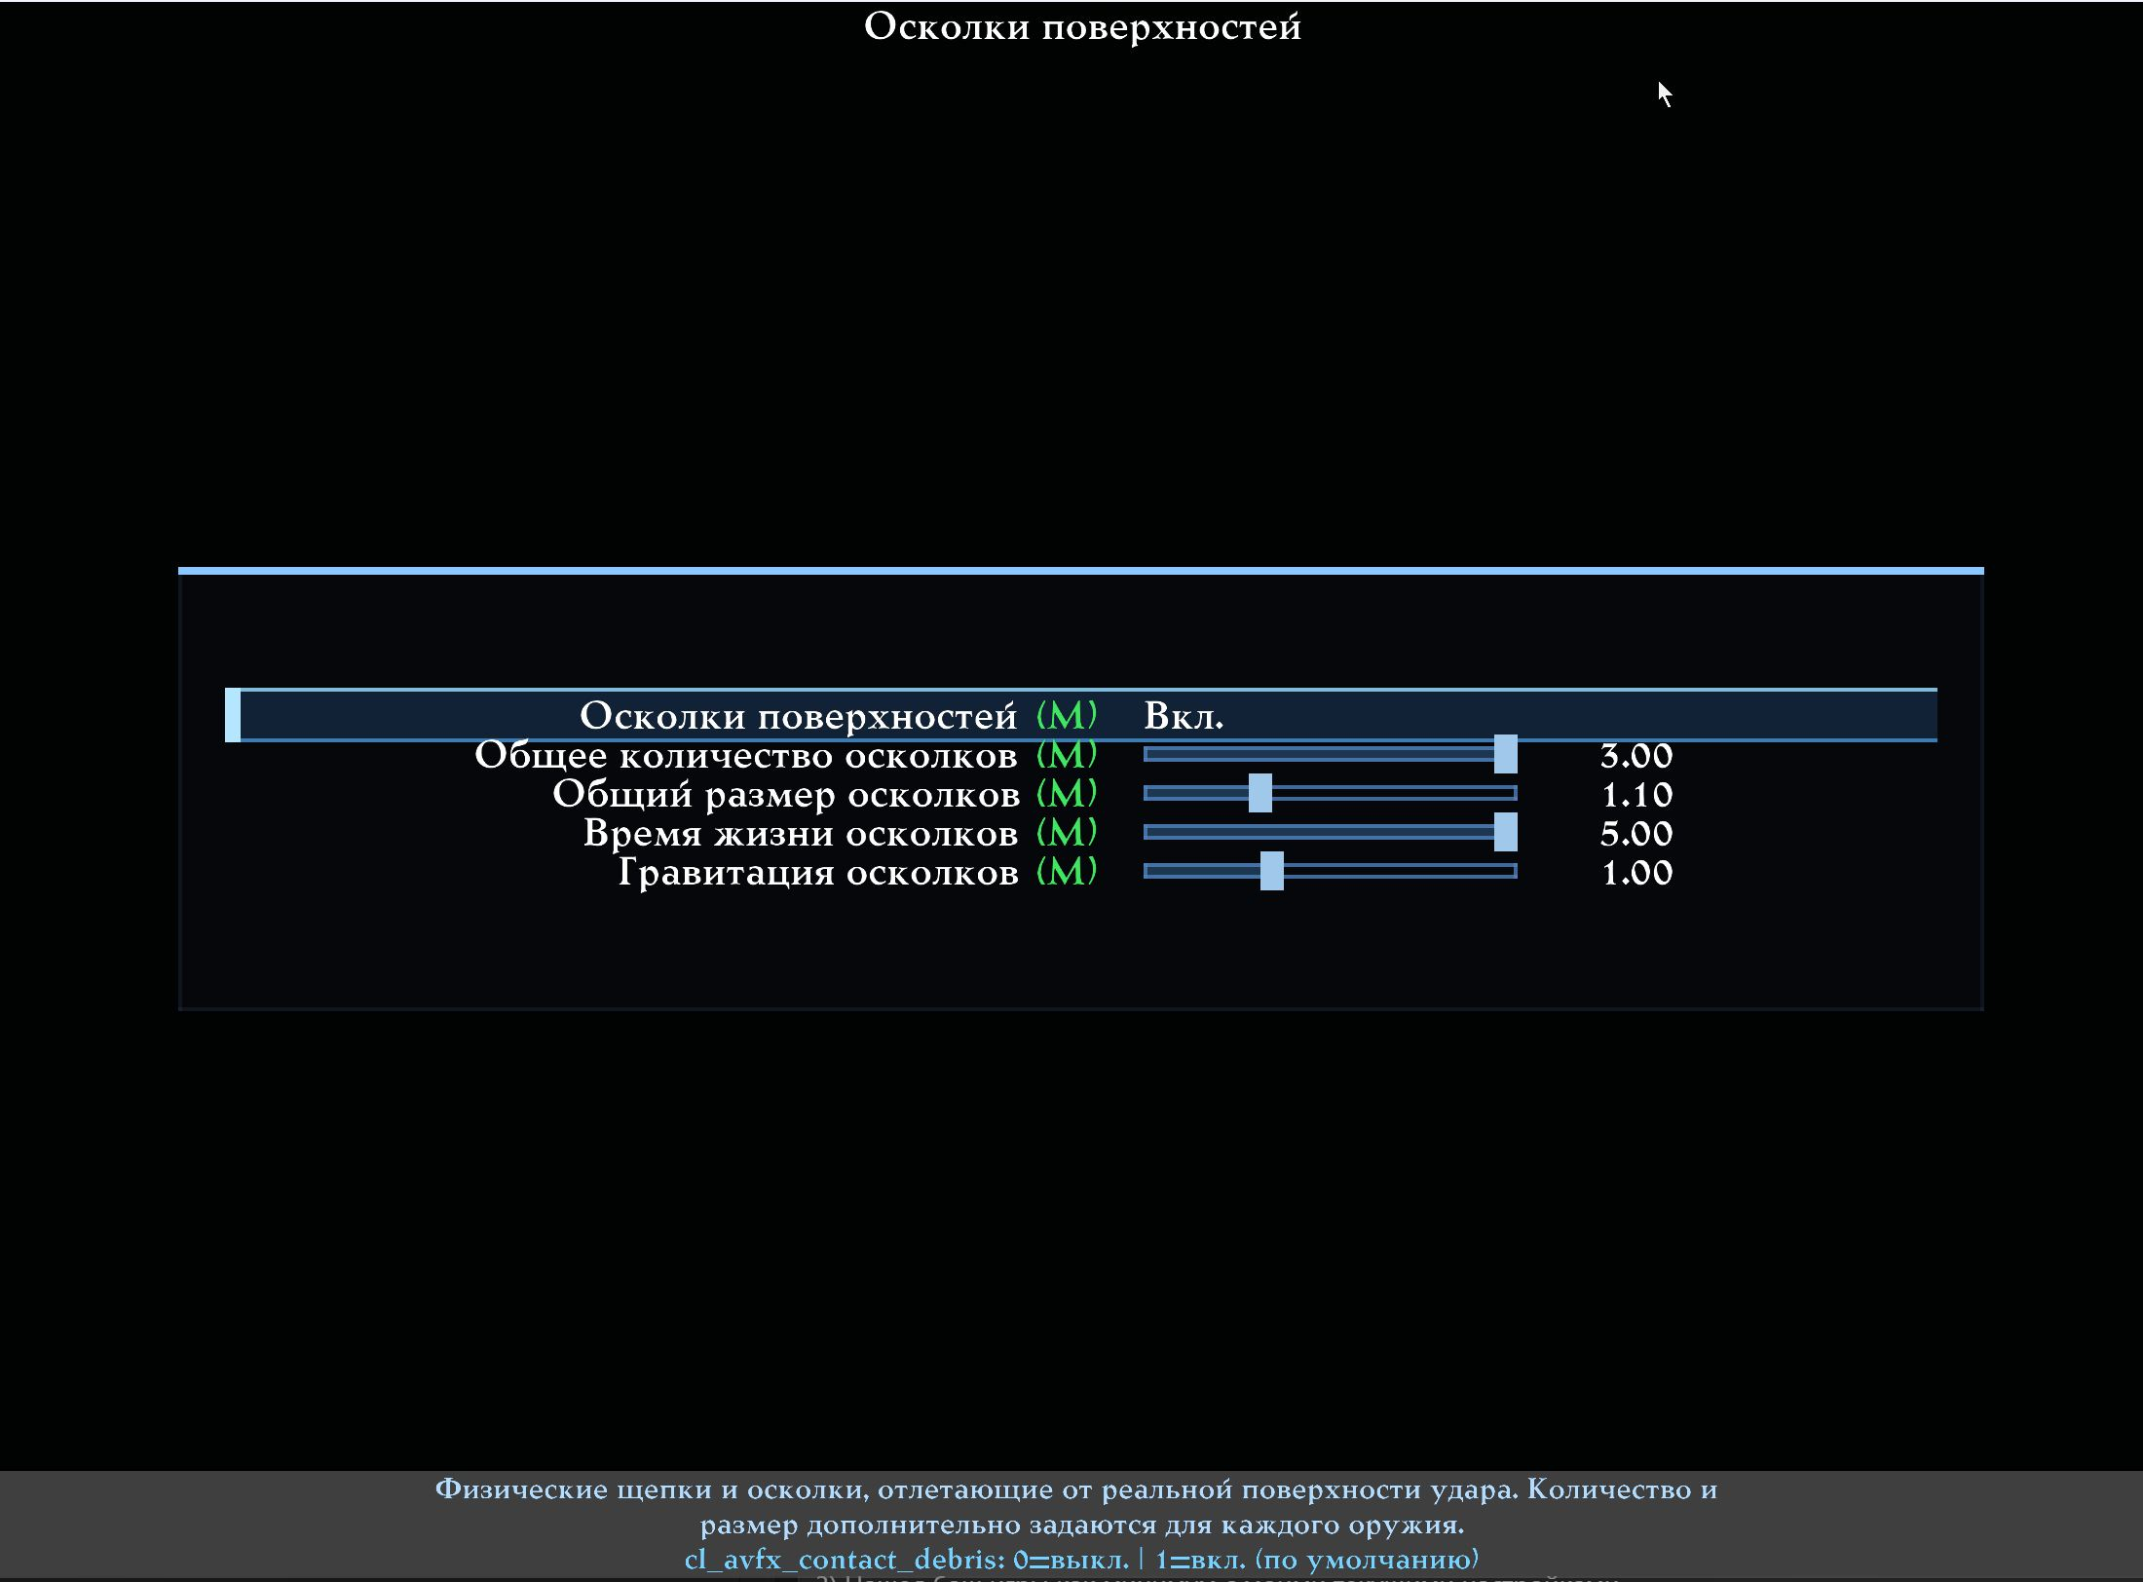
Surface Debris: quantity, size, movement and lifetime.

Blood reflections
These use the reflecting-puddle engine shared with rain puddles and water. The page provides its full quality controls for blood: master, mode, SSR quality, model quality, resolution/scale and capture budgets.
Reflections appear only where a reflecting puddle can exist. Vertical blood remains an ordinary streak without mirror capture, preserving physical meaning and avoiding vertical blood mirrors in online play.
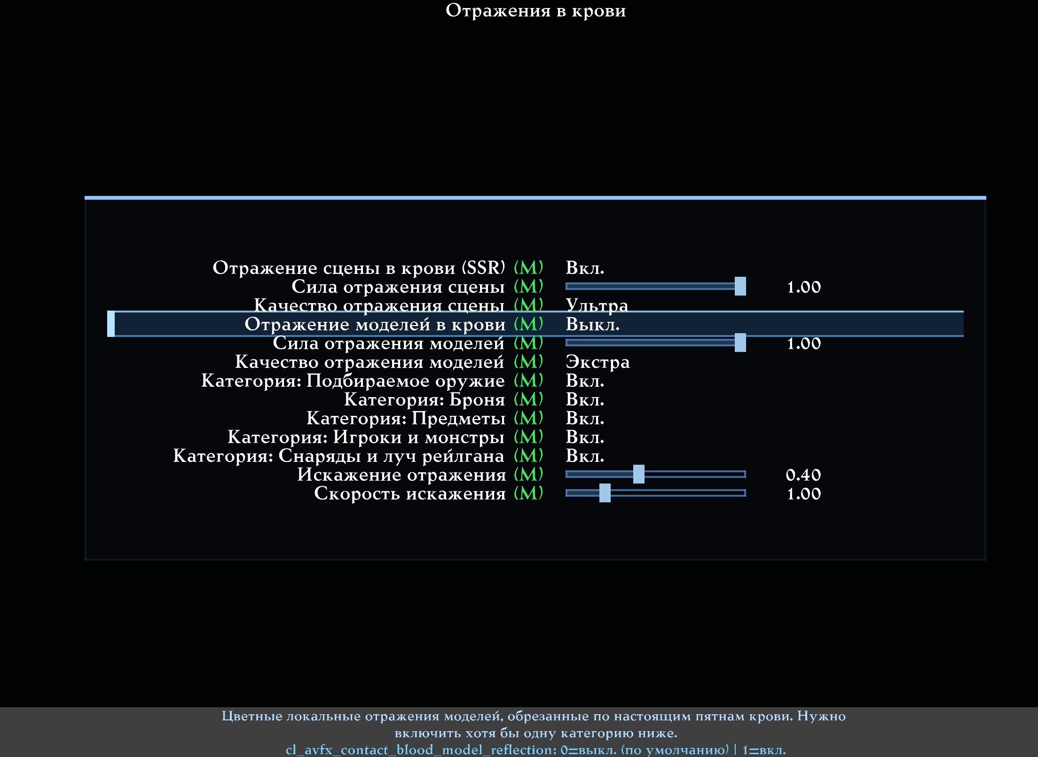
Blood Reflections: SSR and model settings.

Budgets
Budgets bound active work: contact records, wounds, persistent marks, pools, particles and update intervals. When limits are reached, effects scale back within bounds instead of creating unlimited entities or stopping a gameplay frame for one puddle. Use budgets together with quality. On a slower GPU, reduce reflections and their update frequency first, then blood/debris count and lifetime.
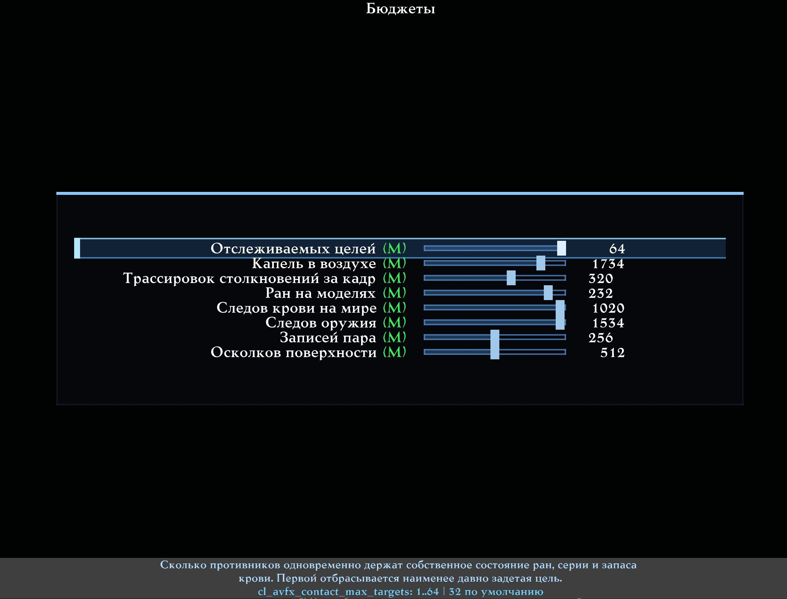
Budgets for records, wounds, marks, pools and updates.

Weapons: light, automatic and explosive
Every weapon has the same seven controls:
1. Contacts: master for that weapon's Contact Effects; ordinary Quake II effects remain.
2. Blood on Living Target: multiplier for spray, wounds and world stains; zero disables only that weapon's living-target blood.
3. Corpse Pool: blood retained for bleeding and pool growth after a confirmed death.
4. Surface Mark: size and weight of a mark/crater on a wall, floor or other surface.
5. Vaporisation: charred remains, smoke and heat in addition to blood.
6. Surface Debris: physical-fragment quantity; zero disables fragments, not the impact mark.
7. Debris Size: fragment-size multiplier for that weapon.
The pages divide weapons as follows:
- Light: generic/unknown, blaster, shotgun and super shotgun.
- Automatic: machinegun, chaingun, hyperblaster and railgun.
- Explosive: hand grenade, grenade launcher, rocket launcher and BFG10K.
For example, keep strong chaingun blood, reduce rocket blood on living targets, increase an explosion's corpse pool and give BFG a large vaporising crater without requiring blood.
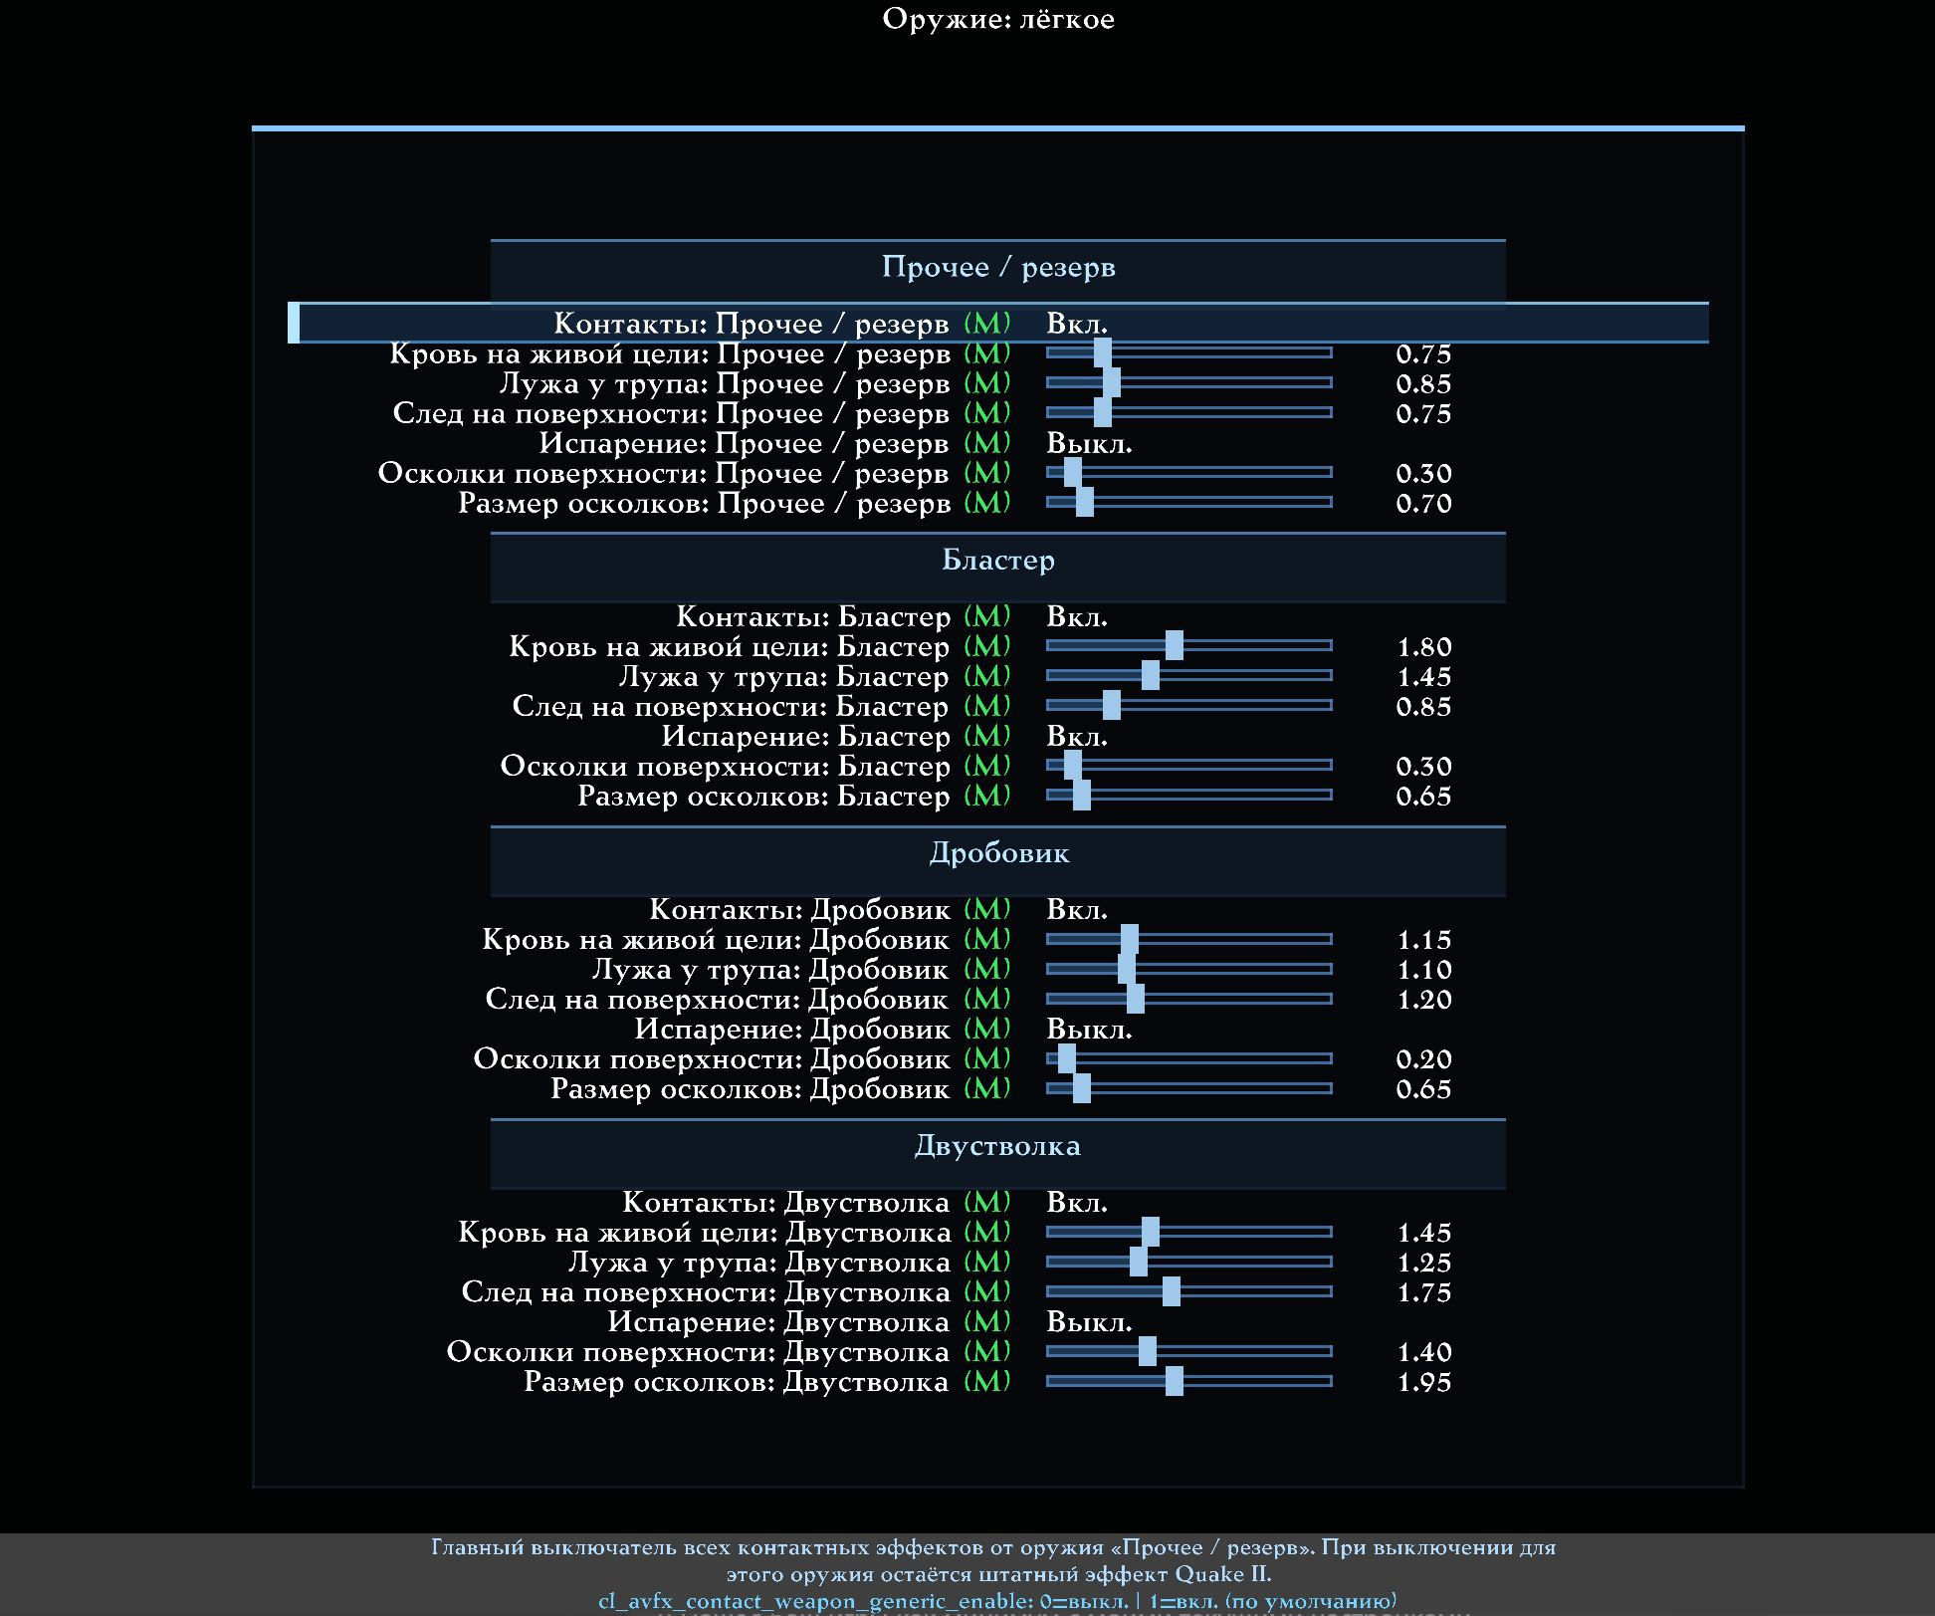
A complete weapon page: seven controls per weapon.

Practical setup

A restrained starting scene
1. Load Factory → Balanced.
2. Adjust general blood RGB for the mod or opponents.
3. Set living-target blood and corpse pools on the weapon pages first.
4. Adjust marks and fragments in keeping with weapon strength.
5. Enable vaporisation only where it suits the weapon.
6. Tune lifetimes and budgets for your system.
7. Save the result to one of the twelve global Contact slots.

Frame-rate drops near blood
- Reduce blood-reflection quality and update frequency.
- Lower pool, persistent-mark and wound limits.
- Shorten stain and particle lifetimes.
- Reduce debris from powerful weapons.
- Do not alter network or prediction settings: they are not Contact performance controls.

Effects are too strong
Start with the individual weapon's multiplier. Change overall blood intensity only after balancing weapons; changing every source together makes results harder to diagnose.

Complete menu reference
The following English labels, variables, ranges and hints are generated from the current client menus. Ordinary users can begin with the sections above.

Preset hub and factory profiles
AVFX Player Contact Presets
Type | Section | Row | Variable or target | What it does
Section | Factory | Factory
Navigation | Factory | Basic | q2prox_avfx_contact_factory_basic | Balanced Factory profile: the shipped defaults for every contact setting.
Navigation | Factory | Extra | q2prox_avfx_contact_factory_extra | Extra Factory profiles: Cinematic Extra (heavier amount, longer lifetimes, Extra quality) and Bloody World (the project owner's own tuning).
Section | Custom (global) | Custom (global)
Navigation | Custom (global) | Custom (global) | q2prox_avfx_contact_custom_global | Open 12 global Player Contact preset slots shared by every mod.
Section | Settings | Settings
Navigation | Settings | Player Contact Effect settings... | q2prox_avfx_contact_settings | Open every Player Contact Effect setting: blood, marks, vaporization, budgets and per-weapon behaviour.
Navigation | Settings | Reset contact settings | cl_avfx_contact_defaults; q2prox_cfg_save_local | Reset every Player Contact setting to its Factory default and clear the contact state. Ordinary AVFX settings are not touched.
Section | Info | Info
Navigation | Info | Info | q2prox_avfx_contact_info | What this layer does, what it never does, and how its presets stay separate from the ordinary AVFX presets.

Factory: Basic
Type | Section | Row | Variable or target | What it does
Navigation |  | Balanced | cl_avfx_contact_preset_load_factory balanced; q2prox_cfg_save_local | Load the Balanced Factory profile: every contact setting at its shipped default, quality High.

Factory: Extra
Type | Section | Row | Variable or target | What it does
Navigation |  | Cinematic Extra | cl_avfx_contact_preset_load_factory cinematic_extra; q2prox_cfg_save_local | Load the Cinematic Extra Factory profile: the same weapon behaviour with more blood, longer lifetimes and the Extra quality tier.
Navigation |  | Bloody World | cl_avfx_contact_preset_load_factory bloody_world; q2prox_cfg_save_local | Load the Bloody World Extra profile: the project owner's own tuning - heavy, long-lived blood, large pools, scene reflections on, Extra quality.

Player Contact Presets (Global)
Type | Section | Row | Variable or target | What it does
Preset name |  | Slot 1 name
Navigation |  | Load | ui_avfx_contact_load_global_custom 1 | Load global Player Contact preset slot 1.
Navigation |  | Save | ui_avfx_contact_save_global_custom 1 | Save the current Player Contact settings to global slot 1.
Navigation |  | Rename | ui_avfx_contact_rename_global_custom 1 | Rename global Player Contact preset slot 1.
Preset name |  | Slot 2 name
Navigation |  | Load | ui_avfx_contact_load_global_custom 2 | Load global Player Contact preset slot 2.
Navigation |  | Save | ui_avfx_contact_save_global_custom 2 | Save the current Player Contact settings to global slot 2.
Navigation |  | Rename | ui_avfx_contact_rename_global_custom 2 | Rename global Player Contact preset slot 2.
Preset name |  | Slot 3 name
Navigation |  | Load | ui_avfx_contact_load_global_custom 3 | Load global Player Contact preset slot 3.
Navigation |  | Save | ui_avfx_contact_save_global_custom 3 | Save the current Player Contact settings to global slot 3.
Navigation |  | Rename | ui_avfx_contact_rename_global_custom 3 | Rename global Player Contact preset slot 3.
Preset name |  | Slot 4 name
Navigation |  | Load | ui_avfx_contact_load_global_custom 4 | Load global Player Contact preset slot 4.
Navigation |  | Save | ui_avfx_contact_save_global_custom 4 | Save the current Player Contact settings to global slot 4.
Navigation |  | Rename | ui_avfx_contact_rename_global_custom 4 | Rename global Player Contact preset slot 4.
Preset name |  | Slot 5 name
Navigation |  | Load | ui_avfx_contact_load_global_custom 5 | Load global Player Contact preset slot 5.
Navigation |  | Save | ui_avfx_contact_save_global_custom 5 | Save the current Player Contact settings to global slot 5.
Navigation |  | Rename | ui_avfx_contact_rename_global_custom 5 | Rename global Player Contact preset slot 5.
Preset name |  | Slot 6 name
Navigation |  | Load | ui_avfx_contact_load_global_custom 6 | Load global Player Contact preset slot 6.
Navigation |  | Save | ui_avfx_contact_save_global_custom 6 | Save the current Player Contact settings to global slot 6.
Navigation |  | Rename | ui_avfx_contact_rename_global_custom 6 | Rename global Player Contact preset slot 6.
Preset name |  | Slot 7 name
Navigation |  | Load | ui_avfx_contact_load_global_custom 7 | Load global Player Contact preset slot 7.
Navigation |  | Save | ui_avfx_contact_save_global_custom 7 | Save the current Player Contact settings to global slot 7.
Navigation |  | Rename | ui_avfx_contact_rename_global_custom 7 | Rename global Player Contact preset slot 7.
Preset name |  | Slot 8 name
Navigation |  | Load | ui_avfx_contact_load_global_custom 8 | Load global Player Contact preset slot 8.
Navigation |  | Save | ui_avfx_contact_save_global_custom 8 | Save the current Player Contact settings to global slot 8.
Navigation |  | Rename | ui_avfx_contact_rename_global_custom 8 | Rename global Player Contact preset slot 8.
Preset name |  | Slot 9 name
Navigation |  | Load | ui_avfx_contact_load_global_custom 9 | Load global Player Contact preset slot 9.
Navigation |  | Save | ui_avfx_contact_save_global_custom 9 | Save the current Player Contact settings to global slot 9.
Navigation |  | Rename | ui_avfx_contact_rename_global_custom 9 | Rename global Player Contact preset slot 9.
Preset name |  | Slot 10 name
Navigation |  | Load | ui_avfx_contact_load_global_custom 10 | Load global Player Contact preset slot 10.
Navigation |  | Save | ui_avfx_contact_save_global_custom 10 | Save the current Player Contact settings to global slot 10.
Navigation |  | Rename | ui_avfx_contact_rename_global_custom 10 | Rename global Player Contact preset slot 10.
Preset name |  | Slot 11 name
Navigation |  | Load | ui_avfx_contact_load_global_custom 11 | Load global Player Contact preset slot 11.
Navigation |  | Save | ui_avfx_contact_save_global_custom 11 | Save the current Player Contact settings to global slot 11.
Navigation |  | Rename | ui_avfx_contact_rename_global_custom 11 | Rename global Player Contact preset slot 11.
Preset name |  | Slot 12 name
Navigation |  | Load | ui_avfx_contact_load_global_custom 12 | Load global Player Contact preset slot 12.
Navigation |  | Save | ui_avfx_contact_save_global_custom 12 | Save the current Player Contact settings to global slot 12.
Navigation |  | Rename | ui_avfx_contact_rename_global_custom 12 | Rename global Player Contact preset slot 12.

Player Contact Effects: info
Type | Section | Row | Variable or target | What it does
Section | What this is | What this is
Navigation | What this is | Effects from your own hits | echo Player Contact Effects: effects from your own weapon hits. | Blood effects and weapon impact marks are configured independently. Weapon vaporization adds scorched residue, smoke and heat alongside blood; it never disables it.
Section | What it never does | What it never does
Navigation | What it never does | Presentation only | echo Player Contact Effects: presentation only. | It changes nothing about the game itself: no server authority, no damage, no hit registration, no prediction, no demo format, no entity visibility and no networking. It works on ordinary Quake II and Q2PRO servers with no server mod, and it never shows your own blood from damage you took.
Section | Presets | Presets
Navigation | Presets | Separate from ordinary AVFX presets | echo Player Contact presets are independent of ordinary AVFX presets. | Player Contact presets and ordinary AVFX presets are separate in both directions: loading one never changes the other. The 12 custom slots are global files shared by every mod.

General settings, blood, marks and vaporisation
Player Contact Effects
Type | Section | Row | Variable or target | What it does
Navigation |  | General and blood... | q2prox_avfx_contact_general | Layer master, quality, distance and every blood control.
Navigation |  | Marks and vaporization... | q2prox_avfx_contact_decals_vapor | Weapon surface marks and BFG vaporization.
Navigation |  | Surface debris... | q2prox_avfx_contact_debris | Physical surface fragments and their global simulation controls.
Navigation |  | Blood reflections... | q2prox_avfx_contact_reflections | Independent SSR and model reflections in blood sheets.
Navigation |  | Budgets... | q2prox_avfx_contact_budgets | Hard caps on everything the layer keeps alive at once.
Navigation |  | Weapons: light... | q2prox_avfx_contact_weapons_a | Per-weapon blood, corpse pool and mark behaviour: light.
Navigation |  | Weapons: automatic... | q2prox_avfx_contact_weapons_b | Per-weapon blood, corpse pool and mark behaviour: automatic.
Navigation |  | Weapons: explosive... | q2prox_avfx_contact_weapons_c | Per-weapon blood, corpse pool and mark behaviour: explosive.

General and blood
Type | Section | Row | Variable or target | What it does
Toggle |  | Player Contact Effects | cl_avfx_contact | Master switch for the whole Player Contact layer. It is a child of the AVFX master, and off means exactly zero work. Applies immediately.
List |  | Quality | cl_avfx_contact_quality | Detail and per-frame budget of the contact layer. Each tier carries its own immutable ceilings on droplets, collision probes, model marks, world blood, impact marks and vapor; your own caps below can only lower them, never raise them. Applies immediately. [Low / Basic / High / Extra]
Slider |  | Maximum distance | cl_avfx_contact_distance | Contacts farther than this from the camera are not submitted for drawing. Lower values keep a busy fight cheap without changing what actually happened. Applies immediately.
Slider |  | Detail scale | cl_avfx_contact_lod | Scales the AMOUNT of everything the layer emits, inside the hard caps. Below 1.00 it thins satellites, smoke lobes and collision probes first, and the immediate hit feedback last. Applies immediately.
Toggle |  | Blood | cl_avfx_contact_blood | Family switch for every blood visual: model wounds, airborne spray, world stains, water response and corpse pools. Off keeps the stock Quake II blood; it does not hide flesh hits. Applies immediately.
Toggle |  | Wounds on models | cl_avfx_contact_blood_model | Irregular wounds projected onto the opponent's model at the real hit point. They follow the animation instead of sliding, and expire on their own lifetime or when the model changes. Applies immediately.
Toggle |  | Sprays and fountains | cl_avfx_contact_blood_spray | Ballistic blood in the air: droplets, filaments and mist thrown from the wound. Sustained fire builds a repeated fountain and it decays naturally after you release the trigger. Applies immediately.
Toggle |  | Stains on the world | cl_avfx_contact_blood_surface | Splashes, stains and running drips on real floors and walls, clipped to the actual surface so nothing hangs over an edge or runs through a wall. Applies immediately.
Toggle |  | Corpse pools | cl_avfx_contact_blood_corpse | Wound-fed leakage and a growing pool under a body, released only when death is actually proven. A disappearance on its own is never treated as a death, so no phantom pool appears. Applies immediately.
Toggle |  | Blood in water and puddles | cl_avfx_contact_blood_water | Blood reaching real BSP water spreads as a short-lived dye film on the animated liquid surface; blood reaching an existing AVFX puddle stays inside its real boundary and ripples it. Applies immediately.
Slider |  | Blood colour: red | cl_avfx_contact_blood_r | Red channel of the blood colour. The same colour is used for model wounds, airborne blood and world stains; lighting may darken it but never replaces it. Applies immediately.
Slider |  | Blood colour: green | cl_avfx_contact_blood_g | Green channel of the blood colour. The same colour is used for model wounds, airborne blood and world stains; lighting may darken it but never replaces it. Applies immediately.
Slider |  | Blood colour: blue | cl_avfx_contact_blood_b | Blue channel of the blood colour. The same colour is used for model wounds, airborne blood and world stains; lighting may darken it but never replaces it. Applies immediately.
Slider |  | Blood opacity | cl_avfx_contact_blood_alpha | Base opacity of every blood visual before age and lighting are applied. Applies immediately.
Slider |  | Blood amount | cl_avfx_contact_blood_amount | Global multiplier on how much blood a contact produces. It scales the emission, not the size of a single droplet. Applies immediately.
Slider |  | Blood size | cl_avfx_contact_blood_size | Scales droplets, wounds and stains together. Applies immediately.
Slider |  | Spray velocity | cl_avfx_contact_blood_velocity | Initial speed of the blood leaving the wound. Higher values throw it farther before gravity and drag take over. Applies immediately.
Slider |  | Gravity | cl_avfx_contact_blood_gravity | How strongly airborne blood falls. 0.00 leaves it floating along its initial direction. Applies immediately.
Slider |  | Air drag | cl_avfx_contact_blood_drag | How quickly airborne blood loses speed. Higher values make short, heavy spatter; lower values make long filaments. Applies immediately.
Slider |  | Spread | cl_avfx_contact_blood_spread | Angular width of the spray around the impact direction. Applies immediately.
Slider |  | Viscosity | cl_avfx_contact_blood_viscosity | How thickly blood spreads and runs on a surface. Higher values keep it tight and slow; lower values let it spread wide and thin. Applies immediately.
Slider |  | Sustained fire gain | cl_avfx_contact_blood_sustained | How much continuous fire on the same target builds the fountain. 0.00 makes every hit independent. Applies immediately.
Slider |  | Corpse flow rate | cl_avfx_contact_blood_corpse_flow | How fast the stored blood leaves a proven corpse and feeds its pool. Applies immediately.
Slider |  | Wound lifetime | cl_avfx_contact_blood_model_lifetime | How long a wound stays on a living model. 0 disables model wounds entirely and purges the ones already there. Applies immediately.
Slider |  | Stain lifetime | cl_avfx_contact_blood_surface_lifetime | How long a blood stain stays on the world. 0 disables persistent stains and purges the ones already there. Applies immediately.
Slider |  | Corpse pool lifetime | cl_avfx_contact_blood_corpse_lifetime | How long a corpse pool and its leak stay. 0 disables corpse pools entirely. Applies immediately.

Marks and vaporization
Type | Section | Row | Variable or target | What it does
Toggle |  | Weapon surface marks | cl_avfx_contact_decals | Weapon- and material-specific impact marks on world surfaces: punctures, pellet clusters, plasma char, rail grooves and blast soot. Each mark is clipped to the real surface and never crosses an edge or a wall. Applies immediately.
Slider |  | Mark opacity | cl_avfx_contact_decal_alpha | Base opacity of every weapon impact mark. Applies immediately.
Slider |  | Mark size | cl_avfx_contact_decal_size | Global multiplier on the size of every weapon impact mark. Applies immediately.
Slider |  | Material response | cl_avfx_contact_decal_roughness | How strongly a mark takes on the surface it landed on. Higher values deepen the difference between a dry wall, wet stone and metal. Applies immediately.
Slider |  | Mark lifetime | cl_avfx_contact_decal_lifetime | How long a weapon impact mark stays. 0 disables persistent marks and purges the ones already there; the transient stock impact feedback is kept either way. Applies immediately.
Toggle |  | Weapon vaporization | cl_avfx_contact_vaporize | Enable configured weapon vapor effects. Vaporization adds residue, smoke and heat; it never disables independently configured blood. Applies immediately.
Slider |  | Residue amount | cl_avfx_contact_vapor_residue | How much scorched residue a vaporizing hit leaves on the target and the nearest valid surface. Applies immediately.
Slider |  | Residue lifetime | cl_avfx_contact_vapor_residue_lifetime | How long vaporization residue stays. 0 disables it. Applies immediately.
Slider |  | Smoke amount | cl_avfx_contact_vapor_smoke | How many smoke lobes rise from a vaporized target. Applies immediately.
Slider |  | Smoke lifetime | cl_avfx_contact_vapor_smoke_lifetime | How long each smoke lobe lives. 0 disables the smoke. Applies immediately.
Slider |  | Smoke rise height | cl_avfx_contact_vapor_smoke_height | How high the smoke climbs above the body volume. Applies immediately.
Toggle |  | Heat shimmer | cl_avfx_contact_vapor_heat_haze | Short-lived air distortion over a vaporized body. It is optional by backend capability: where the renderer cannot provide it, the rest of the vaporization is unchanged and nothing is substituted. Applies immediately.

Debris, reflections and budgets
Surface debris
Type | Section | Row | Variable or target | What it does
Toggle |  | Surface debris | cl_avfx_contact_debris | Physical chips and fragments thrown from the real impact surface. The amount and size remain weapon-specific below. Applies immediately.
Slider |  | Global debris amount | cl_avfx_contact_debris_amount | Global multiplier for every weapon's debris count. Applies immediately.
Slider |  | Global debris size | cl_avfx_contact_debris_size | Global multiplier for fragment size, independent from count. Applies immediately.
Slider |  | Debris lifetime | cl_avfx_contact_debris_lifetime | How long airborne surface fragments remain visible. Applies immediately.
Slider |  | Debris gravity | cl_avfx_contact_debris_gravity | Gravity multiplier for surface fragments. Applies immediately.

Blood reflections
Type | Section | Row | Variable or target | What it does
Toggle |  | Blood-pool scene reflection (SSR) | cl_avfx_contact_blood_scene_reflection | Real screen-space reflection in horizontal blood sheets. Blood owns one SSR layer on BSP and Surface Materials; on AVFX puddles or water it inherits the existing liquid reflection to prevent a duplicate pass. Applies immediately.
Slider |  | Scene reflection strength | cl_avfx_contact_blood_scene_reflection_strength | Strength of the world/static SSR contribution in blood. Applies immediately.
List |  | Scene reflection quality | cl_avfx_contact_blood_scene_reflection_quality | SSR march precision. Higher values are crisper and cost more GPU time. Applies immediately. [Low / Medium / High / Ultra]
Toggle |  | Blood-pool model reflection | cl_avfx_contact_blood_model_reflection | Coloured local model reflections clipped to actual horizontal blood footprints. At least one category below must be enabled. Applies immediately.
Slider |  | Model reflection strength | cl_avfx_contact_blood_model_reflection_strength | Opacity of coloured model reflections in blood. Applies immediately.
List |  | Model reflection quality | cl_avfx_contact_blood_model_reflection_quality | Controls receiver population and distance before model replay work. Applies immediately. [Performance / Medium / Quality / Ultra / Extra]
Toggle |  | Category: Pickup weapons | cl_avfx_contact_blood_model_reflection_weapons | Allow pickup weapons to reflect in blood pools. Applies immediately.
Toggle |  | Category: Armor | cl_avfx_contact_blood_model_reflection_armor | Allow armor to reflect in blood pools. Applies immediately.
Toggle |  | Category: Items | cl_avfx_contact_blood_model_reflection_items | Allow items to reflect in blood pools. Applies immediately.
Toggle |  | Category: Players and monsters | cl_avfx_contact_blood_model_reflection_actors | Allow players and monsters to reflect in blood pools. Applies immediately.
Toggle |  | Category: Projectiles and rail beam | cl_avfx_contact_blood_model_reflection_projectiles | Allow projectiles and rail beam to reflect in blood pools. Applies immediately.
Slider |  | Reflection distortion | cl_avfx_contact_blood_reflection_distort | Optional moving-liquid distortion shared by blood SSR and model reflection. Applies immediately.
Slider |  | Distortion speed | cl_avfx_contact_blood_reflection_distort_speed | Travel speed of reflection ripples; 0 freezes their animation. Applies immediately.

Budgets
Type | Section | Row | Variable or target | What it does
Slider |  | Tracked targets | cl_avfx_contact_max_targets | How many opponents keep their own wound, burst and reservoir state at once. The least recently hit target is dropped first. Applies immediately.
Slider |  | Airborne droplets | cl_avfx_contact_max_droplets | Hard cap on visible blood droplets. The active quality tier may lower it further; it can never raise it. Applies immediately.
Slider |  | Collision traces per frame | cl_avfx_contact_max_collision_probes | How many representative droplet trajectories may be traced against the world each frame. Untraced droplets render as satellites of a traced one. Applies immediately.
Slider |  | Wounds on models | cl_avfx_contact_max_model_marks | Hard cap on animated wounds across every target at once. Applies immediately.
Slider |  | World blood marks | cl_avfx_contact_max_surface_blood | Hard cap on blood stains, drips and pools present in the world. Applies immediately.
Slider |  | Weapon marks | cl_avfx_contact_max_decals | Hard cap on weapon impact marks present in the world. Applies immediately.
Slider |  | Vapor records | cl_avfx_contact_max_vapor | Hard cap on vaporization residue, smoke and shimmer records. Applies immediately.
Slider |  | Surface debris | cl_avfx_contact_max_debris | Hard cap on airborne surface fragments across all weapon impacts. Applies immediately.

All weapon controls
Weapons: light
Type | Section | Row | Variable or target | What it does
Section | Generic / fallback | Generic / fallback
Toggle | Generic / fallback | Generic / fallback contacts | cl_avfx_contact_weapon_generic_enable | Master switch for every Player Contact effect caused by the Generic / fallback. Off leaves the stock Quake II effect for that weapon untouched. Applies immediately.
Slider | Generic / fallback | Generic / fallback blood on a living target | cl_avfx_contact_weapon_generic_live_blood | How much blood a Generic / fallback hit puts on a LIVING opponent: the spray, the wound on the model and the stain it leaves on the world. 0 disables only the blood for this weapon. Applies immediately.
Slider | Generic / fallback | Generic / fallback corpse pool | cl_avfx_contact_weapon_generic_corpse_blood | How much blood a Generic / fallback kill stores for the corpse: the leak from the wounds and the pool that grows under the body once death is proven. Applies immediately.
Slider | Generic / fallback | Generic / fallback surface mark | cl_avfx_contact_weapon_generic_decal | Size and weight of the mark a Generic / fallback impact leaves on a wall, a floor or another world surface. Applies immediately.
Toggle | Generic / fallback | Generic / fallback vaporization | cl_avfx_contact_weapon_generic_vaporize | Add vaporization for the Generic / fallback: scorched residue, layered smoke and heat alongside any blood configured for this weapon. Only the BFG uses vaporization by default. Applies immediately.
Slider | Generic / fallback | Generic / fallback surface debris | cl_avfx_contact_weapon_generic_debris | Amount of physical surface fragments thrown by a Generic / fallback impact. 0 disables only debris for this weapon; the impact mark is independent. Applies immediately.
Slider | Generic / fallback | Generic / fallback debris size | cl_avfx_contact_weapon_generic_debris_size | Size multiplier for surface fragments thrown by a Generic / fallback impact. Applies immediately.
Section | Blaster | Blaster
Toggle | Blaster | Blaster contacts | cl_avfx_contact_weapon_blaster_enable | Master switch for every Player Contact effect caused by the Blaster. Off leaves the stock Quake II effect for that weapon untouched. Applies immediately.
Slider | Blaster | Blaster blood on a living target | cl_avfx_contact_weapon_blaster_live_blood | How much blood a Blaster hit puts on a LIVING opponent: the spray, the wound on the model and the stain it leaves on the world. 0 disables only the blood for this weapon. Applies immediately.
Slider | Blaster | Blaster corpse pool | cl_avfx_contact_weapon_blaster_corpse_blood | How much blood a Blaster kill stores for the corpse: the leak from the wounds and the pool that grows under the body once death is proven. Applies immediately.
Slider | Blaster | Blaster surface mark | cl_avfx_contact_weapon_blaster_decal | Size and weight of the mark a Blaster impact leaves on a wall, a floor or another world surface. Applies immediately.
Toggle | Blaster | Blaster vaporization | cl_avfx_contact_weapon_blaster_vaporize | Add vaporization for the Blaster: scorched residue, layered smoke and heat alongside any blood configured for this weapon. Only the BFG uses vaporization by default. Applies immediately.
Slider | Blaster | Blaster surface debris | cl_avfx_contact_weapon_blaster_debris | Amount of physical surface fragments thrown by a Blaster impact. 0 disables only debris for this weapon; the impact mark is independent. Applies immediately.
Slider | Blaster | Blaster debris size | cl_avfx_contact_weapon_blaster_debris_size | Size multiplier for surface fragments thrown by a Blaster impact. Applies immediately.
Section | Shotgun | Shotgun
Toggle | Shotgun | Shotgun contacts | cl_avfx_contact_weapon_shotgun_enable | Master switch for every Player Contact effect caused by the Shotgun. Off leaves the stock Quake II effect for that weapon untouched. Applies immediately.
Slider | Shotgun | Shotgun blood on a living target | cl_avfx_contact_weapon_shotgun_live_blood | How much blood a Shotgun hit puts on a LIVING opponent: the spray, the wound on the model and the stain it leaves on the world. 0 disables only the blood for this weapon. Applies immediately.
Slider | Shotgun | Shotgun corpse pool | cl_avfx_contact_weapon_shotgun_corpse_blood | How much blood a Shotgun kill stores for the corpse: the leak from the wounds and the pool that grows under the body once death is proven. Applies immediately.
Slider | Shotgun | Shotgun surface mark | cl_avfx_contact_weapon_shotgun_decal | Size and weight of the mark a Shotgun impact leaves on a wall, a floor or another world surface. Applies immediately.
Toggle | Shotgun | Shotgun vaporization | cl_avfx_contact_weapon_shotgun_vaporize | Add vaporization for the Shotgun: scorched residue, layered smoke and heat alongside any blood configured for this weapon. Only the BFG uses vaporization by default. Applies immediately.
Slider | Shotgun | Shotgun surface debris | cl_avfx_contact_weapon_shotgun_debris | Amount of physical surface fragments thrown by a Shotgun impact. 0 disables only debris for this weapon; the impact mark is independent. Applies immediately.
Slider | Shotgun | Shotgun debris size | cl_avfx_contact_weapon_shotgun_debris_size | Size multiplier for surface fragments thrown by a Shotgun impact. Applies immediately.
Section | Super Shotgun | Super Shotgun
Toggle | Super Shotgun | Super Shotgun contacts | cl_avfx_contact_weapon_supershotgun_enable | Master switch for every Player Contact effect caused by the Super Shotgun. Off leaves the stock Quake II effect for that weapon untouched. Applies immediately.
Slider | Super Shotgun | Super Shotgun blood on a living target | cl_avfx_contact_weapon_supershotgun_live_blood | How much blood a Super Shotgun hit puts on a LIVING opponent: the spray, the wound on the model and the stain it leaves on the world. 0 disables only the blood for this weapon. Applies immediately.
Slider | Super Shotgun | Super Shotgun corpse pool | cl_avfx_contact_weapon_supershotgun_corpse_blood | How much blood a Super Shotgun kill stores for the corpse: the leak from the wounds and the pool that grows under the body once death is proven. Applies immediately.
Slider | Super Shotgun | Super Shotgun surface mark | cl_avfx_contact_weapon_supershotgun_decal | Size and weight of the mark a Super Shotgun impact leaves on a wall, a floor or another world surface. Applies immediately.
Toggle | Super Shotgun | Super Shotgun vaporization | cl_avfx_contact_weapon_supershotgun_vaporize | Add vaporization for the Super Shotgun: scorched residue, layered smoke and heat alongside any blood configured for this weapon. Only the BFG uses vaporization by default. Applies immediately.
Slider | Super Shotgun | Super Shotgun surface debris | cl_avfx_contact_weapon_supershotgun_debris | Amount of physical surface fragments thrown by a Super Shotgun impact. 0 disables only debris for this weapon; the impact mark is independent. Applies immediately.
Slider | Super Shotgun | Super Shotgun debris size | cl_avfx_contact_weapon_supershotgun_debris_size | Size multiplier for surface fragments thrown by a Super Shotgun impact. Applies immediately.

Weapons: automatic
Type | Section | Row | Variable or target | What it does
Section | Machinegun | Machinegun
Toggle | Machinegun | Machinegun contacts | cl_avfx_contact_weapon_machinegun_enable | Master switch for every Player Contact effect caused by the Machinegun. Off leaves the stock Quake II effect for that weapon untouched. Applies immediately.
Slider | Machinegun | Machinegun blood on a living target | cl_avfx_contact_weapon_machinegun_live_blood | How much blood a Machinegun hit puts on a LIVING opponent: the spray, the wound on the model and the stain it leaves on the world. 0 disables only the blood for this weapon. Applies immediately.
Slider | Machinegun | Machinegun corpse pool | cl_avfx_contact_weapon_machinegun_corpse_blood | How much blood a Machinegun kill stores for the corpse: the leak from the wounds and the pool that grows under the body once death is proven. Applies immediately.
Slider | Machinegun | Machinegun surface mark | cl_avfx_contact_weapon_machinegun_decal | Size and weight of the mark a Machinegun impact leaves on a wall, a floor or another world surface. Applies immediately.
Toggle | Machinegun | Machinegun vaporization | cl_avfx_contact_weapon_machinegun_vaporize | Add vaporization for the Machinegun: scorched residue, layered smoke and heat alongside any blood configured for this weapon. Only the BFG uses vaporization by default. Applies immediately.
Slider | Machinegun | Machinegun surface debris | cl_avfx_contact_weapon_machinegun_debris | Amount of physical surface fragments thrown by a Machinegun impact. 0 disables only debris for this weapon; the impact mark is independent. Applies immediately.
Slider | Machinegun | Machinegun debris size | cl_avfx_contact_weapon_machinegun_debris_size | Size multiplier for surface fragments thrown by a Machinegun impact. Applies immediately.
Section | Chaingun | Chaingun
Toggle | Chaingun | Chaingun contacts | cl_avfx_contact_weapon_chaingun_enable | Master switch for every Player Contact effect caused by the Chaingun. Off leaves the stock Quake II effect for that weapon untouched. Applies immediately.
Slider | Chaingun | Chaingun blood on a living target | cl_avfx_contact_weapon_chaingun_live_blood | How much blood a Chaingun hit puts on a LIVING opponent: the spray, the wound on the model and the stain it leaves on the world. 0 disables only the blood for this weapon. Applies immediately.
Slider | Chaingun | Chaingun corpse pool | cl_avfx_contact_weapon_chaingun_corpse_blood | How much blood a Chaingun kill stores for the corpse: the leak from the wounds and the pool that grows under the body once death is proven. Applies immediately.
Slider | Chaingun | Chaingun surface mark | cl_avfx_contact_weapon_chaingun_decal | Size and weight of the mark a Chaingun impact leaves on a wall, a floor or another world surface. Applies immediately.
Toggle | Chaingun | Chaingun vaporization | cl_avfx_contact_weapon_chaingun_vaporize | Add vaporization for the Chaingun: scorched residue, layered smoke and heat alongside any blood configured for this weapon. Only the BFG uses vaporization by default. Applies immediately.
Slider | Chaingun | Chaingun surface debris | cl_avfx_contact_weapon_chaingun_debris | Amount of physical surface fragments thrown by a Chaingun impact. 0 disables only debris for this weapon; the impact mark is independent. Applies immediately.
Slider | Chaingun | Chaingun debris size | cl_avfx_contact_weapon_chaingun_debris_size | Size multiplier for surface fragments thrown by a Chaingun impact. Applies immediately.
Section | Hyperblaster | Hyperblaster
Toggle | Hyperblaster | Hyperblaster contacts | cl_avfx_contact_weapon_hyperblaster_enable | Master switch for every Player Contact effect caused by the Hyperblaster. Off leaves the stock Quake II effect for that weapon untouched. Applies immediately.
Slider | Hyperblaster | Hyperblaster blood on a living target | cl_avfx_contact_weapon_hyperblaster_live_blood | How much blood a Hyperblaster hit puts on a LIVING opponent: the spray, the wound on the model and the stain it leaves on the world. 0 disables only the blood for this weapon. Applies immediately.
Slider | Hyperblaster | Hyperblaster corpse pool | cl_avfx_contact_weapon_hyperblaster_corpse_blood | How much blood a Hyperblaster kill stores for the corpse: the leak from the wounds and the pool that grows under the body once death is proven. Applies immediately.
Slider | Hyperblaster | Hyperblaster surface mark | cl_avfx_contact_weapon_hyperblaster_decal | Size and weight of the mark a Hyperblaster impact leaves on a wall, a floor or another world surface. Applies immediately.
Toggle | Hyperblaster | Hyperblaster vaporization | cl_avfx_contact_weapon_hyperblaster_vaporize | Add vaporization for the Hyperblaster: scorched residue, layered smoke and heat alongside any blood configured for this weapon. Only the BFG uses vaporization by default. Applies immediately.
Slider | Hyperblaster | Hyperblaster surface debris | cl_avfx_contact_weapon_hyperblaster_debris | Amount of physical surface fragments thrown by a Hyperblaster impact. 0 disables only debris for this weapon; the impact mark is independent. Applies immediately.
Slider | Hyperblaster | Hyperblaster debris size | cl_avfx_contact_weapon_hyperblaster_debris_size | Size multiplier for surface fragments thrown by a Hyperblaster impact. Applies immediately.
Section | Railgun | Railgun
Toggle | Railgun | Railgun contacts | cl_avfx_contact_weapon_railgun_enable | Master switch for every Player Contact effect caused by the Railgun. Off leaves the stock Quake II effect for that weapon untouched. Applies immediately.
Slider | Railgun | Railgun blood on a living target | cl_avfx_contact_weapon_railgun_live_blood | How much blood a Railgun hit puts on a LIVING opponent: the spray, the wound on the model and the stain it leaves on the world. 0 disables only the blood for this weapon. Applies immediately.
Slider | Railgun | Railgun corpse pool | cl_avfx_contact_weapon_railgun_corpse_blood | How much blood a Railgun kill stores for the corpse: the leak from the wounds and the pool that grows under the body once death is proven. Applies immediately.
Slider | Railgun | Railgun surface mark | cl_avfx_contact_weapon_railgun_decal | Size and weight of the mark a Railgun impact leaves on a wall, a floor or another world surface. Applies immediately.
Toggle | Railgun | Railgun vaporization | cl_avfx_contact_weapon_railgun_vaporize | Add vaporization for the Railgun: scorched residue, layered smoke and heat alongside any blood configured for this weapon. Only the BFG uses vaporization by default. Applies immediately.
Slider | Railgun | Railgun surface debris | cl_avfx_contact_weapon_railgun_debris | Amount of physical surface fragments thrown by a Railgun impact. 0 disables only debris for this weapon; the impact mark is independent. Applies immediately.
Slider | Railgun | Railgun debris size | cl_avfx_contact_weapon_railgun_debris_size | Size multiplier for surface fragments thrown by a Railgun impact. Applies immediately.

Weapons: explosive
Type | Section | Row | Variable or target | What it does
Section | Hand Grenade | Hand Grenade
Toggle | Hand Grenade | Hand Grenade contacts | cl_avfx_contact_weapon_handgrenade_enable | Master switch for every Player Contact effect caused by the Hand Grenade. Off leaves the stock Quake II effect for that weapon untouched. Applies immediately.
Slider | Hand Grenade | Hand Grenade blood on a living target | cl_avfx_contact_weapon_handgrenade_live_blood | How much blood a Hand Grenade hit puts on a LIVING opponent: the spray, the wound on the model and the stain it leaves on the world. 0 disables only the blood for this weapon. Applies immediately.
Slider | Hand Grenade | Hand Grenade corpse pool | cl_avfx_contact_weapon_handgrenade_corpse_blood | How much blood a Hand Grenade kill stores for the corpse: the leak from the wounds and the pool that grows under the body once death is proven. Applies immediately.
Slider | Hand Grenade | Hand Grenade surface mark | cl_avfx_contact_weapon_handgrenade_decal | Size and weight of the mark a Hand Grenade impact leaves on a wall, a floor or another world surface. Applies immediately.
Toggle | Hand Grenade | Hand Grenade vaporization | cl_avfx_contact_weapon_handgrenade_vaporize | Add vaporization for the Hand Grenade: scorched residue, layered smoke and heat alongside any blood configured for this weapon. Only the BFG uses vaporization by default. Applies immediately.
Slider | Hand Grenade | Hand Grenade surface debris | cl_avfx_contact_weapon_handgrenade_debris | Amount of physical surface fragments thrown by a Hand Grenade impact. 0 disables only debris for this weapon; the impact mark is independent. Applies immediately.
Slider | Hand Grenade | Hand Grenade debris size | cl_avfx_contact_weapon_handgrenade_debris_size | Size multiplier for surface fragments thrown by a Hand Grenade impact. Applies immediately.
Section | Grenade Launcher | Grenade Launcher
Toggle | Grenade Launcher | Grenade Launcher contacts | cl_avfx_contact_weapon_grenadelauncher_enable | Master switch for every Player Contact effect caused by the Grenade Launcher. Off leaves the stock Quake II effect for that weapon untouched. Applies immediately.
Slider | Grenade Launcher | Grenade Launcher blood on a living target | cl_avfx_contact_weapon_grenadelauncher_live_blood | How much blood a Grenade Launcher hit puts on a LIVING opponent: the spray, the wound on the model and the stain it leaves on the world. 0 disables only the blood for this weapon. Applies immediately.
Slider | Grenade Launcher | Grenade Launcher corpse pool | cl_avfx_contact_weapon_grenadelauncher_corpse_blood | How much blood a Grenade Launcher kill stores for the corpse: the leak from the wounds and the pool that grows under the body once death is proven. Applies immediately.
Slider | Grenade Launcher | Grenade Launcher surface mark | cl_avfx_contact_weapon_grenadelauncher_decal | Size and weight of the mark a Grenade Launcher impact leaves on a wall, a floor or another world surface. Applies immediately.
Toggle | Grenade Launcher | Grenade Launcher vaporization | cl_avfx_contact_weapon_grenadelauncher_vaporize | Add vaporization for the Grenade Launcher: scorched residue, layered smoke and heat alongside any blood configured for this weapon. Only the BFG uses vaporization by default. Applies immediately.
Slider | Grenade Launcher | Grenade Launcher surface debris | cl_avfx_contact_weapon_grenadelauncher_debris | Amount of physical surface fragments thrown by a Grenade Launcher impact. 0 disables only debris for this weapon; the impact mark is independent. Applies immediately.
Slider | Grenade Launcher | Grenade Launcher debris size | cl_avfx_contact_weapon_grenadelauncher_debris_size | Size multiplier for surface fragments thrown by a Grenade Launcher impact. Applies immediately.
Section | Rocket Launcher | Rocket Launcher
Toggle | Rocket Launcher | Rocket Launcher contacts | cl_avfx_contact_weapon_rocketlauncher_enable | Master switch for every Player Contact effect caused by the Rocket Launcher. Off leaves the stock Quake II effect for that weapon untouched. Applies immediately.
Slider | Rocket Launcher | Rocket Launcher blood on a living target | cl_avfx_contact_weapon_rocketlauncher_live_blood | How much blood a Rocket Launcher hit puts on a LIVING opponent: the spray, the wound on the model and the stain it leaves on the world. 0 disables only the blood for this weapon. Applies immediately.
Slider | Rocket Launcher | Rocket Launcher corpse pool | cl_avfx_contact_weapon_rocketlauncher_corpse_blood | How much blood a Rocket Launcher kill stores for the corpse: the leak from the wounds and the pool that grows under the body once death is proven. Applies immediately.
Slider | Rocket Launcher | Rocket Launcher surface mark | cl_avfx_contact_weapon_rocketlauncher_decal | Size and weight of the mark a Rocket Launcher impact leaves on a wall, a floor or another world surface. Applies immediately.
Toggle | Rocket Launcher | Rocket Launcher vaporization | cl_avfx_contact_weapon_rocketlauncher_vaporize | Add vaporization for the Rocket Launcher: scorched residue, layered smoke and heat alongside any blood configured for this weapon. Only the BFG uses vaporization by default. Applies immediately.
Slider | Rocket Launcher | Rocket Launcher surface debris | cl_avfx_contact_weapon_rocketlauncher_debris | Amount of physical surface fragments thrown by a Rocket Launcher impact. 0 disables only debris for this weapon; the impact mark is independent. Applies immediately.
Slider | Rocket Launcher | Rocket Launcher debris size | cl_avfx_contact_weapon_rocketlauncher_debris_size | Size multiplier for surface fragments thrown by a Rocket Launcher impact. Applies immediately.
Section | BFG10K | BFG10K
Toggle | BFG10K | BFG10K contacts | cl_avfx_contact_weapon_bfg_enable | Master switch for every Player Contact effect caused by the BFG10K. Off leaves the stock Quake II effect for that weapon untouched. Applies immediately.
Slider | BFG10K | BFG10K blood on a living target | cl_avfx_contact_weapon_bfg_live_blood | How much blood a BFG10K hit puts on a LIVING opponent: the spray, the wound on the model and the stain it leaves on the world. 0 disables only the blood for this weapon. Applies immediately.
Slider | BFG10K | BFG10K corpse pool | cl_avfx_contact_weapon_bfg_corpse_blood | How much blood a BFG10K kill stores for the corpse: the leak from the wounds and the pool that grows under the body once death is proven. Applies immediately.
Slider | BFG10K | BFG10K surface mark | cl_avfx_contact_weapon_bfg_decal | Size and weight of the mark a BFG10K impact leaves on a wall, a floor or another world surface. Applies immediately.
Toggle | BFG10K | BFG10K vaporization | cl_avfx_contact_weapon_bfg_vaporize | Add vaporization for the BFG10K: scorched residue, layered smoke and heat alongside any blood configured for this weapon. Only the BFG uses vaporization by default. Applies immediately.
Slider | BFG10K | BFG10K surface debris | cl_avfx_contact_weapon_bfg_debris | Amount of physical surface fragments thrown by a BFG10K impact. 0 disables only debris for this weapon; the impact mark is independent. Applies immediately.
Slider | BFG10K | BFG10K debris size | cl_avfx_contact_weapon_bfg_debris_size | Size multiplier for surface fragments thrown by a BFG10K impact. Applies immediately.

Saved settings and unaffected systems
- Factory and twelve global Contact slots save only the Contact domain.
- Ordinary AVFX presets and their generator do not use Contact variables.
- Global Standard Particle Enable/RGB settings are excluded from Contact presets.
- Contact settings do not change the server, protocol, damage, hit registration,
prediction, Ping Adaptation, Network God or LagHax.
- Settings are available in the Russian and English CVAR browser; menus and
presets are the more convenient starting point.
The guide describes supported behaviour and actual menu controls. Visual results still depend on personal choices, the map and the graphics hardware.

