Q2PRO-X 1.6 Beta 5 by ly
Health and Protection Ambience

Project author: ly
Health and Protection Ambience
English edition • Q2PRO-X 1.6 Beta 5 by ly • 2026-10-10

Contents
The entries are links: click one to jump to that section.
Health and protection ambience
Nine states
How armour contributes
Crossfades and death
Music priority

Health and protection ambience
Project author: ly. Q2PRO-X 1.6 Beta 5.
This optional music layer changes mood according to the controlled player's condition. It is disabled by default. Single-player and Deathmatch are enabled separately; ordinary online music retains its usual behaviour in a disabled mode.
Location: Main menu → Options → Sound & Acoustics → Q2PRO-X / Player state ambient
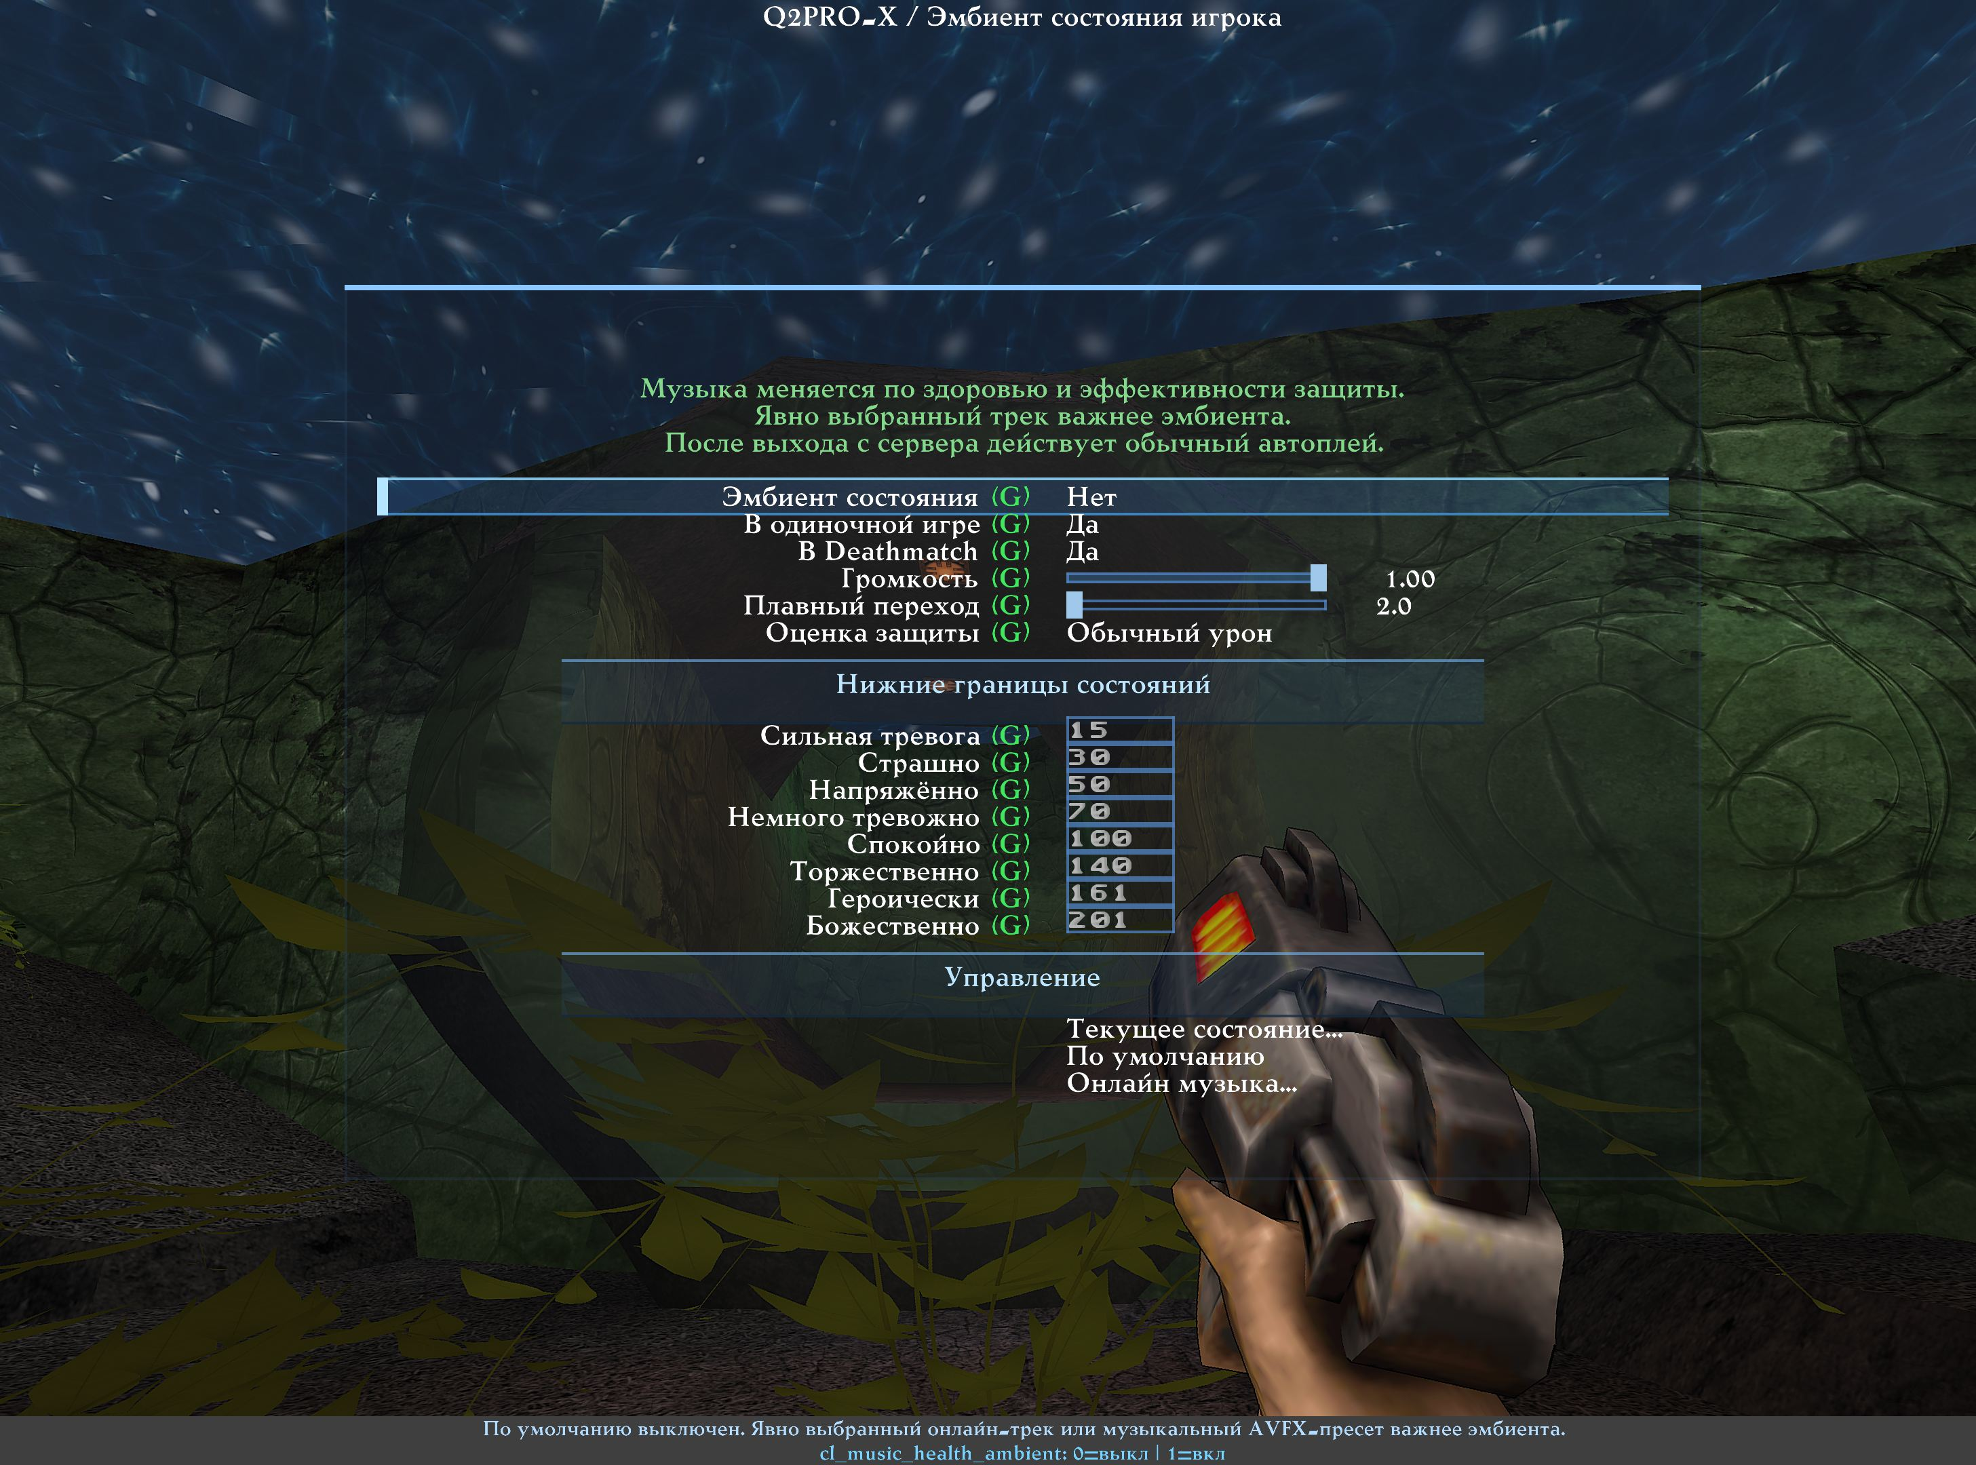
Game-mode switches, volume, transitions and state thresholds. Russian reference screenshot; the control reference below is in English.
Q2PRO-X / Player state ambient
Type | Section | Row | Variable or target | What it does
Toggle |  | cl_music_health_ambient | cl_music_health_ambient | Adaptive ambient scope; explicit online tracks take priority. Applies immediately.
Toggle |  | cl_music_health_ambient_singleplayer | cl_music_health_ambient_singleplayer | Adaptive ambient scope; explicit online tracks take priority. Applies immediately.
Toggle |  | cl_music_health_ambient_deathmatch | cl_music_health_ambient_deathmatch | Adaptive ambient scope; explicit online tracks take priority. Applies immediately.
Slider |  | Volume | cl_music_health_ambient_volume | Ambient volume. Zero keeps auto online music inhibited in enabled modes. Applies immediately.
Slider |  | Crossfade | cl_music_health_ambient_transition | Smooth state and end-to-start transitions, seconds. Applies immediately.
List |  | Protection profile | cl_music_health_ambient_profile | Protection estimate: normal, energy or mixed damage. Applies immediately. [Normal / Energy / Mixed]
Section | State lower boundaries | State lower boundaries
Field | State lower boundaries | panic | cl_music_health_ambient_min_panic | Integer lower boundary; strictly increasing. Below first: critical.
Field | State lower boundaries | fear | cl_music_health_ambient_min_fear | Integer lower boundary; strictly increasing. Below first: critical.
Field | State lower boundaries | tense | cl_music_health_ambient_min_tense | Integer lower boundary; strictly increasing. Below first: critical.
Field | State lower boundaries | uneasy | cl_music_health_ambient_min_uneasy | Integer lower boundary; strictly increasing. Below first: critical.
Field | State lower boundaries | calm | cl_music_health_ambient_min_calm | Integer lower boundary; strictly increasing. Below first: critical.
Field | State lower boundaries | triumphant | cl_music_health_ambient_min_triumphant | Integer lower boundary; strictly increasing. Below first: critical.
Field | State lower boundaries | heroic | cl_music_health_ambient_min_heroic | Integer lower boundary; strictly increasing. Below first: critical.
Field | State lower boundaries | divine | cl_music_health_ambient_min_divine | Integer lower boundary; strictly increasing. Below first: critical.
Section | Controls | Controls
Navigation | Controls | Current state... | music_health_ambient_info | Show score, state and music priority in console.
Navigation | Controls | Defaults | music_health_ambient_reset | Reset adaptive ambient only; master becomes off.
Navigation | Controls | Online music... | q2prox_online_music | Explicit track wins over ambient. Disconnect restores normal autoplay.

Nine states
Evaluation points | Mood | File
Below 15 | Critical alarm | ha_critical.flac
15–29 | Panic | ha_panic.flac
30–49 | Fear | ha_fear.flac
50–69 | Tension | ha_tense.flac
70–99 | Unease | ha_uneasy.flac
100–139 | Calm | ha_calm.flac
140–160 | Triumph | ha_triumphant.flac
161–200 | Heroism | ha_heroic.flac
201 and above | Divine | ha_divine.flac

These are the initial thresholds. The menu changes the lower bounds of the following eight states; they must increase strictly. Values are integers from 1 to 10000. Below the first threshold, critical alarm is selected. Default volume is 50%; the transition is 2.5 seconds, adjustable from 2 to 3 seconds.

How armour contributes
The evaluation is not simply HP plus armour. The ordinary-damage profile uses protection fractions of 30%, 60% and 80% for green, yellow and red armour. The energy profile uses 0%, 30% and 60%. The mixed profile combines the estimates at 75/25. Shards replenish the existing armour type, not a fourth protection type.
For health H, ordinary armour A and protection fraction p, the base estimate is H + min(A, H × p / (1 − p)). For example, 30 HP and 100 red armour yield 130 points in the ordinary profile; green armour yields about 42.9. Equal quantities of different armour can therefore produce very different moods.
Power Shield accounts for energy consumption and its protection fraction. Power Screen is directional, so a conservative factor of 0.35 is used; it is not treated as the shield's all-round protection. Evaluation uses HUD icons and numbers available to the client. It guides music, not an exact lethal-damage prediction: server rounding, attack direction and third-party mod rules can differ. Unknown protection is not invented.

Crossfades and death
The new track mixes in before the previous one ends. Looping also overlaps the end and beginning without a mandatory pause. If health changes during a fade, the mix redirects to the current state. Duration comes from the FLAC actually opened, rather than a fixed number of seconds in the program.
After death, critical alarm plays until respawn or leaving the level. Respawning restores evaluation of the current condition. Demo playback, observing another player and intermissions do not pretend to be a living controlled player. Unknown third-party server modes and cooperative play are not automatically assumed to be single-player.

Music priority
The intro ends through its normal fade, after which ambience may begin. In an enabled game mode, ambience suppresses automatic online-music startup, but not an explicitly selected track or a musical AVFX preset. Disconnecting removes the restriction and restores ordinary autoplay. Disabling ambience does not rewrite online-player settings.
The nine tracks are in baseq2/q2prox_health_ambient.pak, at music/q2prox/health_ambient/ha_<state>.flac. The Audio Assets Guide describes their contents and replacement rules.

