Q2PRO-X 1.6 Beta 5 by ly
Lighting and Visibility Presets

Project author: ly
Lighting and Visibility Presets
English edition • Q2PRO-X 1.6 Beta 5 by ly • 2026-10-10

Contents
The entries are links: click one to jump to that section.
Lighting and visibility presets
Categories
Lighting
Visibility
Four user slots per category
Visibility generator

Lighting and visibility presets
Project author: ly. Q2PRO-X 1.6 Beta 5.
The main menu and in-game menu provide a common Presets entry. It brings together ordinary AVFX, lighting, visibility and separate AVFX player-contact presets.
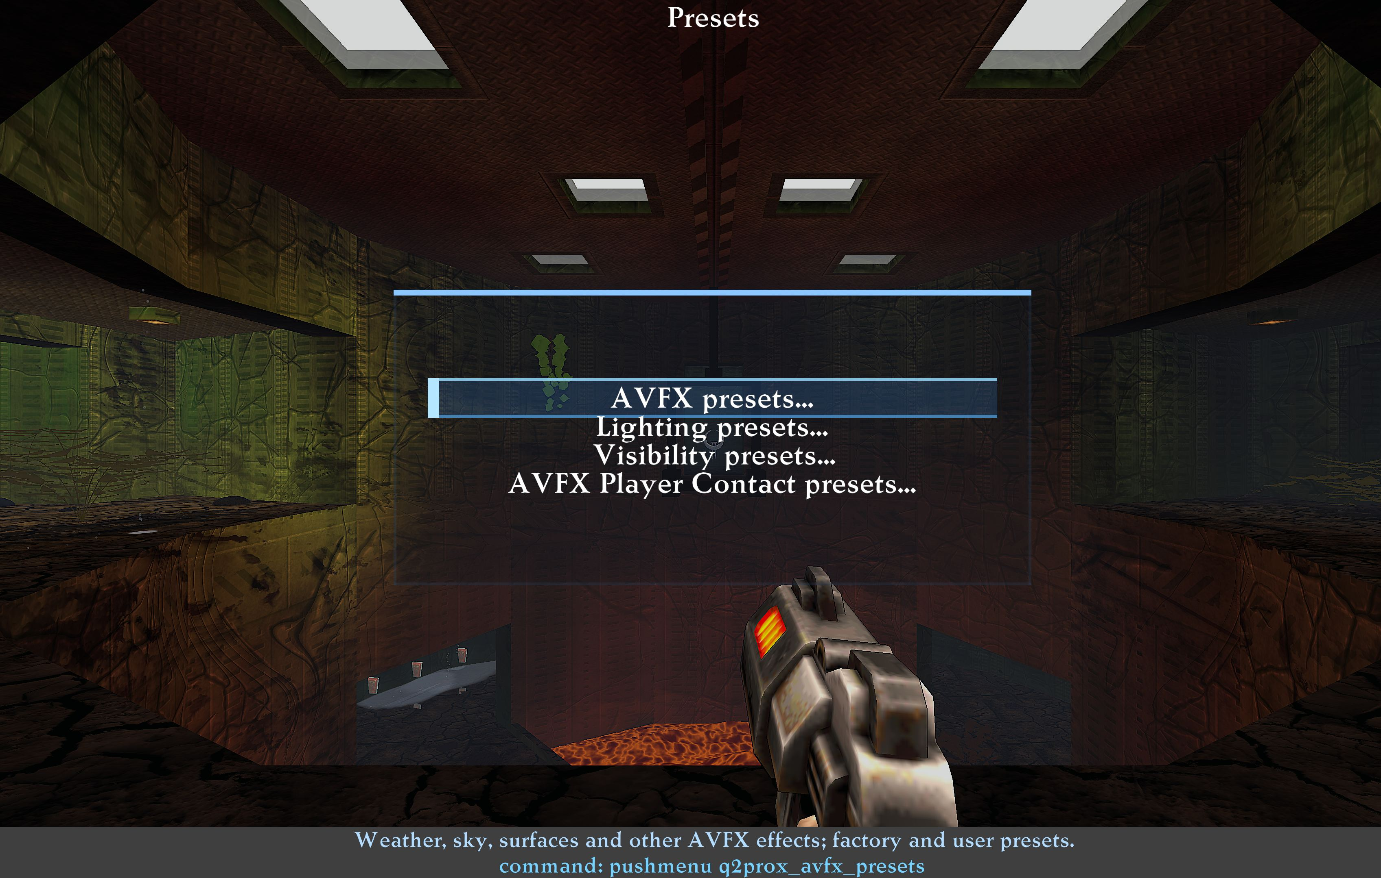
The common entry point for all preset categories.

Categories
Category | Applies
AVFX | Weather, skies, surfaces and other AVFX effects
Lighting | Brightness, saturation, lighting model and dynamic light
Visibility | Player, model-part, weapon and item highlighting; ordinary Bloom
AVFX Player Contact Effects | Blood, spray, impact marks and related effects

A preset applies to the current game. Each variable keeps its existing save scope: global values stay global, and mod values remain in the corresponding mod configuration. Some values can therefore change when switching mods. Both new menus link to related settings and Mod Configs at the bottom.

Lighting
There are 38 parameters. Gameplay presets include Default (Q2PRO-X), Bright, Monochrome, Saturated, Nothing Extra and Luxurious Darkness. The AVFX category contains Default (Q2PRO-X), Alternative, Simplified, Warm Saturated and Calm Cool. The two Default entries belong to different categories and are different snapshots.
For AVFX describes the purpose of the lighting, not enabling weather or materials. Choose effects through an ordinary AVFX preset. Video is restarted only when a changed parameter requires it; reapplying existing values does not restart it unnecessarily.
gl_polyblend, which controls screen flashes for damage, pickups and being underwater, is not lighting and is excluded from lighting presets. Factory presets omit it and user slots do not save it. Older user presets still load, but any gl_polyblend line is ignored, preserving the player's screen-flash choice.
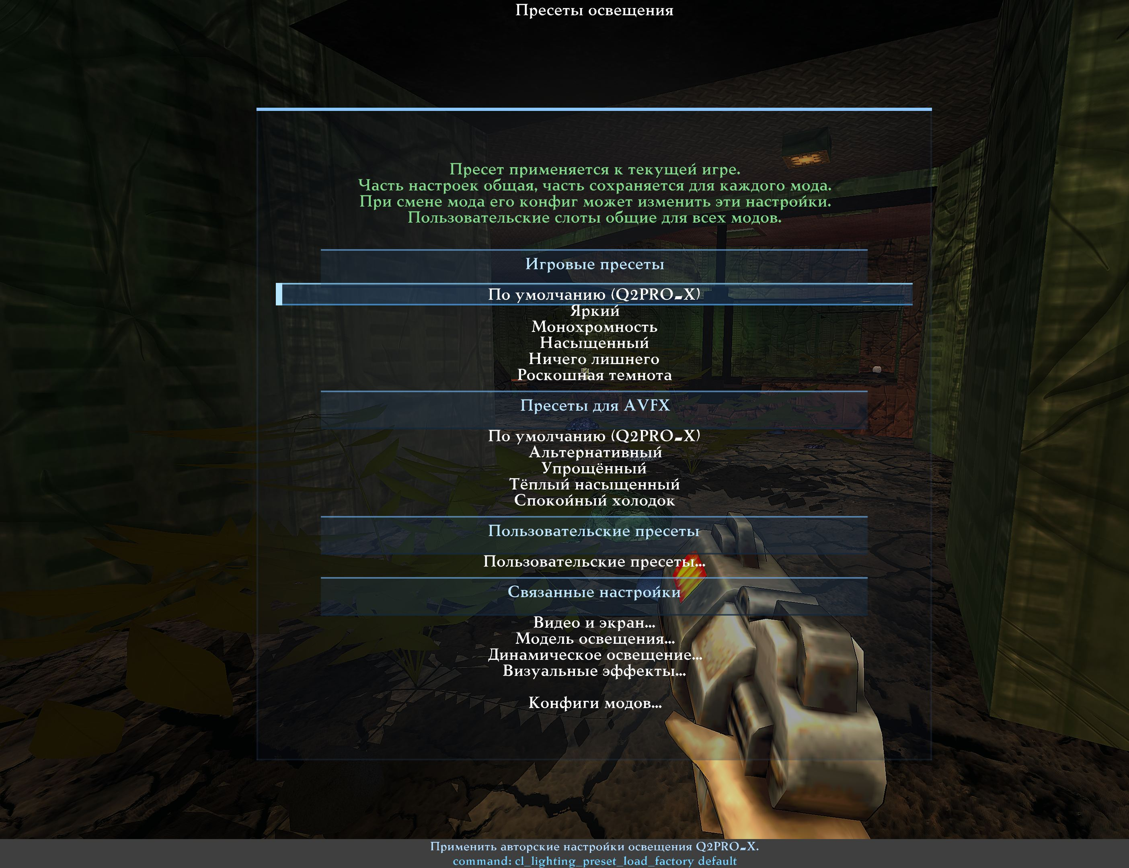
Gameplay lighting, AVFX lighting and separate user presets. Russian reference screenshot; the table below describes the English controls.
Lighting presets
Type | Section | Row | Variable or target | What it does
Section | Gameplay presets | Gameplay presets
Navigation | Gameplay presets | Default (Q2PRO-X) | cl_lighting_preset_load_factory default | Apply the original Q2PRO-X lighting snapshot.
Navigation | Gameplay presets | Bright | cl_lighting_preset_load_factory bright | Apply the Bright lighting snapshot.
Navigation | Gameplay presets | Monochrome | cl_lighting_preset_load_factory monochrome | Apply the Monochrome lighting snapshot.
Navigation | Gameplay presets | Saturated | cl_lighting_preset_load_factory saturated | Apply the Saturated lighting snapshot.
Navigation | Gameplay presets | Nothing Extra | cl_lighting_preset_load_factory minimal | Apply the Nothing Extra lighting snapshot.
Navigation | Gameplay presets | Luxurious Darkness | cl_lighting_preset_load_factory luxury_dark | Apply the Luxurious Darkness lighting snapshot.
Section | Presets for AVFX | Presets for AVFX
Navigation | Presets for AVFX | Default (Q2PRO-X) | cl_lighting_preset_load_factory avfx_default | Apply the default Q2PRO-X lighting snapshot for AVFX.
Navigation | Presets for AVFX | Alternative | cl_lighting_preset_load_factory avfx_alternative | Apply the alternative lighting snapshot for AVFX.
Navigation | Presets for AVFX | Simplified | cl_lighting_preset_load_factory avfx_simplified | Apply the Simplified lighting snapshot for AVFX.
Navigation | Presets for AVFX | Warm Saturated | cl_lighting_preset_load_factory avfx_warm_saturated | Apply the Warm Saturated lighting snapshot for AVFX.
Navigation | Presets for AVFX | Calm Cool | cl_lighting_preset_load_factory avfx_calm_cool | Apply the Calm Cool lighting snapshot for AVFX.
Section | User presets | User presets
Navigation | User presets | User presets... | q2prox_lighting_presets | Load, save or rename four lighting presets shared by all mods.
Section | Related settings | Related settings
Navigation | Related settings | Video and display... | g_video | Gamma and lighting intensity included in lighting presets.
Navigation | Related settings | Lighting model... | q2prox_renderer_lighting | World and model lighting: modulation, shading and light grid.
Navigation | Related settings | Dynamic lighting... | q2prox_dynamic_lighting | Dynamic lights, map emissive sources and shadows.
Navigation | Related settings | Visual effects... | q2prox_vfx | Bloom, colour grading and other visual effects.
Navigation | Related settings | Mod configs... | q2prox_modcfg | Open mod configs: choose and save settings for each mod and manage its default profile.

Visibility
The set contains 123 highlighting and ordinary-Bloom parameters. Skins, model replacements, player name and download settings are excluded. Male/female/cyborg colour and highlighting apply to the corresponding model regardless of its skin.
Factory choices include:
- Default (all highlights off);
- Player Model Parts, Items and Light Bloom;
- Red Males, Green Females and Blue Cyborgs;
- FFA (automatic model colours);
- Purple Males, Lime Females, added in Beta 4 from an author's user slot, including
visibility, Bloom and individual model colours.
The first option disables highlighting masters and ordinary Bloom. It does not change AVFX Bloom categories; the same exclusion applies to all factory and user visibility presets and the generator. Independent model colouring works with EGL/ANGLE and WGL. Saving personal presets is unchanged.
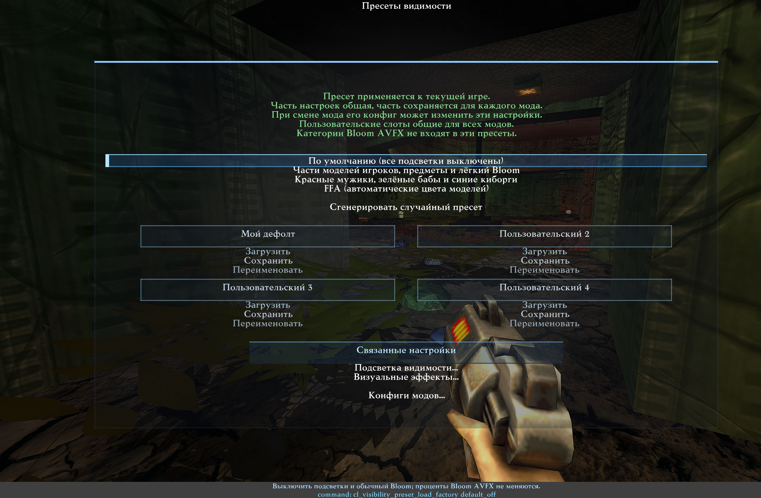
Factory and user visibility presets and the generation button. Russian reference screenshot.
Visibility presets
Type | Section | Row | Variable or target | What it does
Navigation |  | Default (All Highlights Off) | cl_visibility_preset_load_factory default_off | Disable visibility highlights and ordinary Bloom; AVFX Bloom percentages stay unchanged.
Navigation |  | Player Parts, Items and Light Bloom | cl_visibility_preset_load_factory parts_items_light | Apply player-part colours, item highlights and the authored light Bloom settings.
Navigation |  | Red Male, Green Female and Blue Cyborg | cl_visibility_preset_load_factory models_rgb | Apply the captured highlights and Bloom: red male, green female and blue cyborg.
Navigation |  | Purple Male, Lime Female | cl_visibility_preset_load_factory models_purple_lime | Apply the saved purple/lime visibility and Bloom preset.
Navigation |  | FFA (Automatic Model Colours) | cl_visibility_preset_load_factory ffa_auto | Apply the captured FFA automatic player colours, highlights and Bloom.
Navigation |  | Generate random preset | cl_visibility_preset_generate | Enable highlights and apply random colours/settings now. Save a result in a user slot. AVFX Bloom percentages are excluded.
Preset name |  | Slot 1 name
Navigation |  | Load | ui_visibility_load_custom 1 | Load user visibility preset 1; shared by all mods.
Navigation |  | Save | ui_visibility_save_custom 1 | Save user visibility preset 1; shared by all mods.
Navigation |  | Rename | ui_visibility_rename_custom 1 | Rename user visibility preset 1; shared by all mods.
Preset name |  | Slot 2 name
Navigation |  | Load | ui_visibility_load_custom 2 | Load user visibility preset 2; shared by all mods.
Navigation |  | Save | ui_visibility_save_custom 2 | Save user visibility preset 2; shared by all mods.
Navigation |  | Rename | ui_visibility_rename_custom 2 | Rename user visibility preset 2; shared by all mods.
Preset name |  | Slot 3 name
Navigation |  | Load | ui_visibility_load_custom 3 | Load user visibility preset 3; shared by all mods.
Navigation |  | Save | ui_visibility_save_custom 3 | Save user visibility preset 3; shared by all mods.
Navigation |  | Rename | ui_visibility_rename_custom 3 | Rename user visibility preset 3; shared by all mods.
Preset name |  | Slot 4 name
Navigation |  | Load | ui_visibility_load_custom 4 | Load user visibility preset 4; shared by all mods.
Navigation |  | Save | ui_visibility_save_custom 4 | Save user visibility preset 4; shared by all mods.
Navigation |  | Rename | ui_visibility_rename_custom 4 | Rename user visibility preset 4; shared by all mods.
Section | Related settings | Related settings
Navigation | Related settings | Visibility highlights... | q2prox_vis | Item, weapon and player highlights, including model-part colours.
Navigation | Related settings | Visual effects... | q2prox_vfx | Bloom, colour grading and other visual effects.
Navigation | Related settings | Mod configs... | q2prox_modcfg | Open mod configs: choose and save settings for each mod and manage its default profile.

Four user slots per category
There are eight slots: four lighting and four visibility slots, shared by all mods. Save captures the current values of the selected category, Load applies them, and Rename changes the displayed name. Dialogues work like AVFX user presets.
A shared slot does not make its constituent variables global: subsequent configuration saving and mod switching still follow their ordinary rules.

Visibility generator
One button generates and immediately applies a random set. Highlighting masters are enabled, and the remaining parameters vary within supported ranges. This is neither the AVFX generator nor a lighting generator. Save a result you like in a visibility slot. Generating again changes the current appearance but does not automatically overwrite a saved slot.

