Q2PRO-X 1.6 Beta 5 by ly
Particle Families: Enable and RGB

Project author: ly
Particle Families: Enable and RGB
English edition • Q2PRO-X 1.6 Beta 5 by ly • 2026-10-10

Contents
The entries are links: click one to jump to that section.
What this system changes
Opening global Standard settings
Custom Colours master
Controls on each Standard-family page
Switch precedence
Seven Standard group pages
Complete catalogue: 68 Standard families
Ten independent AVFX families
Complete catalogue: ten AVFX families and menu paths
AVFX presets and the generator
Three independent celestial RGB layers
The flying falling meteor's colour
Sky meteors / shooting stars
Comet colour
Resetting and restoring
Reset Colour to Stock
Reset This Family
Reset This Page
Reset All Standard Particles
Practical examples
Disable only standard blood
Recolour a rocket trail without changing its explosion
Keep grenade debris but remove rocket debris
Adjust celestial effects separately from Standard
Complete Standard Particles menus
Finding variables

What this system changes
Q2PRO-X divides ordinary Quake II particles into 68 Standard families. Each can be enabled or disabled independently and optionally assigned an RGB colour. Blood, blaster trails, rocket smoke, explosion fragments, water splashes, teleports, sparks, railgun particles and other standard effects can be controlled separately.
Another 10 families belong to ordinary AVFX. They reuse standard particle generators but have their own Enable/RGB controls beside their AVFX effects. These values belong to ordinary AVFX presets and are independent of global Standard settings.
Sky meteors, falling impact meteors and comets also have glowing heads, streaks, tails, comas and particle-like elements. They are drawn by three separate GPU layers, rather than the standard cparticle generator. Each layer therefore has five AVFX variables: Custom Colour, RGB and Colour Variation. These fifteen settings belong to ordinary AVFX presets and the generator, not global Standard.
The three phenomena remain separate. A sky meteor crosses the celestial sphere; a falling meteor descends to a surface and explodes; a comet moves slowly with a nucleus/coma and one continuous tail. Each has its own RGB, variation, emission switch and stock-colour reset.
Blood and particles in AVFX Player Contact Effects form a third domain, configured separately in the Contact guide.
Global Standard colours do not recolour AVFX. Ordinary AVFX presets do not

change Standard. The AVFX generator includes no Contact variables.

Reference screenshots in this guide use the Russian interface. Generated catalogues and menu tables below provide the English labels and explanations.
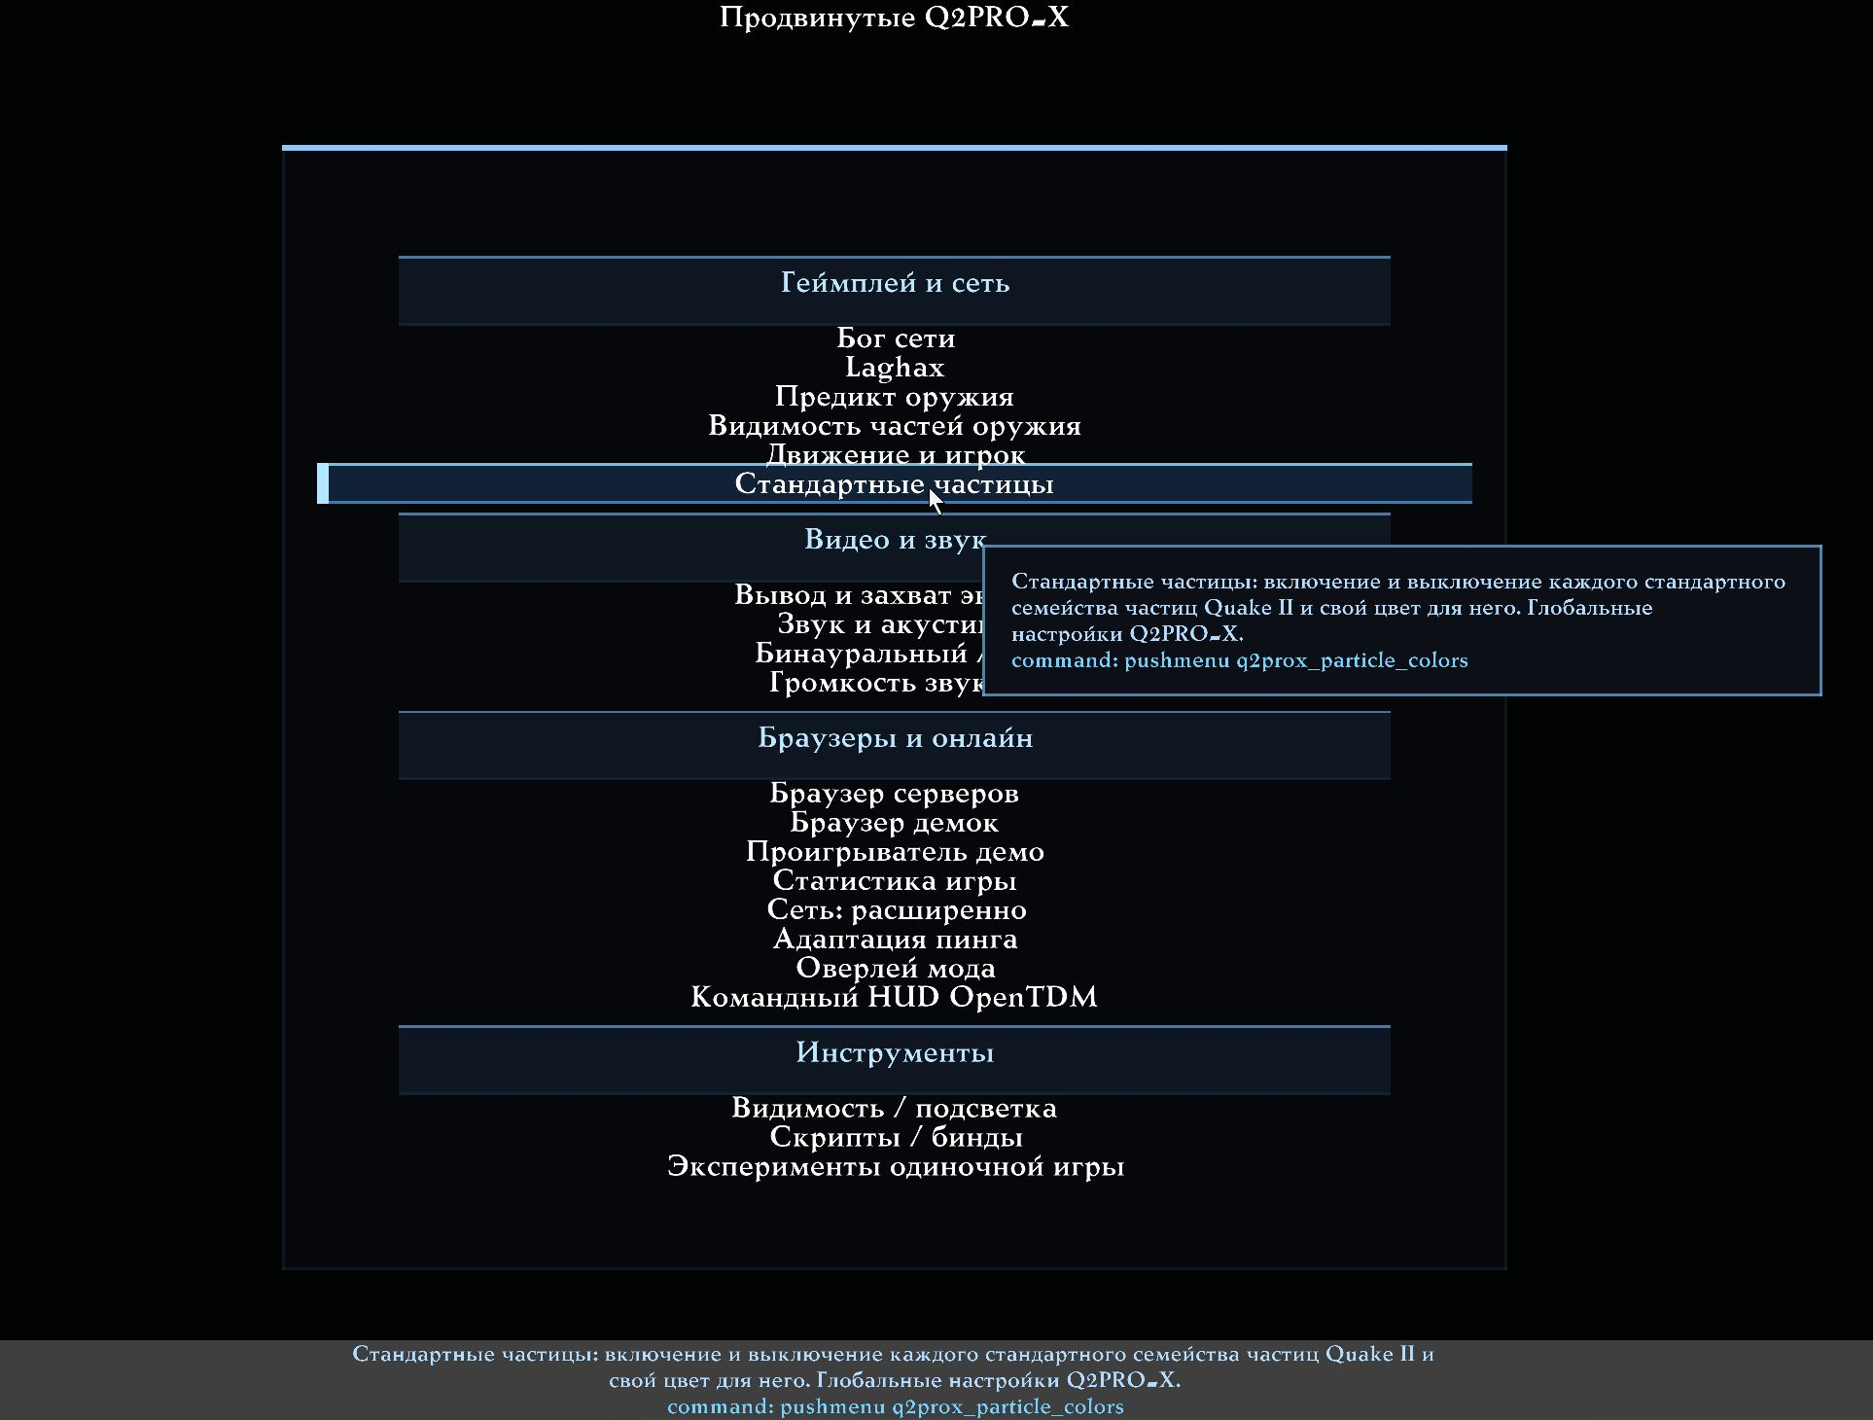
Standard Particles in Advanced Q2PRO-X settings.

Opening global Standard settings
Use Main Menu → Settings → Advanced Q2PRO-X → Standard Particles. The hub contains a Custom Colours master, seven group pages covering 68 families, help on global scope and switch precedence, links to general particles and railgun-trail settings, and Reset All Standard Particles.
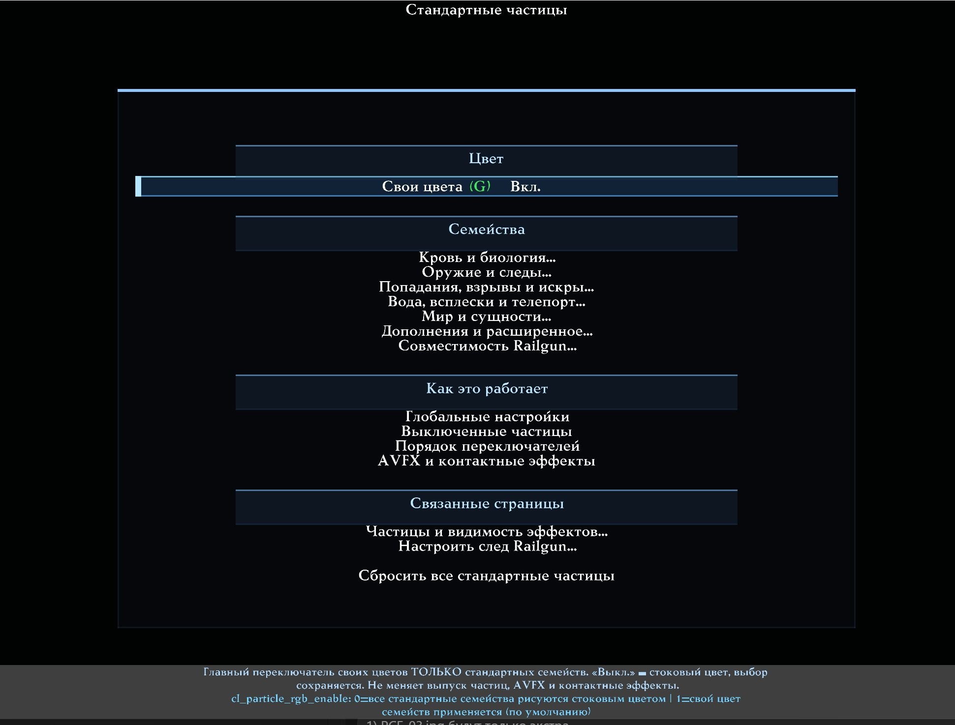
The Standard Particles hub: colour master, seven groups, help and reset.

Custom Colours master
cl_particle_rgb_enable enables custom colours only for Standard. When off, all Standard families use stock colours while retaining their individual choices. Turning it back on restores those choices. The master does not enable or disable particle emission, control AVFX or affect Contact Effects.

Controls on each Standard-family page
All 68 pages use the same arrangement:
1. Particles: emit this family or not. Disabling it stops future particles
before allocation and rendering; existing particles finish their normal lifetime.
2. Custom Colour: use the RGB below instead of the stock family tint.
3. Red: 0.00–1.00, step 0.02.
4. Green: 0.00–1.00, step 0.02.
5. Blue: 0.00–1.00, step 0.02.
6. Reset Colour to Stock: disable Custom Colour and restore RGB, preserving Particles.
7. Reset This Family: enable particles, disable custom colour and restore stock RGB.
8. Back to Group: return to this page's family list.
Custom RGB does not flatten an effect into one uniform dot. The stock brightness curve remains: dark and light parts of the original gradient stay distinct, while their colour changes.
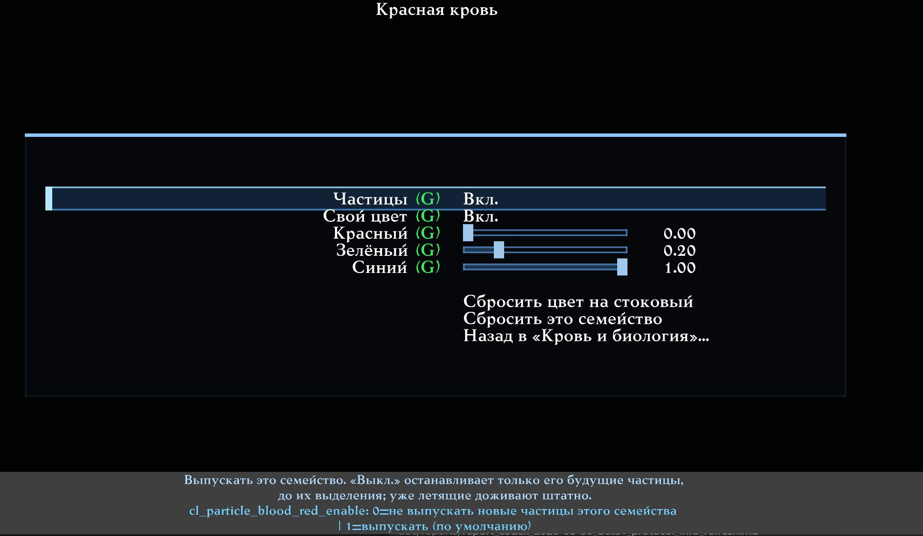
One Standard family: Particles, Custom Colour, RGB and two resets.

Switch precedence
The Quake II particle master and older broad effect-category switches act first. A family setting cannot restore an effect already hidden by a higher-level switch. The individual-family switch is the most specific layer after them.
Disabling a family does not alter its quantity settings, physics, lifetime, sound or gameplay event. It suppresses only future graphics creation, with no effect on networking, prediction, hit registration or demos.

Seven Standard group pages
Each group links to its families, Reset This Page and the common hub. Page reset enables that group's families, disables their custom colours and restores stock RGB without changing other groups, AVFX or Contact Effects.
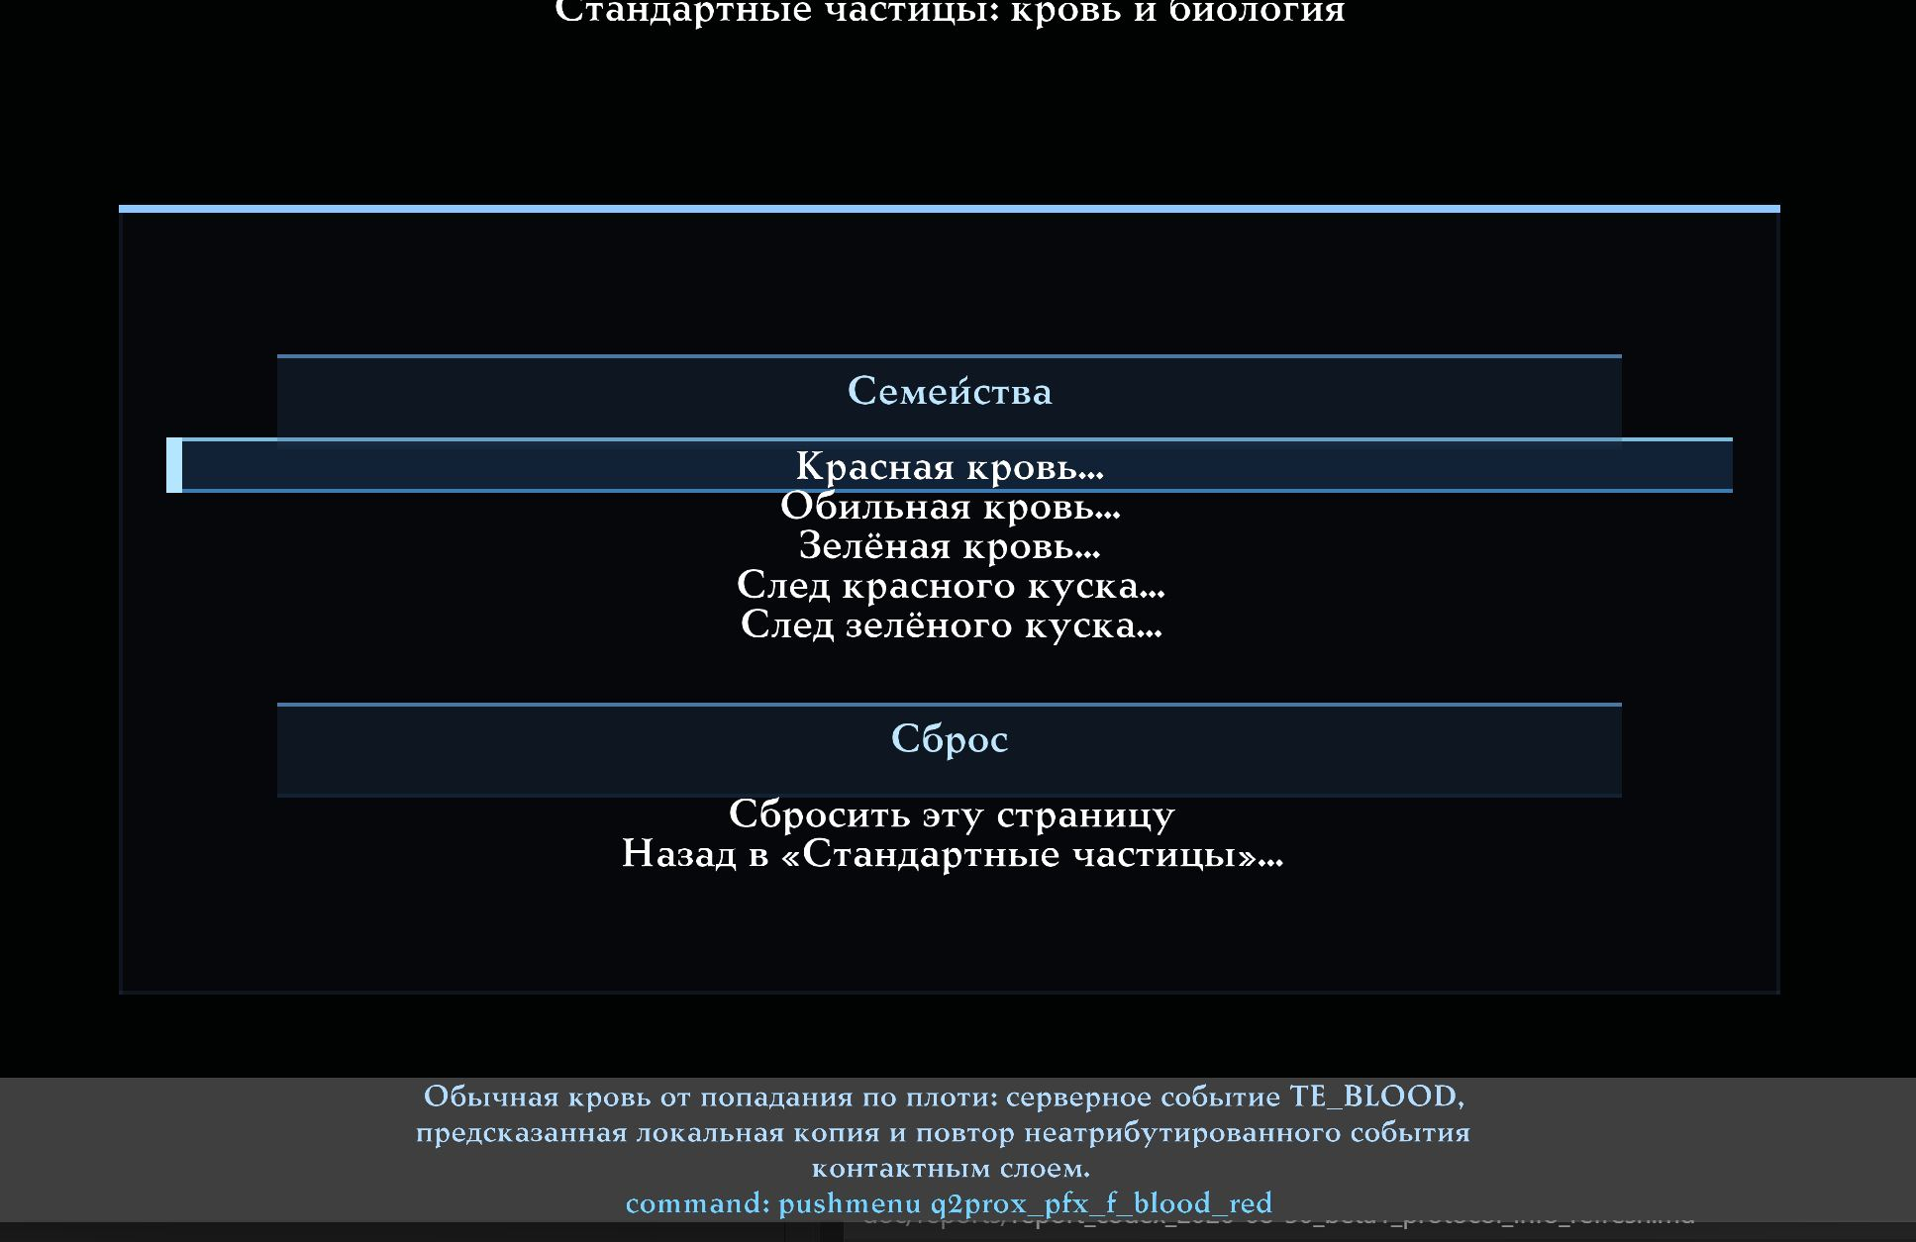
Blood and Biology: five families and a page reset.
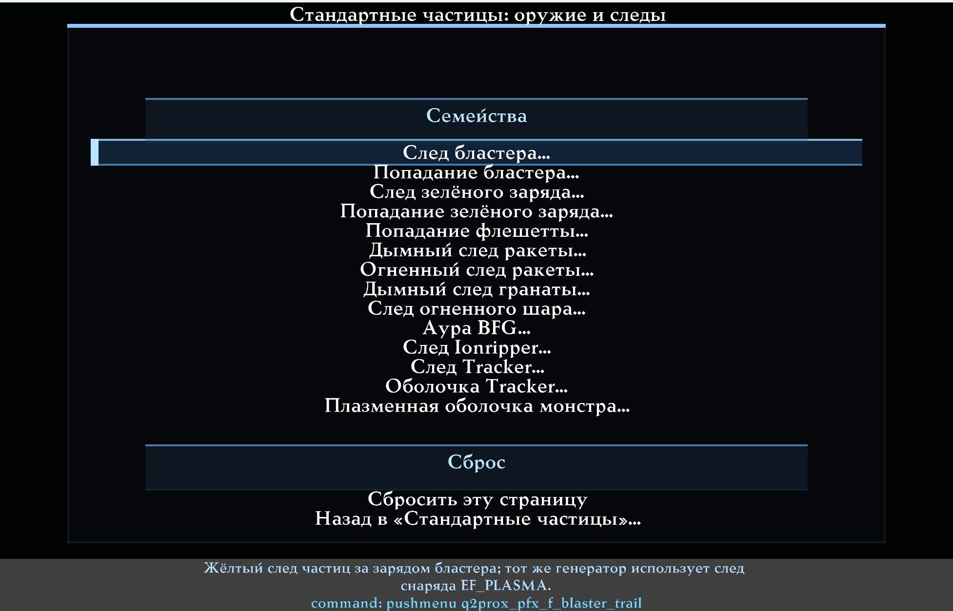
Weapons and Trails: projectile trails and auras.
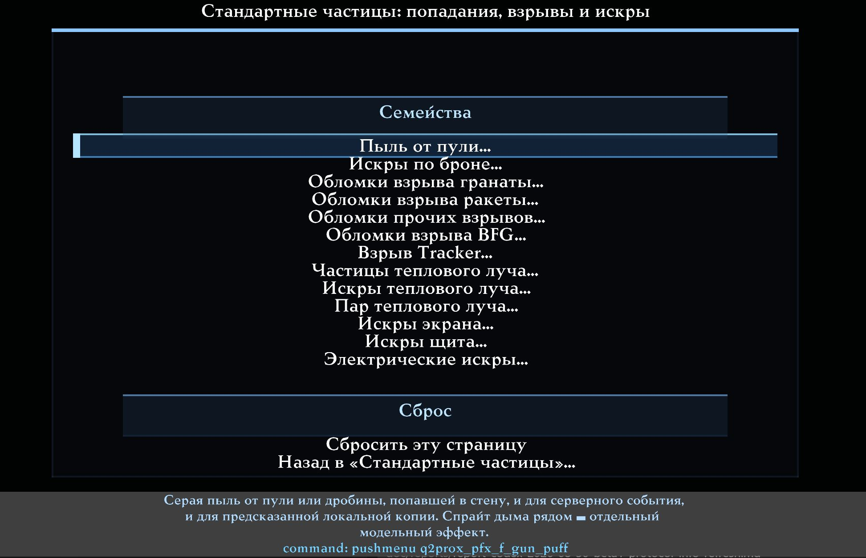
Impacts, Explosions and Sparks.
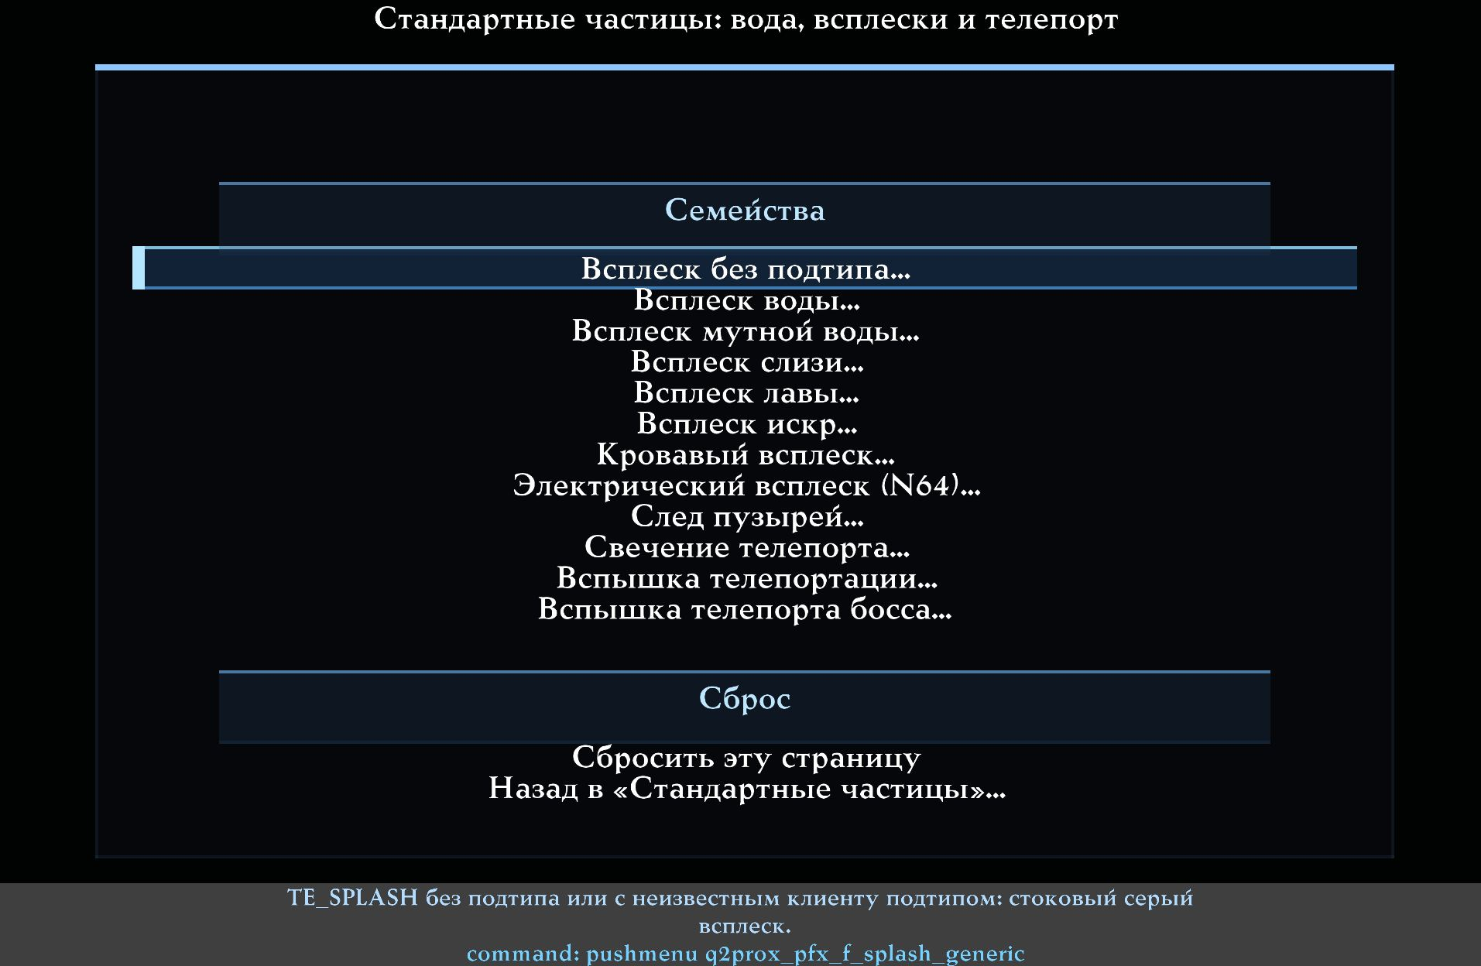
Water, Splashes and Teleports.
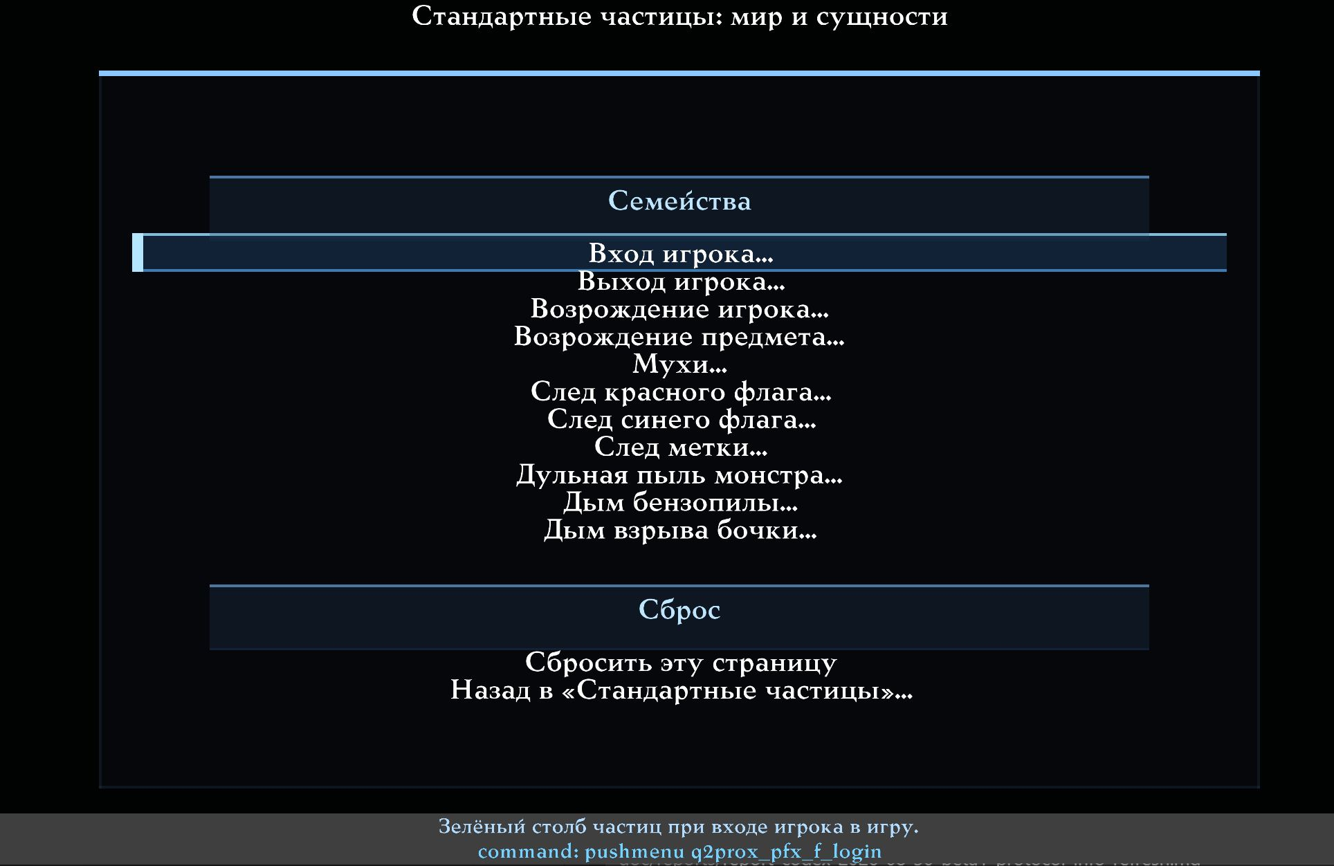
World and Entities.
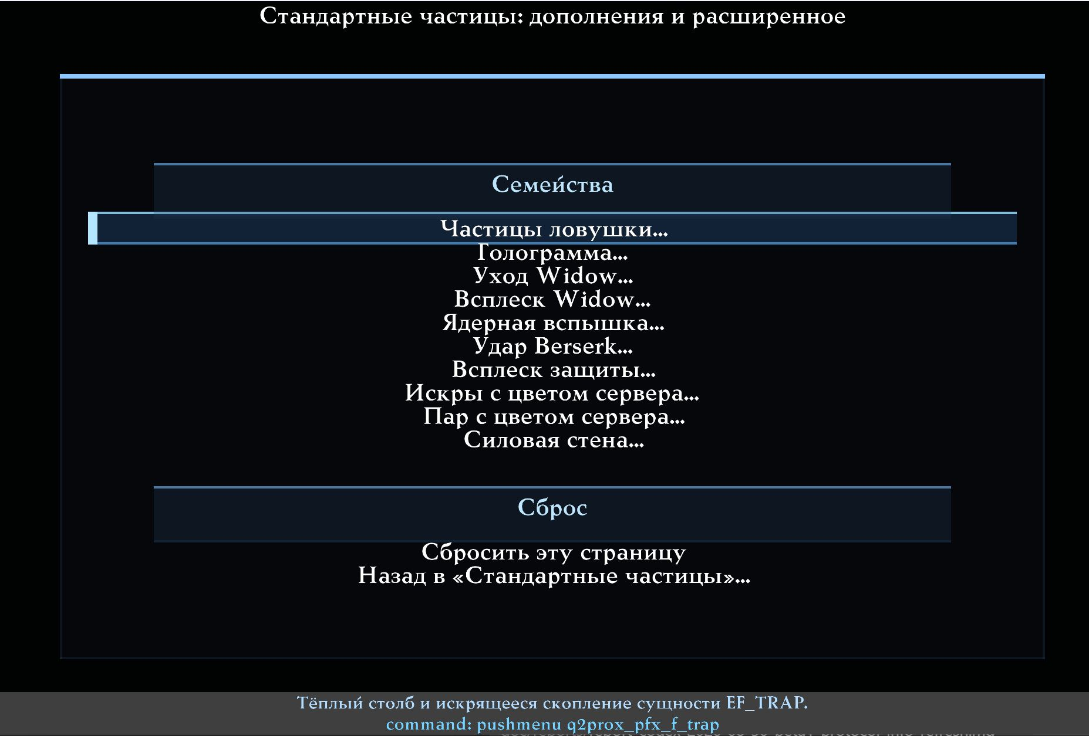
Expansion and Extended effects.
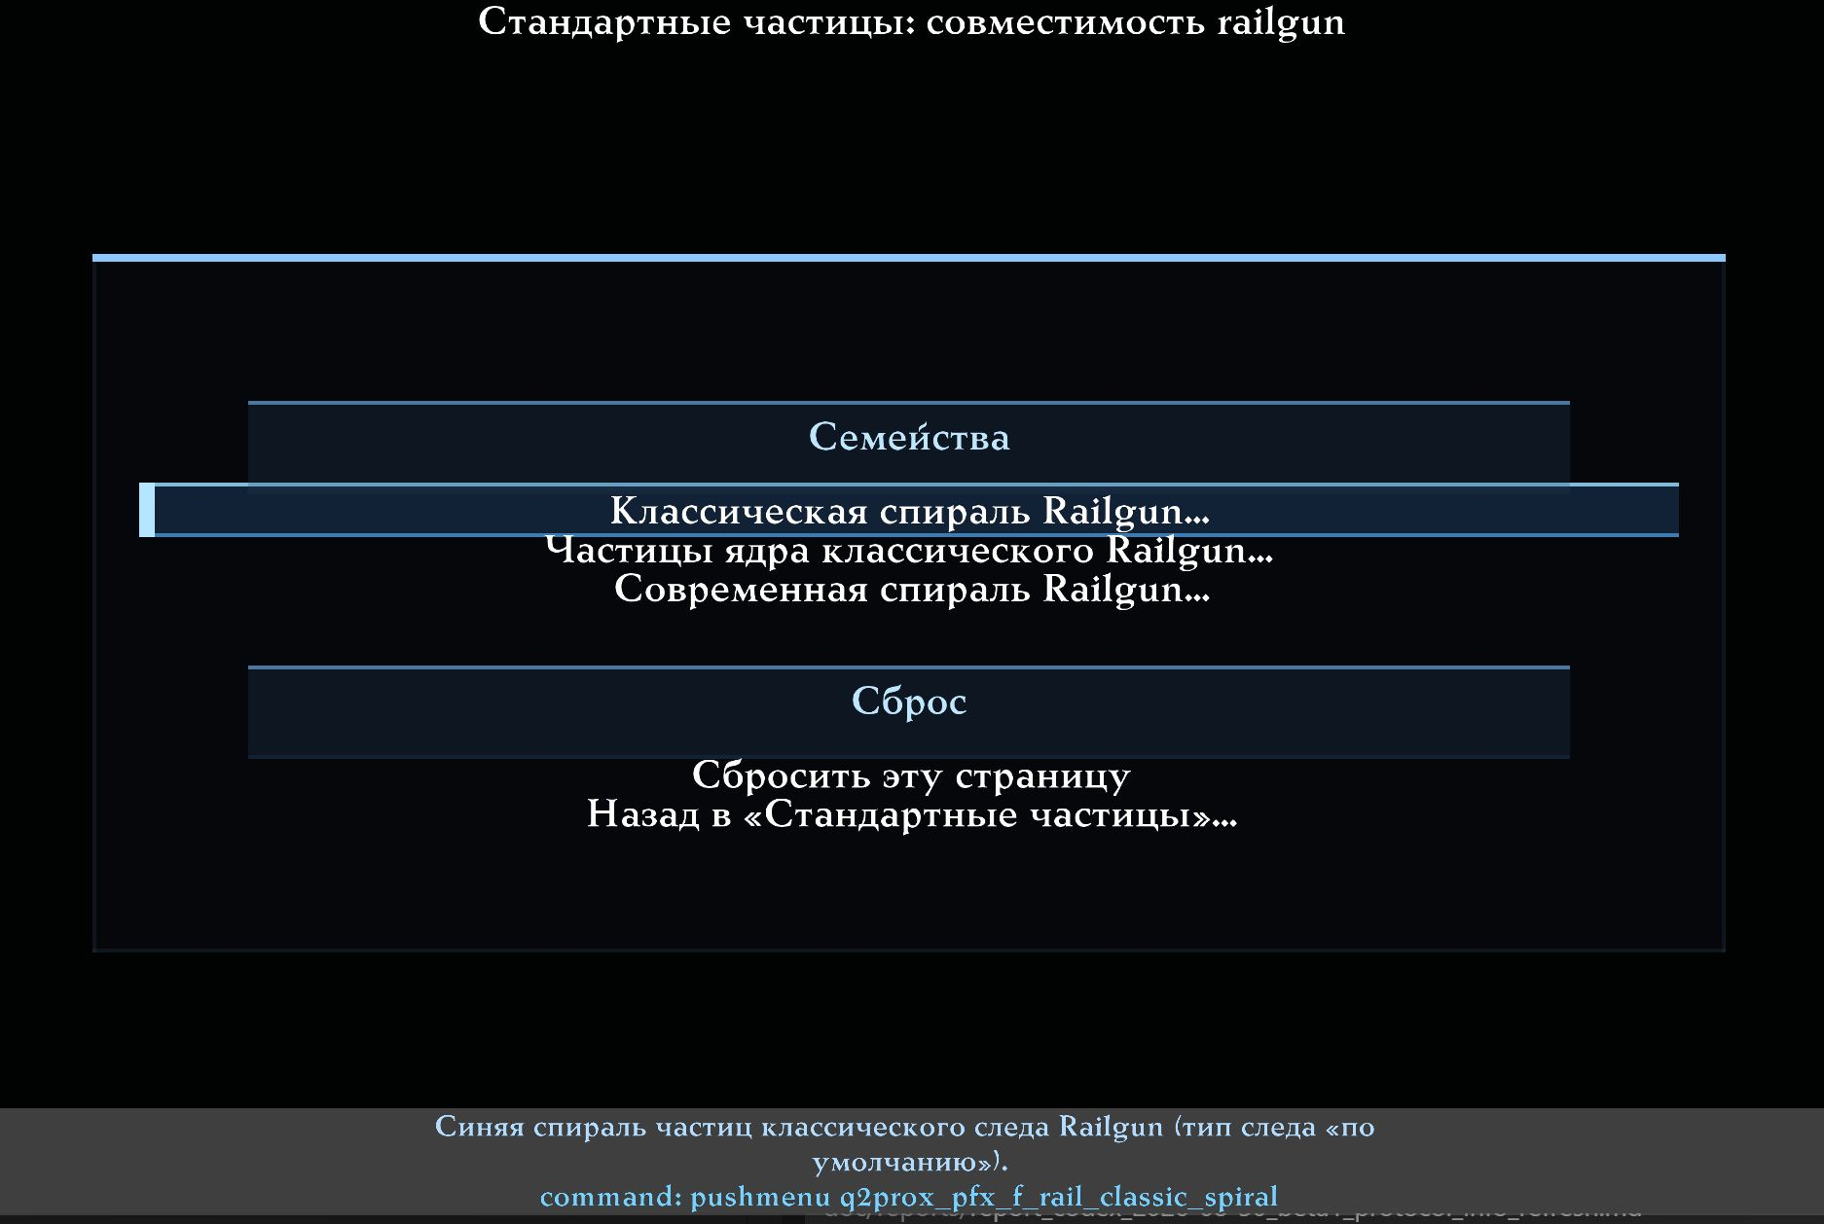
Railgun Compatibility.

Complete catalogue: 68 Standard families
This list is generated from the catalogue used by the client menus and CVAR browser.
Family | Description | Variables
Red blood | Ordinary flesh-hit blood: the server TE_BLOOD event, the predicted local copy, and the Player Contact replay of an unattributed flesh event. | cl_particle_blood_red_enable; cl_particle_rgb_blood_red_custom; cl_particle_rgb_blood_red_r/g/b
Heavy blood | The gib-scale flesh burst: TE_MOREBLOOD and the Contact replay of it. | cl_particle_blood_heavy_enable; cl_particle_rgb_blood_heavy_custom; cl_particle_rgb_blood_heavy_r/g/b
Green blood | The TE_GREENBLOOD event used by non-human targets (exact palette entry, no ramp). | cl_particle_blood_green_enable; cl_particle_rgb_blood_green_custom; cl_particle_rgb_blood_green_r/g/b
Red gib trail | The blood trail dragged behind flying gibs (EF_GIB). | cl_particle_gib_trail_red_enable; cl_particle_rgb_gib_trail_red_custom; cl_particle_rgb_gib_trail_red_r/g/b
Green gib trail | The trail dragged behind EF_GREENGIB debris. | cl_particle_gib_trail_green_enable; cl_particle_rgb_gib_trail_green_custom; cl_particle_rgb_gib_trail_green_r/g/b
Blaster trail | The yellow particle trail behind a blaster bolt; also used by the EF_PLASMA projectile trail. | cl_particle_blaster_trail_enable; cl_particle_rgb_blaster_trail_custom; cl_particle_rgb_blaster_trail_r/g/b
Blaster impact | The yellow impact burst of a blaster bolt: TE_BLASTER, both blue hyperblaster temp entities, and the predicted local impact. | cl_particle_blaster_impact_enable; cl_particle_rgb_blaster_impact_custom; cl_particle_rgb_blaster_impact_r/g/b
Green bolt trail | The green particle trail of a tracker-flagged blaster bolt. | cl_particle_hyperblaster_trail_enable; cl_particle_rgb_hyperblaster_trail_custom; cl_particle_rgb_hyperblaster_trail_r/g/b
Green bolt impact | The green impact burst of TE_BLASTER2. | cl_particle_hyperblaster_impact_enable; cl_particle_rgb_hyperblaster_impact_custom; cl_particle_rgb_hyperblaster_impact_r/g/b
Flechette impact | The cold blue impact burst of TE_FLECHETTE. | cl_particle_flechette_impact_enable; cl_particle_rgb_flechette_impact_custom; cl_particle_rgb_flechette_impact_r/g/b
Rocket smoke trail | The grey diminishing smoke stream behind a rocket. Independent from the rocket fire sub-stream. | cl_particle_rocket_smoke_enable; cl_particle_rgb_rocket_smoke_custom; cl_particle_rgb_rocket_smoke_r/g/b
Rocket fire trail | The bright non-diminishing fire sparks inside the rocket trail. Independent from the rocket smoke stream. | cl_particle_rocket_fire_enable; cl_particle_rgb_rocket_fire_custom; cl_particle_rgb_rocket_fire_r/g/b
Grenade smoke trail | The grey diminishing smoke stream behind a grenade. | cl_particle_grenade_smoke_enable; cl_particle_rgb_grenade_smoke_custom; cl_particle_rgb_grenade_smoke_r/g/b
Fireball trail | The trail of an EF_ROCKET/EF_GIB fireball; its shade follows the projectile's own trail counter instead of a random draw. | cl_particle_fireball_trail_enable; cl_particle_rgb_fireball_trail_custom; cl_particle_rgb_fireball_trail_r/g/b
BFG aura | The green particle sphere that surrounds a flying BFG ball; its shade follows the distance from the ball centre. | cl_particle_bfg_aura_enable; cl_particle_rgb_bfg_aura_custom; cl_particle_rgb_bfg_aura_r/g/b
Ionripper trail | The alternating warm trail behind an EF_IONRIPPER projectile. | cl_particle_ionripper_trail_enable; cl_particle_rgb_ionripper_trail_custom; cl_particle_rgb_ionripper_trail_r/g/b
Tracker trail | The dark weaving trail behind an EF_TRACKER projectile. | cl_particle_tracker_trail_enable; cl_particle_rgb_tracker_trail_custom; cl_particle_rgb_tracker_trail_r/g/b
Tracker shell | The dark particle shell around an entity carrying EF_TRACKERTRAIL. | cl_particle_tracker_shell_enable; cl_particle_rgb_tracker_shell_custom; cl_particle_rgb_tracker_shell_r/g/b
Monster plasma shell | The warm particle shell drawn at a monster plasma beam origin. | cl_particle_monster_plasma_shell_enable; cl_particle_rgb_monster_plasma_shell_custom; cl_particle_rgb_monster_plasma_shell_r/g/b
Bullet wall puff | The grey dust puff of a bullet or shotgun pellet hitting a wall, for both the server event and the predicted local copy. The smoke sprite beside it is a separate model effect. | cl_particle_gun_puff_enable; cl_particle_rgb_gun_puff_custom; cl_particle_rgb_gun_puff_r/g/b
Armor sparks | The small warm spark burst of TE_SPARKS / TE_BULLET_SPARKS on armor. | cl_particle_armor_sparks_enable; cl_particle_rgb_armor_sparks_custom; cl_particle_rgb_armor_sparks_r/g/b
Grenade explosion debris | The warm debris cloud of a grenade explosion. The legacy cl_disable_particles grenade bit still applies on top. | cl_particle_explosion_grenade_enable; cl_particle_rgb_explosion_grenade_custom; cl_particle_rgb_explosion_grenade_r/g/b
Rocket explosion debris | The warm debris cloud of a rocket explosion, server and predicted. The legacy cl_disable_particles rocket bit still applies on top. | cl_particle_explosion_rocket_enable; cl_particle_rgb_explosion_rocket_custom; cl_particle_rgb_explosion_rocket_r/g/b
Other explosion debris | The warm debris cloud of every other explosion event: TE_EXPLOSION1, TE_EXPLOSION2, their no-light variants and TE_PLASMA_EXPLOSION. | cl_particle_explosion_generic_enable; cl_particle_rgb_explosion_generic_custom; cl_particle_rgb_explosion_generic_r/g/b
BFG explosion debris | The green debris cloud of TE_BFG_BIGEXPLOSION. | cl_particle_bfg_explosion_enable; cl_particle_rgb_bfg_explosion_custom; cl_particle_rgb_bfg_explosion_r/g/b
Tracker explosion | The dark particle burst of TE_TRACKER_EXPLOSION. | cl_particle_tracker_explosion_enable; cl_particle_rgb_tracker_explosion_custom; cl_particle_rgb_tracker_explosion_r/g/b
Heat beam particles | The rotating particle sleeve that forms the heat beam itself. | cl_particle_heatbeam_particles_enable; cl_particle_rgb_heatbeam_particles_custom; cl_particle_rgb_heatbeam_particles_r/g/b
Heat beam sparks | The grey spark puff of TE_HEATBEAM_SPARKS at the beam impact point. | cl_particle_heatbeam_sparks_enable; cl_particle_rgb_heatbeam_sparks_custom; cl_particle_rgb_heatbeam_sparks_r/g/b
Heat beam steam | The warm steam puff of TE_HEATBEAM_STEAM. | cl_particle_heatbeam_steam_enable; cl_particle_rgb_heatbeam_steam_custom; cl_particle_rgb_heatbeam_steam_r/g/b
Screen sparks | The green spark burst of TE_SCREEN_SPARKS. | cl_particle_screen_sparks_enable; cl_particle_rgb_screen_sparks_custom; cl_particle_rgb_screen_sparks_r/g/b
Shield sparks | The blue spark burst of TE_SHIELD_SPARKS. | cl_particle_shield_sparks_enable; cl_particle_rgb_shield_sparks_custom; cl_particle_rgb_shield_sparks_r/g/b
Electric sparks | The cold spark burst of TE_ELECTRIC_SPARKS. | cl_particle_electric_sparks_enable; cl_particle_rgb_electric_sparks_custom; cl_particle_rgb_electric_sparks_r/g/b
Unclassified splash | TE_SPLASH with no subtype, or a subtype the client does not know: the stock grey splash. | cl_particle_splash_generic_enable; cl_particle_rgb_splash_generic_custom; cl_particle_rgb_splash_generic_r/g/b
Water splash | The blue-water subtype of TE_SPLASH, and the predicted local pellet splash when a shotgun pellet lands in a fluid. | cl_particle_splash_water_enable; cl_particle_rgb_splash_water_custom; cl_particle_rgb_splash_water_r/g/b
Brown water splash | The brown-water subtype of TE_SPLASH. | cl_particle_splash_brown_water_enable; cl_particle_rgb_splash_brown_water_custom; cl_particle_rgb_splash_brown_water_r/g/b
Slime splash | The slime subtype of TE_SPLASH. | cl_particle_splash_slime_enable; cl_particle_rgb_splash_slime_custom; cl_particle_rgb_splash_slime_r/g/b
Lava splash | The lava subtype of TE_SPLASH. | cl_particle_splash_lava_enable; cl_particle_rgb_splash_lava_custom; cl_particle_rgb_splash_lava_r/g/b
Spark splash | The spark subtype of TE_SPLASH. Its ricochet sound is independent of this family. | cl_particle_splash_sparks_enable; cl_particle_rgb_splash_sparks_custom; cl_particle_rgb_splash_sparks_r/g/b
Blood splash | The blood subtype of TE_SPLASH. Separate from the flesh-hit blood family. | cl_particle_splash_blood_enable; cl_particle_rgb_splash_blood_custom; cl_particle_rgb_splash_blood_r/g/b
Electric splash (N64) | The mixed electric splash of the extended TE_SPLASH variant: both of its colour bands keep their stock brightness curve. | cl_particle_splash_electric_n64_enable; cl_particle_rgb_splash_electric_n64_custom; cl_particle_rgb_splash_electric_n64_r/g/b
Bubble trail | Underwater bubbles: both the TE_BUBBLETRAIL and TE_BUBBLETRAIL2 implementations. | cl_particle_bubble_trail_enable; cl_particle_rgb_bubble_trail_custom; cl_particle_rgb_bubble_trail_r/g/b
Teleporter idle | The steady yellow particles rising from an idle teleporter pad: both implementations. | cl_particle_teleporter_idle_enable; cl_particle_rgb_teleporter_idle_custom; cl_particle_rgb_teleporter_idle_r/g/b
Teleport burst | The grey particle cube produced when a player teleports. | cl_particle_teleport_burst_enable; cl_particle_rgb_teleport_burst_custom; cl_particle_rgb_teleport_burst_r/g/b
Boss teleport burst | The large four-band swirl of TE_BOSSTPORT. | cl_particle_big_teleport_enable; cl_particle_rgb_big_teleport_custom; cl_particle_rgb_big_teleport_r/g/b
Player login | The green column of particles when a player joins the game. | cl_particle_login_enable; cl_particle_rgb_login_custom; cl_particle_rgb_login_r/g/b
Player logout | The red column of particles when a player leaves the game. | cl_particle_logout_enable; cl_particle_rgb_logout_custom; cl_particle_rgb_logout_r/g/b
Player respawn | The yellow column of particles when a player respawns. | cl_particle_respawn_enable; cl_particle_rgb_respawn_custom; cl_particle_rgb_respawn_r/g/b
Item respawn | The green sparkle when an item respawns on its pad. | cl_particle_item_respawn_enable; cl_particle_rgb_item_respawn_custom; cl_particle_rgb_item_respawn_r/g/b
Flies | The dark swarm circling a corpse (EF_FLIES). | cl_particle_flies_enable; cl_particle_rgb_flies_custom; cl_particle_rgb_flies_r/g/b
Red flag trail | The red trail behind a carried EF_FLAG1 flag. | cl_particle_flag_trail_red_enable; cl_particle_rgb_flag_trail_red_custom; cl_particle_rgb_flag_trail_red_r/g/b
Blue flag trail | The blue trail behind a carried EF_FLAG2 flag. | cl_particle_flag_trail_blue_enable; cl_particle_rgb_flag_trail_blue_custom; cl_particle_rgb_flag_trail_blue_r/g/b
Tag trail | The yellow trail behind an EF_TAGTRAIL entity. | cl_particle_tag_trail_enable; cl_particle_rgb_tag_trail_custom; cl_particle_rgb_tag_trail_r/g/b
Monster muzzle puff | The grey particle puff at a monster muzzle flash. The flash model and its dynamic light are separate effects. | cl_particle_monster_muzzle_puff_enable; cl_particle_rgb_monster_muzzle_puff_custom; cl_particle_rgb_monster_muzzle_puff_r/g/b
Chainfist smoke | The grey particle smoke of TE_CHAINFIST_SMOKE. | cl_particle_chainfist_smoke_enable; cl_particle_rgb_chainfist_smoke_custom; cl_particle_rgb_chainfist_smoke_r/g/b
Exploding barrel smoke | The four-band smoke of an exploding barrel, emitted from six points around it; all four bands keep their stock brightness curve. | cl_particle_barrel_smoke_enable; cl_particle_rgb_barrel_smoke_custom; cl_particle_rgb_barrel_smoke_r/g/b
Trap particles | The warm column and the sparkling cluster of an EF_TRAP entity. | cl_particle_trap_enable; cl_particle_rgb_trap_custom; cl_particle_rgb_trap_r/g/b
Hologram | The rotating green particle sphere of the EFX_HOLOGRAM effect. | cl_particle_hologram_enable; cl_particle_rgb_hologram_custom; cl_particle_rgb_hologram_r/g/b
Widow beam-out | The four-band particle sphere of the Widow beam-out sustain effect. | cl_particle_widow_beamout_enable; cl_particle_rgb_widow_beamout_custom; cl_particle_rgb_widow_beamout_r/g/b
Widow splash | The four-band particle burst of TE_WIDOWSPLASH. | cl_particle_widow_splash_enable; cl_particle_rgb_widow_splash_custom; cl_particle_rgb_widow_splash_r/g/b
Nuke blast | The expanding four-band sphere of the nuke sustain effect. | cl_particle_nuke_blast_enable; cl_particle_rgb_nuke_blast_custom; cl_particle_rgb_nuke_blast_r/g/b
Berserk slam | The four-band ground burst of TE_BERSERK_SLAM. | cl_particle_berserk_slam_enable; cl_particle_rgb_berserk_slam_custom; cl_particle_rgb_berserk_slam_r/g/b
Power splash | The green shell burst of TE_POWER_SPLASH around a protected entity. | cl_particle_power_splash_enable; cl_particle_rgb_power_splash_custom; cl_particle_rgb_power_splash_r/g/b
Server-coloured sparks | Laser, welding and tunnel sparks whose colour is chosen by the server or the mod. Stock keeps the incoming colour; Custom replaces it. | cl_particle_server_sparks_enable; cl_particle_rgb_server_sparks_custom; cl_particle_rgb_server_sparks_r/g/b
Server steam | TE_STEAM and its sustained variant, whose colour, count and magnitude come from the server message. Stock keeps the incoming colour. | cl_particle_server_steam_enable; cl_particle_rgb_server_steam_custom; cl_particle_rgb_server_steam_r/g/b
Force wall | The falling curtain of TE_FORCEWALL, whose colour comes from the server message. Stock keeps the incoming colour. | cl_particle_force_wall_enable; cl_particle_rgb_force_wall_custom; cl_particle_rgb_force_wall_r/g/b
Classic rail spiral | The blue particle spiral of the classic rail trail (rail trail type 'default'). | cl_particle_rail_classic_spiral_enable; cl_particle_rgb_rail_classic_spiral_custom; cl_particle_rgb_rail_classic_spiral_r/g/b
Classic rail core particles | The grey particle core of the classic rail trail. This is the particle core, not the modern laser beam. | cl_particle_rail_classic_core_enable; cl_particle_rgb_rail_classic_core_custom; cl_particle_rgb_rail_classic_core_r/g/b
Modern rail spiral | The modern rail spiral. Its colour is shared with the classic Spiral colour list on the rail trail page: the sliders and that list are two views of one setting. | cl_particle_rail_modern_spiral_enable; cl_particle_rgb_rail_modern_spiral_custom; cl_particle_rgb_rail_modern_spiral_r/g/b

Ten independent AVFX families
AVFX families live beside their owning effect, not in the Standard hub. Their pages provide Particles, Custom Colour, Red/Green/Blue (0.00–1.00, step 0.02), Reset Colour to Stock (preserves Enable) and Reset This Family (enables the family and restores stock colour).
They do not depend on cl_particle_rgb_enable: their local Custom Colour works independently. Disabling global Standard colours therefore does not change meteors, lightning, weapon impacts on water/snow or AVFX wildlife blood.
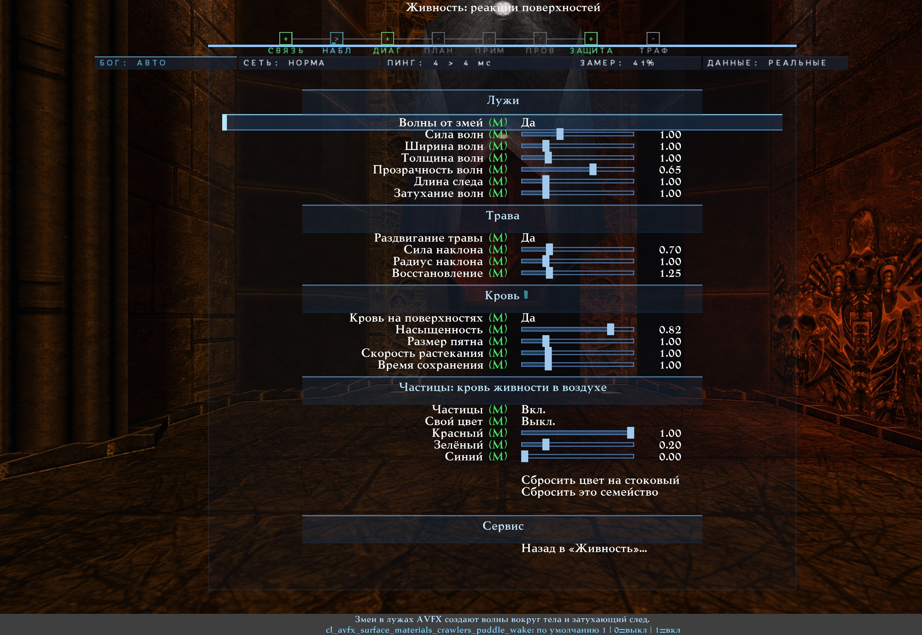
Wildlife blood's AVFX Enable/RGB controls.
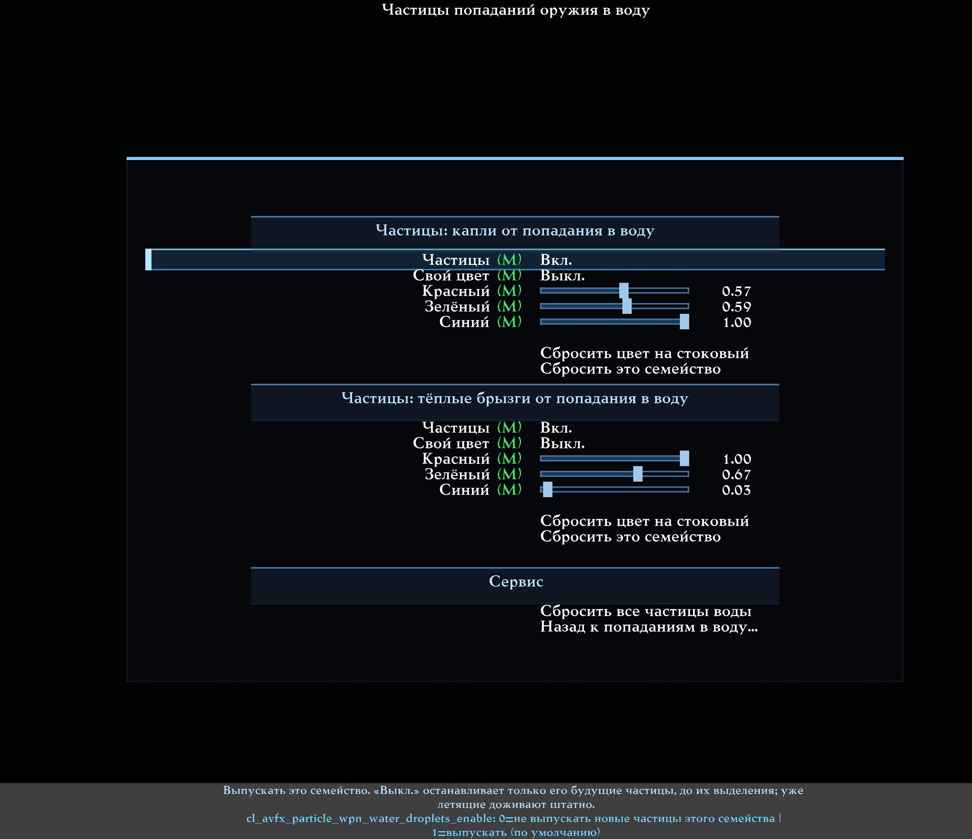
Two independent Enable/RGB families for weapon impacts on water.
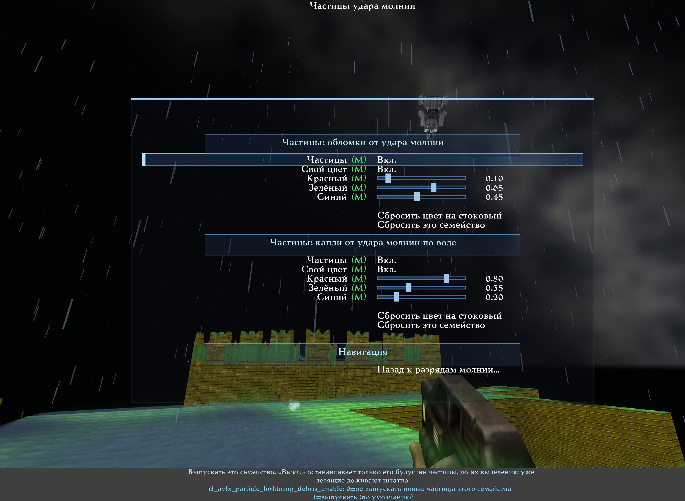
Independent lightning-impact fragments and lightning-water drops.
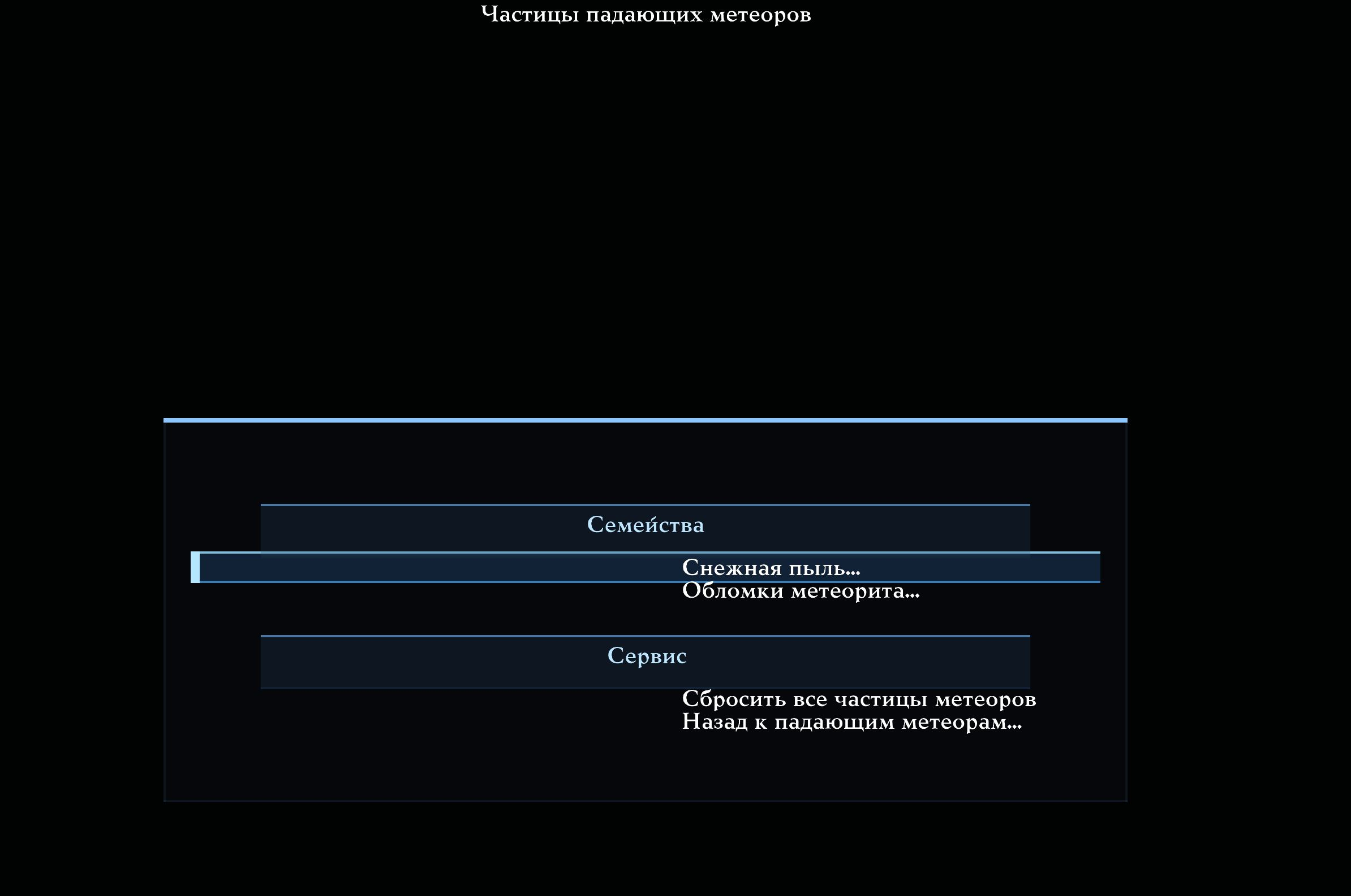
Two meteor-impact branches covering four ground-dust and debris families.

Complete catalogue: ten AVFX families and menu paths
Family | Description | Variables
Airborne wildlife blood | The blood burst thrown by a wounded, killed or striking snake. Its stains and sounds are separate controls. | cl_avfx_particle_wildlife_blood_enable; cl_avfx_particle_rgb_wildlife_blood_custom; cl_avfx_particle_rgb_wildlife_blood_r/g/b
Water impact droplets | The blue droplet fountain thrown up when a weapon hits water. Rings, steam, stains and sounds are separate controls. | cl_avfx_particle_wpn_water_droplets_enable; cl_avfx_particle_rgb_wpn_water_droplets_custom; cl_avfx_particle_rgb_wpn_water_droplets_r/g/b
Water impact warm spray | The warm spray mixed into a weapon water impact, visually distinct from the blue droplets. | cl_avfx_particle_wpn_water_warm_enable; cl_avfx_particle_rgb_wpn_water_warm_custom; cl_avfx_particle_rgb_wpn_water_warm_r/g/b
Snow impact dust | The light snow dust thrown up when a weapon hits snow, including the rocket's radial sprays. | cl_avfx_particle_wpn_snow_dust_enable; cl_avfx_particle_rgb_wpn_snow_dust_custom; cl_avfx_particle_rgb_wpn_snow_dust_r/g/b
Lightning impact debris | The warm debris bursts at a lightning strike point. The smoke flash, surface arcs and water reaction are separate controls. | cl_avfx_particle_lightning_debris_enable; cl_avfx_particle_rgb_lightning_debris_custom; cl_avfx_particle_rgb_lightning_debris_r/g/b
Lightning water droplets | The blue droplets thrown up where lightning hits or crawls across real BSP water and visible AVFX puddles. Weapon-water droplets are a separate family and are never changed by this control. | cl_avfx_particle_lightning_water_droplets_enable; cl_avfx_particle_rgb_lightning_water_droplets_custom; cl_avfx_particle_rgb_lightning_water_droplets_r/g/b
Meteor snow dust | The snow dust thrown up by a meteor landing on snow, including its radial sprays. | cl_avfx_particle_meteor_snow_dust_enable; cl_avfx_particle_rgb_meteor_snow_dust_custom; cl_avfx_particle_rgb_meteor_snow_dust_r/g/b
Meteor debris (warm) | The main warm debris burst at a meteor impact point. | cl_avfx_particle_meteor_debris_warm_enable; cl_avfx_particle_rgb_meteor_debris_warm_custom; cl_avfx_particle_rgb_meteor_debris_warm_r/g/b
Meteor debris (red) | The red half of the meteor's radial debris ring. | cl_avfx_particle_meteor_debris_red_enable; cl_avfx_particle_rgb_meteor_debris_red_custom; cl_avfx_particle_rgb_meteor_debris_red_r/g/b
Meteor debris (energy) | The green half of the meteor's radial debris ring. | cl_avfx_particle_meteor_debris_energy_enable; cl_avfx_particle_rgb_meteor_debris_energy_custom; cl_avfx_particle_rgb_meteor_debris_energy_r/g/b

AVFX presets and the generator
All factory/reset and ordinary user AVFX presets use the complete current schema. They save the ten local AVFX families and fifteen colour controls for sky meteors, falling impact meteors and comets. They save neither global cl_particle_* variables nor Contact Effects.
Existing presets received safe factory values for the added parameters:
- Lightning-water drops: Particles on, Custom Colour off, RGB 0.57 / 0.59 / 1.00.
- Falling meteor: Custom Colour off, RGB 1.00 / 0.65 / 0.30, Variation 0.
- Sky meteors: Custom Colour off, RGB 1.00 / 0.82 / 0.45, Variation 0.
- Comets: Custom Colour off, RGB 0.45 / 0.85 / 1.00, Variation 0.
Generator behaviour:
- Smart mode leaves the new RGB families ungenerated, preserving prior behaviour.
- Full Chaos chooses each of the ten families' RGB values on the actual menu
scale and enables its Custom Colour.
- For selected falling meteors, sky meteors or comets, Full Chaos independently
assigns each selected effect's base RGB, enables Custom Colour and sets Colour Variation to the maximum.
- Full Chaos never changes Particles: Enable set by the user or loaded preset remains.
- Global Standard cl_particle_* and Contact cl_avfx_contact* variables are excluded.
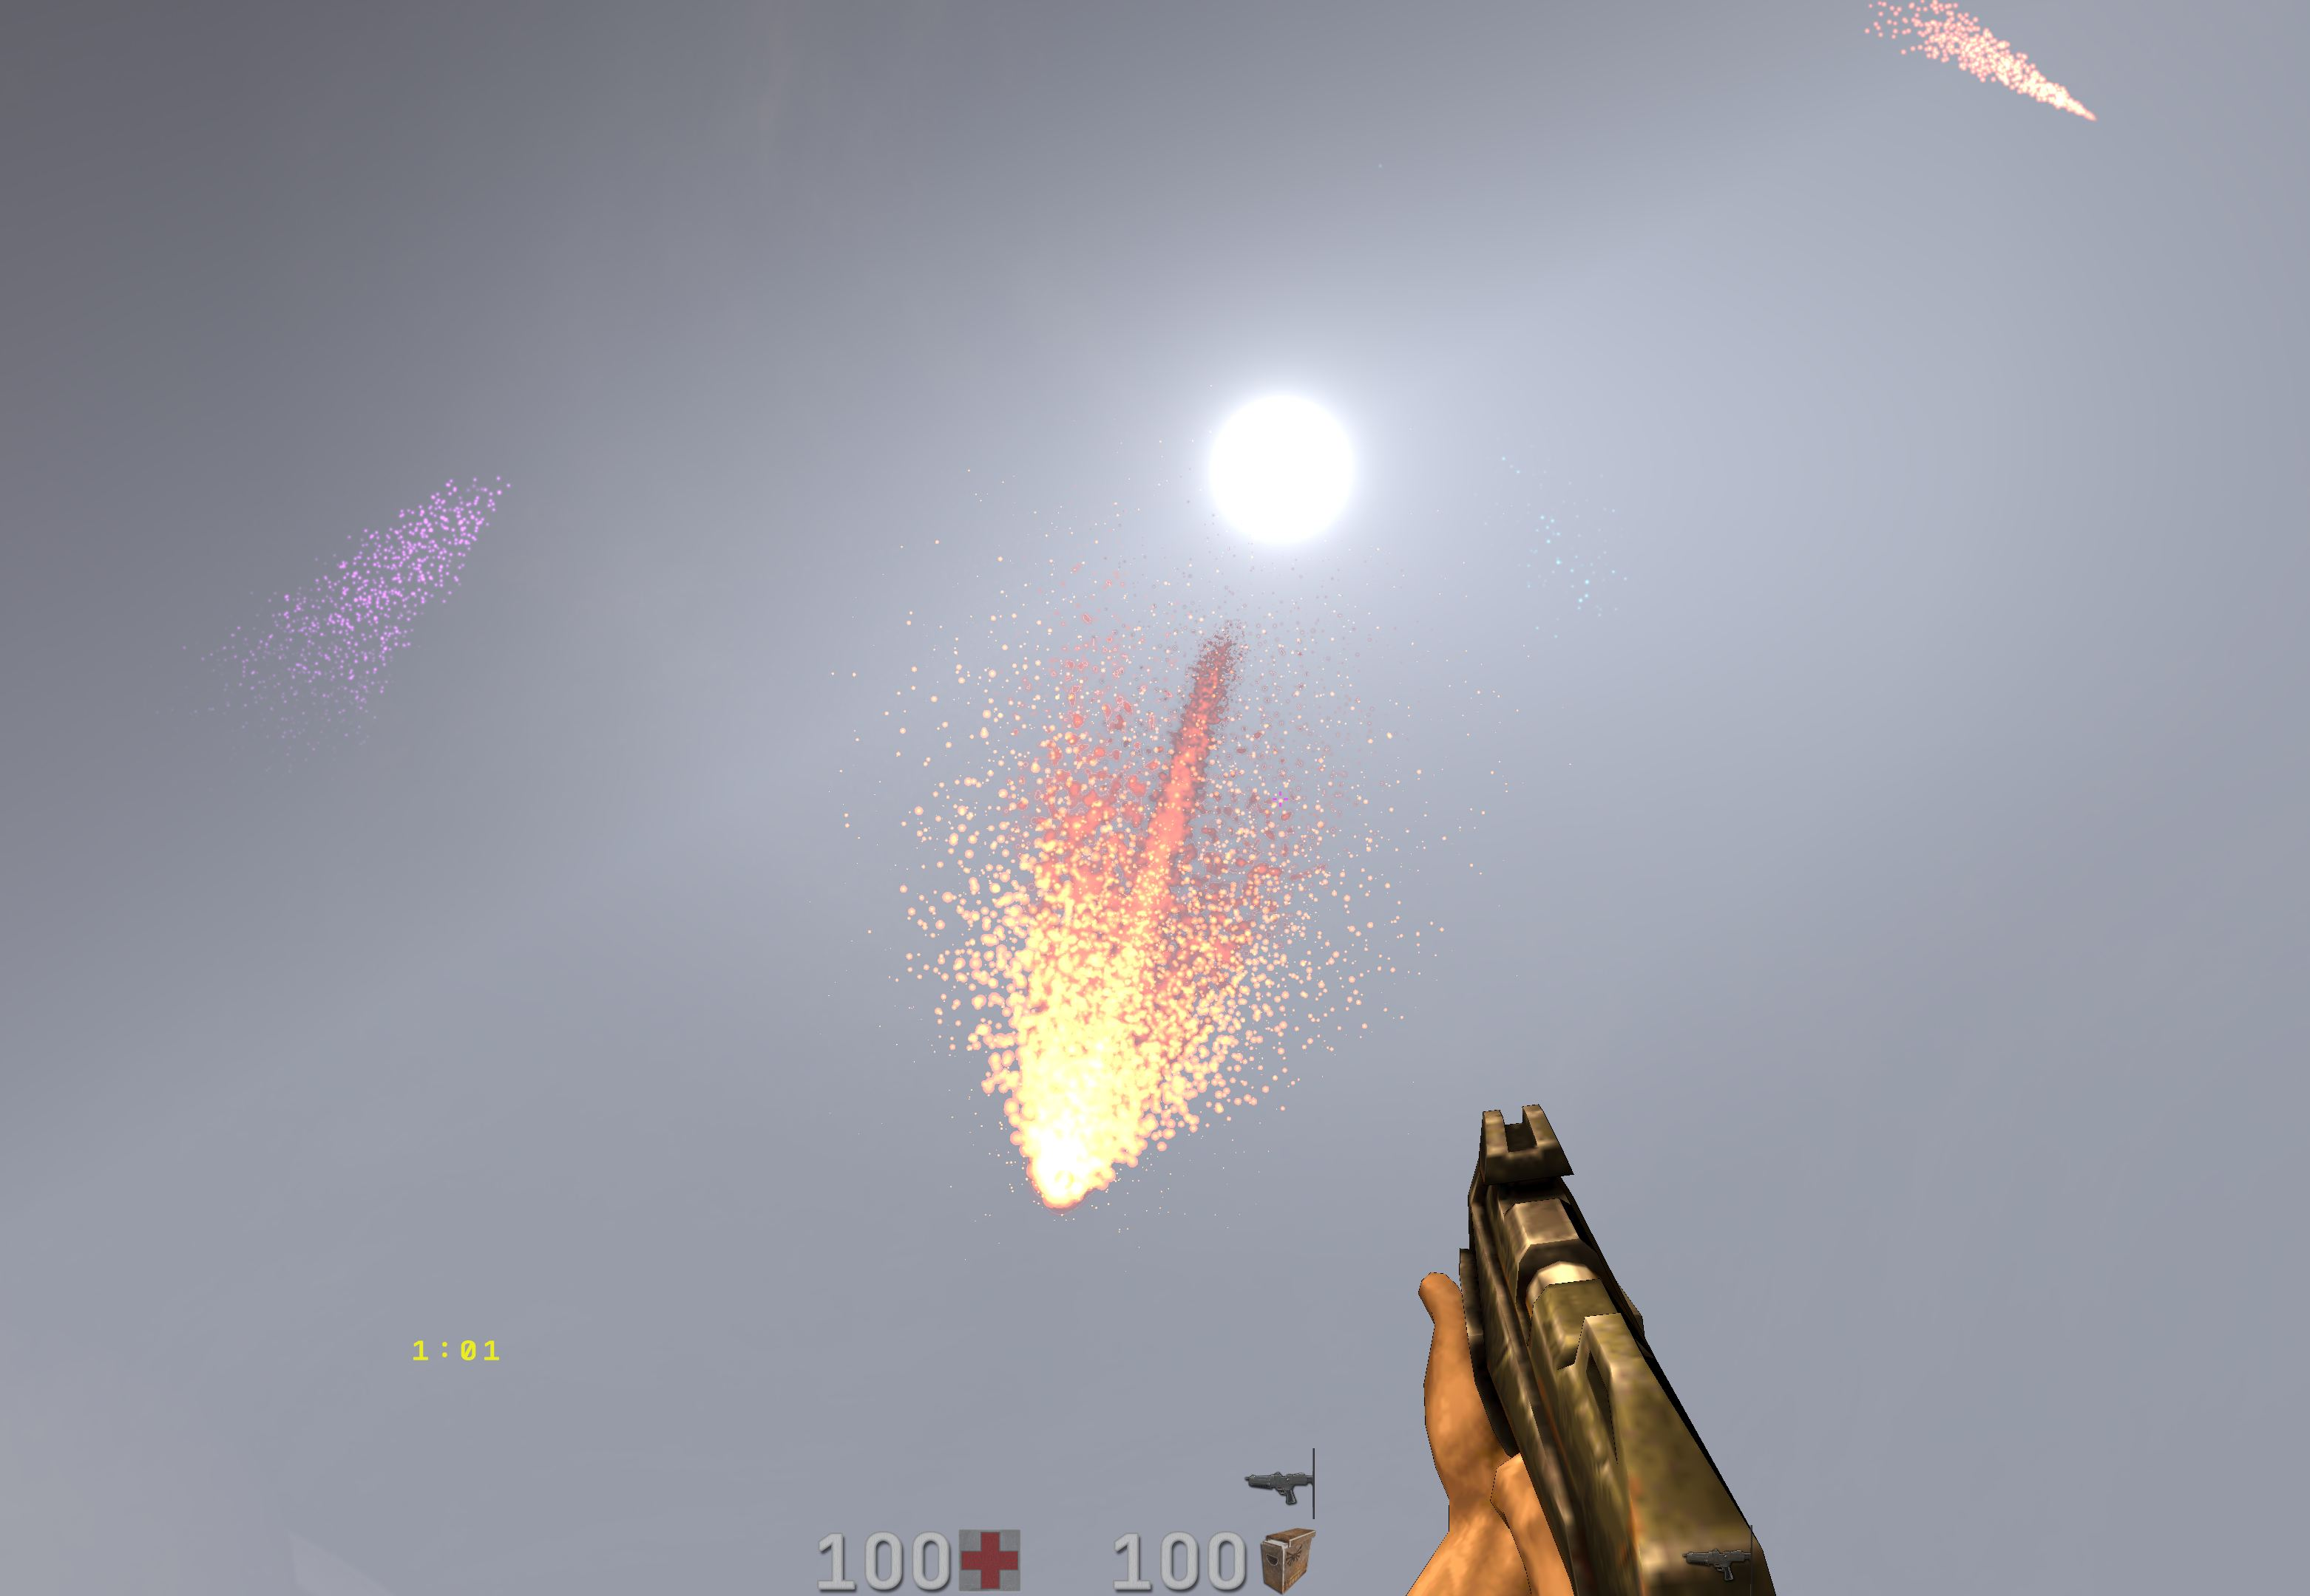
Full Chaos: falling meteors with distinct non-stock head and tail colours.

Three independent celestial RGB layers
1. Sky meteors / shooting stars cross the celestial sphere without BSP
collision. cl_avfx_meteors enables emission; cl_avfx_meteor_color_* controls colour.
2. Falling impact meteors descend into the level, strike ground, water or lava
and create an impact. cl_avfx_meteor_impact enables them; cl_avfx_meteor_impact_color_* colours the flying object. Four Enable/RGB families on the impact-particles page separately control only ground dust and debris.
3. Comets move slowly with a nucleus, coma and one continuous tail. They are
neither kind of meteor. cl_avfx_comets enables them; cl_avfx_comet_color_* controls colour.
Each object's emission switch is on its main page. The colour submenu deliberately does not duplicate Enable: it changes only the palette of new objects.

The flying falling meteor's colour
The four Meteor Impact Particles families affect only dust and debris after surface contact; they do not recolour the flying head or tail.
Use Main Menu → Advanced Visual Effects → Detailed AVFX Settings → Sky and Celestial Bodies → Meteor Settings → Falling Meteor Settings → Falling Meteor: Glow and Tail Colour.
- Custom Colour (cl_avfx_meteor_impact_color_custom) applies the controls
below only to new falling meteors. Off preserves the stock warm palette completely.
- Red / Green / Blue (cl_avfx_meteor_impact_color_r,
cl_avfx_meteor_impact_color_g, cl_avfx_meteor_impact_color_b) set base RGB for head plasma, the hot rim, fiery tail, smoke, hot fragments and local glow.
- Colour Variation (cl_avfx_meteor_impact_color_variation) deterministically
changes each new meteor's tint. Zero preserves exact RGB; one gives maximum variation while retaining the base colour's influence.
The dark rocky body keeps its natural material. An already flying meteor does not change colour mid-flight; the next created meteor receives new values. The main Falling Meteors switch still controls emission.
Defaults: Custom Colour off; red 1.00, green 0.65, blue 0.30; Variation 0.
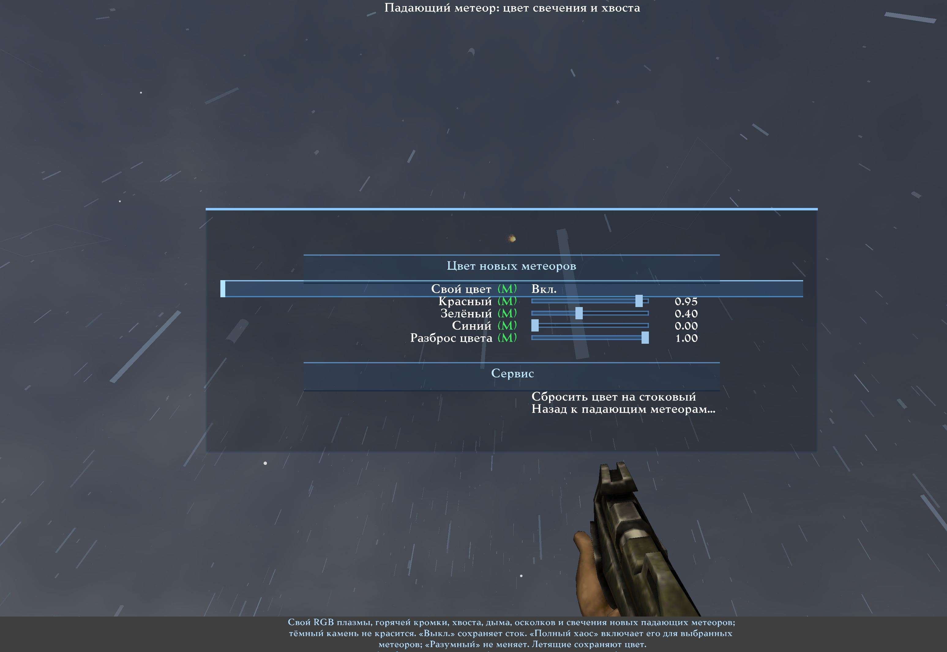
Colour of the flying falling meteor: Custom Colour, RGB and Variation.
Impact Meteor: Head Glow and Tail Color
Type | Section | Row | Variable or target | What it does
Section | New meteor color | New meteor color
Toggle | New meteor color | Custom color | cl_avfx_meteor_impact_color_custom | Custom RGB for new impact-meteor plasma, hot edge, tail, smoke, hot shatter and glow; the dark rock stays natural. Off keeps the stock palette. Full Chaos enables this when impact meteors are selected; Reasonable does not. Existing meteors keep their spawn colour. Applies immediately.
Slider | New meteor color | Red | cl_avfx_meteor_impact_color_r | Red channel of the manual impact-meteor tint. Applied to newly spawned meteors only. Applies immediately.
Slider | New meteor color | Green | cl_avfx_meteor_impact_color_g | Green channel of the manual impact-meteor tint. Applied to newly spawned meteors only. Applies immediately.
Slider | New meteor color | Blue | cl_avfx_meteor_impact_color_b | Blue channel of the manual impact-meteor tint. Applied to newly spawned meteors only. Applies immediately.
Slider | New meteor color | Per-meteor variation | cl_avfx_meteor_impact_color_variation | Seeded colour variation between individual new meteors. 0 keeps the exact RGB above; 1 gives the strongest deterministic vivid variation while retaining influence from that base RGB. Full Chaos enables this so simultaneous falling meteors are not colour clones. Applies immediately.
Section | Service | Service
Navigation | Service | Reset color to stock | reset cl_avfx_meteor_impact_color_custom; reset cl_avfx_meteor_impact_color_r; reset cl_avfx_meteor_impact_color_g; reset cl_avfx_meteor_impact_color_b; reset cl_avfx_meteor_impact_color_variation | Disable manual color, disable per-meteor variation and restore the stock reference RGB values.
Navigation | Service | Back to impact meteors... | q2prox_avfx_meteor_impact | Return to Impact Meteors settings.

Sky meteors / shooting stars
Use Main Menu → Advanced Visual Effects → Detailed AVFX Settings → Sky and Celestial Bodies → Meteor Settings → Sky Meteor Colour.
- Custom Colour (cl_avfx_meteor_color_custom) applies base RGB to new glowing
heads, streaks, long tails and fragmentation. Off exactly preserves the stock warm-gold palette.
- Red / Green / Blue (cl_avfx_meteor_color_r, cl_avfx_meteor_color_g,
cl_avfx_meteor_color_b) set the base tint for new sky meteors.
- Colour Variation (cl_avfx_meteor_color_variation) deterministically changes
new meteors' tints. Zero preserves the base exactly; one produces maximum bright variation while retaining the base's influence.
- Reset Colour to Stock disables custom colour and variation, restores RGB
1.00 / 0.82 / 0.45 and leaves cl_avfx_meteors unchanged.
Existing meteors keep their creation-time colour; changes affect new objects. The Sky Meteors (cl_avfx_meteors) control on the parent page handles emission.
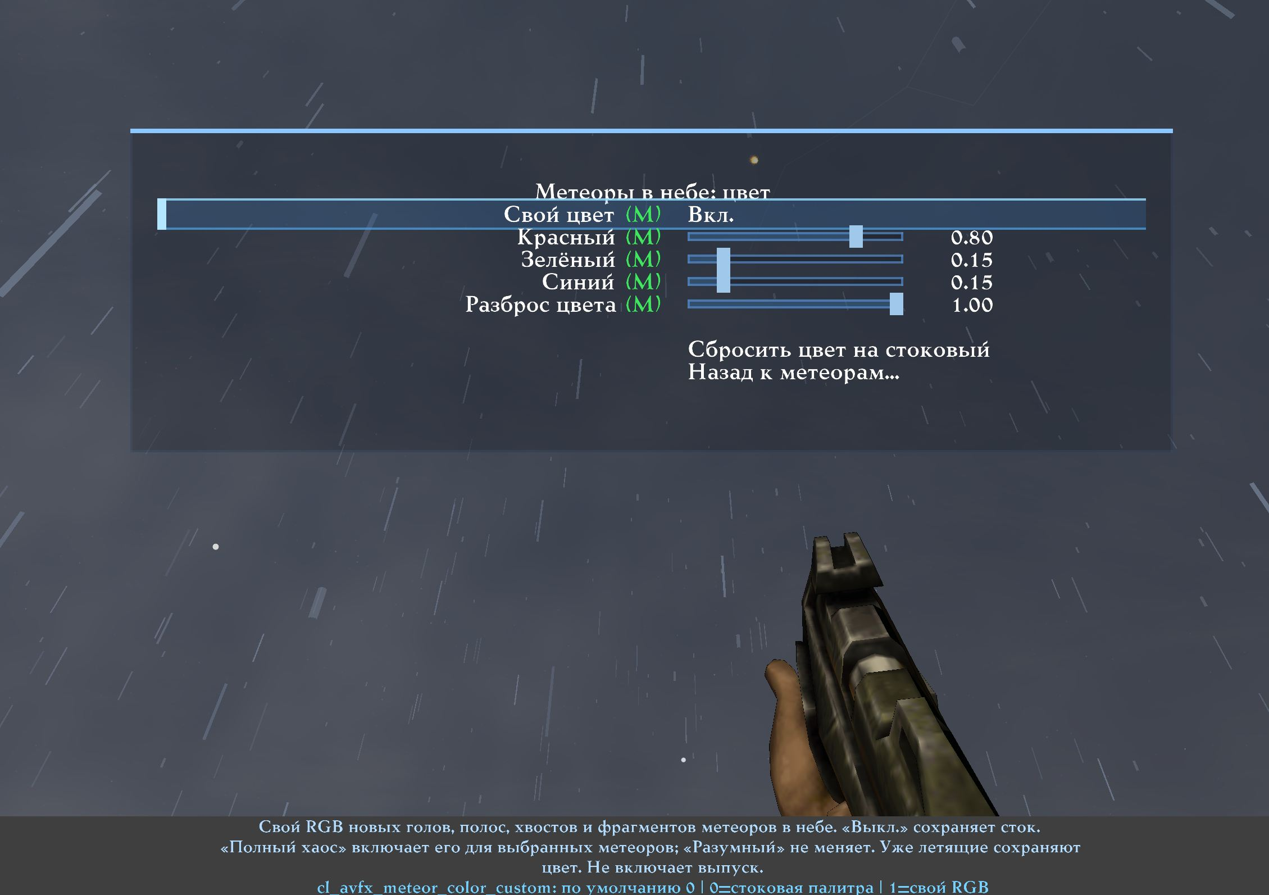
Sky Meteor Colour: independent Custom, RGB, Variation and stock reset.
Sky Meteor Color
Type | Section | Row | Variable or target | What it does
Toggle |  | Custom color | cl_avfx_meteor_color_custom | Custom RGB for new sky-meteor heads, streaks, trains and fragments. Off keeps the stock palette. Full Chaos enables this when sky meteors are selected; Reasonable does not. Existing meteors keep their spawn colour. Does not enable emission. Applies immediately.
Slider |  | Red | cl_avfx_meteor_color_r | Red channel of the manual sky-meteor tint. Applied only to newly spawned sky meteors when Custom color is on. Stock reference: 1.00. Applies immediately.
Slider |  | Green | cl_avfx_meteor_color_g | Green channel of the manual sky-meteor tint. Applied only to newly spawned sky meteors when Custom color is on. Stock reference: 0.82. Applies immediately.
Slider |  | Blue | cl_avfx_meteor_color_b | Blue channel of the manual sky-meteor tint. Applied only to newly spawned sky meteors when Custom color is on. Stock reference: 0.45. Applies immediately.
Slider |  | Per-meteor variation | cl_avfx_meteor_color_variation | Seeded colour variation between individual newly spawned sky meteors. 0 keeps the exact base RGB; 1 gives the strongest deterministic vivid variation while retaining influence from that RGB. Full Chaos uses the strongest variation when sky meteors are selected. Applies immediately.
Navigation |  | Reset color to stock | reset cl_avfx_meteor_color_custom; reset cl_avfx_meteor_color_r; reset cl_avfx_meteor_color_g; reset cl_avfx_meteor_color_b; reset cl_avfx_meteor_color_variation | Disable manual colour and per-meteor variation, and restore the stock warm-gold RGB reference (1.00 / 0.82 / 0.45). The Sky meteors enable toggle is not changed.
Navigation |  | Back to meteors... | q2prox_avfx_meteors | Return to Meteors Settings. Sky-meteor emission is controlled there by Sky meteors.

Comet colour
Use Main Menu → Advanced Visual Effects → Detailed AVFX Settings → Sky and Celestial Bodies → Meteor Settings → Comets → Comet Colour.
- Custom Colour (cl_avfx_comet_color_custom) colours new nuclei, comas and
both parts of the continuous tail. Relative brightness, transparency and shape remain. Off uses the exact stock comet palette.
- Red / Green / Blue (cl_avfx_comet_color_r, cl_avfx_comet_color_g,
cl_avfx_comet_color_b) set the base tint for new comets.
- Colour Variation (cl_avfx_comet_color_variation) adds independent deterministic
tint variation per new comet. Zero preserves exact RGB; one gives maximum bright variation.
- Reset Colour to Stock disables custom colour and variation, restores RGB
0.45 / 0.85 / 1.00 and leaves cl_avfx_comets unchanged.
Two historically named switches on the main comet page now control components of one continuous GPU pass, rather than two separate geometric tails. cl_avfx_comet_dust_tail enables the smooth smoky-fibrous body; cl_avfx_comet_ion_tail enables energetic sparks and strands within it. The glowing nucleus and coma remain when either component is disabled. Manual RGB colours both components along with the rest of the comet.
Flying comets are not recoloured mid-flight. The Comets (cl_avfx_comets) control on the parent page still handles emission.
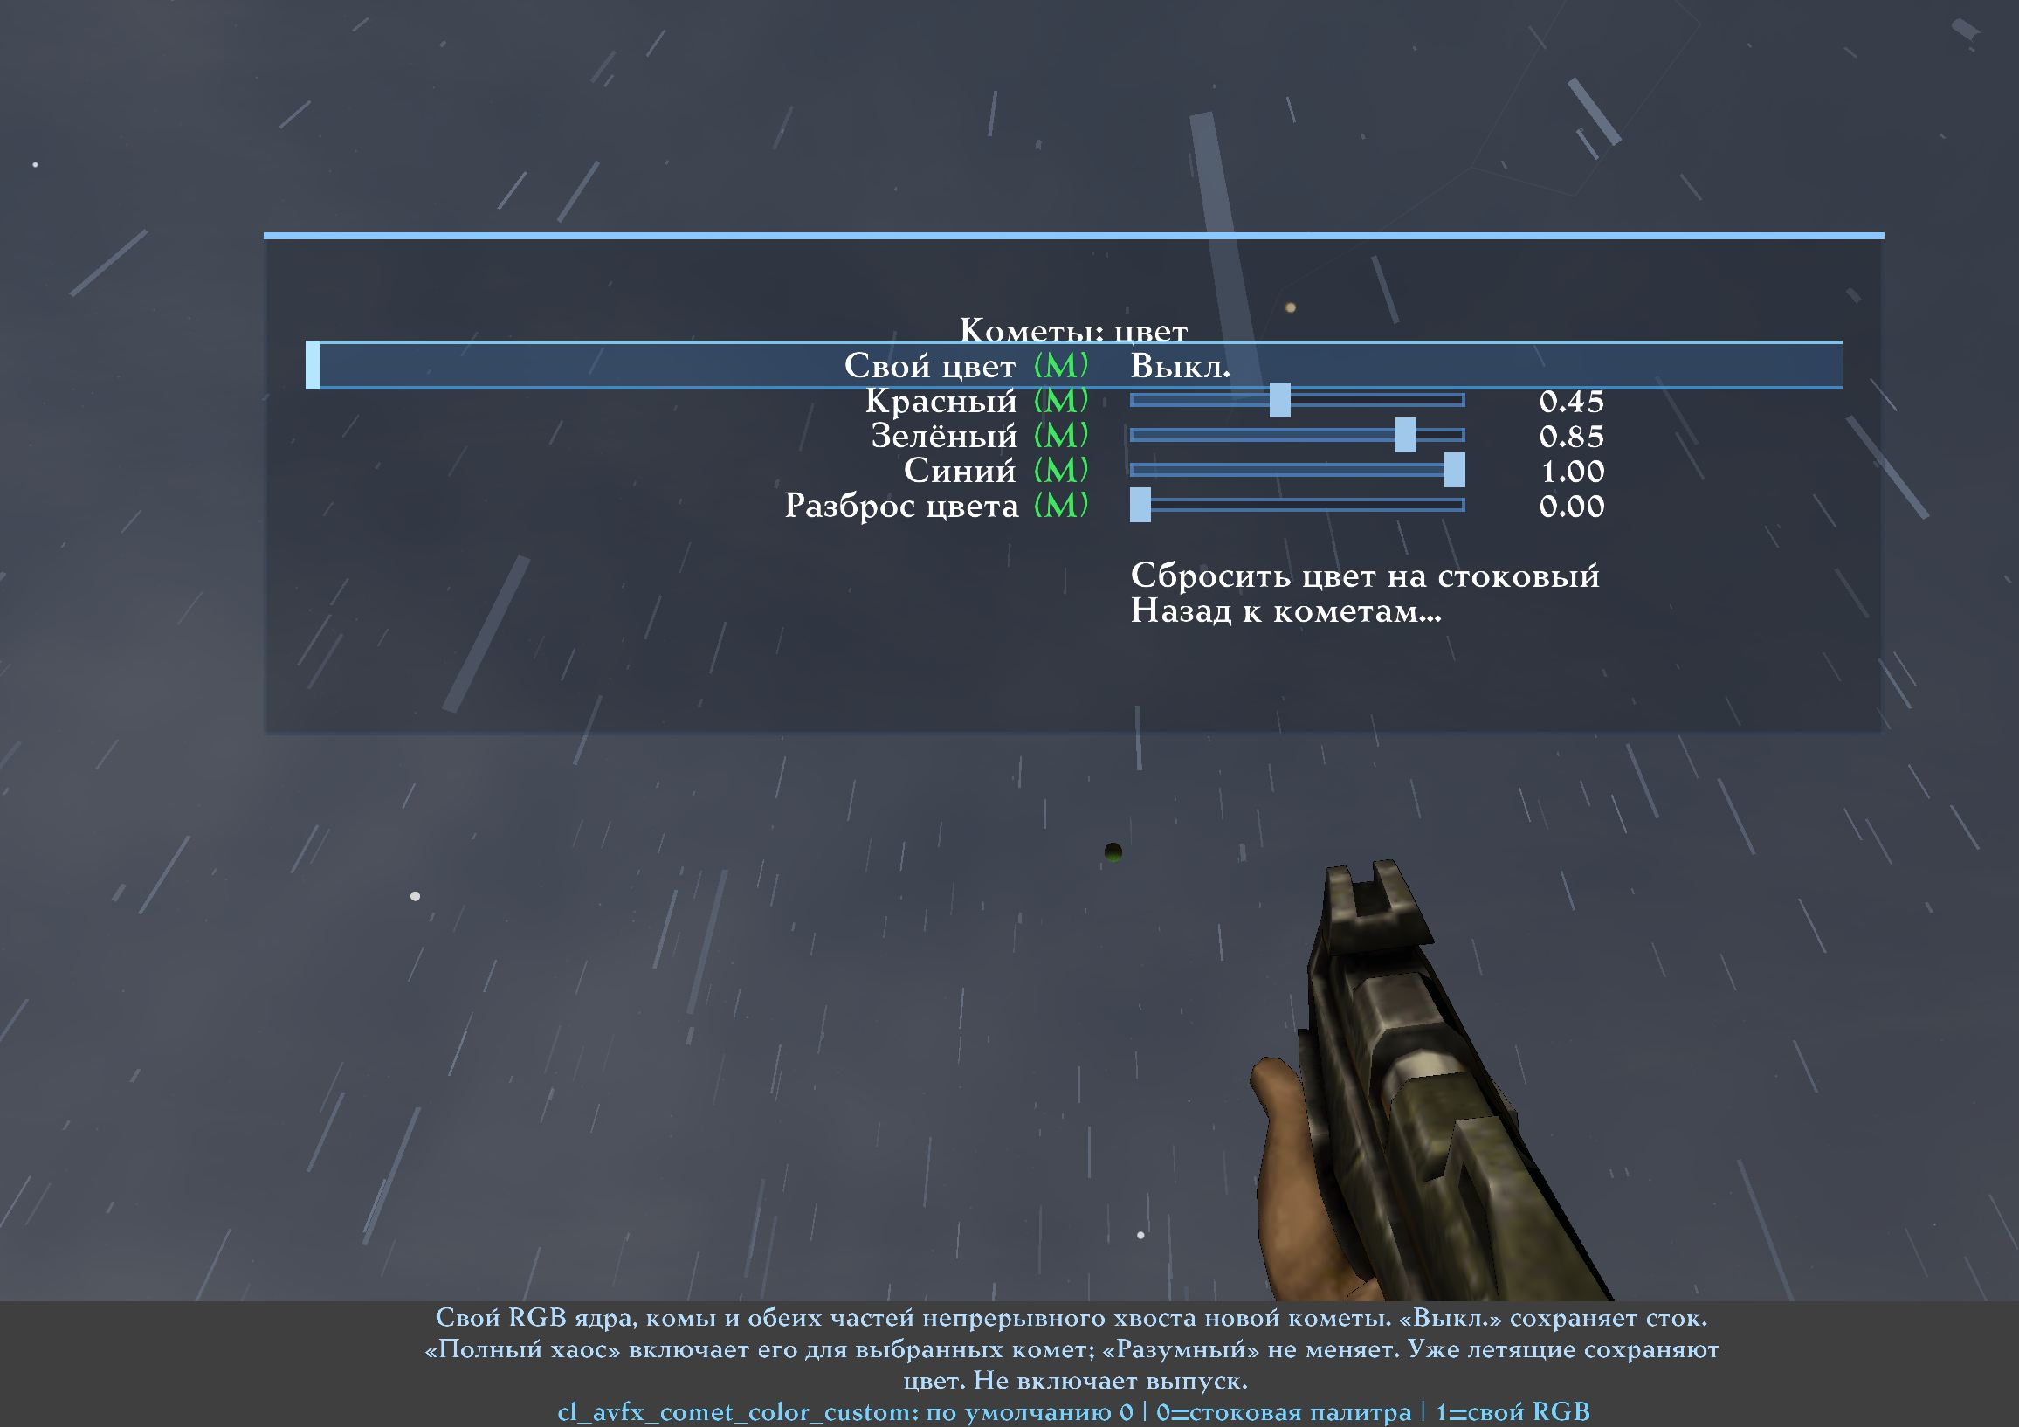
Comet Colour: independent Custom, RGB, Variation and stock reset.
Comet Color
Type | Section | Row | Variable or target | What it does
Toggle |  | Custom color | cl_avfx_comet_color_custom | Custom RGB for a new comet's nucleus, coma and both components of its continuous tail. Off keeps the stock palette. Full Chaos enables this when comets are selected; Reasonable does not. Existing comets keep their spawn colour. Does not enable emission. Applies immediately.
Slider |  | Red | cl_avfx_comet_color_r | Red channel of the manual comet base tint. Applied only to newly spawned comets when Custom color is on. Stock reference: 0.45. Applies immediately.
Slider |  | Green | cl_avfx_comet_color_g | Green channel of the manual comet base tint. Applied only to newly spawned comets when Custom color is on. Stock reference: 0.85. Applies immediately.
Slider |  | Blue | cl_avfx_comet_color_b | Blue channel of the manual comet base tint. Applied only to newly spawned comets when Custom color is on. Stock reference: 1.00. Applies immediately.
Slider |  | Per-comet variation | cl_avfx_comet_color_variation | Seeded colour variation between individual newly spawned comets. 0 keeps the exact base RGB; 1 gives the strongest deterministic vivid variation while retaining influence from that RGB. Full Chaos uses the strongest variation when comets are selected. Applies immediately.
Navigation |  | Reset color to stock | reset cl_avfx_comet_color_custom; reset cl_avfx_comet_color_r; reset cl_avfx_comet_color_g; reset cl_avfx_comet_color_b; reset cl_avfx_comet_color_variation | Disable manual colour and per-comet variation, and restore the stock cool-blue RGB reference (0.45 / 0.85 / 1.00). The Comets enable toggle is not changed.
Navigation |  | Back to comets... | q2prox_avfx_comets | Return to Comets Settings. Comet emission is controlled there by Comets.

Resetting and restoring

Reset Colour to Stock
Restores one family's appearance without changing whether it is enabled.

Reset This Family
Enables particles, disables custom colour and restores the stock RGB reference.

Reset This Page
Affects only Standard families in the current group. Other groups, AVFX and Contact Effects remain unchanged.

Reset All Standard Particles
Restores all 68 Standard families: particles on, custom colours off, reference RGB restored. Broad visibility switches, particle shape, railgun geometry, ordinary AVFX and Contact Effects remain unchanged.

Practical examples

Disable only standard blood
Open Blood and Biology → Red Blood and disable Particles. If needed, separately disable Extra Blood, green blood and gib trails. Contact Effects blood belongs to another domain and remains unaffected.

Recolour a rocket trail without changing its explosion
In Weapons and Trails, adjust Rocket Smoke Trail and Rocket Fire Trail separately. Explosion fragments belong to Impacts, Explosions and Sparks and remain unchanged.

Keep grenade debris but remove rocket debris
Disable only Rocket Explosion Debris on Impacts, Explosions and Sparks. Grenade, other explosion and BFG families are independent.

Adjust celestial effects separately from Standard
For a falling impact meteor, use Meteor and Tail Colour; for its post-impact dust and fragments, use Meteor Impact Particles. Use Sky Meteor Colour for celestial-sphere meteors and Comet Colour for comets. These three GPU palettes and four ground-impact families are independent. None requires the Standard Custom Colours master.

Complete Standard Particles menus
The following tables show the hub and seven groups from the current client.
Standard Particles
Type | Section | Row | Variable or target | What it does
Section | Colour | Colour
Toggle | Colour | Custom colours | cl_particle_rgb_enable | Master for the custom colours of STANDARD families only. Off draws their stock colour and keeps each choice stored. Never changes emission, AVFX or Player Contact. Applies immediately.
Section | Families | Families
Navigation | Families | Blood and biological... | q2prox_pfx_g_blood | Blood, heavy blood, green blood and gib trails. 5 families on this page.
Navigation | Families | Weapons and trails... | q2prox_pfx_g_weapons | Projectile trails and weapon aura particles. 14 families on this page.
Navigation | Families | Impacts, explosions and sparks... | q2prox_pfx_g_impacts | Wall puffs, explosion debris, heat beam and spark families. 13 families on this page.
Navigation | Families | Water, splashes and teleport... | q2prox_pfx_g_water | Splash subtypes, bubbles and teleport particles. 12 families on this page.
Navigation | Families | World and entity effects... | q2prox_pfx_g_world | Login, respawn, flags, flies, muzzle puffs and smoke particles. 11 families on this page.
Navigation | Families | Expansion and advanced... | q2prox_pfx_g_expansion | Expansion pack effects and families whose colour comes from the server. 10 families on this page.
Navigation | Families | Rail compatibility... | q2prox_pfx_g_rail | Classic and modern rail particle families and the legacy colour bridge. 3 families on this page.
Section | How this works | How this works
Navigation | How this works | Global settings | echo Standard particle settings are global Q2PRO-X preferences. | These are global Q2PRO-X preferences for the standard Quake II particle families. They survive maps, mods, servers and ordinary AVFX or Player Contact preset changes.
Navigation | How this works | Particles off | echo Particles off suppresses only future particles of that family. | Turning a family off stops only its future particles, before they are allocated or submitted. Particles already in the air finish normally, and the event's count, physics, lifetime, sound and gameplay are unchanged.
Navigation | How this works | Order of the switches | echo cl_particles and the legacy switches take precedence over the family switches. | The broad Particles master and the legacy per-effect switches decide first and always win when they hide something; the family switch is the finest step after them. The colour master above changes the colour of STANDARD families only.
Navigation | How this works | AVFX and Player Contact | echo AVFX and Player Contact particles have their own controls. | AVFX effects that reuse a stock particle producer are switched and recoloured on their own AVFX pages and in ordinary AVFX presets. Player Contact blood is tuned in Player Contact presets. Nothing here touches either of them.
Section | Related pages | Related pages
Navigation | Related pages | Particles & effect visibility... | g_particles | The broad particle master, the legacy per-effect switches, own blood/armor and water warp.
Navigation | Related pages | Rail trail setup... | g_railtrail | Rail beam style, duration, core and spiral width, and the core and spiral colour lists.
Navigation | Related pages | Reset all standard particles | q2prox_particle_reset all | Turn every standard family's Particles back on, turn every Custom colour off and restore every stock reference colour. AVFX, Player Contact, the broad visibility switches, particle shape and rail geometry are not touched.

Standard Particles: Blood and biological
Type | Section | Row | Variable or target | What it does
Section | Families | Families
Navigation | Families | Red blood... | q2prox_pfx_f_blood_red | Ordinary flesh-hit blood: the server TE_BLOOD event, the predicted local copy, and the Player Contact replay of an unattributed flesh event.
Navigation | Families | Heavy blood... | q2prox_pfx_f_blood_heavy | The gib-scale flesh burst: TE_MOREBLOOD and the Contact replay of it.
Navigation | Families | Green blood... | q2prox_pfx_f_blood_green | The TE_GREENBLOOD event used by non-human targets (exact palette entry, no ramp).
Navigation | Families | Red gib trail... | q2prox_pfx_f_gib_trail_red | The blood trail dragged behind flying gibs (EF_GIB).
Navigation | Families | Green gib trail... | q2prox_pfx_f_gib_trail_green | The trail dragged behind EF_GREENGIB debris.
Section | Reset | Reset
Navigation | Reset | Reset this page | q2prox_particle_reset page blood | Turn Particles on, turn Custom colour off and restore the stock reference colour for every family listed on this page. No other page and no AVFX or Player Contact setting is touched.
Navigation | Reset | Back to Standard particles... | q2prox_particle_colors | Return to the standard particle hub.

Standard Particles: Weapons and trails
Type | Section | Row | Variable or target | What it does
Section | Families | Families
Navigation | Families | Blaster trail... | q2prox_pfx_f_blaster_trail | The yellow particle trail behind a blaster bolt; also used by the EF_PLASMA projectile trail.
Navigation | Families | Blaster impact... | q2prox_pfx_f_blaster_impact | The yellow impact burst of a blaster bolt: TE_BLASTER, both blue hyperblaster temp entities, and the predicted local impact.
Navigation | Families | Green bolt trail... | q2prox_pfx_f_hyperblaster_trail | The green particle trail of a tracker-flagged blaster bolt.
Navigation | Families | Green bolt impact... | q2prox_pfx_f_hyperblaster_impact | The green impact burst of TE_BLASTER2.
Navigation | Families | Flechette impact... | q2prox_pfx_f_flechette_impact | The cold blue impact burst of TE_FLECHETTE.
Navigation | Families | Rocket smoke trail... | q2prox_pfx_f_rocket_smoke | The grey diminishing smoke stream behind a rocket. Independent from the rocket fire sub-stream.
Navigation | Families | Rocket fire trail... | q2prox_pfx_f_rocket_fire | The bright non-diminishing fire sparks inside the rocket trail. Independent from the rocket smoke stream.
Navigation | Families | Grenade smoke trail... | q2prox_pfx_f_grenade_smoke | The grey diminishing smoke stream behind a grenade.
Navigation | Families | Fireball trail... | q2prox_pfx_f_fireball_trail | The trail of an EF_ROCKET/EF_GIB fireball; its shade follows the projectile's own trail counter instead of a random draw.
Navigation | Families | BFG aura... | q2prox_pfx_f_bfg_aura | The green particle sphere that surrounds a flying BFG ball; its shade follows the distance from the ball centre.
Navigation | Families | Ionripper trail... | q2prox_pfx_f_ionripper_trail | The alternating warm trail behind an EF_IONRIPPER projectile.
Navigation | Families | Tracker trail... | q2prox_pfx_f_tracker_trail | The dark weaving trail behind an EF_TRACKER projectile.
Navigation | Families | Tracker shell... | q2prox_pfx_f_tracker_shell | The dark particle shell around an entity carrying EF_TRACKERTRAIL.
Navigation | Families | Monster plasma shell... | q2prox_pfx_f_monster_plasma_shell | The warm particle shell drawn at a monster plasma beam origin.
Section | Reset | Reset
Navigation | Reset | Reset this page | q2prox_particle_reset page weapons | Turn Particles on, turn Custom colour off and restore the stock reference colour for every family listed on this page. No other page and no AVFX or Player Contact setting is touched.
Navigation | Reset | Back to Standard particles... | q2prox_particle_colors | Return to the standard particle hub.

Standard Particles: Impacts, explosions and sparks
Type | Section | Row | Variable or target | What it does
Section | Families | Families
Navigation | Families | Bullet wall puff... | q2prox_pfx_f_gun_puff | The grey dust puff of a bullet or shotgun pellet hitting a wall, for both the server event and the predicted local copy. The smoke sprite beside it is a separate model effect.
Navigation | Families | Armor sparks... | q2prox_pfx_f_armor_sparks | The small warm spark burst of TE_SPARKS / TE_BULLET_SPARKS on armor.
Navigation | Families | Grenade explosion debris... | q2prox_pfx_f_explosion_grenade | The warm debris cloud of a grenade explosion. The legacy cl_disable_particles grenade bit still applies on top.
Navigation | Families | Rocket explosion debris... | q2prox_pfx_f_explosion_rocket | The warm debris cloud of a rocket explosion, server and predicted. The legacy cl_disable_particles rocket bit still applies on top.
Navigation | Families | Other explosion debris... | q2prox_pfx_f_explosion_generic | The warm debris cloud of every other explosion event: TE_EXPLOSION1, TE_EXPLOSION2, their no-light variants and TE_PLASMA_EXPLOSION.
Navigation | Families | BFG explosion debris... | q2prox_pfx_f_bfg_explosion | The green debris cloud of TE_BFG_BIGEXPLOSION.
Navigation | Families | Tracker explosion... | q2prox_pfx_f_tracker_explosion | The dark particle burst of TE_TRACKER_EXPLOSION.
Navigation | Families | Heat beam particles... | q2prox_pfx_f_heatbeam_particles | The rotating particle sleeve that forms the heat beam itself.
Navigation | Families | Heat beam sparks... | q2prox_pfx_f_heatbeam_sparks | The grey spark puff of TE_HEATBEAM_SPARKS at the beam impact point.
Navigation | Families | Heat beam steam... | q2prox_pfx_f_heatbeam_steam | The warm steam puff of TE_HEATBEAM_STEAM.
Navigation | Families | Screen sparks... | q2prox_pfx_f_screen_sparks | The green spark burst of TE_SCREEN_SPARKS.
Navigation | Families | Shield sparks... | q2prox_pfx_f_shield_sparks | The blue spark burst of TE_SHIELD_SPARKS.
Navigation | Families | Electric sparks... | q2prox_pfx_f_electric_sparks | The cold spark burst of TE_ELECTRIC_SPARKS.
Section | Reset | Reset
Navigation | Reset | Reset this page | q2prox_particle_reset page impacts | Turn Particles on, turn Custom colour off and restore the stock reference colour for every family listed on this page. No other page and no AVFX or Player Contact setting is touched.
Navigation | Reset | Back to Standard particles... | q2prox_particle_colors | Return to the standard particle hub.

Standard Particles: Water, splashes and teleport
Type | Section | Row | Variable or target | What it does
Section | Families | Families
Navigation | Families | Unclassified splash... | q2prox_pfx_f_splash_generic | TE_SPLASH with no subtype, or a subtype the client does not know: the stock grey splash.
Navigation | Families | Water splash... | q2prox_pfx_f_splash_water | The blue-water subtype of TE_SPLASH, and the predicted local pellet splash when a shotgun pellet lands in a fluid.
Navigation | Families | Brown water splash... | q2prox_pfx_f_splash_brown_water | The brown-water subtype of TE_SPLASH.
Navigation | Families | Slime splash... | q2prox_pfx_f_splash_slime | The slime subtype of TE_SPLASH.
Navigation | Families | Lava splash... | q2prox_pfx_f_splash_lava | The lava subtype of TE_SPLASH.
Navigation | Families | Spark splash... | q2prox_pfx_f_splash_sparks | The spark subtype of TE_SPLASH. Its ricochet sound is independent of this family.
Navigation | Families | Blood splash... | q2prox_pfx_f_splash_blood | The blood subtype of TE_SPLASH. Separate from the flesh-hit blood family.
Navigation | Families | Electric splash (N64)... | q2prox_pfx_f_splash_electric_n64 | The mixed electric splash of the extended TE_SPLASH variant: both of its colour bands keep their stock brightness curve.
Navigation | Families | Bubble trail... | q2prox_pfx_f_bubble_trail | Underwater bubbles: both the TE_BUBBLETRAIL and TE_BUBBLETRAIL2 implementations.
Navigation | Families | Teleporter idle... | q2prox_pfx_f_teleporter_idle | The steady yellow particles rising from an idle teleporter pad: both implementations.
Navigation | Families | Teleport burst... | q2prox_pfx_f_teleport_burst | The grey particle cube produced when a player teleports.
Navigation | Families | Boss teleport burst... | q2prox_pfx_f_big_teleport | The large four-band swirl of TE_BOSSTPORT.
Section | Reset | Reset
Navigation | Reset | Reset this page | q2prox_particle_reset page water | Turn Particles on, turn Custom colour off and restore the stock reference colour for every family listed on this page. No other page and no AVFX or Player Contact setting is touched.
Navigation | Reset | Back to Standard particles... | q2prox_particle_colors | Return to the standard particle hub.

Standard Particles: World and entity effects
Type | Section | Row | Variable or target | What it does
Section | Families | Families
Navigation | Families | Player login... | q2prox_pfx_f_login | The green column of particles when a player joins the game.
Navigation | Families | Player logout... | q2prox_pfx_f_logout | The red column of particles when a player leaves the game.
Navigation | Families | Player respawn... | q2prox_pfx_f_respawn | The yellow column of particles when a player respawns.
Navigation | Families | Item respawn... | q2prox_pfx_f_item_respawn | The green sparkle when an item respawns on its pad.
Navigation | Families | Flies... | q2prox_pfx_f_flies | The dark swarm circling a corpse (EF_FLIES).
Navigation | Families | Red flag trail... | q2prox_pfx_f_flag_trail_red | The red trail behind a carried EF_FLAG1 flag.
Navigation | Families | Blue flag trail... | q2prox_pfx_f_flag_trail_blue | The blue trail behind a carried EF_FLAG2 flag.
Navigation | Families | Tag trail... | q2prox_pfx_f_tag_trail | The yellow trail behind an EF_TAGTRAIL entity.
Navigation | Families | Monster muzzle puff... | q2prox_pfx_f_monster_muzzle_puff | The grey particle puff at a monster muzzle flash. The flash model and its dynamic light are separate effects.
Navigation | Families | Chainfist smoke... | q2prox_pfx_f_chainfist_smoke | The grey particle smoke of TE_CHAINFIST_SMOKE.
Navigation | Families | Exploding barrel smoke... | q2prox_pfx_f_barrel_smoke | The four-band smoke of an exploding barrel, emitted from six points around it; all four bands keep their stock brightness curve.
Section | Reset | Reset
Navigation | Reset | Reset this page | q2prox_particle_reset page world | Turn Particles on, turn Custom colour off and restore the stock reference colour for every family listed on this page. No other page and no AVFX or Player Contact setting is touched.
Navigation | Reset | Back to Standard particles... | q2prox_particle_colors | Return to the standard particle hub.

Standard Particles: Expansion and advanced
Type | Section | Row | Variable or target | What it does
Section | Families | Families
Navigation | Families | Trap particles... | q2prox_pfx_f_trap | The warm column and the sparkling cluster of an EF_TRAP entity.
Navigation | Families | Hologram... | q2prox_pfx_f_hologram | The rotating green particle sphere of the EFX_HOLOGRAM effect.
Navigation | Families | Widow beam-out... | q2prox_pfx_f_widow_beamout | The four-band particle sphere of the Widow beam-out sustain effect.
Navigation | Families | Widow splash... | q2prox_pfx_f_widow_splash | The four-band particle burst of TE_WIDOWSPLASH.
Navigation | Families | Nuke blast... | q2prox_pfx_f_nuke_blast | The expanding four-band sphere of the nuke sustain effect.
Navigation | Families | Berserk slam... | q2prox_pfx_f_berserk_slam | The four-band ground burst of TE_BERSERK_SLAM.
Navigation | Families | Power splash... | q2prox_pfx_f_power_splash | The green shell burst of TE_POWER_SPLASH around a protected entity.
Navigation | Families | Server-coloured sparks... | q2prox_pfx_f_server_sparks | Laser, welding and tunnel sparks whose colour is chosen by the server or the mod. Stock keeps the incoming colour; Custom replaces it.
Navigation | Families | Server steam... | q2prox_pfx_f_server_steam | TE_STEAM and its sustained variant, whose colour, count and magnitude come from the server message. Stock keeps the incoming colour.
Navigation | Families | Force wall... | q2prox_pfx_f_force_wall | The falling curtain of TE_FORCEWALL, whose colour comes from the server message. Stock keeps the incoming colour.
Section | Reset | Reset
Navigation | Reset | Reset this page | q2prox_particle_reset page expansion | Turn Particles on, turn Custom colour off and restore the stock reference colour for every family listed on this page. No other page and no AVFX or Player Contact setting is touched.
Navigation | Reset | Back to Standard particles... | q2prox_particle_colors | Return to the standard particle hub.

Standard Particles: Rail compatibility
Type | Section | Row | Variable or target | What it does
Section | Families | Families
Navigation | Families | Classic rail spiral... | q2prox_pfx_f_rail_classic_spiral | The blue particle spiral of the classic rail trail (rail trail type 'default').
Navigation | Families | Classic rail core particles... | q2prox_pfx_f_rail_classic_core | The grey particle core of the classic rail trail. This is the particle core, not the modern laser beam.
Navigation | Families | Modern rail spiral... | q2prox_pfx_f_rail_modern_spiral | The modern rail spiral. Its colour is shared with the classic Spiral colour list on the rail trail page: the sliders and that list are two views of one setting.
Section | Reset | Reset
Navigation | Reset | Reset this page | q2prox_particle_reset page rail | Turn Particles on, turn Custom colour off and restore the stock reference colour for every family listed on this page. No other page and no AVFX or Player Contact setting is touched.
Navigation | Reset | Back to Standard particles... | q2prox_particle_colors | Return to the standard particle hub.

Finding variables
All 406 system variables have Russian and English descriptions in the CVAR browser: one global Standard master, Enable/Custom/R/G/B for 68 Standard and ten AVFX families, plus five colour controls each for sky meteors, falling impact meteors and comets.
Menus are preferable for ordinary setup: they show ownership, effect meaning, actual ranges and safe reset actions. Console variables are chiefly useful for precise configuration transfer and diagnosis. The user chooses the final visual result; the system preserves separate domains, stock behaviour with Custom off and unchanged networking/gameplay mechanics.

