Q2PRO-X 1.6 Beta 5 by ly
Server History and Automatic Reconnection

Project author: ly
Server History and Automatic Reconnection
English edition • Q2PRO-X 1.6 Beta 5 by ly • 2026-10-10

Contents
The entries are links: click one to jump to that section.
Recent server history
Settings
The History tab
Reconnecting after restarting
Automatic connection at startup
Data location

Recent server history
Q2PRO-X remembers servers to which a connection succeeded and lets you return to the last one after closing and restarting the game. The store is shared across baseq2, OpenFFA, OpenTDM and other mods.

Settings
Open Network Play settings and the recent-server section. By default, ten unique servers are retained and automatic connection is disabled.
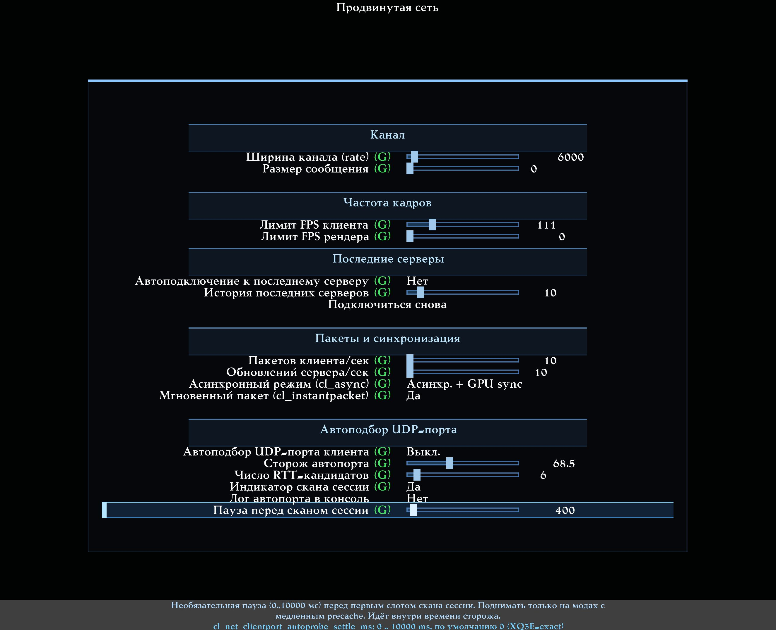
Recent-server settings: history size and automatic connection. The reference screenshot uses the Russian interface.
Setting | Default | Purpose
cl_reconnect_history_limit | 10 | Number of unique servers, 1–100. Set 0 to disable history.
cl_reconnect_last_server_auto | 0 | Connect to the last server at startup: 0 off, 1 on.

These settings are global and do not belong to AVFX visual presets.

The History tab
Open the modern server browser. History follows Favourites. A newly visited server appears first; entries beyond the configured limit are discarded. Each entry records its address, date/time and server mod directory.
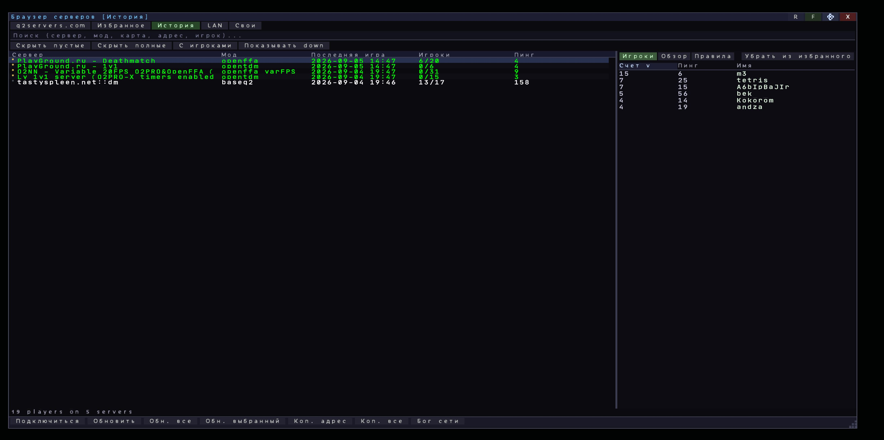
History in the modern server browser. The reference screenshot uses the Russian interface.
Revisiting an earlier server moves it to the top without creating a duplicate. Reconnecting to the already most recent server does not change its position, timestamp or the file. Selecting a row, refreshing pings and failed connections do not add history entries.

Reconnecting after restarting
reconnect uses the saved last server when no current connection exists in the new process. During an ordinary online session, normal reconnect behaviour is unchanged. An empty or disabled history provides no saved address to return to.
An old server may be unavailable or require a password. A history entry neither guarantees connection nor bypasses the server's requirements.

Automatic connection at startup
Enable automatic connection in recent-server settings to return directly to online play, skipping the intro and main menu. It is attempted only after remote online play.
- Single-player and a local server started by the client retain ordinary startup.
- Demo viewing also retains ordinary startup.
- An explicitly requested startup map, server or recording takes precedence.
- No automatic connection occurs with an empty or disabled history.
The saved mod folder describes the previous visit. A new connection uses the current mod reported by the server, rather than forcing the old saved path.

Data location
History is stored in baseq2/q2pro-x/reconnect_history.json under the game's user-writable root. All mods share it; separate openffa/opentdm copies are not created. Timestamps are unambiguously tied to UTC and displayed in local time. Server passwords are not stored.
Updating the game does not require deleting personal settings or history. Factory packages do not contain a developer's or another player's history.

