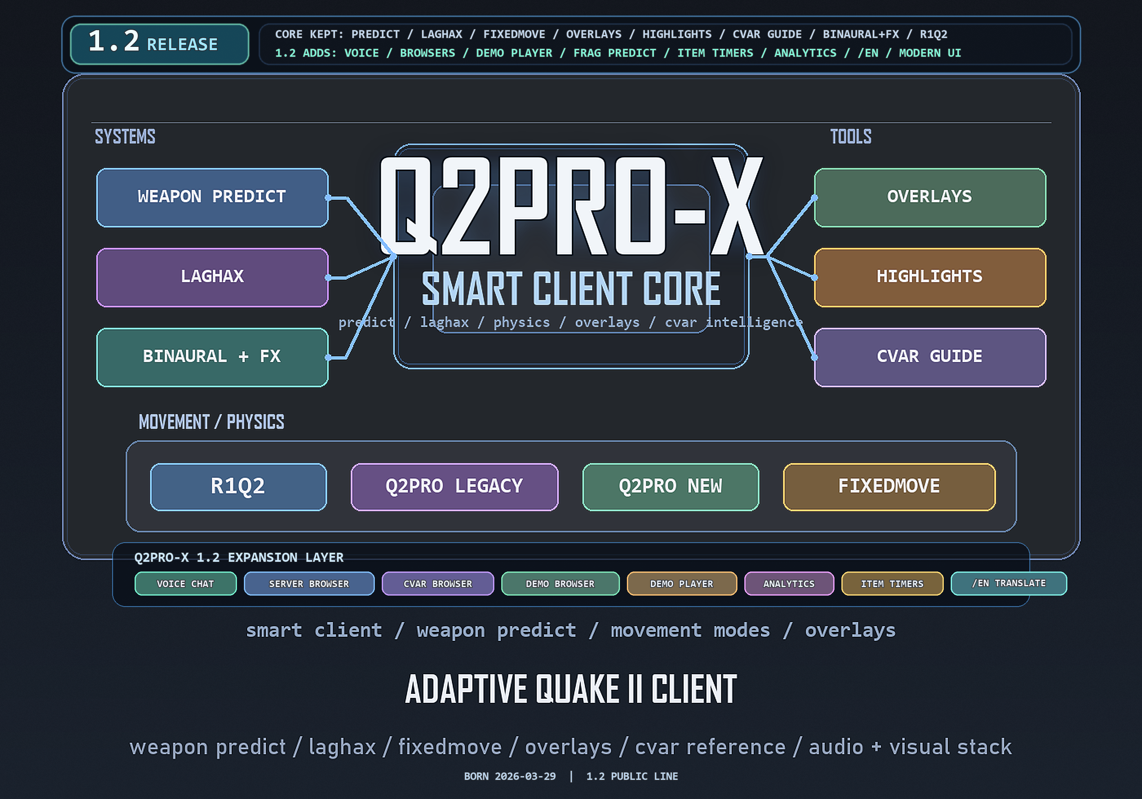
Q2PRO-X 1.2
Q2PRO-X 1.2: cvars, configs, and Cvar Browser
Cvars, configs, and the built-in variable reference
English edition
April 28, 2026
q2pro-x.com

Contents
- 1. What a cvar is
- 2. The three main Q2PRO-X scopes
- Global
- Mod-local
- Demo visual
- 3. Why the release does not ship q2pro-x.cfg
- 4. 1.2 schema migration
- 5. Save and defaults commands
- 6. Why you should not manually wipe cfg files first
- 7. What Cvar Browser can do
- 8. Favorites
- 9. Commands tab
- 10. Search
- 11. Language and fonts
- 12. How to predict where a value will be saved
- 13. Mini recipes
- Save everything before exit
- Reset only demo visuals
- Find all demo cvars
- Check why a value is not saving

Q2PRO-X 1.2: cvars, configs, and Cvar Browser
This guide explains variables, scopes, config saving, and the built-in cvar
browser in Q2PRO-X 1.2.

1. What a cvar is
A cvar is a console variable: a named engine variable that can be:
- read from the console;
- changed from the console;
- changed from the menu;
- saved into cfg;
- used as runtime/UI state.
Examples:
- sensitivity;
- vid_driver;
- cl_vis_enable;
- vc_enable;
- cl_demo_analytics_mode.
In 1.2, most user-facing Q2PRO-X cvars have a clear config scope, so values
are saved to the right place.

2. The three main Q2PRO-X scopes

Global
Global settings are written to:
baseq2/q2pro-x/q2pro-x.cfg
These are settings that usually apply everywhere:
- menu and UI;
- language / typography;
- mouse and zoom;
- video backend;
- voice;
- server browser;
- shared demo browser/player settings;
- cvar browser;
- network tools.

Mod-local
Mod-local settings are written to:
<game>/q2pro-x/q2pro-x.cfg
These may depend on the current mod:
- visibility highlights;
- visual effects;
- item/weapon/player highlight colors;
- part of the render look;
- mod-local binds.

Demo visual
During .dm2 / .mvd2 playback, mod-local visual settings can be written to
a unified profile instead of the mod folder:
baseq2/q2pro-x/demo_visual/q2pro-x.demo.cfg
This keeps demos from different mods visually consistent.

3. Why the release does not ship q2pro-x.cfg
The 1.2 release package does not include a user q2pro-x.cfg in baseq2.
This is intentional:
- do not overwrite the user's existing config;
- do not ship someone else's local/demo state;
- keep the release runtime separate from a personal profile;
- let the engine create clean cfg files on first save.
When cfg files are missing, Q2PRO-X starts from compiled defaults and creates
its own files when settings are saved.

4. 1.2 schema migration
1.2 adds the internal marker:
cl_q2prox_cfg_version
If the marker is missing or older than 1.2, the engine applies only safe
recommended interface defaults, for example:
- guided menu as default;
- Q2PRO-X config autosave;
- modern menu autoscale.
It then writes:
set cl_q2prox_cfg_version "1.2"
The migration will not repeat on the next start.
Important: this is not defaults all. User sensitivity, sound, voice, mouse,
zoom, and other settings should not be fully reset.

5. Save and defaults commands
Main commands:
- q2prox_cfg_save - save global + local;
- q2prox_cfg_save_global - save the global profile;
- q2prox_cfg_save_local - save the mod-local profile, or the demo-visual
profile while a demo is playing;
- q2prox_cfg_save_demo_visual - explicitly save the demo-visual profile;
- q2prox_cfg_defaults - reset all Q2PRO-X settings;
- q2prox_cfg_defaults_global - reset only the global scope;
- q2prox_cfg_defaults_local - reset the local scope, or only demo visual
cvars during demo playback; binds are preserved in demo playback;
- q2prox_cfg_defaults_demo_visual - reset only demo-visual cvars.
Autosave is controlled by:
- cl_q2prox_cfg_autosave.
In 1.2 it defaults to enabled.

6. Why you should not manually wipe cfg files first
Q2PRO-X 1.2 already avoids full profile resets on normal startup. If something
looks wrong, first:
- open the matching menu page;
- inspect the value in the cvar browser;
- use a scope-specific defaults command, for example
q2prox_cfg_defaults_demo_visual, instead of deleting all of baseq2.
Deleting cfg files is useful only when you intentionally want a clean profile.

7. What Cvar Browser can do
Cvar Browser is the built-in variable reference and editor.
Path:
- Options -> Cvar Browser;
- or bind cvar_browser_toggle;
- or console command cvar_help.
Main capabilities:
- tabs: All, Favorites, Demo, Visual, Audio, Input, Network, Gameplay, HUD/UI,
Server, System;
- commands tab;
- search by name, description, and values;
- RU/EN display following the unified localization mode;
- live value column;
- detail pane with description and accepted values;
- mouse selection and copy;
- Ctrl+A, Backspace/Delete clear;
- favorites state;
- resize / drag / fullscreen;
- remember last tab.

8. Favorites
Favorites are a local list of frequently used cvars.
State is stored separately:
baseq2/q2pro-x/cvar_browser_state.txt
Useful entries:
- vid_driver;
- vid_resolution;
- sensitivity;
- cl_mouse_behavior_mode;
- cl_zoom_fov;
- cl_vis_enable;
- cl_demo_analytics_mode;
- vc_enable;
- cl_laghax.

9. Commands tab
The Commands tab helps you quickly find and run related commands:
- open a menu page;
- run an action;
- open an overlay;
- call a helper command;
- open the console with prefilled command text.
When a command needs console input, the browser can put the console above
itself and then resume the previous browser state.

10. Search
Search is not limited to cvar names. It also searches descriptions,
categories, and command metadata. Cyrillic input is supported in Russian mode.
Practical examples:
- demo - demo browser/player/analytics cvars;
- voice - voice chat;
- mouse, zoom - controls;
- highlight - visibility highlights;
- port, clientport, xq3a - advanced network.

11. Language and fonts
Cvar Browser follows the unified Russian localization mode, not the old
standalone cl_cvar_browser_lang. The old cvar is retained for compatibility,
but it is no longer the main language switch.
Related UI cvars:
- cl_browser_font_mode - browser/UI chrome typography;
- cl_cvar_browser_alpha;
- cl_cvar_browser_scale;
- cl_cvar_browser_remember_tab;
- cl_cvar_browser_last_tab.

12. How to predict where a value will be saved
Simple rule:
- mouse, sound, voice, networking, browser UI - global;
- mod visuals, highlights, render look - mod-local;
- the same visual settings during demo playback - demo visual.
If unsure, open the cvar browser and read the entry. In 1.2, new Q2PRO-X cvar
metadata usually explains the purpose and expected values.

13. Mini recipes

Save everything before exit
Console:
q2prox_cfg_save

Reset only demo visuals
Console:
q2prox_cfg_defaults_demo_visual
Then, if needed:
q2prox_cfg_save_demo_visual

Find all demo cvars
Open the cvar browser and switch to the Demo tab, or type demo into the
search field.

Check why a value is not saving
- Make sure cl_q2prox_cfg_autosave 1.
- Check that you are not editing a debug/internal cvar.
- Check the scope: global, local, or demo visual.
- Run the explicit q2prox_cfg_save* command for the needed scope.

