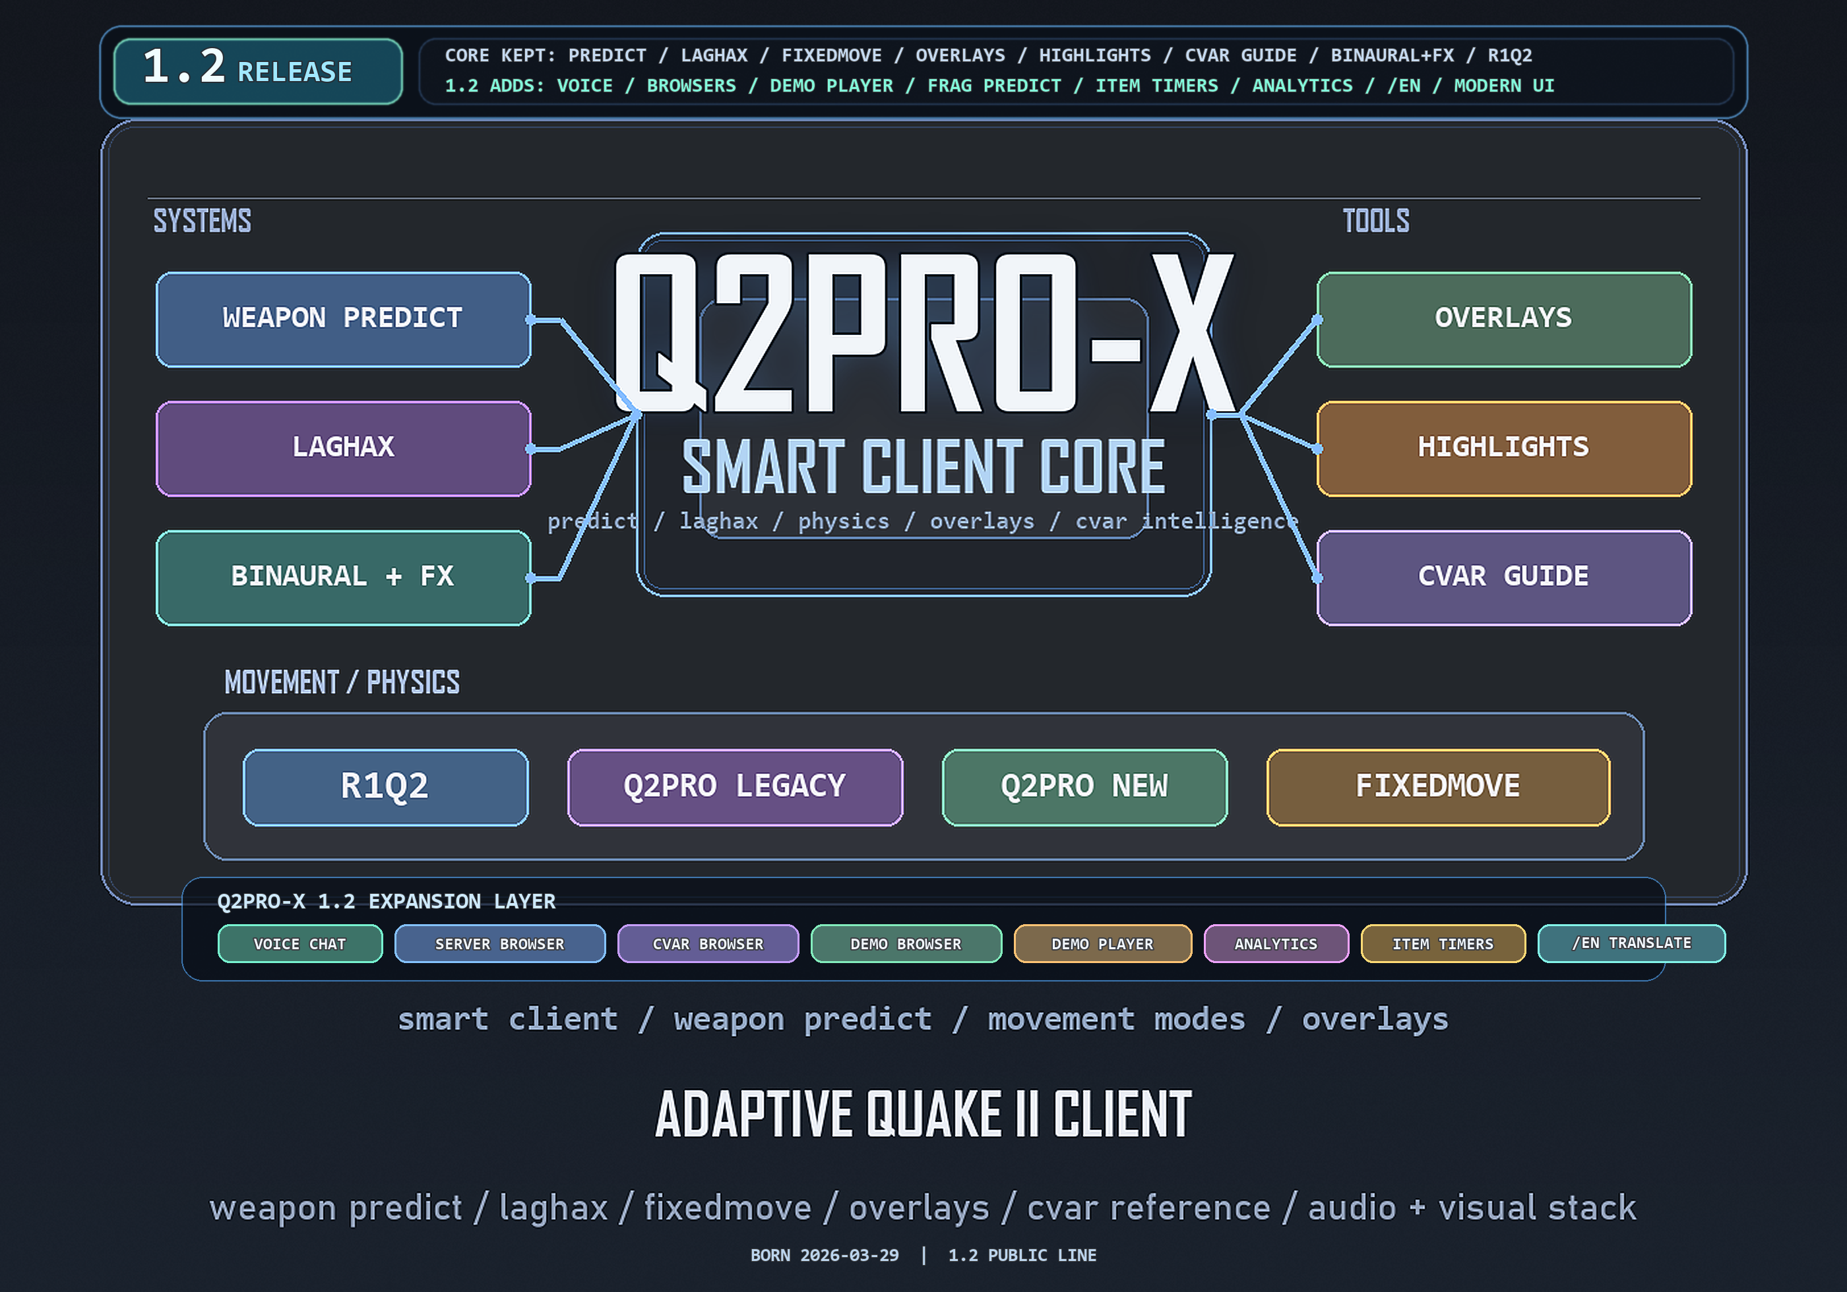
Q2PRO-X 1.2
Q2PRO-X 1.2: network play
Network play, predict, laghax, and server browser
English edition
April 28, 2026
q2pro-x.com

Contents
- 1. Where to find the settings
- 2. Server Browser
- 3. Advanced Network: client UDP port autoprobe
- RTT mode
- XQ3A mode
- 4. Laghax
- 5. Weapon Predicts and Player Predict
- 6. Weapon Parts Visibility
- 7. OpenTDM Team HUD
- 8. Visibility Highlights in live play
- 9. Weapon and player volumes
- 10. Practical profiles
- Clean competitive baseline
- High ping test
- Problem route diagnostics

- 11. Russian input, transliteration, and /en translation

Q2PRO-X 1.2: network play
This guide covers network-play settings: server browser, advanced network,
OpenTDM Team HUD, laghax, weapon/player predict, weapon FX visibility, weapon
volumes, and highlights.

1. Where to find the settings
Guided menu:
- Options -> Online Play Setup;
- Options -> Server Browser;
- Options -> Advanced Network;
- Options -> Laghax;
- Options -> Weapon Predicts;
- Options -> Weapon Parts Visibility;
- Options -> Visibility Highlights;
- Options -> Sound & Acoustics -> weapon / player volumes.
Classic Q2PRO-X menu:
- Q2PRO-X -> server browser;
- Q2PRO-X -> advanced network;
- Q2PRO-X -> laghax;
- Q2PRO-X -> weapon predicts;
- Q2PRO-X -> weapon parts visibility;
- Q2PRO-X -> visibility highlights;
- Q2PRO-X -> sound volumes.

2. Server Browser
The modern server browser is an overlay for finding and joining servers.
Main settings:
- cl_serverbrowser_ui - modern / legacy;
- cl_serverbrowser_alpha;
- cl_serverbrowser_scale;
- cl_serverbrowser_compact;
- cl_serverbrowser_fullscreen;
- cl_serverbrowser_show_details;
- cl_serverbrowser_show_badges;
- cl_serverbrowser_row_colors;
- cl_serverbrowser_hide_empty;
- cl_serverbrowser_hide_full;
- cl_serverbrowser_only_players;
- cl_serverbrowser_max_ping;
- cl_serverbrowser_show_passworded;
- cl_serverbrowser_show_down;
- cl_serverbrowser_default_source;
- cl_serverbrowser_custom_source;
- cl_serverbrowser_pillarbox_workspace.
Sources:
- q2servers.com;
- favorites;
- LAN;
- custom source.
Practical baseline:
- modern browser enabled;
- details and row colors enabled;
- hide empty to taste;
- max ping 0 if you do not want filtering;
- fullscreen on small screens or very long server lists.

3. Advanced Network: client UDP port autoprobe
Some routes/providers/servers can behave differently depending on the
client's UDP source port. Q2PRO-X 1.2 includes an experimental client-port
autoprobe.
Main cvar:
cl_net_clientport_autoprobe
Modes:
- off - do nothing;
- RTT - fast pre-connect challenge-RTT probe;
- XQ3A - live-session scan over 20 slots, an xq3e-like adaptation.
Related cvars:
- cl_net_clientport_autoprobe_time - safety watchdog;
- cl_net_clientport_autoprobe_ports - candidate count for RTT mode;
- cl_net_clientport_autoprobe_indicator - on-screen XQ3A scan indicator;
- cl_net_clientport_autoprobe_verbose - detailed console log;
- cl_net_clientport_autoprobe_settle_ms - pre-scan grace for XQ3A.

RTT mode
RTT mode opens independent probe sockets, sends challenges, and selects the
candidate by reply RTT. It is fast and safe, but its metric is not identical
to the gameplay ping shown in the HUD.

XQ3A mode
XQ3A mode is intentionally intrusive: during an active session, the socket may
rebind up to 20 times. While the scan runs, the player can feel jitter. Treat
it as a diagnostic tool, not a default for every match.
Recommendation:
- normal players should keep it off;
- use RTT for one-off connection tests;
- use XQ3A only when you accept temporary scan jitter.

4. Laghax
cl_laghax controls network-feel smoothing.
Modes:
- 0 - off;
- 1 - fixed window;
- 2 - adaptive smoothing.
Related settings:
- cl_laghax_hud;
- cl_laghax_hud_alpha;
- cl_laghax_hud_show_predict_params;
- cl_laghax_hud_show_physics_params;
- cl_laghax_hud_show_predict_runtime;
- cl_laghax_hud_hide_deathmatch0;
- cl_laghax_hud_hide_demo;
- cl_laghax_maxms;
- cl_laghax_maxwindow;
- cl_laghax_minerror;
- cl_laghax_ping_weight;
- cl_laghax_jitter_weight;
- cl_laghax_loss_weight;
- cl_laghax_debt_weight;
- cl_laghax_gap_weight.
Laghax does not move the server closer and does not change server authority.
It changes local presentation of networked movement so some micro-jitter feels
smoother.
For testing, enable the HUD, use adaptive mode, play for a few minutes, and
compare against off. If it feels too soft, lower the window/weights or use
fixed/off.

5. Weapon Predicts and Player Predict
Weapon predict draws part of the local firing feedback before server
confirmation arrives. This matters on high ping: you press fire, and the
client immediately shows local feedback.
Master:
- cl_predict_weapons_enable.
Per-weapon toggles:
- cl_predict_rockets;
- cl_predict_rockets_explosion;
- cl_predict_railgun;
- cl_predict_shotgun;
- cl_predict_super_shotgun;
- cl_predict_machinegun;
- cl_predict_chaingun;
- cl_predict_blaster;
- cl_predict_grenades;
- cl_predict_hand_grenades;
- cl_predict_hyperblaster.
Player predict:
- cl_predict_player;
- cl_predict_move_mode.
Adaptive ping gate:
- cl_predict_ping_min_ms;
- cl_predict_ping_dwell_sec.
When cl_predict_ping_min_ms is above 0, predicts are gated by ping and
dwell time. This avoids keeping the extra predicted layer active on low ping
where it may be unnecessary.

6. Weapon Parts Visibility
This page controls visibility of weapon FX parts, separately from prediction.
Master:
- cl_weaponfx_vis_enable.
Groups:
- cl_weaponfx_vis_own_predicted;
- cl_weaponfx_vis_own_server;
- cl_weaponfx_vis_other;
- cl_weaponfx_vis_muzzle;
- cl_weaponfx_vis_muzzle_light;
- cl_weaponfx_vis_hitscan;
- cl_weaponfx_vis_projectiles;
- cl_weaponfx_vis_trails;
- cl_weaponfx_vis_impact_wall;
- cl_weaponfx_vis_impact_flesh;
- cl_weaponfx_vis_explosion_visual;
- cl_weaponfx_vis_explosion_particles;
- cl_weaponfx_vis_explosion_light;
- cl_weaponfx_vis_hit_markers.
This is useful when you want gameplay feedback but less visual noise, for
example disabling explosion particles while keeping hit markers.
Command:
- weaponfx_info.

7. OpenTDM Team HUD
OpenTDM Team HUD is a passive teammate-state HUD for OpenTDM. It does not
require teammates to run active commands: the client decodes already-visible
information and presents it in a separate HUD.
Main settings:
- cl_opentdm_team_hud;
- cl_opentdm_team_hud_alpha;
- cl_opentdm_team_hud_scale;
- cl_opentdm_team_hud_width;
- cl_opentdm_team_hud_show_weapon;
- cl_opentdm_team_hud_show_powerarmor;
- cl_opentdm_team_hud_show_freshness;
- cl_opentdm_team_hud_show_teamchat;
- cl_opentdm_team_hud_fresh_sec;
- cl_opentdm_team_hud_stale_sec;
- cl_opentdm_team_hud_pillarbox_workspace.
Position can be edited through drag mode:
- opentdm_team_hud_edit;
- opentdm_team_hud_reset.

8. Visibility Highlights in live play
For online play, the important player highlight modes are:
- team - friendly/enemy colors;
- duel - primary/secondary duel colors;
- auto - attempt to select a sensible mode;
- model - more of a demo/FFA use case, but still available live.
Related cvars:
- cl_vis_players_team_source;
- cl_vis_players_team_friendly_color;
- cl_vis_players_team_enemy_color;
- cl_vis_players_team_fallback;
- cl_vis_players_team_hold_ms;
- cl_vis_players_duel_hold_ms;
- cl_vis_players_auto_fallback.
For TDM, start with team, friendly cyan, enemy red. For duel, use duel.
For FFA, use random FFA or model.

9. Weapon and player volumes
The sound volumes page lets you tune groups independently:
- weapons;
- player sounds;
- voice / pain;
- pickup;
- environment;
- monster;
- announcer;
- interface;
- ambient;
- other.
For network play this matters as much as graphics: explosions that are too
loud can hide footsteps, and pickups that are too quiet hurt map control.
Detailed sound theory is in:
Q2PRO-X_1.2_Sound_Guide_EN.md

10. Practical profiles

Clean competitive baseline
- modern server browser;
- cl_laghax 0 or 2 after personal testing;
- cl_predict_weapons_enable 1;
- cl_predict_ping_min_ms 20;
- cl_predict_ping_dwell_sec 5;
- weapon FX visibility defaults;
- cl_vis_players_mode team for TDM;
- cl_net_clientport_autoprobe off.

High ping test
- enable weapon predict;
- enable player predict;
- raise cl_predict_ping_min_ms only if the predicted layer is distracting at
low ping;
- enable laghax HUD;
- compare cl_laghax 0, 1, and 2 on the same server.

Problem route diagnostics
- enable cl_net_clientport_autoprobe RTT;
- try connect_autoport <server>;
- if deeper testing is needed, use XQ3A with indicator and verbose log, but
not during an important match.

11. Russian input, transliteration, and /en translation
Q2PRO-X 1.2 covers two separate chat problems: safe Russian input/transliteration for Quake II console/chat, and a separate /en command that translates Russian text to English before you send it.
Setting / command | Meaning
cl_console_utf8_ru | Russian display localization. It affects UI/hints rendering, but it is not the Russian-input switch.
cl_translit_x_style 0 | Transliterate Russian х as kh. Default.
cl_translit_x_style 1 | Transliterate Russian х as h if that style is preferred.
/en <text> | Asynchronously translates Russian text to English through the active provider and replaces the current prompt. You still press Enter manually.
/en -team <text> | Same workflow, prepared for team chat.
translate_status | Prints provider, URL, timeout, and key availability.
translate_reload | Reloads the local translation secret/config file.

- Transliteration preserves a leading / or \ and the command token, so say/say_team commands do not become plain chat text.
- /en never sends automatically. The player sees the English result and decides whether to send it.
- The default provider in 1.2 is q2prox, the hosted Q2PRO-X endpoint. It does not require a client API key.
- Related provider cvars: cl_translate_provider, cl_translate_q2prox_url, cl_translate_google_url, cl_translate_deepl_url, cl_translate_azure_url, cl_translate_libre_url, cl_translate_custom_url, cl_translate_timeout_ms.
- Secrets for third-party providers live in baseq2/q2pro-x/translate.local. This file is not archived, not echoed, and must not be shipped in public packages.
- Text translated through /en is sent to the configured provider. Do not use it for private keys, passwords, or other secrets.
- Only one translation request is in flight at a time. On timeout or failure, the prompt remains unchanged so the message is not lost.

Practical workflow
- Type /en привет, идём на railgun.
- Wait for the prompt to be replaced with the English result.
- Review the text and press Enter if you want to send it.
- For team chat, use /en -team ... or your usual say_team workflow if it is already in the prompt.

Troubleshooting
- translate_status reports an invalid provider: check cl_translate_provider.
- Translation does not arrive: check cl_translate_timeout_ms, the hosted endpoint, or your third-party provider.
- The prompt was not replaced: you may have edited it after starting /en; the client does not overwrite new user input.
- Need ASCII immediately without an online provider: use Russian input/transliteration rather than /en.

