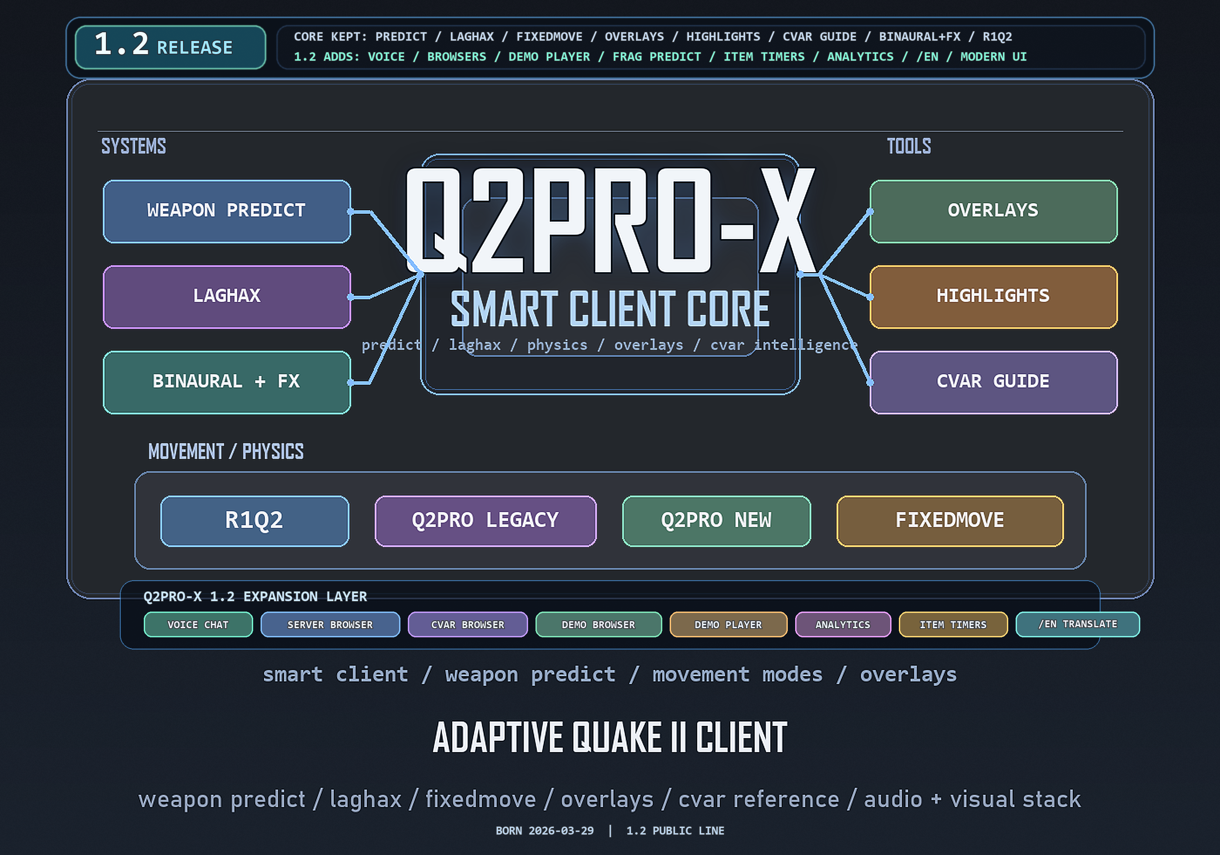
Q2PRO-X 1.2
Q2PRO-X 1.2: video, visuals, and highlights
Video, visuals, highlights, and the demo-visual profile
English edition
April 28, 2026
q2pro-x.com

Contents
- 1. Where to find the settings
- 2. Video backend: why win32egl is the default
- 3. Resolution, refresh, windowed, and fullscreen
- Desktop fullscreen
- Exclusive fullscreen
- Windowed mode
- 4. Render scale
- 5. Base visual effects
- 6. OLED protection
- 7. Visibility Highlights: base model
- 8. Items and weapons
- 9. Player highlighting
- 10. Player model color overrides
- 11. Demo visual config
- 12. Recommended starting profiles
- Competitive play
- Demo watching
- Video capture

Q2PRO-X 1.2: video, visuals, and highlights
This guide explains the video and visual layers in Q2PRO-X 1.2: backend,
fullscreen modes, render scale, post-processing, OLED protection, visibility
highlights, and the demo-visual profile.

1. Where to find the settings
Guided menu:
- Options -> Video;
- Options -> Visibility Highlights;
- Options -> Demo Player -> Demo Analytics;
- Options -> Demo Player -> Item Timers.
Classic Q2PRO-X menu:
- Q2PRO-X -> video;
- Q2PRO-X -> visibility highlights;
- Q2PRO-X -> demo player;
- Q2PRO-X -> demo analytics;
- Q2PRO-X -> demo item timers.
Some base Quake II video cvars still live in the legacy menu and the console.
For normal 1.2 setup, start with the Q2PRO-X pages.

2. Video backend: why win32egl is the default
On Windows, the release build defaults to win32egl. This is the EGL/ANGLE
path, selected because it behaves better with modern capture and
desktop/fullscreen workflows.
Available options:
- vid_driver win32egl - recommended Q2PRO-X default on Windows;
- vid_driver win32wgl - classic WGL OpenGL fallback.
If the selected backend fails to start, the engine probes fallback drivers and
rewrites vid_driver to the backend that actually came up. The menu therefore
shows the real running backend, not only the requested one.
Practical advice:
- keep win32egl if the game starts normally;
- try win32wgl only if this machine has an EGL/ANGLE problem;
- after changing backend, use vid_restart or restart the client if the menu
did not apply it immediately.

3. Resolution, refresh, windowed, and fullscreen
Q2PRO-X 1.2 wraps the older vid_fullscreen model in clearer pickers:
- vid_resolution - desktop or a concrete 1920x1080-style value;
- vid_refresh - max or a concrete rate such as 144;
- vid_windowed - windowed mode;
- vid_fullscreen_type - desktop or exclusive;
- vid_desktop_fullscreen_fit - fill or aspect;
- vid_desktop_fullscreen_margin - small borderless-window margin.

Desktop fullscreen
desktop fullscreen is borderless fullscreen. It is usually the best mode for
Alt+Tab, recording, and modern Windows desktop behavior. With
vid_desktop_fullscreen_fit aspect, the game can preserve the selected aspect
ratio and draw black bars.

Exclusive fullscreen
exclusive is the classic monitor mode switch. Here vid_refresh matters
directly. If the exact refresh is not available, the engine snaps to the
closest valid mode from vid_modelist.

Windowed mode
In windowed mode, vid_resolution drives the window size. vid_refresh is
ignored because the desktop compositor owns refresh timing.

4. Render scale
Render scale separates internal 3D resolution from the window / framebuffer
size.
Key cvars:
- gl_render_scale - internal render scale percentage;
- gl_render_scale_mode - application mode;
- gl_render_scale_filter - upscale/downscale filter.
Typical use:
- 100 - native sharpness;
- below 100 - more FPS at the cost of blur;
- above 100, where available, - supersampled look.
For competitive play, 100 is normally the sane baseline. Disable expensive
visual effects first if you need more FPS.

5. Base visual effects
These settings belong to the mod-local visual profile:
- gl_dynamic - dynamic lights;
- gl_shadows - shadows;
- gl_coloredlightmaps - colored lightmaps;
- gl_brightness - local render brightness;
- gl_polyblend - screen blend effects;
- gl_bloom, gl_bloom_strength, gl_bloom_threshold - bloom;
- gl_post_profile, gl_post_contrast, gl_post_vibrance,
gl_post_temperature, gl_sharpen - post-processing;
- usefog, fogdensity, foghue, fogsaturation, foglightness - fog.
The scope matters: different mods may want different visual profiles. During
demo playback these values can come from the demo-visual profile instead of a
mod-local cfg.

6. OLED protection
OLED protection is a set of UI and fullscreen safeguards for cases where
static elements remain on the same pixels for a long time.
Key cvars:
- vid_oled_enable - master switch;
- vid_oled_bar_protection - animated app-owned black bars;
- vid_oled_idle_protection - idle dimming;
- vid_oled_idle_monitor_off - optional monitor-off idle action;
- vid_oled_ui_protection - breathing alpha for supported overlays;
- vid_oled_ui_min_alpha, vid_oled_ui_max_alpha,
vid_oled_ui_cycle_sec.
Bar protection applies only when Q2PRO-X owns the black bars, for example
desktop fullscreen plus aspect fit. Idle/UI protection is not limited to that
case.

7. Visibility Highlights: base model
Visibility Highlights do not replace models and do not change game data. They
are a local visual rendering layer:
- item highlighting;
- weapon highlighting;
- player highlighting;
- per-class item colors;
- per-weapon colors;
- player model color overrides.
Master switch:
- cl_vis_enable.
Separate groups:
- cl_vis_items;
- cl_vis_weapons;
- cl_vis_players.
Styles are:
- off;
- shell;
- tint;
- shell+tint.
Each group has alpha, shell thickness, brightness, and scale controls where
they apply.

8. Items and weapons
Items:
- cl_vis_items_style;
- cl_vis_items_alpha;
- cl_vis_items_shell_alpha;
- cl_vis_items_shell_scale;
- cl_vis_items_brightness;
- cl_vis_items_scale;
- per-class toggles: health, armor, ammo, powerups, keys;
- per-class colors.
Weapons:
- cl_vis_weapons;
- cl_vis_weapons_scale;
- per-weapon toggles;
- per-weapon colors.
The system is useful for both live play and demo watching. If the highlight is
too strong, start with shell+tint but lower tint alpha and brightness.

9. Player highlighting
Key settings:
- cl_vis_players;
- cl_vis_players_mode;
- cl_vis_players_style;
- cl_vis_players_alpha;
- cl_vis_players_shell_alpha;
- cl_vis_players_shell_scale;
- cl_vis_players_scale;
- cl_vis_players_brightness;
- cl_vis_players_self.
cl_vis_players_mode values:
- off - disabled;
- all - one common color;
- random FFA - FFA palette by slot;
- duel - two duel roles;
- auto - attempt to select a sensible mode;
- team - friendly/enemy colors;
- model - color by resolved player-model directory.
For live TDM/duel, team, duel, or auto usually make sense. For demos,
model is often better because recordings do not always provide reliable
friendly/enemy truth.

10. Player model color overrides
model mode colors players by model name: male, female, cyborg, or a
custom players/<model> directory.
The menu has a dedicated editor:
- Player model colors....
It lists models available in the current user configuration and lets you pick
colors using the same preset style as the other color editors. Hex values are
also possible through the console / cvar browser.
Dynamic cvars use this form:
- cl_vis_player_model_color_<model>.
They are mod-local, and during demo playback they are saved into the
demo-visual cfg.

11. Demo visual config
The goal is simple: .dm2 / .mvd2 demos should keep one visual profile even
when they were recorded in different mods.
During playback, mod-local visual Q2PRO-X settings are written to:
baseq2/q2pro-x/demo_visual/q2pro-x.demo.cfg
This covers:
- Visibility Highlights;
- model color overrides;
- demo analytics colors and trail settings;
- demo item timer colors and toggles;
- other mod-local visual Q2PRO-X cvars.
Practical flow:
- Start a demo.
- Tune highlights / analytics / item timers.
- The saved values land in the demo-visual profile.
- The next demo from another mod uses the same demo-watching profile instead
of that mod's local cfg.
Commands:
- q2prox_cfg_save_demo_visual;
- q2prox_cfg_defaults_demo_visual;
- q2prox_cfg_save_local writes to the demo-visual target while a demo is
playing.

12. Recommended starting profiles

Competitive play
- vid_driver win32egl;
- vid_fullscreen_type desktop;
- vid_resolution desktop;
- gl_render_scale 100;
- keep bloom/post-processing moderate or off;
- cl_vis_players_mode team or auto;
- use low-alpha item highlights so models remain readable.

Demo watching
- cl_vis_players_mode model;
- cl_vis_players_style shell+tint;
- open Player model colors... and assign readable model colors;
- enable demo analytics only when you need the event map;
- enable item timers as needed: world only, strip only, or both.

Video capture
- keep win32egl;
- use desktop fullscreen;
- check vid_desktop_fullscreen_fit aspect if you need 4:3 pillarbox;
- keep post-processing and highlights stable through the demo-visual cfg.

