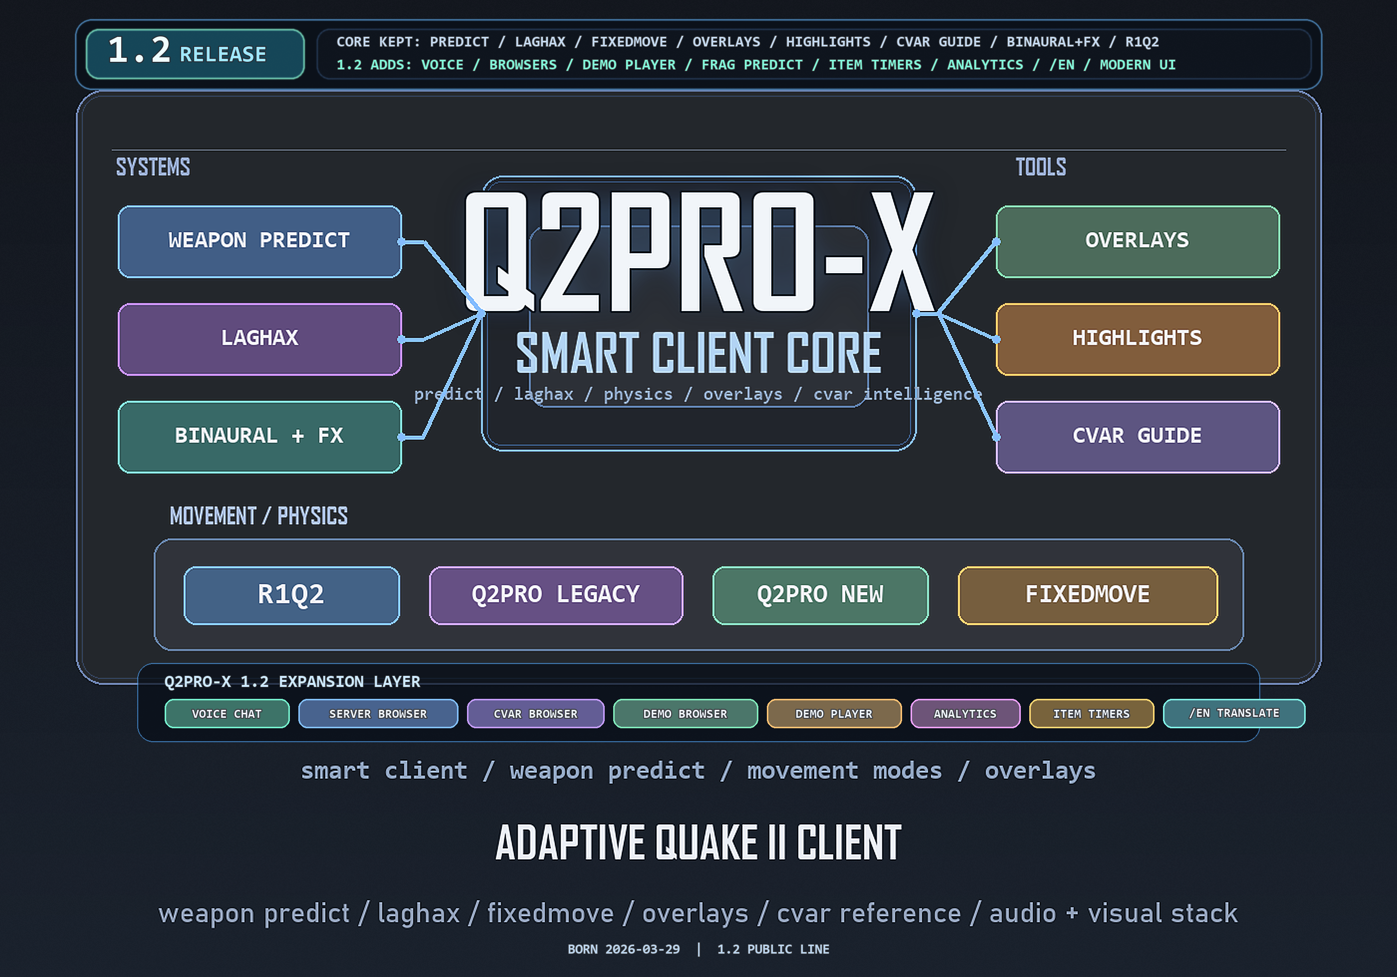
Q2PRO-X 1.2
Q2PRO-X 1.2: Voice Chat
Built-in voice chat
English edition
April 28, 2026
q2pro-x.com

Contents
- 1. What voice chat does
- 2. Where to find the menu
- 3. Requirements
- 4. Main cvars
- 5. Commands
- 6. Room mode
- Server mode
- Manual mode
- 7. Push-to-talk and VAD
- 8. Gain and volume
- 9. Microphone
- 10. Hosted control server
- 11. Autojoin
- 12. Troubleshooting
- The menu is enabled, but voice does not work
- Others cannot hear me
- I cannot hear others
- Voice distracts from the game
- 13. Good baseline

Q2PRO-X 1.2: Voice Chat
Q2PRO-X 1.2 includes built-in voice chat. It is a separate voice
side-channel inside the client. It does not change the Quake II game protocol
and does not replace say / say_team.

1. What voice chat does
Voice chat lets players join a voice room and talk through the microphone from
inside the client.
Main user model:
- vc_enable 1 enables the feature;
- vc_autojoin 1 joins a voice room when entering a game server;
- vc_room_mode server derives the room from the current game server;
- vc_room_mode manual uses vc_room_name;
- vc_server points to the control-plane service that prepares room access.
Default hosted control server:
https://voice-api.q2pro-x.com

2. Where to find the menu
Guided menu:
- Options -> Sound & Acoustics -> Voice Chat;
Classic Q2PRO-X menu:
- Q2PRO-X -> voice chat.
The page contains:
- master switch;
- autojoin;
- room mode;
- manual room name;
- control server;
- microphone enabled;
- mic device picker;
- transmit mode;
- VAD threshold;
- mic gain;
- receive volume;
- deafen;
- display name;
- join / leave room;
- PTT key;
- mic toggle key;
- restore voice defaults.

3. Requirements
The current voice chat phase requires OpenAL for both transmit and receive.
Check:
- s_enable 2 or menu value Sound engine = OpenAL;
- soft_oal.dll is present in the release directory;
- livekit_ffi.dll is present in the release directory;
- Windows allows microphone access for the application.
If the game uses the software DMA sound path, voice chat may be unavailable
even when vc_enable is on.

4. Main cvars
- vc_enable - voice chat master switch;
- vc_autojoin - automatically join on game server connect;
- vc_server - control-plane service URL;
- vc_room_mode - server or manual;
- vc_room_name - room name in manual mode;
- vc_mic_enable - allow microphone capture;
- vc_mic_device - selected microphone, "(default)" follows the system
default;
- vc_ptt_mode - 1 push-to-talk, 0 voice activation;
- vc_vad_threshold - VAD threshold;
- vc_input_gain - microphone gain;
- vc_receive_volume - incoming voice volume;
- vc_deafen - mute incoming voice without disabling your mic;
- vc_display_name - name in the voice room, empty = use player name.
Most vc_* cvars are saved in the global Q2PRO-X cfg.

5. Commands
- voice_join - join the current voice room;
- voice_leave - leave the room;
- +voiceptt / -voiceptt - push-to-talk;
- voice_mic_toggle - toggle microphone enabled;
- voice_mic_list - print microphone list;
- voice_mic_pick <index> - select microphone by index;
- voice_defaults - restore the recommended voice baseline.
Calling voice_mic_pick without an argument acts like voice_mic_list.

6. Room mode

Server mode
vc_room_mode server is the recommended mode. The room is derived from the
current game server, so players on the same server enter the same voice room
without typing a room name.
For normal play:
- enable vc_enable;
- enable vc_autojoin;
- keep vc_room_mode server;
- connect to a game server.

Manual mode
vc_room_mode manual uses vc_room_name.
This is useful when:
- testing voice without a game server;
- using a separate room for a group;
- avoiding a dependency on the current game server address.

7. Push-to-talk and VAD
vc_ptt_mode 1 is push-to-talk. It is the recommended play mode:
- bind a PTT key;
- hold the key to transmit.
vc_ptt_mode 0 is VAD, voice activity detection:
- the microphone opens based on signal level;
- lower vc_vad_threshold = more sensitive;
- too low can pick up keyboard and room noise;
- too high can cut the beginning of words.
Practical start:
- PTT: vc_ptt_mode 1;
- VAD: vc_vad_threshold 0.02, then lower toward 0.005 if the mic is quiet.

8. Gain and volume
vc_input_gain boosts the microphone before transmit. 1.0 is unity. Values
above 3-4 may clip loud speech, but can help quiet microphones.
vc_receive_volume controls incoming voice independently from game volume.
1.0 is unity, up to 10.0 is strong boost.
If others hear distortion:
- reduce vc_input_gain;
- check Windows input level;
- use PTT so constant room noise is not transmitted.

9. Microphone
The Mic device... menu lists capture devices visible to OpenAL.
Command:
voice_mic_list
prints:
- current selection;
- Windows default device;
- indexed device list.
vc_mic_device "(default)" means "follow the system default".
If a device was renamed or disappeared, select it again from the menu.

10. Hosted control server
Default vc_server:
https://voice-api.q2pro-x.com
The client asks the control-plane for room preparation. After joining, voice
traffic goes through the voice infrastructure, not through the Quake II game
server.
Local dev setups can point vc_server to a local service. Normal users should
keep the default.

11. Autojoin
To join automatically:
- vc_enable 1;
- vc_autojoin 1;
- vc_room_mode server;
- connect to a game server.
If you left manually with voice_leave, use voice_join to enter again.

12. Troubleshooting

The menu is enabled, but voice does not work
Check:
- sound engine = OpenAL;
- vc_enable 1;
- vc_mic_enable 1;
- Windows microphone permission;
- selected vc_mic_device;
- vc_server availability;
- firewall/antivirus.

Others cannot hear me
Check:
- PTT key is bound and held;
- in VAD mode, vc_vad_threshold is not too high;
- vc_input_gain is not 0;
- the correct microphone is selected.

I cannot hear others
Check:
- vc_deafen 0;
- vc_receive_volume is not 0;
- OpenAL backend is active;
- you are actually in the same room.

Voice distracts from the game
Use:
- PTT instead of VAD;
- vc_deafen 1 for temporary incoming mute;
- a dedicated PTT key;
- lower vc_receive_volume.

13. Good baseline
For most players:
- vc_enable 1;
- vc_autojoin 1;
- vc_room_mode server;
- vc_server https://voice-api.q2pro-x.com;
- vc_mic_device "(default)";
- vc_mic_enable 1;
- vc_ptt_mode 1;
- vc_input_gain 1.0;
- vc_receive_volume 1.0;
- vc_deafen 0.
Then tune only microphone, PTT key, and incoming voice volume.

