Q2PRO-X 1.0
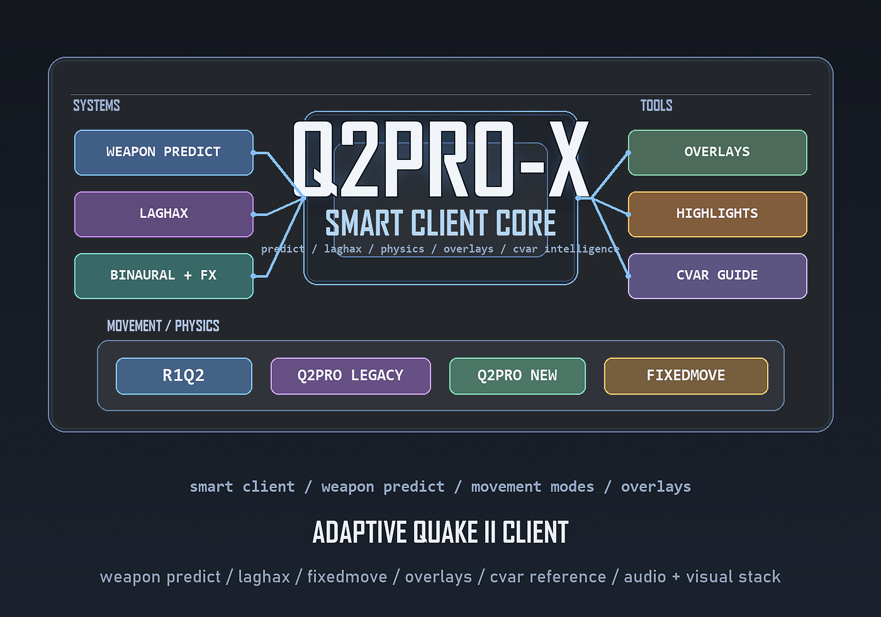
Change Log
English edition for the public website

Contents
- General logic of the document
- 0.95 - first public beta
- 0.95-a - target hotfix wave
- 0.96 - 4:3 / pillarbox / display wave
- 0.97 - OLED protection + predict follow-up
- 0.98 - display/audio/predict/browser wave
- 0.99 - guided menu + WFX + cvar reference wave
- 1.0 - release polish wave

General logic of the document
This log is organized by release wave so public website visitors can see how Q2PRO-X evolved from early beta into release 1.0.
It is not a raw commit dump. The goal is to summarize the product-level milestones that matter to players, testers, and anyone trying to understand what 1.0 actually contains.

0.95 - first public beta
- First public beta wave with Q2PRO-X presented as a distinct client layer on top of Q2PRO.
- Early public testing of weapon prediction and related ghost-fire, hidden-gun, and wrong-viewmodel cases.
- Release process and tester-facing documentation started to become structured instead of ad hoc.

0.95-a - target hotfix wave
- Stabilization of the first public beta based on tester reports.
- Weapon-predict follow-up fixes and stronger runtime/debug support.
- Alt+F4 behavior turned into a real global option instead of an undocumented detail.

0.96 - 4:3 / pillarbox / display wave
- 4:3 pillarbox and fullscreen semantics became a central product focus.
- Display mode picker and clearer desktop-fullscreen versus exclusive-fullscreen behavior.
- OLED-protection work started to turn into a proper feature branch.

0.97 - OLED protection + predict follow-up
- OLED protection architecture matured into a wider display-care subsystem.
- Hyperblaster, machinegun, chaingun, and related prediction follow-up cases were investigated and stabilized.
- LAGHAX HUD became a more serious diagnostic surface, and lift jitter in step smoothing was addressed.

0.98 - display/audio/predict/browser wave
- Windowed mode and clearer display state handling were added as deliberate product features.
- Audio inactivity handling and OLED-related sound behavior were expanded.
- Weapon-predict architecture became more stable and server browser favorites moved toward a real workflow.

0.99 - guided menu + WFX + cvar reference wave
- Guided menu mode became a major onboarding surface.
- Cvar browser and inline cvar help advanced through bilingual support, font work, wrapping fixes, and copy actions.
- Overlay ergonomics, reference material, and public product presentation all moved closer to a release-quality state.

1.0 - release polish wave
- Q2PRO-X 1.0 consolidates the long beta line into a stable branded release layer with bilingual docs, website presentation, and coherent packaging.
- The modern cvar browser reached release quality through EN/RU support, unified browser-local font rendering, UTF-8-safe wrapping, detail scrolling, independent alpha, independent scale, and clipboard features.
- Overlay settings gear buttons and tracked return flow were added so users can move from overlay to settings and back without losing context.
- LAGHAX HUD gained a new optional weapon-predict runtime diagnostics block while preserving read-only behavior.
- The website became part of the release story itself: bilingual product pages, screenshots, document previews, branded assets, theme selection, and public-facing documentation now ship as part of the 1.0 presentation layer.

