Q2PRO-X 1.0
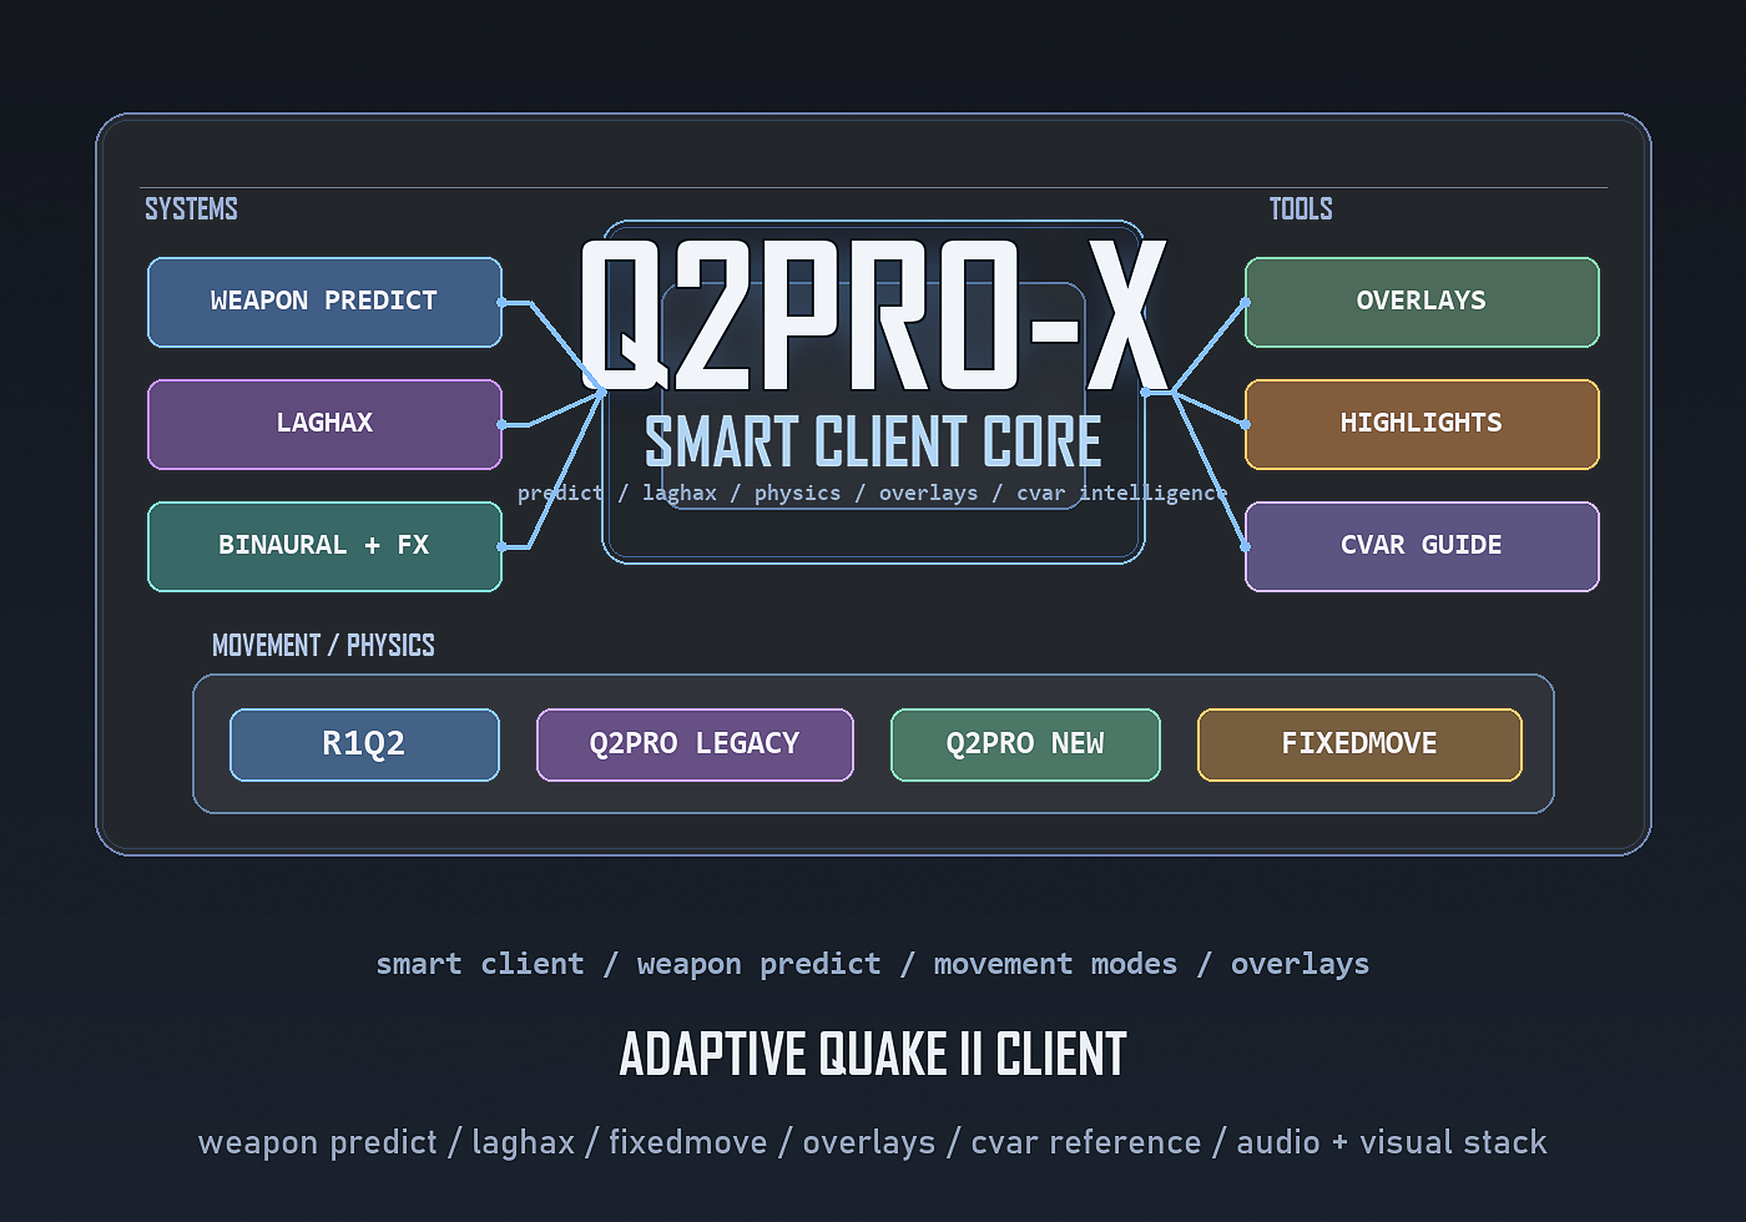
Architectural review of multiplayer fairness
English edition for the website

Q2PRO-X 1.0 Multiplayer Fairness Audit
Date: 2026-04-14 Language: English Status: architecture and code audit

1. Audit Goal
Determine whether the current Q2PRO-X build provides any real cheat-capable advantage in `deathmatch > 0`, as opposed to legitimate client-side quality-of-life behavior.
Primary audit focus:
- Predicted weapons: can the client actually fire faster, earlier, or more accurately than the server allows.
- Client-side movement and latency-improvement systems: whether they qualify as cheats.
- Q2PRO-X visual systems: whether they can provide gameplay advantage without directly violating server authority.

2. Final Conclusion

2.1. No server-authority combat cheat path was confirmed
Based on the current code, Q2PRO-X does not expose a confirmed path that would allow the client to:
- increase actual weapon fire rate;
- apply damage before server authorization;
- improve true hit accuracy beyond the server model;
- create extra projectile or hitscan events outside server logic;
- bypass server-side command-time validation through client prediction.
In other words, weapon prediction in Q2PRO-X is a client-side responsive visual layer. It does not replace authoritative server combat logic.

2.2. Predict and movement paths do not qualify as cheats
`cl_fixedmove`, `cl_predict_move_mode`, `cl_movement_feel`, `cl_step_smoothing_mode`, `cl_laghax`, and related branches do not qualify as cheats, because:
- they do not alter authoritative server weapon logic or damage;
- they do not originate server fire events on their own;
- they do not bypass server-side `usercmd` processing;
- they do not replace world physics on the server;
- they operate as client-side input normalization, smoothing, and latency-perception improvements.

2.3. The remaining risk is not server-authority abuse, but visibility advantage
That said, Q2PRO-X still contains client-side systems that do not break server fairness, but can alter scene readability and visual burden. For broader semi-public 1.0 testing, this should be treated as a separate policy-risk.
The clearest example is `weapon parts visibility`, which can hide portions of other players' weapon FX.

3. Predicted Weapons: Technical Basis

3.1. Client ghost/predict does not control actual firing
In [input.c](O:/Claude2/q2pro/src/client/input.c), attack input first enters the normal `usercmd` path, and only after command finalization does the client call `Ghost_OnFireCmd`:
- `BUTTON_ATTACK` is set in [input.c](O:/Claude2/q2pro/src/client/input.c:1103)
- the finalized `usercmd` is stored in [input.c](O:/Claude2/q2pro/src/client/input.c:1154)
- `Ghost_OnFireCmd(...)` is called afterward in [input.c](O:/Claude2/q2pro/src/client/input.c:1162)
Therefore, the ghost layer is not the source of server fire authorization. It is a local reaction to an already-formed input command.

3.2. The server validates client command time
In [user.c](O:/Claude2/q2pro/src/server/user.c), the server tracks `command_msec`:
- time budget initialization: [user.c](O:/Claude2/q2pro/src/server/user.c:531)
- subtraction of `cmd->msec`: [user.c](O:/Claude2/q2pro/src/server/user.c:1123)
- underflow validation through `sv_enforcetime`: [user.c](O:/Claude2/q2pro/src/server/user.c:1127)
`sv_enforcetime` defaults to enabled:
- [main.c](O:/Claude2/q2pro/src/server/main.c:2207)
This means that even if the client changes local command cadence or packet packing behavior, the server remains authoritative over the amount of valid client time it will execute.

3.3. Real fire decisions are made by server-side `Think_Weapon`
In [p_client.c](O:/Claude2/q2pro/src/game/p_client.c), the server:
- accepts `ucmd->buttons` in [p_client.c](O:/Claude2/q2pro/src/game/p_client.c:1637)
- derives `latched_buttons` in [p_client.c](O:/Claude2/q2pro/src/game/p_client.c:1638)
- calls `Think_Weapon(ent)` on attack in [p_client.c](O:/Claude2/q2pro/src/game/p_client.c:1656)
- also calls `Think_Weapon(ent)` during the server-frame path in [p_client.c](O:/Claude2/q2pro/src/game/p_client.c:1709)
As a result, the authoritative server weapon state machine is not replaced by client prediction.

3.4. Fire rate is defined by the server weapon state machine
In [p_weapon.c](O:/Claude2/q2pro/src/game/p_weapon.c), `Weapon_Generic(...)` is the authoritative weapon finite-state machine:
- `WEAPON_READY` path: [p_weapon.c](O:/Claude2/q2pro/src/game/p_weapon.c:413)
- transition into `WEAPON_FIRING` only on valid attack plus sufficient ammo: [p_weapon.c](O:/Claude2/q2pro/src/game/p_weapon.c:414)
- actual shot dispatch only on allowed `fire_frames[]`: [p_weapon.c](O:/Claude2/q2pro/src/game/p_weapon.c:458)
- return to `WEAPON_READY` by server frame logic: [p_weapon.c](O:/Claude2/q2pro/src/game/p_weapon.c:472)
Concrete fire-frame schedules are defined server-side, for example:
- Rocket Launcher: [p_weapon.c](O:/Claude2/q2pro/src/game/p_weapon.c:720)
- Blaster: [p_weapon.c](O:/Claude2/q2pro/src/game/p_weapon.c:778)
- HyperBlaster: [p_weapon.c](O:/Claude2/q2pro/src/game/p_weapon.c:843)
- Machinegun: [p_weapon.c](O:/Claude2/q2pro/src/game/p_weapon.c:936)
- Chaingun: [p_weapon.c](O:/Claude2/q2pro/src/game/p_weapon.c:1045)
- Shotgun: [p_weapon.c](O:/Claude2/q2pro/src/game/p_weapon.c:1105)
- Super Shotgun: [p_weapon.c](O:/Claude2/q2pro/src/game/p_weapon.c:1162)
- Railgun: [p_weapon.c](O:/Claude2/q2pro/src/game/p_weapon.c:1222)
- BFG: [p_weapon.c](O:/Claude2/q2pro/src/game/p_weapon.c:1294)
Therefore, `Super Shotgun` cannot actually fire faster than its authoritative server cycle merely because client prediction is enabled.

3.5. Real projectile, trace, and damage logic is server-side
Actual combat creation and damage logic resides in [g_weapon.c](O:/Claude2/q2pro/src/game/g_weapon.c):
- `fire_bullet(...)`: [g_weapon.c](O:/Claude2/q2pro/src/game/g_weapon.c:249)
- `fire_shotgun(...)`: [g_weapon.c](O:/Claude2/q2pro/src/game/g_weapon.c:261)
- `fire_blaster(...)`: [g_weapon.c](O:/Claude2/q2pro/src/game/g_weapon.c:312)
- `fire_rocket(...)`: [g_weapon.c](O:/Claude2/q2pro/src/game/g_weapon.c:575)
- `T_Damage(...)`: for example [g_weapon.c](O:/Claude2/q2pro/src/game/g_weapon.c:202), [g_weapon.c](O:/Claude2/q2pro/src/game/g_weapon.c:550)
- `T_RadiusDamage(...)`: for example [g_weapon.c](O:/Claude2/q2pro/src/game/g_weapon.c:396), [g_weapon.c](O:/Claude2/q2pro/src/game/g_weapon.c:562)
This means:
- the client does not apply damage on its own;
- the client does not spawn real server projectiles;
- the client cannot accelerate actual damage resolution through the ghost layer.

3.6. The ghost layer is explicitly documented as visual-only
In [ghost.c](O:/Claude2/q2pro/src/client/ghost.c:1), the system is explicitly described as `client-side ghost projectile prediction` that spawns `visual-only ghosts`.
In addition:
- [weaponfx.c](O:/Claude2/q2pro/src/client/weaponfx.c:6) states that the weapon FX layer does not touch the admission gate and does not dispatch sound;
- [ghost.c](O:/Claude2/q2pro/src/client/ghost.c:2438) states that when predicted visuals are hidden, handoff/suppress bookkeeping remains active and only the visual layer changes.
Conclusion: the client prediction layer is not an alternative damage or fire-rate system.

4. Movement / Laghax / Fixedmove
These systems do not qualify as cheats because, in the code, they do not introduce a separate server physics model and do not replace weapon authority.
Even when `cl_fixedmove` changes local command subdivision, the server still:
- receives normal `usercmd` input;
- tracks `command_msec`;
- executes standard game DLL movement and weapon logic.
These systems therefore belong to the category of client experience improvements, not server-authority bypass.

5. Visual Systems: Where the Boundary Lies

5.1. Visibility highlights do not currently create a wallhack path
The `visibility / highlights` branch already contains multiplayer-safe restrictions:
- item and dropped-weapon scale above `1.0` is clamped in multiplayer in [vis_items.c](O:/Claude2/q2pro/src/client/vis_items.c:537)
- the enlarged model still uses original-size culling through `ent.cull_scale = base` in [entities.c](O:/Claude2/q2pro/src/client/entities.c:945)
- the renderer uses `entcullscale` during culling in [main.c](O:/Claude2/q2pro/src/refresh/main.c:199) and receives it from the entity in [main.c](O:/Claude2/q2pro/src/refresh/main.c:309)
- player shell thickness is limited to a very small range `0.0 .. 0.05` in [vis_items.c](O:/Claude2/q2pro/src/client/vis_items.c:953)
As a result, this system should not allow players or pickups to protrude through geometry purely because of scaling.
However, it still increases visibility of already visible targets and objects. That is not a server cheat, but it is still a visual assist.

5.2. Weapon Parts Visibility remains a policy-risk for competitive multiplayer
The most debatable system at present is `weapon parts visibility`.
By code:
- it is explicitly described as a `visual-only policy layer` in [weaponfx.c](O:/Claude2/q2pro/src/client/weaponfx.c:1)
- it does not alter the admission gate and does not dispatch sound in [weaponfx.c](O:/Claude2/q2pro/src/client/weaponfx.c:6)
- but it allows entire FX classes for `WFX_SRC_OTHER` to be disabled through [weaponfx.c](O:/Claude2/q2pro/src/client/weaponfx.c:38)
- foreign projectile models are skipped in [entities.c](O:/Claude2/q2pro/src/client/entities.c:716)
- other-source wall impacts are classified in [tent.c](O:/Claude2/q2pro/src/client/tent.c:1602)
This does not change damage and does not make a weapon mechanically stronger, but it can:
- simplify scene readability;
- reduce visual noise;
- hide part of the projectile and combat-effect information emitted by other players.
From a strict multiplayer fairness perspective, this should not be classified as a server cheat, but it should be classified as a competitive visibility assist.

6. Practical 1.0 Readiness Assessment

6.1. What can be considered safe
For 1.0, the following statements are technically justified:
- predicted weapons do not fire faster than the server-authoritative rate;
- predicted weapons do not deal damage outside server authorization;
- fixedmove, laghax, and movement feel modes do not qualify as cheats;
- visibility highlights do not create a geometry-protrusion wallhack path.

6.2. What requires explicit policy before broader testing
Before wider semi-public testing, it is recommended to define an explicit multiplayer policy for:
- `cl_weaponfx_vis_other` and related hiding branches;
- player and item highlighting in competitive modes;
- any visual assist settings that materially clean the scene in `deathmatch > 0`.

7. Recommendation
For 1.0, the issue should be separated into two classes:
- **Server-authority fairness**
This area appears technically sound based on the code audit.
- **Competitive visual policy**
This area should be handled via a dedicated `deathmatch > 0` profile if the 1.0 goal is not only "no mechanical cheats", but also "no debatable visual advantages".

8. Final Statement
Based on the audit:
- Q2PRO-X does not contain a confirmed mechanism that allows predicted weapons to actually fire faster, more accurately, or more powerfully than the server-authoritative model permits;
- client prediction, fixedmove, movement feel, and laghax do not qualify as cheats because they do not bypass server gameplay authority;
- the primary remaining concern before 1.0 is visual assist and visibility policy, not server-authority exploitation.
Final formulation:
**No server-mechanical cheat capability was confirmed in the audited code. The remaining area of attention before 1.0 is client-side visibility advantage, most notably in the weapon parts visibility branch.**

