1. Login form

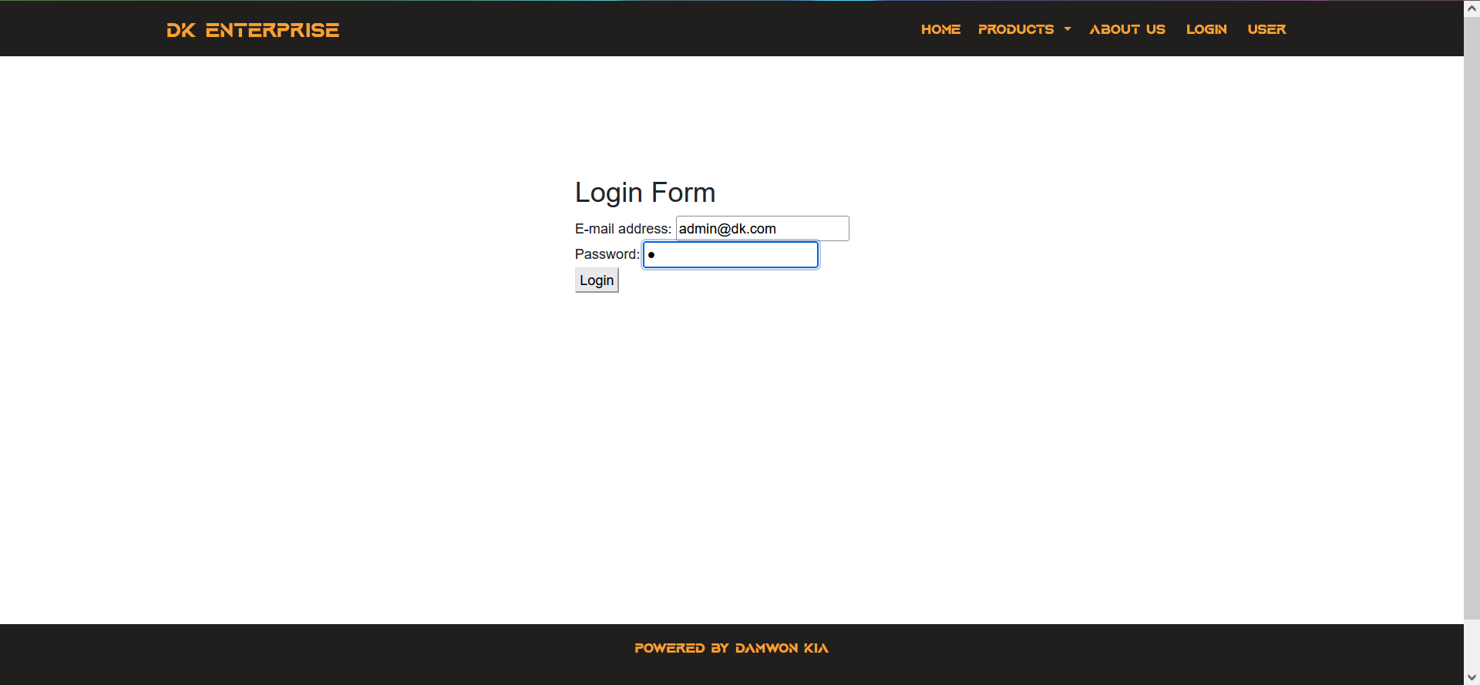

1. Error thrown when enter account not in database

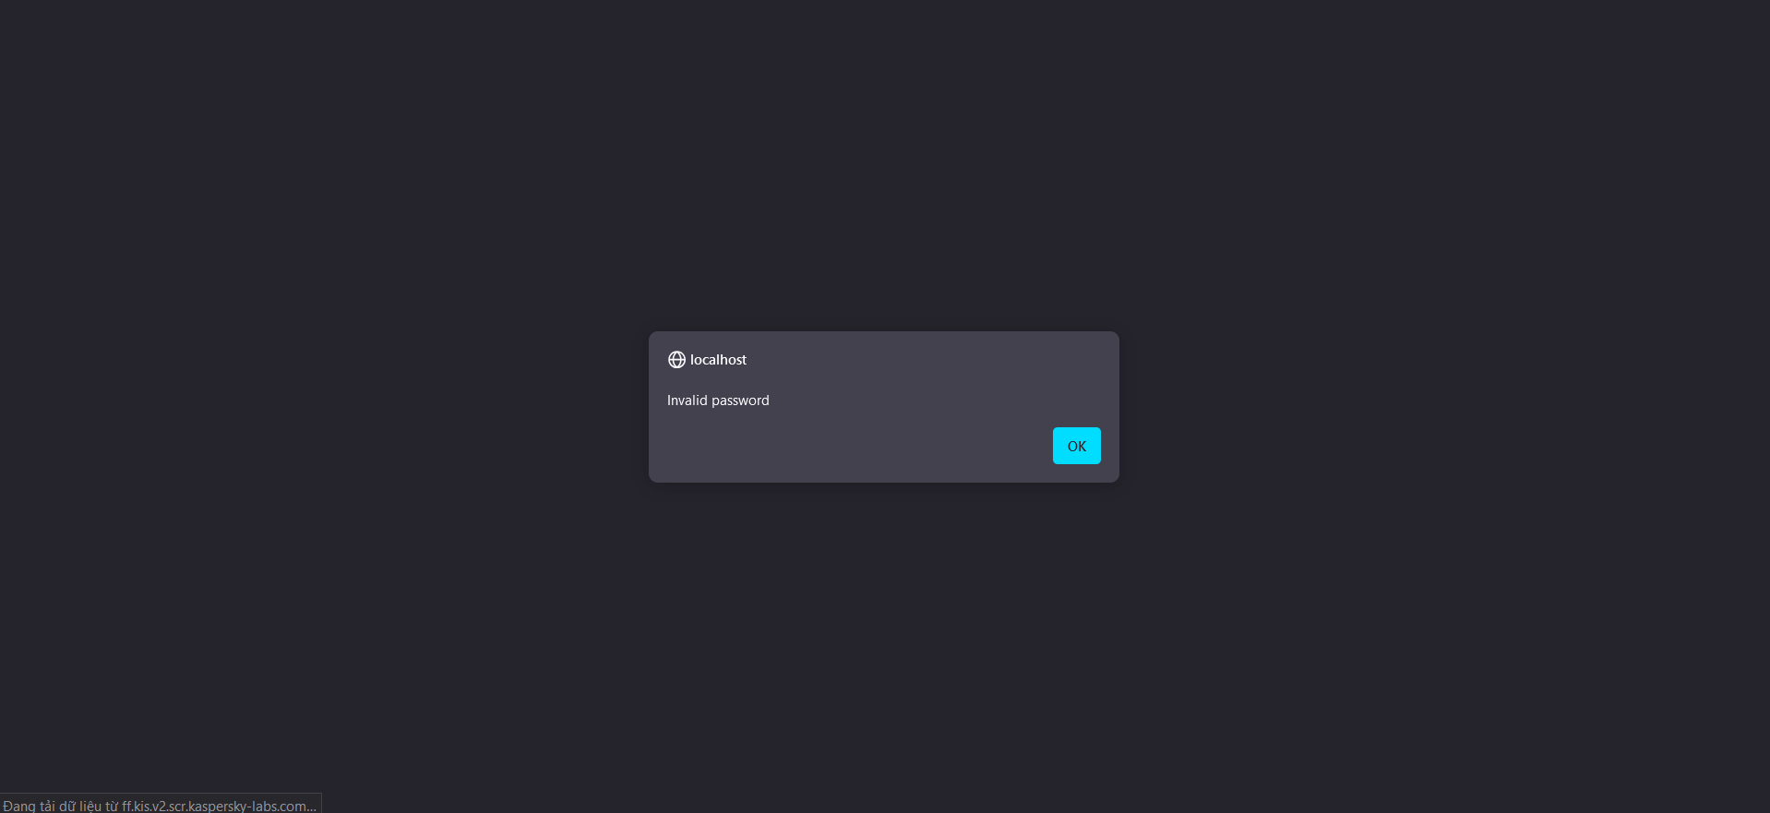

1. Login succesfully (login button on navbar now change to logout)



1. Press logout button return to the login page  
   
2. Session is added to every php file needed to ensure only when login by authorized account can user do certain action like manage users or products.