Onboarding & Developer Notes
V1: 5nov2025
Hi there! This document is a quick onboarding guide that is expanding in the coming months. Currently it provides a useful guide to install VSC, JustRelax.jl and run a mini-application to test if your installation went alright.
For the rest, this document has Developer Notes. These notes are on how to install and run MATLAB within VSC, and how to set up auto-formatters within VSC. You’re free to ignore these, these I have written as I installed the software myself, and I will refine these as we need them as a team. Finally, I’ve saved the old developers notes from my previous company at the bottom. It has some useful resources and extension for Python development using VSC. I’ll keep them there for people who are curious, and will refine them later once the project aims are more refined.

First things first
- Install Microsoft Teams on your current device to communicate with the team. We can support you at any step.
- Obtain a laptop from Utrecht University
  - Is done via the Secretariat and GEO-ICT. There s a form how to order, just ask someone in the group.
- First start-up: log into Utrecht University wi-fi and accept all softwares that will be installed by the UU IT department. This is done through the app ‘UU apps & services’.
- Install Visual Studio Code
  - If you’re aiming to develop also a lot in Python, check out the recommended extensions in chapter 5: Advanced Visual Code Extensions

Getting started with Julia
- Install Julia https://julialang.org/install/
- Open Visual Studio Code
- Find and install in Extensions the ‘Julia’ extension by julialang
- Use Ctrl+` or Cmd+` to open a terminal
- Typing ‘julia’ to open the Julia REPL
  - This is an interactive terminal. Follow this guide to get a general feeling for the language https://unimainzgeo.github.io/JuliaIntro/Basic_Operations/
  - Type ; (a semicolon) to open a shell in the terminal.
    - With this you can use familiar terminal commands like pwd, cd, ls
  - Type ] (closing square bracket) to open the package manager
- Download JustRelax.jl repository
- Open the folder JustRelax.jl in visual studio code
- Get familiar with JustRelax.jl
  - Read the documentation here:
  - https://ptsolvers.github.io/JustRelax.jl/dev/man/installation
  - https://ptsolvers.github.io/JustRelax.jl/dev/man/subduction2D/setup
  - This site combines all the README.md files found in the codebase. You can find these also in JustRelax.jl/docs/src/man. (Short for ‘manual’. IMO it is quite hidden..)
- Activate the project
  - Open a Julia (REPL) terminal
    - Run ‘julia’ in default terminal
    - Or run ‘Julia: Start REPL’ from the Command Palette (Cmd+Shift+P)
  - Activate the package
    - Run in the Julia REPL terminal:
      - using Pkg
      - Pkg.instantiate()
      - Pkg.activate(“.”)
    - This makes Julia look, in the current directory (.), for a Project.toml file with a list of necessary dependencies.
- Run the Subduction2D.jl miniapp
  - Open the file miniapps\subduction\2D\Subduction2D.jl
    - Documentation is found here: https://ptsolvers.github.io/JustRelax.jl/dev/man/subduction2D/setup
  - Edit line 4:
    - const isCUDA = false
    - (This makes the software run locally instead of looking for a cluster.)
  - Run the script with Shift+Enter or by clicking the Run triangle in the top right.
- Find the resulting figures every 10 timestamps under (root\)Subduction2D
- Note all the packages being used are also found under https://gpu4geo.org/software/

Shortcuts
Open terminal: Ctrl+`
Open explorer: Ctrl+E
Toggle left window: Ctrl+b

MATLAB
Add your project to the matlab PATH so VSC can run without changing working directory. Otherwise, it will give you a warning pop-up and ask you to change working directory every time.
- In a VSC MATLAB terminal, run these three commands
  - rootFolder = /path/to/directory/
  - addpath(genpath(rootFolder))
  - savepath (to make it permanent)

(Auto-)formatters
When collaborating on code, it can be convenient to agree and enforce a certain default lay-out of the code. Some examples are the amount of spaces that are used for an indent, whether to write an equation as y=ax+b or y = a * x + b, or whether or not to split long lines of code over multiple lines. Python has a community-agreed standard style called PEP8. I’ve had a look and found standards for C, MATLAB and Julia, although I am not certain if these are community wide. The benefit of using a standard is a very readable code.
Formatters are (custom) extensions of Visual Studio Code that format your code when pressing Option + Shift + F (Mac) or Shift + Alt + F (Windows). I’ve learned to use auto-formatters, which automatically format your code when saving the document. Very convenient!
Below I’ve provided a step-by-step walk-through how to set up an auto-formatter for Julia, C, MATLAB and Python. The Python method is widely used. The other formats are not certain yet if it follows a format. Bert will ask during Hackathon ’25 whether GPU4GEO uses a certain format.
  - https://github.com/fredrikekre/Runic.jl
  - JustRelax uses Runic for formatting. Its strict and makes all files the same lay-out to improve workflow in a team.
  - ChatGPT prompt I used to learn more: ‘ the project i work on, justrelax.jl, mentions it uses code style ' runic.jl'. please elaborate, and can you help with how i use it? Im used to using Black formatter in python and format on save. is this similar and how do i use it’
  - In VSC bash terminal:
    - Add Runic and creates a new environment for it. This way, we don’t add this clutter to the main project JustRelax.
      - julia --project=@runic --startup-file=no -e 'using Pkg; Pkg.add("Runic")'
    - Add executables for runic so we can run it from the command line
      - curl -fsSL -o ~/.local/bin/runic https://raw.githubusercontent.com/fredrikekre/Runic.jl/refs/heads/master/bin/runic
      - chmod +x ~/.local/bin/runic
      - curl -fsSL -o ~/.local/bin/git-runic https://raw.githubusercontent.com/fredrikekre/Runic.jl/refs/heads/master/bin/git-runic
      - chmod +x ~/.local/bin/git-runic
      - If directory ~/.local/bin not found
        - mkdir ~/.local/bin
    - add Runic to $PATH, so the terminal/shell knows where to find it
      - For Temporary use, type in terminal:
        - export PATH="$HOME/.local/bin:$PATH"
      - For everytime, add the above line to ~/.bashrc and reload using ‘source ~/.bashrc’
      - Verify installation using ‘ runic –help’ or ‘runic --version’
    - To format a file or folder by hand, run
      - runic --inplace <path/to/file/or/directory>
    - Setup auto-format upon save (very handy!)
      - Install the VS Code extension Custom Local Formatters.
      - Install juliaformatter in the Julia REPL
      - and go to settings.json and set auto-formatting to on:
"[julia]": {“editor.formatOnSave": true,
"editor.defaultFormatter": "julialang.language-julia"
}

Auto formatter for Matlab
There is a convenient formatter for Matlab too.
- Install Matlab, VSC and the Matlab extension for VSC by MathWorks.
  - Verify the installation by typing in the vsc terminal ‘where matlab’, by observing ‘MATLAB: Connected’ in the bottom bar, and by running a .m file.
- Find, in the Extensions pane, ‘matlab-formatter’ by AftenWiesel and install.
- You can execute this by using Option + Shift + F (Mac) or Shift + Alt + F
- To auto-format upon saving, add this to settings.json
  - "[matlab]": {
  - "editor.defaultFormatter": "MatlabFormatter.matlab-formatter",
  - "editor.formatOnSave": true}
- This will make your editor save Matlab files using AftenWiesel-matlab-formatter.

Auto-formatter for C
A quick chatgpt search pointed me to the autoformatter LLVM/Clang-Format. These are part of the same overarching project. I did not ask further questions.
Install LLVM
https://github.com/llvm/llvm-project/releases/tag/llvmorg-18.1.8
find LLVM-18.1.8-win64.exe if youre working on Windows
During installation, make sure to check the flag to add the location of the program to PATH. This is how VSC will find the program.
Add clang-format in Visual Studio Code
Go to the Extensions tab in the left panel (or press Ctrl+Shift+X)
search for Clang-Format, by author Xaver Hellauer
Press the blue ‘install’ button
Set up the formatter
Press Ctrl+Shift+P to show all commands
run ‘Preferences: open User settings (JSON)’
This will open settings.json, where all your user settings are saved.
Add to this file
"clang-format.executable": "C:\\Program Files\\LLVM\\bin\\clang-format.exe"
or if you did not install it in the default directory, then change it so it points to clang-format.exe.
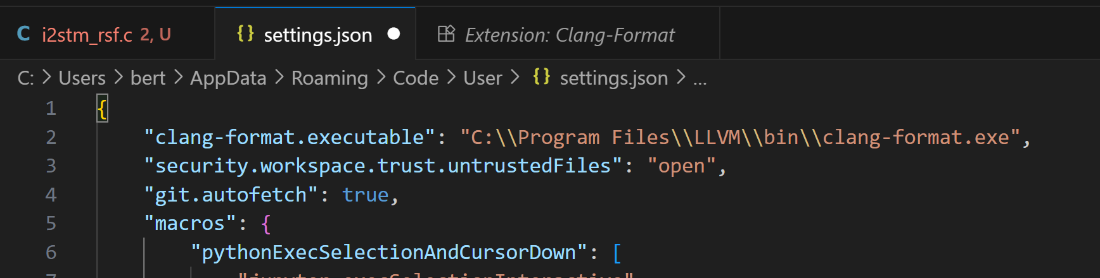
Set up auto-formatting on saving file
Add this to the file
"[c]": { "editor.defaultFormatter": "xaver.clang-format", editor.formatOnSave": true },
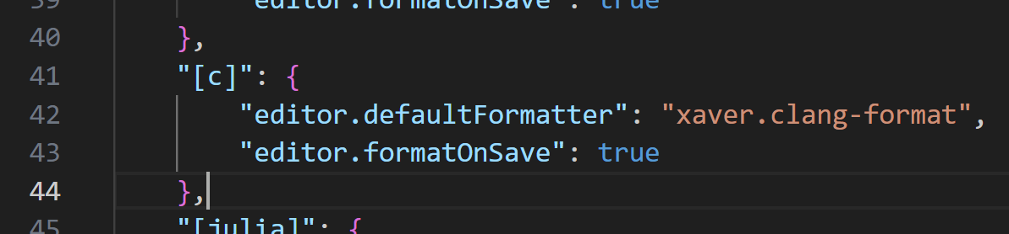
This will make your editor save c-language files using clang-format.

Advanced Visual Code extensions
Install the IDE of your choice. We recommend Visual Studio Code.
List of useful Visual Code extensions Extensions help to make the development progress easier and more consistent. If you discover a fancy new extension, share it with your teammates!
- autoDocstring - Python Docstring Generator: after starting a docstring (""") press enter to create a dockstring template.
- Black - Python code formatter: auto formatting python code to follow PEP8 style. Run black cable_tracker/* in terminal for formatting files. Set up auto execution of black after saving a file (see section below).
- Jupyter: Run jupyter notebooks inside Visual Code.
- Markdown All in One: Include a Markdown preview reader for rendering markdown files.
- Pylance: Make the editor understanding Python commands. Really useful in combination with type hinting (see section below)
- Python: Include additional tools for Python development
- MATLAB: Run MATLAB scripts in VSC. Make sure MATLAB is linked and connected with “MATLAB.installpath” in settings.json.
- Rewrap: automatic start a new line when text in docstrings extends end of line
- Code Spell Checker: mark wrong spelled words with blue lines.

Advanced visual code settings
Visual Code can format your code every time a file is saved using black and isort. This helps to comply with our coding practices. It must be manually set up following the instructions.
black is a python library which is also part of the requirement.txt file and formats code into PEP8 standard. PEP8 is the recommended python formatting style, developed by the Python foundation.

Best Coding practices
Best coding practices are rules we agreed on as software developers. We try to follow them in all situations.

Code formatting: PEP8
PEP8 is the code formatting style we use. Please follow it at all times. Use the library black at auto-save and you never have to worry again to follow the PEP8 standard.

Docstrings: PEP257
Docstrings are the first lines of classes and functions which describe their purpose. They start with """. Our Docstrings follow the PEP257 standard by the Python foundation. Please read it and compare it with already existing Docstrings in our code base.
We use the Google Style Python Docstrings following the PEP484 type hinting. See the following example:
def function_with_pep484_type_annotations(param1: int, param2: str) -> bool:
"""Example function with PEP 484 type annotations.

Args:
param1: The first parameter.
param2: The second parameter.

Returns:
The return value. True for success, False otherwise.

"""

Type hinting: PEP484
Type hinting is code which describes the type of function input and return variables. It is extra code which is ignored by the Python interpreter since python does dynamic typing. Writing typing in function declarations, however, are useful for two reasons. First, a developer directly understands which type variables have. This makes code easier to read. Second, Visual Code (with the Pylance extension) understands these types! This means, it can do auto-complete and spell checks for you: really useful.
Type hinting is describes in PEP484.

Boy/Girl-scout rule
The famous software developer Uncle Bob (yes, I'm not kidding) formulated the girl/boy-scout rule: Always leave the code better than you found it. Read this article for more information.
The code-base belongs to the development team. We all own it. Therefore, we are all responsible for its health. When you see something complicated or wrong, make it better. Check in particular dockstrings for spelling, grammatical mistakes and content. Do you understand the function or class by just reading the dockstring? Is the dockstring up-to-date? If not, rewrite the dockstring. The same holds for documentation like this one.

The SOLID principle
Another set of rules by Uncle Bob: the SOLID principle for object-oriented-programming. Read or watch this nice tutorial for a good overview.

