Adding hours and minuets to scope selection using QS_ElastiCubeTemplate

In case you used QS_ElastiCube template – when you built the ElastiCube you added few custom fields which can help you create time selection in dashboards creation.

* 1. Open the Prism ElastiCube manager – see your ElastiCube template
  2. In the execution table you can see few custom fields exist:
* Start Time Numeric
* Numeric Hour
* Numeric Minute
* Numeric Second

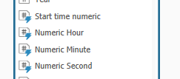

* 1. Once the ElastiCube is built it will be possible to use those fields in the dashboards.
  2. Add pivot to the sheet with the relevant fields - in order to see time drop down selection add the Execution.StartTime (TimeStamp) to the pivot
  3. To Set the **start time** add 4 dropdowns according to the following table:

|  |  |  |  |  |
| --- | --- | --- | --- | --- |
| **Widget Name** | **Widget Data** | **Affect global scope** | **Affected by global scope** | **Widget interconnectivity** |
| StartDays_A | Executions.ExecutionStartTime(days) | No | No | --- |
| Hours_A | Executions.NumericHour | No | No | StartDays_A |
| Minutes_A | Executions.NumericMinutes | No | No | StartDays_A,  Hours_A |
| CustomWidget_A | Execution.DateTimeNumeric | No | No | StartDays_A,  Hours_A,  Minutes_A,  Secondes_A |

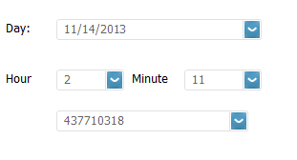

* 1. To Set the **end time** add another 4 dropdowns according to the following table:

|  |  |  |  |  |
| --- | --- | --- | --- | --- |
| **Widget Name** | **Widget Data** | **Affect global scope** | **Affected by global scope** | **Widget interconnectivity** |
| StartDays_B | Executions.ExecutionStartTime(days) | No | No | --- |
| Hours_B | Executions.NumericHour | No | No | StartDays_B |
| Minutes_B | Executions.NumericMinutes | No | No | StartDays_B,  Hours_B |
| CustomWidget_B | Execution.DateTimeNumeric | No | No | StartDays_B,  Hours_B,  Minutes_B,  Secondes_B |

* 1. In the Data Browser find Execution.DateTimeNumeric add it new filter:
     1. Filter by value.
     2. >= [@CustomWidget_A] AND <= [@CustomWidget_B]
     3. Name the filter 'NumricFilter'
  2. Add new pivot – present the relevant tests data.
  3. Set the filter to be in the pivot background.

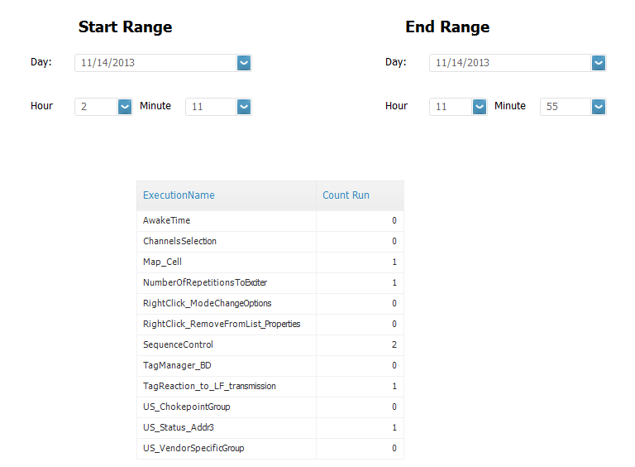

* 1. Drag and drop CustomWidget_A and CustomWidget_B out of the canvas so user won’t be able to select those drop downs.