**SNMP Overview**

SNMP (Simple Network Management Protocol) is an “Internet standard protocol” for managing devices on IP networks.

SNMP uses an extensible design, where the available information is defined by [management information bases](http://en.wikipedia.org/wiki/Management_information_base) (MIBs). MIBs describe the structure of the management data of a device subsystem; they use a [hierarchical namespace](http://en.wikipedia.org/wiki/Hierarchical_name_space) containing [object identifiers](http://en.wikipedia.org/wiki/Object_identifier) (OID). Each OID identifies a variable that can be read or set via SNMP.

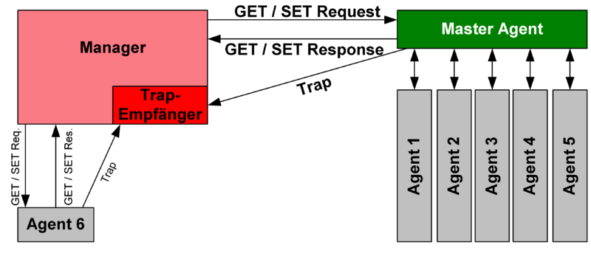

**SNMP in TestShell Studio**

In TestShell Studio we have 3 tools to work with SNMP:

1. SNMP Trap Listener – Sets a session in order to enable capturing SNMP traps that will be sent to the local computer where the test is running on.
2. Grab SNMP Traps – Enables to capture SNMP traps.
3. SNMP Manager – Enables to run different methods related to SNMP. (e.g : GetValue , Set Value, Walk, etc’)

In order to capture data out of SNMP traps you can use earthier an external MIB Browser that will allow you to use the relevant OID out of the SNMP trap or you can use Studio Grab SNMP Trap tool in order to grab the trap and extract the OID out of it.

**Capture SNMP traps using TestShell Studio**

The following section will describe what are the steps you should perform in order to create a simple test that will enable you to capture SNMP traps and extract data out of the relevant OID using TestShell Studio tools.

Note – Before you will be able to start capturing any SNMP trap you need to make sure that your device is configured to send SNMP Traps to the IP where you will run the test.

1. First we will need to set an SNMP Trap Listener that will allow us to listen to all traps that will be sent to our computer:

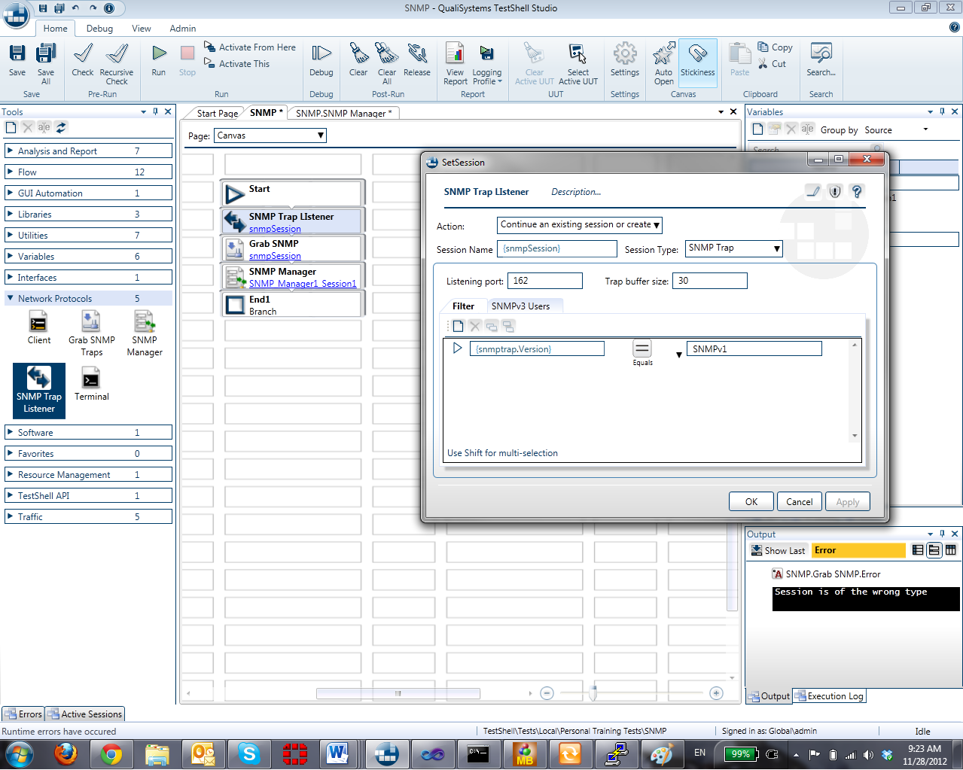

* Listening port – 162 is the default value. In case your device is sending the SNMP trap to a different port you will need to change this value.
* Filter – SNMP has different versions, in this example we are using SNMP version 1. In case you would like to capture a trap from a different version you can edit the filter section and add more versions to the listener.

1. The second step will be adding a “Grab SNMP” tool to our canvas in order to capture all SNMP traps that are being sent from our device. After defining the session (which should be the same session as we defined in step 1) we can click activate and get all SNMP traps that our device sent to our computer.

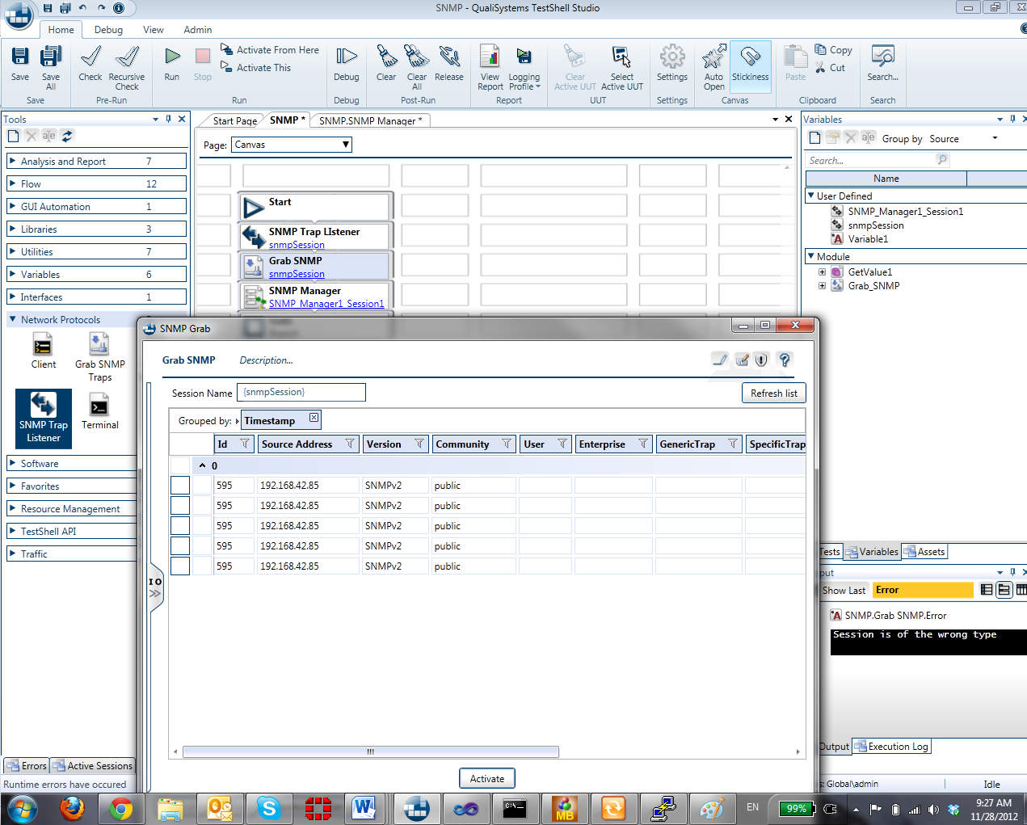

Using the Grab SNMP tool we can capture all SNMP traps and also get further details about each one of the traps:

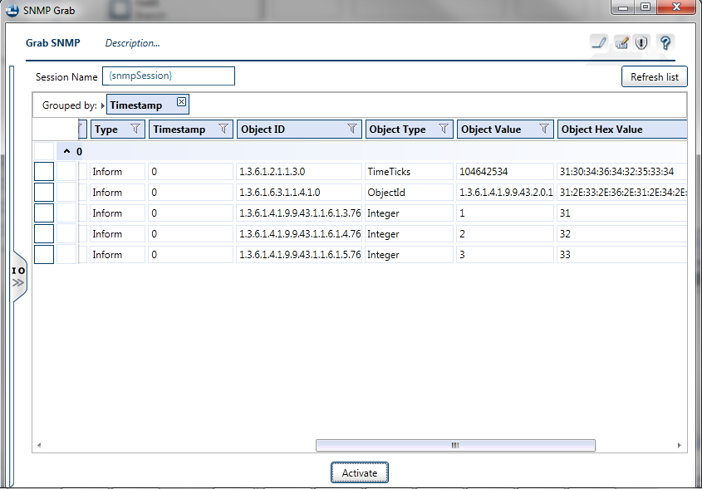

**Using SNMP Manager tool in TestShell Studio**

SNMP manager tool allows to run specific SNMP methods.

* Note – In order to use SNMP manager you will need to know the OID (Object ID) that you would like to work with.

The following steps will describe a simple example for working with SNMP manger tool:

1. Add an SNMP manager tool to your canvas and double click on it in order to get into the mini-canvas.
2. In order to start working with the SNMP manager we will need to set a session to the device we would like to work with:

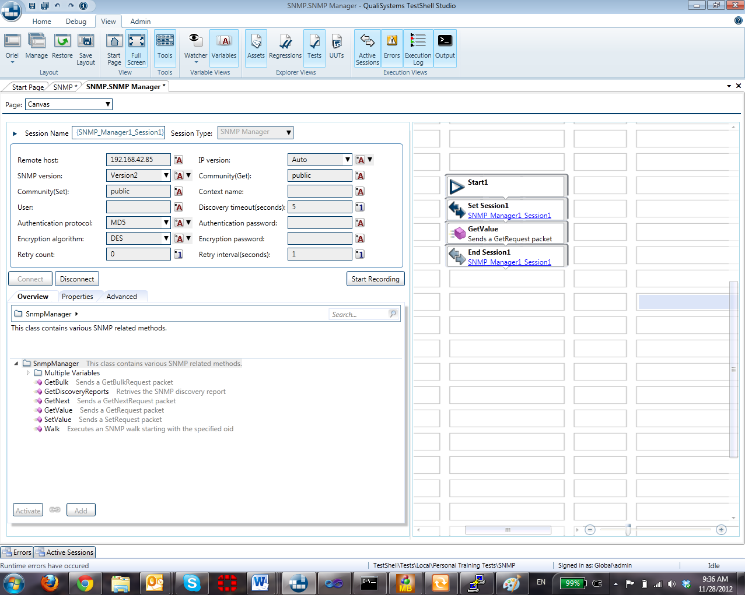

1. After setting the session we can use all available methods, in the following example we will see how to get a value:

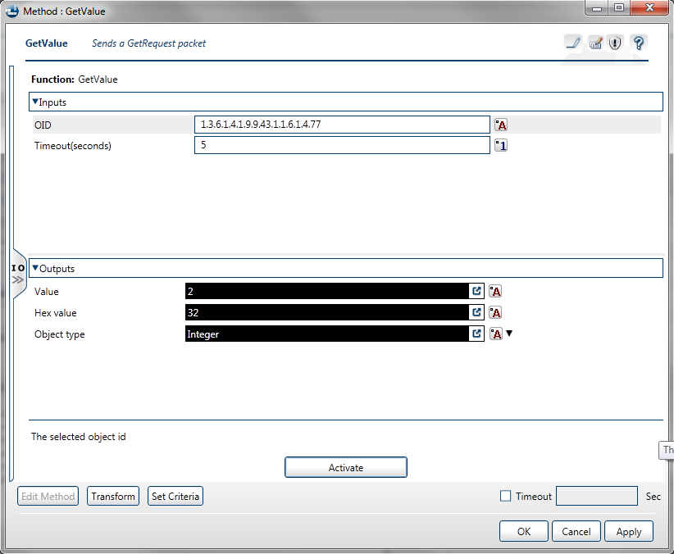

* Working with the SNMP methods will require you to know the OID that you would like to work (getValue, setValue, Walk, etc’) with, in order to get the OID you can either use the “Grab SNMP” tool in TestShell Studio or using an external MIB Browser.