Go to the Assets window in Studio and create a new folder under the Scripter. Name it VB.
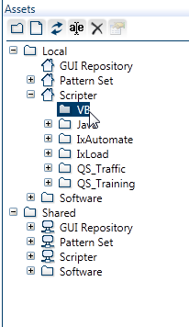

Create a new asset – Enter your own value for asset name and then browse to your vb script (its name will be added automatically). In the Engine name – scroll down and find VB.
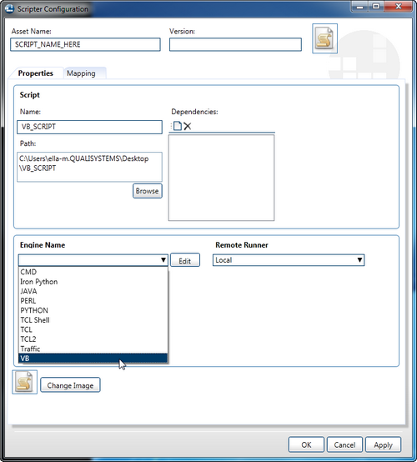

After you’ve selected VB press “Edit” next to the Engine name
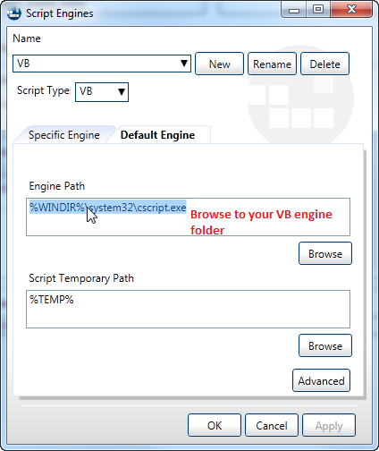

Click OK and return back to the main Scripter Configuration window.

Go to the Mapping tab, you’ll see your script there. Press on the little brush next to the Auto Scan (not the auto scan itself though), and select the text that‘d like to be able to set as a parameter. Do that for each piece of information you’d like to be able to set a parameter for.

The Auto Scan is not relevant in this case, since we only want to add one or two parameters. If you press the Auto Scan it will scan your entire script and will add a lot of potential parameters. You can then delete some if they are irrelevant, or edit them as you see fit.
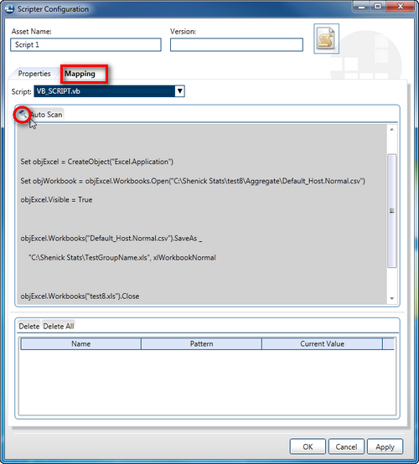

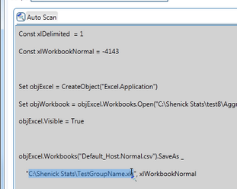

Then a small window will pop up – and there you can choose the pattern for your parameter and rename it into something that makes sense. It will also show the current value
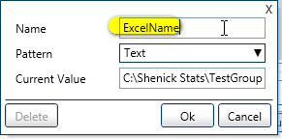

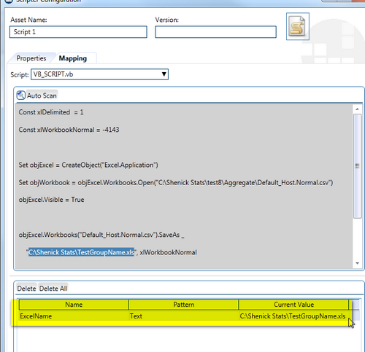

After you’ve configured all these, go back to your test and drag that asset in.

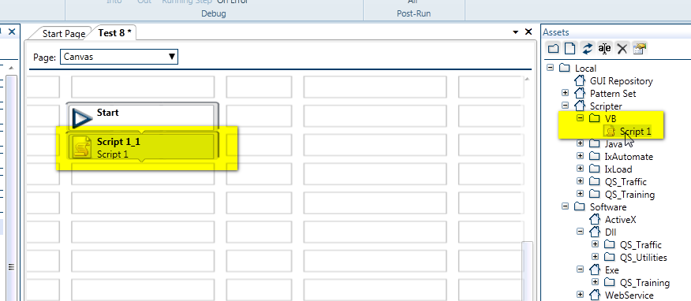

If you double click that block to open it up , you’ll see:
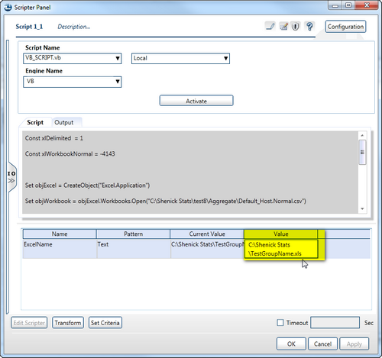

This highlighted part is where you insert your variable:

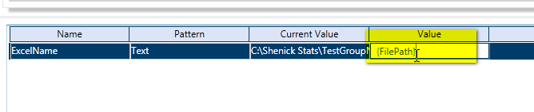

Now, if you initialize the FilePath before this step, then the new value will be used.

