|  |  |  |
| --- | --- | --- |
| publishing | **Journal of Quality and System Engineering**  Journal homepage **www.q-sci.rs** | ISSN 2812-975X  X (XXXX) X |

Your title goes here: Please use a short informative title   
no longer than two rows

Author's Name Surname1, Co-author's Name Surname2

1 Author's institution name, address, town, country

2 Co-Author's institution name, address, town, country

|  |  |  |
| --- | --- | --- |
| **Abstract** |  | **Key words** |
| This document is template. Before submitting your final paper, check that the format conforms to this template.  Abstract goes here and contains between 150-250 words. Please do NOT change any of our pre-set formatting (i.e., headers, footers, line spacing, indentations, etc.) in this file at all.  The Abstract should state the principal objectives and the scope of the research work, as well as the methodology employed. It should summarize the results and state the principal conclusions.  An effective abstract can be understood fully even when made available without the full paper. To this end, avoid referring to figures or the bibliography in the abstract.  Please introduce any acronyms the first time you use them in the abstract (if needed), and do so again in the full paper. About 4 to 6 significant key words should follow the abstract to aid indexing. |  | Key Word 1;  Key Word 2;  Key Word 3;  up to 6 Key words |
|  | **Corresponding author** |
|  | Corresponding author e-mail address |
| **Article info** |
| Original Scientific Paper  Received XXXXX  Accepted XXXXX  Online available XXXXX  Open access article CC BY license |

# Introduction section

An Introduction should provide a review of the recent literature on the topic and sufficient background information to allow the results of the article to be understood and evaluated.

In the Introduction section, state the motivation for the work presented in your manuscript and prepare readers for the structure of the paper. Write four components, preferably (but not necessarily) in four paragraphs: context, need, task, and objective of the article.

First, provide some context to orient those readers who are less familiar with your topic and to establish the importance of your work.

Second, state the need for your work, as a comparison between what the scientific community currently has and what it wants.

Third, indicate what you have done in an effort to address the need (this is the task).

Finally, preview the remainder of the paper to prepare readers for its structure, in the objective of the document.

Please note that heading numeration starts with 1.

# Methodology section

The Methodology section details the theoretical or experimental methods used. What justifies using a given method? What is special, unexpected, or different in your approach? If you use a standard or usual procedure, mention that upfront, too.

# Experiment section

The Experimental section should provide details of the experimental set-up and the methods used to obtain the results. Explain the choices you made in your experimental procedure with sufficient detail for other scientists to be able to reproduce the experiments presented in this paper.

The Methodology and Experimental part may be combined.

## Paper layout

You may organize the body of your paper into subsections or sub-subsections; No more than 3 levels of headings should be used.

## Article Types

The Science of Maintenance journal publishes:

Original scientific papers - Scientific papers should report significant and innovative results and exhibit a high level of originality.

Review scientific papers - Review articles are in the form of systematic reviews and literature reviews and are a form of secondary literature. Systematic reviews determine an objective list of criteria and find all previously published original experimental papers that meet the criteria. They then compare the results presented in these papers with proposed innovative or novel findings.

Short scientific papers - These generally have the same structure as longer scientific papers but are shorter (max 6 pages) and report on a significant, but limited, aspect of research work meriting a separate publication.

### Units

*The SI system of units for nomenclature, symbols and abbreviations should be followed closely. Please also see:*[*https://www.keyence.eu/ss/products/measure/measurement_library/basic/si/*](https://www.keyence.eu/ss/products/measure/measurement_library/basic/si/)

### *Abbreviations*

Abbreviations should be spelt out in full on first appearance followed by the abbreviation in parentheses, e.g. variable time geometry (VTG). The meaning of symbols and units belonging to symbols should be explained in each case or cited in a nomenclature section at the end of the manuscript before the References.

## *Figures and tables*

Figures (figures, graphs, illustrations digital images, photographs) and tables must be cited in consecutive numerical order in the text and referred to in both the text and the captions as Fig. 1, Fig. 2, etc and Table 1, Table 2, etc.

Figures and tables must be centered in the column. Large figures and tables may span across both columns. Any table or figure that takes up more than 1 column width must be positioned either at the top or at the bottom of the page. Graphics may be full color in high resolution, as shown consecutively in Fig. 1 and Fig 2. All letters and numbers within figure should be readable.

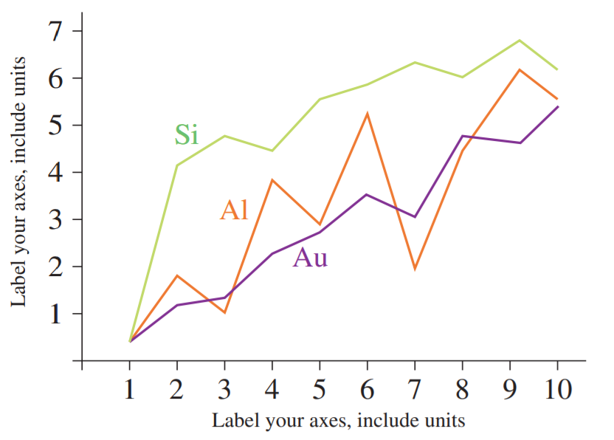

Fig. 1. A sample line graph using colors which contrast well both on screen and on a black-and-white hardcopy

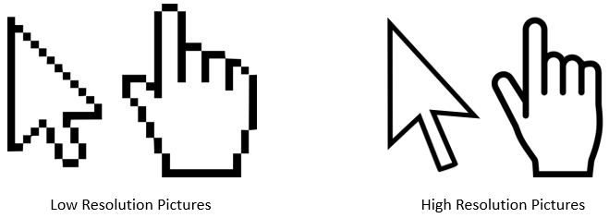

Fig. 2. Example of difference between low- and high-resolution pictures. with acceptable resolution

### Figure Captions

Figures must be numbered using Arabic numerals. Figure captions must be written below the figure in 10 pt Cambria italic font with center alignment.

### Table Captions

Tables must be numbered using Arabic numerals. Table captions must be placed before their associated tables, written in 10 pt Cambria italic font with center alignment, as shown in Table 1.

Table 1. Font sizes and alignment for text preparation

|  |  |  |  |  |
| --- | --- | --- | --- | --- |
|  | Font type | Font size | Font  style | Alignment |
| Title | Cambria | 16 | Regular | Left |
| Authors | 12 | Regular | Left |
| Affiliation | 10 | Regular | Left |
| Heading 1 | 12 | Bold | Left |
| Heading 1.1 | 11 | Bold | Left |
| Heading 1.1.1 | 11 | Bold | Left |
| Text | 11 | Regular | Justify |
| Figure / table caption | 10 | Regular | Center |
| Reference | 10 | Regular /Italic | Left |

## Equations

Equations should be numbered in consecutive numerical order with the use of brackets in the text and referred in the text as Eq. (1), Eq. (2), etc. The equation editor should be used for composing equations.

$A= a+b$ (1)

$\frac{A}{B}=\frac{\sqrt{c}}{d^{2}}$ (2)

## References

All reference items must be in 10 pt Cambria font left alignment. Please use Regular and Italic styles to distinguish different fields as shown in the References section. References must be cited consecutively in the text using square brackets [1] and collected together in a reference list at the end of the manuscript. A reference list must be included using the following information as a guide. Only cited text references are to be included. Each reference is to be referred to in the text by a number enclosed in a square bracket (i.e. [1] or [2] to [3] for more references; do not combine more than 3 references, explain each). References must be numbered and ordered according to where they are first mentioned in the paper, not alphabetically. All references must be complete and accurate. Please add DOI code when available.

# Results section

A Results section should clearly and concisely present the obtained data, using figures and tables where appropriate.

# Discussion section

A Discussion section should describe the relationships and generalizations shown by the results and discuss the significance of the results, making comparisons with previously published work. (It may be appropriate to combine the Results and Discussion sections into a single section to improve clarity.)

# Conclusions section

A Conclusions section should present one or more conclusions drawn from the results and subsequent discussion and should not duplicate the Abstract.

# Acknowledgement

Acknowledgement of collaboration or preparation assistance should be included as a separate section that contain: full name of the project, evidential number of project and full name of the institution that financed the project.

# Reference section

Journal Papers: Surname 1, Initials., Surname 2, Initials. (year). Article title. *Journal title*, volume, number, pages, DOI code.

1. Hrabala, M., Opletalova, M., Tučekc, D. (2017). Business process management in Czech higher education. *Journal of Applied Engineering Science*, vol. 15, no. 1, 35-44, DOI: 10.5937/jaes15-12171

Books: Surname 1, Initials, Surname 2, Initials (year). Title. Publisher, place of publication.

1. Vasić, B., Stanojević, N. (2007). Integrated cost-benefit and multi-criteria analysis based on the principles of life cycle engineering: a case study. MIRCE Science, Exeter.

Chapters in Books: Surname 1, Initials, Surname 2, Initials (year). Chapter title. Editor(s) of book, book title. Publisher, place of publication, pages.

1. Carbone, G„ Ceccarelli, M. (2005). Legged robotic systems. Kordic, V., Lazimca, A., Merdan, M. (Eds.), Cutting Edge Robotics. Pro literatur Verlag, Mammendorf, p. 553­576.

Proceedings Papers: Surname 1, Initials, Surname 2, Initials (year). Paper title. Proceeding’s title, pages.

1. Danon, G., Furtula, M., Lukačev, D., (2017). Energy efficiency in the wood industry: Example of wood pellets production. Maintenance Forum 2017, p. 44-52.

WWW pages: Surname, Initials or Company name. Title, from http://address, date of access.

1. IIPP. ISO Standards implementation, from http://www.iipp.rs/implementacija-iso-standarda.php, accessed on 2017-09-07.

# Appendix

Appendix(-icies) if any. In some cases, detailed information for other scientists is placed in the appendix, primarily because it is not what most readers want to know first.